Underwater Archaeology: Sunken Cities
By Marc Silver
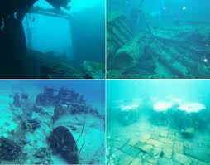
If you are anything like me, you probably spend more time than you intend watching the History Channel, the Science Channel, or National Geographic. You start with a program about ancient engineering or maritime exploration, and before long you notice a recurring theme. Again and again, entire civilizations seem to vanish beneath the sea.
At first glance, it feels like a curiosity. Then it starts to feel like a pattern.
I am not talking about the mythical Atlantis, with its allegorical lessons and moral warnings. Atlantis is a story designed to teach, not to document. What interests me far more are the cities we know existed. Places where people lived ordinary lives. They built houses, laid out streets, worshipped in temples, traded with distant neighbors, raised families, and assumed that tomorrow would look much like today.
Those cities were real. Many of them are now underwater.
Underwater archaeology has quietly become one of the most important tools we have for understanding how fragile civilization really is. It shows us that coastlines are temporary, land is negotiable, and water always has the final vote. These submerged cities were not wiped out by myth or mystery. They were erased by geology, climate, and human decisions, often working together.
Why Humans Build Near Water
Before looking at specific cities, it helps to ask a basic question. Why were so many important settlements built in places that later became vulnerable?
The answer is simple. Water meant survival.
Rivers and coastlines provided food, transportation, and trade. Long before paved roads or railways, water was the fastest and cheapest way to move goods and people. Ports became economic engines. River mouths became cultural crossroads. Entire civilizations grew outward from shorelines because water connected them to the wider world. 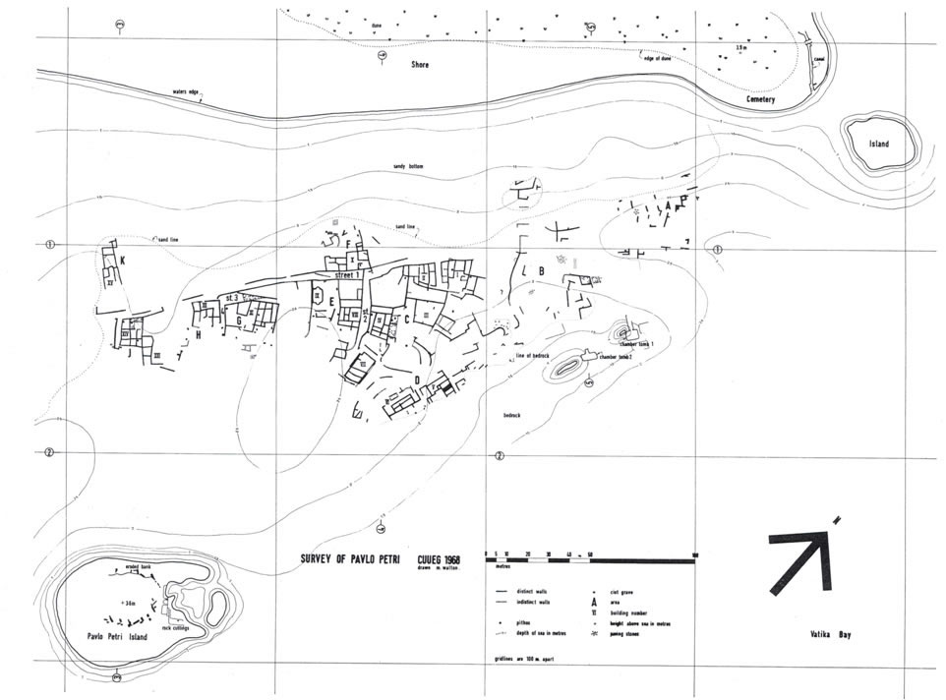
The risk was always there. Most people understood floods, storms, and erosion. What they could not easily account for were long-term changes. Sea levels rising by inches over centuries. Land slowly subsiding. Earthquakes that turned solid ground into liquid mud.
From a human perspective, those changes felt invisible until they were irreversible.
Underwater archaeology forces us to confront the long view. It shows us cities not as static achievements, but as temporary negotiations between people and their environment.
Cities That Slipped Away Slowly
Some cities did not vanish in a single dramatic moment. They faded.
Off the coast of southern Greece lies Pavlopetri, one of the most extraordinary archaeological discoveries of the modern era. Often described as the oldest known submerged city in the world, Pavlopetri dates back roughly 5,000 years to the Bronze Age.
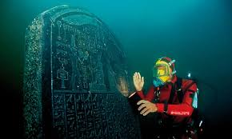
What makes Pavlopetri so remarkable is not just its age. It is how legible it still is. Streets are clearly defined. Courtyards sit where you would expect them. Buildings follow an organized layout that suggests deliberate urban planning rather than organic sprawl. This was not a temporary settlement. It was a functioning town with social structure and economic purpose.
When archaeologists mapped the site, they found evidence of houses, tombs, and even drainage systems. That level of planning tells us the inhabitants expected permanence. They were not hedging their bets.
Pavlopetri likely disappeared due to a combination of gradual sea-level rise and repeated seismic activity. No single catastrophe wiped it out. Instead, the shoreline crept forward over generations. Earthquakes subtly reshaped the land. Eventually, living there became impractical. The sea did not rush in. It simply waited.
This slow disappearance is important. It challenges the idea that civilizations always fall dramatically. Sometimes they retreat quietly, leaving behind no written record of their final days. Without underwater archaeology, Pavlopetri would be completely unknown.
A similar process played out in ancient Egypt with Heracleion, also known as Thonis. For centuries, Heracleion was Egypt’s primary gateway to the Mediterranean. Before ships entered the Nile, they passed through Heracleion. Taxes were collected there. Temples dominated the skyline. Religious rituals blended Egyptian and Greek traditions, reflecting the city’s role as a cultural and commercial bridge.
Heracleion was wealthy and strategically important, but it was built on unstable ground. The Nile Delta consists largely of soft, water-saturated sediment. Earthquakes in the region caused soil liquefaction, a process where solid ground temporarily behaves like a liquid. When that happens, buildings lose their support and sink.
Over time, Heracleion collapsed inward. Temples toppled. Canals filled with silt. The sea gradually covered what remained. By the time the city was rediscovered in 2000, statues, ships, and architectural fragments lay preserved beneath layers of sediment.
What is striking about Heracleion is how complete the archaeological record is. Objects were not looted or repurposed. They fell where they stood. It is not a ruin in the traditional sense. It is a city frozen mid-collapse.
When the Earth Moves Under Your Feet
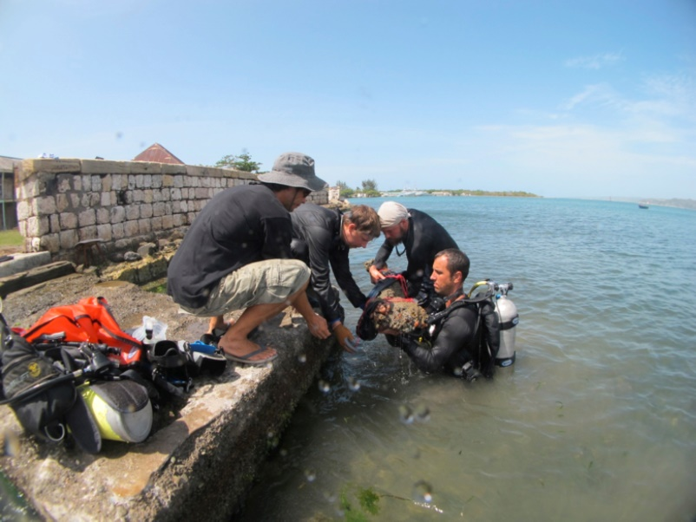
Italy provides one of the clearest examples of how geology can quietly undo even the most powerful societies.
Baiae was once the ultimate luxury resort of the Roman world. Emperors, senators, and wealthy elites built lavish villas along its coast. The city was famous for its thermal baths, fine dining, and excess. To vacation in Baiae was to announce your status.
Baiae’s problem was not war or economics. It was location.
The city sits atop a volcanic system near the Phlegraean Fields. Over centuries, volcanic activity caused the land to rise and fall through a process known as bradyseism. In Baiae’s case, the land slowly sank. Sea levels did not need to rise dramatically. The ground itself moved downward.
As the shoreline shifted, villas were abandoned. Streets flooded. Portions of the city slipped beneath the sea. Today, Baiae exists as an underwater archaeological park. Mosaics, columns, statues, and walkways remain visible just offshore. 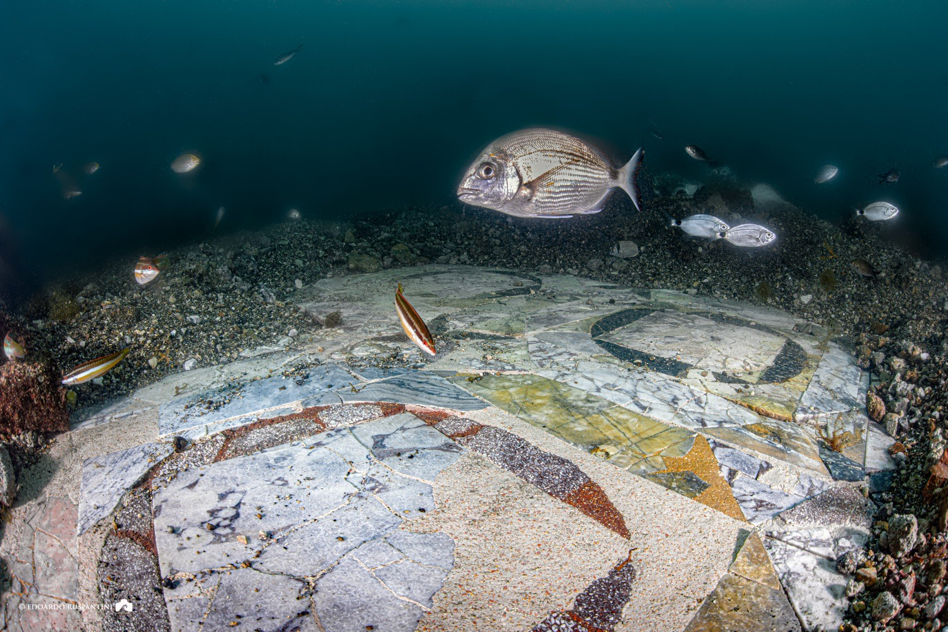
What makes Baiae particularly fascinating is how gradual its disappearance was. The Romans likely understood something was happening, but lacked the scientific framework to predict the outcome. They adapted as long as they could, then moved on.
Baiae reminds us that even advanced engineering and wealth cannot override geological reality. Rome ruled an empire. It could not command the ground to stay still.
A City Lost in Minutes
Not all sunken cities faded quietly.
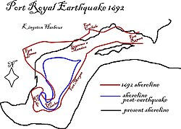
Port Royal stands apart because its destruction was sudden, violent, and witnessed.
In the late 17th century, Port Royal was one of the busiest ports in the Caribbean. It was rich, crowded, and unapologetically corrupt. Pirates, privateers, merchants, and tavern owners packed onto a narrow strip of reclaimed land guarding Kingston Harbour. Gold and silver passed through daily. So did rum, gambling, and vice.
Port Royal’s reputation earned it the nickname “the wickedest city in the world.” But reputation had little to do with its fate.
The city was built on loosely packed sand. Much of it had been reclaimed from the sea to accommodate rapid growth. On June 7, 1692, a powerful earthquake struck. The sandy soil liquefied. Streets split open. Buildings slid into the sea largely intact. A tsunami followed, finishing the collapse.
In a matter of minutes, roughly two-thirds of Port Royal vanished underwater.
What makes Port Royal archaeologically unique is documentation. Survivors described watching churches sink straight down. Streets disappeared before their eyes. For archaeologists, this created a rare time capsule. Cannons, tools, foundations, and everyday objects remain exactly where they fell.
Port Royal was not destroyed because it was immoral or reckless. It was destroyed because it was built quickly, densely, and on unstable ground in a seismically active region. The lesson is brutally simple. Physics does not care about wealth or reputation.
When Humans Pull the Plug
Not every sunken city is ancient.
In China, Lion City, also known as Shi Cheng, was deliberately flooded in the late 1950s to create a hydroelectric reservoir. The city dated back more than 1,300 years. It had walls, gates, temples, and administrative buildings that reflected centuries of regional importance.
When the decision was made to build the dam, Lion City was sacrificed. Residents were relocated. The valley was flooded. The city disappeared beneath the lake.
Ironically, the flooding preserved it.
Unlike cities exposed to waves and saltwater, Lion City rests in freshwater, protected from strong currents and erosion. Carvings remain sharp. Stairways are intact. Walls still stand. Divers often describe it as eerie, not ruined.
Lion City forces an uncomfortable realization. Some underwater archaeological sites are not ancient tragedies. They are modern decisions. They represent deliberate trade-offs between cultural heritage and economic development.
Future archaeologists may study our own era the same way, cataloging what we chose to preserve and what we allowed to drown.
Setting Atlantis Aside
It is impossible to discuss sunken cities without mentioning Atlantis. Plato’s story has endured for over two thousand years because it resonates symbolically. It is a cautionary tale about hubris, power, and moral decay.
But Atlantis is not archaeology.
There is no credible physical evidence that Atlantis existed as described. And once you examine Pavlopetri, Heracleion, Baiae, Port Royal, and Lion City, the legend begins to feel unnecessary.
The real stories are more compelling because they are grounded in evidence. Streets you can map. Walls you can touch. Objects you can date.
Myth is seductive. Reality is more instructive.
What Underwater Archaeology Really Teaches Us
Underwater archaeology is not just about discovery. It is about perspective.
These submerged cities challenge the idea that civilization is permanent. Many of them were technologically advanced for their time. They were wealthy. They were strategically important. They were confident in their future.
They disappeared anyway.
What ties these sites together is not mystery. It is geography, geology, and time. Humans have always followed water. Trade routes, food sources, and cultural exchange depend on it. But water is not static. Seas rise. Land sinks. Earth shifts.
Sometimes the change is slow enough to adapt to. Sometimes it is not.
Underwater archaeology reminds us that collapse does not always look like conquest or decline. Sometimes it looks like a harbor getting a little deeper. A street flooding more often. A foundation settling unevenly.
Those are easy signs to ignore.
Why This Matters Now
It is difficult to look at these submerged cities without thinking about the present.
Rising sea levels, coastal subsidence, and increasingly severe storms are not abstract concepts. They are processes that have erased cities before. The archaeological record proves it.
Modern engineering is impressive, but it does not cancel geology. Seawalls buy time. Dams reshape landscapes. But none of them make coastlines permanent.
Underwater archaeology is not just about the past. It is a quiet warning from the seabed. It shows us what happens when long-term environmental change collides with short-term human planning.
These cities were not foolish. They were human.
And that may be the most unsettling lesson of all.
A diver kicks gently, careful not to stir the silt. Below him, a stone street grid appears with unsettling clarity. Doorways still open onto nothing. A mosaic catches the light, its colors muted but intact. This was not always underwater. People walked here. They argued, traded, prayed, worried about money, complained about politics, and assumed the ground beneath their feet was solid.
That assumption has undone more civilizations than we tend to admit.
If you are anything like me, you probably spend more time than planned watching the History Channel, the Science Channel, or National Geographic. Somewhere between ancient engineering specials and lost-world documentaries, a pattern emerges. Again and again, entire cities vanish beneath the sea. Not symbolically. Literally.
I am not talking about the mythical Atlantis. Atlantis is useful as philosophy. It is less useful as history. What matters far more are the cities we know existed. Places with tax records, trade goods, street plans, and everyday objects left behind exactly where life stopped.
Underwater archaeology has changed how we understand collapse. These cities were not erased by mystery or divine judgment. They were undone by slow environmental shifts, sudden geological violence, or deliberate human choice. Often, all three.
What lies beneath the water is not legend. It is evidence.

Why Humans Always Build Too Close to Water
Before looking at the cities themselves, it helps to understand why this story repeats.
Water meant survival. Rivers and coastlines offered food, transportation, irrigation, and access to trade. Long before roads or railways, water was the cheapest and fastest way to move people and goods. Ports became economic engines. River mouths became cultural crossroads. Entire civilizations grew outward from shorelines.
The risk was always present, but it rarely felt urgent. Floods came and went. Storms were remembered, then forgotten. What people struggled to perceive were changes measured not in seasons, but in generations. A shoreline creeping forward. Land slowly subsiding. An earthquake that turns solid ground into something closer to soup.
From a human timescale, those changes feel invisible until they are irreversible.
Underwater archaeology forces us to take the long view. It shows cities not as permanent achievements, but as temporary agreements between people and the landscapes they occupy.

Cities That Slipped Away Quietly
Some cities did not die in a single moment. They faded.
Off the southern coast of Greece lies Pavlopetri, often described as the oldest known submerged city in the world. Dating back roughly 5,000 years, Pavlopetri is extraordinary not just for its age, but for its clarity.
The layout is unmistakable. Streets run with intention. Courtyards sit where you expect them. Houses follow an organized plan rather than organic sprawl. This was not a temporary settlement or fishing camp. It was a town designed to last.
A resident walking Pavlopetri’s streets would have known his neighbors. He would have followed familiar routes to shared spaces, burial grounds, and work areas. This was a place built with confidence in tomorrow.
Its disappearance was unremarkable in the worst way. Gradual sea-level rise. Repeated seismic activity. No single catastrophe forced evacuation. The water crept in, the land shifted, and eventually the city became impractical to inhabit. People moved on. The sea stayed.
Without underwater archaeology, Pavlopetri would be completely unknown. There is no dramatic written account of its end. Its silence is the story.
A similar fate awaited Heracleion, also known as Thonis. For centuries, Heracleion served as Egypt’s main gateway to the Mediterranean. Ships passed through its harbors before entering the Nile. Taxes were collected there. Temples dominated the skyline. Greek and Egyptian cultures blended in daily life.
A merchant walking Heracleion’s quays would have heard multiple languages, smelled incense and salt water, and watched cargo being weighed and taxed before moving inland. This was a city that mattered.
But Heracleion sat on unstable ground. The Nile Delta is composed largely of water-saturated sediment. Earthquakes triggered soil liquefaction, causing the ground to lose strength. Buildings tilted, collapsed, and sank. Over time, canals filled with silt and the sea covered what remained.
When Heracleion was rediscovered in 2000, statues, ships, and temples lay scattered exactly where they fell. It is not a ruin stripped by time. It is a city caught mid-collapse.

When the Ground Refuses to Cooperate
Italy offers one of the clearest examples of how geology can quietly defeat even the most powerful societies.
Baiae was once the ultimate Roman resort town. Emperors, senators, and elites built lavish villas along its coast. Thermal baths steamed. Mosaics gleamed. To vacation in Baiae was to advertise status.
A guest reclining beside the baths would have felt utterly secure. Rome ruled the Mediterranean. Engineering seemed limitless. Nature felt manageable.
Baiae’s problem was location. The city sat atop a volcanic system near the Phlegraean Fields. Over centuries, volcanic activity caused the land to rise and fall through a process known as bradyseism. In Baiae’s case, the land sank.
The change was slow enough to tolerate, until it wasn’t. Villas flooded. Streets slipped below the tide. Sections of the city were abandoned. Today, Baiae exists as an underwater archaeological park. Light filters across mosaics. Columns stand half-buried in sand. The city feels paused rather than destroyed.
Baiae is a reminder that wealth and engineering do not cancel geology. Rome commanded an empire. It could not command the earth to stay still.

A City Lost in Minutes
Then there are cities that vanish all at once.
Port Royal stands apart because its destruction was sudden, violent, and witnessed.
By the late 1600s, Port Royal was one of the busiest ports in the Caribbean. It was rich, crowded, and famously corrupt. Pirates, privateers, merchants, and tavern owners packed onto a narrow strip of reclaimed land guarding Kingston Harbour. Gold flowed through daily. So did rum, gambling, and vice.
A shopkeeper opening his door on the morning of June 7, 1692, expected another profitable day.
Instead, the ground liquefied beneath him.
Built on loosely packed sand, Port Royal collapsed when a powerful earthquake struck. Streets split open. Buildings slid into the sea largely intact. A tsunami followed. In minutes, roughly two-thirds of the city disappeared underwater.
Survivors described watching churches sink straight down. Streets vanished before their eyes. For archaeologists, this created an unparalleled time capsule. Cannons, tools, foundations, and everyday objects remain exactly where they fell.
Port Royal was not destroyed because it was immoral or reckless. It was destroyed because it was built quickly, densely, and on unstable ground in a seismic zone. The earth did not care who lived there.

When Humans Choose What to Drown
Not every sunken city is ancient.
In China, Lion City, also known as Shi Cheng, was deliberately flooded in the late 1950s to create a hydroelectric reservoir. Founded more than 1,300 years ago, Lion City had walls, gates, temples, and administrative buildings that reflected centuries of regional importance.
Residents were relocated. The valley was flooded. The city disappeared beneath the lake.
Ironically, the flooding preserved it. Protected by freshwater and calm conditions, Lion City remains astonishingly intact. Gates stand upright. Stairways descend into darkness. Carvings remain sharp.
Lion City introduces an uncomfortable modern dimension. Some underwater archaeological sites are not accidents. They are choices. They represent trade-offs made in the name of progress.
Future archaeologists may study our own era the same way.

Why Atlantis Is the Least Interesting Part of This Story
Atlantis endures because it is symbolic. Plato used it as a moral lesson about hubris and collapse.
But archaeology does not need it.
Once you examine Pavlopetri, Heracleion, Baiae, Port Royal, and Lion City, myth becomes redundant. The real stories are grounded, documented, and far more instructive. Streets you can map. Walls you can touch. Objects you can date.
Reality does not need embellishment.

What Underwater Archaeology Really Reveals
Underwater archaeology is not just about discovery. It is about humility.
These submerged cities were not failures. Many were advanced, wealthy, and strategically vital. Their inhabitants were not careless or ignorant. They made reasonable decisions based on the knowledge they had.
They disappeared anyway.
What ties these sites together is not mystery, but physics. Humans follow water. Trade, food, and culture demand it. But water moves. Land sinks. Earth shifts. Sometimes slowly. Sometimes violently.
Collapse does not always arrive as invasion or decline. Sometimes it arrives as a harbor that grows deeper. A street that floods more often. A foundation that settles unevenly.
Those are easy signs to ignore.

Why This Matters More Than Television Ever Will
It is difficult to look at these submerged cities without thinking about the present. Rising seas, coastal subsidence, and extreme weather are not theoretical. They are processes that have erased cities before.
Modern engineering buys time. It does not buy permanence.
Underwater archaeology reminds us that vulnerability is not a flaw in civilization. It is a constant. The cities beneath the waves were human achievements, and they were temporary.
The next time a documentary teases a “lost city,” it is worth remembering that the most compelling stories are not the ones wrapped in myth. They are already there, quietly waiting beneath the water, proving that history does not disappear.
It just changes depth.

