Understanding Tuned Traps: Targeting Problem Frequencies in Your Room
By Marc Silver
In my last article, we explored the fundamentals of broadband bass traps, the unsung heroes of room acoustics. These versatile tools do an excellent job of managing a wide range of low frequencies, but sometimes, you need a scalpel rather than a Swiss Army knife. That’s where tuned traps come into play.
As someone who’s spent countless hours fine-tuning listening spaces and tackling stubborn low-end issues, I know firsthand the frustration of dealing with problem frequencies. Whether it’s the overwhelming boom of bass in a home theater or the uneven response of a small studio, low-frequency issues can derail even the best sound systems.
f you’re nodding along, wondering how to take your acoustic treatment to the next level, this article is for you. Building on the concepts we covered in the Bass Trap article, we’ll dive into the precision tools of acoustic treatment: Helmholtz resonators, diaphragmatic absorbers, and quarter-wavelength traps. These specialized solutions allow you to zero in on specific problem areas, transforming your room from chaotic to crystal-clear.
Of course, if you’ve got the budget, you could hire an expert to design a solution for you. But if you’re anything like me—frugal and hands-on—you’d rather roll up your sleeves, learn the process, and create something uniquely suited to your space. The bonus? You’ll save a few hundred dollars while gaining the satisfaction of doing it yourself.
In this article, we won’t just cover when and why to use tuned traps. We’ll also walk through how to build them yourself. With some DIY effort, you can take full control of your sound and finally achieve the clarity you’ve been striving for. Let’s dive in and get started.

When to Use Each Type of Trap
Each type of tuned trap addresses particular acoustic challenges. Here’s a breakdown of their strengths and applications:
Helmholtz Resonators 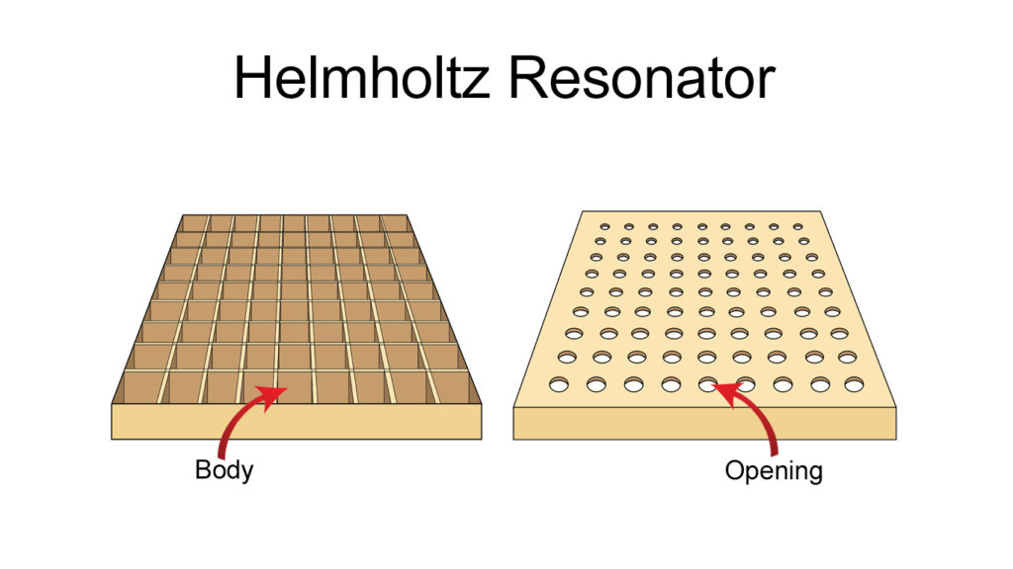
Best for:
- Tackling specific low-frequency problems in small to medium-sized rooms.
- Resolving modal peaks caused by room dimensions, such as boomy bass. 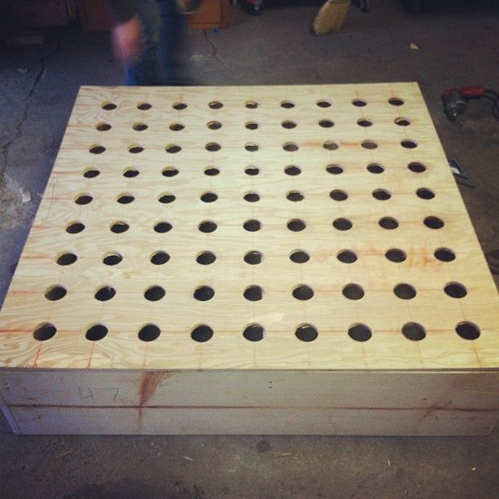
Why They Work:
Helmholtz resonators are highly precise, designed to absorb targeted frequencies without affecting others. They are perfect for resolving one or two dominant frequency issues.
Example:
Imagine a home theater with a bass resonance at 60 Hz due to standing waves. A Helmholtz resonator tuned to this frequency can neutralize the issue, ensuring balanced sound.

Diaphragmatic Absorbers 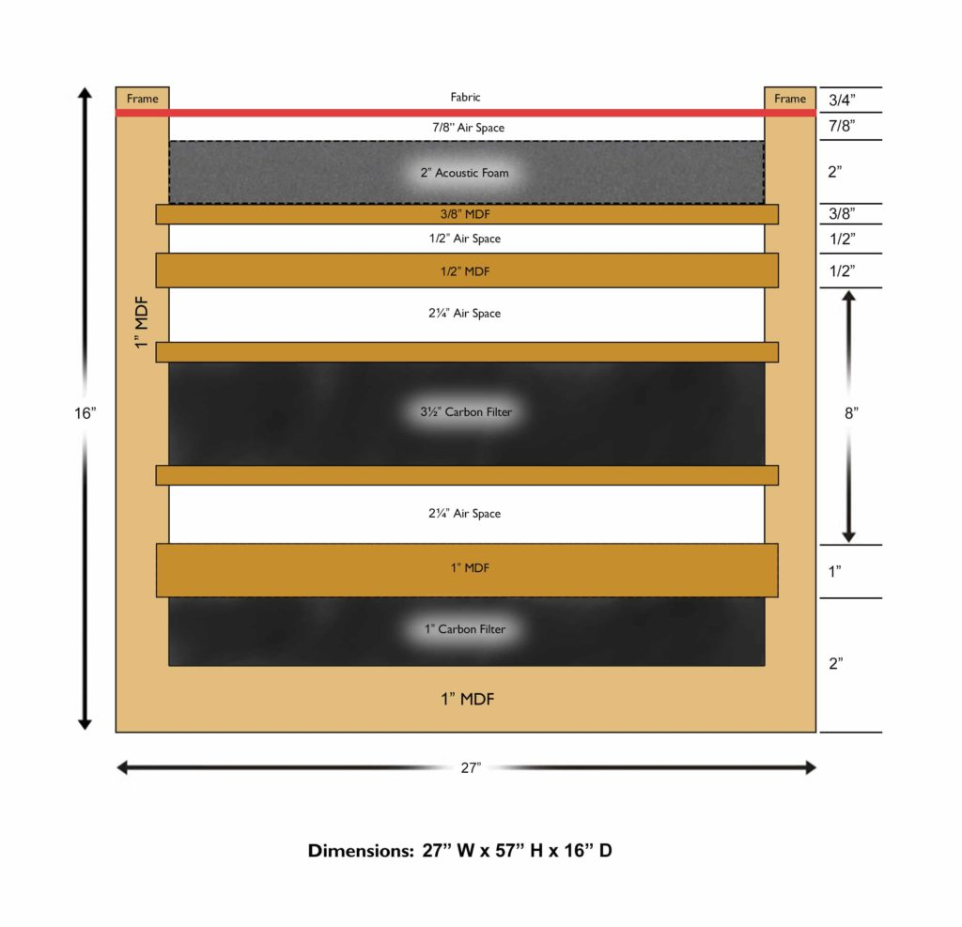
Best for:
- Rooms with broad low-frequency issues (e.g., 40–300 Hz).
- Studios or listening spaces that need tighter, controlled bass across multiple frequencies.
Why They Work:
These absorbers feature a flexible diaphragm that converts sound energy into heat, making them ideal for broader absorption while remaining compact enough for smaller rooms.

Quarter-Wavelength Traps
Best for:
- Large spaces with significant low-end issues, like open-concept rooms or home cinemas.
- Deep bass frequencies (e.g., 20–80 Hz) that are difficult to control.
Why They Work:
These traps excel at absorbing very low frequencies caused by subwoofers or room modes in expansive spaces. Their design simplifies tuning for extreme low-end control.

Managing Mid and High Frequencies
While tuned traps are designed to manage low-frequency issues, mid and high frequencies also require attention to create a truly balanced room. Here’s how to address them:
Broadband Absorbers for Mid Frequencies
Broadband absorbers are excellent for managing mid frequencies that can muddy sound. Made from dense acoustic foam or fiberglass, they absorb sound across a broad range.
- Placement: Install broadband panels at first reflection points—such as side walls, ceilings above your speakers, and behind your listening position—for maximum clarity.
- DIY Tip: Build a wooden frame, fill it with rigid fiberglass or mineral wool, and cover it with breathable fabric. These panels are simple to construct and effective.
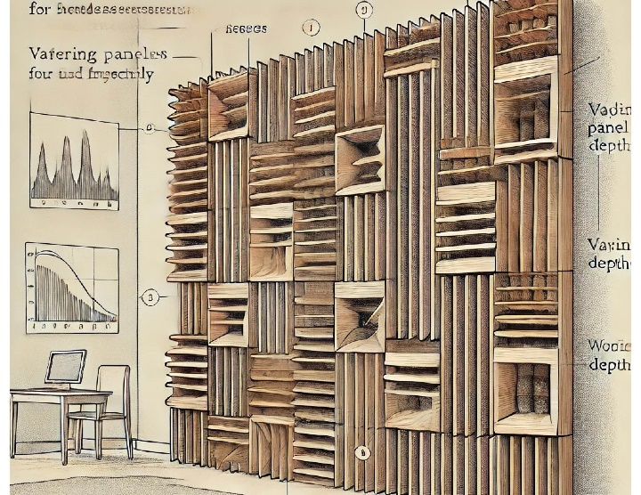
Diffusers for High Frequencies
Diffusers scatter high frequencies, preserving the liveliness of your room without harsh reflections.
- Placement: Use diffusers on rear walls or other areas where echoes are problematic. They work particularly well in larger rooms.
- DIY Tip: Create a wooden diffuser with panels cut into varying depths to scatter sound effectively.
Combination Panels for Mid and High Frequencies
Hybrid panels that combine absorption and diffusion are versatile solutions for managing both mid and high frequencies. These are particularly useful in rooms where balance is key, such as multipurpose studios.

How to Build Each Type of Trap
Building a Helmholtz Resonator
Materials Needed:
- Plywood or MDF, PVC pipe, sealant, drill, measuring tape
Steps:
Construct a sealed wooden box.
Drill a hole for the PVC pipe and attach it as the neck.
Use a frequency calculator to determine dimensions for your target frequency.
Seal all joints with caulk.
Test placement and effectiveness with room analysis tools.
Building a Diaphragmatic Absorber
Materials Needed:
Dense wood, insulation, flexible membrane, screws, sealant
Steps:
Build a sealed box filled with insulation.
Attach a flexible membrane to the front.
Seal edges to ensure airtightness.
Place strategically for best results.
Simplified Diaphragmatic Absorber Design
If the standard design feels too complex, a simplified diaphragmatic absorber can offer an effective and budget-friendly alternative.
Materials Needed:
Wooden Frame: Simple rectangular frame made from plywood or MDF.
Flexible Front Panel: Thin plywood or dense rubber sheet.
Insulation: Fiberglass or mineral wool.
Backing Panel: A solid piece of plywood or MDF.
Screws or Nails: To secure parts.
Sealant: Caulk or similar to make it airtight.
Steps:
- Build the Frame:
- Construct a rectangular wooden box, around 6–12 inches deep, depending on the desired frequency range.
- Install the Backing Panel:
- Attach a solid plywood or MDF panel to one side of the frame as the back.
- Add Insulation:
- Fill the box with evenly packed fiberglass or mineral wool.
- Attach the Diaphragm:
- Secure the flexible panel to the front with screws or nails, leaving no gaps.
- Seal the Box:
- Apply caulk along all edges and joints to make it airtight.
Mount or Place:
Position the absorber in corners or on walls where low frequencies are problematic.
Benefits of This Design:
Cost-Effective: Uses readily available materials.
Compact: Suitable for small spaces.
Easy Construction: Streamlined steps make it accessible for DIY enthusiasts.
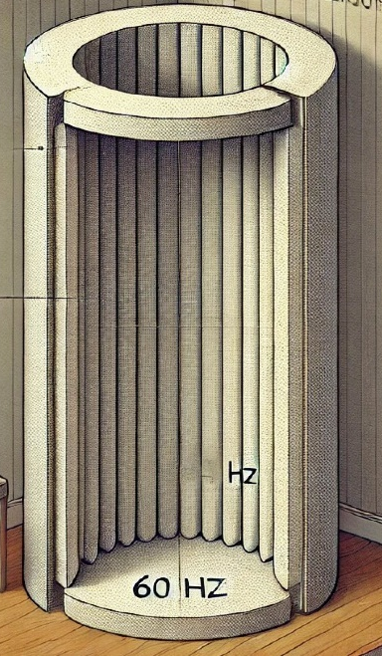
Building a Quarter-Wavelength Trap
Materials Needed:
- PVC pipe, insulation, saw, tape measure
Steps:
- Calculate trap length using the formula: Trap Length = Speed of Sound / (4 x Target Frequency).
- Cut PVC pipe to the required length.
- Fill with insulation, seal one end, and leave the other open.
- Position in corners or areas with low-end issues.

Fine-Tuning and Testing
After installing your traps, use tools like Room EQ Wizard to measure their effectiveness. Make adjustments to placement and tuning as needed for optimal results.

Conclusion
Combining tuned traps with broadband absorbers and diffusers ensures your room is treated across the full frequency spectrum. Whether you’re tackling deep bass, muddy mids, or harsh highs, these tools work together to create a balanced, professional sound environment.
By understanding their applications and building your own solutions, you can overcome even the most stubborn acoustic challenges. With your treatment in place, you’ll finally achieve the clear, balanced sound you’ve been chasing.
Stay tuned for the next article in this series:
“Broadband Absorbers: The Backbone of Room Treatment.”

Resources and Citations
Helmholtz Resonators
- Euphonics.org: Provides a mathematical breakdown of Helmholtz resonators, including formulas for resonance frequency and construction tips for designing them effectively. Great for a technical audience. Link​: Euphonics
- American Physical Society: Discusses advancements in hybrid porous Helmholtz resonators for low-frequency absorption, ideal for understanding modern adaptations. Link: Physical Review
Diaphragmatic Absorbers
- Acoustic Modelling Guides: Various academic and practical resources are available on diaphragmatic absorbers, focusing on their ability to convert sound energy into heat for specific frequencies. AIP's publications can provide in-depth technical data. Link: AIP Publishing
Quarter-Wavelength Traps
- MIT Acoustics: Offers insights into resonant absorbers, with a focus on quarter-wavelength designs for targeting low-frequency problems in rooms. This can provide inspiration for DIY and professional builds.
General Acoustic Treatment Resources
- Acoustics Today: Features articles about the science of room acoustics and practical implementations of various tuned traps, including Helmholtz and diaphragmatic designs.
RPG Diffusor Systems: Offers technical documents and case studies on resonators and absorbers used in professional and home studios.
These resources blend theoretical knowledge with practical applications, ideal for explaining when and why specific traps are most effective, as well as how to construct them.

