Turntable Technology for Millennials
or everything you wanted to know but didn’t ask.
By Marc Silver
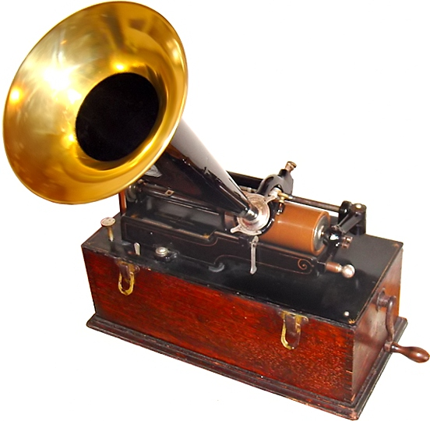
Where it all started
It always helps to know where it all started. Thomas Edison invented the phonograph in 1877. His invention was able to record sounds onto tinfoil wrapped around a rotating cylinder. It used a steel needle attached to a resonator mounted at the end of a horn that moved across the cylinder to both record and playback sound. This was a mechanical system that evolved over time to use a wax-coated cardboard cylinder and a steel stylus that moved from side to side in a zigzag groove around the record.
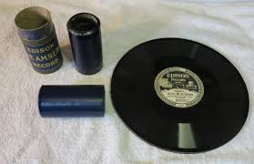
Eventually, the cylinder was replaced with a flat disc similar to what we use today. This transition was the brainchild of Emile Berliner in the 1890s when the term gramophone for disc record players was universally adopted. The first commercially available 78rpm shellac records were still played back mechanically with either a cactus or steel needle.
It wasn’t until technological advancements in the 1940s that the console radio/phono moved to tube-amplified systems.
Things stayed relatively the same for the next decade and a half until 1955 when Philco developed the first transistor record player. It was at this time that the phono cartridge appeared as an electrical transducer.
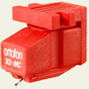
Cartridges
The phono cartridge has perhaps the most important job in analog reproduction, converting the undulations within the record grove to electrical output. There currently are 4 basic/common types of phone cartridge designs: Moving Coil, Moving Magnet, Moving Iron (incorrectly referred to as a moving magnet) and Ceramic (sometimes referred to as piezo-electric or crystal. I need to comment that there are a few other designs, like Strain gauge, optical and electrostatic, but they are not common and not to confuse anyone I am ignoring them for this article.
Before I go any farther, I think it makes sense to explain the basic parts of a phono cartridge and their function. These are the same regardless of type. The tip that touches the record is referred to as the stylus. Generally made from either diamond or another type of semi-precious man-made gem. The stylus can be either conical, elliptical, or multi-radial in shape, and either bonded to a shank or made of solid gemstone.
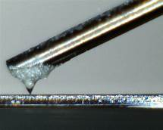
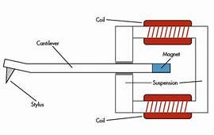
The stylus is mounted to the end of a cantilever. The cantilever (the moving armature) can be made of anything from plastic (not a good choice), aluminum, tapered aluminum, boron, carbon fiber, or solid synthetic gem. A notable example of the last design is the Dynavector DV-17D3 moving coil cartridge, which uses a solid diamond cantilever with a line contact diamond stylus. The cantilever is supported by a damper at its pivot point. Normally there is a magnet, coil of wire, or piece of iron mounted to the cantilever. In the example to the right is a moving magnet design. The magnet moved by the cantilever causes an electrical flow from the coils to the terminal posts at the rear of the cartridge body. Moving Magnet designs are the most commonly available cartridge type used in high-fidelity systems.
Moving Iron designs from companies such as ADC, Bang & Olufsen, Grado, Stanton/Pickering, and Ortofon, utilize a small piece of iron sitting between the magnet and the coil and interrupting the field between the magnets and the coils causing electrical flow to the output terminals.
With a Moving coil design, the coils are mounted to the cantilever and move in the gap between the magnets. Moving coil designs traditionally are lower output designs that required additional amplification to increase the output voltage to equal that of a moving magnet/iron design. Advancements in rare earth magnets and improvements in manufacturing technics allowed the development of high-output moving coil designs with output similar to MM designs.
Ceramic cartridges have the stylus trace the grooves of the record and the cantilever bends the crystal causing a small amount of output voltage. I should mention that the output of a ceramic cartridge is significantly higher than that of an MM/MI (Moving Magnet/Moving Iron) design.
Cartridge Design Advantages and Disadvantages
Depending upon personal preferences, different people have different opinions. Generally speaking, however, the best performance comes from low-output moving coil designs because of the reduced moving mass of the stylus and cantilever assembly. The disadvantage of a moving coil is the stylus is normally not user-replaceable. There have been exceptions in the past, but as of this writing, there are no MC cartridges being built with a user-replaceable stylus. Examples of MC designs with replaceable stylus were Denon, Audio Technica, and Panasonic.
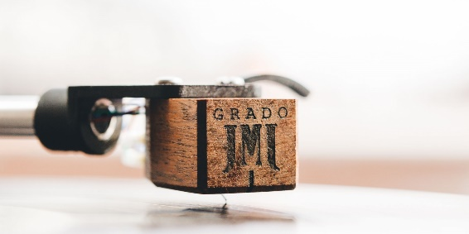
Both MM, MI, and ceramic designs have the advantage of a user-replaceable stylus. There are exceptions, such as the Grado Reference and Statement designs where the precision is so precise they opted to make in non-replaceable.
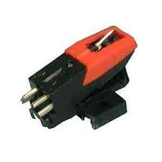
I can say with confidence that universally ceramic cartridges are considered the poorest quality. The advantages of a ceramic cartridge however are they don’t require a phono preamp due to their high output voltage and they are cheap to manufacture.
Cartridge Compliance
Compliance has to do with the stiffness of the damper the cantilever is suspended from. Think of it like a shock absorber on a automobile. Some are stiff and require more effort to move. Others are soft and easy to move. I will discuss why this is important when I discuss tonearm differences. As for why cartridges have different compliances, that is dependent upon the manufacturers design preferences. Compliance specs are measured in µm/mN (micrometer per milli newton). What that means is how far the stylus moves in micrometers with one milli newton of force.
Stylus Design
I discussed earlier the basic shapes and types of stylus configurations. To elaborate on that a little more. I will begin with 78 rpm records. They have larger groves cut in the record and require a stylus to accommodate the record design. Typically, a conical tip with a tip radius of 65µm to 70 µm is required. Likewise, 45 and 33rpm records which use RIAA equalization have much narrower grooves and require smaller diameter styli.

Cross-section diagram comparing two common types of styli. Spherical (left), Elliptical (right). Note the difference in contact area. The elliptical stylus shape of approximately 0.3 x 0.7 mil allows for more groove contact area, which increases fidelity, whereas the spherical makes less contact with the groove and generates lower fidelity.
Higher end styli shapes have evolved, and tip mass and shape has gotten smaller to allow the cartridge to produce higher frequencies, with lower noise and flatter frequency response. It is not unusual to see styli with 0.2 x 0.7 mil shapes.
Additionally, the polish and profile on this stylus can be quite exotic. Examples are the "Hughes" Shibata variant (1975), "Ogura" (1978), and Van den Hul (1982). Such a stylus may be marketed as "Hyper elliptical" by Shure, "Fine Line" by Ortofon, "Line contact" by Audio Technica, "Stereohedron" by Stanton) and Fritz Gyger's (1989) design which is marketed by several different cartridge companies.

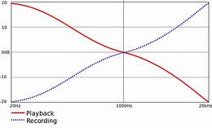
Equalization
Early gramophones had very limited frequency response and dynamic range due to the physical limitations of the design. When the magnetic phono cartridge became available in the early 1950s, the Recording Industry Association of America (RIAA) developed a standardized equalization curve for recording and playing back records. Because low frequencies have a higher amplitude than high frequencies (for the same perceived loudness), the space used to produce low frequencies needs to be significantly larger resulting in limited playback time per side of the record.

RIAA playback equalization is not a simple low-pass filter or high-frequency boost. It defines transition points in three places: 50Hz, 500Hz and 2122Hz. The diagram to the right shows both the record and playback curves as specified by RIAA.
The introduction of electronic amplification allowed these issues to be addressed. Records are made with boosted high frequencies and reduced low frequencies, as defined by the RIAA, this allows for different ranges of sound to be produced. The net result is a relatively flat extended frequency response with lower noise levels and improved dynamic range. Additionally, it conserves the amount of physical space needed for each groove, by reducing the size of the low-frequency undulations.
Prior to 1950 the record industry used many different EQ curves, as every record manufacturer seemed to use their own curves. Fortunately, RIAA has standardized the industry worldwide.
Turntable construction
There are literally hundreds of variations of designs for turntables. But basically, they all consist of a plater to support the record, some sort of motor assembly drive to rotate the plater, an a tonearm to support the phono cartridge and allow it to move across the surface of the record.
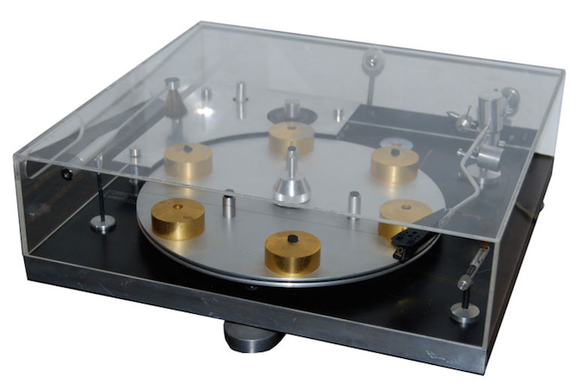
Inexpensive record players typically used a stamped steel platter. Other options include machined aluminum, glass, polymer and even wood. J. A. Michelle Transcriptor uses vertical posts with small rubber pucks to support the record.
Normally a rubber mat is used to secure the record and minimize vibrations of the record. Again, here there are options, from cork, to leather to Sorbithan.
The plater typically is mounted on a spindle bearing often made of bronze or steel. There are variations of this as well. A number of tables use inverted thrust bearings, Others use magnetic bearings while the most exotic I have seen use air or fluid to support the plater.
Most high-end turntables use heavy aluminum castings that have greater balanced mass and inertia, helping minimize vibration at the stylus, and maintaining constant speed without wow or flutter, even if the motor exhibits cogging effects.
This is a good time to explain wow and flutter as well as rumble. Wow is a slow variation in speed, similar to a Doppler effect where the tone varies slowly. Flutter is similar but faster repetition. Both cause distortions of the music. The lower the figure the better. Finally, rumble is typically the noise produced by the motor and transferring though the system. Rumble can also be caused by poor quality bearing under the platter.

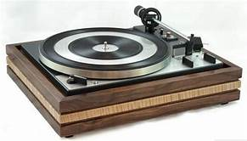
Turntable drive systems
So, what is the main reason a turntable may have poor wow and flutter specs has to do with the drive system? I remember when I first started selling turntables the majority of turntables sold were record changers that stacked 5 or 6 records and dropped them in succession. They included Dual, Garrard, BSR, ELAC Miracord, and Perpetuum Ebner PE. Later on, Technics and BIC joined the Big 4. Fortunately, record changes fell out of fashion and have not come back.

Idler-wheel drive system
As far as drive systems, historically early design drives were idler wheels. An idler is a rubber wheel that comes in contact between the plater and the motor. In the early 1960s Thornes produced the TD124 which used an idler that rides against the platter but used a belt drive that connected the idler to the motor.
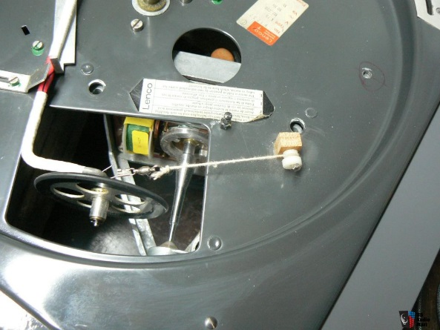
Another classic was the Swiss company "Lenco" whose idler wheel ran along a tapered motor drive shaft. This reminds me of a variable speed transmission in cars, which allowed variable speed control on the drive. Lenco L75 pictured. These are the audiophile exceptions to a drive system that is mostly used by cheap entry-level turntables like the BSR 310 and the Garrard 40B.

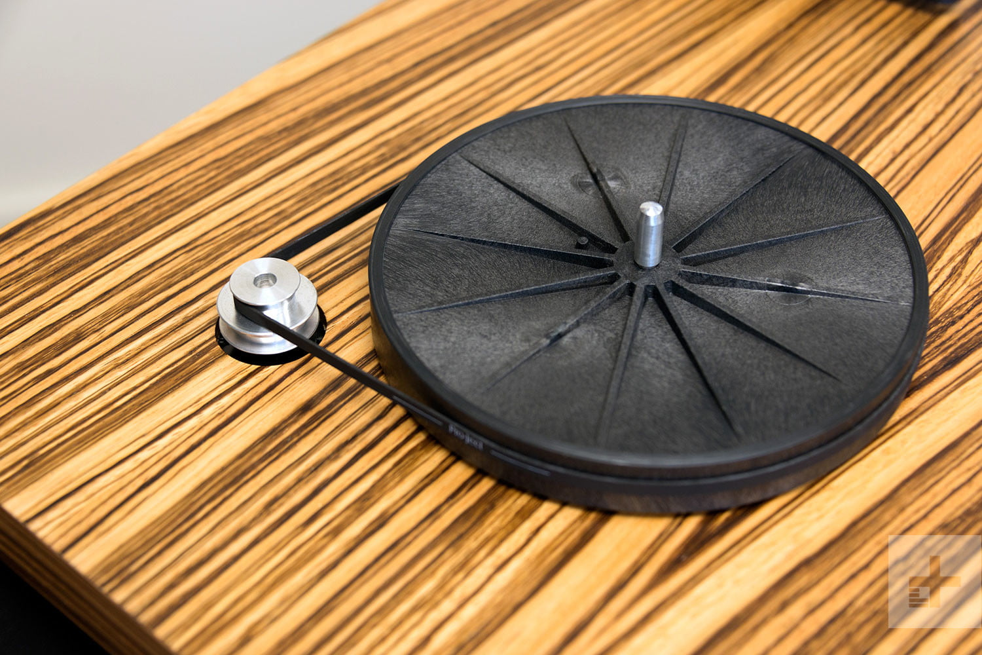
Belt drive system
Interestingly belt drive tables have become the most common transport design in high-end turntables today. They can range in price from a few hundred dollars to over a hundred thousand dollars.
Belt drive tables are intrinsically simple in concept. You have a motor and a platter with a belt running between the two. You can also have the belt wrap around the turntable bearing assembly and the plater sits on top. The basic design allows for separation and isolation of the motor from the platter. When you consider the improvements in motor technology, and the simplicity of the design, even the most inexpensive tables sound very good. When you start adding in heavy mass platters and well-engineered bearings, plinths and suspensions, the result is exceptional performing turntables.
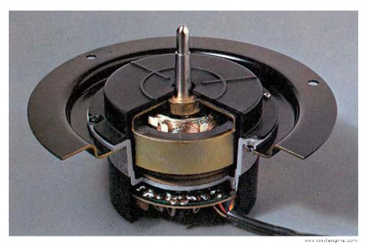
Direct drive system
What is a direct drive turntable? Simply put is a turntable with the motor directly coupled to the plater at the bearing. There are no wheels, belts, or gears involved. Probably the most renown direct drive turntable is the Technics SL-1200, shown to the right with the platter removed.

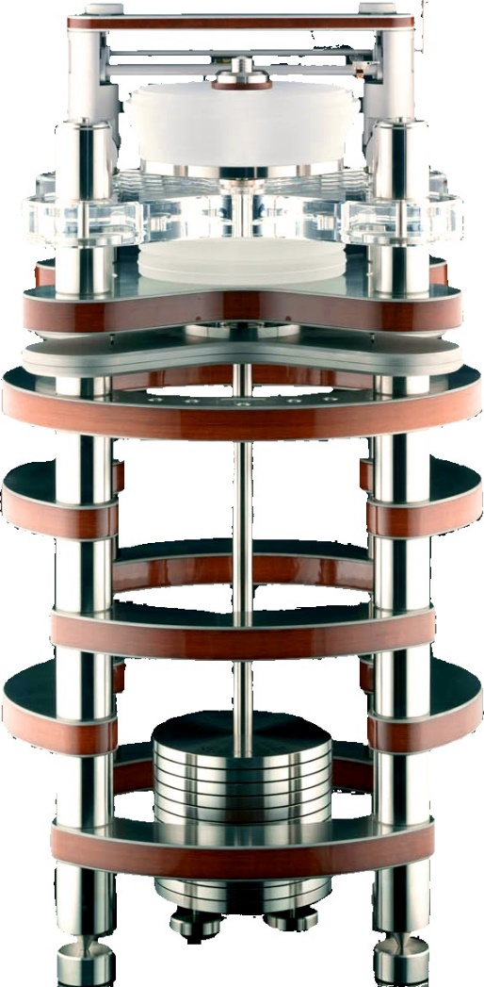
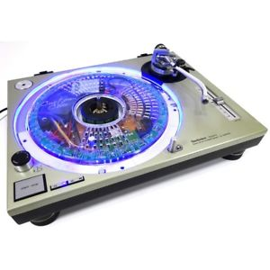
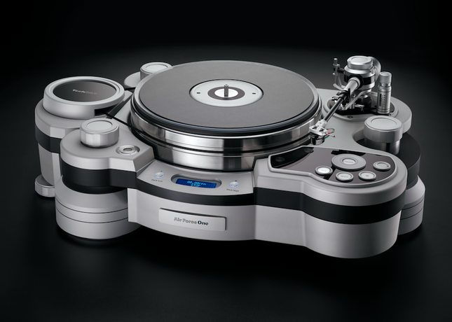
Direct vs belt drive
There has been an ongoing controversy over what is better sounding a direct drive or belt drive turntable. The argument for the direct drive has been they have higher torque, faster start, lower wow and flutter and more accurate speed. All excellent attributes for DJ operation. The argument against direct drive are subject to noise (rumble) caused from the motor coupled to the platter, and poor base response.

I have used both, and more importantly is the quality of the table and tonearm of the system. The most expensive direct drive tables can cost $2,000 or $3,000, while there are many belt drive tables costing well over $100,000. Above is an Air Force One with a Graham Phantom tonearm at about $105,000 and to the right is a Clearaudio Statement with their TT-2 linear tracking tonearm at $110,000

Arm systems
Since I just mentioned two of my favorite tonearms, this seems like a good time to delve into the various tonearm designs. There are three basic types of arms. Linear tracking, “S” or “L” shaped, and straight. Also, each of these designs can come in either high mass, medium mass, or low mass designs.

Arm Mass Differences
When we talk about tonearm mass, what I mean is how heavy the arm wand is.
The reason for the mass differences is to match cartridge compliance.

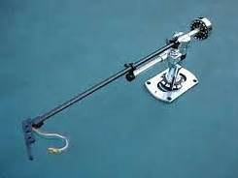
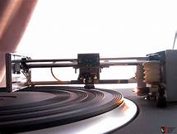
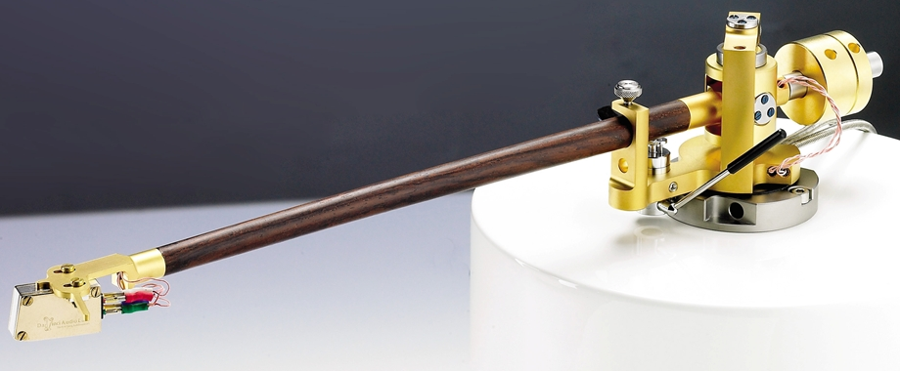
Linear tracking
The first type I want to talk about is linear tracking. Basically, this is how it all started back in 1877. When records are produced, the process includes a turntable lathe that cuts the master in a linear fashion. It only makes sense to play back the resulting record the same way the record is made. There have been many designs of linear tracking tonearms in the past. Companies like B&O produced a series of linear tracking tables from 1972 to two decades. But also include: Revox, Rabco, Harman/Kardon, Mitsubishi, Technics, Pioneer, Sony, Sansui, and many others. There are arms like the Clearaudio TT-2 and TT-3 which are amongst the best available today. The basic concept of a linear tracking tonearm is to minimize the small angular error which would otherwise occur when the pick-up arm moved in an arc. The drawback with linear tracking arms is their tendency to “walk”. By that I mean the arm lags when moving across the record and then catches up. The better the design the better the results.
Straight Tone Arms
A straight is exactly as described. Usually a low to moderate mass design with an angled head assembly. The Infinity Black Widow pictured to the right is a great example of an ultra low mass to straight tonearm. While examples of Moderate mass are Rega RP-300 and the Davinci Grandezza. This style of arm is ideal
for cartridge with high to moderate compliance. Most straight arm designs used a fixed head shell for mounting the cartridge, but there were many designs that utilized replaceable head shells as well.
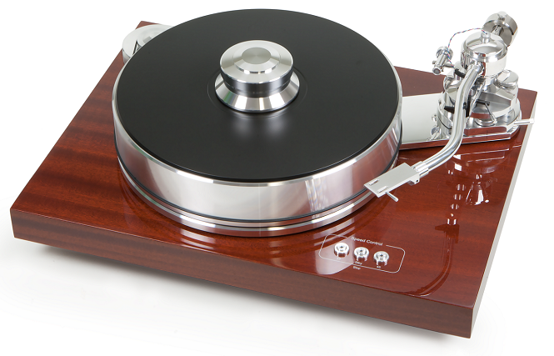

“S” & “L” Shaped Tonearms
Curved arms are designed to accommodate moderate to low compliance cartridge designs. The one real advantage of most S and L-shaped arms was they used an EIA replaceable headshell. The replaceable headshell made it easy to exchange different cartridges on the turntable.
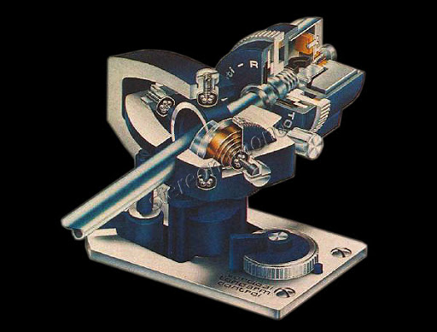
Pivot Variations
Basically, tonearm pivots are either gimbaled, knife edge, or uni-pivots.
Gimble Pivot
The most common would be gimbaled designs. With gimbaled arms, the vertical and horizontal pivots use a needlepoint in contact with bearings, which allows the arm to move freely at the axis points. Shown is a cutaway of a Dual tonearm from a CS1237.

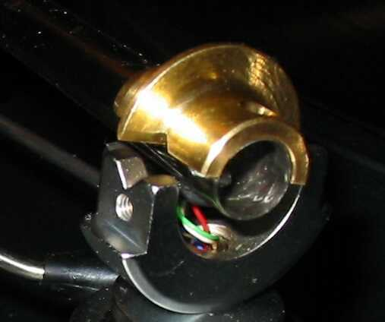
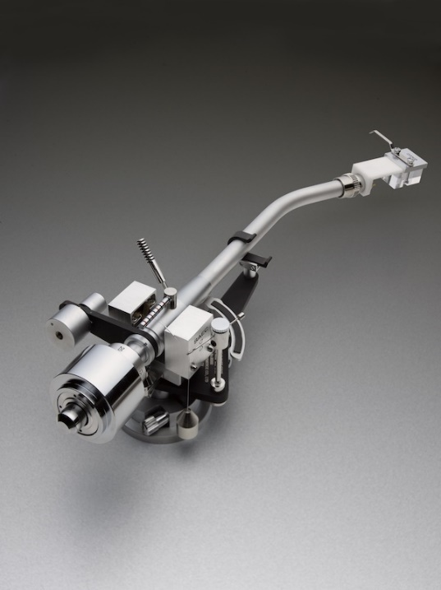
Knife Edge Pivot
Knife edge designs generally use a gimbal for lateral movement, but they use a knife edge bearing for vertical movement. The SEAC to the right was a dual knife edge design. If you can imagine a sharp edge sitting in a V trough that the arm pivoted on. Pictured is a single pivot design.
Figure 1Proj-ject Signature 10 turntable
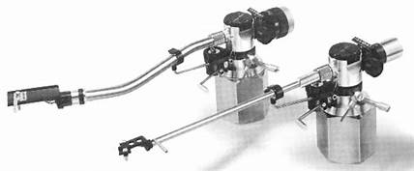
Some examples of knife-edge arms are SME, SEAC, Jelco, and Infinity discussed earlier.
Uni-pivot
I have to admit I have a personal bias in favor of Unipivot arms. In fact, up until the development of the Clarify suspended tonearm, Unipivot arms were my favorite. A Unipivot arm uses a needle point as the thrust point in contact with a jewel to act as the veering. The advantage of this design is there is almost zero friction and minimizes resonances from passing through the arm. The Audiocraft AC-300 arms pictured above also used oil damping in the pivot to eliminate tonearm resonances. Later designs also used replaceable arm tubes both straight and “S” shaped.
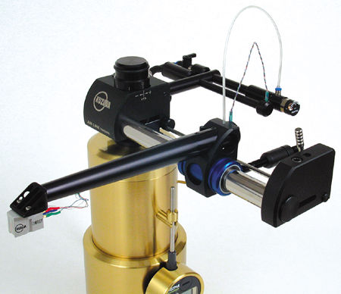
Exotics
There are also what I call “Exotics”. These are designs that fit into their own categories. A great example is the Kuzma air-bearing linear tracking tonearm. It uses air under pressure to isolate the arm from the tubular track it runs on, therefore eliminating friction.
A much simpler exotic at a much more affordable price is the Clear Audio Clarify tonearm. This unique design uses a nylon thread to suspend the arm as a pivot, held in place vertically with a magnet. If no parts of the arm touch, then there is virtually no friction. Also, it prevents resonances from affecting the performance of the system.
There are also a number of strange and exotic designs like fluid drive turntables, laser cartridges, and who knows what else. But because of the fact that most of these designs were more an experiment in design than practicality, I don’t think spending time is of any benefit.
Conclusion
I hope this article is somewhat helpful in explaining many of the fundamentals of turntable and cartridge design. I need to apologize for the brevity of the article as I could spend pages and pages on just one of these topics. But the intent is to enlighten you the reader on the basics of design and to that end I hope I was successful.

