Turntable Setup for the Novice
By Marc Silver

When I started selling HiFi back in 1968 our choices for music sources were limited to either a Reel to Reels, Radio, or turntables. Notice I didn’t mention cassette decks, CD players or MP-3s because they hadn’t been inventoried yet. We had to know how to select a proper phono cartridge, mount it, and set up the turntable. Today it seems that ability has been lost by 99% of the audio/video salespeople today. Perhaps I should say not lost just not learned.

What I want to talk about is the basics for selecting a phono cartridge and then setting up modern turntables. I plan to discuss just the basics to get the most out of your turntable.

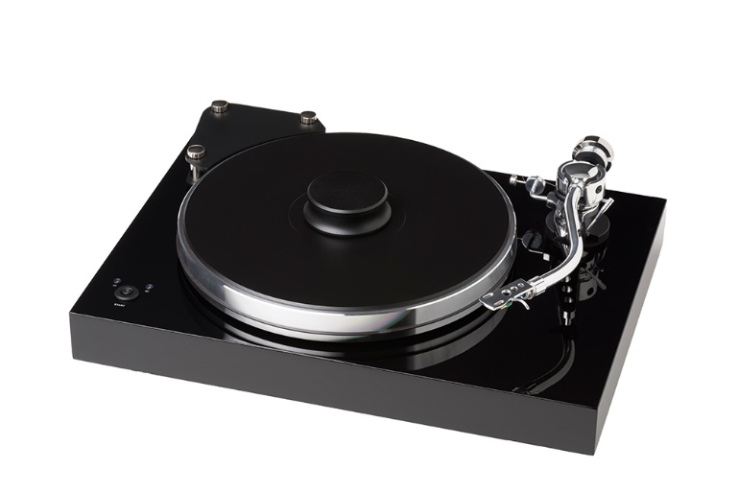
Cartridge Selection
If the factory didn’t select and pre-mount your cartridge, it’s a good idea to know what is going to work best on your particular turntable. What you need to know to make a proper cartridge choice are two basic things. First, what is the relative mass of the tonearm being used, and how much do you want to invest in a cartridge? If you have an “S” or “L” shaped arm you will need a cartridge with a relatively low compliance. If you have a straight tonearm with relatively low mass, you will need a cartridge with high compliance.

To explain this concept, we need to understand what compliance is and how compliance is calculated. The figure comes from the distance the moving assembly moves in with micro-meters with one milli newton of force. These are extremely small numbers. A phono cartridge with a compliance in the range of 5 to 10 µm/mN is considered as a very low compliance cartridge, a cartridge with a compliance in the range of 10 to 20 µm/mN is a moderate compliance cartridge and a cartridge with a compliance value above 35µm/mN is very high compliance cartridge.

If you want to get tweaky, here is the formulas courtesy of Ortofon:
“Resonance frequency can be calculated by using the formula
f = 1000 : (2 x π x √ (M x C)) where:
f - Cartridge resonance frequency in Hz
π - 3.14159265359...
C - Cartridge compliance lateral in µm/mN
M - Total tonearm system mass which is the sum of the Mass of the cartridge, the Mass of the headshell and screws, and the Effective mass of the tonearm (all values in grams). Resonance frequency within 7-12Hz is optimal for the system. “

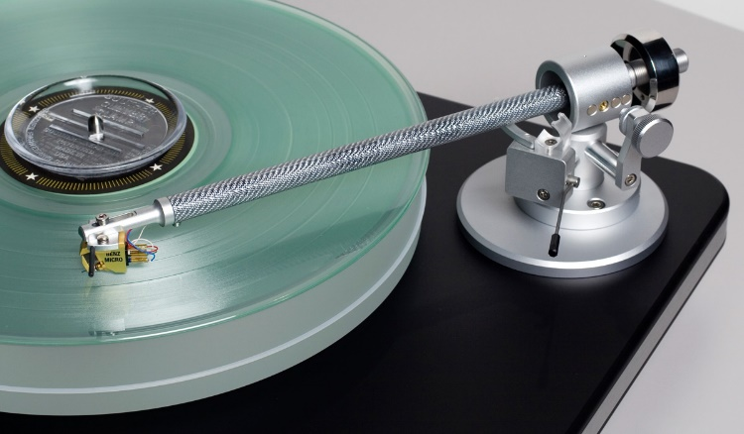
If you can find the arm spec of for your tonearm then you should know that an arm with an effective mass of 10 grams or below it is considered low mass. If the arm mass is between 11 and 25 grams then it is considered a moderate mass arm. If the effective mass is above 26 grams then it is considered high mass.

I like to use an automotive analogy. If you have a truck, you need heavy-duty shock absorbers. If you have a little sports car you need a very compliant set of shock absorbers. If you use the wrong shock, the vehicle will not handle or ride well. The same thing applies to a tonearm and cartridge match.

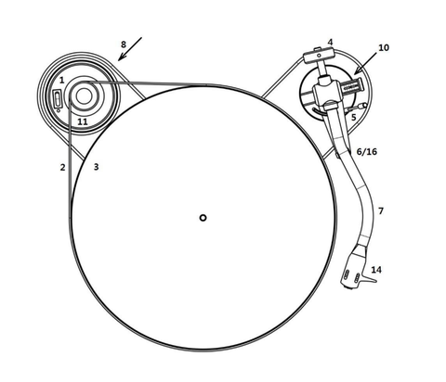
Installing the belt
If you have a direct drive turntable, then you can skip this section, as all you have to do is put the platter on the center spindle, but if you have a belt drive turntable the first thing you need to do is attach the belt. There are two types of belt positions. The first is where the belt is stretched between the motor and a sub-platter with an outer platter on top. The second is a bigger belt that is stretched between the motor and the outer rim of the main platter.
I recommend washing your hands before mounting the belt. I say that because you have oils on your hands that can affect the performance and reliability of the table. If you have a motor that sits outside of the turntable, you’ll need to install the outer platter before you install the belt.
In both cases, then just give the platter a gentle spin and the belt will self-center. Place the mat that came with your turntable on top of the platter.
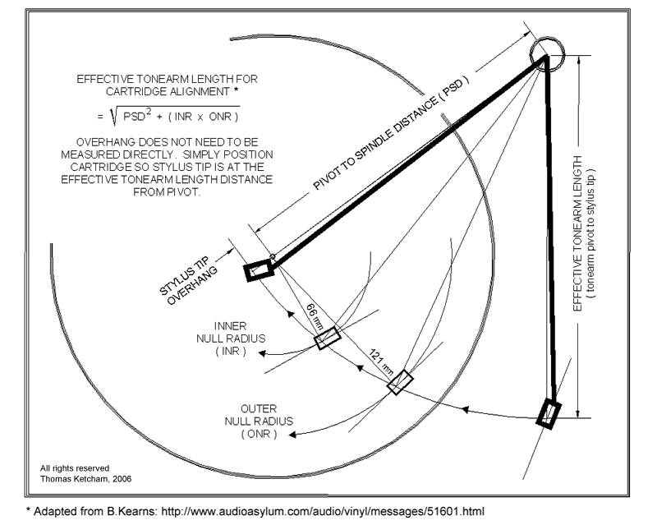
Mounting the Cartridge.
When mounting the phono cartridge, we need to know where to place it on the headshell. We have three things to be aware of. First is the overhang. The second is VTA which stands for vertical tracking angle and the third is offset angle.
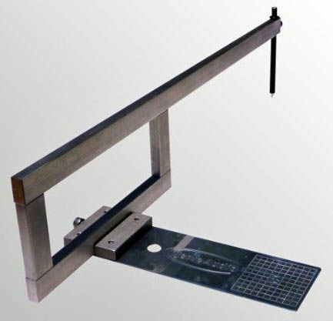
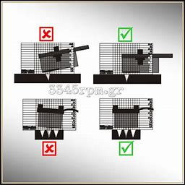
Overhang is the point the tip of the arc the styli needs to move in for the proper geometry of the tonearm. If the cartridge is to far forward or back the tracking error is going to be off and result in poor cartridge performance. To know where to mount the cartridge most good turntables will include a overhang template. I have been using a Dennison overhang gauge that I purchased over 40 years ago. If you want to purchase one there are several available on the market at a variety of prices and sophistication.
Vertical tracking angle is the angle of the styli when it is in the groove of the record. On a few tonearms, there is the ability to move the arm up and down to achieve the optimal VTA for the cartridge. The image to the left shows proper VTA for both vertical planes.
Once the cartridge is mounted and aligned, tighten the screws so the cartridge is secure and won’t move in the head shell.

Setting the Tracking Force
Tracking force is the downward pressure of the cartridge onto the record. With every cartridge there should be a spec sheet or card with the recommended tracking force for your cartridge.
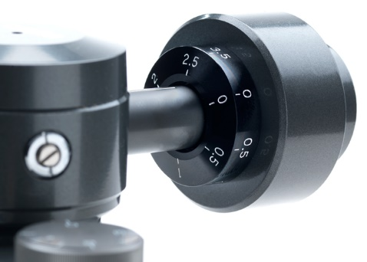
The process to properly set the tonearm requires you to first remove the stylus guard if present. Then you want to adjust the counterweight at the rear of the arm until the tonearm balances horizontally to the record. Then hold the rear part of the counterweight and adjust the front scale to zero. Then verify that with the scale at zero the arm is still balanced. Finally, you will rotate the rear of the counterweight to the desired tracking force recommended by the cartridge manufacturer.
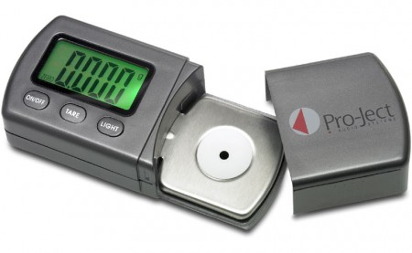
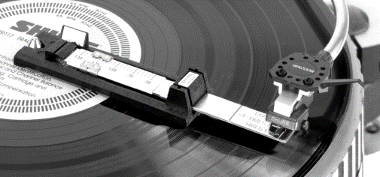
There are tables like Rega where the counterweight simply slides back and forth without any gauge to adjust the weight. In this case you will need to move the counterweight back and forth then check the weight using a stylus force gauge.
I recommend always using a stylus force gauge to verify accurate tracking force for any turntable. I have found that sometimes the gauge on turntables can be off as much as .4 grams. So, I have used a digital gauge for years.
Anti-skate
Before I discuss anti-skating I need to explain skating. If you use a blank record, the geometry of all turntables causes the tonearm to move inward toward the spindle. If not corrected the needle will ride up the inside wall of the record.
Anti-skating is used to keep your stylus centered in the groove of your record.
Anti-skate adjustment gauges come in three different system types: gravity, dial, or slider. If you have an anti-skate dial or slider, you set the gauge to the same number as your tracking force.
If your table uses the gravity method, you’ll find with your packaging a very small weight with a tiny piece of monofilament running through it. One end of the monofilament will have a loop.
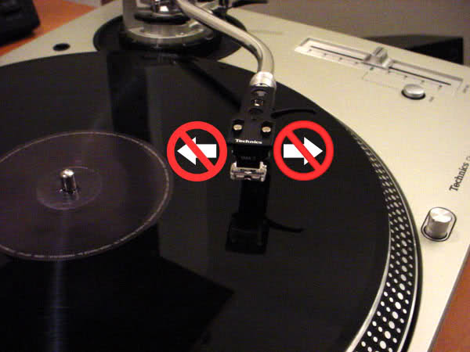
At the rear of the tonearm, is a tiny post with little notches in it. Typically, there are three notches. Choose the one recommended for tracking force of the cartridge and place the small loop around the post centered in the correct notch. Consult the turntable manufacture owner’s manual for proper settings.
Next, take the monofilament that has the weight on it and loop it through the little hook, so the weight hangs freely.
With any luck either of these adjustments will be relatively close to correct. Again, rarely is anti-skate adjustments truly actuate. Historically, a turntable would be connected to a dual trace scope and a test record is used to properly set the anti-skating. This required lots of test gear and expertise to use. I personally use a glass platter to set the anti-skate. In the image above a grooveless record is used to adjust the table. If the arm doesn’t skate in or out then the setting is accurate. This method is both simple and effective.

Almost finished
At this point, the proper cartridge has been chosen, mounted, and aligned. It has been balanced and the anti-skate adjusted. The last thing to do is decide where the table will sit and hook it up.
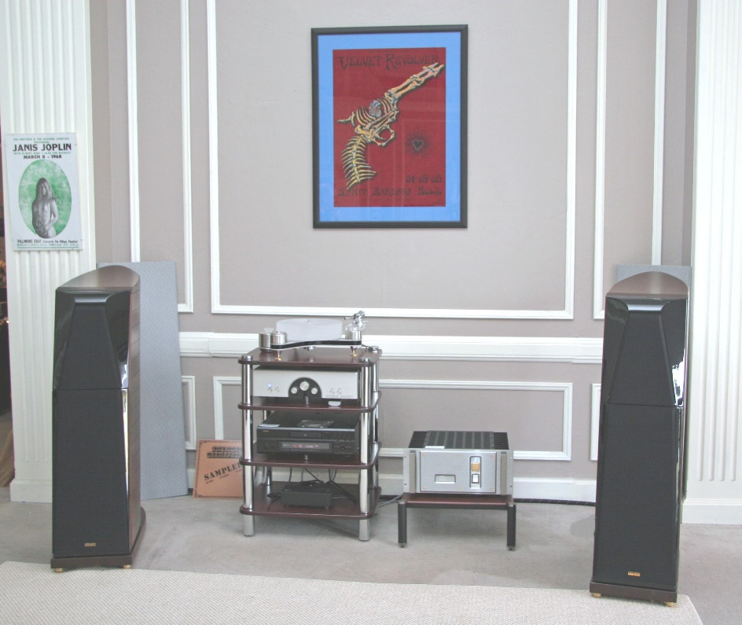
Placement should be on a level solid surface. The more solid the surface, the better. If the surface isn’t completely level often the table has adjustable feet to make it level. An inexpensive spirit level will help achieve this process. The relationship between the placement of the turntable and speakers can be an issue. Feedback can occur when the low frequencies from the speakers interfere with the turntable. I recommended keeping the speakers away from the turntable to minimize this possible issue.
The turntable will normally include a 3’ cable to connect it to the sound system. I recommend not extending the cables unless absolutely necessary. I assume we have been discussing either an MM or High-output MC cartridge throughout this discussion. At this point, the only thing left is to connect the cables to the phono input on your electronics and attach the ground wire if supplied. Then sit back put on your favorite record and enjoy the benefits of your effort.

Care and Feeding
Dirt, dust and oils are the enemies of good-sounding vinyl. It occurs on both your records and on your stylus tip from scraping dirt out of the grooves.
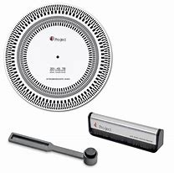
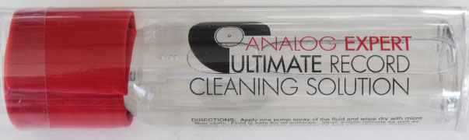
For everyday use I recommend a good record cleaning solution and record cleaner from companies as Analog Expert, Discwasher or Last. Additionally, a stylus brush is also a good idea. Pro-ject has an excellent stylus brush but you can also pickup an eyebrow brush at a beauty supply for under a dollar, that does the job. Actually, there are lots of little accessories that improve one’s enjoyment of your system.
Every 4 to 5 years it’s a good idea to replace your turntable belt. Even if you do not use your table that often, the belt is subject to the chemicals in the atmosphere. If you don’t plan to use your table for several months, you can extend the life of your belt by removing it and store it in a sealed plastic bag. The stylus also needs periodic replacement.
With normal use a stylus needs to be replaced after approximately 2000 hours of use to maintain optimum performance.
In Conclusion
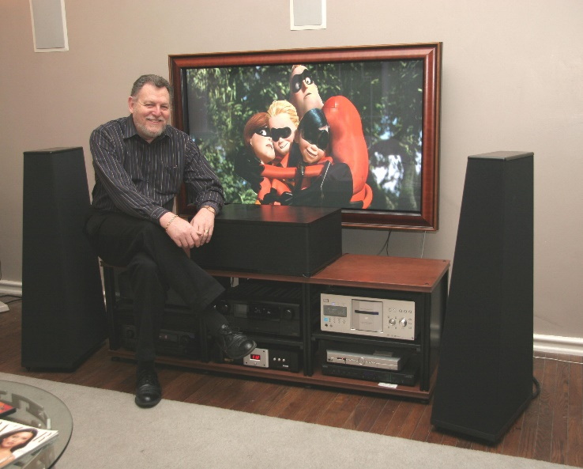
I sincerely hope this information has been both informative and entertaining. I know there is a lot of information I have opted not to include, but I did that with the realization that had I needed to keep this article accessible for as many people as possible. Thanks for time and attention.

