The Uyghurs of Xinjiang:
Threads of Silk, Songs of the Desert
By Marc Silver
A contemporary look at cultural identity, language preservation, and the intersection of tradition with modern political pressures

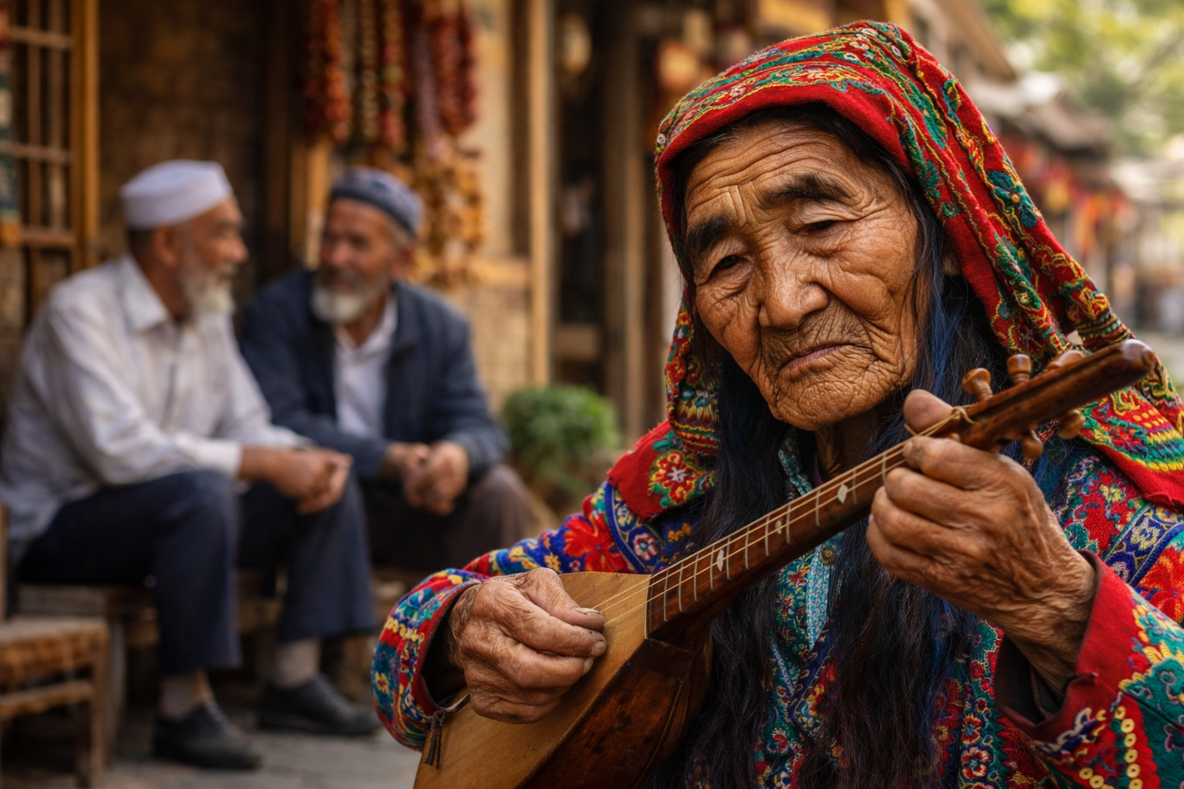
In the old quarters of western China, bread is still baked the traditional way. A baker presses a round of dough against the inside wall of a clay oven, where it clings, bubbles, and browns in the heat. The smell carries down the street, warm and nutty. A man nearby tunes a long-necked lute, plucking softly as he tightens the strings. Children dart past with skewers of grilled lamb. Older men sit on low stools, talking quietly, watching the street go by.
This is Xinjiang, China’s far-western frontier, and this is Uyghur life as it has been lived for centuries.
To understand what is happening to the Uyghurs today, it helps to begin here, with everyday moments. Not policy statements or headlines, but bread, music, language, and family. Because what is under pressure in Xinjiang is not only political autonomy or religious practice. It is the ordinary, inherited rhythm of daily life.
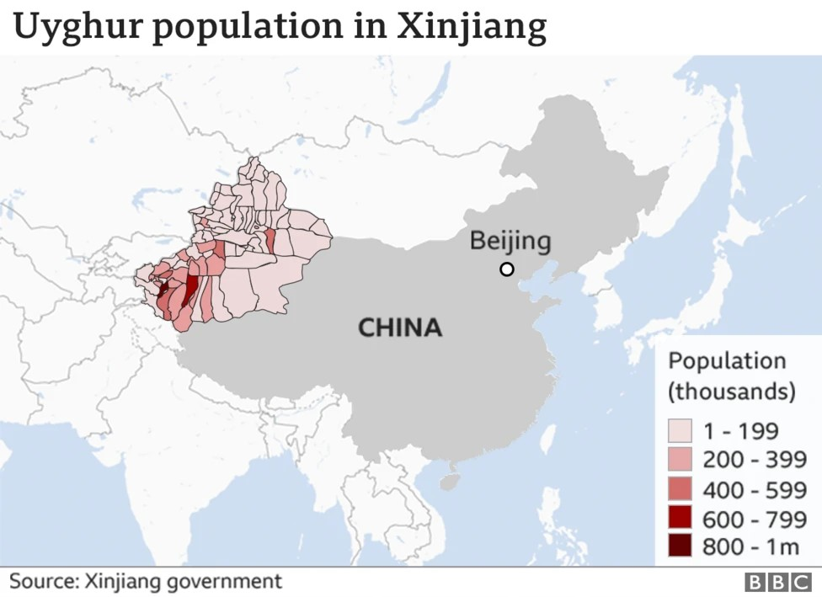
A Land Shaped by Movement
Xinjiang is vast. Roughly the size of Alaska, it borders eight countries, including Kazakhstan, Kyrgyzstan, Pakistan, and Afghanistan. For much of recorded history, this region sat at the center of the Silk Road, not as a destination but as a passage. Caravans moved through carrying silk, jade, spices, horses, ideas, and beliefs. Empires came and went. Trade endured.
The Uyghurs emerged from this movement. They are a Turkic-speaking people, culturally and linguistically closer to Central Asia than to eastern China. Most are Sunni Muslims. Their language sounds more like Uzbek or Turkish than Mandarin. Their cities were shaped by trade routes and oasis life, not imperial capitals.
That history still shows. Uyghur towns feel outward-facing. Food, music, architecture, and even social customs reflect centuries of exchange. This was never a closed culture. It was a connective one.

Streets, Courtyards, and Water in the Desert
Older Uyghur neighborhoods were designed for climate and community. Narrow streets offered shade. Homes opened inward around courtyards, where families gathered in the evenings. Grape vines were trained over wooden trellises to create green tunnels against the summer heat.
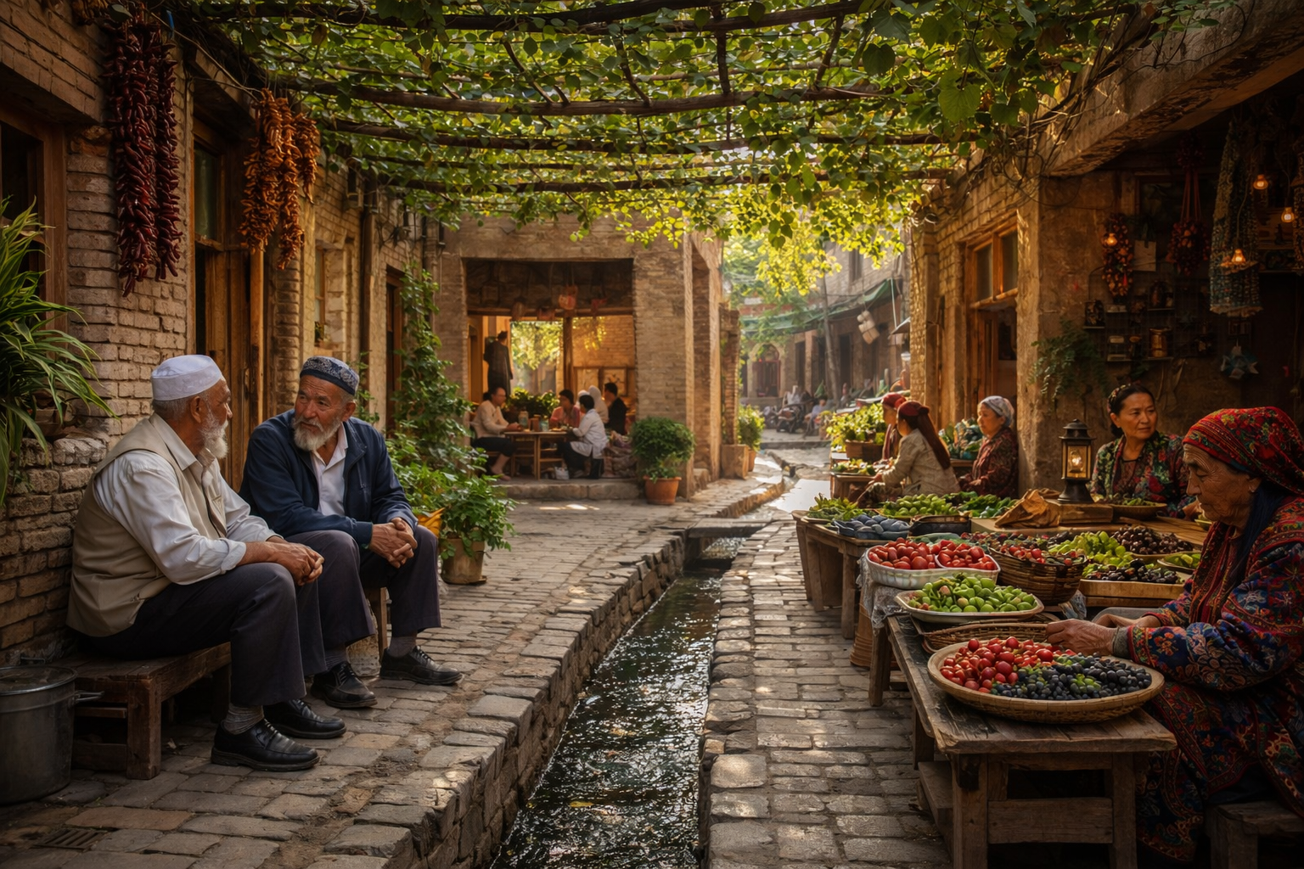
Water, scarce and precious, was managed through ingenious systems of channels and wells. In places like Turpan, underground canals once carried snowmelt from distant mountains to fields and homes. These systems were maintained collectively. Everyone depended on them. Everyone helped keep them working.
Daily life unfolded in shared spaces. Markets were social centers as much as commercial ones. News traveled by conversation, not announcement. Elders held informal authority simply by being present.
These environments shaped behavior. They encouraged cooperation, patience, and continuity.

Music as a Living Archive
If there is a single thread running through Uyghur culture, it is music. Not as background entertainment, but as memory and instruction.
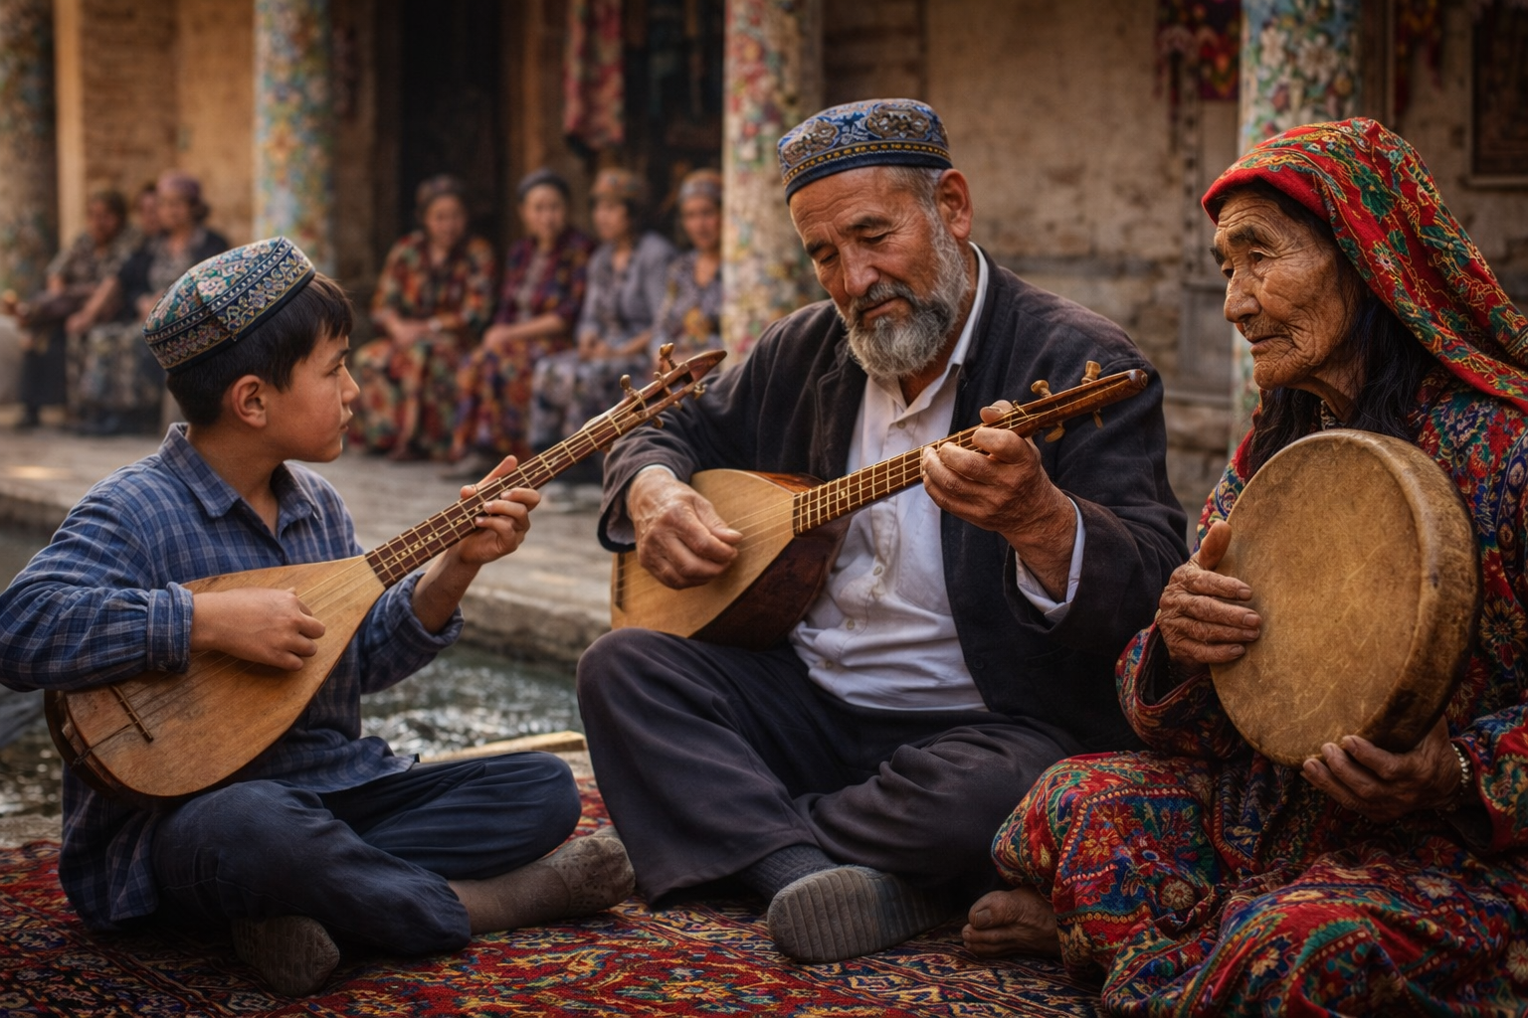
The most important tradition is the Twelve Muqam, a monumental cycle of music, poetry, and dance recognized internationally as Intangible Cultural Heritage. A full performance can last more than twenty-four hours, unfolding in sections that move from contemplative to exuberant.
The instruments are distinctive. The dutar has a long neck and two strings. The rawap features a carved wooden face covered with skin. Frame drums set the rhythm. The music begins slowly, almost conversational, then builds into something communal. Listeners become participants.
Learning this music is not formal. A child grows up hearing it at weddings, festivals, and family gatherings. A young musician may sit beside a parent or uncle for years before ever playing publicly. The music teaches language, poetry, history, and emotion all at once.
This kind of learning depends on time and proximity. It requires generations sharing space.

Food That Holds a Community Together
Uyghur food is practical, generous, and deeply social. Meals are meant to be shared.
Polo, the most iconic dish, is rice cooked with carrots, onions, and chunks of lamb, seasoned with cumin and garlic. It is traditionally served on a single large platter placed at the center of the table. Everyone eats from the same dish. Conversation matters as much as food.
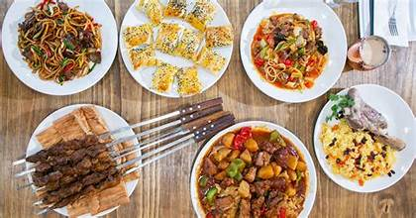
Laghman, hand-pulled noodles served with a rich meat and vegetable sauce, takes skill and patience. Watching a cook stretch dough into long strands is part of the experience. Samsa, savory pastries baked in clay ovens, are sold from street stalls, their crisp crusts hiding spiced meat inside.
These dishes are not reserved for festivals. They are everyday food. They reflect how people live in a dry, demanding environment, using what the land provides and stretching it through technique rather than abundance.
Cooking is often communal. Recipes are learned by watching, not writing. Like music, food is memory passed hand to hand.

Language and the Fragile Chain
Language ties all of this together. For generations, Uyghur was the language of home, school, literature, and prayer.
That has changed.
Today, most schools in Xinjiang operate almost entirely in Mandarin. This is officially described as bilingual education, but in practice Uyghur often plays a limited role. Children may speak it at home, but they learn to read, write, and think academically in another language.
The effects are subtle but profound. Parents struggle to help with homework. Grandparents find it harder to communicate deeply with grandchildren. Traditional stories lose their natural audience.
Language loss is rarely dramatic. It does not announce itself. It happens quietly, one generation at a time.

Everyday Life Under Surveillance
Since around 2017, daily life in Xinjiang has changed sharply. The Chinese government expanded security measures across the region, citing concerns about extremism and violence.
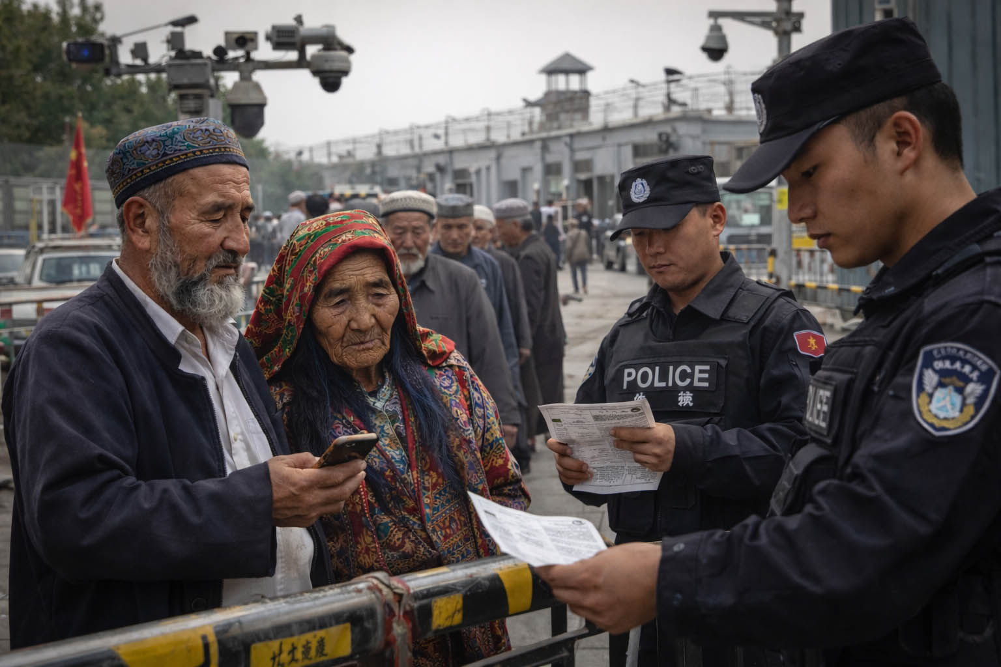
Cities were divided into grid zones. Checkpoints appeared. Cameras became omnipresent. Phones were monitored. Travel between neighborhoods required documentation. Everyday activities became cautious.
Large numbers of Uyghurs were detained in facilities the government initially denied and later described as vocational training centers. Former detainees spoke of long periods of confinement, political indoctrination, and restrictions on religious practice. Families were often left without information about where relatives had gone or when they might return.
At the same time, traditional livelihoods were disrupted. Investigations linked forced labor to cotton harvesting and manufacturing. Some countries responded by restricting imports connected to the region.
For ordinary people, the impact was not theoretical. It changed how people spoke, gathered, prayed, and even cooked.

Culture on Display, Life Behind Closed Doors
Here is the central contradiction of Xinjiang today.
While everyday cultural life has been restricted, a carefully managed version of Uyghur culture has been promoted. Tourists are shown colorful costumes, energetic dances, and cheerful performances. Restaurants serve Uyghur dishes, stripped of context. Music plays, often without words.
This is culture as display. It looks vibrant, but it no longer functions as it once did.
Dance without community. Music without transmission. Food without family.
What remains is form, not continuity.

Kashgar: A City Rewritten
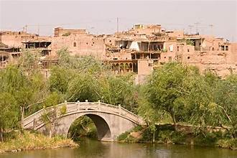
Kashgar, one of Central Asia’s oldest cities, illustrates this transformation clearly. For centuries, its old city was a maze of narrow lanes, workshops, mosques, and homes. It was chaotic, alive, and deeply human.
Large portions have since been demolished and rebuilt. The new structures are safer by modern engineering standards, officials say. They are also standardized, widened, and sanitized. Traditional neighborhoods were replaced with tourist-friendly facades.
Visitors can still walk through a version of the old city. But many longtime residents no longer live there. The rhythm has changed. What was once a lived space has become a curated one.

The Diaspora as Cultural Custodian
Outside China, Uyghur communities have taken on an unexpected role. In Turkey, Central Asia, Europe, and North America, families teach children the language, record songs, and cook traditional meals as acts of preservation.
Many have lost contact with relatives back home. Some report harassment or surveillance even abroad. Yet these communities now carry much of the cultural memory that once lived freely in Xinjiang.
A Uyghur restaurant in Istanbul or Munich is more than a business. It is a gathering place, a classroom, a reminder of continuity.

Beyond Xinjiang
The Uyghur story is often framed in terms of geopolitics and human rights. Those issues matter. But at its heart, this is about something more universal.
Culture survives through use. Through repetition. Through ordinary days.
When a culture is allowed to exist only as performance, it becomes fragile. When it is lived, it endures.
For travelers, especially those curious about the world beyond postcard views, the Uyghur experience offers a reminder. The most meaningful parts of a culture are often quiet. The meals cooked at home. The songs learned by listening. The language spoken without thinking.
Recognizing that difference changes how we see places, and how we value what we inherit ourselves.

Leaving with Something More Than Facts
Most cruise passengers will never visit Xinjiang. That is not the point.
The point is understanding what it means for a culture to be lived rather than displayed. Once you see that distinction, you start noticing it everywhere. In historic towns turned into theme parks. In traditions reduced to souvenirs. In languages spoken less each year.
The Uyghurs of Xinjiang remind us that culture is not a costume. It is a practice. And once interrupted, it is difficult to restore.
Learning that, even from far away, is its own kind of journey.

This article aims to provide educational context about the Uyghur people, their rich cultural heritage, and the contemporary challenges they face. The subject matter involves ongoing human rights concerns that are disputed by different parties. Readers interested in learning more are encouraged to consult multiple sources and to approach the topic with both compassion and critical thinking.
References
UNESCO. Uyghur Muqam of Xinjiang. Representative List of the Intangible Cultural Heritage of Humanity.
https://ich.unesco.org/en/RL/uyghur-muqam-of-xinjiang-00109
Encyclopaedia Britannica. Uyghur.
https://www.britannica.com/topic/Uyghur
Council on Foreign Relations. China’s Repression of Uyghurs in Xinjiang.
https://www.cfr.org/backgrounder/china-xinjiang-uyghurs-muslims-repression-genocide-human-rights
Human Rights Watch. China’s Algorithms of Repression: Reverse Engineering a Xinjiang Police Mass Surveillance App.
https://www.hrw.org/report/2019/05/01/chinas-algorithms-repression
United Nations Office of the High Commissioner for Human Rights. Assessment of Human Rights Concerns in the Xinjiang Uyghur Autonomous Region.
https://www.ohchr.org/en/documents/country-reports/ohchr-assessment-human-rights-concerns-xinjiang
Associated Press. China threatens Uyghurs with detention for listening to traditional music.
https://apnews.com/article/1e8a90286d63552ca598428dc29b3bf8
RAND Corporation. China’s Disappeared: What Satellite Images Reveal About Xinjiang’s Detention Facilities.
https://www.rand.org/pubs/articles/2021/chinas-disappeared-uyghurs-what-satellite-images-reveal.html
The Bulletin of the Atomic Scientists. China’s High-Tech Surveillance Drives Oppression of Uyghurs.
https://thebulletin.org/2022/10/chinas-high-tech-surveillance-drives-oppression-of-uyghurs/
Wikipedia. Persecution of Uyghurs in China.
https://en.wikipedia.org/wiki/Persecution_of_Uyghurs_in_China
(Used for background synthesis and cross-reference only)

