The Tanka Boat People of Hong Kong
By Marc Silver
A Floating World, Now Mostly Ashore
For generations, long before Hong Kong became a skyline of glass and steel, there were families who lived their entire lives on the water. Not weekend sailors or seasonal fishermen, but people born, raised, married, and buried without ever setting foot on land unless absolutely necessary. These were the Tanka, sometimes written as Danjia, the boat people of South China’s coast. In Hong Kong, they formed a self-contained floating society that moved with the tides, fed the city, and stayed largely invisible to those on shore.
Today, most Tanka families live on land. The boats are fewer, the harbors quieter. Yet their traditions, habits, and worldview still carry the imprint of life afloat. To understand Hong Kong’s past, and some of its present, you have to understand the Tanka.
This is not a story of a vanished people. It is a story of adaptation, resilience, and a culture shaped as much by saltwater as by history.

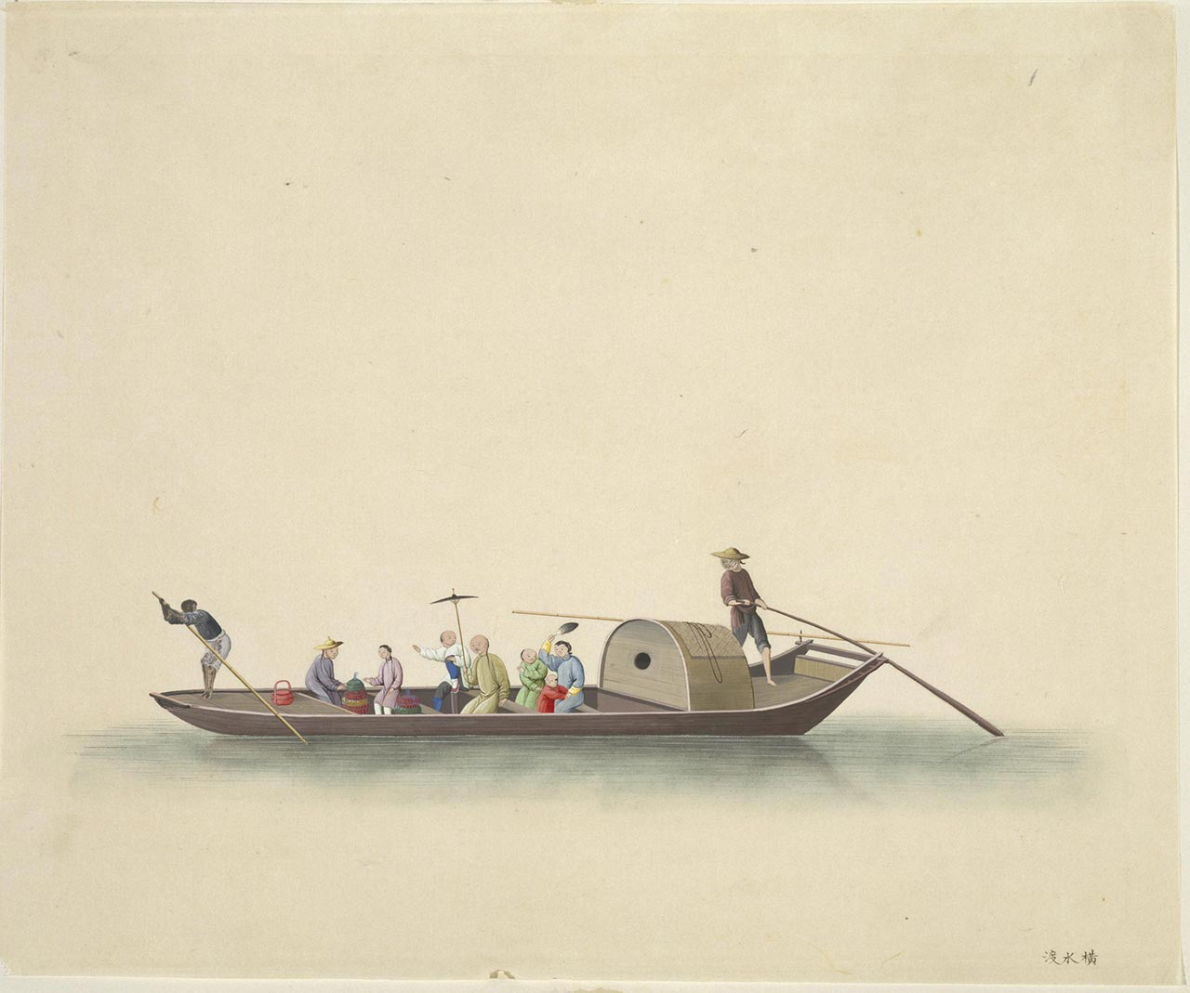
Who Are the Tanka?
The Tanka are an ethnic subgroup traditionally associated with China’s southern coast, especially the Pearl River Delta. For centuries, they were known as boat dwellers, living on junks, sampans, and fishing vessels rather than in villages or towns. In Hong Kong, they clustered in sheltered harbors like Victoria Harbour, Aberdeen, and Tai O.
Their origins are debated. Some historians believe they descend from coastal peoples pushed off the land by Han Chinese expansion. Others suggest they were fishermen who gradually became socially distinct through occupation and isolation. What is clear is that by the late imperial period, the Tanka occupied a marginalized position in Chinese society.
They were often barred from land ownership. Intermarriage with land-based communities was discouraged or outright forbidden. In some regions, they were excluded from the imperial examination system. The water was not just their home, it was their boundary.
In Hong Kong, under British colonial rule, these distinctions softened but never fully disappeared.

Life Afloat: A Boat as Home, Workplace, and World
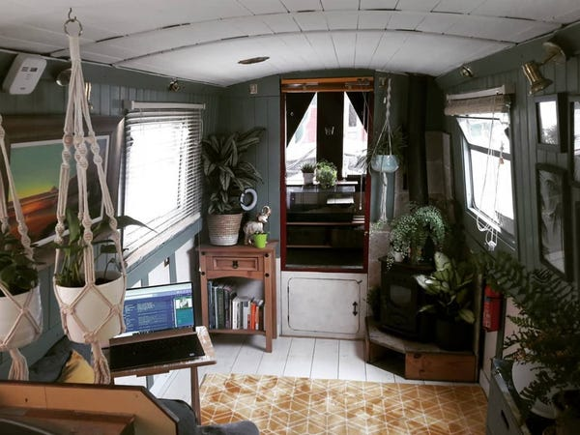
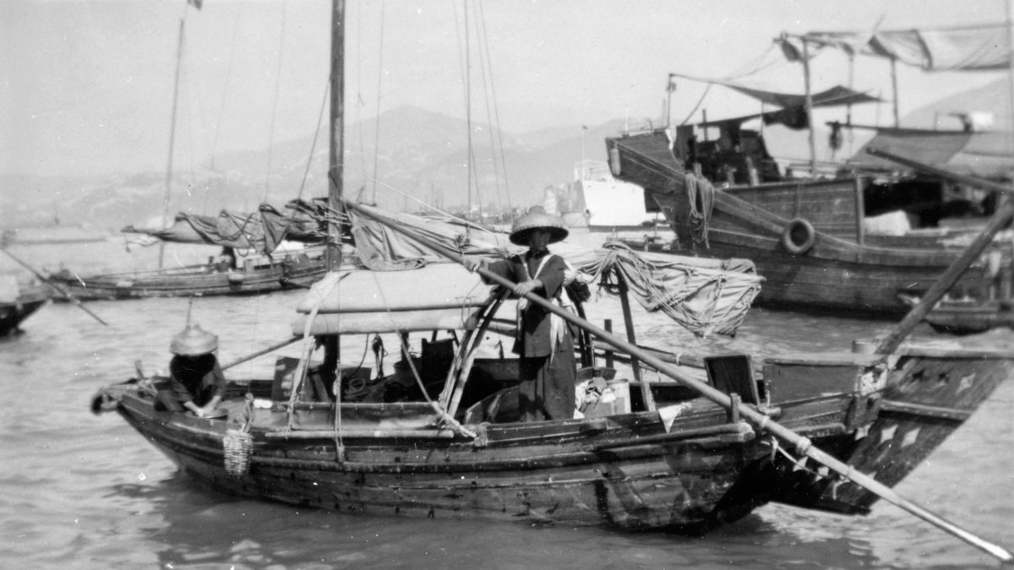
To call a Tanka boat a houseboat undersells the reality. These vessels were compact, crowded, and relentlessly practical. A single boat might shelter three generations. Cooking, sleeping, repairing nets, and raising children all happened within a space not much larger than a modern studio apartment.
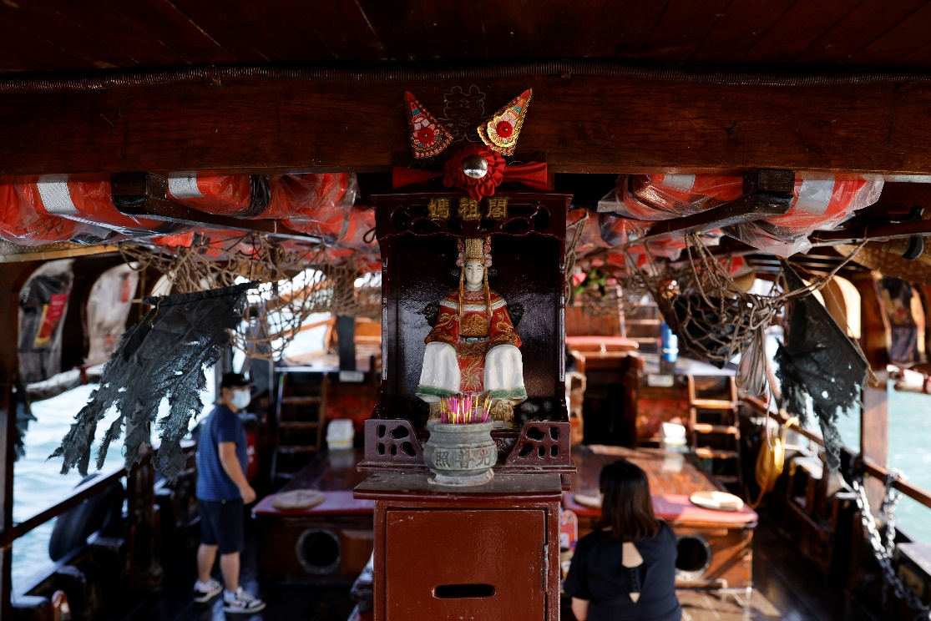
Privacy, as land people understand it, barely existed. Children learned early how to make themselves small. Hammocks and narrow bunks doubled as seating. Storage was everywhere, tucked into every possible corner.
Daily life followed the rhythms of tide and weather. Calm seas meant fishing, mending nets, or trading at shore markets. Storms meant riding them out at anchor, trusting generations of boat-handling knowledge and a healthy dose of luck.
Fresh water was precious. Many families collected rainwater or bought water from shore. Waste went straight into the harbor, a practice that would later draw criticism but was simply how life worked before modern infrastructure.
And yet, within this constrained environment, there was a strong sense of belonging. The harbor was not chaotic to those who lived there. It was a neighborhood.

Fishing, Trade, and Feeding the City
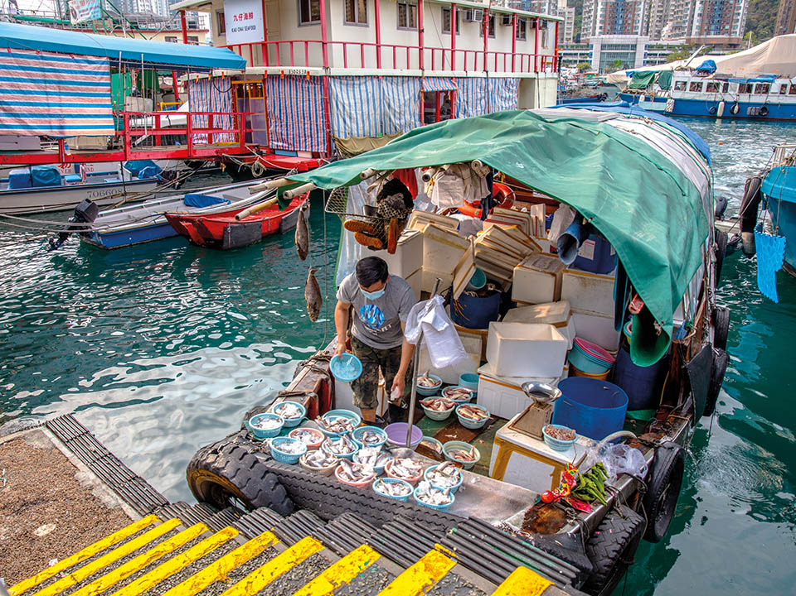
The Tanka were fishermen first and foremost. They supplied much of Hong Kong’s fresh seafood well into the twentieth century. Early mornings saw fleets heading out before dawn, returning with fish, shrimp, and shellfish destined for wet markets and restaurants.
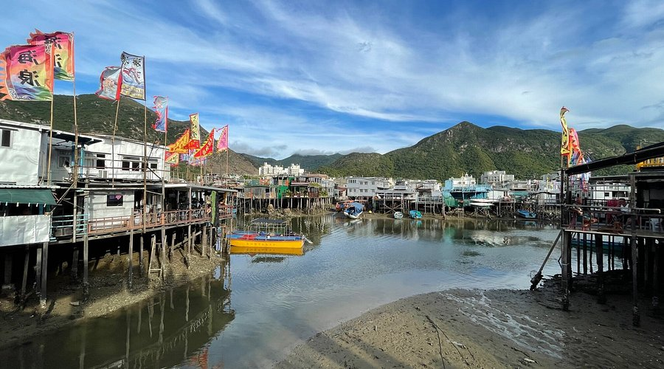
Some specialized. Others diversified. A few boats acted as floating shops, selling rice, oil, or household goods to neighboring families. Children might paddle sampans between larger vessels, delivering messages or small items, earning a few coins along the way.
In places like Aberdeen and Tai O, the line between fishing village and floating community blurred. Stilt houses extended the land into the water, creating hybrid neighborhoods where Tanka and land dwellers interacted daily.
Despite their importance, the Tanka rarely gained wealth. Fishing was unpredictable, markets volatile, and storms unforgiving. Survival depended on cooperation. Boats helped each other in bad weather. Nets were shared. Information about fish movements passed quickly through the fleet.
A Note on Cormorant Fishing and Coastal Reality
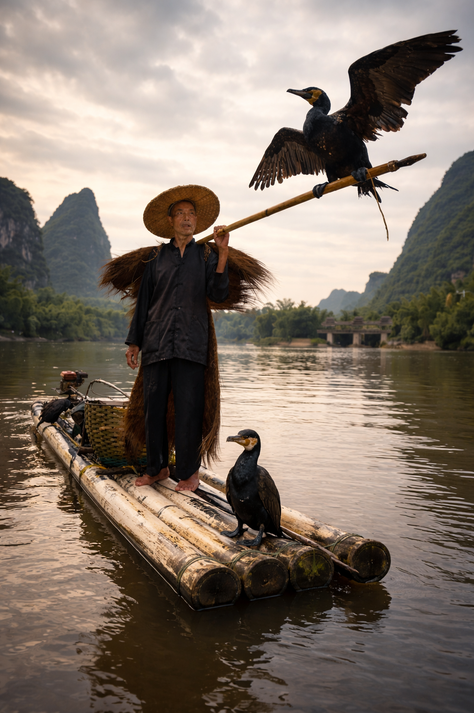
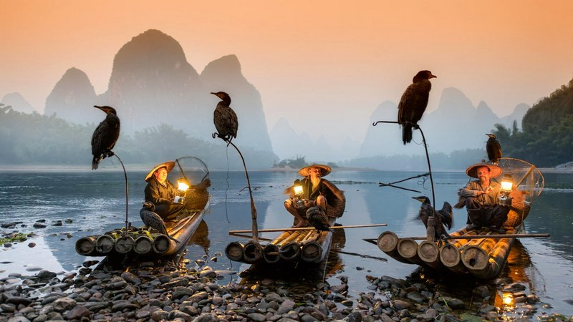
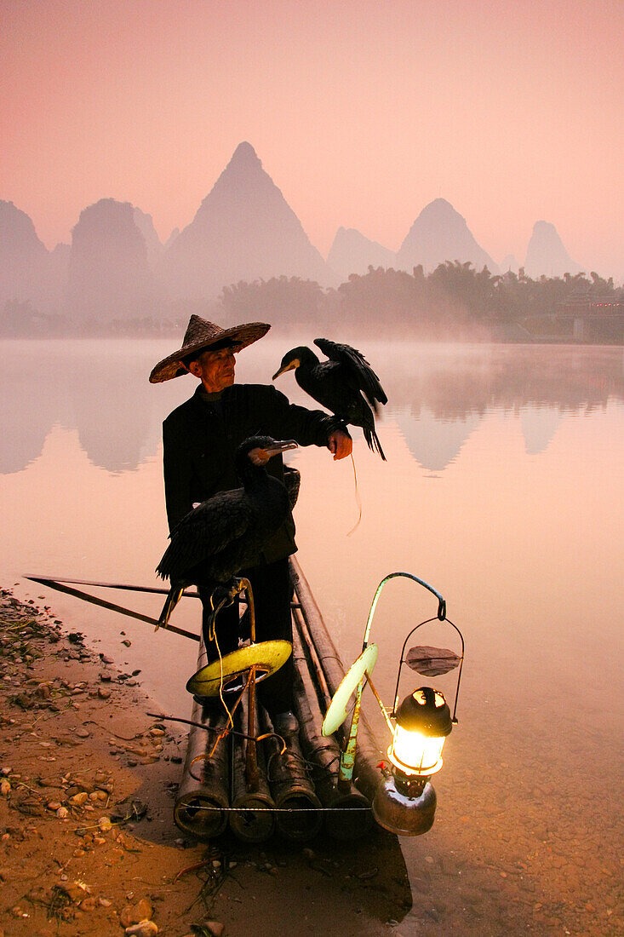
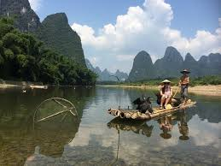
When people think of traditional Chinese fishing, this is often the image that comes to mind. A lone fisherman balanced on a bamboo raft. A cormorant perched on a pole, another waiting at his feet. At a signal, the bird dives, returning with a fish caught in its beak.
I’ve seen it done in person. It’s precise, quiet, and oddly intimate. The bird is trained from a young age. A loose ring around its neck prevents it from swallowing larger fish. The catch is retrieved, the ring loosened, the bird rewarded. Then it dives again.
It’s an extraordinary system. It’s also not a Hong Kong tradition.
Cormorant fishing belongs to inland river cultures, especially in Guangxi province, where shallow, slow-moving rivers make this technique practical. Hong Kong’s Tanka lived in tidal waters, busy harbors, and open coastal zones where nets and collective effort mattered more than individual finesse.
The confusion is understandable. Both traditions are old. Both involve boats as extensions of daily life. Both look timeless. Yet they evolved in very different environments, shaped by very different waters.
What connects them is not technique, but mindset. A deep understanding of fish behavior. An economy built on patience. And a relationship with water that is learned, not romanticized.

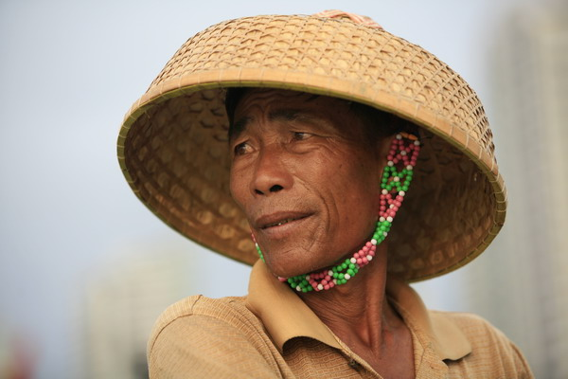
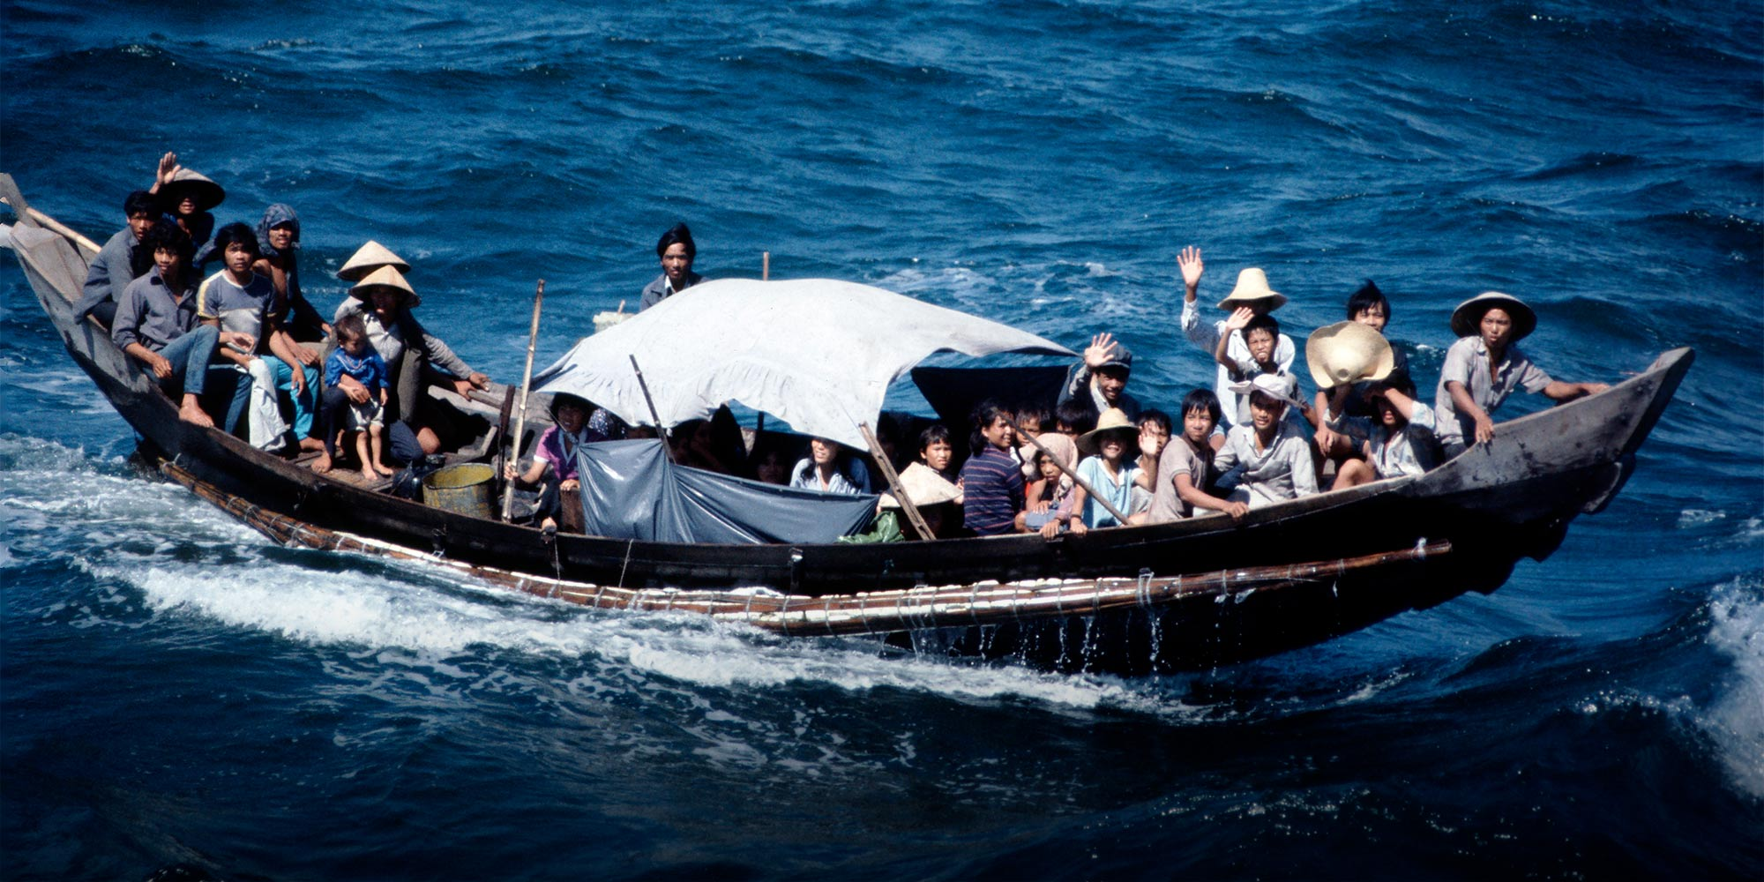
Language, Identity, and Outsiders
The Tanka traditionally spoke a variant of Cantonese with distinctive pronunciation and vocabulary. On the water, this linguistic difference reinforced group identity. On land, it marked them as outsiders.
Discrimination was a fact of life. The term “boat people” carried social weight. Land dwellers often viewed the Tanka as rough, uneducated, or unclean. Some restaurants refused service. Schools were reluctant to accept Tanka children.
These barriers began to erode in the twentieth century, especially after World War II. Education became more accessible. Younger generations adopted mainstream Cantonese speech. The boundary between water and land slowly weakened.
Still, many older Tanka recall being treated as second-class citizens well into the 1960s and 1970s. The harbor might have been home, but it was also a reminder of exclusion.

Religion and Ritual on the Water
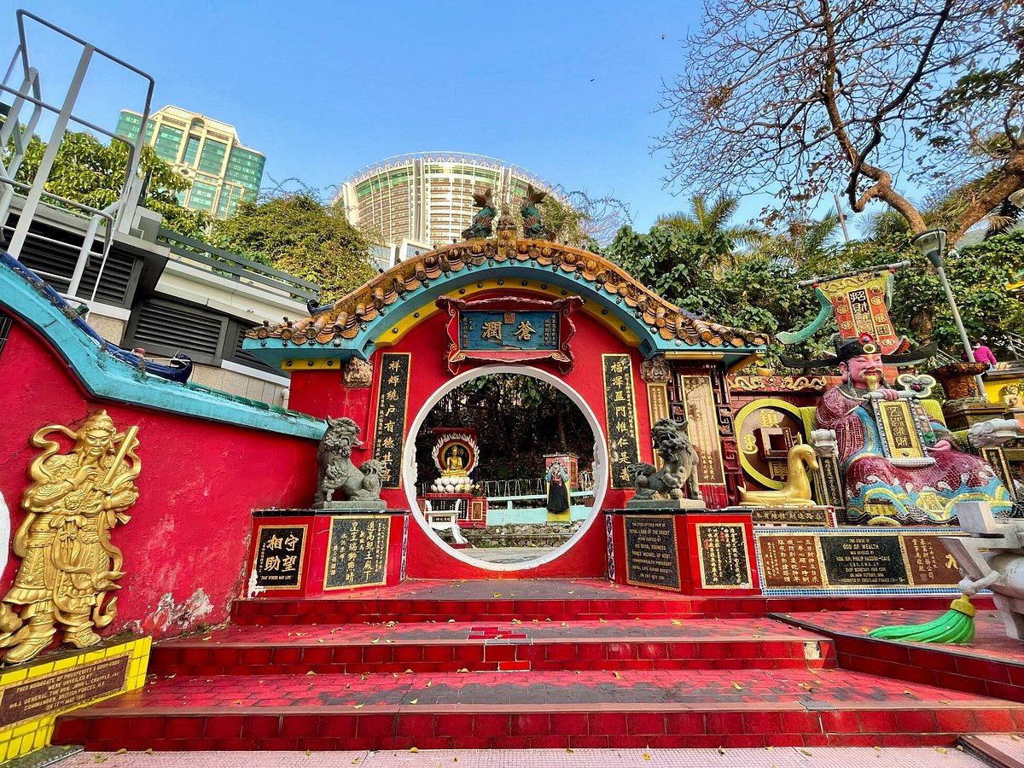
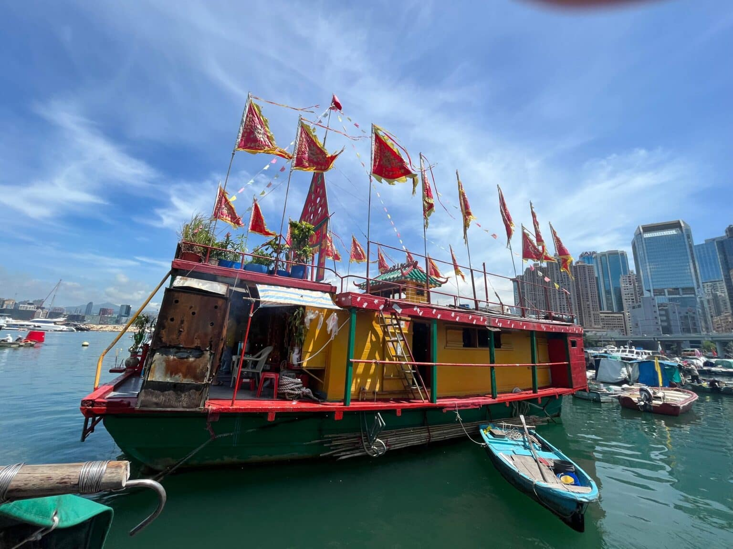
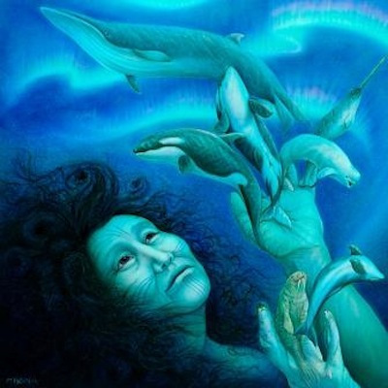
Life at sea encourages belief. For the Tanka, spiritual practice centered on protection, luck, and the unpredictable moods of water.
The most important figure was Tin Hau, the goddess of the sea. Shrines to Tin Hau appeared on boats, on shore, and even on floating platforms. Before major fishing trips, families made offerings, burning incense and asking for calm seas and full nets.
Festivals were communal affairs. Boats decorated with flags and lanterns gathered for celebrations that blended religion, social bonding, and spectacle. On festival days, harbors came alive with color, music, and ritual.
These traditions persist, even as fewer families live full-time on boats. Tin Hau temples remain active across Hong Kong, serving both former Tanka families and land-based fishermen.

Children of the Harbor
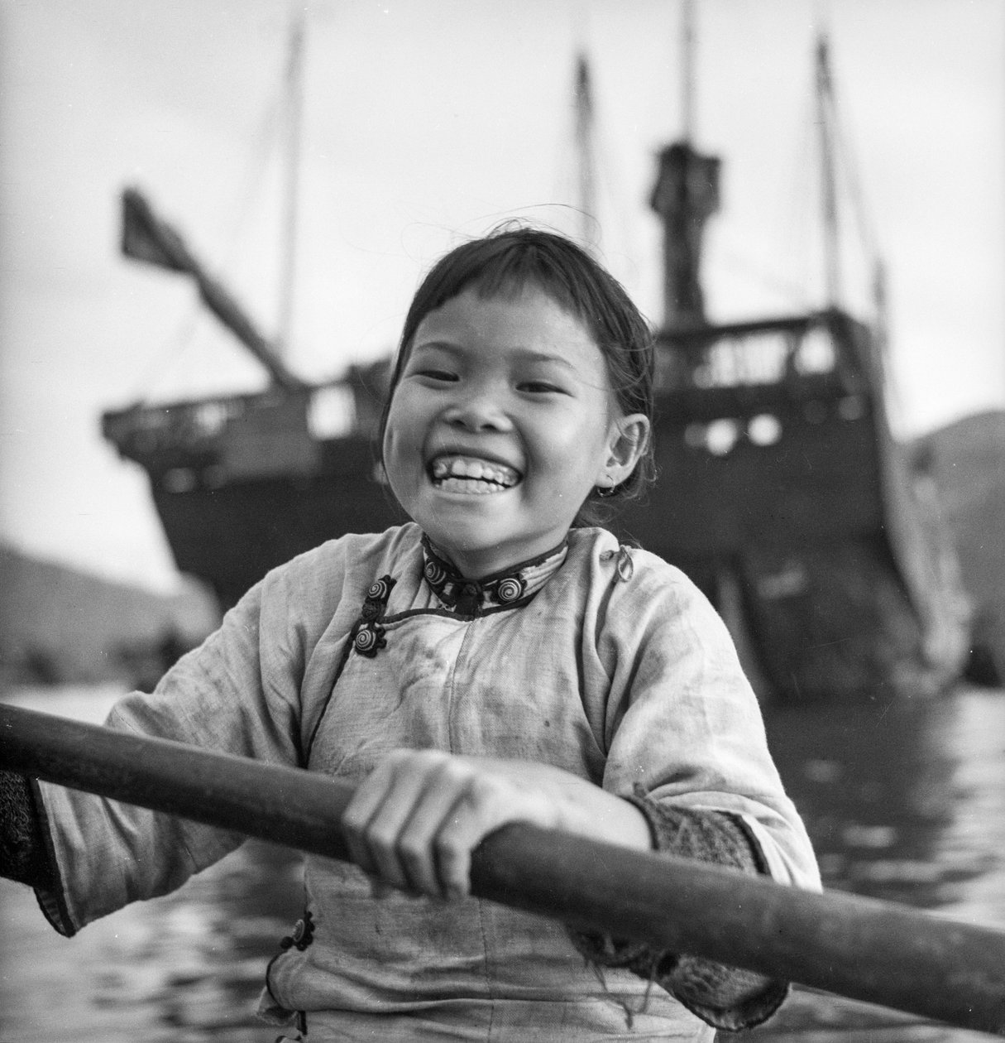

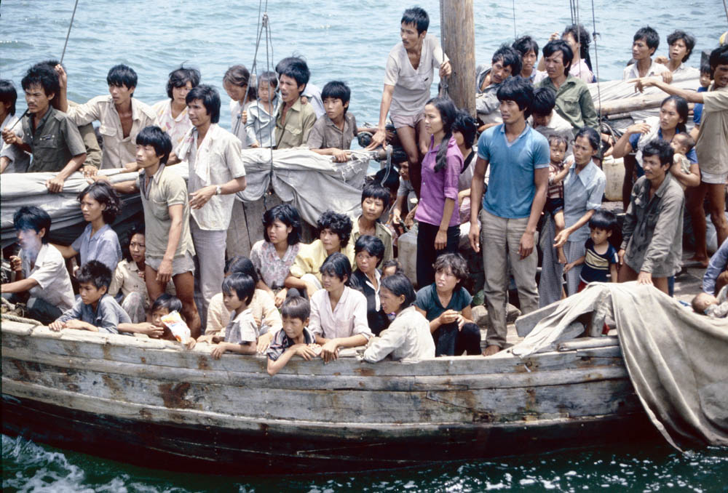
Perhaps the most striking aspect of Tanka life was childhood. Children learned to swim almost as soon as they could walk. Falling overboard was treated as an inconvenience, not a crisis. Many could paddle a sampan before they could read.
Education was informal for generations. Practical skills mattered more than schooling. Knot tying, net mending, reading the weather, and handling a boat in crowded waters were taught early.
As Hong Kong modernized, this changed. Compulsory education and social programs encouraged families to send children to school on land. This meant daily commutes by boat or relocation ashore.
For many elders, this shift was bittersweet. Education opened doors. It also loosened the ties that bound families to the water.

The Push to Land
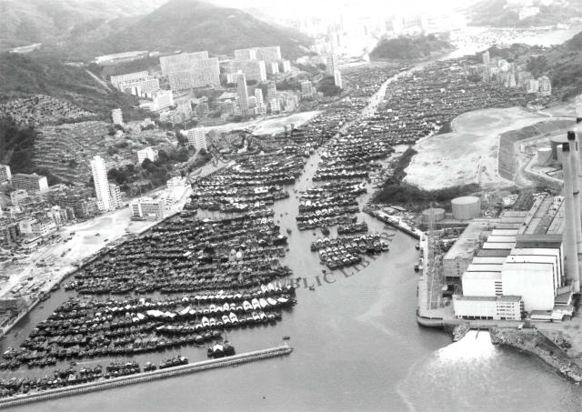
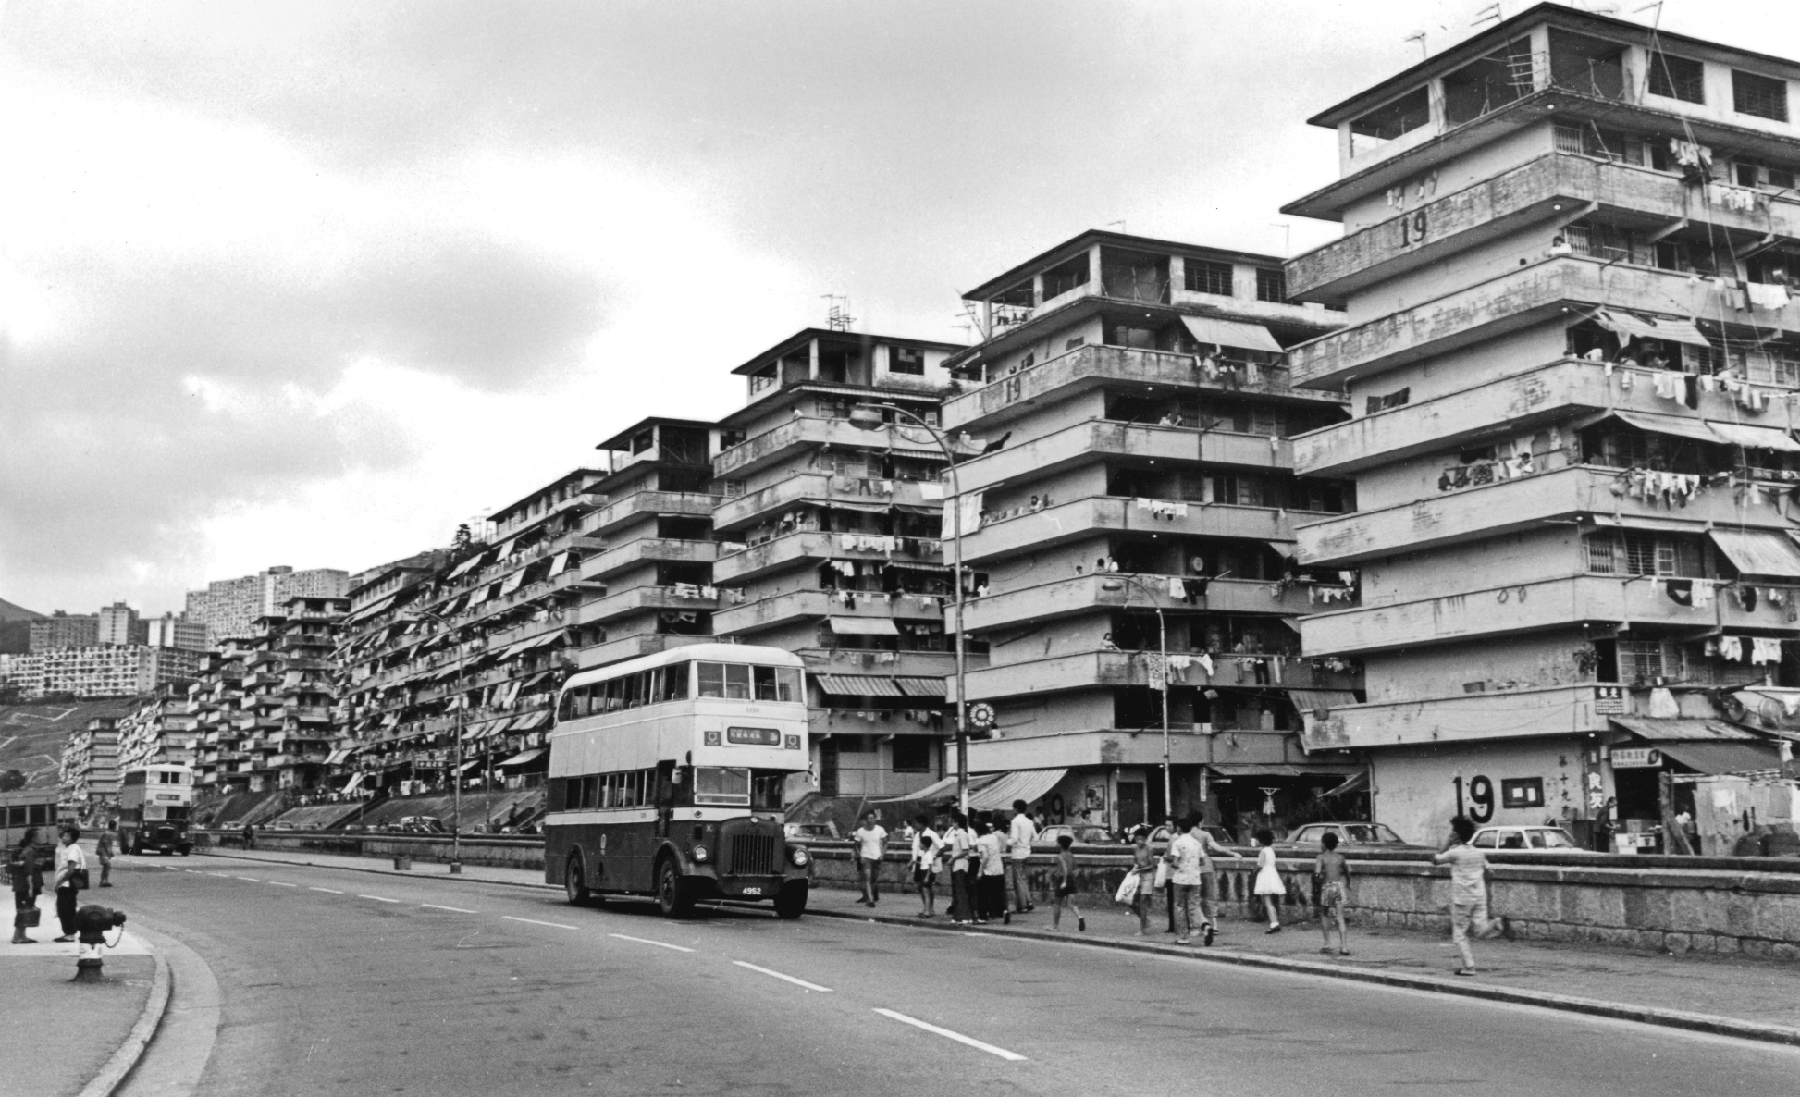
The mid-twentieth century marked a turning point. Several forces converged.
Typhoons grew deadlier as harbors filled with more boats. Pollution increased. Fishing yields declined. The colonial government, concerned about safety and public health, encouraged resettlement.
Public housing projects offered stability, sanitation, and access to schools. For many Tanka families, the choice was pragmatic. Living on land was safer for children. Jobs beyond fishing became possible.
Entire floating communities gradually dispersed into apartment blocks. Boats were sold, repurposed, or abandoned. Some families kept small vessels for work. Others left the water entirely.
By the 1980s, the era of mass boat living in Hong Kong was effectively over.

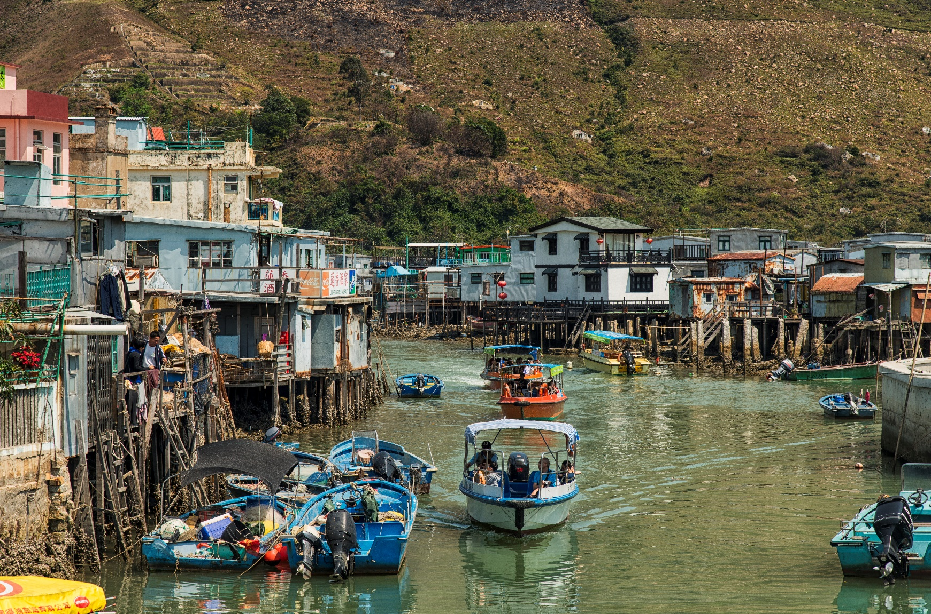
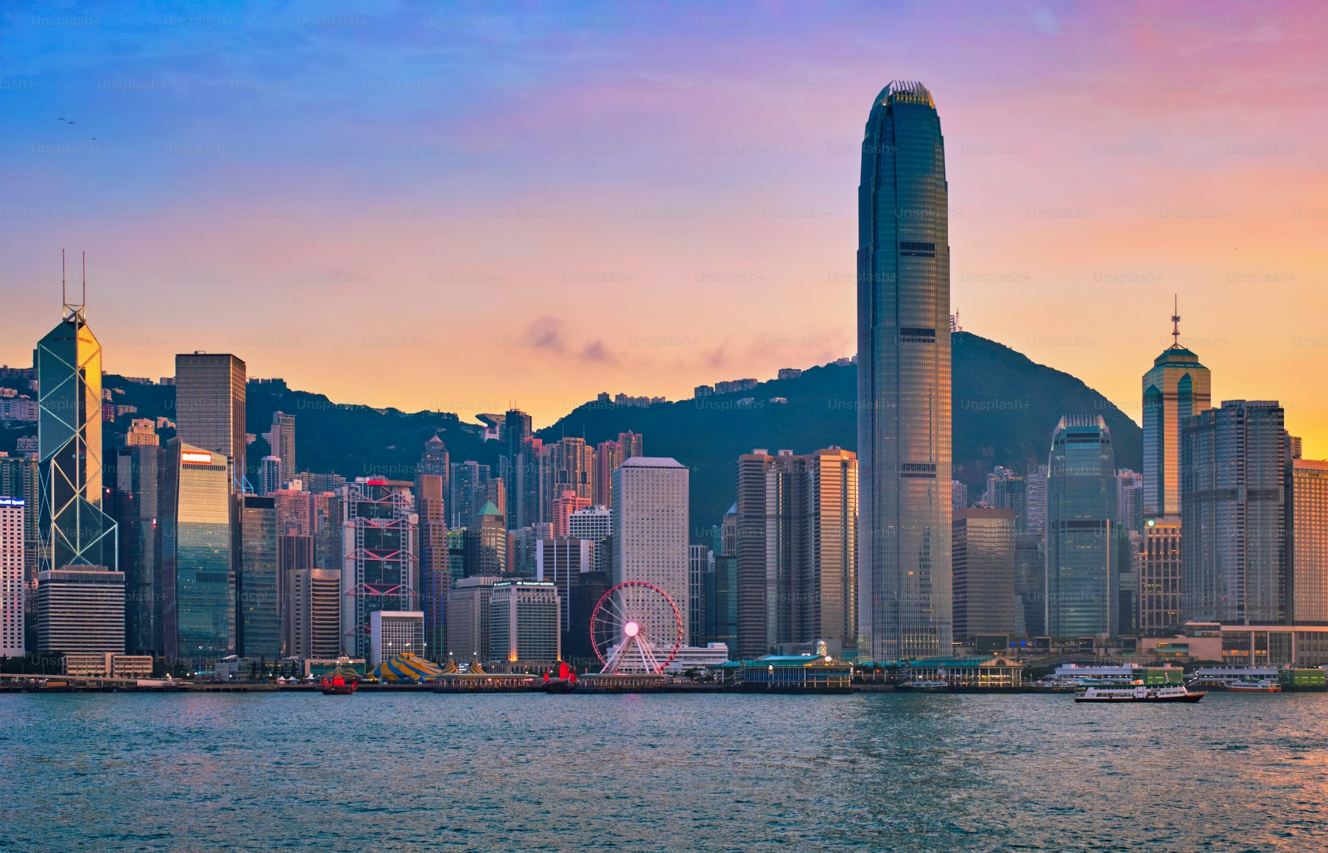
What Was Lost, What Remains
Something intangible disappeared with that transition. The tight social fabric of harbor life. The unspoken rules of anchoring, movement, and mutual aid. The ability to read the water like a map.
Yet not everything vanished.
Many former Tanka families still work in seafood, shipping, or marine trades. Festivals continue. Stories are passed down. In places like Tai O, echoes of the old life remain visible, even if lived by fewer people.
The modern skyline of Hong Kong rises from land reclaimed from the sea. Beneath it lies a history built by people who never owned property, but who knew every current and cove.

Seeing the Tanka Today
Visitors to Hong Kong sometimes glimpse a sampan crossing the harbor or spot fishing boats clustered near a typhoon shelter. It is easy to romanticize these images, to treat them as picturesque remnants.
The reality is more complex.
For the Tanka, the move to land was not cultural erasure. It was survival. Their identity was never just about boats. It was about adaptability. About making a living where others would not. About building community in motion.
If you talk to older members, many will say they miss the water. If you talk to their children, many will say they are grateful for solid ground.
Both can be true.

Between Tides and Time
The Tanka challenge a simple idea of what a city is. Hong Kong was not only built upward. It was built outward, across water, by people whose homes floated and shifted with the tide.
Their story also reminds us that modernization always carries trade-offs. Safety improves. Opportunity expands. Something else fades.
Understanding the Tanka is not about nostalgia. It is about recognizing a way of life that shaped a place, even if it no longer defines it.
When you look out over Hong Kong’s harbors today, crowded with ferries, container ships, and pleasure craft, remember that for centuries this water was not a thoroughfare. It was home.
And for some families, in memory and tradition, it still is.

