The Shark Attack Myth
How Our Deadliest Fears Compare to Reality
By Marc Silver
Look, I get it. That primal chill when murky water brushes your leg? The way Jaws still hijacks your brain at midnight? I'm right there with you. But what if I told you that your fear is wildly misplaced? That the creature waiting to greet you when you towel off is statistically 4,300 times more likely to kill you than any shark?
Seriously, that's not a typo.
I stumbled onto this truth like stepping on a sea urchin: sharp and sudden. It was an otherwise dull Tuesday. I was on my way home from dinner with my wife, half-listening to PBS, when a reporter asked: “How many people were killed in 2024 by shark attacks worldwide? 5,000? 10,000?” The answer? “In 2024, sharks killed 7 people globally.” Seven. And only 4 were truly "unprovoked." For context? Lightning kills 24,000 people yearly. Falling coconuts? 150. Vending machines? They crush about 2 people annually just in the United States. You’re literally as likely to be murdered by a snack dispenser as by a shark.
This got me thinking: why do we dread the ocean's sleekest predator while ignoring the tail-wagging land-shark on our sofa? Let's dive in, no cage required.

The "Usual Suspects" Responsible for the Vast Majority of Attacks
Only 3 species consistently rank as the primary culprits in unprovoked, serious attacks:
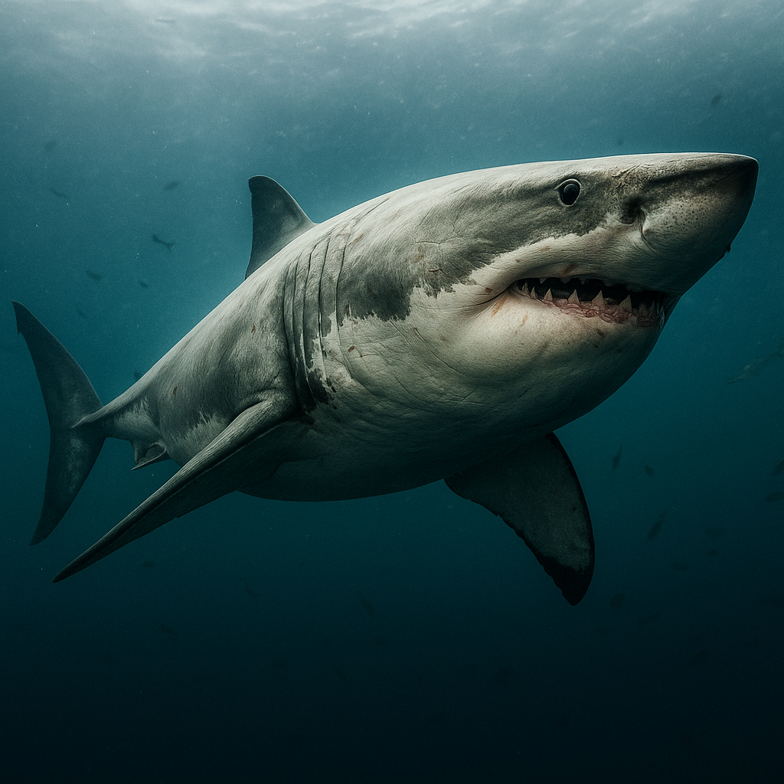
Great White Shark (Carcharodon carcharias): The iconic predator. Responsible for the highest number of fatal attacks globally. Their size,
Figure 1 Great White Shark
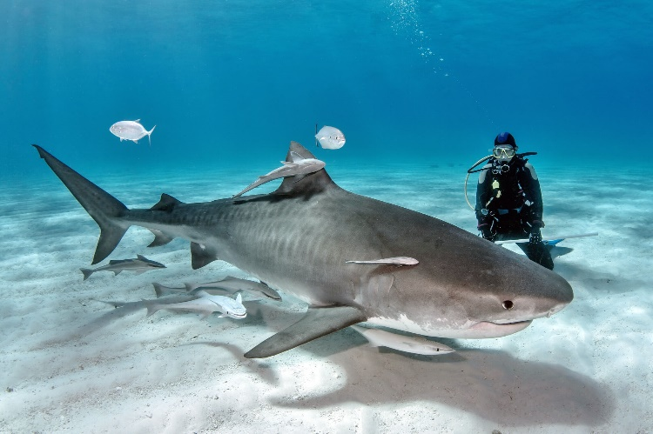
power, curiosity often involving test bites, and preference for coastal areas near seal colonies bring them into contact with surfers and swimmers.
Figure 2 Tiger Shark
Tiger Shark (Galeocerdo cuvier): Known as the "garbage can of the sea" for their incredibly broad diet. Highly curious and less discerning than white sharks. Found in tropical and subtropical waters, often in murky harbors and estuaries, raising the risk of encounters.
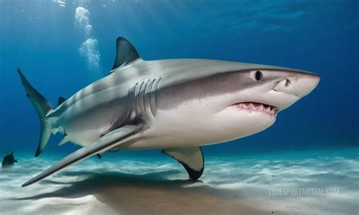
Bull Shark (Carcharhinus leucas): Perhaps the most dangerous in context. Uniquely adaptable to fresh and brackish water. Aggressive, territorial, and thrives in shallow, murky areas where humans swim, creating a perfect storm for close encounters.
Figure 23 Bull Shark
Why So Few Species Attack?
Most sharks aren’t dangerous. Here’s why:
  - Deep Water Dwellers: Many large species like Greenland sharks, megamouths, sleeper sharks, live far offshore or at extreme depths, rarely encountering humans.
  - Specialized Feeders: Whale sharks and basking sharks are gentle filter-feeders. Nurse sharks, wobbegongs, and angel sharks are bottom-dwellers focused on crustaceans/fish and typically only bite defensively if stepped on or harassed.
  - Oceanic Nomads: Species like blue sharks or oceanic whitetips spend lives in the open ocean. While potentially dangerous if opportunity arises (e.g., shipwreck survivors), encounters with swimmers are vanishingly rare.
Behavior & Diet:
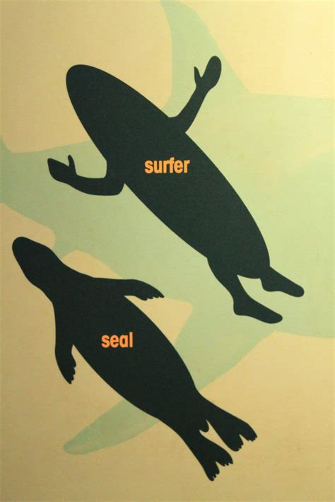
  - Mistaken Identity: Most serious attacks by the "Big 3" are believed to be investigative bites or cases of mistaken identity.
  - They rarely target humans as prey.
  - Defensive Reactions: Many bites attributed to other species like reef sharks, lemon sharks, blacktips, occur during provoked incidents (spearfishing, feeding, handling) or are quick, defensive nips when the shark feels cornered or surprised.
Figure 3 surfer & seal silhouette i
  - Lack of Interest: Humans are not a natural or desirable food source for sharks. Our bony structure and low-fat content make us unappealing. Most sharks quickly release a human after an initial test bite.
Beyond the "Big 3": Occasional Players
A few other species can and have bitten humans, but attacks are infrequent and rarely fatal:
- Oceanic Whitetip (Carcharhinus longimanus): Historically dangerous in open ocean disaster scenarios (e.g., ship/plane wrecks), but encounters with swimmers are rare.
- Shortfin Mako (Isurus oxyrinchus): Fast, powerful, occasionally aggressive, but primarily an open ocean fish-eater. Attacks are very uncommon.
- Various Reef Sharks like Blacktip, Reef Whitetip, and Gray Reef: Most bites are minor, provoked, or occur in low-visibility water during feeding (spearfishing, chumming). They are generally wary of humans.
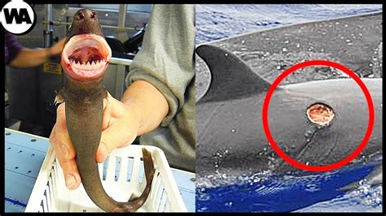
- Cookiecutter Shark (Isistius brasiliensis): Technically "attacks" by taking small, round bites out of large animals, including humans swimming at night in deep water, but these are parasitic nibbles, not predatory attacks.
Figure 4 Cookiecutter Shark
Key Statistic: While around 34 species have been documented biting a human at least once under various circumstances, the overwhelming majority of unprovoked bites and fatalities come from just 3 species: White, Tiger, and Bull sharks.

What's the Real Risk?
It’s not “sharks.” It’s specific sharks, in specific places, under specific conditions.
Risk is Concentrated: You’ll only run into trouble where large coastal predators overlap with human activity, near seal colonies, estuaries, and murky surf zones.
Attacks ≠ Predation: Most bites aren’t attempts to eat you. They’re investigative or defensive reactions.
Human Behavior Plays a Role: Don’t swim at dawn or dusk in murky water. Don’t hang around seal colonies. Don’t spear fish near reefs. Simple precautions make a big difference.
Perspective: You are vastly more likely to be killed by bees, lightning, falling coconuts, or even cows than by a shark. Our fear is inflated by appearance and media, not probability.
In essence: The ocean is home to an incredible diversity of sharks, most fascinating and harmless. The threat to humans comes almost exclusively from just three remarkable, but ecologically distinct, apex predators whose paths occasionally cross ours in specific, often avoidable, situations. It's not a "shark" problem; it's a "very specific sharks in very specific contexts" situation. Compared to the territorial panic of a hippo or the silent drop of a widow maker, shark attacks are statistically minute, though understandably terrifying when they occur.
Perspective: You're vastly more likely to be killed by countless everyday things, from bees and lightning to household accidents or even livestock, than by a shark.

The Takeaway: Context is Everything
- Risk is Highly Concentrated: The danger isn't spread across hundreds of species. It's focused on a very small number of large, powerful, coastal predators often found in areas humans use for recreation.
- Attacks ≠ Predation: Most bites are exploratory, defensive, or cases of mistaken identity, not attempts to eat humans.
- Human Behavior Matters: Avoiding areas where the "Big 3" are common, especially near seal colonies, murky estuaries, river mouths, avoiding swimming at dawn/dusk, and not provoking sharks drastically reduces risk.
- Perspective: You are vastly more likely to be killed by bees, lightning, falling coconuts, or even cows than by a shark. The fear is disproportionate to the actual risk, fueled by their appearance and media portrayal.
Our ocean is home to an incredible diversity of sharks, most fascinating and harmless. The threat to humans comes almost exclusively from just three remarkable, but ecologically distinct, apex predators whose paths occasionally cross ours in specific, often avoidable, situations. It's not a "shark" problem; it's a "very specific sharks in very specific contexts" situation. Compared to the territorial panic of a hippo or the silent drop of a widow maker, shark attacks are statistically minute, though understandably terrifying when they occur.
Despite this narrow risk profile, sharks suffer from a massive PR problem fueled by primal fears and sensational headlines.

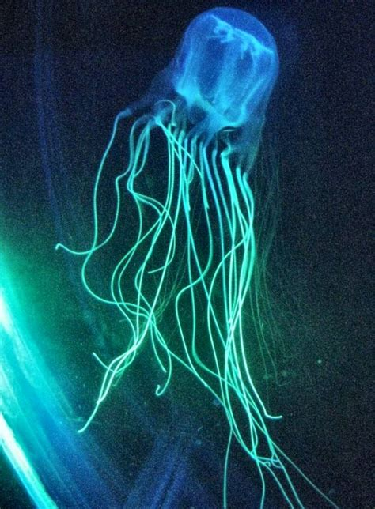
Sharks have a PR Problem
Let's be real: sharks look terrifying and attacks are horrific when they happen. But the ocean's silent killers? They're often way less dramatic:
The Ocean's Real Killers
- Jellyfish kill ~100 people/year via venomous stings. That’s 14 times the shark toll. Ever panic at a floating plastic bag? Same instinct.
Figure 5 Box Jelly
- Drowning claims ~236,000 lives annually. You’re 33,714 times more likely to die choking on saltwater than teeth.
- Think about that next time you gulp seawater, H₂O itself is astronomically deadlier than teeth.
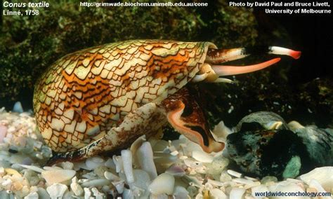
- Even the humble sea snail. Cone snails, specifically, injects enough venom to kill 10 humans per year. Nature’s most unassuming killer.
So why the shark hysteria? One word: drama. Shark attacks make headlines. Drowning doesn’t. Our brains remember the spectacular, not the statistical.
- Yeah, a snail. Nature's slowest assassin puts sharks to shame.

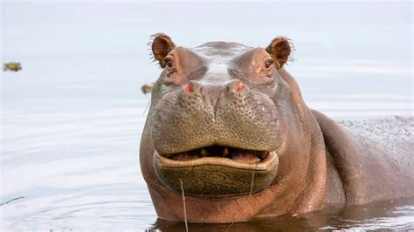
Meanwhile, Back on Shore
Want to see real danger? Step onto land where "harmless" things bite back:
The Herbivore Hit Squad
- Hippos: (stats + new detail) Don't let those lazy yawns fool you, these vegetarians erupt into river rage titans when blocked from water, snapping 500 people/year like celery sticks.
Figure 6 Hippopotamus
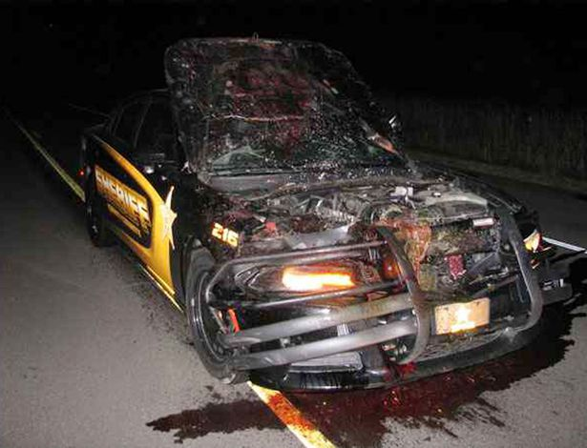
- Deer: Bambi's a menace, causing 440 fatal U.S. crashes/year (that's 63x global shark deaths).
Figure 7 Cop racing to crime scene smashes into deer at 100mph
- Cows: "Gentle grazers"? Try "1-ton stompy rage machines" killing 20 Americans yearly via goring, trampling, or deadly side-eye.
Everyday Death Traps
(Consolidated stats with flair)
- 🤳 Selfie deaths: ~30/year (Darwin Awards love these)
- 🥥 Falling coconuts: 150/year (estimates vary) One of nature's unexpected killer.
- 🥤 Vending machines: ~2 U.S. deaths/year (rage-shaking is a sport)
- 🪑 IKEA furniture: ~8 deaths/year (some assembly required... for your coffin)
Tiny Terrors
The undisputed champions of human destruction:
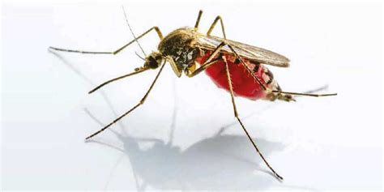
- 🦟 Mosquitoes: 725,000+ deaths/year (new context), Malaria's grim reaper makes Jaws look like a guppy
Figure 8 Mosquito
- 🐝 Bees/Wasps: ~60 U.S. deaths/year (added), Nature's kamikaze bombers
- 🔥 Fire ants: ~50 global deaths, Because even insects have anger issues

Why I Fear Fido More Than Fins
I grew up loving dogs. Still do. But the numbers don’t lie:
Figure 9 Pit Bull Dog
🐶 Dogs: Man's best friend? More like rabies vector/chihuahua-of-doom Kill ~30,000 yearly(mostly via rabies in areas without vaccines. Even in the U.S., dog attacks kill around 30 people annually, mostly by pit bulls
- 😼 Cats: They rarely kill, but they do send 66,000 people to the hospital every year with infected bites. Hospitalizing 66,000/year with infected bites.

The Psychology of Fear
Our brains aren't rational danger-calculators:
- Why do we fear sharks more than Labradors?
- The Jaws Effect: That movie rewired public perception. We don’t get Cujo-themed roller coasters.
- Control: We leash dogs. We can’t leash the ocean.
- Evolution: We’re wired to fear lurking predators, not traffic or blood sugar.
- The Unknown: Oceans are mysterious. Our homes feel safe, even when statistically more dangerous.
- It's why we white-knuckle rollercoasters but ignore the deadlier drive to the amusement park. Our wiring prioritizes spectacle over statistics.

The Actual Death Rankings (Spoiler: Sharks Are Benchwarmers)
Let’s stack the real killers:
Cause of Death | Yearly Deaths | Multiplier vs. Sharks
Mosquitoes | 725,000+ | 103,571 x
Humans (Homicide) | 400,000+ | 57,142 x
Snakes | 81,000–138,000 | 11,571 x–19,714 x
Dogs | 30,000 | 4,286 x
Selfies | ~30 | 4.3 x
Coconuts | 150 | 21 x
IKEA Furniture | ~8 | 1.1 x
Selfie Sticks | ~5 | 0.7 x
Vending Machines | ~2 | 0.3x
Sharks | 4–10 | 1 x
(Sources: WHO, CDC, Journal of Trauma, Consumer Product Safety Commission)
Yes, you read that right: Falling coconuts kill 21 times more people than sharks. And if you’ve ever wrestled a stubborn vending machine for your Cheetos? You flirted with a predator deadlier than our friend the Shark.
Falling tree limbs are called “widow makers”, and they kill about 100 people yearly in the U.S. alone. Hikers, loggers, firefighters. These deaths are silent, sudden, and common.

Swim Freely, Fear Wisely
Respect sharks? Absolutely. Fear them irrationally? Nah. They're apex predators doing their job in oceans we invade.
- Avoid dawn/dusk swims in murky water (shark rush hour)
- Steer clear of seal colonies (shark buffets)
- Don't spearfish near reefs (dinner bell ringing)
The deadliest predator in your life isn't patrolling the reef. It's likely:
- 🚗 On your commute (traffic kills 1.3 million yearly)
- 🛋️ Snoring on your sofa (heart disease: 17 million)
- 🐶 Wagging its tail at your door (dogs: 30,000)
So next time you panic at a dorsal fin, remember:
" The ocean isn't out to get you. That vending machine
you kicked last week? Statistically scarier.
"
Now go surf. And maybe apologize to Fido for side-eyeing him.

References
- International Shark Attack File. "2024 Worldwide Shark Attack Summary." Florida Museum of Natural History. Accessed June 2025.
- World Health Organization. "Snakebite envenoming." WHO Fact Sheet. Updated May 2023.
- Mohapatra, B., et al. "Snakebite Mortality in India: A Nationally Representative Mortality Survey." PLOS Neglected Tropical Diseases, 2011.
- Caldicott, D.G., et al. "An examination of the scope and patterns of stonefish envenomation in Australia." Medical Journal of Australia, 2003.
- Forrester, J.A., et al. "An evaluation of the global burden of snakebite." Bulletin of the World Health Organization, 2019.
- Dunham, K.M., et al. "Human-crocodile conflict in sub-Saharan Africa." Oryx, 2010.
- 7. Lewison, R.L., et al. "Quantifying the effects of human encroachment on African hippo." Biological Conservation, 2006.
- Sacks, J.J., et al. "Breeds of dogs involved in fatal human attacks in the United States between 1979 and 1998." Journal of the American Veterinary Medical Association, 2000.
- Overall, K.L., et al. "Frequency of nonrecognized aggression in dogs." Journal of Applied Animal Welfare Science, 2001.
- American Veterinary Medical Association. "Dog Bite Prevention." AVMA Position Statement, 2023.
- Centers for Disease Control and Prevention. "Preventing Dog Bites." CDC Injury Prevention Guidelines, 2024.
- Ozanne-Smith, J., et al. "Dog bite and injury prevention, analysis, critical review, and research agenda." Injury Prevention, 2001.

