The Sea Nomads: Life on the Water Among the Bajau Laut
By: Marc Silver
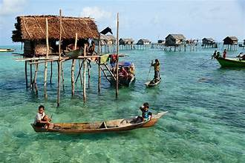
There are people in Southeast Asia who live their entire lives on the water. Not near the water in a sea side village, but on it. Families born on boats. Memories shaped by tides. A sense of home that moves with the horizon. These are the Sea Nomads, known as the Bajau Laut. Their world stretches across the Philippines, Malaysia, and Indonesia.
If floating villages give you a sense of a community anchored in place, the Bajau are the opposite. Their homes drift. Their boundaries shift with wind and season. And their identity comes from the sea in a tradition that stretches back millennia.
The Bajau have lived this way for centuries. They are known for navigating without maps, free-diving to astonishing depths, and reading the ocean with the kind of calm confidence most of us reserve for neighborhood streets. They are one of the few remaining maritime nomadic cultures on Earth. And their way of life is under pressure from almost every direction.
This is their story.
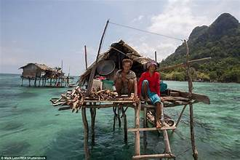
A Life Built Around the Boat
For many Bajau, water greets them first thing in the morning, and it’s the last thing they hear before sleep. Families live in long wooden boats called lepa-lepa. These boats are narrow, fast, and simple. They were designed for fishing, traveling, and raising kids in a moving world.
Cooking happens on board. Repairs happen on board. Some ceremonies even happen on board. For many elders, stepping onto land feels strange, as if the ground itself is unsteady.
Their homes are practical. The real shelter is knowledge of the sea.
The Bajau know reefs, currents, and seasons the way farmers know soil and weather. They know where fish are likely to gather, where storms build, and where the tide hides shallow sandbars. The ocean is their map, pantry, and road system combined.

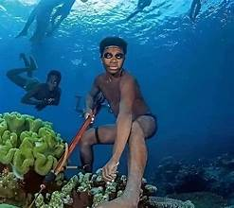
The Deep Breath: A Human Adaptation Story
The Bajau are famous for their free-diving. This is not weekend snorkeling. They dive to hunt. They dive to gather. They dive because this is how they live, how their parents lived and how their grandparents lived.
Some Bajau divers can descend more than 200 feet without diving equipment, and can stay underwater for minutes at a time. Scientists have studied them and discovered something remarkable. Over generations, their spleens have grown larger. A larger spleen releases more oxygen-rich red blood cells during deep dives. This is evolution in fast-forward. A population shaped by its environment in a very direct way.
Most people train to dive. The Bajau have physically adapted to dive.
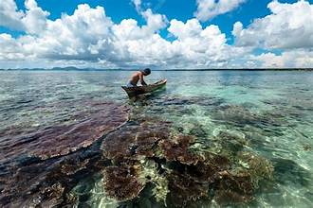
A Culture That Moves with the Tide
The word nomadic can sound romantic. But it also means constant adjustment. The Bajau move based on weather, fishing patterns, and the needs of their families.
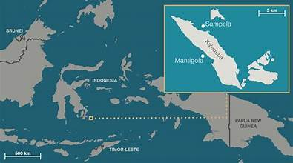
There is no fixed border in the sea. Most Bajau today practice Islam, though older traditions and sea-based beliefs still influence daily life, especially in rituals connected to the ocean.
Their social life reflects this blend of old and new. Families gather when boats anchor near each other. Celebrations and songs drift across the waves. Stories travel faster than boats. Many traditions center on the ocean itself, including rituals tied to spirits believed to inhabit reefs and certain stretches of water.
The Bajau live in a part of the world with many borders but few lines drawn on the water. Malaysia, Indonesia, and the Philippines share the region. Governments expect people to have documents. The Bajau often do not.
A nomadic community that spent most of its life offshore rarely visited government offices. Many elders were never registered at birth. Many children today still aren’t. Without papers, entire families fall through the cracks of modern systems.
This creates difficult situations. School becomes harder to access. Healthcare becomes complicated. Legal protection becomes unsure. Even fishing rights become uncertain.
The sea has always been open. Governments are not.

Pressure on a Traditional Way of Life
Life on the water is beautiful, but it comes with challenges. And recent decades have pushed those challenges harder.
Overfishing has made traditional fishing methods less reliable. Climate change has damaged reefs that once held predictable fish stocks. Storms are more intense. Patrols are stricter. And many Bajau have been pushed toward shore by force or by necessity.
Some end up in stilt villages with uncertain incomes. Some move to towns and take whatever work they can find. Others remain at sea but face restrictions that ancestors never imagined.
It is not that the culture is fragile. The Bajau are resilient. But the changes are happening faster than any nomadic group can adapt on its own. Among all global cultures, the Bajau might be among the best prepared to adapt to rising seas and shifting coastlines.
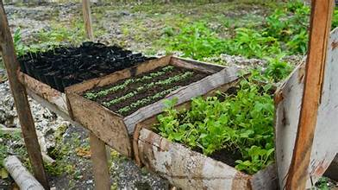
Efforts to Preserve Culture and Dignity Across Southeast Asia, a number of groups have started working with Bajau communities rather than around them. This makes a real difference.
Some programs help families register births so children can attend school. Others support sustainable fishing practices to keep the reefs healthy. A few have created partnerships in eco-tourism where Bajau guides lead visitors through their world, with payment flowing directly to the community.
These efforts work best when the Bajau themselves take the lead, when they set the terms When the ocean remains central rather than an afterthought.
It is not about preserving a museum culture. It is about letting the community shape its own future while maintaining its identity.
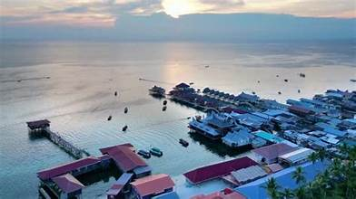
Blend of Old and New
You can visit a Bajau community today and see both tradition and change. A diver still hunting underwater with a handmade spear. A child watching videos on a phone under a thatched roof. A mother repairing nets while talking about weather patterns from her parents’ days.
Cultures evolve. The Bajau are no different. But the core of their life remains tied to the sea.
For many, the boat is not simply a home. It is an inheritance. A way of seeing the world.

Final Thoughts
The Bajau Laut represent one of humanity’s ongoing relationships with the ocean. They show what it looks like when a culture is shaped by tides instead of roads. Their world is not romantic fantasy. It is real, practical, and deeply tied to knowledge most of us will never fully understand.
Sea levels will rise. Borders will tighten. Technology will continue to reshape everything. Traditions will shift. But there is something powerful in the idea of a community that still reads the world through the water beneath them.
The Bajau remind us that identity can float. Home does not always have to be built on land.

