The Rise, Fall, and Return of the Integrated Amplifier
By Marc Silver
There was a time when just about every stereo system in America started with an integrated amp or a receiver. Walk into any hi-fi store in the 1970s, and you'd see a glowing wall of silver faces, meters dancing, toggle switches snapping into place, and that satisfying click of a power button engaging something serious. Brands like Sherwood, Kenwood, Pioneer, Marantz, Sony, and Sansui turned these machines into objects of both function and beauty.
They did everything. And for most listeners, that was enough.
So what changed?
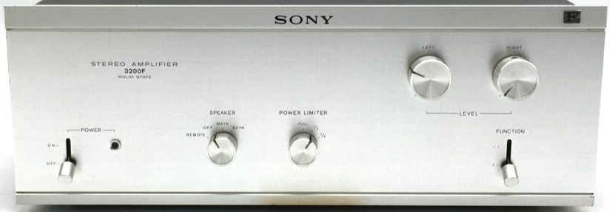
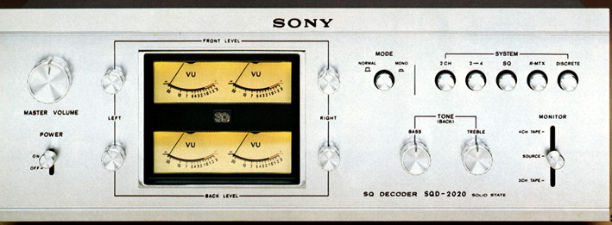
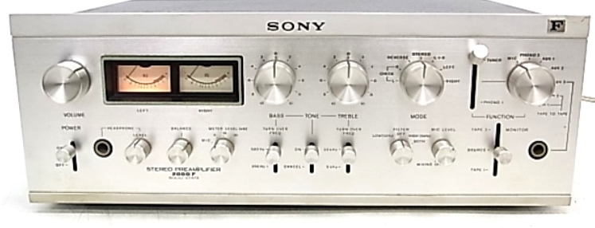
As audiophiles got deeper into the hobby, separates became the benchmark. Preamp for controls, power amp to deliver the power, each doing a single job, and doing it well. You weren’t serious until you had component boxes stacked like a high-rise condo, with cables thick enough to tow a car. My setup at the time? A Sony TA-2000 stereo preamp, three Sony stereo amps including the 3200F, a Sony SQD-2020 surround processor, tuner, turntable, reel-to-reel, and cassette deck. Safe to say, I was on Team Sony.
For a while, the integrated amp became an afterthought, something you sold to a friend who was just getting started. But as digital streaming took hold and the gear racks started shrinking, the tide began to turn.
Back When All You Needed Was a Receiver
In the early days of home audio, a good integrated amp or receiver did it all, tuner, phono stage, preamp, and enough power to bring bookshelf speakers to life. That was more than enough for most people. My first stereo was a Kenwood TK-50, an early transistor model. It didn’t have much power, but it made music, and that was enough.
What made those units memorable wasn’t just their function, it was their presence. They looked and felt substantial. Knobs had resistance. Switches had purpose. They were built to last, and many did.
You could walk into an audio store, buy a receiver, turntable, and speakers, and be set for years. No fuss, no confusion. Was it high-end? No. But it played music and did a good job at it.
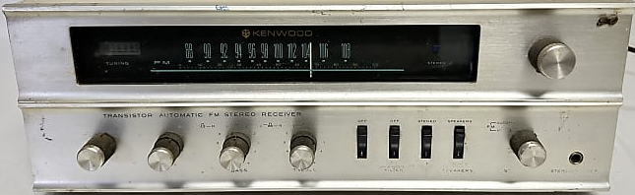
The Era of Separates
By the late ‘80s and through the ‘90s, the integrated amp started to fade. Audiophiles chased perfection, which meant isolating every function. Preamps got cleaner. Power amps got heavier. Cables got... well, excessive.
Magazines and forums pushed the idea that separates were superior. And often, they were. With the right synergy, separates could deliver more control, clarity, and authority. But that came with cost, complexity, and a lot of rack space.
Integrated amps stuck around, but they were now seen as entry-level high-end, something to outgrow.
The Streaming Age and the Minimalist Revival
Fast forward to now. Music has gone digital. Streaming is everywhere. Most listeners, even many enthusiasts, want fewer boxes, not more.
That shift opened the door for a new generation of integrated amps, and they’re not compromises. They’re complete solutions: DACs, wireless streaming, phono inputs, headphone stages, all in one chassis.
Manufacturers like Arcam, Hegel, Rega, Marantz, Cambridge Audio, and Luxman have all embraced the new integrated. Even Pass Labs and Naim are building one-box solutions that go toe-to-toe with separates.

Who’s Doing it Right Today?
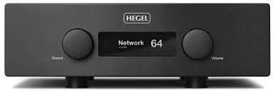
Hegel H390
- Released: 2019
- Original MSRP: $6,000
- Current Used Price: $3,500–$4,800
Nicknamed "Robin Hood" by Hegel, this unit borrows heavily from their $11,000 H590, offering high-end performance without the full flagship price tag
Hegel’s H190 and H390 are deceptively simple on the outside, but under the hood they’re high-current beasts. Known for their natural sound and iron-fisted control over loudspeakers, they combine musicality with modern practicality. Built-in streaming via AirPlay and UPnP doesn’t hurt either. These are the amps for people who want less gear, not less performance.
Rega Elicit MK5
- Released: 2022
- Original MSRP: $2,195
- Current Used Price: $1,500–$1,800
This British-built amp doesn’t chase specs. It focuses on the rhythm, timing, and emotional pull of the music. Best with vinyl, but digital shines too.
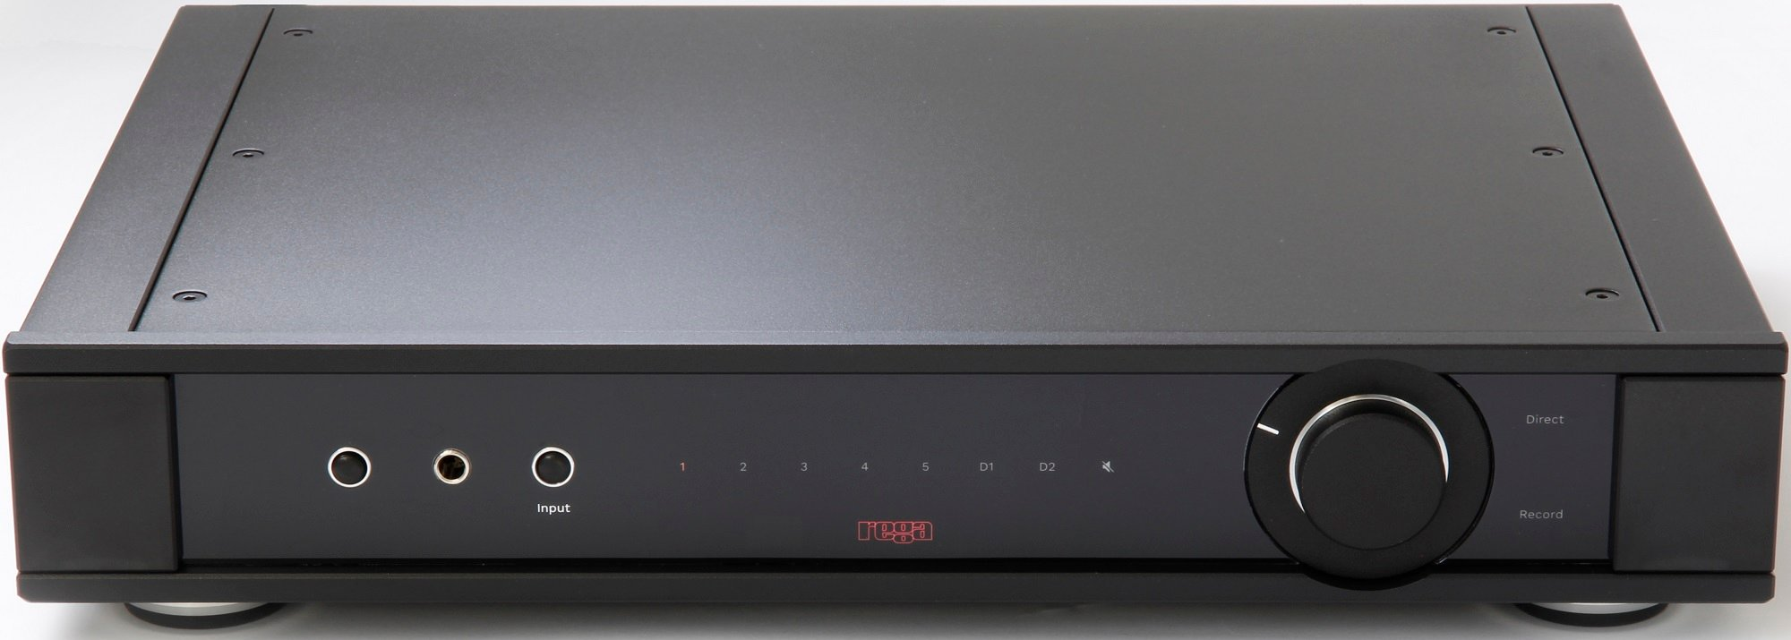
Rega’s Elicit MK5 is a reminder that analog still rules when done right. It doesn’t try to win you over with spec sheets, it wins with timing, rhythm, and emotional weight. There’s a sense of pace and coherence that makes it a joy with vinyl and digital alike.
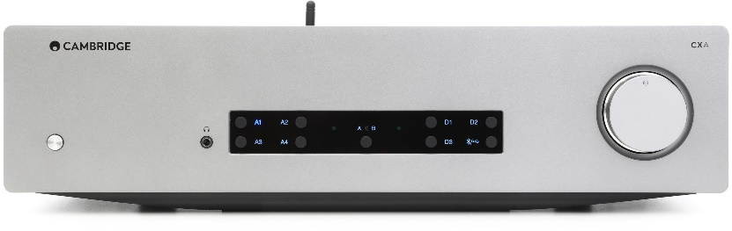
Cambridge Audio CXA81
- Released: 2019
- Original MSRP: $1,299
- Current Used Price: $600–$900
Fast, dynamic, and refined, the CXA81 is an easy entry point for serious two-channel listening. At its price, it punches well above its weight and is often found discounted, making it a great value today.
punches well above its price point. It’s fast, dynamic, and surprisingly refined. For those getting serious about two-channel listening without breaking the bank, it’s an easy recommendation.
Luxman L-505uXII
- Released: 2020
- Original MSRP: $4,495
- Current Used Price: $3,000–$3,800
Beautifully built, sonically warm, with old-school VU meters and modern internals. If you love tactile interfaces, this is your amp.
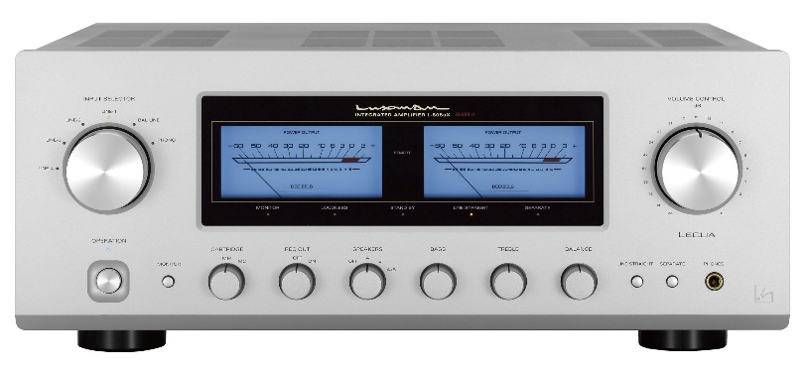
Luxman’s L-505uXII is where old-school charm meets modern precision. You get real analog meters, brushed aluminum, and that signature Luxman tone, smooth, balanced, and effortlessly musical. But under that retro exterior is a refined circuit layout, carefully shielded transformers, and a sound that stays relaxed without getting soft.
Pass Labs INT-25
- Released: 2020
- Original MSRP: $7,250
- Current Used Price: $5,000–$6,000
Pure Class A. 25 watts of sweetness for high-efficiency speakers. Built like a tank and sounds like warm honey.
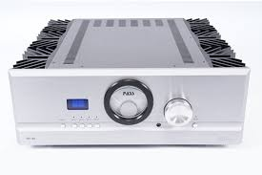
Pass Labs' INT-25 and INT-60 are in a different league altogether. These aren’t feature-packed, they’re performance-driven. No onboard DAC, no streaming module, just pure analog design, executed with the obsessive detail Nelson Pass is known for. The INT-25 is ideal for sensitive speakers, with a grain-free warmth and stunning inner detail. Pass Labs INT-60
- Released: 2015
- Original MSRP: $9,000
- Current Used Price: $6,000–$8,000
More power, more presence, and the same Class A voicing. A flagship-level performer that makes you forget you’re not using separates
The INT-60, with its higher power and deeper reserves, brings even greater authority. If you’re after that rich Class A magic without the usual pre/power stack, this is the real deal.
And that’s just the surface. Today’s integrated amps aren’t a compromise, they’re a choice. A very good one.
And these are just the tip of the iceberg.
These amps aren't “starter gear”, they’re what experienced listeners buy when they’re tired of fussing. They offer performance without the puzzle.
Why the Integrated Amp Still Matters
The rebirth of the integrated amp isn’t just about convenience. It’s about purpose.
A good integrated amp brings coherence to a system. It eliminates variables. You’re not chasing synergy between preamp and power amp. You’re not dealing with mismatched gain or wondering if your interconnects are coloring the sound. You’re just listening.
Arcam FMJ A49
- Released: 2014
- Original MSRP: $4,999
- Current Used Price: $2,000–$2,800
Class G operation with 50 watts in pure Class A before sliding into Class AB for peaks. Delivers clean power, stability, and muscle for hard-to-drive speakers.
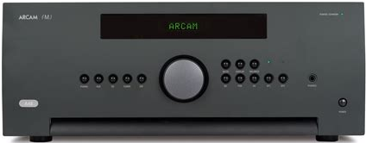
That’s what led me to the Arcam FMJ A49. My first concern was finding something that could drive my full-range electrostats, not just play them, but do them justice. That meant real current, amplifier stability, and the ability to handle a difficult load. The A49 fit the bill. It gives me 50 watts of Class A operation for pure, refined listening, and when needed, it opens up to 200 watts per channel in Class AB. If cost hadn’t been a factor, I probably would’ve gone with a big all-tube rig in the 150-to-200-watt range. That would’ve made me supremely happy, but probably not my wife.
What to Look for in a Modern Integrated Amp
If you’re in the market for an integrated amp today, you’ll find more options than ever, but not all of them are built to the same standard. Here’s what to keep in mind:
1. Solid Power Supply
Look for toroidal transformers and high-current output. Clean power makes a noticeable difference in dynamics and noise floor.
2. Built-in DAC (if you need one)
Not all digital sections are created equal. A good internal DAC based on ESS Sabre, AKM, or Burr-Brown chips can rival standalone units.
3. Streaming Support
Whether it’s AirPlay, Chromecast, Roon Ready, or UPnP, having native streaming on board can simplify your setup and reduce cable clutter.
4. Phono Stage (MM/MC)
If you spin vinyl, make sure the amp includes a phono input. Some even offer moving coil support, which saves you from needing a separate phono preamp.
5. Headphone Amp Quality
Some Integrateds toss in a headphone jack as an afterthought. Others treat it like a serious listening option. Check output specs and impedance matching.
6. Amplifier Class and Bias
Class A sounds rich and full, but it runs hot and draws more power. Class AB is more efficient. Some, like Arcam’s Class G, use sliding bias for the best of both worlds.
7. Remote and App Control
Many new amps offer app-based control or smart remotes. If your gear lives across the room, that convenience matters more than you think.
8. Aesthetics and Ergonomics
Don’t underestimate the feel of the knobs, the readability of the display, or the look of the chassis. You’ll be living with this gear, it should feel right.
An integrated amp today isn’t just a starting point. It can be the centerpiece of a serious system, if you know what to look for.
Know Your Budget and Priorities
Integrated amps range from just a few hundred dollars to several thousand. Entry-level models often focus on core features like power and connectivity, while higher-end units may offer better DACs, more refined circuits, or pure Class A operation. Decide what matters most to you, sound quality, streaming convenience, phono stage, brand reputation, and let your budget guide you toward the right mix.
Final Thoughts
In a world increasingly filled with digital noise, the simplicity of a well-designed integrated amp feels refreshing. One box. One mission. No distractions. And maybe that’s the point.
Audio doesn’t always need to be complicated. Sometimes the best system is the one that lets you forget about the gear altogether, and just enjoy the music.

