The Nicaragua Canal That Almost Was
By Marc Silver

For much of the late nineteenth century, the most important canal decision in the world was not Panama.
It was Nicaragua.
Before Panama became inevitable, serious engineering commissions, U.S. senators, naval planners, and financiers spent years weighing an alternative route that appeared cleaner, shorter, and far more cooperative. Instead of carving a canal entirely from scratch, ships would follow waterways that already existed.
The proposed route worked like this.
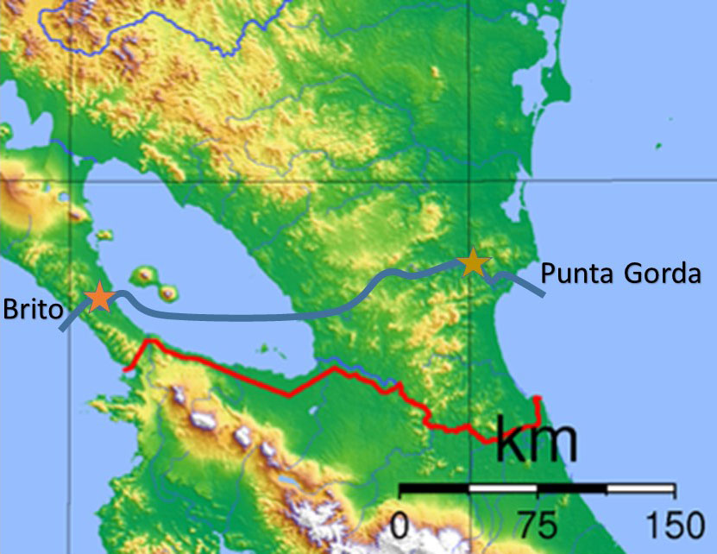
Ships from the Caribbean would enter the San Juan River, follow it inland, cross Lake Nicaragua, then cut a relatively short canal, roughly twelve to fifteen miles, across the Rivas Isthmus to the Pacific.
On paper, it looked almost elegant.
More than half the route was already water. Lake Nicaragua could serve as a massive natural reservoir. The Pacific cut was shorter than Panama’s. Early estimates suggested fewer locks and less excavation. Compared to Panama’s mountains and jungles, Nicaragua looked restrained.
On a map, Nicaragua made sense.
That turned out to be the problem.

The River That Refused to Cooperate
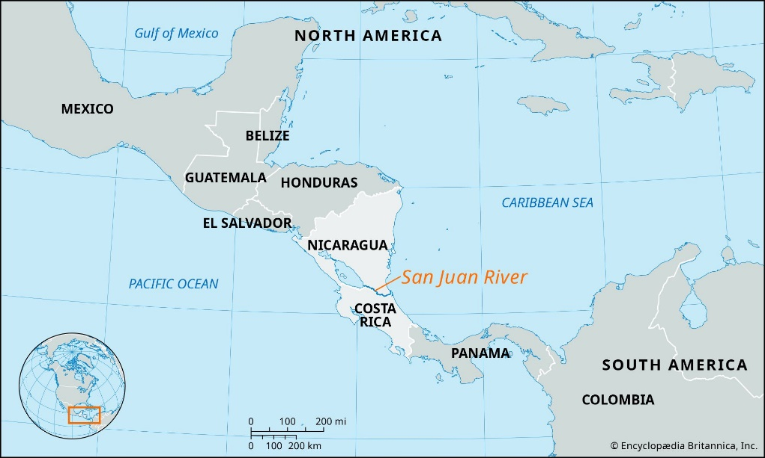
The San Juan River appears cooperative when traced with a pencil. In practice, it resisted almost every assumption canal planners made.
Engineering surveys conducted in the 1890s, later summarized by the U.S. Walker Commission, found the river shallow in long stretches, split into multiple shifting channels in others, and constantly burdened by sediment washed down from the interior. Tropical rainfall moved enormous amounts of silt every year, reshaping the river faster than dredging could stabilize it.
Seasonal behavior compounded the problem. During dry months, water levels dropped below navigable depth. During the wet season, the river became violent, eroding banks and altering channels.
Engineers eventually concluded they would not be adapting a river for shipping. They would be reconstructing it entirely, with dams, locks, spillways, and artificial channels designed to force stability onto a system that naturally resisted it.
Once that realization set in, the Nicaragua route lost much of its apparent simplicity.

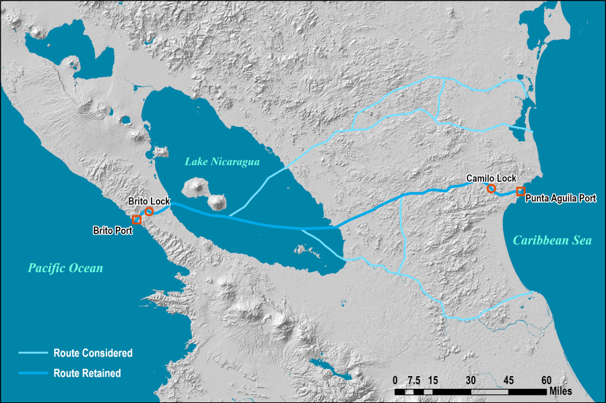
Lake Nicaragua Was Both Asset and Liability
Lake Nicaragua was the centerpiece of the proposal and its most serious liability.
The lake is vast, over 3,000 square miles, which made it attractive as a transit basin. But it is also shallow, averaging roughly forty-five feet deep. Even by early twentieth-century standards, this required extensive dredging to accommodate large commercial vessels.
Dredging a lake of that size introduced a different problem: sediment management. Unlike a confined canal cut, disturbed lake sediment spreads. It clouds water, alters ecosystems, and does not conveniently return to place.
Even at the time, engineers and public health officials raised concerns about water contamination. Lake Nicaragua was the country’s primary freshwater source. A canal would introduce saltwater intrusion, fuel spills, invasive species, and waste discharge directly into that reserve.
By modern environmental standards, the risk would be prohibitive. What is often overlooked is that the risk was recognized, if not fully quantified, even then.

Volcanoes, Perception, and Politics
From a geological standpoint, neither Nicaragua nor Panama offered a “safe” route.
Nicaragua had volcanoes. Panama sat on seismic fault lines. Both regions faced landslides, flooding, and earthquakes.
What differed was perception.
During U.S. Senate debates over canal routes, proponents of Panama quietly emphasized Nicaragua’s volcanic landscape. One of the most effective tools was political theater rather than technical argument. Senators were circulated Nicaraguan postage stamps depicting the volcano Momotombo erupting above Lake Nicaragua, an image that suggested instability even where none directly threatened the canal route.
This lobbying effort is commonly attributed to Philippe Bunau-Varilla, whose influence in Washington extended far beyond engineering.
The image stuck.

The Orizaba Incident
In 1902, the steamship SS Orizaba docked at Corinto on Nicaragua’s Pacific coast. While the ship was in port, Momotombo erupted.
It was not a catastrophic eruption. No infrastructure was damaged. But ash and smoke were clearly visible, and passengers witnessed it firsthand. Newspapers reported the event.
The timing was disastrous.
At the precise moment U.S. senators were being asked to choose between two canal routes, Nicaragua became visually and emotionally associated with volcanic activity. It did not matter that the proposed canal lay miles from active volcanoes. It did not matter that Panama had its own geological hazards.
The image was enough.
A modern steamship. A smoking volcano. A story that required no explanation.
From that point forward, Nicaragua was no longer the elegant alternative. It was the risky one.
Large infrastructure projects are approved not only by engineers, but by financiers, insurers, and politicians. Those groups respond less to technical nuance than to uncertainty. Volcanoes, even distant ones, symbolize uncertainty in a way spreadsheets never can.

Panama’s Advantage Was Not Geography
By the early 1900s, the United States was already financially and strategically committed to Panama.
The French canal effort had failed, but it left behind excavations, railroads, machinery, and a partially carved corridor. The U.S. government could purchase those assets and finish a project already underway.
By contrast, Nicaragua remained theoretical.
Cost estimates reflected that difference. Contemporary projections placed the Nicaragua Canal at comparable or higher cost than Panama once river reconstruction, lake dredging, and lock systems were fully accounted for. Panama could be bought at a discount. Nicaragua would have to be built.
When the United States supported Panama’s independence from Colombia, the decision became irreversible. The canal ceased to be a purely engineering question. It became a geopolitical commitment.

The Irony of Scale
There is a quiet irony in how this decision aged.
In 1902, ships were smaller, drafts were shallower, and global trade volumes were modest. Panama’s lock dimensions were sufficient.
Modern container ships resemble what Nicaragua’s designers imagined more closely than what Panama ultimately built. Large transit basins, extensive lock systems, and high-volume throughput were baked into the Nicaragua concept from the start. Panama had to retrofit itself a century later to accommodate ships that its original designers never anticipated.
History did not choose the canal best suited for the future. It chose the canal best suited for the moment.

Why the Idea Keeps Returning
The Nicaragua Canal has resurfaced repeatedly, most recently in the 2010s with a Chinese-backed proposal. That effort collapsed under financing challenges, environmental opposition, and political instability.
The reasons were familiar.
The environmental risks remained unresolved. The cost estimates escalated. Investor confidence wavered. Nicaragua still had to build everything. Panama still existed.
The idea persists because the map has not changed. The constraints have.

What This Story Actually Tells Us
Nicaragua did not lose because its canal concept was foolish. Engineers took it seriously. Governments debated it earnestly.
It lost because infrastructure decisions are not made by logic alone. They are shaped by timing, perception, sunk costs, and narratives that feel reassuring in the moment.
Panama offered something tangible. Nicaragua offered something theoretical.
History chose the thing it could see.
And once that choice was made, there was no going back.
Sources and Further Reading
McCullough, David. The Path Between the Seas: The Creation of the Panama Canal, 1870–1914. New York: Simon & Schuster, 1977.
Still the definitive narrative history of the canal decision. McCullough covers the Nicaragua–Panama debate in detail, including Senate politics, French assets, and Bunau-Varilla’s lobbying efforts.
Walker Commission. Report of the Isthmian Canal Commission to the Secretary of War. Washington, D.C., 1901–1902.
Primary engineering and policy source evaluating both Nicaragua and Panama routes. Contains assessments of the San Juan River, Lake Nicaragua, lock requirements, and cost comparisons.
Philippe Bunau-Varilla. Panama: The Creation, Destruction, and Resurrection of a Republic. New York: McBride, Nast & Company, 1914.
Firsthand account by the most influential political advocate for the Panama route. Essential for understanding how perception and lobbying shaped the final decision.
Greene, Julie. The Canal Builders: Making America’s Empire at the Panama Canal. New York: Penguin Press, 2009.
Explores the geopolitical and labor dimensions of the canal decision, including why Panama was strategically attractive to the United States.
Connell, William F. “The Nicaragua Canal Project.” Journal of Interamerican Studies and World Affairs 12, no. 2 (1970): 257–272.
Scholarly overview of the Nicaragua canal proposals, including environmental and engineering challenges often glossed over in popular accounts.
U.S. Army Corps of Engineers. Historical Overview of Interoceanic Canal Studies. Washington, D.C., various editions.
Technical background on lock design, dredging requirements, and hydrological challenges relevant to both routes.
Meyer, Michael. The Panama Canal. New York: Oxford University Press, 2009.
Concise modern synthesis that places the original canal decision in long-term context, including later expansions and capacity limits.

Optional Editor’s Note (if needed)
Primary engineering assessments and Senate deliberations are drawn from Walker Commission reports and contemporaneous U.S. congressional records. Environmental impacts are interpreted through modern scholarship in hydrology and canal engineering, applied retrospectively to historical proposals.

