The Most Legendary Audio Demonstrations in History
By Marc Silver
Some demonstrations introduce equipment, others introduce ideas. And once in a long while, a demonstration becomes something closer to folklore, retold in showrooms, workshop benches, and late nights in audio shops long after the gear itself has gone out of production. The best of these moments never relied on technical jargon or spec sheets. They relied on perception, surprise, psychology, and theater.
Across decades of hi-fi history, certain demonstrations didn’t just show what was possible. They redefined it. These are the stories that survived, the ones people still tell.

The Acoustic Research Orchestra Switcheroo
In the late 1950s and early 1960s, when hi-fi was still finding its place in living rooms and laboratories alike, Acoustic Research had something rare. Edgar Villchur understood the public didn’t care about acoustic suspension theory or cabinet damping calculations. They cared about whether something sounded real.
AR staged one of the most famous demonstrations in audio history, the live-versus-recorded concerts. An orchestra played onstage with a pair of AR loudspeakers tucked quietly among the musicians. A piece would begin with the performers playing live. Then, mid-phrase, players quietly set down their instruments and stepped offstage as the AR system took over.
The audience didn’t notice.
Not noticing was the point.
When the house lights rose and the empty stage showed only the speakers, debates broke out. Some attendees insisted the musicians must have crouched behind chairs. Others accused AR of trick lighting. Villchur didn’t argue. He simply watched the room absorb the implication: a loudspeaker could be convincing enough to undo your assumptions.
The AR concerts didn’t just win customers. They changed the collective belief about what a relatively small speaker could accomplish.

OPTIONAL SIDEBAR: Why the AR Demo Worked
- Controlled acoustic environment in Carnegie Recital Hall
- Speakers voiced to mimic live timbre
- Smooth, level-matched handoff between orchestra and playback
- Audience preconditioned to trust what they thought they heard

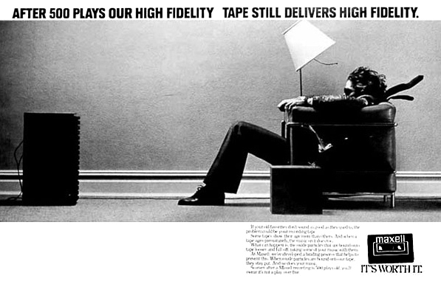
Maxell’s “Blown Away” Demonstrations Come to Life
A generation later, hi-fi advertising shifted from cutaway diagrams to cinematic imagery. Maxell set the standard with the now-iconic ad of a man blasted backward in his chair by sound. Few knew that Maxell and several enthusiastic dealers brought that concept to life at trade shows and special events.
The staging was simple, almost primitive. You sat in a chair facing a wall of loudspeakers tall enough to raise mild questions about structural integrity. The host cued up an orchestral passage or a track with serious low-frequency impact.
The first notes didn’t just hit you.
They entered you.
Hair moved. Clothing rippled. Drinks jittered their way across tables. This wasn’t about imaging or midrange texture. It was about the physicality of sound, a reminder that bass isn’t merely heard, it's experienced in the body.
The effect wasn’t subtle. But once you felt it, you never forgot it. Maxell’s brand became synonymous not with tape, but with intensity.

Advent’s Blind A/B Challenge
While other companies built their reputations on spectacle, Henry Kloss trusted the listener’s ears. In the early 1970s, Advent was challenging speakers priced two and three times higher. Kloss didn’t explain the value proposition. He demonstrated it.
Advent set up blind comparison rooms with a simple switch box that alternated between their speakers and premium competitors. No labels. No visual cues. Just sound.
People were surprised. Some were unsettled. Many preferred the Advents.
In an era before forums, measurement databases, or YouTube reviewers, these A/B sessions carried weight. They shifted perceptions of value and proved that high fidelity didn’t require high financing. Kloss used engineering and restraint to dismantle pricing assumptions, one listener at a time.

Bang & Olufsen’s Real-World Torture Tests
Bang & Olufsen spent much of the 1970s and 80s fighting a persistent myth: beautiful equipment must be delicate. Anyone who sold the gear knew that wasn’t true, but telling people wouldn’t cut it. Showing them would.
The Bounce Test
In my shop, the B&O bounce test became legend and I and all my salespeople loved this demonstration. I would cue up a record on a B&O turntable, let the music settle into its groove, then slightly bounce it with my fingertips. Not a gentle nudge. A firm, visible bounce. Like I was bouncing a ball, but with the turntable.
The suspension, tonearm, platter, and chassis, absorbed the shock. The record kept playing as though nothing was wrong. No wow, no rattle, no skip. Customers who had spent years stepping gingerly around their turntables stared in disbelief.
The Scratch Test
Once the room was fully awake, I’d move to the stylus. While the record spun, I would grab the tonearm and drag back and fourth across the vinyl surface. Audible gasps. A few hands shot out, trying to stop me. But B&O’s cartridge design allowed the stylus to ride the groove without gouging it.
No stylus damage. No vinyl scar. Just a room relieved and slightly shaken.
Those demonstrations made a simple point: elegance and durability weren’t mutually exclusive. And B&O’s engineering didn’t just look good. It survived abuse most turntables never would.

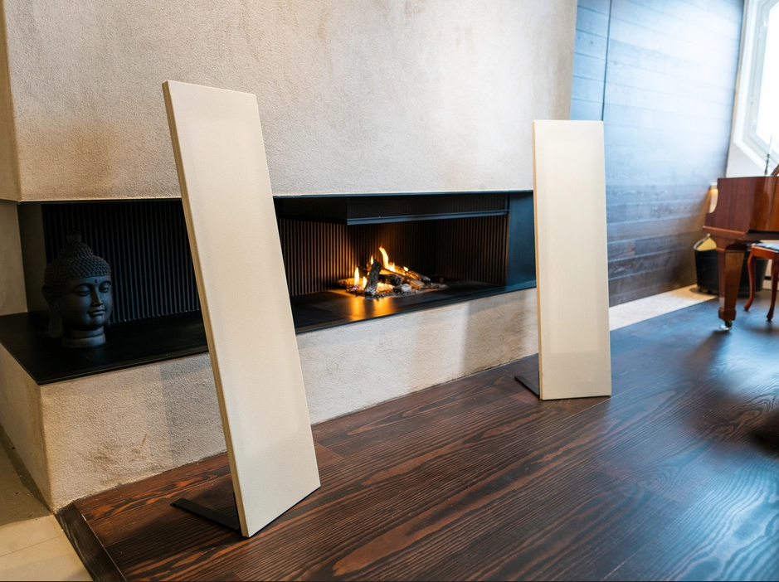
Magnepan’s Curtain Surprise
Magnepan has always had a gift for illusion, and one particular demo is still repeated decades later. I remember attending CES some 30 odd years ago and the company borrowed the famous Bose curtain trick when unveiling its smallest planar panel. A sheer scrim hid the speaker. The sound behind the curtain had the familiar openness and scale of Magnepan’s towering full-range panels. The room was convinced it was listening to something six feet tall.
When the curtain was pulled aside there it was: an eighteen-inch-tall panel, barely the size of a cafeteria tray.
The room froze.
People laughed.
Some walked forward, convinced there had to be another speaker hiding somewhere.
It wasn’t a trick. It was a reminder that great sound could dismantle assumptions before it dismantled budgets. This was a great demo that I remember from some 30+ years ago. I don’t believe Magnepan ever released this proto-type as they already had a remarkably good model SMG at $600/pr and Wendle explained the smaller speaker would not be significantly cheaper. But he wanted to demonstrate the concept. Today they have the updated version called the LRS+ at around $1000/pr.

When It Backfired: Magnepan at CES
Even legends misfire. At a CES in the late 1980s, a grounding fault caused a startling electrical pop during a demo. Fortunately the panels survived, but the audience’s collective heart rate got nearly as large a shock. Wendle shrugged it off and continued the show. Even failures become part of the lore.

Martin Logan’s Delayed Debut
[This is where the verified Martin Logan CES story will appear once I have confirmation from Gayle Sanders.]

Klipsch and the Parking-Lot Test
Paul W. Klipsch loved drama almost as much as he loved horns. He once set up a single speaker in a parking lot and aimed it at a warehouse wall 100 yards away. The reflected sound returned startlingly loud and clean.
When someone accused him of hiding additional speakers, Klipsch handed him a small yellow button with one word printed boldly:
“Bullshit.”
That button became an audio icon of its own.

Early -1960s
Paul W. Klipsch grows increasingly frustrated with what he saw as exaggerated claims in the loudspeaker industry. Internally, he begins using the term “Bullshit” in engineering meetings and correspondence. This is the period when the famous stamp appears on memos and test sheets inside the Hope, Arkansas lab.
Mid-1960s
The idea evolves into an actual button. Former employees and longtime dealers remember seeing the first yellow buttons circulating among insiders sometime around 1966–1967. They weren’t a formal marketing item, more of an inside joke that carried PWK’s personal touch.
Late 1960s
By 1968, when I began selling Klipsch speakers, both the button and the story were already in circulation. That means the parking-lot test, or at least the earliest retellings of it, must have originated earlier than that. Dealers didn’t get those buttons casually unless PWK was already using them publicly to punctuate his demonstrations and commentary.
Given that, the tightest and most historically coherent window for the parking-lot test is:
Circa 1965–1968
Mono demos were still common, Klipsch was actively touring and promoting the Klipschorn’s capabilities, and he was known for eye-catching demonstrations that made technical points in blunt, memorable ways. A single horn speaker projected across a parking lot and reflecting off a warehouse wall fits perfectly with his personality and his engineering style during this exact period.

Linn’s Bath-Towel Turntable Trick
Ivor Tiefenbrun, founder of Linn, believed in mechanical isolation. To prove it, he placed an LP12 on a bath towel, set a record spinning, and then jumped up and down on nearby furniture.
The LP12 floated serenely through the chaos. The music played without a skip, reinforcing the idea that a well-designed suspension could reject external energy better than any mass-loaded platform. Customers eventually learned their own floors weren’t quite as forgiving, but the demo made its point.

Quad ESL: Angels, Transparency, and the Arc
When Peter Walker demonstrated the original Quad ESL, listeners described the experience in almost spiritual terms. Increasing volume during a string quartet didn’t thicken the sound, it made it dissolve into the room, as if the panel were breathing music rather than reproducing it.
Electrostatics, though, live at the edge of physics. At a particularly humid demonstration, a blue arc snapped across the panel. The audience jumped. Walker, calm as always, wheeled out a second speaker and continued as if nothing unusual had happened.
The moment revealed both the beauty and fragility of the ESL, a balance that still defines electrostatics today.

SIDEBAR: What Made the Quad ESL Special
- Extremely low moving mass
- Full-range electrostatic diaphragm
- Midrange transparency unmatched in its era
- Sensitivity to humidity and excessive volume

The JBL Paragon Reveal
The JBL Paragon remains one of the most recognizable pieces of acoustic furniture ever built. At trade shows, JBL often kept the sculpted behemoth under a cloth. They filled the room with a soundstage so wide that listeners assumed they were hearing a pair of spaced, full-range towers.
When the cover came off and they saw a single cabinet using curved reflections to create stereo spread, reactions ranged from disbelief to admiration. The Paragon was polarizing. But nobody forgot it.

KEF’s Blind Box Mystery
In the 1970s, KEF staged blind tests with a prototype hidden behind a curtain and a competing speaker in full view. Listeners, stripped of visual bias, frequently preferred the hidden KEF.
At one show, the curtain unexpectedly collapsed mid-demo, eliciting laughter rather than insight. KEF spent the rest of the afternoon explaining driver design instead of proving it.

The Telarc 1812 Overture: The Woofer Ejector
Few recordings have caused as much collateral damage as the Telarc digital 1812 Overture. The cannons were captured with unapologetic realism. On systems without adequate headroom, the result was catastrophic.
At one Chicago shop, the opening cannon blast launched both woofers out of their enclosures. Customers screamed, then burst into laughter. Telarc sold more discs. The dealer bought sturdier speakers. Everyone left with a story.

Sennheiser Orpheus: The “Is It Still On?” Test
The original Sennheiser Orpheus was so transparent that listeners often reached up mid-track to confirm it was still on their head. In the right room, the sound didn’t feel like it came from headphones. It felt like it formed directly inside the listener’s mind.
At a Munich demo, a noisy HVAC vent broke the illusion entirely. Even the Orpheus couldn’t outperform bad acoustics.

Sony’s CD Demonstrations: Triumph and Stall
Sony introduced the compact disc with a theatrically rugged demo: shaking a prototype CD player while it continued playing without a skip. It was a physical metaphor for digital reliability.
At a different event, the prototype froze mid-track in front of journalists. Revolutions rarely unfold without stumbles.

Wilson Audio WATT/Puppy: The Giant-Killer
In the 1980s, hotel-room demos of Wilson Audio’s WATT/Puppy system created a recurring illusion. Listeners walked in assuming concealed floorstanders were responsible for the scale of the presentation. When they finally saw the petite monitors and compact Puppy modules, disbelief was the dominant reaction.
In well-set-up rooms, the pairing punched far above its size. In poor rooms, even Wilson couldn’t save the acoustics.

Altec A7: Loud Enough to Alter Architecture
The Altec Voice of the Theatre A7 was designed to fill cinemas with articulate power. At one demonstration, someone pushed the system hard enough that plaster fell from the ceiling.
Half the room cheered.
The venue manager did not.

The Electrified Tonearm Incident
Not all demos are aspirational. In the 1950s, a dealer wired a tonearm incorrectly. When a customer touched it, he received a shock. The story traveled quickly, and the dealer exited the business shortly after. Some demonstrations teach possibility. Others teach danger.

Pink Floyd’s Azimuth Coordinator: Surround Before Surround
Pink Floyd didn’t demo equipment. They demoed the future. In the early 1970s, their concerts used a joystick-controlled quadraphonic system designed by Bernard Speight. The Azimuth Coordinator allowed sounds to move fluidly around the audience in a 360-degree field.
It wasn’t stereo. It wasn’t even consumer quad. It was early immersive audio before the tools existed to describe it. The idea would influence everything from home surround sound to today’s spatial formats.

SIGSALY: The Secret Origin of Digital Audio
When SIGSALY was declassified in 1976, historians heard demonstrations of a system decades ahead of its time. Built during World War II to secure conversations between Roosevelt and Churchill, SIGSALY used early digital sampling and noise-masking techniques long before PCM entered consumer vocabulary.
It didn’t need theatrics. It simply rewrote history.

Dolby Atmos: Redefining the Room
Dolby’s Atmos debut in 2012 showed that sound no longer needed to exist only around you, it could exist above you. Using object-based mixing instead of channels, Atmos created a three-dimensional field that expanded the imagination.
During the famous Brave demo, an arrow flew from behind the room, passed overhead, and struck the screen. The audience gasped. The experience made surround sound feel suddenly outdated.
Atmos didn’t just refine the room. It reinvented it.

Why These Demonstrations Endure
The thread running through these stories is simple: a great demonstration bypasses logic and touches emotion. For an instant, the equipment disappears, and the listener suspends disbelief. It becomes pure experience.
Even the failures endure. They remind us how fragile the illusion can be, how easily real-world variables can intrude on perfection. Audio is built on physics and engineering, but the experience is built on moments, moments that shift expectations, challenge assumptions, and change what people believe is possible.

The Demonstration That Never Ends
Every legendary demo recognizes one truth: you can measure distortion, phase, group delay, and impulse response, but you cannot measure the instant when a listener realizes the system has vanished and only the music remains.
That moment is why these stories endure.
It’s why we keep telling them.
And it’s why the next legendary demonstration is already out there, waiting for its audience.

