THE HISTORY OF NUMBERS
Presented By Marc Silver

Introduction: The Greatest Misnomer in Math
Let’s start with a pop quiz: What do the numbers 0, 1, 2, 3, 4, 5, 6, 7, 8, and 9 have in common? If you said, “They’re Arabic numerals!”, well, you’re technically right… but also dead wrong.
Here’s the thing: These digits weren’t invented by Arabs. They weren’t even perfected by Arabs. They’re Indian numerals, revolutionary symbols born in ancient South Asia, complete with the game-changing concept of zero.
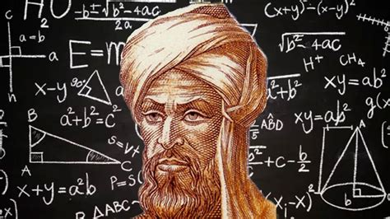
So why do we call them “Arabic numerals”? Because of a 1,200-year-old case of mistaken identity, a Persian math whiz named al-Khwarizmi, and a European habit of lumping entire cultures together.
This isn’t just a story of numbers. It’s a tale of globalization, intellectual theft, and how a single innovation, zero, changed everything from how we buy groceries to how we land rockets on Mars.
So, Buckle up.
Figure 1 al-Khwarizmi

Before Numbers Got Cool
(Or: Why Ancient Accounting Sucked)
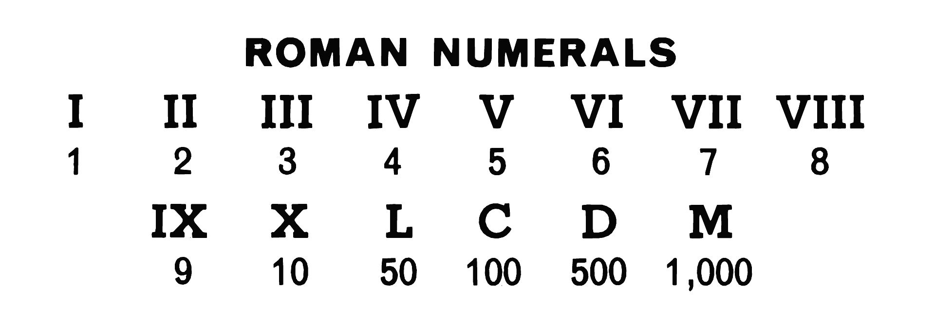
Imagine you’re a Roman merchant in 50 BCE. Your client wants to buy 57 amphorae of wine, multiplied by 4 dinarii per jar. How do you calculate 57 x 4 without losing your mind?
Figure 2 Roman Numerals
You’d probably grab a counting board (like an abacus) and push beads around, because Roman numerals, I, V, X, L, C, D, M, were terrible for math. Let’s break it down:
57 in Roman numerals = LVII (L = 50, V = 5, II = 2).
4 = IV.
To multiply LVII by IV? Good luck. You’d need to convert everything to mental tally marks or use that clunky abacus.
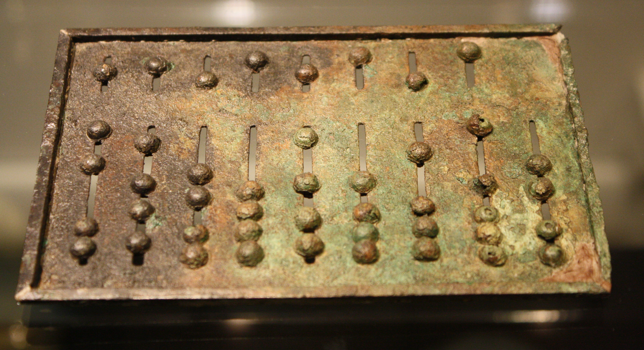
Figure 3 Ancient Roman Abacus
But wait, let’s make this personal. Try adding XLVIII (48) + XXVII (27) in Roman numerals:
Write them out: XLVIII + XXVII.
Combine the symbols: X L V I I I + X X V I I.
Now simplify:
X (10) + X (10) = XX (20)
L (50) stays.
V (5) + V (5) = X (10)
I (1) x 5 = V (5)
Total: XX (20) + L (50) + X (10) + V (5) = LXXXV (85).
In Arabic numerals? 48 + 27 = 75 (and yes, the Roman answer is wrong, they’d have needed to adjust for subtractive notation like XL = 40). This is why Roman tax collectors hated their jobs.
These systems shared three fatal flaws:
No zero.
How do you write “205” if you can’t show the absence of tens?
In Roman numerals: 100 + 100 = C + C = CC. Add 5 (V), and you get CCV.
No positional value.
In Roman math, “V” always means 5—whether it’s in VIII (8) or XV (15).
Arithmetic was a chore. Multiplication? Division?
Grab a coffee. This’ll take a while.
Then came India.
India’s Big Brain Moment (Or: Why Zero Is the Ultimate Hero)
Bakhshali Manuscript Additions:
UNESCO’s 2017 recognition as intellectual heritage.
Fixed equation formatting:
√2 ≈ 1.41421
​≈1+2+2+2+…1​1​1​(≈1.41421)
Clarified the manuscript’s role in tracking debts and calculating profits.
Around the 5th century CE, Indian mathematicians did something wild: They turned nothing into something.
Step 1: The Prototype Numbers
Early Indian numerals, called Brahmi digits (circa 300 BCE), looked like squiggly cousins of today’s numbers. By the Gupta Empire (think “Golden Age of India”), these evolved into symbols we’d recognize:
1 was a horizontal line.
9 resembled a modern “9” but with a hat.
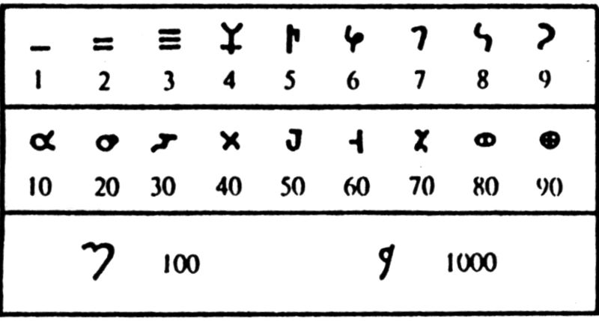
Each digit (1-9) was distinct, no more additive nonsense like VII = 5 + 1 + 1.
Step 2: The Invention of Zero
Here’s where things get genius. Indian thinkers didn’t just use zero as a placeholder (like the Babylonians’ awkward space between numbers). They made zero a number, with rights!
Meet Brahmagupta, the rockstar mathematician of 628 CE. In his textbook Brahmasphutasiddhanta (try saying that three times fast), he laid down the law:
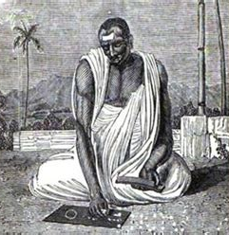
Zero plus a number? That’s the number. (a + 0 = a)
Figure 4 Brahmagupta: Inventor of Zero
Zero times a number? Zero. (a x 0 = 0)
Dividing by zero? Uh… let’s not go there. (He tried, but even geniuses have limits.)
But India’s math revolution wasn’t just Brahmagupta.
Centuries earlier, the Bakhshali Manuscript (3rd–4th century CE), a birch-bark text found in modern Pakistan, showed a dot representing zero in equations like:
2 = 1 + 1
This wasn’t just theory. Indian astronomers used zero to calculate planetary orbits, while merchants tracked debts with negative numbers (yes, India invented those too).
With zero, positional notation was born. Suddenly, “3” could mean 3, 30, or 300, depending on where you put it. Multiply 57 x 4? Easy:
Write 57 as 5 and 7.
Multiply 5 x 4 = 20 (that’s the tens place).
Multiply 7 x 4 = 28 (units place).
Add them up: 20 + 28 = 228.
No abacus. No tears. Just clean, efficient math.
But before Brahmagupta formalized zero, another Indian text was quietly scribbling its own revolutionary marks. The Bakhshali Manuscript, less known but deeply significant, shows us that the story of zero didn’t start with one man, it evolved through generations.
The Bakhshali Manuscript, Zero’s First Draft
Before Brahmagupta’s zero, there was the Bakhshali Manuscript, a fragile birch-bark text found in 1881 near Peshawar (modern Pakistan). Carbon-dated controversially between the 3rd and 12th centuries, it’s the oldest record of a zero symbol: a fat dot.
Advanced arithmetic: Square roots and rules for negative numbers (yes, India invented those too). One equation approximates √2 as 1.41421, accurate to five decimal places.
Why does this matter?
The Bakhshali zero wasn’t just a placeholder. It acted like a number in equations:
Example: 102−10=90(written as “1 0” squared minus “1 0” equals “9 0”)Example: 102−10=90(written as “1 0” squared minus “1 0” equals “9 0”)
This “dot” evolved into the open circle we know today. UNESCO recognized the manuscript in 2017 as a pivotal piece of humanity’s intellectual heritage.
How Persia Hijacked the Credit (Thanks, al-Khwarizmi!)
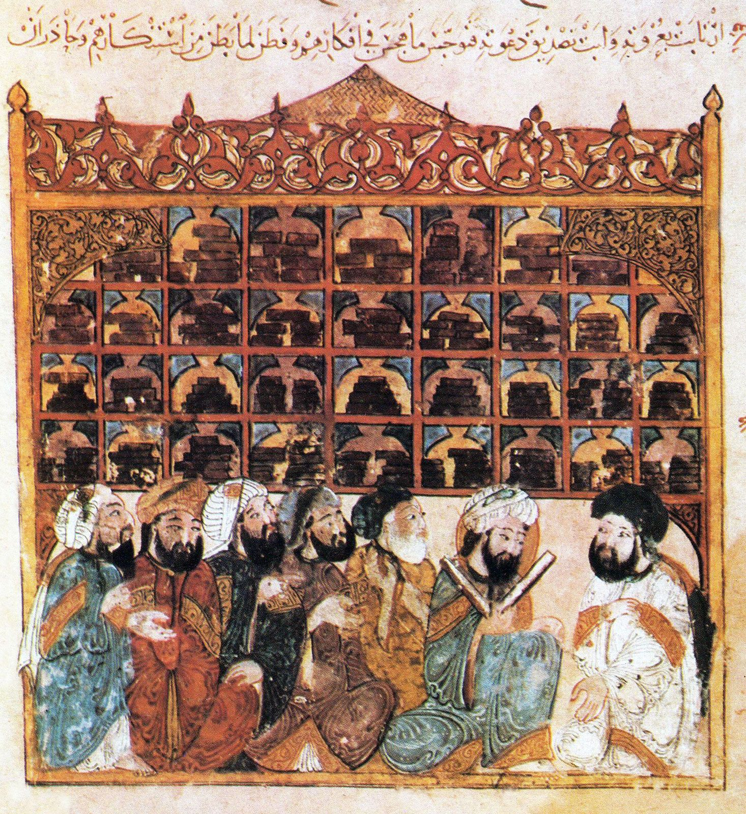
So how did India’s numbers become “Arabic”? Enter Muhammad ibn Musa al-Khwarizmi, a Persian scholar with a name so iconic, it gave us the word algorithm.
The House of Wisdom: Medieval Silicon Valley
Figure 6 The House of Wisdom Bagdad
In 8th-century Baghdad, the Abbasid Caliphate was having a “Let’s collect all human knowledge” moment. At the House of Wisdom, scholars translated Greek, Indian, and Chinese texts into Arabic. Among them was al-Khwarizmi, who stumbled upon Indian math texts and had a lightbulb moment.
In his 820 CE bestseller On the Calculation with Hindu Numerals, he wrote:
“The Hindus have a method of calculation that’s more efficient than anything Europe had seen. They use nine symbols and this little dot called ‘sifr’ (zero). Trust me, guys, this is the future.”
He wasn’t wrong. Al-Khwarizmi’s work spread across the Islamic world, and the numbers morphed into two flavors:
Eastern Arabic numerals (used in Persia and the Middle East): Curvy and ornate, like ٤ for 4.
Western Arabic numerals (via North Africa): Angular and practical, evolving into our 0-9.
But here’s the kicker: When Europeans encountered these numbers in the 12th century, they couldn’t tell Persians from Arabs. So they slapped on the label “Arabic numerals”, and the name stuck.

Europe’s Math Drama (Or: Why People Hated New Numbers)
Europe’s adoption of Indian numerals was… messy.
Phase 1: Suspicion and Boycotts
In 1348, a Venetian merchant was caught altering a debt from “10 ducats” to “70” by adding a squiggle to the zero. This paranoia wasn’t unfounded—without standardized symbols, a “0” could easily morph into a 6 or 9.
Medieval Europeans were like, “Why fix what isn’t broken?” (Spoiler: It was broken.)
Religious bias: Clerics called the numerals “devilish” because Arabs used them.
Fraud fears: A “0” could easily be turned into a 6 or 9 with a quick pen stroke.
Florence’s 1299 ban: Italian bankers were forbidden from using Arabic numerals in ledgers. Stick to Roman numerals or face fines!
The Paperwork Rebellion:
By 1445, German scribe Adam Ries had enough of Roman numeral chaos. He published *Calculation on Lines and Quills*—a math textbook in everyday German (scandalous!). He mocked traditionalists: *“If you think Roman numerals are better, try dividing MCMXLIV by XXIII. I’ll wait.”
His book became a medieval bestseller, and Germans still say *“Das macht nach Adam Ries…”* (“That’s according to Adam Ries…”) when double-checking math.
Enter Leonardo Fibonacci, an Italian kid who grew up in Algeria. He learned numerals from Muslim traders.
Liber Abaci: Practical examples like calculating silk costs (7×8=56, not VII×VIII).
Zero’s PR campaign: Renamed "zephirum" (later "zero").
In 1202, he wrote *Liber Abaci* (*The Book of Calculation*), a manual disguised as a merchant’s cheat code. His pitch? “Want to outpace your rivals? Use these nine Indian figures + 0!” For example:
“If you buy 7 yards of silk at 8 bezants per yard, you owe 56 bezants. Calculate it as 7×8, not VII×VIII.”
Skeptics dismissed him, but by the 15th century, Gutenberg’s press standardized the numerals. The rest? History.
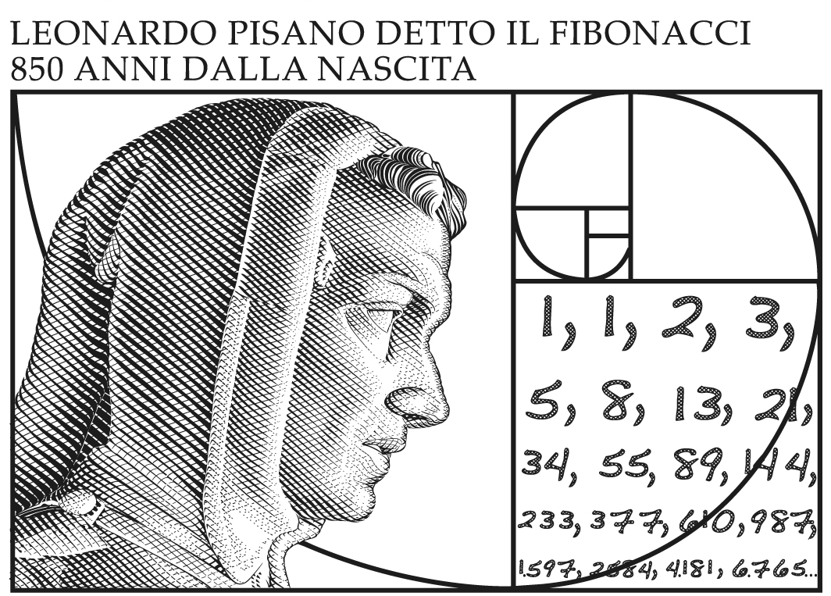
There, Fibonacci encountered Indian numerals and realized they’d save merchants hours of calculation.

In 1202, he wrote Liber Abaci (The Book of Calculation), a math manual disguised as a merchant’s cheat code. He didn’t just explain numbers; he sold them:
Real-world examples: “If you buy 7 yards of silk at 8 bezants per yard, how much do you owe?” (Answer: 56, calculated as 7x8, not VIIxVIII).
Interest calculations: Showed how to compute compound growth, critical for bankers.
Zero’s PR campaign: Called it “zephirum” (from Arabic sifr), later “zero” in Venice.
Fibonacci wasn’t an instant star. Many dismissed his work, but by the 15th century, the printing press standardized the numerals. Gutenberg’s Bible? Printed with Indian numbers.
By the time Gutenberg’s press rolled out, the numbers were here to stay. But zero? Zero was just getting started.
Europe’s Math Drama (Or: Why People Hated New Numbers)
Europe’s adoption of Indian numerals was… messy.
Phase 1: Suspicion and Boycotts
Medieval Europeans were like, “Why fix what isn’t broken?” (Spoiler: It was broken.)
Religious bias: Clerics called numerals "devilish."
Fraud fears:
In 1348, a Venetian merchant altered "10 ducats" to "70" by modifying the zero.
Florence’s 1299 ban on Arabic numerals (rebel tax records used them secretly by 1390).
Florence’s 1299 ban: Italian bankers were forbidden from using Arabic numerals in ledgers. Stick to Roman numerals or face fines! But even the rebels ultimately caved: By 1390, Florentine tax records sneakily used Arabic numerals for calculations, they just hid them in margins.
The Paperwork Rebellion:
In 1445, a German scribe named Adam Ries wrote a math textbook in the vernacular (gasp!) titled Rechnung auff der linihen und federn (“Calculation on Lines and Quills”).
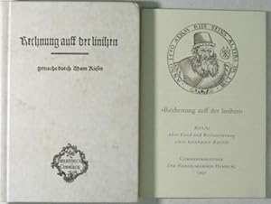
He trolled traditionalists:
Figure 7 Calculation on Lines and Quills
“If you think Roman numerals are better, try dividing MCMXLIV by XXIII. I’ll wait.”
His book became a bestseller, and German households still say “Das macht nach Adam Ries…” (“That’s according to Adam Ries…”) when double-checking math.
Zero’s Revenge (Or: How Nothing Changed Everything)
Zero wasn’t just a math trick, it rewrote human progress:
Science: Newton and Leibniz used zero to invent calculus. No zero, no physics.
Technology: Binary code (0s and 1s) is the DNA of every computer.
Philosophy: Zero forced humans to grapple with the concept of “nothingness”, a idea that shaped everything from Buddhism to modern physics.
Even today, India’s legacy hides in plain sight. When you text “BRB” or check your bank account, you’re using the intellectual grandchildren of Brahmagupta’s zero.
The Numbers Don’t Lie
Let’s set the record straight:
India gave us the numerals.
Persia (via al-Khwarizmi) supercharged them with algebra.
Europe eventually got on board after a few centuries of kicking and screaming.
Calling them “Arabic numerals” is like crediting Starbucks for inventing coffee, it’s a middleman mix-up. But maybe the misnomer is fitting. After all, these numbers belong to everyone now. They’re the closest thing humanity has to a universal language.
So next time you split a dinner bill or rocket-tweet about math, take a sec to thank ancient India. And maybe whisper, “Thanks—and sorry for the name mix-up.”
References
- The Bakhshali Manuscript and the Earliest Zero
  - The Bakhshali Manuscript, discovered in 1881 near Peshawar, Pakistan, contains the earliest known use of a zero symbol. Carbon dating suggests it dates back to the 3rd or 4th century CE. ​University of Oxford
- Brahmagupta and the Formalization of Zero
  - In 628 CE, Indian mathematician Brahmagupta formalized the rules for arithmetic operations involving zero in his seminal work, Brahmasphutasiddhanta. He treated zero as a number in its own right, a groundbreaking concept at the time. ​Math Tutoring & Homework Help
- Al-Khwarizmi and the Spread of Hindu-Arabic Numerals
  - Persian scholar Al-Khwarizmi played a pivotal role in introducing Hindu-Arabic numerals to the Islamic world through his 9th-century work, On the Calculation with Hindu Numerals. His writings were instrumental in the numerals' eventual adoption in Europe. ​
- Fibonacci's Liber Abaci and European Adoption
  - Leonardo of Pisa, known as Fibonacci, introduced Hindu-Arabic numerals to Europe with his 1202 book Liber Abaci. This work demonstrated the efficiency of the numeral system and advocated for its use in commerce and daily calculations. ​
- Resistance to Arabic Numerals in Medieval Europe
  - Despite their efficiency, Arabic numerals faced resistance in Europe. For instance, a 1299 decree in Florence banned their use in official documents due to concerns over fraud and unfamiliarity. ​
- Adam Ries and the Popularization of Modern Arithmetic
  - German mathematician Adam Ries published works in the 16th century that promoted the use of Hindu-Arabic numerals and arithmetic among the general populace, aiding in their widespread adoption. ​Time+3arabicwithhamid.com+3Reddit+3
- The Misnomer of "Arabic Numerals"
  - The term "Arabic numerals" is a misnomer; the numeral system originated in India and was transmitted to Europe through Arabic scholars. The name reflects the route of transmission rather than the system's origin. ​Wikipedia

