The History of Cartography
By Marc Silver

Every Map Tells a Story
Cartography is the making of maps. My belief is the very first map were probably created out of necessity tens of thousands of years ago, when early humans migrating across the plains may have come upon another group of people traveling the opposite ways and they would describe the path they just traveled by scratching their path into the ground describing the terrain, food sources and water they had passed getting there. These might be considered the very first maps made by man.
Every map tells a story. The question is whose.
We tend to think of maps as neutral. Objective. Scientific. Lines on paper that simply describe reality. But that is not how maps work. A map is a decision. It reflects what someone believed was important enough to measure, draw, and preserve.
Open an old atlas and you can feel it. The weight. The authority. The quiet suggestion that this is the world as it is.
Except it never was.
Cartography is not just the history of mapmaking. It is the history of how humans tried to control uncertainty. How we reduced wilderness into something we could fold, carry, and claim.
And that changes everything.

The First Maps Were About Survival
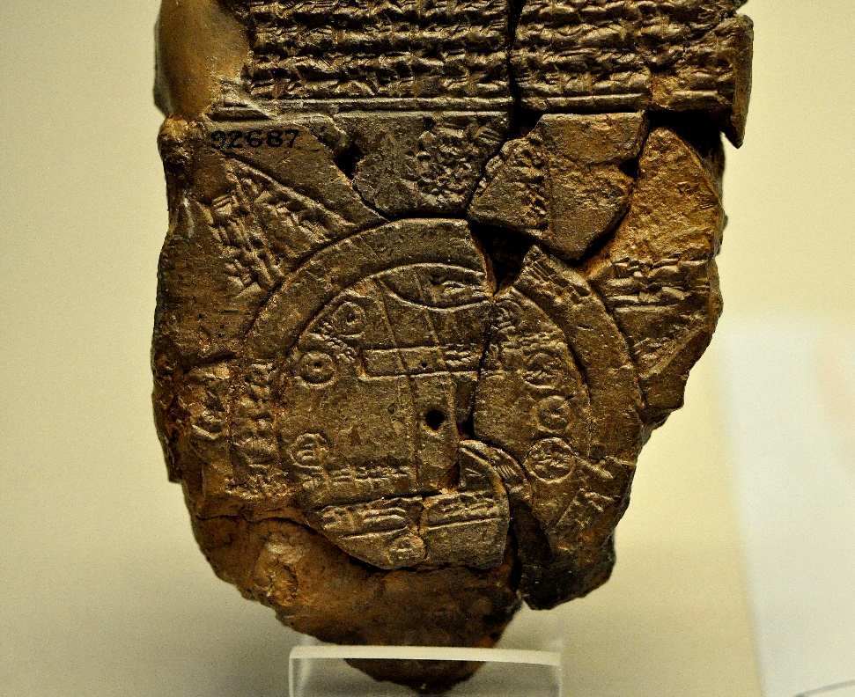
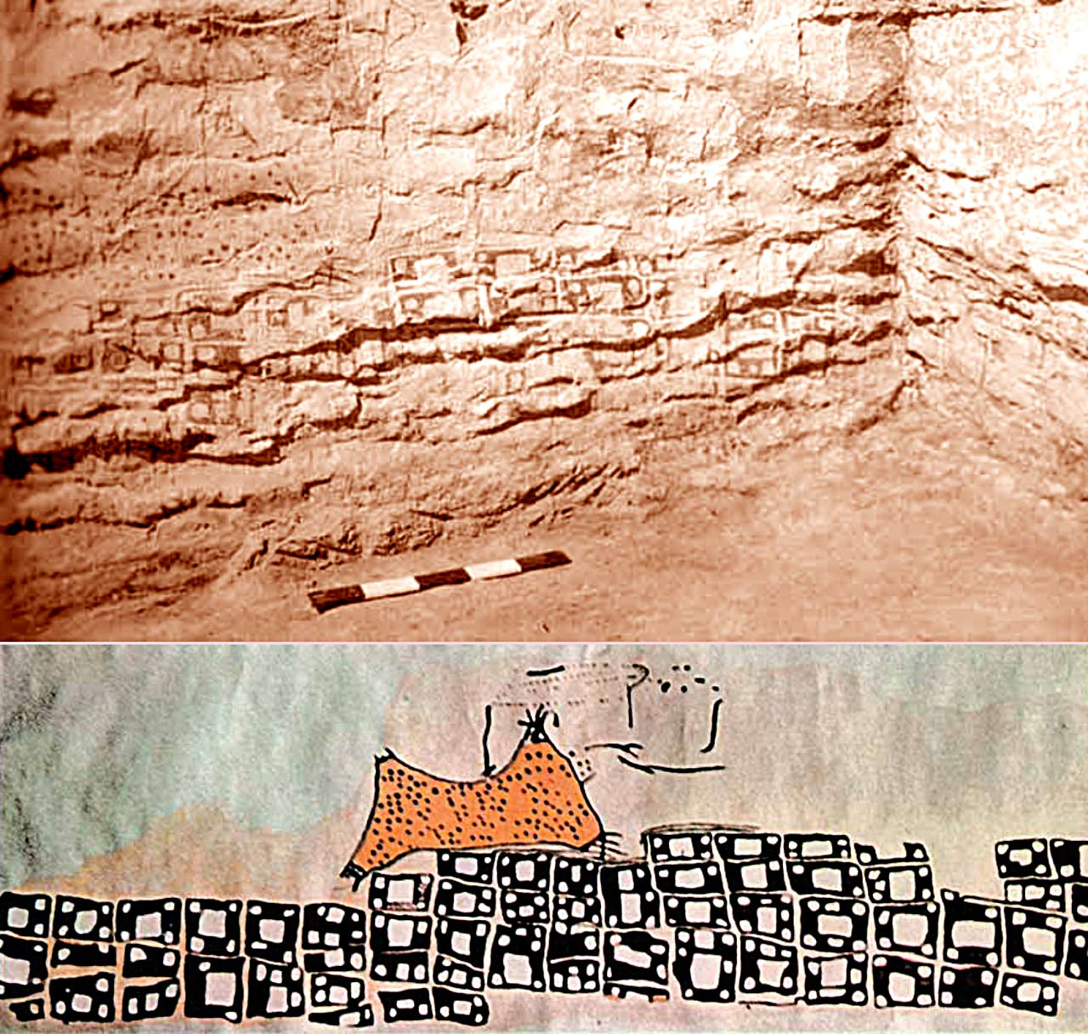

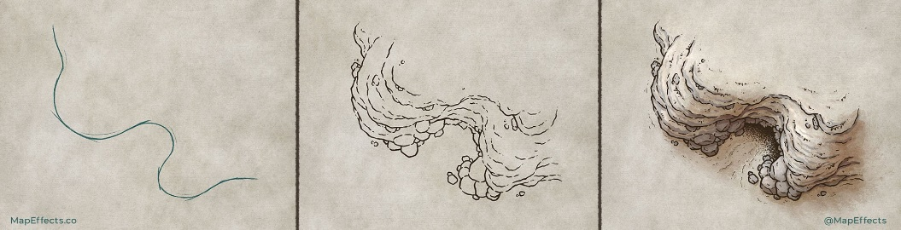

The earliest maps were not about borders. They were about staying alive.
Before there were nations, there were rivers that flooded. Mountain passes that closed in winter. Hunting grounds that shifted with the seasons. The first maps were memory aids. Shared knowledge. Practical sketches of how not to die.
One of the oldest known maps, the Babylonian Map of the World, carved into a clay tablet around the 6th century BCE, shows a small circular world surrounded by water. Babylon sits near the center. Beyond the edges are mythical regions.
It is part geography. Part worldview.
That combination never really went away.
Early maps were not trying to be precise. They were trying to make sense of existence. Where are we? What surrounds us? What lies beyond what we know?
There is something honest about those early attempts. No pretense of perfection. Just a desire to understand the world around us.

The World Had a Center
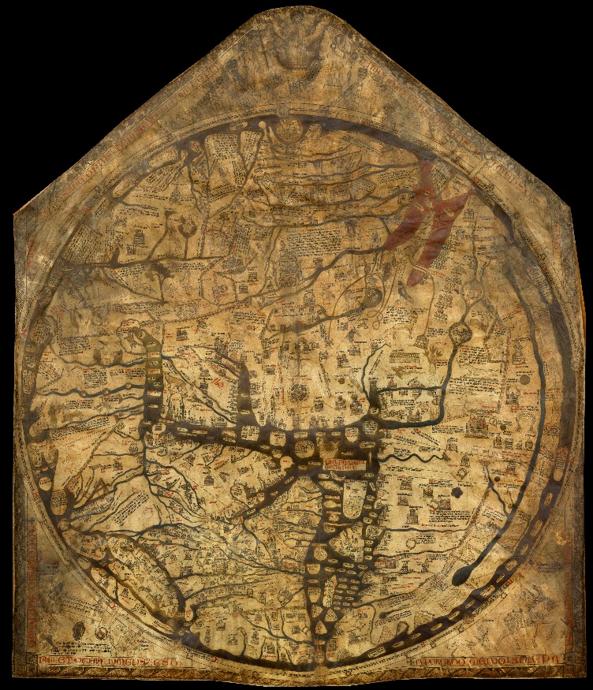
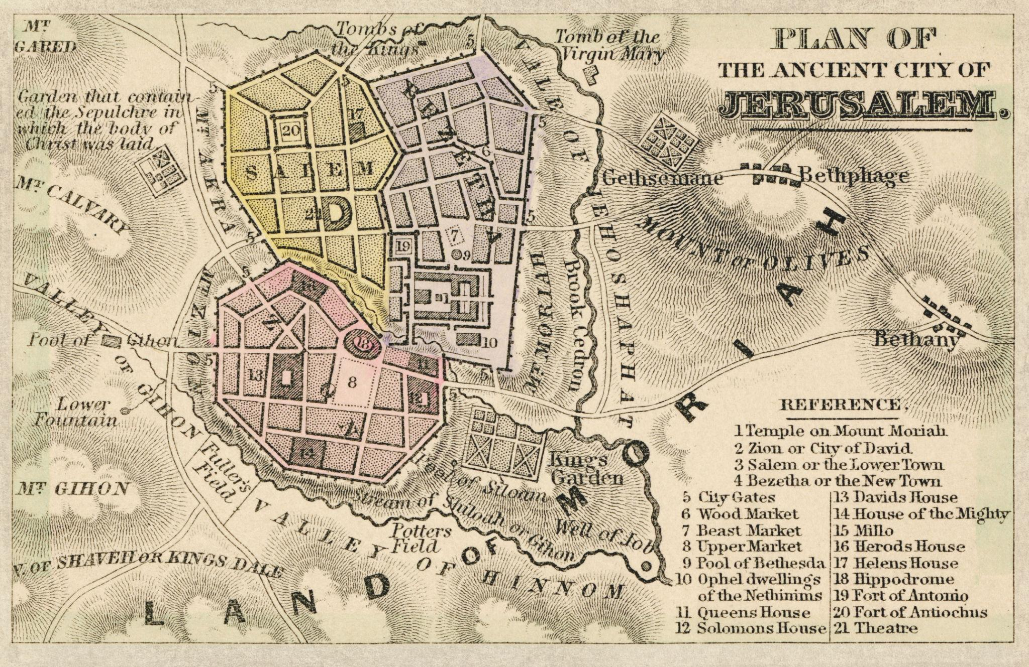
Move forward to medieval Europe and maps become theological statements.
The classic T-O map divided the world into three continents, Asia, Europe, and Africa, separated by a T-shaped body of water and encircled by an ocean. At the center sat Jerusalem.
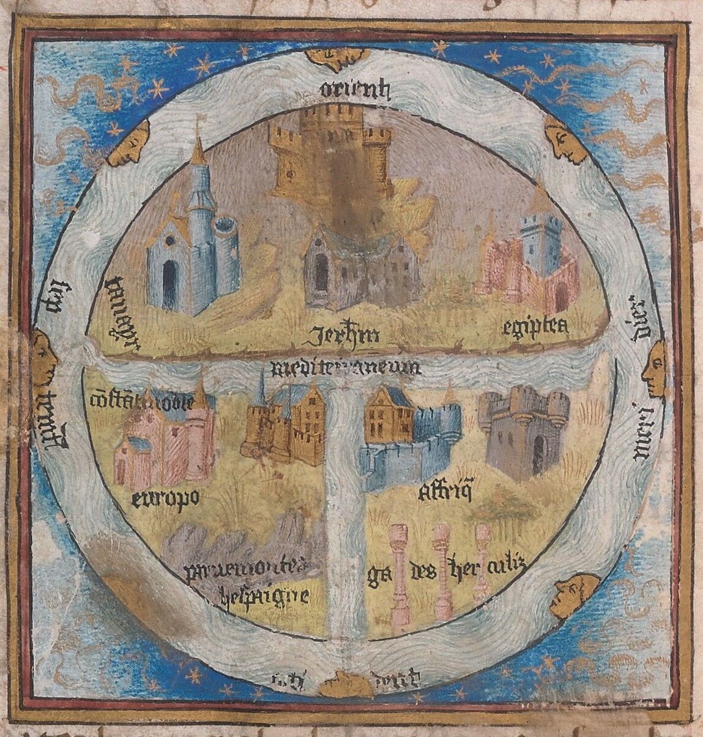
This was not ignorance. It was intention.
These maps were not designed for sailors. They were diagrams of belief. They showed a moral universe arranged around a sacred center.
When you look at one, you realize something important. Maps reflect what a culture thinks is central. Not just geographically, but spiritually and politically.
If your worldview changes, your maps change.

When the Earth Became Measurable
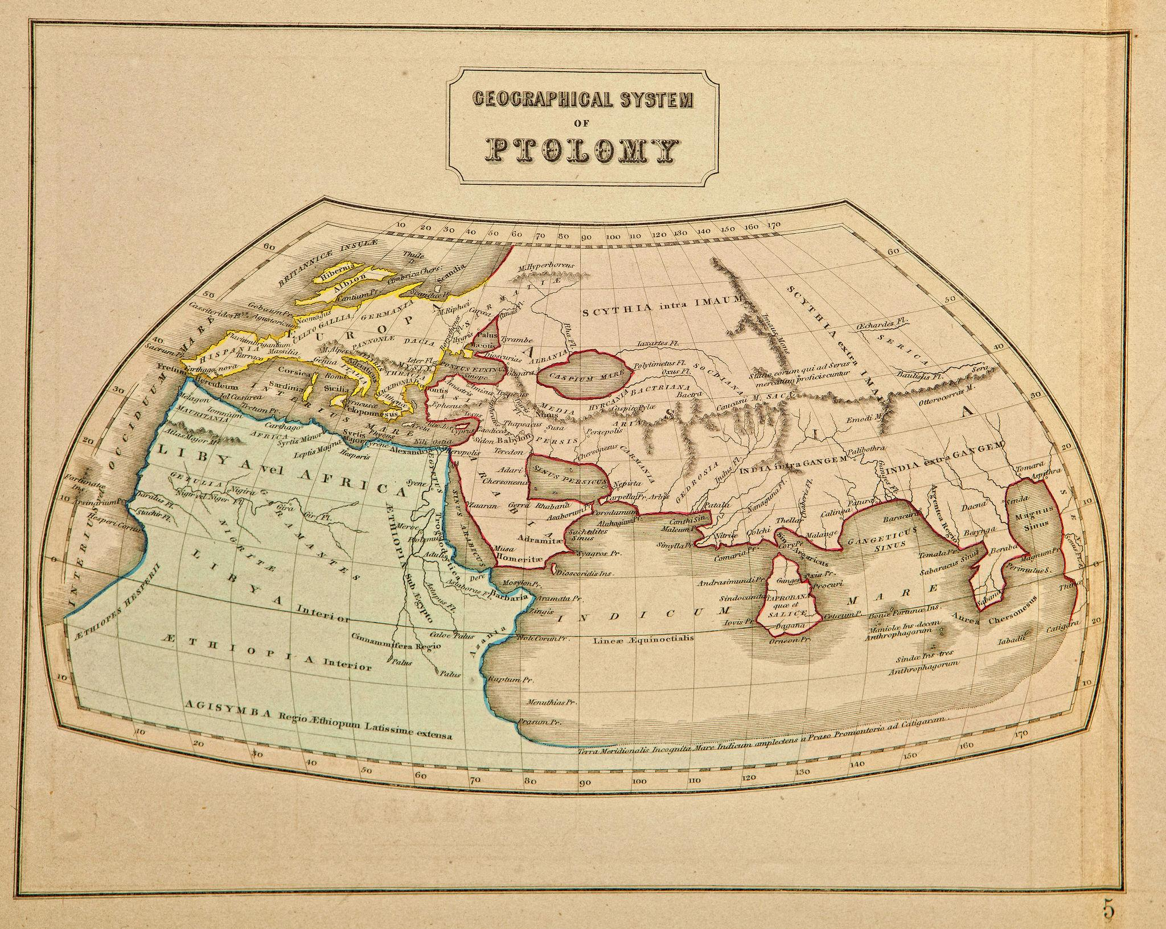
Then comes a shift that feels almost modern.
Claudius Ptolemy, writing in the 2nd century CE, described a coordinate system using latitude and longitude. His work, Geographia, compiled geographic knowledge and explained how to project the curved Earth onto a flat surface.
Even though many of his calculations were wrong, the idea itself was revolutionary.
The Earth could be measured.
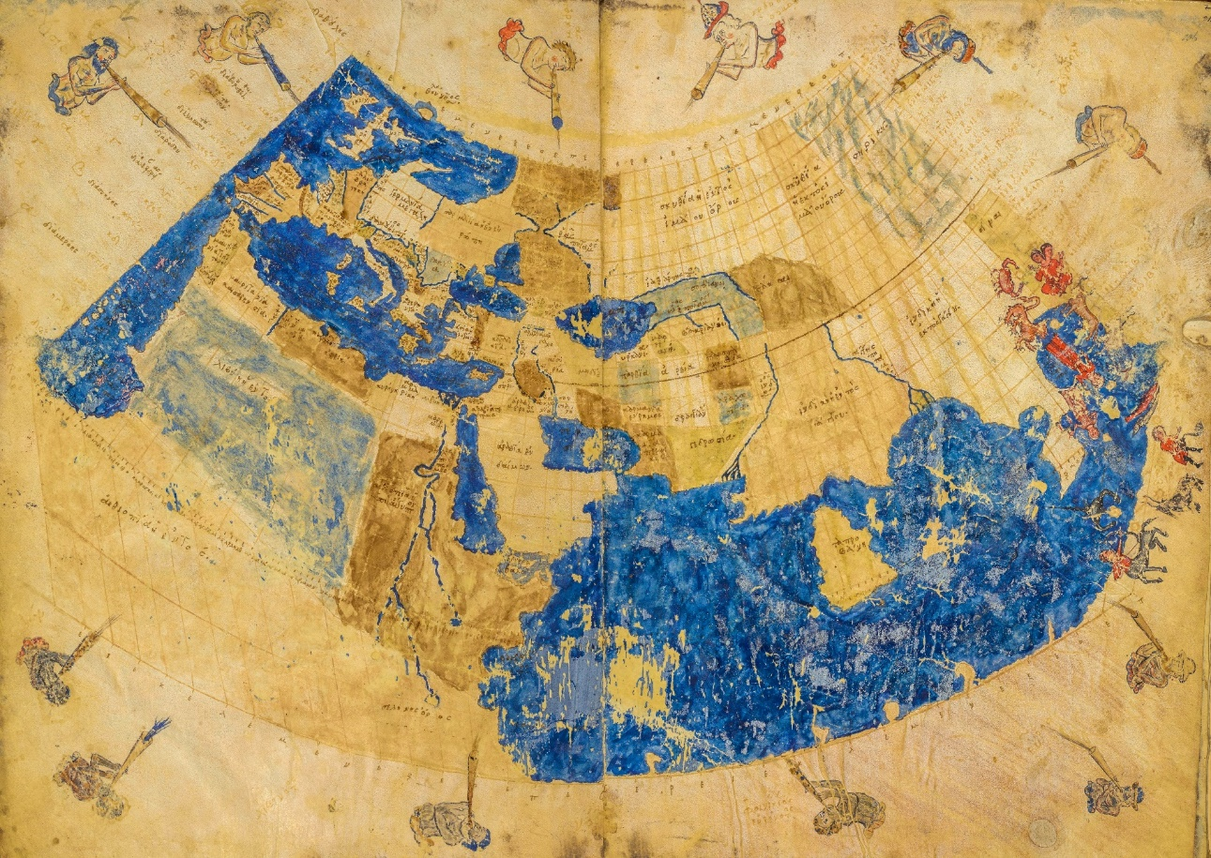
Once you introduce coordinates, the world becomes something that can be calculated. Location turns into numbers. Distance becomes predictable. Space becomes manageable.
Think about how radical that is. Instead of a symbolic center, you now have a grid. Instead of divine placement, you have mathematics.
Cartography begins to move from philosophy toward science.
And once measurement enters the picture, ambition follows.

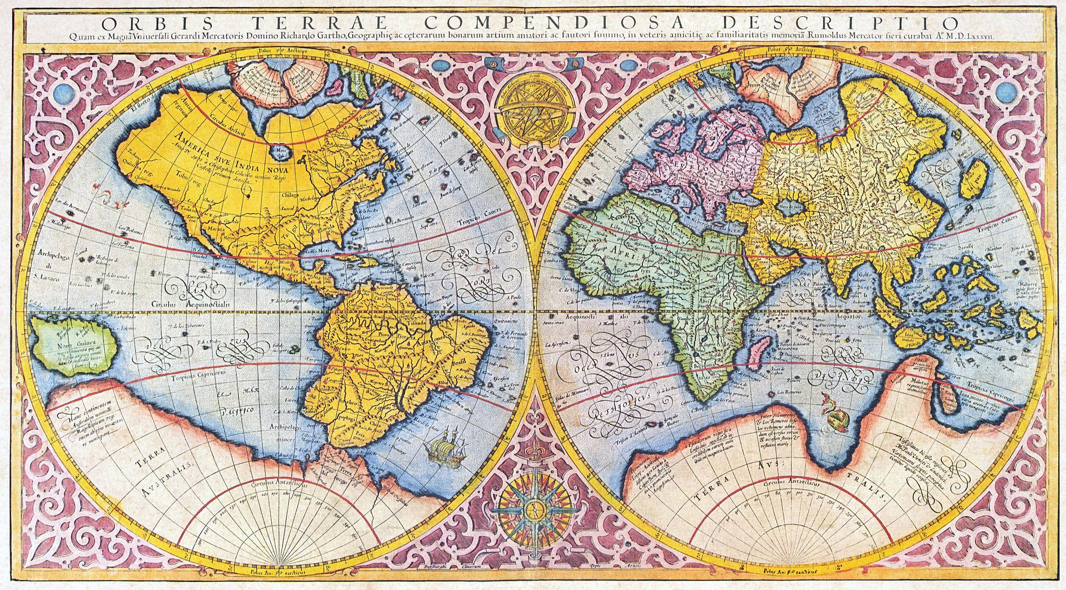
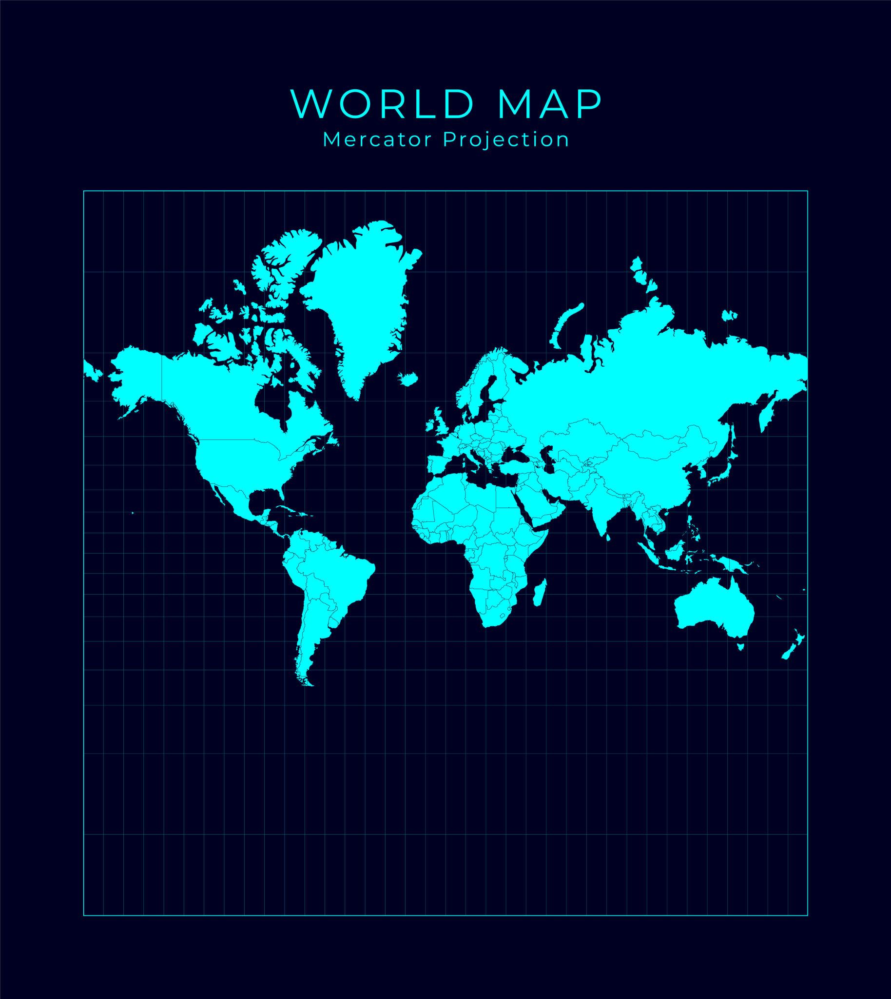
Exploration, Navigation, and Distortion
The Age of Exploration forced maps to become practical.
Sailors needed charts that worked. Empires needed routes. Merchants needed predictable trade paths.
In 1569, Gerardus Mercator introduced a projection that preserved angles. On his map, a straight line represented a constant compass bearing. That was invaluable for navigation.
But flattening a sphere is not simple.
If you peel an orange and press the peel flat on a table, it tears and stretches. That distortion is unavoidable. Mercator chose to preserve angles, which meant land masses near the poles expanded dramatically. Europe appears larger than it is. Africa appears smaller.
It worked beautifully for sailors. It also quietly reshaped perception.
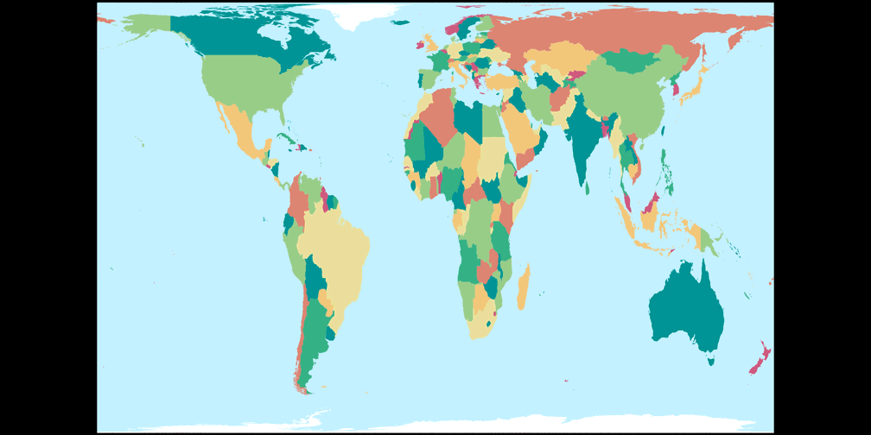
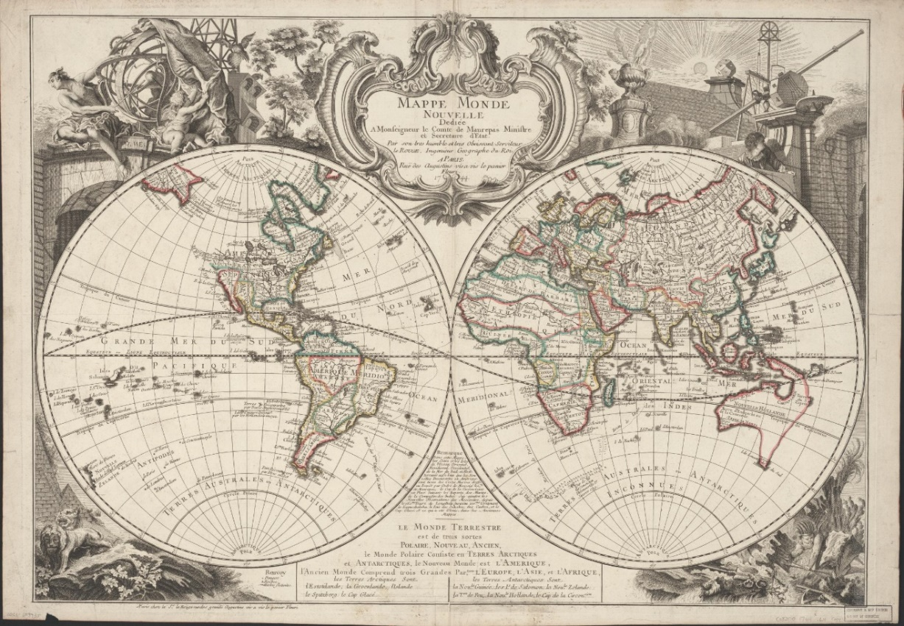
When a continent looks larger on the map, it feels more important. When another looks compressed, it feels diminished.
Mercator probably did not intend that consequence. But maps influence how we see the world, and how we see ourselves within it.
Exploration and cartography moved together. As European powers expanded overseas, maps recorded new territories and, in many cases, renamed them. Indigenous place names often disappeared. Borders were drawn that ignored local realities.
A map was not just a guide. It was a claim.

Precision Becomes Authority
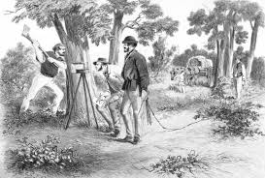
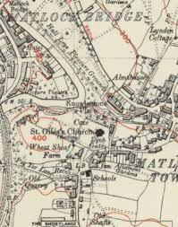
By the 18th and 19th centuries, cartography had become institutional.
The British Empire’s Ordnance Survey began as a military effort to map Scotland after the Jacobite uprising. Over time, it expanded into a comprehensive national mapping program.
Surveyors used triangulation. They measured angles between distant points, building vast networks of precise geographic data. The results were astonishingly accurate.
Land could now be divided with confidence. Property could be taxed. Borders could be enforced.
Accuracy became authority.
But there is another layer here. When colonial administrations mapped India, Africa, or North America, they imposed their own systems of measurement and naming. Traditional land-use patterns were translated into grids. Rivers and mountains received new labels.
The act of mapping often preceded control.
You cannot administer what you cannot measure.
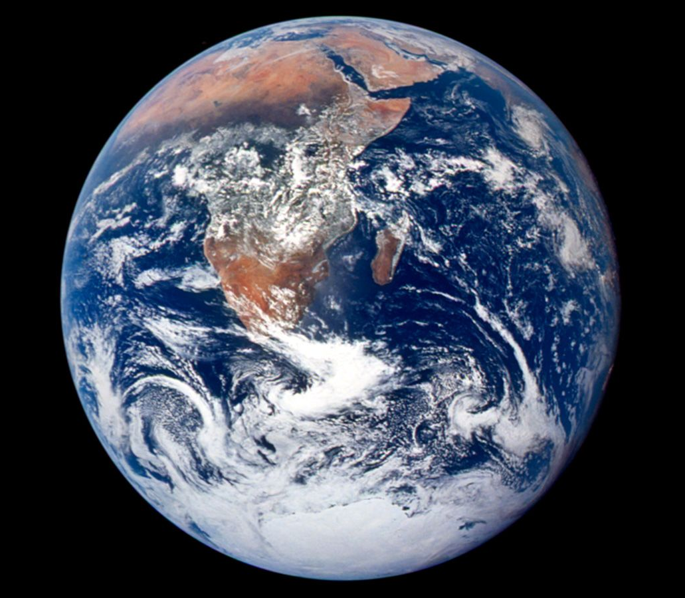
The View From Above
The 20th century delivered a perspective no cartographer had ever imagined.
In 1972, astronauts aboard Apollo 17 captured the Blue Marble photograph of Earth. For the first time, humanity saw the planet whole.
No borders. No names. Just a fragile sphere suspended in darkness.
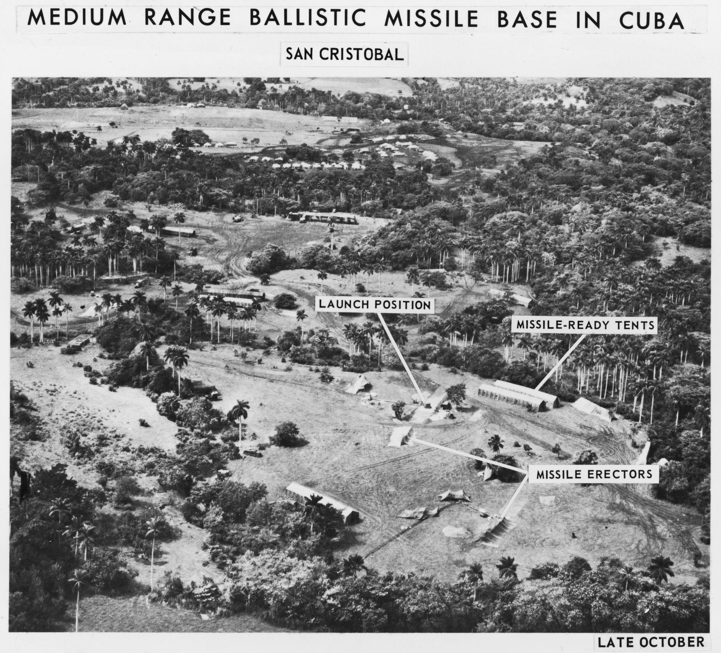
That image reshaped environmental thinking and global consciousness. Suddenly, the world felt connected.
At the same time, Cold War technology drove advances in satellite imaging. Governments could map enemy territory from orbit. GPS systems, initially military, later became civilian tools.
Today, platforms like Google Earth allow anyone to zoom from space down to a single rooftop.
Cartography is now dynamic. Layers of data update in real time. Traffic flows shift by the minute. Weather systems are tracked continuously.
We no longer carry the map. The map carries us.

Invisible Cartography
Modern cartography is often invisible.
Every time your phone reroutes you around traffic, a digital map recalculates your path. Every package tracked online moves through a geographic system built on layers of mapping data.
Cartography now intersects with artificial intelligence, logistics, climate science, and urban planning.
And here is where things become interesting again.
Digital maps collect information. They record movement patterns. They reveal habits. They become tools of efficiency, but also of surveillance.
In earlier centuries, a map might expand an empire. Today, it might optimize delivery routes or analyze population density.
The tools have changed. The underlying principle remains.
Who controls the map controls perception.

The Future of Mapping
What happens when maps are layered with augmented reality? When autonomous vehicles rely entirely on digital cartography? When climate change redraws coastlines?
Cartography is not finished. It is evolving faster than ever.
Artificial intelligence can now generate predictive maps, modeling migration patterns or environmental shifts before they occur. Three-dimensional mapping allows cities to be recreated digitally in extraordinary detail.
The map is no longer just a representation. It is a simulation.
And yet, despite all the technology, the core issue remains surprisingly human.
Every map reflects choices.
What to measure.
What to emphasize.
What to omit.
What to name.
To draw a map is to shape reality.

Closing Thought
From clay tablets to satellites, cartography has always been about more than geography. It is about control, curiosity, ambition, and belief.
We like to think we see the world as it is.
In truth, we see it as it has been drawn.
And someone is always holding the pen.

The History of Cartography
By Marc Silver
Every Map Tells a Story
Cartography is the making of maps. The earliest maps were likely created out of necessity tens of thousands of years ago. Early humans migrating across open plains or through unfamiliar terrain would have needed ways to describe safe routes, water sources, hunting grounds, and seasonal hazards. One group encountering another may have traced paths into the earth, marking rivers, hills, and resources. Those scratches in the dirt were not art. They were survival.
Every map tells a story. The question is whose.
We tend to think of maps as neutral. Objective. Scientific. Lines on paper that simply describe reality. But maps are never neutral. A map is a decision. It reflects what someone believed was important enough to measure, draw, and preserve.
Open an old atlas and you can feel it. The weight. The authority. The quiet suggestion that this is the world as it is.
Except it never was.
Cartography is not just the history of mapmaking. It is the history of how humans tried to reduce uncertainty. How wilderness became something we could fold, carry, and claim.
And that changes everything.

The First Maps Were About Survival
The earliest maps were not about borders. They were about staying alive.
Before there were nations, there were rivers that flooded, mountain passes that closed in winter, and hunting grounds that shifted with the seasons. Early maps functioned as memory aids and shared knowledge. They were practical guides to survival.
One of the oldest surviving examples, often called the Babylonian Map of the World, carved into a clay tablet in the 6th century BCE, shows a circular landmass surrounded by water. Babylon sits near the center. Beyond the known world lie mythical regions.
It is part geography. Part worldview.
That combination never disappeared.
Early maps were not striving for precision. They were attempts to answer deeper questions. Where are we? What surrounds us? What lies beyond what we know?
There is something direct about those early efforts. No illusion of perfection. Just an attempt to understand place.

The World Had a Center
In medieval Europe, maps became theological statements.
The classic T-O map divided the world into three continents — Asia, Europe, and Africa — separated by a T-shaped body of water and encircled by an ocean. At the center sat Jerusalem.
This was not ignorance. It was intention.
These maps were not designed for sailors. They were diagrams of belief. They illustrated a moral universe organized around a sacred center.
Maps reflect what a culture believes is central, not just geographically, but spiritually and politically.
When worldviews change, maps change.

When the Earth Became Measurable
A major shift occurred in the 2nd century CE with the work of Claudius Ptolemy.
In his work Geographia, Ptolemy described a coordinate system using latitude and longitude and explained methods for projecting the curved Earth onto a flat surface. Although many of his calculations were incorrect, the conceptual breakthrough was profound.
The Earth could be measured.
Ptolemy’s work did not maintain continuous influence in Western Europe. Much of it was lost for centuries, preserved in the Islamic world, and later rediscovered and translated into Latin during the 14th and 15th centuries. That rediscovery played a significant role in shaping Renaissance cartography.
Once coordinates enter the picture, space becomes numerical. Location turns into data. Distance becomes predictable.
Instead of a symbolic center, there is a grid. Instead of divine placement, mathematics.
Cartography begins to move from philosophy toward science.
And once measurement enters the picture, ambition follows.

Exploration, Navigation, and Distortion
The Age of Exploration forced maps to become practical.
Sailors required reliable charts. Merchants required consistent trade routes. Expanding empires required geographic knowledge that could be trusted at sea.
In 1569, Gerardus Mercator introduced a projection that preserved angles. On his map, a straight line represented a constant compass bearing. For navigation, this was invaluable.
But flattening a sphere is not simple.
Peel an orange and press the peel flat against a table. It stretches and tears. That distortion cannot be eliminated, only managed.
Mercator chose to preserve angles, which meant land masses near the poles expanded dramatically. Europe appears larger. Africa appears smaller.
The projection worked beautifully for sailors. It also quietly influenced perception.
When a region looks larger on a map, it can feel more important. When it appears compressed, it can feel diminished.
Mercator likely did not intend that consequence. Yet maps shape how we see the world and how we position ourselves within it.
As European powers expanded overseas, maps recorded new territories and often renamed them. Indigenous place names disappeared. Borders were drawn with little regard for local realities.
A map was not merely a guide.
It was a claim.

Precision Becomes Authority
By the 18th and 19th centuries, cartography had become institutional.
The British Empire’s Ordnance Survey began as a military effort to map Scotland after the Jacobite uprising. Over time, it evolved into a comprehensive national mapping system.
Surveyors used triangulation, measuring angles between distant points and building networks of geographic reference. The results were remarkably precise.
Land could now be divided confidently. Property could be taxed. Borders could be enforced.
Accuracy became authority.
Yet precision also accompanied expansion. Colonial administrations mapped India, Africa, and North America using their own systems of measurement and naming. Traditional land use was translated into grids. Rivers and mountains received new labels.
The act of mapping often preceded control.
You cannot administer what you cannot measure.

The View From Above
The 20th century introduced a perspective no earlier cartographer could imagine.
In 1968, astronauts aboard Apollo 8 captured the famous Earthrise photograph, revealing Earth suspended above the lunar horizon. In 1972, the crew of Apollo 17 took what became known as the Blue Marble image, one of the first fully sunlit photographs of the entire planet.
These images did not represent the first time Earth had been seen from space, but they became defining visual symbols of a shared planet.
No borders. No labels. Just a fragile sphere against darkness.
The effect was cultural as much as scientific. Environmental awareness expanded. Global consciousness shifted.
At the same time, Cold War technology accelerated satellite imaging and positioning systems. GPS, initially military, became civilian infrastructure. Today, digital platforms allow anyone to zoom from orbit down to a single rooftop.
Cartography is now dynamic. Layers update in real time. Traffic flows shift by the minute. Weather systems are tracked continuously.
We no longer simply carry maps.
The map carries us.

Invisible Cartography
Modern cartography often operates quietly.
When a phone reroutes around congestion, a digital map recalculates. When a package is tracked across continents, it moves through geographic systems built on layers of mapping data.
Cartography now intersects with artificial intelligence, logistics, climate modeling, and urban planning.
Digital maps do more than describe space. They record behavior. They analyze movement. They reveal patterns.
Earlier maps supported exploration and empire. Today’s maps optimize delivery routes, allocate resources, and manage infrastructure.
The tools have changed.
The principle remains.
Who controls the map influences perception.

The Future of Mapping
Mapping continues to evolve.
Augmented reality overlays digital information onto physical streets. Autonomous vehicles rely entirely on detailed cartographic databases. Climate change reshapes coastlines and forces maps to be redrawn.
Artificial intelligence can generate predictive maps, modeling migration patterns and environmental shifts before they fully unfold. Three-dimensional digital models recreate entire cities with remarkable precision.
The map is no longer only a representation.
It is a simulation.
And yet the central issue remains human.
Every map reflects choices.
What to measure.
What to emphasize.
What to omit.
What to name.
To draw a map is to shape reality.

Closing Thought
From clay tablets to satellites, cartography has always been about more than geography. It reflects control, curiosity, ambition, and belief.
We like to think we see the world as it is.
In truth, we see it as it has been drawn.
And someone is always holding the pen.

References
Ptolemy, Claudius. Geographia. 2nd century CE.
Mercator, Gerardus. Nova et Aucta Orbis Terrae Descriptio ad Usum Navigantium Emendata. 1569.
Harley, J. B., and David Woodward, eds. The History of Cartography. University of Chicago Press.
Monmonier, Mark. How to Lie with Maps. University of Chicago Press.
Brotton, Jerry. A History of the World in Twelve Maps. Viking.
British Ordnance Survey historical archives.
NASA. Apollo 17 Blue Marble photograph, 1972.
Google Earth platform documentation.

