The Great THD Deception:
Why Your Amp's Spec Sheet is Lying to Your Ears
By Marc Silver
When Specs Took Over
In the 1970s, an amplifier with one percent distortion didn’t raise eyebrows. Then came the spec wars. Manufacturers chased lower numbers, brochures trumpeted “zero point zero something percent THD,” and buyers started quoting decimal points as if they were gospel.
I’ve spent decades watching customers walk into my showroom armed with spec sheets. They’d point to the numbers, convinced they equated to fidelity. But specs don’t tell you how a piano note hangs in the air or why one amp makes you lean forward and another leaves you tired in twenty minutes. If you’ve ever swapped amplifiers and felt more engaged—even when the new amp “measured worse”—you already know where this story is going.

The Demo That Broke the Rules
One afternoon, I had a client listening to a 100-watt solid-state amplifier with a flawless spec sheet: THD under 0.01 percent, ruler-flat specs across the board. It sounded excellent.
Then I swapped in a pair of Quicksilver Mid-Mono tube amps. Forty watts each. Same speakers, same source.
Within half a minute, the client leaned forward. “What just happened? The music sounds alive. What else did you change?”
He wasn’t imagining it. The tube amp was layering in harmonic color that the solid-state amp had sterilized out. It wasn’t about volume or frequency response. It was about emotional connection.
On paper, the tube amp’s spec was “worse.” But the performance was richer, fuller, more natural, more emotionally convincing. That moment reminded me, again, why I trust my ears over the spec sheet.
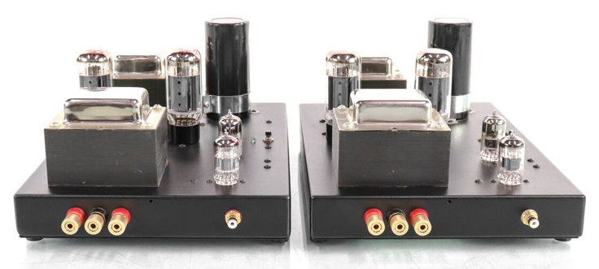
Figure 1 Quicksilver Mid-Mono amps
The kicker? The tube amp measured far worse in terms of THD. But it pulled the listener deeper into the music. And that’s what matters.
That moment reminded me why I trust what I hear over what I read. It wasn’t the first time, and it won’t be the last. Breaking the rules, trusting my ears instead of the published specs, turned out to be the right call. It’s a lesson I’ve leaned on ever since.

Harmonics: The Salt and Vinegar of Sound
Total Harmonic Distortion (THD) is a blunt tool. It doesn’t tell you what kind of distortion you’re hearing. That’s like saying a dish has five ingredients without mentioning whether one of them is garlic—or motor oil.
Let’s break it down: Here’s the important distinction:
Even-order harmonics (2nd, 4th): Add warmth and fullness, like butter or salt. They smooth edges and feel natural.
Odd-order harmonics (3rd, 5th): Add bite. A little can bring presence; too much turns violins into buzz saws.
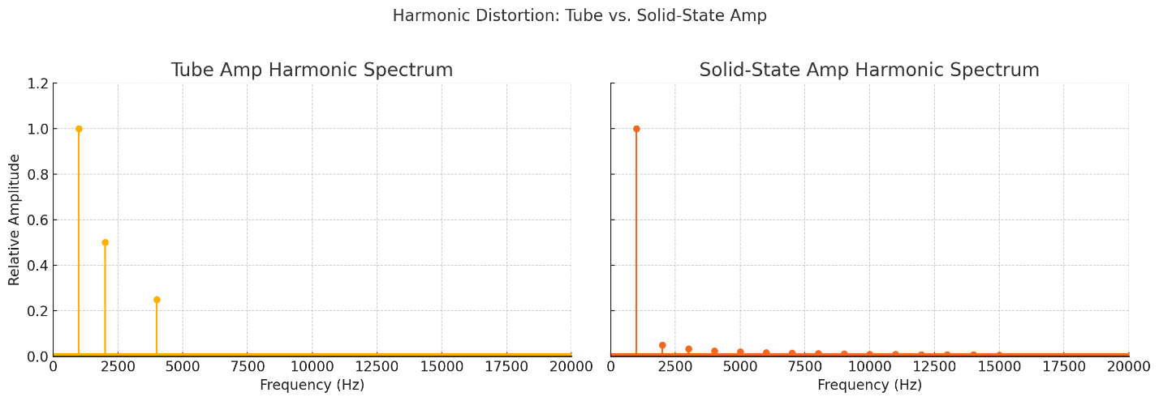
High-order harmonics (7th and up): Fatiguing and unnatural. They’re the fluorescent light buzzing in your brain.
Figure 2 Harmonic Distortion Comparison
Tube amps tend to produce mostly even-order harmonics. That’s why they sound rich, textured, human. Solid-state amps often hide their distortion in higher harmonics, low in quantity but nasty in quality.
That’s why two amplifiers with identical THD numbers can sound completely different. It isn’t how much distortion, it’s what kind.
I’ve always explained it like this: ocean waves and wind are mostly even-order in nature. You can easily fall asleep to their sound even when it’s loud.
And I have gotten more than one sun-burn to prove my point.
Sidebar: Why It Matters: Harmonics and Human Hearing
Screeching tires, glass breaking, or nails on a chalkboard are all odd-order in nature. These sounds trigger our fight-or-flight response. They're anything but comforting.
That’s why even a small trace of odd-order distortion can wear on you. But a little even-order distortion? It can make the music more engaging, even comforting.
Low-order harmonics, especially the 2nd and 3rd, tend to sound musical, natural, and pleasing. They’re found in acoustic instruments, human voices, and real-world environments. These harmonics add warmth, fullness, and a sense of depth.
High-order harmonics, 7th and above, are harsh, unnatural, and fatiguing. They rarely occur in natural soundscapes. When amps produce them, they don’t just sound wrong, they feel wrong. These are the tones that tire your ears, even when you can’t pinpoint why.
This is why two amps with the same THD number can sound wildly different. It’s not just how much distortion, but what kind.

The Price Tag Doesn’t Tell You How It Sounds
I’ve done plenty of amp comparisons over the years, but one particular shootout stuck with me. These weren’t all the same tubes or brands, but they did share one thing: every amp claimed to be engineered for maximum fidelity. And yet, they sounded wildly different.
- Transformer-coupled push-pull: Smooth harmonic decay, midrange to die for. Like slow-cooked stew. THD? 0.8%
- Capacitor-coupled: A little punchier, but also a little glassier. THD? 0.3%
- 300B Single Ended Triode (SET): Open, effortless, and honest. THD? Over 2%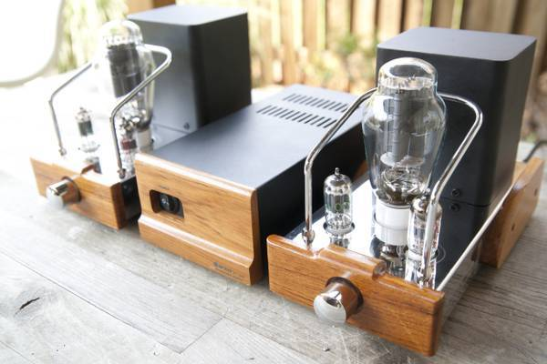
Figure 3 Dared VP300b 300B single ended triode tube amp
Each circuit handled harmonic decay in its own way. Some let it breathe; others pinched it off. It wasn’t just about the tubes. It was about the topology, the voicing, the design.
It wasn’t about how much distortion. It was about what kind, and how gracefully the amp handled it.
Another time, I had two integrated amps from the same brand, one entry-level solid-state model with a stellar spec sheet, and one higher-end tube model that measured worse on every lab metric. I played the same cut, solo piano, then full orchestra. The tube amp created a 3D illusion. The solid-state sounded like someone had drawn it with a ruler and Sharpie.
The lesson? The circuit’s soul matters more than the lab report.

Feedback: Audio’s Dirty Little Secret
Negative feedback is the trick every amplifier designer knows to reduce distortion, That’s why it’s everywhere. Negative feedback is like the magician’s trick of amplifier design. Feed some output back to the input, and, presto change-o, the distortion number drops. But the distortion hasn’t disappeared, it’s only changed its disguise. The low end looks clean, while sharp, high-order harmonics sneak back into the mix, like weeds popping up where you least want them. On a scope, the amp looks perfect. To the ear, cymbals sound flat, vocals lose breath, and after thirty minutes you want silence, not because the amp is “clean,” but because you’re fatigued.
I once blind-tested ten listeners. Eight preferred the “badly measuring” tube amp. One described it as “like taking earplugs out.” That’s the kind of distortion a spec sheet never shows.
Negative feedback reduces THD. But it’s also why so many amps sound sterile.
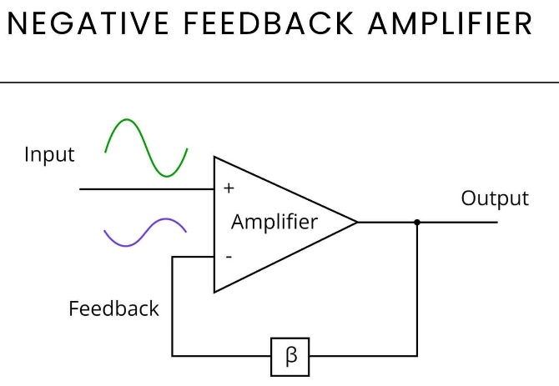
Feedback loops suppress distortion at one frequency by generating more of it elsewhere, often way up in the harmonics, where it irritates your brain but hides from the meter.
Cymbals go “TSSSSK.” Vocals lose breath. After 30 minutes, you want silence. Not because the amp is clean, but because your brain is fatigued, thanks to the buildup of high odd-order distortion.
A blind test I ran several years ago, ten listeners. Eight picked the “badly measuring” tube amp. One said, “Feels like I just took earplugs out.” I have to assume two of the men in the room have severe hearing loss.
That kind of distortion doesn’t leap out, it creeps in. You don’t notice it right away. You just stop enjoying the music.
Negative feedback, where the amp loops part of its output back into the input, lowers THD but at a cost. It suppresses distortion at one frequency by kicking it somewhere else, often way up in the harmonic stack, where your brain notices even if the meter doesn’t.

IMD: The Distortion Nobody Talks About
Intermodulation distortion, IMD, is the quiet saboteur in high-fidelity audio. It’s what happens when two or more tones interact inside a circuit to create sum and difference frequencies that never existed in the original music.
Unlike THD, which is measured with a steady sine wave, IMD appears when music gets complex—multiple instruments, overtones, voices colliding. The amp coughs up artifacts that make everything sound cloudy and vague. You can’t always name what’s wrong, but your ears know.
Yet spec sheets rarely mention it. And when they do, the tests don’t resemble how music actually behaves.

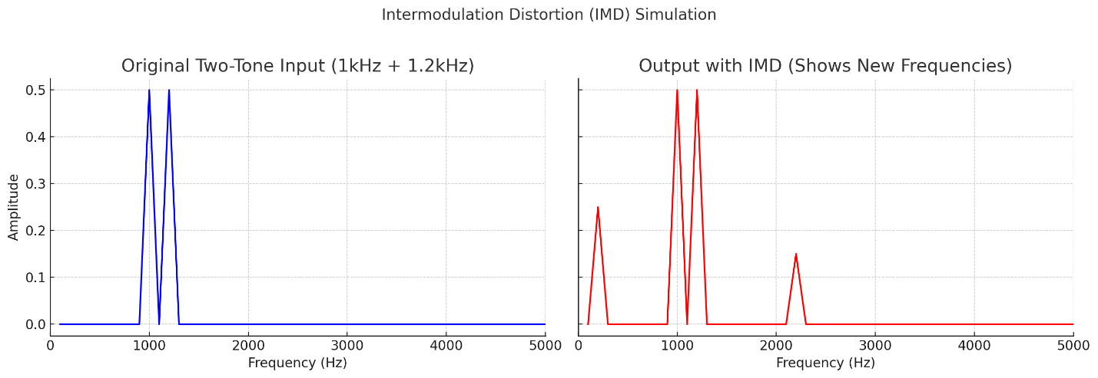It doesn’t just sound distorted, it sounds wrong. Cloudy. Fatiguing. Vague. You can’t always describe what’s off, but your ears know something is.
Yet most spec sheets barely mention it. And if they do, the test methods don’t reflect how music actually behaves.
This is why two amps with the same THD can sound night and day different when you actually sit down and listen.

Power Supplies: The Sneaky Saboteur
Intermodulation distortion, IMD, is the quiet saboteur in high-fidelity audio. It’s what happens when two or more tones interact inside a circuit to create sum and difference frequencies that never existed in the original signal.
Your amp doesn’t just amplify music. It also amplifies the noise leaking from its power supply.
Modern amps often use cheap rectifiers that spray RF noise from 150kHz to 2MHz. You don’t hear it directly, but you feel it:
- Violins sound flat, like AM radio
- Bass loses punch and focus
- Background silence becomes a hissy smear
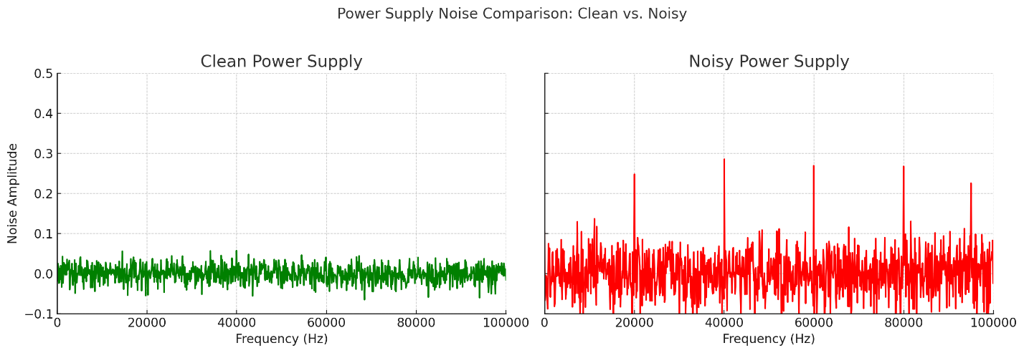
Figure 4 Clean vs. Noisy Power Supply
I’ve had my tech modded countless amps with this problem. Swap the diodes, add a choke filter, suddenly the music breathes. It costs maybe $20 in parts. But manufacturers don’t bother, because THD doesn’t catch it.
Even when the output waveform looks clean on a scope, you can feel the haze. It’s like watching a movie through a slightly dirty lens. Everything is technically there, but something’s missing.

Speakers: The Brutal Truth-Tellers
Speakers are the truth-tellers. Pair a harsh amp with a ribbon tweeter and you’ll think you’re at the dentist. Pair it right, and the same system will move you to tears.
Vintage speakers often love tubes, with their natural damping. Metal-dome tweeters prefer low-distortion solid-state. Planars and ribbons reveal everything—good or bad. The point is simple: specs won’t tell you how an amp behaves in the real world, with real speakers.
“It’s like watching a vivid sunset through a dirty window.” The amp may be painting a masterpiece, but the speakers blur the view. Or worse, they reveal every wart.
Speaker pairing matters. A lot.
Speaker Type | Best With | Why
Vintage Speakers | Tube Amps | Natural damping, low-resistance match
Metal Dome Tweeters | Low-distortion Solid State | Avoids stimulating harshness
Planars/Ribbons | Low-noise Class A or Tube | Reveals everything, good or bad
Some speakers act like magnifying glasses. Others are filters. You put a harsh amp on a ribbon tweeter, and suddenly your high-end sounds like a dentist drill. Pair it right, though, and the results can be staggering.
Play Allegri’s Miserere. With a good amp/speaker match, the voices blend like honey in tea. A bad match? Like bees in a tiled bathroom.

The Spec Sheet Revolution
If spec sheets told the truth, they’d include:
- Harmonic Breakdown: Show the ratio of even to odd and high-order distortion.
- Real-World IMD: Test distortion during actual music, not sine waves.
- Noise Modulation: Rate how much the power supply adds or smears when dynamics spike.
One designer I admired, Frank Van Alstine, used to publish specs this way: “Power: More than you need. Distortion: Below audibility. Frequency response: Beyond what you can hear.” He was ahead of his time. He knew that the numbers people quote aren’t the ones that matter.
THD alone is like measuring a restaurant by the calorie count. It tells you nothing about flavor.
I remember Frank Van Alstine had a very different approach to specs. He used to publish his numbers like this:
“Power – More than you need. Distortion – Below audibility. Frequency Response – Beyond what you can hear.”
Maybe he was ahead of the world by a few decades. He understood that what matters isn’t what you can prove on paper, it’s what you feel in your gut when the music starts.

The Moment That Changed Everything
A young engineer visited my shop with his "perfect" amp: 200 watts per channel, multiple power supplies (I think there were six in total), and a spec sheet boasting 0.0001% THD. We played Eva Cassidy’s Fields of Gold on a pair of MartinLogan electrostats.
His amp: super clean, clinical, flat.
Then we switched to a pair of Quicksilver tube mono-blocks. Halfway through, he teared up. “It’s like she’s in the room. Breathing.”
His amp showed tiny harmonics all the way up to the 15th harmonic. Quicksilver’s was just flat-out supper musical. Specs be damned.
He looked at his amp, then at the Quicksilvers, then back at me. “How is this possible?”
I just smiled.
“You built a calculator. Quicksilver built a musician.”

Your Ear VS. The Owner’s Manual
After six decades in this business, here’s what I’ve learned, and it’s not in any user guide.
For Listeners:
- Trust your ears. If it gives you chills, it’s good.
- Use your music, something you know and love..
- Listen for fatigue. If silence feels like a relief, something’s wrong.
For Designers:
- Chase beauty, not zeroes.
- Bring back the stuff that worked: transformers, choke filtering, minimalist gain stages.
- Measure what actually matters.
A Stradivarius doesn’t measure flat. It breathes. So should your amp.
So next time someone points to their amp’s THD rating with pride?
Ask them,
“Yeah, but does it make you feel anything?”
That’s the only spec that matters.
“But does it make you feel something?”
That’s the only spec that counts.
I remember Frank Van Alstine had a very different approach to specs. He used to publish his specs as “Power – More than you need”, Distortion below audibility, Frequency response Beyond what you can hear. Maybe he was way ahead of the world years ago.

FIX THESE:
Sidebar: Harmonics and Human Hearing
You already described odd vs even harmonics just above.
➡️ This sidebar is good, but it overlaps with your earlier description. Trim the repetition — maybe keep the “screeching tires / chalkboard” analogy here (it’s vivid) and drop the earlier “fluorescent light buzzing” line, or vice versa.

Feedback: Audio’s Dirty Little Secret
- This section repeats the same explanation three times:
  - “Negative feedback… feed some output back to the input, distortion drops.”
  - “On a scope the amp looks perfect…”
  - “Negative feedback reduces THD. But it’s also why so many amps sound sterile.”
➡️ Choose the clearest metaphor (the “magician’s trick” disguise one is excellent) and trim the others to avoid sounding circular.
- You also repeat the blind test anecdote twice — once early in this section and again further down.
➡️ Keep one.

IMD Section
Starts with “Intermodulation distortion, IMD, is the quiet saboteur…” then repeats the same definition again under “Power Supplies.”
➡️ The second instance is likely a copy/paste slip. Cut the repeated definition in the “Power Supplies” section and start that section clean.

The Spec Sheet Revolution
“One designer I admired, Frank Van Alstine…” → appears twice in almost identical form.
➡️ Keep one reference, probably at the end, so it lands as a closer.

The Moment That Changed Everything
“Specs be damned.” → This line works.
➡️ Let it stand alone for emphasis — you don’t need to repeat the same idea again in the “Your Ear vs. Owner’s Manual” section.

Closing Section
You end with:
- “That’s the only spec that matters.”
- “That’s the only spec that counts.”
➡️ Use one. Doubling weakens the punch.

Accuracy Tweaks
- Harmonics: Maybe note that single-ended tube amps emphasize even-order distortion, while push-pull tube amps often cancel it. Keeps you factually safe without losing flow.
- Feedback: Instead of saying “Negative feedback is why so many amps sound sterile,” you might soften to “When it’s overused or poorly applied, feedback can make amps sound sterile.” That way, you’re not dismissing the many great designs that use it well.

