The Forgotten Pioneers
By Marc Silver
Audio Innovators Who Deserve More Credit
You’ve heard the names McIntosh, Fisher, Scoot and Marantz. But have you heard of Stu Hegeman, Lincoln Walsh, or James Bongiorno? You should have.
The history of high-fidelity audio is filled with boldface names, but just beneath the surface are engineers, designers, and visionaries whose work shaped the gear we still revere. Some were inventors, some entrepreneurs, and a few were memory keepers who refused to let the history of great audio be forgotten. These pioneers mattered just as much, yet often didn't get the credit they deserved.
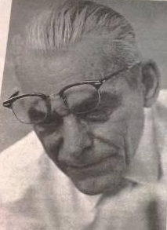
Stu Hegeman
(1915 – 1967)
Mention high-end tube amps, and names like William Johnson, Saul Marantz, and Peter Walker dominate. But Stu Hegeman belongs on that list. He was an early, passionate advocate for wideband, low-phase-shift design (minimizing timing errors) in both amplification and speakers. His circuits, particularly in the Harman-Kardon Citation Series, were renowned for being clean, linear, and musical. Hegeman deeply cared about realism and soundstage long before they became audiophile buzzwords.
Later, with his own Hegeman Labs, he developed the Model 1 speaker. Based on acoustic theory rather than fashion, it used an omni-directional driver system. Though not a huge seller, its influence was profound.
I recall making lunch for both Stu and Saul Marantz at CES over forty years ago. Saul's wife urged me to finish so the "boys" could eat. What struck me most was their contrasting temperaments. Stu was subdued, cerebral, and quietly thoughtful. Saul was outspoken and commanding.
I believe this difference seemed to reflect their design philosophies as well.
Hegeman was that rare engineer who understood both math and music. His work still echoes in modern topologies, even if his name doesn't.

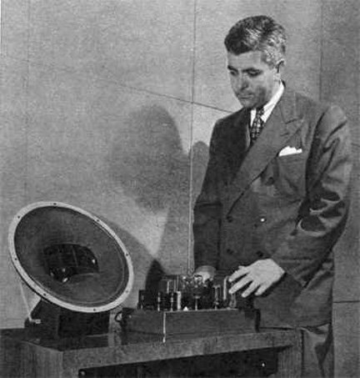
David Hafler
(1919 – 2003)
Most audiophiles know the name Hafler from the kits sold in the back of Audio and Stereo Review. But David Hafler was more than just a kit guy, he was one of the first to bring affordable, high-quality solid-state amplification to hobbyists.
He co-founded Acrosound and Dynaco, two companies that essentially defined the DIY audio movement. His circuits were simple, reliable, and easy to build. The Dynaco ST-70 might be the most popular tube amp ever made. Even today, countless clones and rebuild kits exist for it.
Later, the Hafler brand launched some of the most neutral, utilitarian amplifiers in pro audio. He also developed the Hafler circuit, a clever way to extract ambient surround information from stereo recordings, no extra channels required.
Hafler democratized good sound. While others chased flash and profit, he empowered average listeners to build something great.
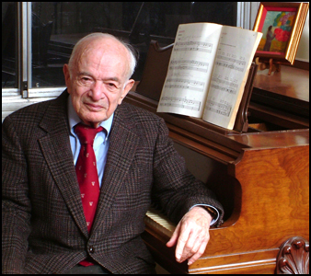
Irving M. "Bud" Fried
(1920 – 2005)
Fried wasn’t a circuit guy, he was a speaker guy. A missionary, really. He believed in time-aligned, phase-correct designs, and in transmission line bass long before it was trendy.
Through his work with IMF and later his own Fried Products, Bud introduced American audiences to a British school of speaker design that prioritized musicality over marketing specs. He was vocal, opinionated, and often a thorn in the side of bigger brands.
I really liked Bud. I was his largest West Coast dealer for over ten years, and I looked forward to his annual visits. He would host speaker seminars at my store, and I’d have customers drive in from hundreds of miles away just to hear him speak. He had a way of cutting through the noise, opinionated, yes, but always grounded in experience. Listening to Bud wasn’t just informative, it was inspiring.
His speakers, especially the early Q and C series, offered a depth and coherence that still holds up. He believed that audio should be about listening, not just measuring.
He never received mainstream praise, but to many enthusiasts, Bud Fried was the conscience of the speaker world.
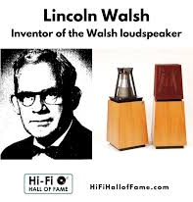
Lincoln Walsh
(1903 – 1971)
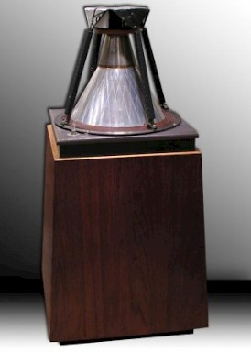
Lincoln Walsh was a quiet genius. He developed a unique, wide-dispersion driver that became the foundation for Ohm Acoustics' Walsh speaker line. His idea was radical: a true 360-degree radiating driver maintaining coherence and phase integrity.
Walsh's prototype work was groundbreaking, though he passed away before his designs reached full commercial potential. Ohm carried the torch, and the Walsh driver remains one of the most intriguing transducer technologies ever conceived.
I became aware of the Ohm Walsh A in 1972 shortly after it’s introduction and shortly after the death of Lincoln, so I never had the opportunity to meet him. I did however get to me Marty Gerstein who brought Lincoln Walsh’s technology to market and I sold the later models in 1984 and continued to sell them for many years after.
Lincoln Walsh didn't invent the most products, but he may have invented one of the most original.

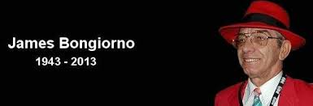
James Bongiorno
(1941 – 2013)
I first met Jim Bongiorno holding court in the sound room of "Saint James Infirmary and Gramophone Annex" on Santa Monica Boulevard, owned by a mutual friend. The shop didn't last long, but it drew an interesting crowd. Jim visited often, testing his electronics, drinking straight scotch, and puffing on foul-smelling black stogies. Brilliant, eccentric, and entirely his own man – that was Jim. His contributions to solid-state amplifier design are undeniable.
He worked for Dynaco, SAE, and Sumo before founding GAS (Great American Sound), where he created the Ampzilla – a powerful bipolar transistor amp renowned for avoiding the harsh "buzzsaw" sound of early solid-state.
Bongiorno believed in wide bandwidth, minimal phase shift, and dynamic range. His amps had authority, clarity, and attitude. So did he.
Part engineer, part showman, Jim was unforgettable to anyone who met him. His influence still resonates in modern designs.

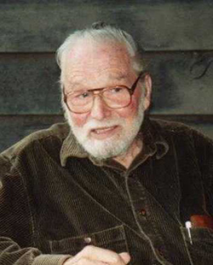
Edgar Villchur
(1917 – 2011)
Edgar Villchur figured out something revolutionary: you don't need a huge box for deep bass, just smarter engineering.
Before Villchur co-founded Acoustic Research (AR), decent low-end meant furniture-sized speakers or thin sound from bookshelf models. His acoustic suspension design changed everything. By utilizing the sealed air inside the cabinet as the primary restoring force for the driver, he achieved real bass from compact enclosures.
This was practical genius. The AR-1 and its descendants made high-fidelity accessible to people who didn't want their homes looking like recording studios.
But Villchur was more than the "sealed-box guy." He had a missionary zeal for honest testing and real measurements. While others played loose with specs, Edgar championed blind listening tests and standardized measurements. He wanted people to trust their ears, not marketing copy.
I never met him, but I deeply respected his approach. In an industry often sloppy with the truth, Villchur insisted on doing things right. His speakers sounded good because he designed them to sound good, not just measure well on paper.
Villchur essentially invented the modern bookshelf speaker. Every compact monitor today owes a debt to his 1950s innovation.

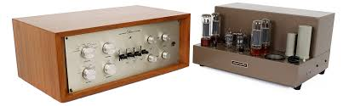
Sid Smith
(1923 –2000)
A behind-the-scenes legend, Sid Smith was the circuit designer behind iconic Marantz components like the Model 7 preamplifier and Model 8B power amplifier. While Saul Marantz provided the vision and branding, Smith ensured the products actually delivered the legendary Marantz sound.
He wasn't flashy and shunned the spotlight. Yet, his circuits are still analyzed, cloned, and restored today, often guided by his original notes.
To those in the know, Sid Smith was the quiet genius behind the sound of classic Marantz.

Jon Dahlquist
(1927 – 2005)
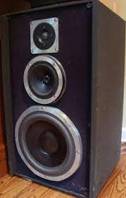
The first time I met Jon Dahlquist and Saul Marantz was when my first wife, Joni, and I were in New York. We went to visit her best friend Lannie, who was Jon’s National Sales Manager. Jon was eager to show me his latest speaker concept. He had been working with Magnat of Germany on some new designs, and also collaborating with 3M. The entire exterior of the enclosure was covered in 3M "Nextel," a textured material that resembled flocking. It was said to damp surface resonances and lower the Q of the cabinet.
I asked Jon why he chose green for the cabinet color. He kept insisting it was grey. He had this 10-inch magnifier with a bright light on a boom, and I pulled it up close to the surface and told him to take a closer look. Sure enough, there were tiny green modules mixed in. My recommendation was to spray the interior of the cabinet and use wood on the outside, so it would retain the damping properties while looking better. I hate to say it, but he didn’t listen, and after about ten years in the field, the Nextel coating started to break down and turn into a gummy mess.
Still, the DQ-10 was a standout. Jon wanted to combine the transparency of an electrostat with the punch of dynamic drivers, and he got closer than most. The open-baffle midrange and tweeter array was time-aligned and phase-consistent. It looked odd but sounded cohesive, especially when paired with the right amp. He may not have had a deep product catalog, but the DQ-10 inspired a generation of speaker designers to think differently.

Rudy Bozak
(1910 – 1982)
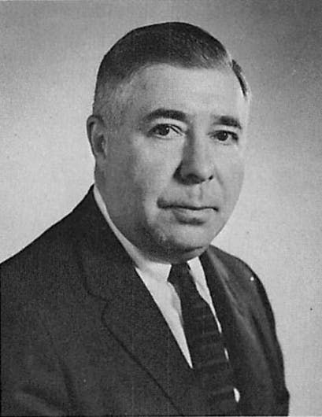
Rudy Bozak was one of the great loudspeaker visionaries of the mid-20th century. Where Edgar Villchur proved that small boxes could deliver real bass, Bozak leaned in the opposite direction, believing scale and realism required big enclosures and uncompromising driver design. His flagship creations, the massive Concert Grand and Symphony speakers, were monuments to that philosophy—systems capable of filling auditoriums as easily as living rooms.
Bozak was an early adopter of aluminum cone technology, casting woofers and midranges from the material decades before it became fashionable. The stability and low coloration of those drivers gave his speakers a distinctive, natural character that won him a following in recording studios and among serious music lovers. If Villchur gave us the modern bookshelf, Bozak gave us the experience of a concert hall transplanted into the home.
I remember attending the Los Angeles HiFi Show at the Ambassador Hotel, sometime around 1975. I took my girlfriend, Mimi Saxon, who was working with me at Northridge Audio. Mimi had recently become the first woman to achieve SAC certification, a milestone that gave her instant respect in the industry. We wandered into the Bozak room, and I was immediately impressed.
Rudy had displayed his speakers along both sides of one of the large ballrooms, with his Concert Grands set up at the end. Even in a huge room (probably 80 x 30) these speakers managed to completely fill the space. The sound hit us like a wave, full, rich, and unashamedly big. It wasn’t about subtlety; it was about presence. The sound was so loud Mimi almost immediately, turned around and walked out, later telling me it was “just too loud.” I did apologize to Rudy for that reaction.
That day reminded me why Rudy’s speakers inspired such devotion. It wasn’t until years later, when I first heard the Infinity IRS system, that I experienced such dynamics in a large venue delivered by a single pair of speakers..
Bozak may not have had the marketing reach of AR or JBL, but his work left a clear mark on American hi-fi. He believed music should be heard with the same weight and authority it had in the concert hall. To the end, his designs reflected that conviction.

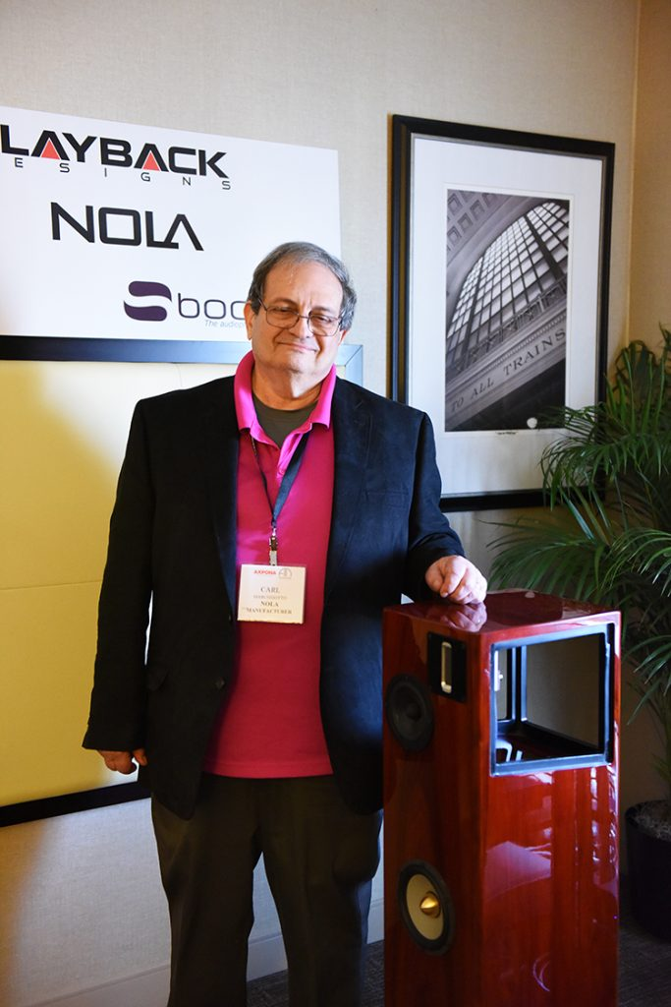
Carl Marchisoto
1949 - Present
Speaking of the Dahlquist DQ-10, not a lot of people know that even though the concept was from John Dahlquist the math behind the design was Carl Marchisoto.
I got to know Carl over the years as a dealer for NOLA, and most recently interviewed him for an article.
Carl joined Dahlquist in 1976 as chief engineer, working alongside Saul Marantz and Jon Dahlquist. His technical expertise extended beyond just the DQ-10 design calculations. His first assignment was to develop an electronic crossover for a Dahlquist subwoofer, which resulted in the LP1 variable low pass filter, with Carl handling the electronics while Saul Marantz managed the graphics.
Marchisotto brought solid academic credentials to the role, having graduated from City College in 1967 and completed his master's degree at NYU, giving him experience in precision engineering before entering the audio field.
His influence at Dahlquist was significant, he designed and launched the DQ-8, DQ-12 and DQ-20 speakers, the LP-1 frequency divider and the CM-1 amplifier.
Carl Marchisotto left Dahlquist around May 1, 1990, when Dahlquist was sold for the first time to some people that worked at Harman Kardon. He left after a couple of months working under the new owners, describing them as "mostly some mid-fi people." He told me, that the new owners had a different vision for the company's direction.
After leaving Dahlquist in 1990, Marchisotto and his wife Marilyn founded Acarian Systems in 1991. He headed ALON (also known as Acarian Systems Ltd.) for the next 14 years. During his time at Acarian, Marchisotto was prolific, creating 28 different loudspeaker designs in 12 years.
The ALON speakers carried forward some of the design philosophy from his Dahlquist days, particularly the Open Baffle Array technology, derived from concepts pioneered at Dahlquist. The partnership eventually ended when a decision was made to bring the cabinet maker in as a partner which led to complications that caused Carl and Marilyn to leave the company around 2005, before starting NOLA Speakers.
Soon after his split from ALON as he says… He turned things around, eventually founding Nola Speakers (Accent Speaker Technology) with his wife Marilyn. In 2004, they started Accent Speaker (NOLA) to recreate a listening experience as close to the "live one" as possible.
Today Nola has a reputation as one of the finest audiophile line of speakers in the world, standing beside Genisis, Von Schweikert, Wilson Audio and Magico to name a few.
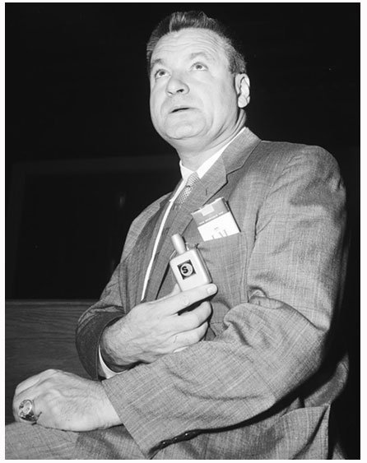
Emmanuel Bert Berlant
(1911 – 1985)
Most know Bert Berlant, if at all, as the builder of the world's most complete Marantz collection. True. Less known is that before becoming American hi-fi's unofficial historian, he helped shape it.
Berlant co-founded Concertone, an early reel-to-reel tape recorder company. When Concertone shifted from manufacturing its own tape machines to importing high-quality decks from Japan, it laid the groundwork for what would eventually become TEAC America. In many ways, Bert helped introduce Japanese precision engineering to the U.S. audio scene well before most audiophiles even knew what was coming.
But that’s only part of the story.
I met Bert because he was in a romantic relationship with my second cousin. My father, reconnecting with her after many years, invited them both over for dinner. It was meant to be a casual family evening. Instead, we ended up talking audio the entire night. What unfolded was one of the most memorable conversations of my life.
Bert didn’t just know the names, Avery Fisher, Saul Marantz, Stu Hegeman, he had worked with them. These weren’t distant industry legends to him. They were colleagues, some friends, some rivals, all part of a tight-knit era when American hi-fi was still figuring out what it wanted to be. He didn’t speak with ego or nostalgia. He simply remembered, clearly, honestly, with the kind of insight you only get from someone who was there when it all happened.
What stuck with me most was how deeply he cared about preserving the truth of that history. Later, Bert would become known as the world’s foremost private archivist of Marantz gear and documentation. His collection wasn’t just about owning mint-condition 10Bs or early Model 1 preamps. He had internal memos, handwritten notes from Sid Smith, photos from the original factory floor. He preserved the things most people would throw away, and in doing so, he preserved the story.
Bert wasn’t a circuit designer. He didn’t start a global brand. But without him, huge pieces of this industry’s history would be gone. He gave us context. He gave us clarity. And he made sure the early vision of high fidelity wasn’t reduced to just marketing slogans and collector’s trivia.
That dinner taught me something. This business wasn’t built solely by engineers or marketers. It was also built by people like Bert, people who remembered, who documented, who gave a damn about getting the story right.
Because history doesn’t preserve itself. Bert Berlant made sure the soul of American hi-fi didn’t disappear.

Final Thoughts
The industry moves forward. New technologies emerge, new brands rise, and the conversation around audio keeps evolving. But the foundations were laid by people who rarely make the front of a glossy catalog or get quoted in a press release. These were men of principle, vision, and in many cases, quiet brilliance. They didn’t chase trends; they built ideas that lasted.
Some of them, like Saul Marantz or Edgar Villchur, had their moment in the sun. Others, Stu Hegeman, Sid Smith, Bud Fried, remained largely in the shadows. But each of them brought something irreplaceable to the table: a commitment to sound as both science and art. And a belief that better listening makes for better living.
Their gear may be vintage now, but their values still resonate. And if we’re lucky, we’ll carry a few of them forward into whatever comes next.

