The Dumbest Cars of All Time
Presented by: Marc Silver

Some cars are built to break speed records. Others aim to revolutionize design. And then there are those that, intentionally or not, redefine what it means to fail.
This is not a list of just bad cars. This is about the dumbest: vehicles so poorly conceived, laughably constructed, or bafflingly unnecessary that their very existence begs the question: "What were they thinking?"
Let’s hit the gas and drive straight into absurdity.
The Dawn of Automotive Disasters
Before the auto industry had regulations, crash testing, or even common sense, inventors worked with little more than imagination and scrap metal. Some of these early attempts feel like failed dreams.
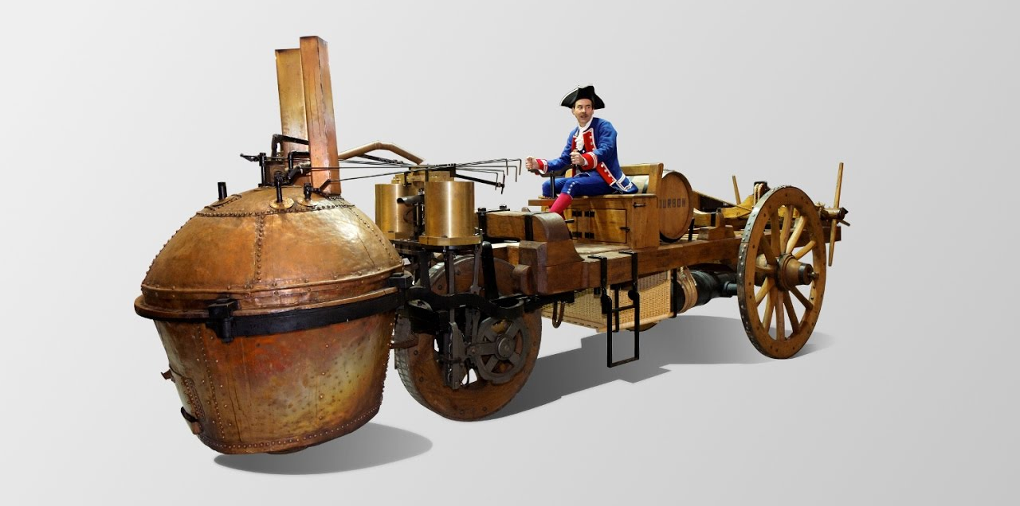
Cugnot Fardier (1769, France)
The first self-propelled vehicle, a steam-powered artillery tractor, moved at 2 mph and was so hard to steer it caused the first recorded automobile accident.
A bold idea, but barely drivable.
Legacy: Gave us the first car, and the first fender bender.
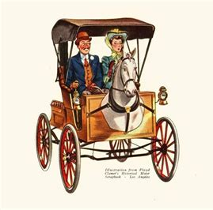
Horsey Horseless (1899, USA)
An attempt to ease horses into the motor age with a wooden horse head mounted on the front of a motorized carriage.
It was supposed to make horses feel comfortable. It didn’t.
Bonus Dumbness: The horse head stored gasoline. Fire risk? Maybe, but where did you pour in the gas?.


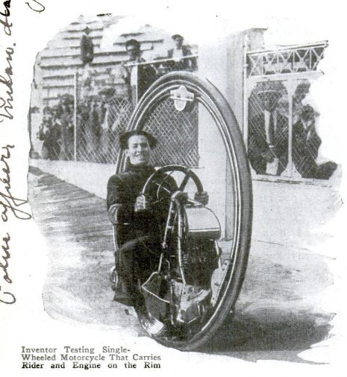
Buckingham Monowheel (1869, UK)
Imagine a hamster wheel, but for humans. You sat inside and pedaled. Later models added steam. What they didn’t add was balance.
Nickname: The "Gerbilmobile."
Modern Take: Believe it or not, the monowheel concept is still rolling—literally. In 2020, a Duke University team developed the EV360, an electric monowheel designed to top 70 mph and challenge the Guinness World Record. With hubless tech and lean-based steering, it’s a sleek nod to a wobbly past. Sometimes history doesn’t just repeat—it laps itself.

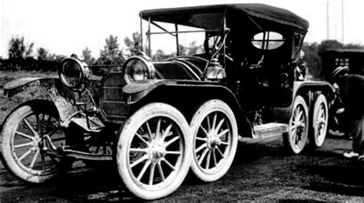
Overland OctoAuto (1911, USA)
Eight wheels. Twenty feet long. Zero buyers. This monstrosity was intended to provide a smoother ride. Instead, it proved that more wheels do not mean more wisdom. The front two wheels did the steering, which created a problem for the second set of wheels that didn’t steer. This proved that some ideas are just not well thought out.

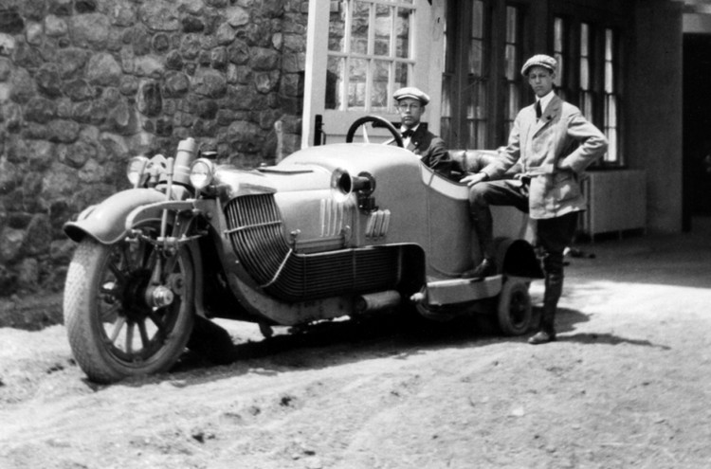
Scripps-Booth Bi-Autogo (1913, USA)
Weighing 3,200 pounds and riding on wooden wheels, this early V8-powered motorcycle needed outrigger wheels to stay upright. At least it set a record, for being utterly impractical. On the plus side it was one of the first vehicles with a V8 engine.

Briggs & Stratton Flyer (1920, USA)
More park bench than car. It had no roof, no body, no suspension, just a lawnmower engine and a prayer. It’s a miracle it moved at all.
Reminds me of the go-carts we had as children. Except this sat two and had a horn.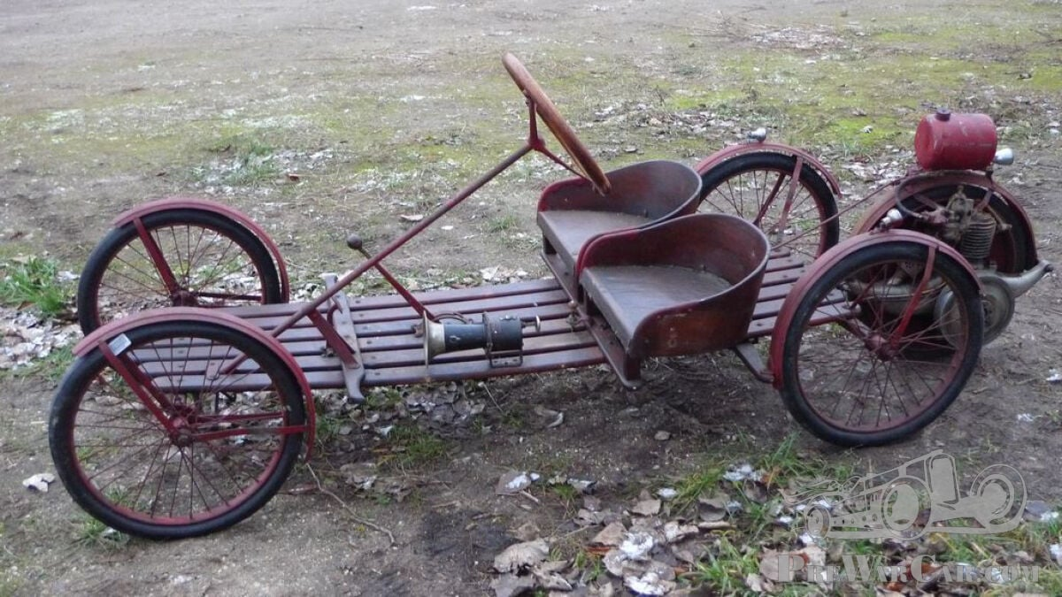
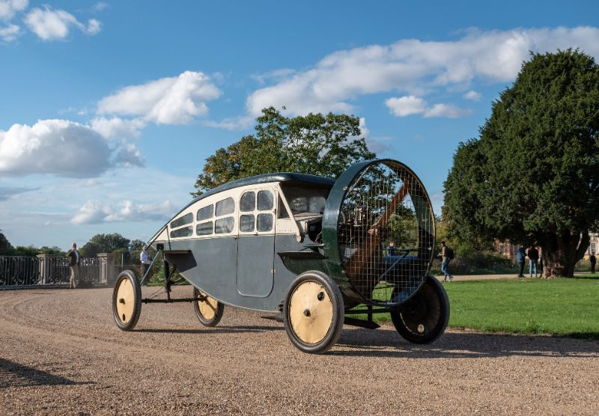
Leyat Hélica (1919–1925, France)
Propeller-driven at the front. No windshield. No protection. The car blew wind and road debris straight into your teeth. Somehow, it hit 106 mph. Also, somehow, you lived to talk about it. It was one of the fasted vehicles on the road at the time.
Then again what can you do with the parts after you crash a plane?
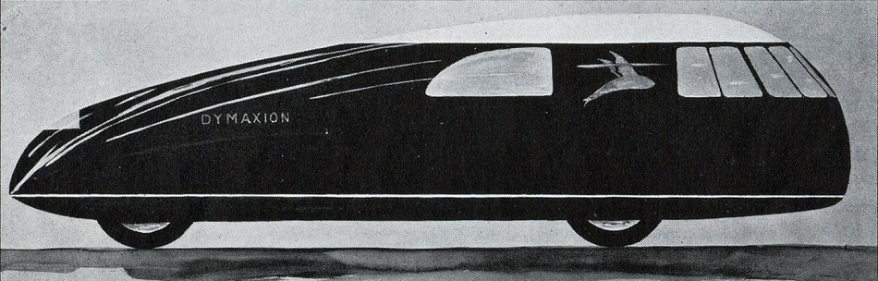
Fuller Dymaxion (1933, USA)
Part car, part zeppelin, part bad idea. A rear-steering three-wheeler that handled like a greased unicycle. One crash was enough to end its run. It remains the poster child for brilliant but doomed ambition.

When Weird Turns Dangerous: Mid-20th Century Failures
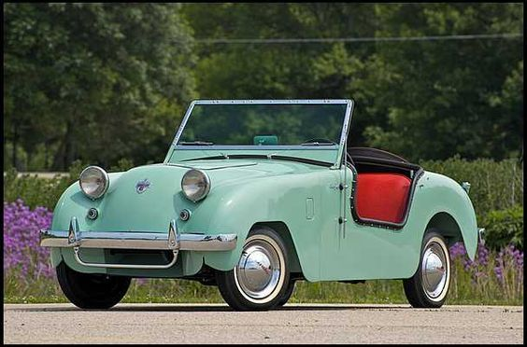
Crosley Hotshot (1949, USA)
One of America’s earliest sports cars. Also, one of the worst. Its tin-can engine was brazed together and known to explode. So yes, technically it livd upto it’s name “hotshot”.

Renault Dauphine (1956, France)
If rust were a feature, this car would be a masterpiece. It was so slow; it took over 30 seconds to hit 60 mph. Often described as the French answer to a question no one asked. Considered one of the slowest vehicles ever made, regrettably it also was not one of the safest.
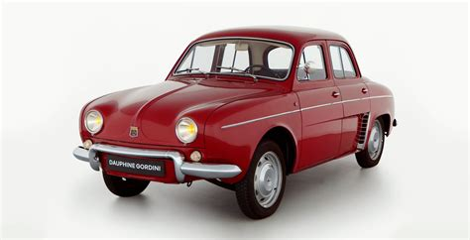
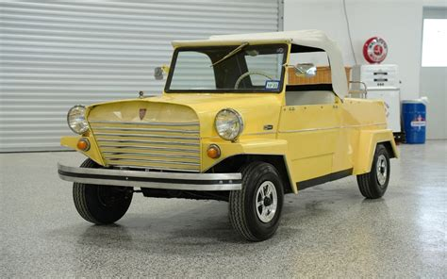
King Midget Model III (1957, USA)
Marketed as an affordable car for everyone. What you got was a 9-hp engine wrapped in glorified tin foil. Folded steel, zero safety, all charm. Sort of. It was reviewed as a car barely viable for city streets.
Waterman Aerobile (1957, USA)
A flying car that couldn’t quite fly. Or drive. Or sell. But it had wings and ambition, and almost killed its pilot. Today, it’s safely grounded in a museum.

Zündapp Janus (1958, Germany)
With passengers facing backward in the rear seat, this car was always going the wrong direction. Its 14-hp engine ensured that either way, you weren’t going far.
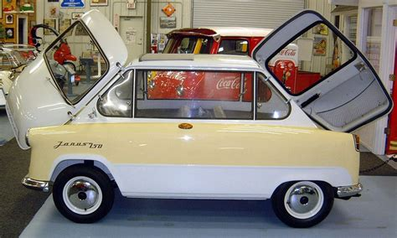 Reminicent of two Issetas crammed together.
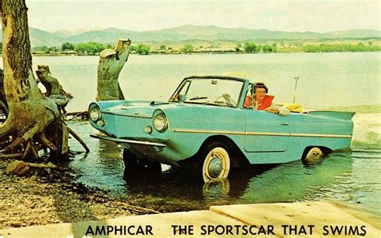
Amphicar (1961, Germany)
A car that doubled as a boat, badly. On land it handled like a drunk otter; on water, it leaked like a sieve. But you could sort of float. Sometimes.
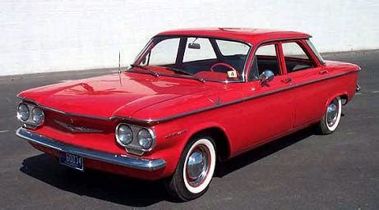
Chevrolet Corvair (1960s, USA)
Beautiful, dangerous, and beloved. The rear-engine design caused deadly handling quirks. Ralph Nader’s Unsafe at Any Speed helped sink it, but it went down swinging, and spinning.
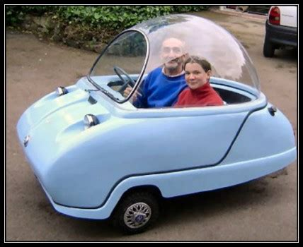
Peel Trident (1966, Isle of Man)
A bubble-topped microcar barely big enough for a child and a sandwich. Looked like a washing machine with ideas. Drove like one too.
Some of you may have seen the Peel on BBC’s “Top Gear”

The Golden Age of Stupid: 1970s–1980s
AMC Gremlin (1970, USA)
Imagine slicing the back off a normal car and calling it done. Welcome to the Gremlin. Its design was baffling, its build quality lacking, and its name unintentionally perfect.
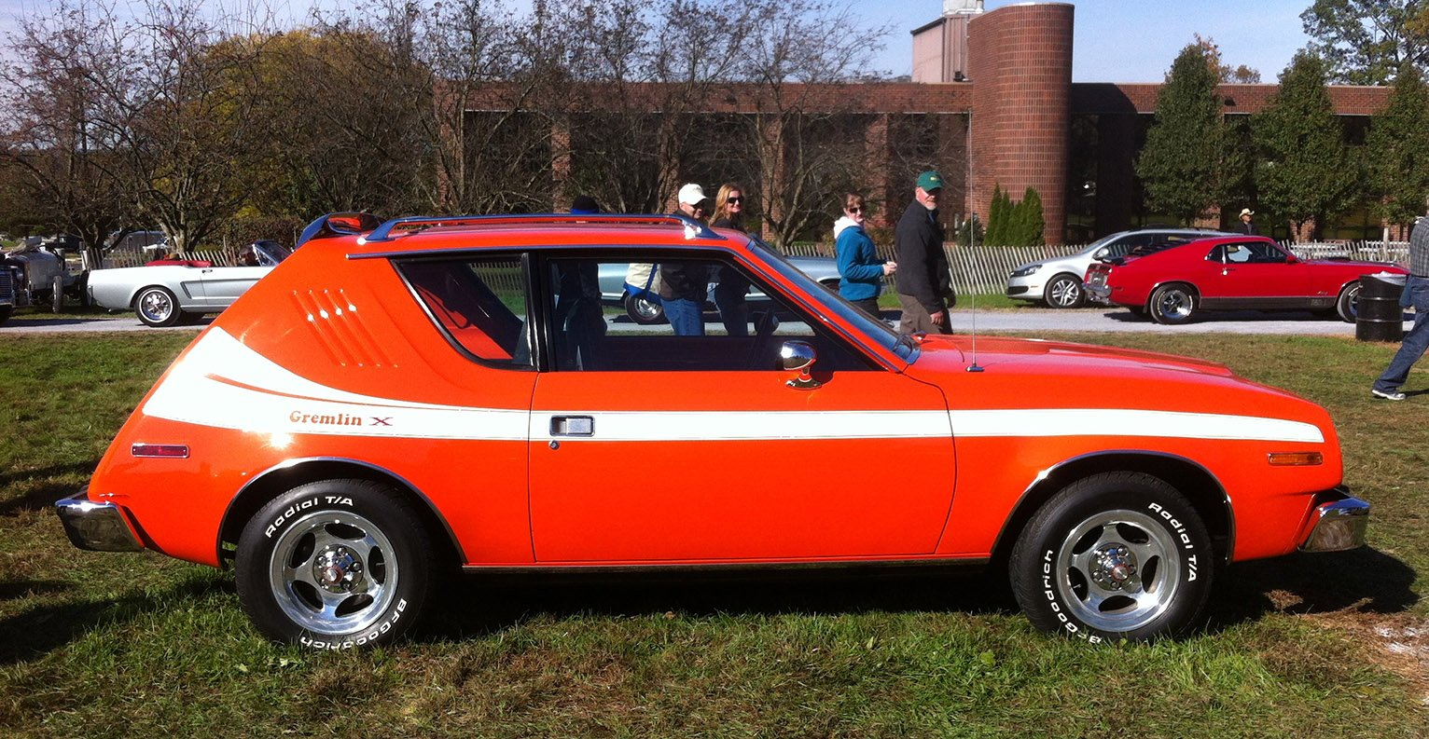
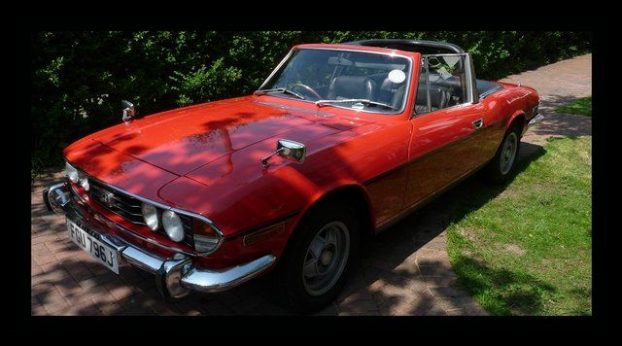
Triumph Stag (1970, UK)
Stylish, yes. Reliable? Not even close. The V8 engine was a Frankenstein’s monster of parts that rarely worked together. Water pumps failed, engines overheated, and owners wept. Triumph nearly single handedly gave British Automobile the reputation of being the most unreliable cars on the road.

Speaking of unreliable, we all need to give the nod to Ford Motors and the Pinto.
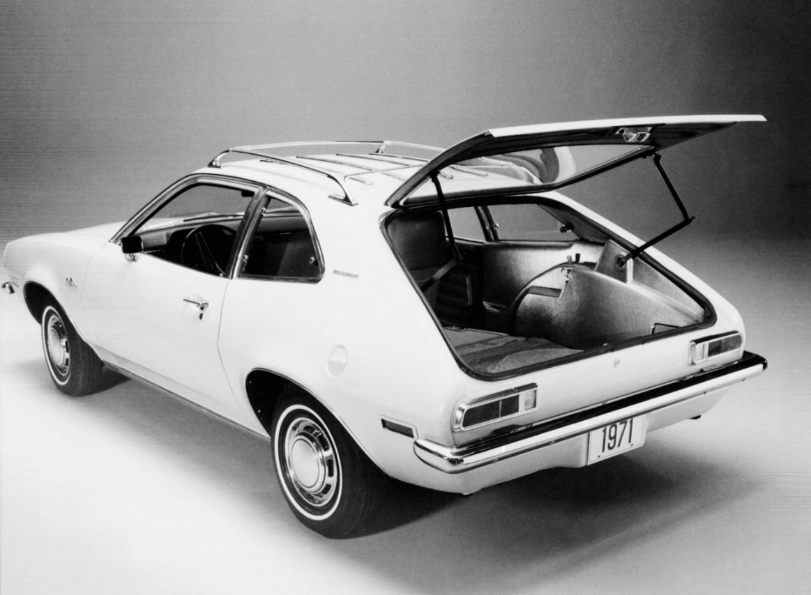
Ford Pinto (1971, USA)
The fireball that drove a nation to re-think auto safety. Its fuel tank could rupture in rear-end collisions, turning fender-benders into funeral processions. And Ford knew it even before the offered the Pinto for sale. They just underestimated the number of rear end collisions the Pinto would be in.
Trabant (1957–1991, East Germany)
Two-stroke pollution boxes made of cotton and plastic. So underpowered it couldn’t outrun sarcasm. To add insult to injury it took 16 years to get one thanks to the efficiency of the Communist Party. Most were left behind after the Berlin Wall fell. Thousands of East Germans drove their Trabants over the border when the Wall fell, which made it a kind of automotive liberator. Once across the border, the none-too-sentimental Ostdeutschlanders immediately abandoned their cars. Ich bin Junk!
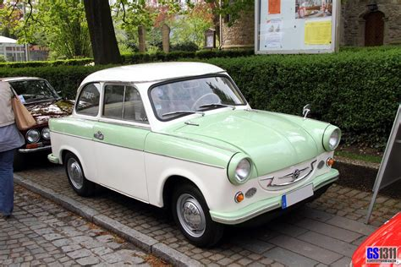
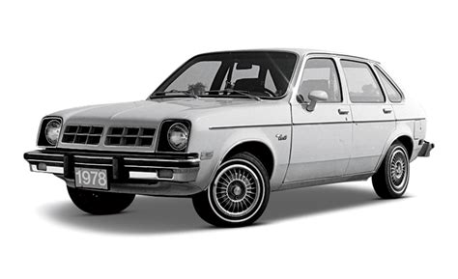
Chevy Chevette (1976, USA)
An economy car that redefined the word "basic." It was cheap, slow, and dull, but surprisingly durable. There’s always one person who swears by it. That person is wrong.

AMC Pacer (1978, USA)
More glass than car. The Pacer looked like a fishbowl on wheels and had the structural integrity of wet cardboard. It’s now a campy classic, but dumb? Absolutely.
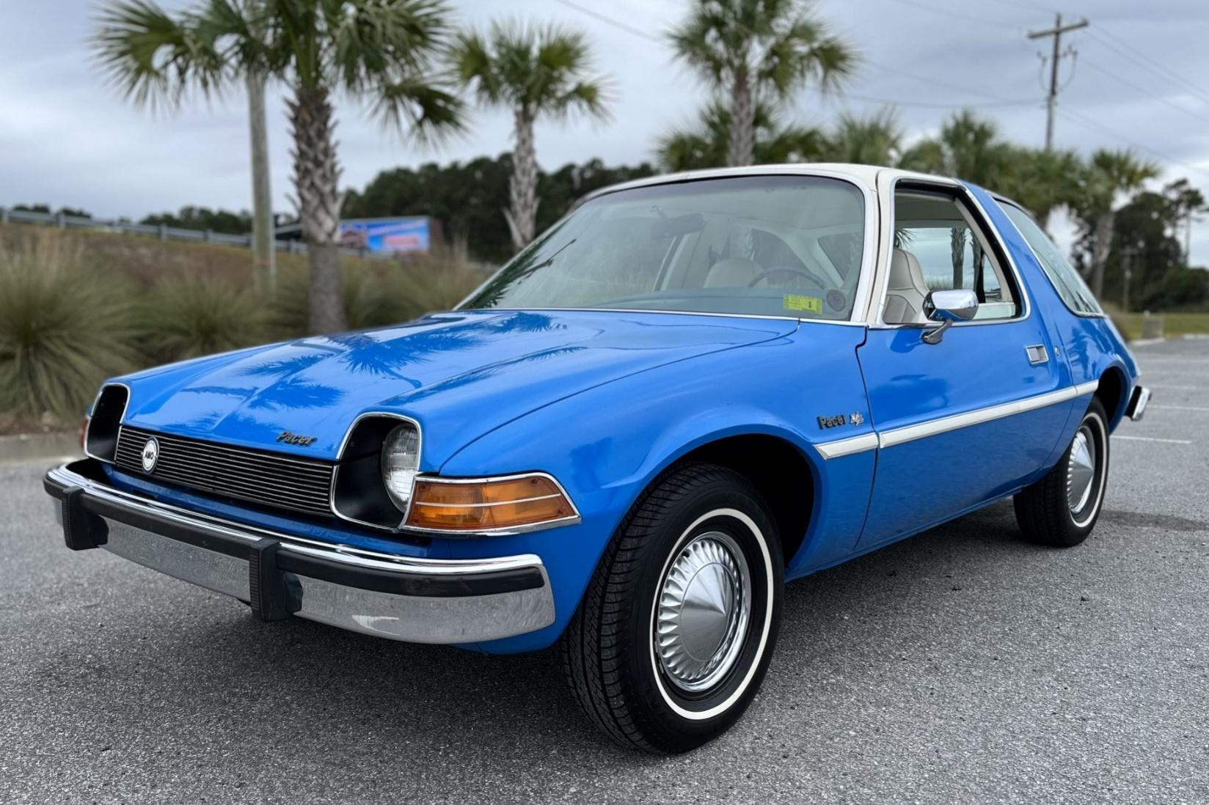
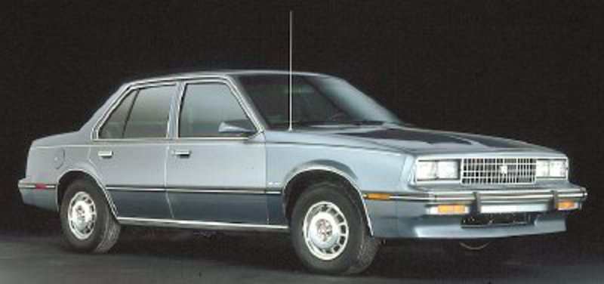
Cadillac Cimarron (1982, USA)
A rebadged Chevy Cavalier dressed up in Cadillac badges and false promises. It nearly destroyed the brand’s reputation, and it deserved to. Gives us the term lipstick on a Pig.Yugo GV (1985, Yugoslavia)
A car so bad, it became a punchline. When Fiat sold their old tooling to Yugoslavia so the Soviets could build what was already a poor car. Built with all the joy of a cold war, it had zero reliability, zero performance, and even less charm.
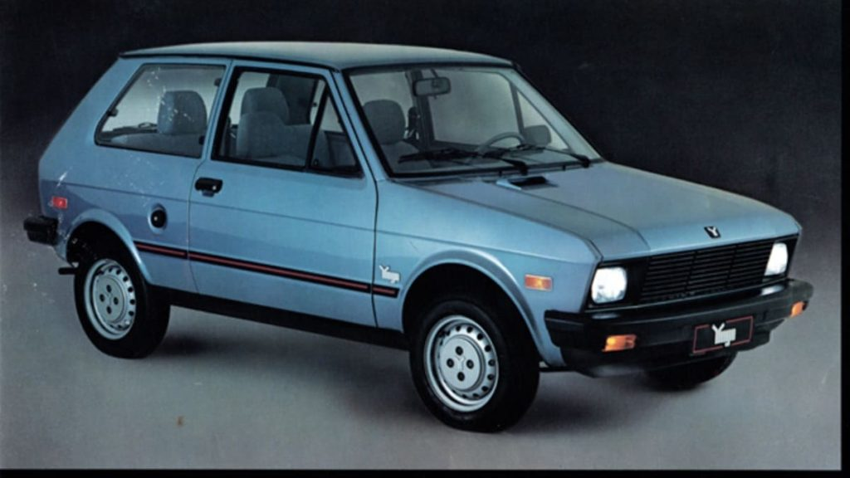
The Modern Misfires
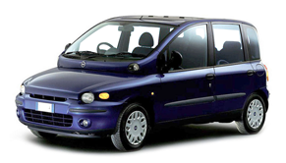
Fiat Multipla (1998–2004, Italy)
Designed like a frog in mid-sneeze. While it technically worked, its design was so off-putting that it became shorthand for “what not to do.” At least the USA never had to deal with the Multipla.
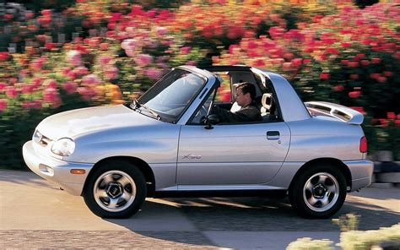
Suzuki X-90 (1995–1997, Japan)
Part SUV, part sports car, all confusion. It had a T-top roof and no real purpose. Sales were dismal. So was the handling.
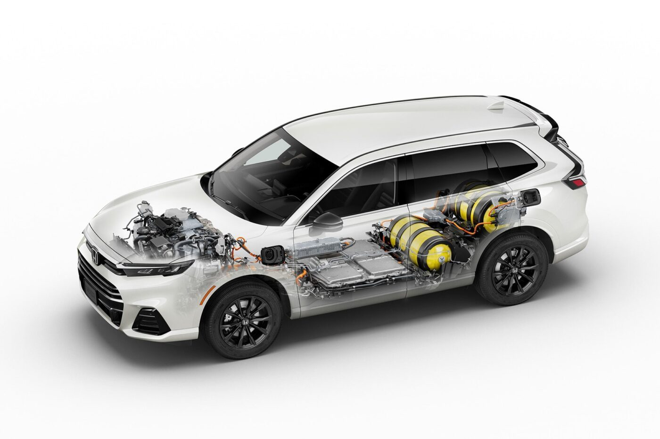
Toyota Mirai (2014–present, Japan)
Hydrogen-powered dreams meet real-world infrastructure problems. With almost nowhere to refuel and high costs, the Mirai is the future we’re still not ready for.
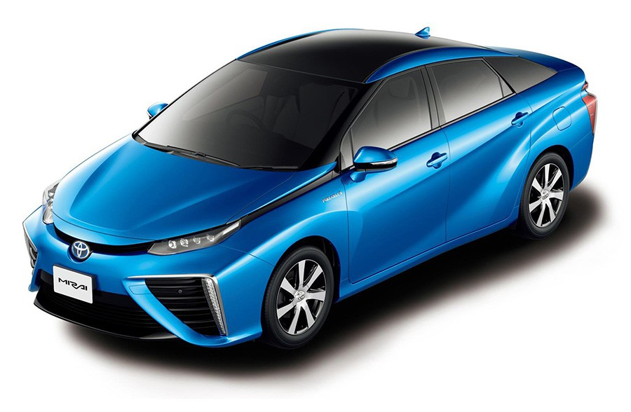
Reva G-Wiz (2001–2012, India)
An electric city car with crash safety ratings lower than a cardboard box. Its range was a joke. Its performance was a tragedy. Its buyers were either brave, or just uninformed.
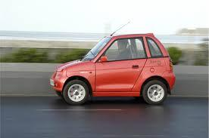
Honda CR-V FCEV (2023, Japan)
Like the Mirai, but dressed as a family SUV. Only leaseable. Nearly unserviceable. And unlikely to leave California.
Mazda MX-30 (2021–2023, Japan)
An EV that could barely go 100 miles on a full charge. Which is fine, if you live inside a parking lot.
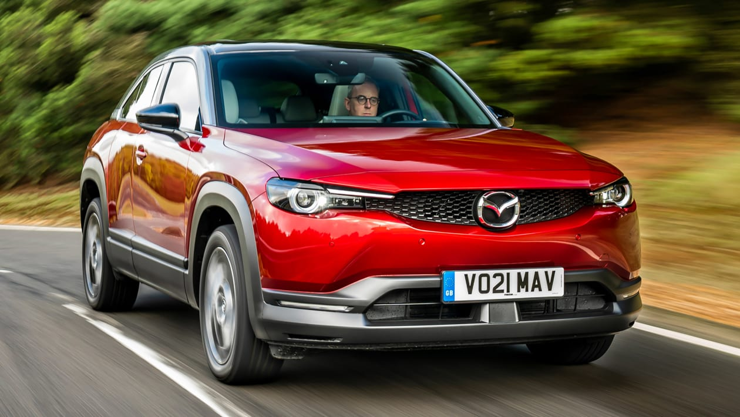
Tesla Cybertruck (2024–, USA)
The truck that broke the internet, and maybe a few bones, if you believe the sharp edges. With unfinished software, panel gaps you could walk through, and a price tag that keeps climbing, it’s equal parts design experiment and industrial dare.
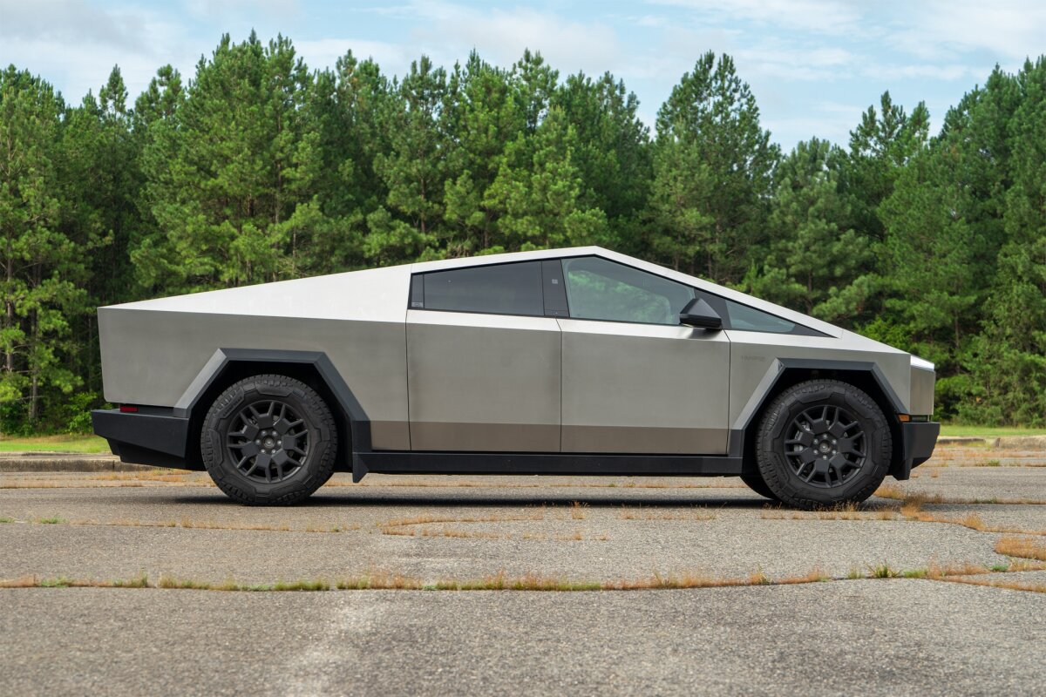
Nissan Murano CrossCabriolet (2011–2014, Japan)
A convertible SUV no one asked for. It was structurally weak, weirdly proportioned, and the only thing worse than driving it was being seen in it.
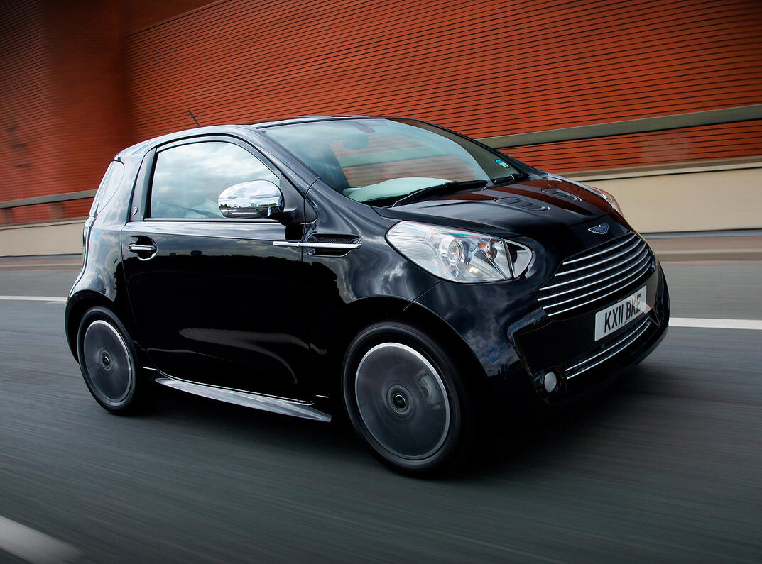

Aston Martin Cygnet (2011–2013, UK)
A Toyota iQ wearing a tuxedo. It cost more than $37,000 and delivered none of the performance Aston Martin was known for. Brand dilution in its purest form.
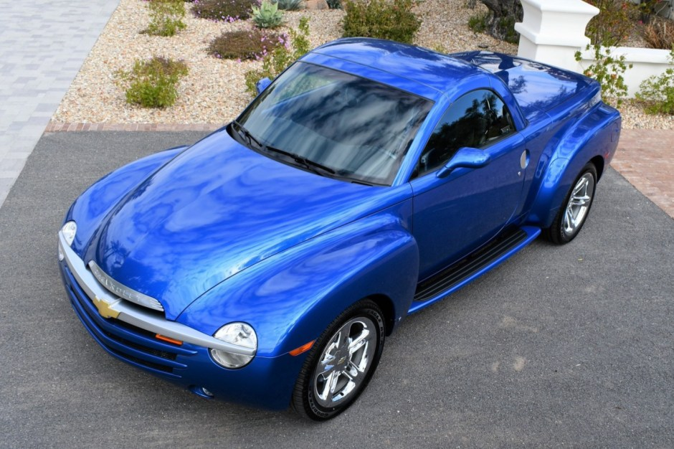
Chevrolet SSR (2003–2006, USA)
A convertible pickup that couldn’t haul, couldn’t tow, and couldn’t find a market. Now a cult car, then a head-scratcher.
Jeep Compass (2006–2016, USA)
Designed for youth appeal, but delivered rubbery steering, a whiny CVT, and an interior that felt like a punishment. The first-gen Compass chased customers away, right into the arms of Honda and Toyota.
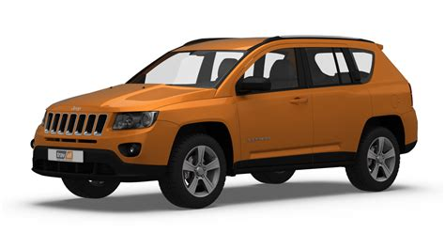
Final Thoughts
Cars reflect our culture. Sometimes they reflect our mistakes. From early steam-powered failures to modern hydrogen experiments, the dumbest cars ever made remind us that innovation often walks hand-in-hand with disaster. But there’s value in failure. These cars dared to be different. Most failed spectacularly. Some became cult classics. And all of them make the automotive world a more interesting place.
So next time you pass a weird little coupe on the highway and wonder, "What were they thinking?", remember: they were probably thinking just like everyone else who made this list. Boldly. Incorrectly. And with the pedal to the floor.

What cars are considered the worst vehicles ever built based upon a worldwide analysis? I want to focus on the cars that have been reviewed as the worst, however I put a premium on the most ridiculous and badly built.

The Dawn of Automotive Disasters: 19th & Early 20th Century
When inventors threw logic out the window and embraced chaos.
1. Cugnot Fardier (1769)
Inventor: Nicolas-Joseph Cugnot (France)
Why It Was Awful:
- The first self-propelled vehicle was a steam-powered artillery tractor that weighed 2.5 tons and moved at 2 mph.
- Uncontrollable steering; famously crashed into a wall during a demo (the first car accident in history).
Redeeming Quality:
- Pioneered the concept of mechanical locomotion.
Legacy:
- Proof that even genius inventors need brakes.

2. Horsey Horseless (1899)
Inventor: Uriah Smith (USA)
Why It Was Awful:
- A literal wooden horse head mounted on the front to "trick real horses" into thinking it was a carriage.
- The hollow head stored gasoline, creating a fire hazard. Horses were not fooled.
Redeeming Quality:
- A+ for effort in bridging the gap between horse-drawn and motorized travel.
Legacy:
- The automotive equivalent of putting googly eyes on a toaster.

3. Buckingham Monowheel (1869)
Inventor: D.J. Smith (UK)
Why It Was Awful:
- A single giant wheel with the driver sitting inside it, powered by pedals and later steam.
- Prone to "gerbiling" (spinning uncontrollably) and near-impossible to balance.
Redeeming Quality:
- Inspired sci-fi designs (e.g., Star Wars’ wheel bikes).
Legacy:
- A reminder that wheels work better in pairs.

4. Overland OctoAuto (1911)
Inventor: Milton Reeves (USA)
Why It Was Awful:
- Eight wheels arranged in two rows, designed for a "smoother ride." It was 20 feet long, weighed 4,000 lbs, and looked like a drunken centipede.
- Zero sales. Not. One.
Redeeming Quality:
- Early exploration of multi-wheel suspension (later used in trucks and tanks).
Legacy:
- Sometimes, more is definitely less.

5. Scripps-Booth Bi-Autogo (1913)
Inventor: James Scripps-Booth (USA)
Why It Was Awful:
- A 3,200-lb "motorcycle" with a V8 engine and outrigger training wheels.
- Top-heavy, unwieldy, and about as stable as a drunk tightrope walker.
Redeeming Quality:
- First V8-powered vehicle built in Detroit (a precursor to American muscle).
Legacy:
- The answer to the question: What if a locomotive and a bicycle had a baby?

6. Briggs & Stratton Flyer (1920)
Inventors: Stephen Briggs & Harold Stratton (USA)
Why It Was Awful:
- A motorized park bench with bicycle wheels, powered by a 2-hp lawnmower engine.
- No suspension, no body, no windshield, just you, the road, and existential dread.
Redeeming Quality:
- Cost $150 (about $2,300 today), making it the "Model T for hobos."
Legacy:
- Proof that "car" is a generous term.

7. Leyat Hélica (1919–1925)
Inventor: Marcel Leyat (France)
Why It Was Awful:
- A propeller-driven car with no traditional engine, just a giant airplane propeller bolted to the front.
- Deafening noise, zero safety, and a tendency to blow debris into the driver’s face.
Redeeming Quality:
- Hit 106 mph in 1927, making it one of the fastest cars of its time.
Legacy:
- The only car where "wind in your hair" meant "propeller gusts in your teeth."

8. Fuller Dymaxion (1933)
Inventor: Buckminster Fuller (USA)
Why It Was Awful:
- A teardrop-shaped three-wheeler with rear-wheel steering that caused violent wobbles at speed.
- One prototype crashed fatally, killing the driver and dooming its reputation.
Redeeming Quality:
- Aerodynamic design inspired future concepts (and the name Dymaxion later graced a utopian house).
Legacy:
- A lesson in how "futuristic" can mean "fatally flawed."

Why These Early Disasters Matter
- They Defined Failure (So Others Could Succeed): Each disaster taught engineers what not to do, paving the way for modern standards.
- They’re Time Capsules of Creativity: These vehicles reflect the optimism and naivety of early industrial innovation.
- They’re Collector Gold: Today, oddities like the Dymaxion or Hélica sell for millions as art-meets-engineering relics.

The Takeaway for Enthusiasts
- Embrace the Chaos: These cars remind us that progress is messy, weird, and occasionally explosive.
- Seek Them Out: Many early disasters survive in museums (e.g., the Cugnot Fardier in Paris, the Dymaxion in Nevada).
- Laugh & Learn: The automotive industry owes its success to these glorious failures.

Final Thought
The road to the modern car was littered with horse heads, steam explosions, and eight-wheeled monstrosities. While these early disasters were objectively terrible, they’re a testament to human ingenuity, and our unmatched ability to laugh at ourselves.
Want more deep dives into automotive insanity? Let me know!

Fuller Dymaxion (1933)
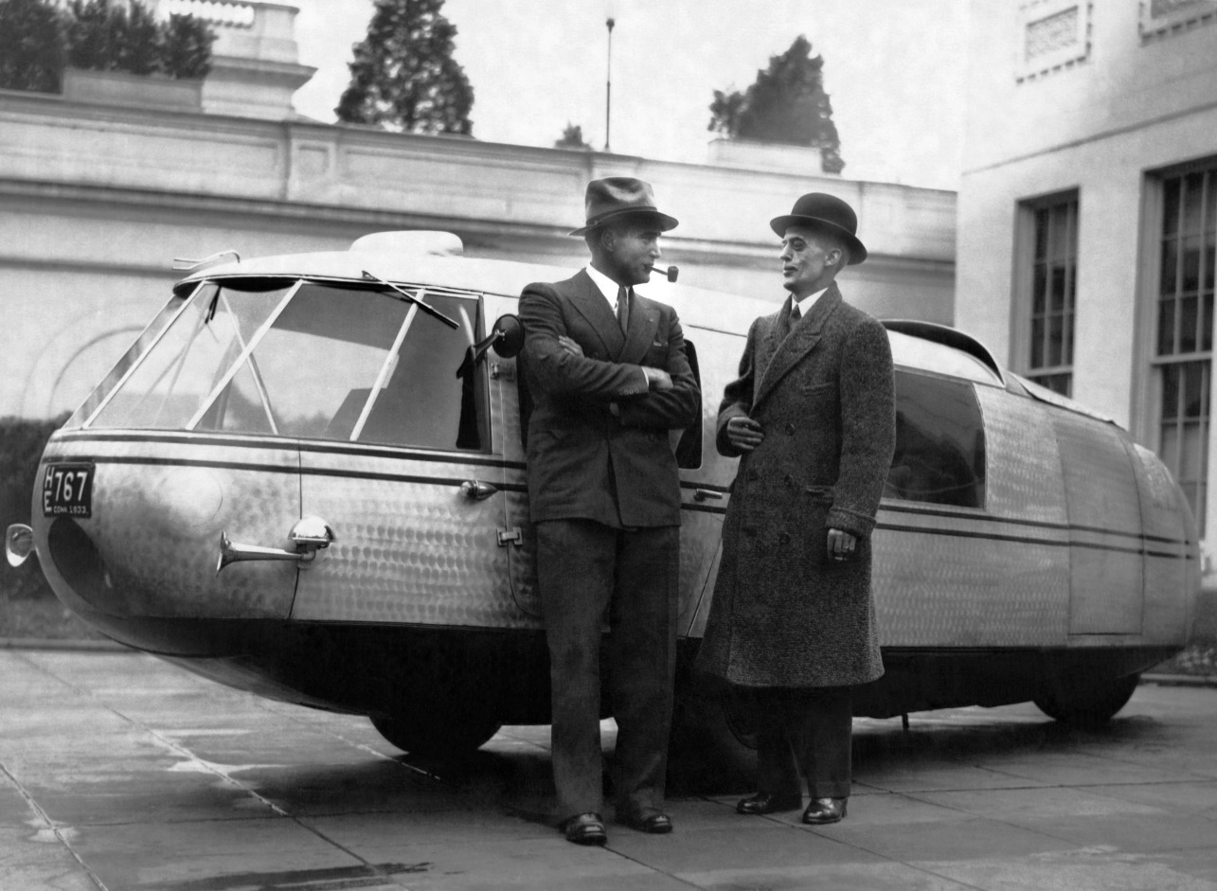Underwood Archives/Getty Images
Renault Dauphine (1956)
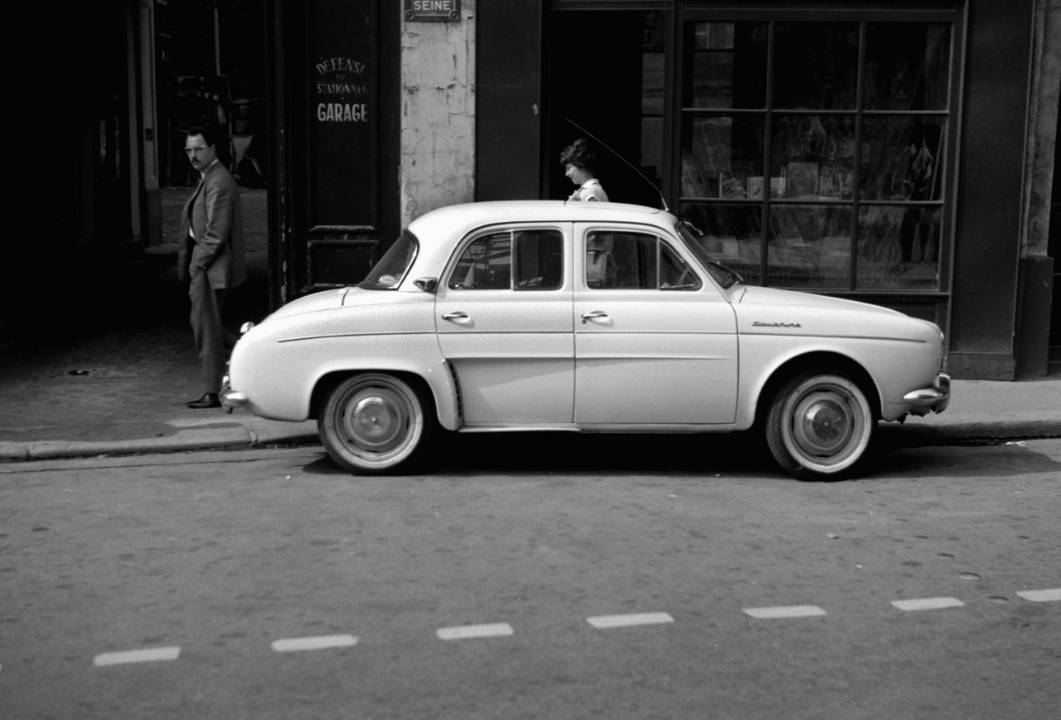Roger Viollet Collection/Getty Images
Trabant (1975)
This is the car that gave Communism a bad name. Powered by a two-stroke pollution generator that maxed out at an ear-splitting 18 hp, the Trabant was a hollow lie of a car constructed of recycled worthlessness (actually, the body was made of a fiberglass-like Duroplast, reinforced with recycled fibers like cotton and wood). A virtual antique when it was designed in the 1950s, the Trabant was East Germany’s answer to the VW Beetle , a “people’s car,” as if the people didn’t have enough to worry about. Trabants smoked like an Iraqi oil fire, when they ran at all, and often lacked even the most basic of amenities, like brake lights or turn signals. But history has been kind to the Trabi. Thousands of East Germans drove their Trabants over the border when the Wall fell, which made it a kind of automotive liberator. Once across the border, the none-too-sentimental Ostdeutschlanders immediately abandoned their cars. Ich bin Junk!
Chevy Chevette (1976)
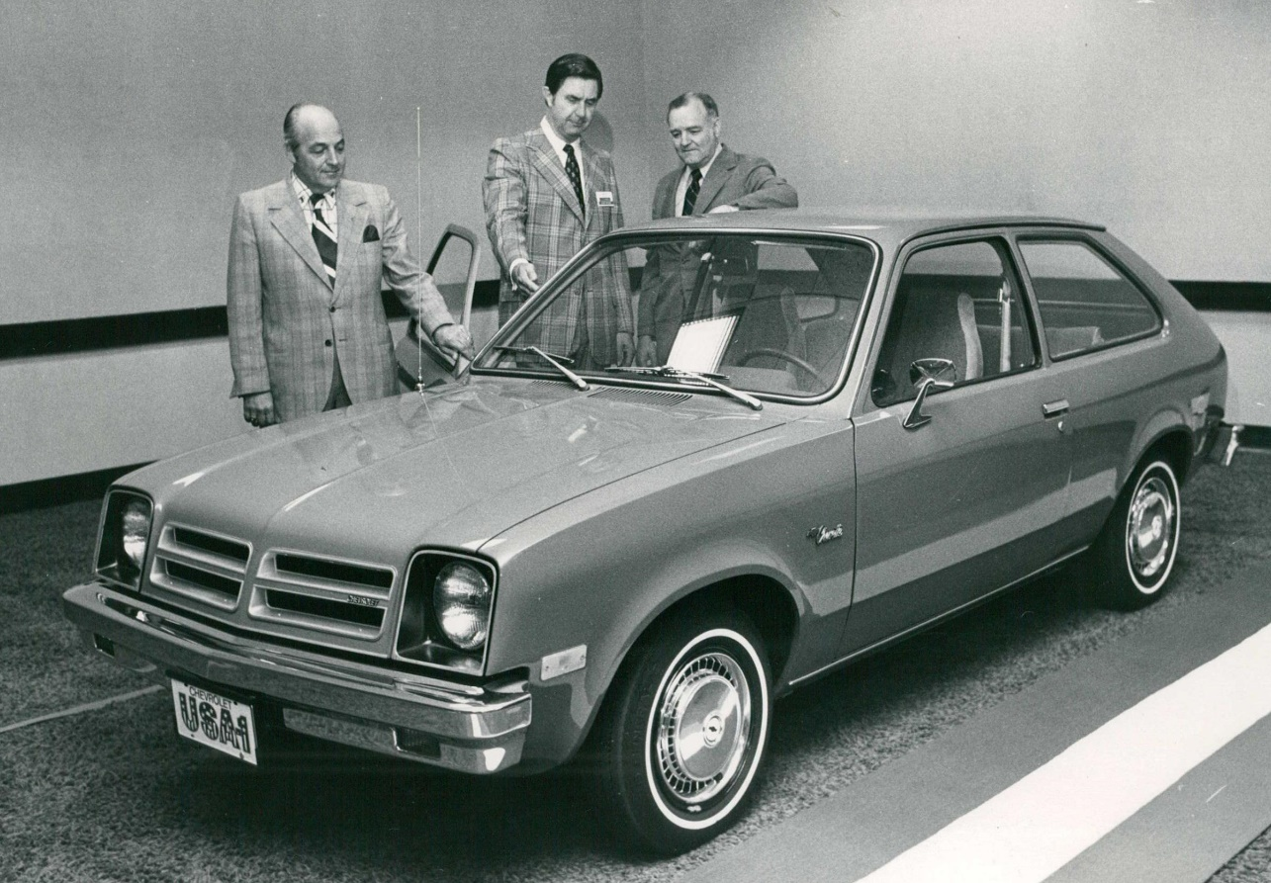Bill Johnson, The Denver Post/Getty Images
I include the Chevy Chevette only to note that even the most unloved and unlovely cars have their partisans. There are Pacer fan clubs and Yugo fan clubs, and if there is a Chevette fan club, let it begin with me. My girlfriend in college had a diaper-brown Chevette three-door hatchback, as bare bones as an exhibit at the natural history museum. It had a 51-hp engine and a four-speed manual transmission and not much else. It was loud and it was tinny, but we drove that car across the country three times and it never failed us. Once I got a 85-mph speeding ticket in it. That was on the down slope of the Appalachians, but still. The last time I saw that Chevette it was still plugging along. Vaya con Dios, old paint.
AMC Pacer (1978)
A recent poll by Hagerty Insurance asked enthusiasts to name the worst car design of all time: This glassine bolus of dorkiness is the pathetic winner. Remember Richard Teague, designer of the amputated Gremlin? Him again. But, come on, the Pacer, it’s Wayne and Garth’s Mirth-mobile, for Heaven’s sake! You can’t hate on that. Indeed, my family owned a dark green Pacer with that Navajo-blanket upholstery, and it worked just fine until I drove it through a ditch, after which the heavy doors hung off their hinges like beagle ears. What I remember of this car is that, in the summer, it was like being an ant under a mean kid’s magnifying glass. The air conditioning was non-existent. You could actually see fumes of volatile petrochemicals out-gassing from the plastic dash. Wayne, I feel woozy.
Cadillac Cimarron (1982)
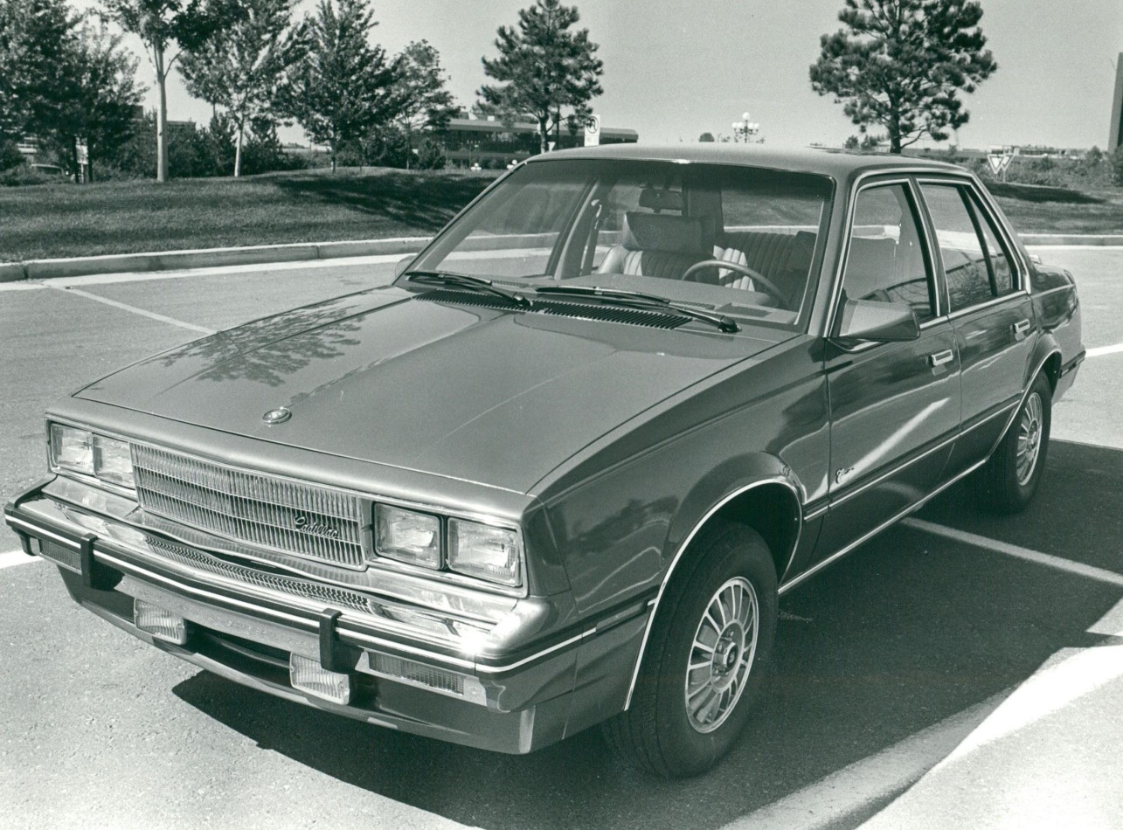Duane Howell, The Denver Post/Getty Images
The horror. The horror. Everything that was wrong, venal, lazy and mendacious about GM in the 1980s was crystallized in this flagrant insult to the good name and fine customers of Cadillac. Spooked by the success of premium small cars from Mercedes-Benz, GM elected to rebadge its awful mass-market J-platform sedans, load them up with chintzy fabrics and accessories and call them “Cimarron, by Cadillac.” Wha…? Who? Seeking an even hotter circle of hell, GM priced these pseudo-caddies (with four-speed manual transmissions, no less) thousands more than their Chevy Cavalier siblings. This bit of temporizing nearly killed Cadillac and remains its biggest shame.
Mosler Consulier GTP (1985)
Warren Mosler, a brilliant economist and investor, built his sports racer out of bits and parts that fell off the Big Three’s table , a steering wheel from a minivan here, a Chrysler engine there, some mismatched gauges , but mostly what he did was to add lightness. The resulting fiberglass-bodied car had a marvelous power-to-weight ratio and did so well in racing that it was eventually banned. Or it might have been that the course workers were suffering from post-traumatic stress from the sight of the thing. Mosler had thought of everything but a stylist, and the pride and joy of this arch-capitalist looked like something from an East German kit-car company. Truly one of the ugliest cars ever, the Consulier GTP proved once and for all that building a car is harder than it looks.
Yugo GV (1985)
Malcolm Bricklin, he of the Bricklin SV1, wouldn’t be satisfied until he had forced every American to walk to work. To that end, in 1985, he began importing the Yugo GV, which turned out to be the Mona Lisa of bad cars. Built in Soviet-bloc Yugoslavia, the Yugo had the distinct feeling of something assembled at gunpoint. Interestingly, in a car where “carpet” was listed as a standard feature, the Yugo had a rear-window defroster , reportedly to keep your hands warm while you pushed it. The engines went ka-blooey, the electrical system , such as it was , would sizzle, and things would just fall off. Yugo. Or not.
Fiat Multipla (1998)
“Multipla” is a time-honored name for Fiat. The company made an adorable microvan by that name in the ’50s and ’60s, based on the Fiat 600. The Multipla that appeared in 1998 was anything but adorable. With its strange high-beam lenses situated at the bottom of the A-pillars (base of the windshield), the Multipla looked like it had several sets of eyes, like an irradiated tadpole. It had this weird proboscis out front and a bulky, glass cabin in back, and the whole thing was situated on dwarfish wheels. I rented one of these in Europe and it worked beautifully, but it was just so tragic to look at. The Multipla (and the Aztek and the Consulier GTP) reminds us that cars cannot just work beautifully. They have to be beautiful. At least they can’t look like this.
Suzuki Jimny
The third-generation Suzuki Jimny was introduced in Japan in late 1998, which means you'll be able to import one to the USA next year.
Many of you will have seen this tiny off-roader embarrass much larger machines in YouTube videos, and we're here to tell you that it does indeed punch well above its weight. If you fit aftermarket lockers on the front and rear axle, it will pretty much go anywhere.
But there's another side to the Jimny that few road tests mention. It's dreadfully slow and doesn't come standard with handling. It has something resembling handling, but not quite.
For the first two years of its life, the third generation was only available with the three-cylinder K6A engine, with or without a turbocharger.
The naturally aspirated 658 cc engine produced 53 hp and 46 lb-ft of torque while adding a boosty boi took these figures up to 63 hp and 80 lb-ft.
The Jimny is magnificent off-road, but the bits in between will drive you crazy. Keeping it at 60 mph is arduous, even if you opt for the later 1.3-liter NA four-pot. Alternative means of transport that are more comfortable include walking, taking the bus, or getting a lift from a dodgy stranger who will 100% stab you as soon as you fall asleep.
There is a proviso, however. If you intend to import a Jimny as a workhorse, all will be good. Using it to drive around on a ranch or a wildlife sanctuary falls right in the sweet spot of what the Jimny is capable of. Ask it to do anything else, and it falls apart.
Jeep Compass (First Gen)
Jeep has made several terrible cars in the past. Examples include the Patriot, Jeep's take on the Dodge Caliber mentioned earlier. The Liberty and Commander were also outdated before they went on sale. The latter was produced during the era when Jeep struggled with interior quality, which is no longer the case.
But the biggest stinker of them all was the first-generation Compass, made between 2006 and 2016. It also used the same platform and engines as the Patriot and Caliber, but Jeep tweaked the marketing for the Compass. It was designed to be more youthful to lure younger buyers to the brand. Instead, the Compass scared many young people off.
Allow us to explain.
The first problem was the CVT transmission. This was in the early days of CVTs when manufacturers promised that they would save fuel and have no downside. As anyone who has ever driven the 2.0-liter or 2.4-liter models will tell you, that's not the case. It feels like the clutch is constantly slipping, the whine is unbearable, and you must give it some stick to make any meaningful progress. This actually increases fuel consumption, so you're stuck with a car that's horrible to drive and not as frugal as the salesperson promised.
Manual modes were equipped with Freedom Drive I, a helpful permanent four-wheel-drive system. But if you wanted a 4WD Compass with a CVT, Jeep fitted it with Freedom Drive II, a 19:1 gear reduction meant to simulate low range.
It was a terrible car with a horrid interior. Instead of luring younger customers in, the Compass scared people right into a Honda CR-V or Toyota RAV4.
Yugo GV
Produced in communist-led Yugoslavia, the Yugo GV or the 1980s Yugo made it to the American markets. It was a cheap car, but you certainly got what you paid for. The car was bulky, had no comfortable interior, and had to pay extra for carpeting under your feet. The Yugo was solely focused on getting you from place to place. Even its motion was lethargic, with a 55-hp 1.1-liter engine powering the car. JD Power ranked it as the lowest for customer satisfaction back in 1986, according to Fidelity. The Yugo GV’s unreliability because of constant breakdowns couldn’t be worse. But it was. The exterior had zero imagination, and the car looked like a tank.
Suzuki X-90
Some engineers in the 90s had an idea to create an off-road sports car. The result was the Suzuki X-90. The car was so diabolical you couldn’t even figure out which end was the front and rear. The design wasn’t the X-90’s only drawback, as it had lethargic acceleration and struggled to reach 60 mph from a standstill. The awful acceleration is due to the 1.6-liter four-cylinder engine that made 94 horsepower. Because the X-90’s high center of gravity couldn’t handle sharp bends at high speeds, Suzuki stopped manufacturing cars in the US which is no surprise owing to the horror show the X-90 pulled. The Suzuki X-90 was removed from the market just after 18 months.
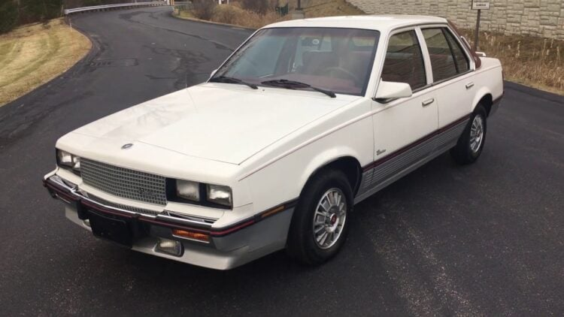
Reva G-Wiz
Awful safety ratings were the hallmarks of the Reva G-Wiz. Produced in India, the Reva G-Wiz was intended to be an affordable four-seater. But the design ended up eking out a cramped car that could hardly seat one person. It could reach top speeds of 50 mph. However, when you approached 30 mph, you could hear the death bells chyme since it had twitchy handling at top speeds. Its mileage was a teeny 50 miles meaning you would spend most of the time charging rather than driving. Also, the car was loosely fitted, meaning it could rain inside through the doors. Simply put, the structural integrity was jelly and driving at top speeds the sun. The Reva G-Wiz was a disaster waiting to happen and lasted 12 years in the market, ending its run in 2012.
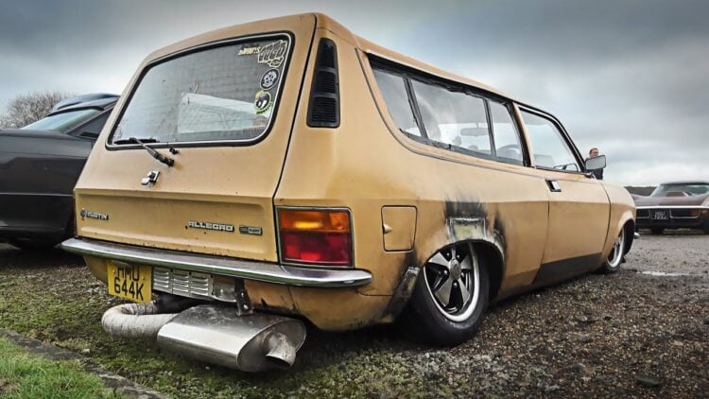
Polones FS0
Thanks to Fiat, the Polones isn’t the worst car ever. The Polones FS0 is a spinoff of the FS0 Polski Fiat 125p. The Polones carried over the chassis and made tweaks to its styling. According to Lemon Cars, the manufacturer brought iconic designers like Giorgetto Giugiaro and Walter De Silva to design the lines. On paper, it seemed like an eye-catching car. Upon production, the car rubbed users the wrong way owing to its underpowered 1.3 liter and 1.5-liter engines. The extended front and rear overhangs meant the car lacked symmetry. The Polones FS0 and the Yugo GV are classic examples of failed communist engineering.
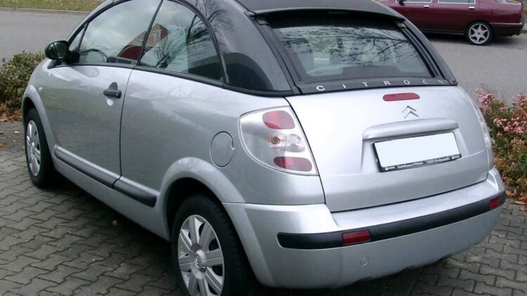
6. Citroen C3 Pluriel
Let’s not even talk about the styling. The C3 Pluriel is one of those terrible designs you have after a drinking spree. The car came with a manual for assembling and disassembling the roof. Even worse, once you disassembled the roof, you couldn’t fit the parts in the car. Overall, the car was a joke, and you’d earn more street cred with a motorbike than the Citroen C3 Pluriel. Now to the design, the C3 Pluriel was a pickup, saloon, and convertible rolled in one. It did not excel in any of those fields. The interior leaked at times, and it had very cheap furnishing.
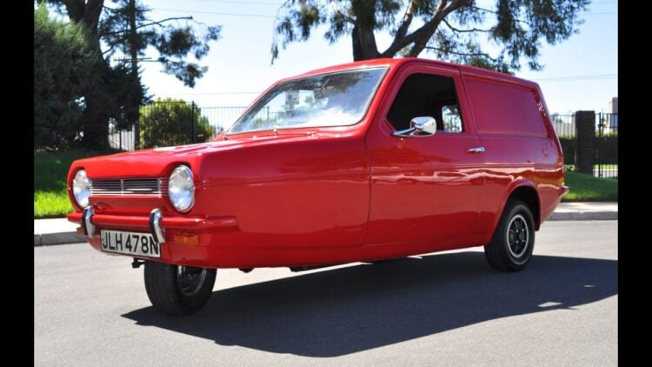
Trabant
The Trabant was East Germany’s reply to the VW Beetle. But you have to question whether the designers were on drugs. The Trabant was a two-cylinder, two-stroke engine car that enjoyed its time before and after the fall of the Berlin Wall. The car’s body panels fell off at high speeds.
The precaution against collecting car parts on the road is that you can rarely reach top speeds thanks to an 18-hp engine. The design was a complete afterthought, and the car lacked basic interior features. When it ran, it smoked, and you had a woozy driving feeling. Ask the Trabant’s designers, “where’s the brake light? Where are the indicators?” “You don’t need them,” they would answer. The awful safety metrics in a car made of old clothes and glue could easily have been the second leading cause of death after World War II.

