The Art of Speaker Design
By Marc Silver
Foundations: The Routes of Loudspeaker Technology (1860s–1920s)
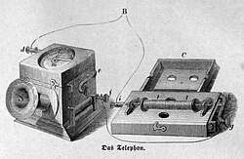
The story of the loudspeaker doesn’t begin with high-end audio; it begins with communication. In 1861, German inventor Johann Philipp Reis developed an early form of an electric loudspeaker for his prototype telephone. The idea was there, but the execution fell short, his design could barely reproduce musical tones and was nearly unintelligible for speech.
Figure 1 Musiktelegraphen aus der Zeitschrift Die Gartenlaube, 1863
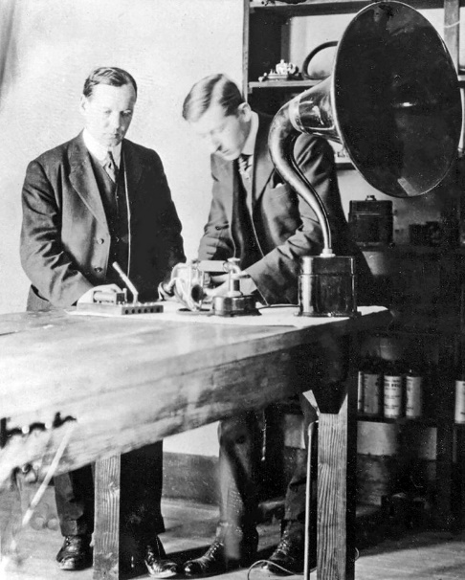
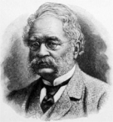
Fast-forward to 1876. Alexander Graham Bell, building on Reis’s work, patented a speaker that could produce understandable audio. Still primitive, it marked the beginning of real-world audio reproduction. The next major leap came in 1877 when Werner von Siemens proposed using a moving coil and magnetic field, a concept far closer to what we’d recognize as a speaker today. But it wasn’t until the invention of tube amplifiers that these early designs could actually project sound at usable volumes.
Figure 2 Werner von Siemens 1816 to 1892
By 1898, British scientist Oliver Lodge had created a moving-coil speaker, but it wasn’t commercially viable. The first practical loudspeaker would arrive in 1915, thanks to Peter Jensen and Edwin Pridham. They were living in Napa, California, and though telephone companies passed on their design, they went on to found Magnavox and focused on radio technology.
Figure 3 Peter Jensen and Edwin Pridham
The Birth of High Fidelity
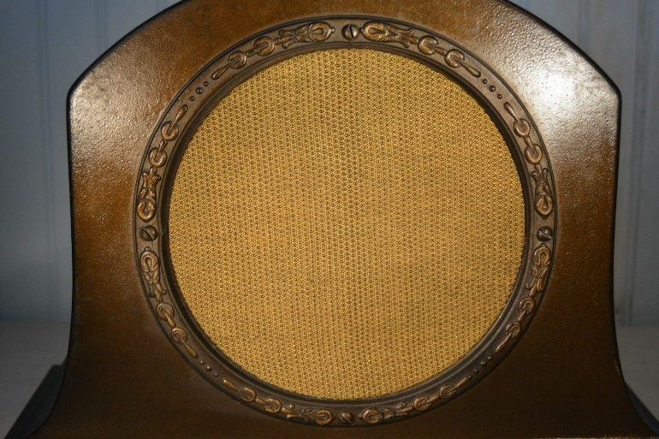
C.W. Rice and E.W. Kellogg of General Electric and AT&T would eventually bring everything together. In 1925, they introduced the first modern moving-coil speaker: the Radiola Loudspeaker #104. Their breakthrough combined amplification and wide-range frequency response. This was the first speaker to be called "high fidelity," and it set the standard for everything to come.
Figure 4 Radiola Loudspeaker
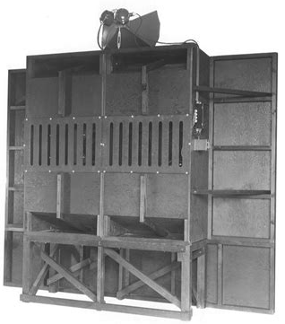
The 1930s–1950s: From Horns to High Fidelity
Throughout the 1930s and ’40s, speakers were largely utilitarian, made for public address systems and movie theaters. The "Shearer Horn," developed in 1937 for MGM by James B. Lansing and others, was one of the earliest serious attempts at high-output, high-fidelity sound reinforcement.
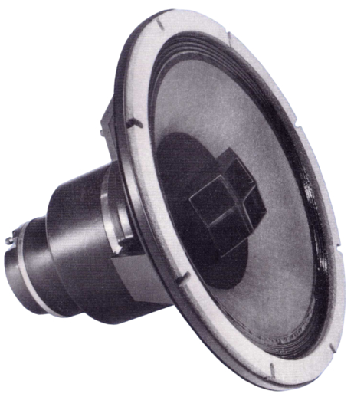
In 1943, Altec Lansing introduced the Duplex 604, the first coaxial driver that put a tweeter inside the woofer. Two years later, they released the "Voice of the Theatre" system, a mainstay in cinemas for decades and a cult classic today. These designs offered wide dispersion, excellent dynamics, and far better sound than the mechanical horns of the early 20th century.
Figure 5 MGM's Shearer Horn
Meanwhile, materials science caught up. Permanent magnets (like Alnico) replaced bulky and noisy electromagnets. This made speakers lighter, more efficient, and easier to integrate into home systems.
Figure 6 Altec Lansing 604
It was a time of big horns, big cabinets, and a growing belief that speakers could, and should, aim for realism, not just loudness.
The 1950s–1960s: The Birth of the Consumer Hi-Fi Market
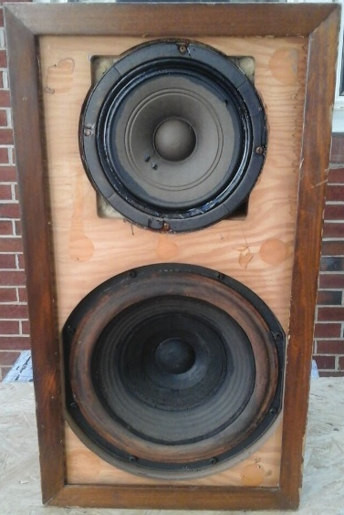
The postwar years were transformative. Early adopters wanted music in the home, and companies responded. Designs began shrinking thanks to acoustic suspension. Edgar Villchur and Henry Kloss introduced the AR-1 in 1954, using a sealed box to control woofer motion and deliver surprisingly deep bass from a small cabinet. It became a blueprint for modern bookshelf speakers.
Figure 7 Acoustic Research AR-1 Speaker
Electrostatics also arrived. In 1956, Peter Walker’s Quad ESL hit the market, followed by Arthur Janszen’s high-frequency electrostatic tweeters. These speakers were limited in dynamics and dispersion but offered shockingly clean, transparent sound. The midrange was alive in a way cones couldn’t quite capture.
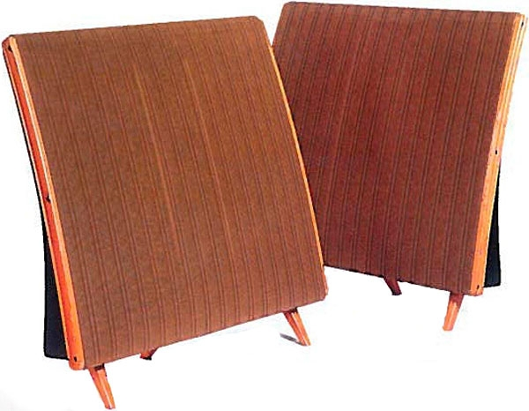
At the same time, ribbon and planar technologies were taking root. These used lightweight diaphragms suspended in magnetic fields, offering low mass and fast transient response. Air Motion Transformers, pioneered by Oskar Heil, and designs from Magnapan would build on this.
Figure 8 Quad ESL 57
The 1970s: Objective Meets Subjective
By the 1970s, designers had new tools. KEF’s Laurie Fincham was using computers to model crossovers. Richard Heyser invented Time Delay Spectrometry. Measurement systems like TEF and MLSSA brought time-domain and spectral information into the design process. No longer were designers relying solely on ear and oscilloscope, they had real data to work with.
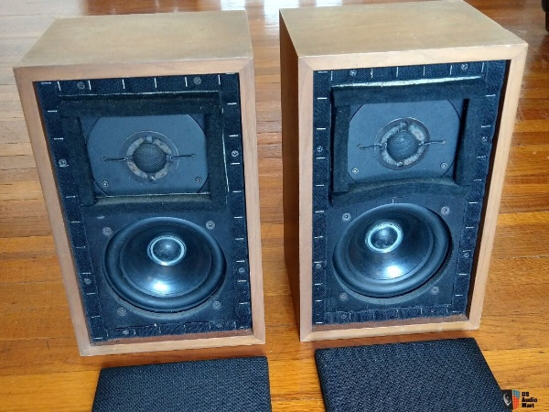
Speaker philosophies began to split into schools of thought:
- Flat Response: Designers aimed for laboratory neutrality. Think BBC monitors or Canadian NRC designs, where on-axis response and minimal resonance were prioritized.
- Pulse Coherent: Brands like Vandersteen and Spica pursued time alignment and minimal crossover distortion, often at the cost of efficiency or dynamic range.
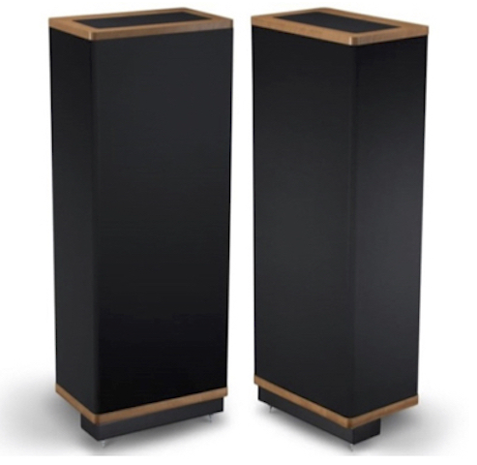
- Minimalist: A reaction to complexity. Some designers stripped things down to a single capacitor, full-range drivers, and exotic materials.
Figure 9 Vandersteen Model 2Ce Signature III
Efficiency began to resurface as an important metric, especially for fans of tube amplification. Horns came back into vogue. Not the honky, boomy types of the past, but carefully damped, phase-correct designs using Tractrix and exponential curves.
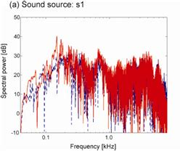
The 1980s–1990s: New Materials and the Return of Emotion
Figure 10 Spectra of impulse responses
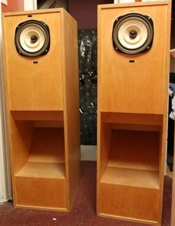
This era brought polypropylene cones, carbon-fiber composites, and ventilated pole pieces. Drivers got faster, lighter, and more linear. Designers began to consider distortion spectra, impulse response, and even subjective qualities like "presence" or "emotional impact."
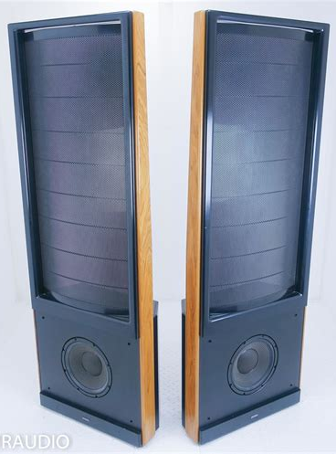
Meanwhile, ultra-fi movements in Japan, Italy, and France preserved high-efficiency and triode-tube designs. These often-used horn speakers or Lowther-type full-range drivers, and while they didn’t always measure well, they connected emotionally.
Figure 11 Lowther-type full-range speakers
Figure 12 Martin Logan Monolith
Electrostatics evolved too. MartinLogan introduced curved panels that fixed the narrow dispersion of earlier Quads. Hybrid systems paired dynamic woofers with planar or electrostatic panels, aiming for the best of both worlds.
The 2000s to Present: Measurement-Driven Design and the Myth of Perfection
Modern speaker design has never had it better, or more complicated. Measurement tools can now resolve distortions, resonances, and diffraction effects that were once invisible. Designers chase flat response, smooth phase, perfect directivity, and even room-corrected playback using DSP (Dirac, Audyssey, Trinnov).
And yet, the trade-offs remain.
- Distortion is still real, though now we know where it hides.
- Diffraction and radiation patterns are still tricky, especially at crossover points.
- Cabinet and room interactions still color the sound no matter how flat the frequency response is on paper.
New driver materials like beryllium, graphene, and advanced ceramics push boundaries. Some speakers now reach 90–95 dB sensitivity while retaining linearity and low coloration. Others aim for pinpoint imaging through waveguides and cardioid dispersion control.
But at the end of the day, it's still a dance between compromises.
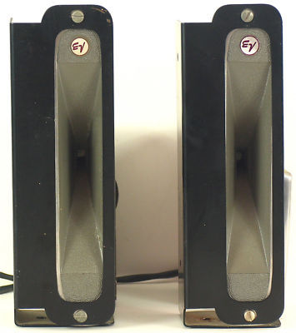
The Fringe: Ionovacs, Flames, and the Future
The Ionovac, introduced in the 1950s, used an ionized gas instead of a diaphragm. It offered vanishingly low distortion and massive bandwidth, but required helium tanks and emitted ozone. It was as close to the theoretical perfect speaker (zero mass, infinite bandwidth) as anything that’s ever been commercially sold.
Figure 13 Electro-Voice T-3500 IONOVAC Plasma Tweeters
Plasma speakers and flame transducers remain largely experimental, but they raise a fascinating question: What happens when we no longer need cones, domes, or diaphragms at all?
Nanotechnology? Laser-guided air pulses? Electro-acoustic metamaterials? The possibilities are limitless, but we’re not there yet.
Final Thoughts: No Perfect Speaker, Just Better Stories
After nearly 150 years of evolution, speakers are still imperfect translators. They bend air in ways that our ears interpret as music, but they always carry artifacts, of their materials, their designs, and their makers' priorities.
Some tell stories with warmth. Others with clarity. A few try to disappear entirely.
The best ones remind us not that we’re listening to gear, but that we’re in the room with the music. And when that happens, whether it's a 1940s horn or a 21st-century ribbon, you’ve found your speaker.

