The Ainu of Japan
By Marc Silver
Reviving a Silenced Voice
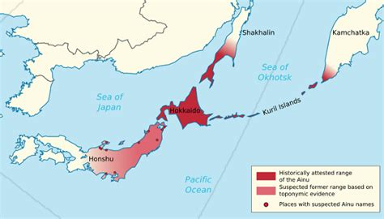
In the rugged landscapes of Hokkaido, the northernmost island of Japan, the Ainu people are reclaiming a cultural identity long suppressed by centuries of forced assimilation. Once marginalized as a "dying race" by Japanese authorities, the Ainu are now at the forefront of a resurgence, challenging historical erasure and demanding recognition as Japan’s indigenous people. Their journey from invisibility to empowerment offers a poignant narrative of resilience and revival.
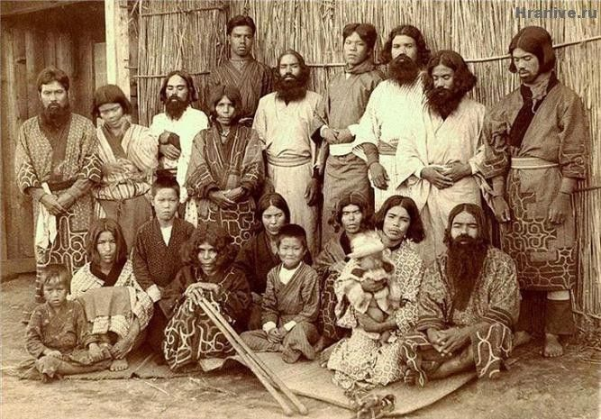
Historical Context: Origins and Oppression
The Ainu, whose ancestral lands span Hokkaido, Sakhalin, and the Kuril Islands, thrived for millennia as hunter-gatherers with a deep spiritual connection to nature. Their cosmology, centered on kamuy (deities) inhabiting all beings, shaped traditions like the iyomante (bear-sending ceremony), intricate woodcarving, and oral epics (yukar).
This way of life was disrupted in the late 19th century during the Meiji Restoration. Japan’s annexation of Hokkaido in 1869 triggered aggressive colonization: Ainu lands were confiscated, and policies like the 1899 Hokkaido Former Aborigines Protection Act enforced assimilation. Banning Ainu language, rituals, and even traditional tattoos, the law reduced them to poverty, pushing many to hide their heritage to survive.
Cultural Suppression and Its Legacy
By the 20th century, the Ainu faced systemic discrimination, labeled as “primitive” in school textbooks and excluded from mainstream society. Their population, estimated at over 100,000 before colonization, dwindled, though exact numbers remain uncertain due to intermarriage and forced integration. The Ainu language, now critically endangered, teetered on the brink of extinction, with only a handful of elderly native speakers by the 2000s.
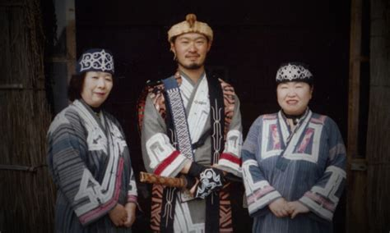
Revival Efforts: From Recognition to Reclamation
The 1997 Ainu Cultural Promotion Act marked a tentative shift, replacing assimilationist policies with state-funded cultural initiatives. However, it overlooked land rights and political representation.
A breakthrough came in 2019, when Japan’s government recognized the Ainu as Indigenous people under the Ainu Policy Promotion Act, acknowledging their “distinct language, religion, and culture.”
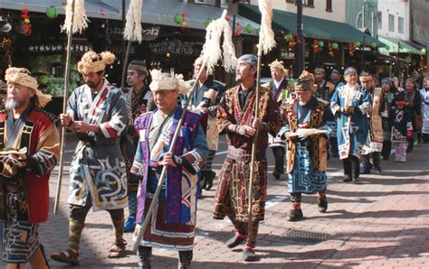

Grassroots efforts have driven meaningful change. The Ainu Association of Hokkaido, founded in 1946, advocates for rights and cultural preservation. Language revitalization projects, such as online courses and community workshops, aim to revive the Ainu tongue. Festivals like Icarpa and Marimo celebrate traditional dance and music, while artists like sculptor Bikky Sunazawa blend ancestral motifs with modern expression.
The 2020 opening of Upopoy National Ainu Museum and Park in Shiraoi, Hokkaido, symbolizes this revival, though critics argue it risks reducing Ainu culture to a tourist spectacle. Meanwhile, younger Ainu, like artist and activist Mayunkiki, use social media to challenge stereotypes and assert their identity.
Ongoing Challenges: Beyond Symbolic Gestures
Despite progress, the Ainu face entrenched challenges. Economic disparities persist, with many struggling in low-wage jobs. Discrimination lingers, compounded by a lack of public awareness. Environmental threats, such as development projects encroaching on sacred sites, echo past injustices, evident in the 1990s Nibutani Dam conflict, where courts recognized Ainu land rights for the first time.
Internationally, the Ainu have allied with global Indigenous movements, leveraging platforms like the UN Declaration on the Rights of Indigenous Peoples. Yet, Japan’s 2019 law remains critiqued for its limited scope, failing to address sovereignty or reparations.
Conclusion: The Path Forward
The Ainu’s revival is not merely about reclaiming the past but shaping a future where their voice is integral to Japan’s multicultural tapestry. As Ainu poet and activist Shizue Ukaji once asserted, “We are not a relic of history.” Their struggle underscores a universal truth: the survival of Indigenous cultures enriches humanity’s collective heritage. For the Ainu, the journey toward justice and self-determination continues, a testament to the enduring power of resilience.
In a world increasingly aware of Indigenous rights, the Ainu remind us that cultural revival is both an act of resistance and a celebration of life. Their silenced voice, now resurgent, invites Japan, and the world, to listen.
Note for Readers:
For further exploration, consider primary sources such as Ainu oral traditions (yukar) and documentaries like Ainu: Path to Memory (2019). Academic databases like JSTOR and Project MUSE also offer peer-reviewed articles on Ainu history and politics.
References
- Ainu Association of Hokkaido. (n.d.). About the Ainu. Retrieved July 15, 2023, from https://www.ainu-assn.or.jp/english/about.html
  - Official website providing historical and cultural context about the Ainu, including advocacy efforts and policy updates.
- Government of Japan. (2019). Act on the Promotion of Ainu Culture and Dissemination of Knowledge Regarding Ainu Traditions. https://www.japaneselawtranslation.go.jp
  - Official translation of Japan’s 2019 legislation recognizing the Ainu as Indigenous people.
- Hilger, M. I. (1967). Together with the Ainu: A Vanishing People. University of Oklahoma Press.
  - Ethnographic study documenting Ainu traditions and the impacts of assimilation policies.
- Howell, D. L. (2005). Geographies of Identity in Nineteenth-Century Japan. University of California Press.
  - Explores Japan’s colonization of Hokkaido and its effects on Ainu society.
- Kayano, S. (1994). Our Land Was a Forest: An Ainu Memoir. Westview Press.
  - Autobiography by Shigeru Kayano, the first Ainu politician, detailing cultural erasure and resilience.
- Lewallen, A. (2016). The Fabric of Indigeneity: Ainu Identity, Gender, and Settler Colonialism in Japan. School for Advanced Research Press.
  - Examines Ainu identity revival, gender roles, and contemporary activism.
- Siddle, R. (1996). Race, Resistance, and the Ainu of Japan. Routledge.
  - Seminal work on Ainu-Japanese relations, focusing on colonial oppression and resistance.
- United Nations. (2007). Declaration on the Rights of Indigenous Peoples. https://www.un.org/development/desa/indigenouspeoples/declaration-on-the-rights-of-indigenous-peoples.html
  - International framework cited in Ainu advocacy for land rights and cultural preservation.
- Upopoy National Ainu Museum and Park. (2020). Mission and Vision. https://ainu-upopoy.jp/en/
  - Official site detailing the museum’s role in preserving and promoting Ainu culture.
- Watson, M. K. (2014). Japan’s Ainu Minority in Tokyo: Diaspora and Indigeneity. Routledge.
  - Analyzes urban Ainu communities and challenges to cultural continuity.
- Yamada, T. (2001). The Worldview of the Ainu: Nature and Cosmos Reading from Language. Kegan Paul International.
  - Study of Ainu spirituality, language, and ecological philosophy.
- UNESCO. (2009). Atlas of the World’s Languages in Danger. http://www.unesco.org/languages-atlas
  - Lists Ainu as a critically endangered language, highlighting revitalization efforts.
- The Japan Times. (2020). “Ainu Indigenous Recognition: A New Era or Empty Gesture?” https://www.japantimes.co.jp
  - News analysis of Japan’s 2019 Ainu policy and its limitations.
- Nibutani Dam Decision. (1997). *Supreme Court of Japan, Case Heisei 7 (Gyo-Tsu) No. 38*.
  - Landmark court ruling acknowledging Ainu land rights in the Nibutani Dam case.
- Mayunkiki (Artist). (2022). Contemporary Ainu Art and Activism [Interview]. Ainu Art Project. https://www.ainuartproject.com
  - Insights from a modern Ainu artist on cultural revival and identity.

