Tasmania Wine Region: A Sommelier's Guide
1. Region Overview
Geographic Location
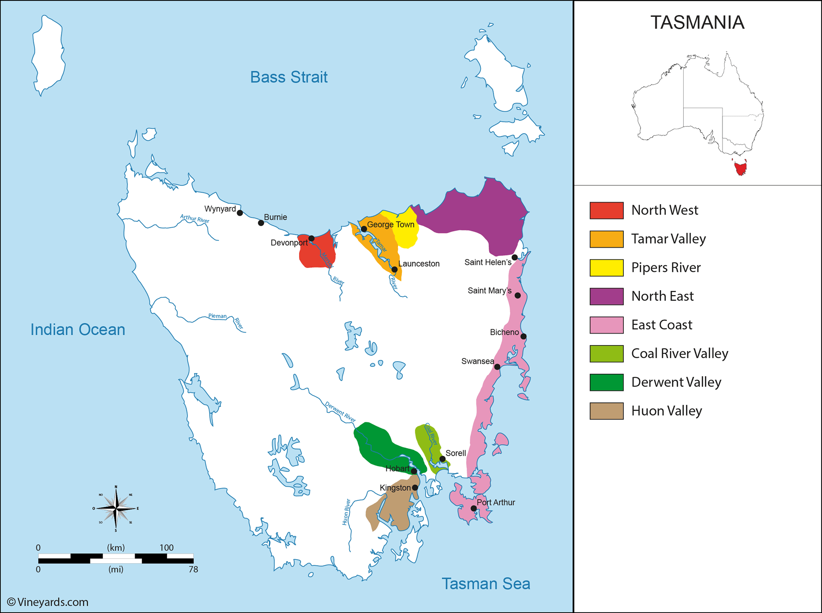
Tasmania, Australia’s island state, lies approximately 150 miles south of the mainland across the Bass Strait. This cool-climate wine region is separated into several key sub-regions, including the Tamar Valley, Coal River Valley, East Coast, Pipers River, and Derwent Valley. Tasmania is the southernmost wine-producing region of Australia, giving it a distinct climatic profile compared to mainland counterparts such as Victoria and South Australia .
Climate and Terroir
Tasmania’s maritime climate is characterized by cool temperatures, high humidity, and significant diurnal shifts, which extend the growing season. Rainfall is moderate, with coastal areas receiving higher precipitation than inland valleys. The island's terroir is diverse, featuring a mix of volcanic soils, sandstone, and well-draining gravelly loams, contributing to the structure and minerality of its wines . Long sunshine hours during the growing season help grapes reach full phenolic ripeness while retaining acidity.
Structural Organization
Tasmania does not have a multi-tiered appellation system like Europe but is recognized as a single Geographic Indication (GI). However, its sub-regions exhibit distinct styles and characteristics, particularly in sparkling wine production .
Historical Context
Viticulture in Tasmania dates back to the early 19th century when European settlers planted the first vines in 1823. However, commercial winemaking only took off in the late 20th century. Today, Tasmania is globally recognized for its high-quality sparkling wines and cool-climate varietals, rivaling renowned Old World regions .
Distinctive Features
Tasmania stands out for its exceptional sparkling wine production, often compared to Champagne due to its ideal growing conditions. The region’s focus on sustainability and low-intervention winemaking further enhances its reputation .

2. Key Grape Varieties
Primary Red Varieties
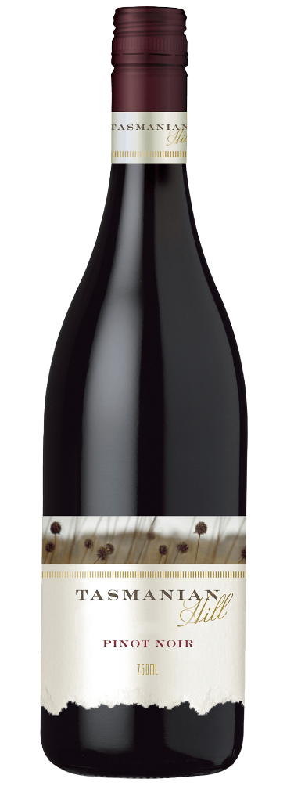
- Pinot Noir – Tasmania’s flagship red grape, producing elegant, perfumed wines with bright red fruit, earthy undertones, and fine tannins. Used extensively in both still and sparkling wines.
Primary White Varieties
- Chardonnay – A cornerstone of Tasmania’s sparkling wine production, yielding complex, mineral-driven wines with crisp acidity.
- Riesling – Produces dry and off-dry styles with intense citrus, floral, and slate-like minerality, reflecting the region’s cool climate.
Indigenous/Regional Varieties
Tasmania does not have indigenous varieties, but its expressions of Pinot Noir, Chardonnay, and Riesling are distinct from mainland Australian counterparts due to the region’s cooler growing conditions.
Significance
Pinot Noir and Chardonnay dominate, with a strong emphasis on sparkling wine production. Riesling and Sauvignon Blanc play secondary roles, offering highly aromatic, high-acid white wines.

3. Wine Classification System
Quality Hierarchy
Tasmania follows the Australian GI system, with Tasmania recognized as a single GI. No official quality tiers exist, but certain producers and vineyards have earned reputations for producing premier wines .
Appellation Structure
- Tasmania GI – Encompasses the entire island, with notable sub-regions informally recognized.
Special Classifications
- Tasmanian Sparkling Wine – An unofficial but widely recognized category, rivaling top-tier sparkling wines worldwide .
Sub-Regional Distinctions
- Pipers River – Renowned for sparkling wines with high acidity and structure.
- Tamar Valley – The largest sub-region, producing balanced Pinot Noir and Chardonnay.
- Coal River Valley – Known for structured, age-worthy Pinot Noir.
- East Coast – Warmer than other sub-regions, yielding fuller-bodied whites and reds.
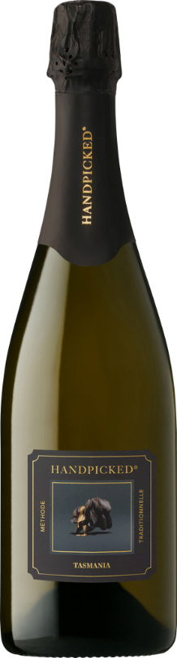
4. Notable Wine Styles
Sparkling Wine
- Classification Level: Tasmania GI
- Composition: Pinot Noir, Chardonnay, and Pinot Meunier (traditional method)
- Production Method: Méthode Traditionnelle
- Aging Requirements: Typically 18+ months on lees
- Alcohol Content: 12–13%
- Organoleptic Profile: Bright citrus, green apple, brioche, and minerality with persistent acidity
- Style Variations: Vintage and non-vintage expressions, rosé styles .

5. Additional Context
Recent Developments
Tasmania’s wine industry has seen rapid growth, with an increasing number of boutique producers focusing on organic and biodynamic viticulture. The region’s reputation for high-quality sparkling wines has also attracted international investment .
Food Pairing Notes
- Sparkling Wine – Fresh oysters, seafood, soft cheeses
- Pinot Noir – Duck, lamb, mushroom-based dishes
- Riesling – Asian cuisine, shellfish, spicy dishes .
Producer Information
- House of Arras – Australia’s premier sparkling wine producer
- Jansz Tasmania – Pioneering sparkling wine house
- Stefano Lubiana – Biodynamic-focused producer excelling in Pinot Noir and Chardonnay
- Pooley Wines – Coal River Valley producer known for elegant Pinot Noir and Riesling

6. Key Takeaways for Sommeliers
- Tasmania is Australia’s leading cool-climate region, excelling in Pinot Noir and Chardonnay.
- Its sparkling wines rival those from Champagne due to the region’s climate and meticulous winemaking.
- The region’s Rieslings are highly regarded for their acidity and purity.
- Tasmania lacks an official appellation hierarchy but has well-recognized sub-regions with distinct styles.
- Sustainability and organic practices are increasingly shaping production methods.
- Tasmania is Australia’s leading cool-climate region, excelling in Pinot Noir and Chardonnay.
- Its sparkling wines rival those from Champagne due to the region’s climate and meticulous winemaking.
- The region’s Rieslings are highly regarded for their acidity and purity.
- Tasmania lacks an official appellation hierarchy but has well-recognized sub-regions with distinct styles.
- Sustainability and organic practices are increasingly shaping production methods .

7. Citations and References
- Wine Australia, 2023. https://www.wineaustralia.com/
- Halliday Wine Companion, 2023. https://www.winecompanion.com.au/
- Tasmanian Wine Show, 2022. https://www.tasmanianwineshow.com.au/
- Australian Wine Research Institute, 2023. https://www.awri.com.au/
- Decanter, 2023. https://www.decanter.com/
- Wine Tasmania, 2023. https://winetasmania.com.au/
- House of Arras, 2023. https://www.houseofarras.com.au/
- Gourmet Traveller Wine, 2023. https://www.gourmettravellerwine.com/

