The Sullivan-Clinton Campaign of 1779
By Marc Silver

A Dark Chapter in Revolutionary War History
American history is rarely as simple as virtuous patriots standing opposite a uniformly wicked British crown. The reality of the Revolutionary War was morally complex, often brutal, and filled with choices that produced lasting human consequences. Among the most troubling of these episodes was the Sullivan-Clinton Campaign of 1779, one of the most destructive military operations carried out by the Continental Army.

Ordered by General George Washington and executed by Major General John Sullivan and Brigadier General James Clinton, the campaign targeted the Haudenosaunee Confederacy, often referred to as the Iroquois Six Nations, across what is now central and western New York and parts of northern Pennsylvania. Its purpose was not simply military engagement but the systematic destruction of Indigenous towns, food supplies, and agricultural infrastructure. At least forty established towns were destroyed, vast quantities of crops were burned, and orchards that had taken decades to cultivate were deliberately cut down.
Figure 1 General George Washington 1775
Understanding this campaign requires examining both the strategic pressures that produced it and the profound human cost it imposed.

The Haudenosaunee: Beyond the Stereotypes
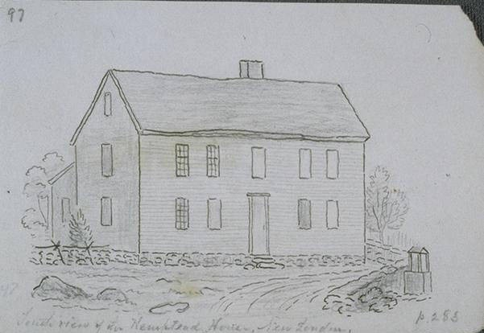
A persistent misconception suggests that Native American societies of the colonial era were largely transient, living in temporary shelters and lacking permanent infrastructure. The Haudenosaunee Confederacy stood in sharp contrast to this image. Comprising the Mohawk, Oneida, Onondaga, Cayuga, Seneca, and Tuscarora nations, the confederacy governed a sophisticated political system rooted in the Great Law of Peace, with permanent settlements, advanced agriculture, and long-established territorial claims.
Figure 2 Drawing of Native American House 1779
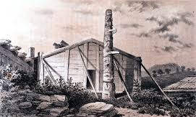
By the eighteenth century, many Haudenosaunee communities had incorporated elements of European building practices alongside traditional longhouses. Towns often featured substantial frame houses, some two stories tall, with glass windows, wooden floors, fireplaces, and European-style furnishings. These were not temporary encampments but established civilian communities reflecting generations of settlement and adaptation.
Figure 3 Cayuga house 1779
Haudenosaunee agriculture was equally advanced. The cultivation of the “Three Sisters,” corn, beans, and squash, formed the foundation of a sustainable farming system later admired and adopted by European settlers. In addition, many communities maintained extensive orchards of apple, pear, and peach trees, some planted decades earlier. These orchards represented long-term agricultural investment and provided both food security and trade goods.

Strategic Context: Division and War
The outbreak of the Revolutionary War in 1775 placed the Haudenosaunee Confederacy in an impossible position. For the first time since its formation, the confederacy fractured along political lines. The Oneida and Tuscarora largely supported the American cause, while the Mohawk, Seneca, Cayuga, and Onondaga tended to ally with the British.
From the British perspective, Haudenosaunee alliances offered significant strategic value. The confederacy controlled vast territory and possessed deep knowledge of the frontier landscape, making them effective participants in irregular warfare. British officials in Canada actively encouraged these alliances, supplying weapons and logistical support.
Between 1777 and 1779, British and Haudenosaunee forces conducted raids on American frontier settlements in New York and Pennsylvania. These actions ranged from small-scale attacks on isolated farms to large assaults on fortified communities. Events such as the Wyoming Valley and Cherry Valley attacks produced significant civilian casualties and generated widespread fear among frontier settlers.
From the Haudenosaunee perspective, alliance with Britain was driven less by loyalty than by survival. Decades of colonial expansion had demonstrated that American victory would likely accelerate settlement onto Indigenous land. British promises to restrain westward expansion, though often unreliable, appeared more credible than American assurances. The Haudenosaunee were not acting as mercenaries but as nations defending their homelands against what they correctly perceived as an existential threat.

Washington’s Orders and the Choice of Devastation
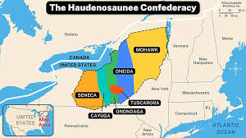
By early 1779, pressure mounted on Continental Army leadership to address the continuing instability along the frontier. Washington rejected a defensive posture or negotiated settlement and instead authorized a campaign aimed at eliminating Haudenosaunee capacity to support British operations.
His instructions to Sullivan were explicit. The objective was not merely to defeat opposing forces but to destroy the economic foundations that sustained them. Washington directed that towns be burned, crops ruined, and future planting prevented.
Figure 4 Haudenosaunee Confederacy 1779
In his letter of May 31, 1779, Washington wrote:
“The expedition you are appointed to command is to be directed against the hostile tribes of the six nations of Indians, with their associates and adherents. The immediate objects are the total destruction and devastation of their settlements, and the capture of as many prisoners of every age and sex as possible. It will be essential to ruin their crops now in the ground and prevent their planting more… that the country may not be merely overrun but destroyed.”
While not “total war” in the modern industrial sense, the campaign was clearly designed to target civilian survival rather than opposing armies alone. Washington understood that destroying homes, food supplies, and orchards would leave entire communities unable to endure the coming winter.
This decision reflected prevailing European military thinking, where destroying an enemy’s economic base was considered a legitimate means of warfare. It was also shaped by cultural attitudes that often dehumanized Indigenous peoples and framed westward expansion as inevitable.

The Campaign: Destruction Without Battle
In August 1779, Sullivan led approximately 4,000 Continental Army troops into Haudenosaunee territory, joined by Clinton’s brigade advancing from the north. After the Battle of Newtown on August 29, the only significant engagement of the
campaign, organized resistance largely collapsed.
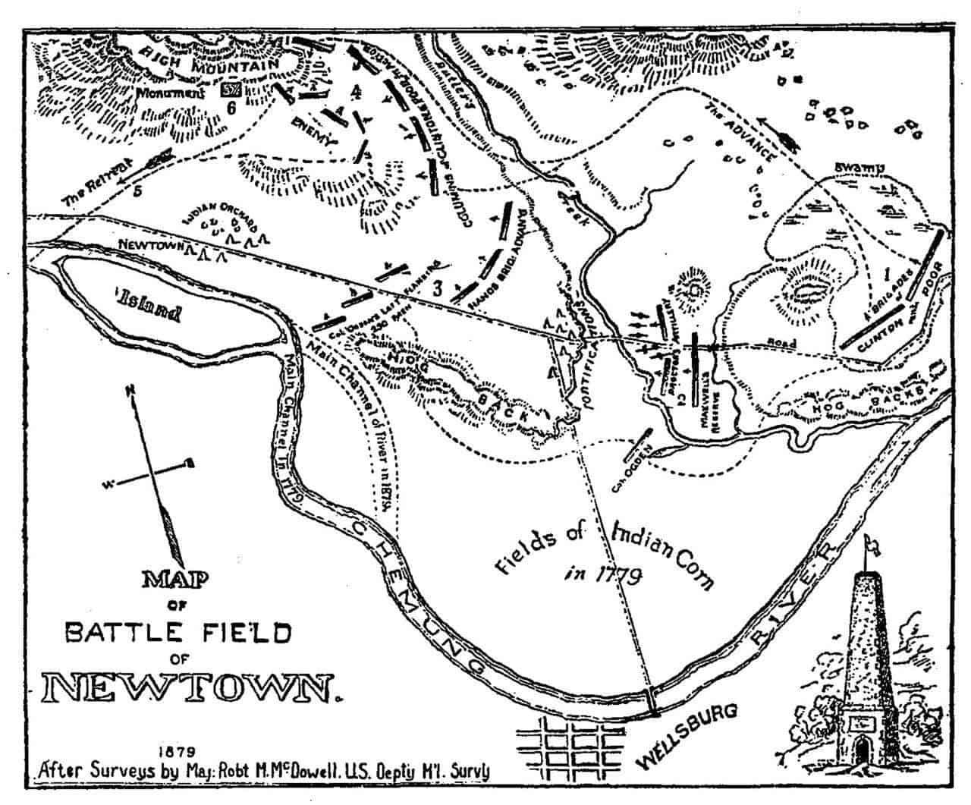
What followed was a methodical campaign of destruction. Soldiers’ journals and official reports describe the burning of well-built towns and the systematic eradication of food supplies. Lieutenant William Barton recorded destroying “128 houses, mostly very large and elegant.” Major Jeremiah Fogg described houses with stone chimneys and glass windows.
Agricultural devastation was extensive. Contemporary estimates suggest well over 100,000 bushels of corn were destroyed, along with fields of beans, squash, and other crops. Orchards were cut down or girdled to ensure they could not recover. These acts were deliberate, calculated to deny both immediate sustenance and long-term recovery.
Some officers expressed discomfort with their orders, describing the Seneca country as an “Eden-like” landscape before its destruction. Nonetheless, the campaign proceeded as directed. By October 1779, at least forty towns had been destroyed across the Finger Lakes and Genesee Valley regions.

Human Consequences: The Winter of the Hungry
The immediate military objective was achieved, but the human consequences were catastrophic. As winter approached, thousands of Haudenosaunee civilians fled north to Fort Niagara, seeking refuge under British protection.
The British garrison was unprepared for the influx. Supplies were inadequate, shelter scarce, and disease spread rapidly. The winter of 1779–1780 became known among the Haudenosaunee as “the winter of the hungry.” British officials documented widespread suffering and high mortality, particularly among children and the elderly.
The destruction of orchards compounded the disaster. Unlike annual crops, fruit trees required many years to mature. Their loss represented not only immediate starvation but the erasure of agricultural systems developed over generations.
Beyond physical suffering, the campaign inflicted deep cultural trauma. Sacred sites, burial grounds, and ancestral landscapes were destroyed. The campaign deepened and hardened existing fractures within the Haudenosaunee Confederacy, reshaping its future in ways that proved impossible to reverse.

Long-Term Consequences and Historical Reckoning
Although the campaign reduced Haudenosaunee military capacity, it hardened Indigenous resistance and strengthened allegiance to Britain. When the war ended in 1783, Britain abandoned its Indigenous allies in the Treaty of Paris, leaving the Haudenosaunee vulnerable to American expansion.
In the decades that followed, the United States acquired Haudenosaunee lands through treaties often negotiated under duress. The campaign demonstrated that military resistance was futile and set a precedent for later U.S. policies that targeted Indigenous civilian infrastructure as a means of coercion.
Among the Haudenosaunee, Washington became known as “Town Destroyer,” a name preserved in oral history that reflects a vastly different memory of the American founding.
For much of American history, the Sullivan-Clinton Campaign was portrayed as a necessary military success. Only in recent decades has its moral and human cost received sustained attention.

A History That Must Be Remembered
The Sullivan-Clinton Campaign of 1779 stands as one of the most troubling episodes of the Revolutionary War. It was a deliberate strategy of devastation that achieved short-term military goals while inflicting profound and lasting harm on civilian populations.
Recognizing this history does not require rejecting the American Revolution or its ideals. It requires acknowledging that nation-building involved choices that violated those ideals in practice. Honest reckoning means holding both truths at once.
The Haudenosaunee Confederacy endures today, preserving its cultural identity and political traditions despite centuries of displacement. Their survival stands as a testament to resilience and as a reminder that the communities destroyed in 1779 were not abstractions, but living societies whose descendants remain.
This is not a footnote. It is a central chapter in understanding how the United States was formed, and at what cost.

