HISTORIC TRADE ROUTES
The Spice Islands
By Marc Silver
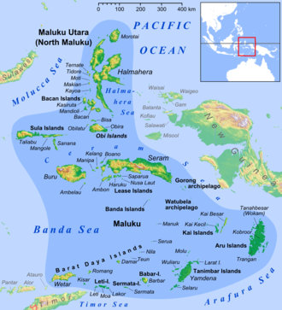
A small cluster of volcanic islands in eastern Indonesia once carried weight far beyond their size. Cloves and nutmeg, dried flower buds and wrinkled brown seeds, were worth more than gold in parts of Europe. Men crossed oceans they barely understood to reach them. Governments financed voyages that nearly ruined treasuries. Entire populations were destroyed in the attempt to control their harvest.
The islands were small. The consequences were not.
Known historically as the Spice Islands, or the Moluccas, today the Maluku Islands, they were the only place on earth where cloves, nutmeg, and mace grew naturally. From these forested islands between Sulawesi and New Guinea emerged trade networks that linked Asia, the Middle East, Europe, Africa, and eventually the Americas into a single economic system.
This is how that happened.

I. Why Spices Were Worth the Risk
In the ancient and medieval world, spices were not minor luxuries. The Latin word species referred to valuable goods. Cloves and nutmeg were used as medicines, incense, perfumes, preservatives, and visible displays of wealth. In Europe, serving heavily spiced dishes was a public signal of status.
The economics were startling.
Historian M. N. Pearson calculated that a kilogram of pepper costing one or two grams of silver at its source could sell for ten to fourteen grams in Alexandria, fourteen to eighteen in Venice, and twenty to thirty grams in northern Europe.
The margins multiplied fifteenfold between origin and consumer.
That differential explains much of what followed. When profit expands that dramatically across distance, someone eventually tries to eliminate the intermediaries and control the source directly.

II. Before Europe: An Asian Maritime System
Long before European ships rounded the Cape of Good Hope, the Spice Islands were already integrated into a sophisticated Asian trade network.
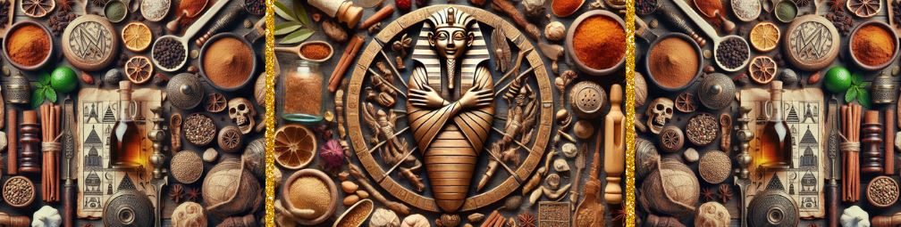 By around 1000 BCE, cinnamon and pepper were moving west toward Egypt and the Middle East. Arab sailors from Yemen and Oman became important intermediaries, guarding their sources carefully. Indian, Malay, and Chinese traders-maintained sea corridors that linked Indonesia to India and China using predictable monsoon patterns.
The North Moluccas could be reached through established maritime routes via Java and Flores, or through Borneo and the Sulu Sea. These routes carried not only spices but ceramics, textiles, metals, and religious ideas. Buddhism, Hinduism, and later Islam traveled alongside cargo.
The islands were not isolated outposts waiting for discovery. They were already central nodes in a dynamic regional economy.

III. Iberian Breakthrough
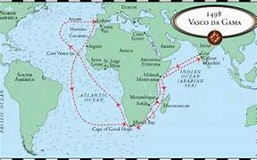
European access to spices had long depended on Middle Eastern and Mediterranean intermediaries. Venetian and Genoese merchants purchased spices in Levantine ports, passing along steep markups.
The frustration was obvious.
In 1488, Bartolomeu Dias rounded the Cape of Good Hope. In 1497, Vasco da Gama reached India by sea. In 1511, Afonso de Albuquerque seized Malacca, the principal Asian trade emporium. By 1512, Portuguese ships reached the Moluccas.
Spain sought the same prize from the west. Magellan’s 1519 expedition crossed the Pacific, and when one surviving ship returned in 1522 with 26 tons of spices, it paid for the voyage and completed the first circumnavigation of the globe.
The globe was now connected in pursuit of cloves and nutmeg.
Portugal secured formal control of the Moluccas under the Treaty of Zaragoza in 1529. But distance, corruption, and competition gradually weakened its position.

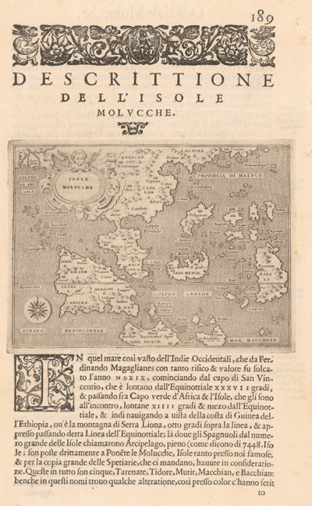
IV. The Dutch and the Logic of Monopoly
The Dutch entered in the late sixteenth century with disciplined financing and strong maritime capability. Their ships could reliably sail the Cape route, and their commercial structure differed from Iberian royal patronage.
In 1602, the Netherlands created the Vereenigde Oost-Indische Compagnie, the VOC, a joint-stock company granted state authority to wage war, build forts, sign treaties, and govern territory. It was a commercial enterprise fused with sovereign power.
Ambon became one of the VOC’s early regional headquarters before Batavia was firmly established in 1619. From Ambon, Dutch officials systematically pushed Portuguese and Spanish influence out of the clove-producing islands, consolidating control island by island.
The objective was not participation in trade. It was monopoly.
Dutch authorities restricted cultivation zones, uprooted clove trees on islands outside direct supervision, and destroyed “surplus” harvests to prevent price decline. Exported nutmeg seeds were soaked in lime so they could not germinate elsewhere. Production was centralized. Supply was deliberately limited.
The strategy was systematic and sustained.

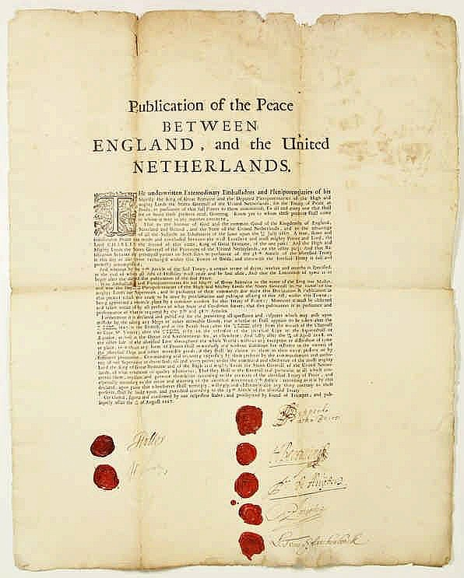
V. Banda, 1621
Nutmeg and mace grew only in the Banda Islands.
Before Dutch conquest, Banda was organized around village communities led by orang kaya, respected local leaders. Trade was competitive. English merchants were welcomed because they offered favorable terms. The Bandanese resisted exclusive Dutch contracts because monopoly meant dependency and loss of bargaining power.
In 1621, Governor-General Jan Pieterszoon Coen resolved the matter militarily.
He arrived with ships, soldiers, Javanese convicts, and Japanese mercenaries. Villages were destroyed. Survivors were hunted down. Forty-four orang kaya were subjected to summary trials and executed. Their heads were displayed publicly.
Of approximately 15,000 inhabitants before the campaign, only about 480 remained afterward.
The islands were repopulated with Dutch perkeniers and enslaved laborers brought from elsewhere in the archipelago. Nutmeg production continued under direct VOC supervision.
Modern historians characterize the event as genocide. The demographic collapse supports the description.
By the mid-seventeenth century, Dutch authority in Maluku was secure. Iberian garrisons had been expelled. English competition had been constrained. Clove and nutmeg flowed almost entirely through VOC control.

VI. An Unusual Exchange
In 1667, the Treaty of Breda settled Anglo-Dutch conflicts.
England relinquished its claim to the tiny nutmeg island of Run in the Banda group.
The Dutch ceded Manhattan.
At the time, the calculation reflected immediate economic logic. Run’s nutmeg monopoly generated measurable profit. Manhattan was a distant colonial foothold of uncertain value.
Historical hindsight assigns value differently.

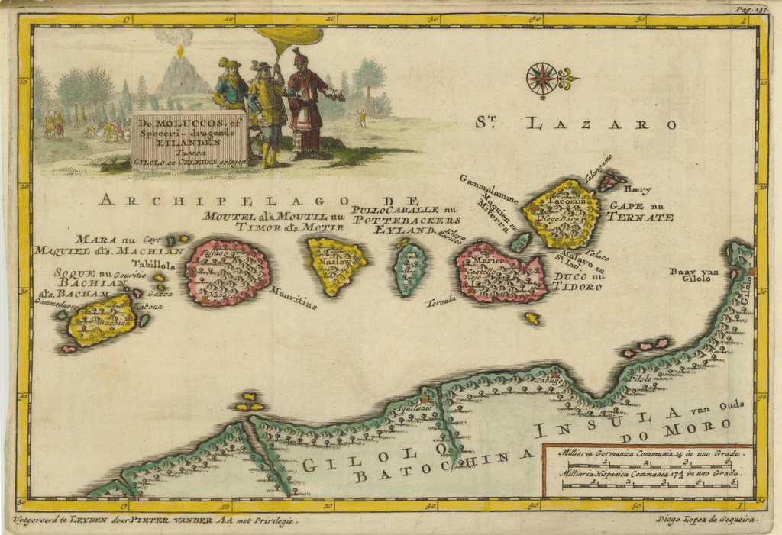
VII. The Unraveling of Exclusivity
The monopoly proved durable but not permanent.
During the Napoleonic Wars, British forces seized the Banda Islands and transplanted nutmeg and clove seedlings to Ceylon, Penang, Grenada, and Zanzibar. A French missionary had earlier transferred seedlings to other colonies.
Once the plants grew outside Maluku, exclusivity ended.
Simultaneously, European tastes shifted. French culinary trends favored subtler flavors. Coffee, tea, chocolate, and tobacco gained prominence. Spices became common commodities rather than rare luxuries.
The VOC collapsed in 1799, weakened by corruption and mounting debt.

VIII. The Islands Today
Fort Belgica still stands on Banda Neira. Ambon remains an administrative center in modern Indonesia. Nutmeg trees continue to grow.
At Parigi Rante, a monument commemorates those killed in 1621.
The islands appear tranquil. The history beneath them shaped global systems of trade, finance, and empire.

Conclusion
The hunger for cloves and nutmeg helped drive oceanic exploration, accelerate maritime technology, and foster the development of the joint-stock corporation, a structure that continues to influence global business.
It also fueled conquest and mass killing.
Small commodities can generate disproportionate consequences when placed within systems of extreme profit and expanding power.
The Spice Islands demonstrate how something that fits in the palm of a hand can alter the structure of the world.

Sources & Citations
[1] Wikipedia. "Spice Trade." Accessed February 2026. https://en.wikipedia.org/wiki/Spice_trade
[2] Cartwright, Mark. "The Spice Trade & the Age of Exploration." World History Encyclopedia, June 9, 2021. https://www.worldhistory.org/article/1777/the-spice-trade--the-age-of-exploration/
[3] CABI Digital Library. "A History of the Spice Trade: How Spices Shaped the World." https://www.cabidigitallibrary.org/do/10.5555/blog-history-spice-trade
[4] Vaia. "Spice Islands: History & Trade Exploration." https://www.vaia.com/en-us/explanations/history/classical-studies/spice-islands/
[5] NOW! Bali. "The Spice Islands of Indonesia: A Brief History Told Through Old Maps." October 27, 2025. https://www.nowbali.co.id/the-spice-islands-of-indonesia-a-brief-history-told-through-old-maps/
[6] Study.com. "Spice Trade History, Routes & Examples." https://study.com/academy/lesson/spice-trade-overview-history-routes.html
[7] UNESCO Silk Roads Programme. "What Are the Spice Routes?" https://en.unesco.org/silkroad/content/what-are-spice-routes
[8] Ptak, Roderich. "The Northern Trade Route to the Spice Islands: South China Sea – Sulu Zone – North Moluccas (14th to Early 16th Century)." Persée, 1992. https://www.persee.fr/doc/arch_0044-8613_1992_num_43_1_2804
[9] American History Central. "Spice Islands." October 15, 2025. https://www.americanhistorycentral.com/entries/spice-islands/
[10] Princeton University Library. "Spice Islands Historic Maps." https://static-prod.lib.princeton.edu/visual_materials/maps/websites/pacific/spice-islands/spice-islands-maps.html
[11] Epoch Magazine. "Of Spice and Men: How Spices Built the VOC." May 27, 2022. https://www.epoch-magazine.com/post/of-spice-and-men-how-spices-built-the-voc
[12] Wikipedia. "Dutch Conquest of the Banda Islands." January 1, 2026. https://en.wikipedia.org/wiki/Dutch_conquest_of_the_Banda_Islands
[13] Facts and Details. "Dutch, the Spice Trade and the Wealth Generated From It." https://factsanddetails.com/indonesia/History_and_Religion/sub6_1b/entry-3949.html
[14] Western Australian Museum. "VOC – United Dutch East India Company." https://museum.wa.gov.au/explore/dirk-hartog/voc-united-dutch-east-india-company
[15] Duke University (The FinReg Blog). "The Dutch East India Company at the Dawn of Modern Capitalism." October 25, 2021. https://sites.duke.edu/thefinregblog/2021/10/25/the-dutch-east-india-company-at-the-dawn-of-modern-capitalism-civilized-dispossession-on-the-banda-islands/
[16] Historia Bersama. "The VOC Genocide." https://historibersama.com/the-voc-genocide-historia/
[17] Leiden University. "Food, Destruction and Depopulation: How the Dutch East India Company Gained a Clove Monopoly on the Ambon Islands." March 2023. https://www.universiteitleiden.nl/en/news/2023/03/food-destruction-and-depopulation.-how-the-dutch-east-india-company-gained-a-clove-monopoly-on-the-ambon-islands
[18] Cambridge University Press. "Genocide in the Spice Islands" (Chapter 8), The Cambridge World History of Genocide. https://www.cambridge.org/core/books/abs/cambridge-world-history-of-genocide/genocide-in-the-spice-islands/
[19] Ocean Earth Travels. "Band Neira History: From the Glory of Spices and Colonial Grip to Stunning Natural Wonders." November 25, 2024. https://www.oceanearthtravels.com/history/history-banda-neira-spices-trade/
[20] Wikipedia. "Invasion of the Spice Islands." November 7, 2025. https://en.wikipedia.org/wiki/Invasion_of_the_Spice_Islands

