Speakers I Find Historically Significant.
By: Marc Silver

The other day I was looking over the list of Absolute Sound’s “12 Most Historically Significant Speakers” and it got me to thinking. Of the twelve choices I definitely agree with most of them. These where all speakers of note in the history of High Fidelity we enjoy today.

That’s when I started to think about other speakers of merit that didn’t make their list possibly because the people making the list just don’t even know of some of these models or perhaps didn’t feel they met the criteria they established. I kept thinking about this list and what I would consider significant. This, by the way, kept me up for quite a while after I went to bed. So today I decided to list some of my favorites and include my reasoning for your consideration.
The list of speakers that I feel are of historical significance in speaker design or technology, is in no particular order. It is just speakers that I felt for the most part that were overlooked.

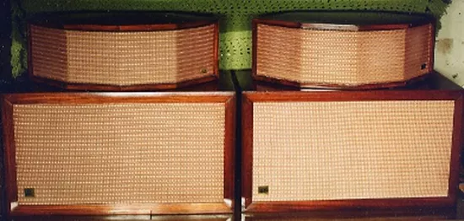
AR1/JanZen 1-30

I think every reader is probably familiar with Acoustic Research speakers but may not be aware that their very first speaker was the AR1 introduced in 1956 as a single 12” air suspension speaker in a box and a 8” Western Electric 755-A mid/tweeter. For all intense the Western Electric driver had limited output above 12kHz. What it needed was extended high frequencies to complete the design. Enter the JanZen 1-30 (130 square inch radiating area for the array, counting both sides.) At the time the only full range electrostatic design was the Quad ELS (number one choice for Stereophile), but at the time JanZen was developing their own full range panels. It wasn’t until 1959 when they were acquired by KLH and the KLH 9 was soon to be the result.

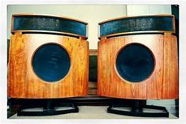
Bowers & Wilkins DM70 Hybrid Electrostat
Only 4 years into production the DM-70 was a fairly early design for B&W. Introduced in 1970. One of B&W’s very first speaker designs, this was a totally different concept B&W would become famous for. The DM70 was a 12” 2-way design with an electrostatic horizontal array. I believe this was their one and only venture into the electrostatic world. I only know this speaker by reputation as I didn’t become a B&W dealer until 1980. As for it’s inclusion on my list to the best of my recollection these where the very first hybrid-electrostatic design from a single manufacturer.

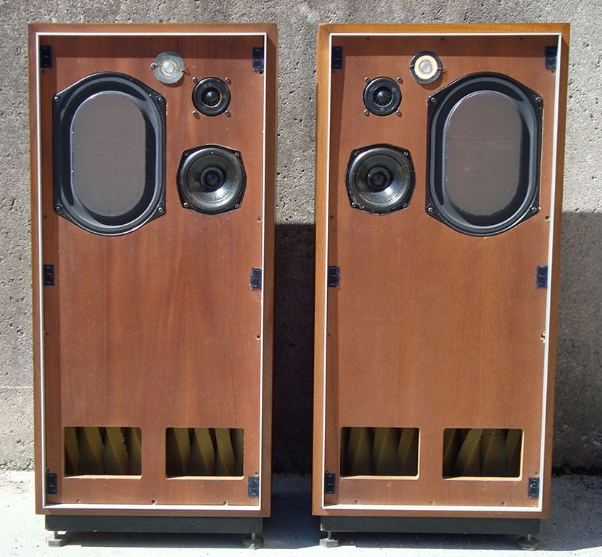
IMF TLS80
The TLS80 was designed by the late great Irving “Bud” Fried back in the 1970s. IMF as a company was an Anglo-American venture with Bud as the chief design engineer. I used to sell the line back then and continued later with his Freid line which was all American. The thing about the TLS80 was they had the most incredible bass. He designed a transmission line concept around the KEF B139 woofer with unbelievable success. It also incorporated a KEF B110 mid, and a Celestion HF1300 and HF2000 tweeters.

In my mind this design set new standards for bass extension and detail. Exceptional even by todays highest standards.

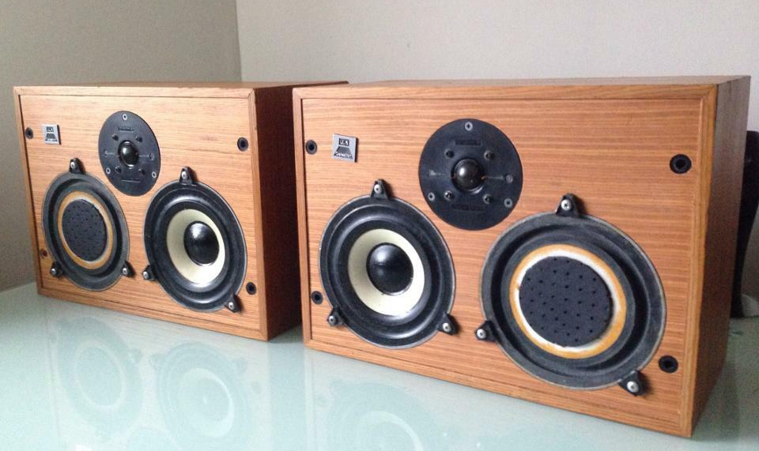
CELESTION UL6
Since I am talking about Celestion, also around that same time they introduced a remarkable small bookshelf. Utilizing a 150mm woofer and passive radiator for bass and a supper smooth 1” soft dome tweeter. I remember them as being just a delight to listen to. They followed it with their SL6 which was probably slightly more detailed with a tighter image, but the UL6 offered a musicality and warmth that was way ahead of its time.

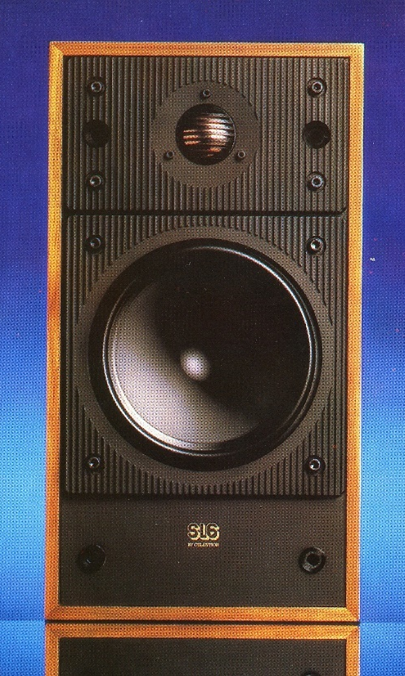
Celestion SL-6

If I recall correctly the SL6 was one of the first speakers utilizing a metal dome tweeter to hit the market. It would be years before I heard a near field monitor that performed as well as the SL6.

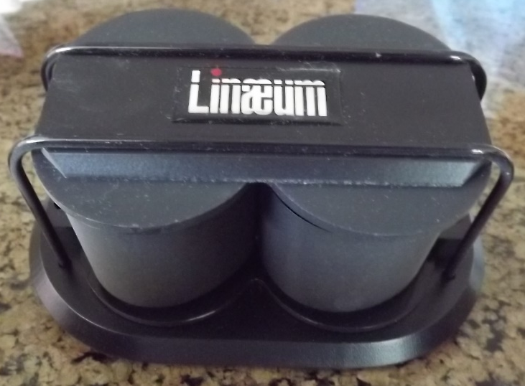
Lineaum Model 5
Lineaum is probably a name some of you may remember from Radio Shack’s Optimus line. But the original design was worlds apart from the mass-market low-end product you may be familiar with. The Model 5 was a close competitor to the B&W 801 and KEF 105 but with a very unique dipole ribbon tweeter. From what I remember there were only two Northern California Dealers for Lineaum of which I was one. The reason for its inclusion on the list is due to its amazing advancement to ribbon technology. Regrettably, Aura Sound acquired the company and then ultimately did nothing with the dipole technology.

I didn’t realize this until I completed this list that I actually put three different ESS speakers on the list. The next three system are all from ESS, which is even surprising to me. But here they are in order of appearance.

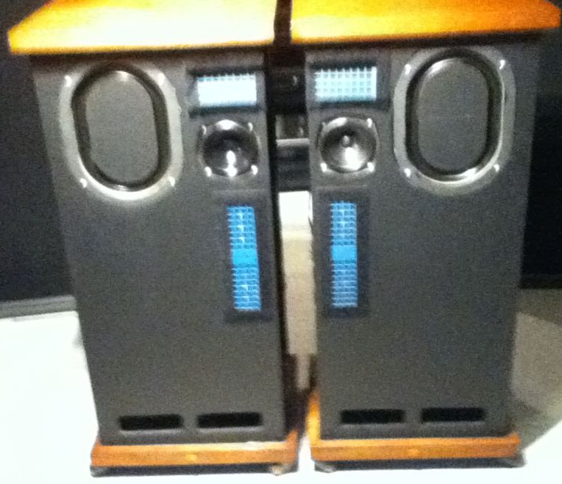
ESS Transtatic Hybrid Electrostat
One of the first ESS speaker systems offered for the audiophile market. At the time ESS was able to marry drivers from KEF and RTR into a hybrid electrostat that was supper impressive for the time. I think there is a lot of influence from for JanZen and KEF in this design. To be honest I am not sure the Transtatics meet the criteria for a historically significant design, but it was an amazing design. Years ahead of the IMF TLS80s and not long after the KLH 9 but it was one of the earliest true audiophile speakers on the market.

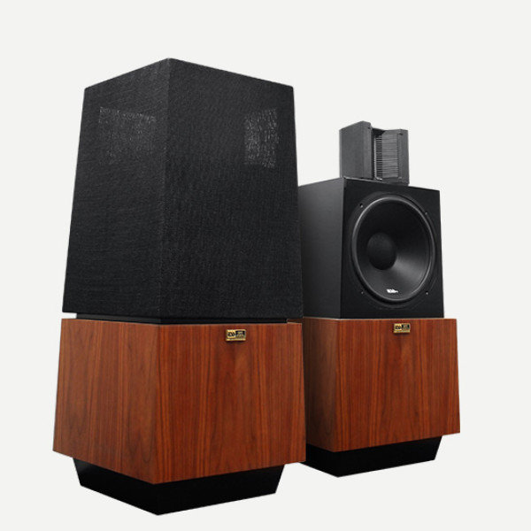
ESS AMT1
The AMT1s was a real breakthrough in ribbon technology. The thing I found totally new was how easy it was to replace the ribbon diaphragm of the “Air Motion Transformer”. That made it the first user and possibly only replaceable tweeter diaphragm on the market. Although they failed in successfully smoothly marrying the 12” woofer to the tweeter the overall performance was very good. Its mid-band suffered as the ribbon failed to reach down far enough to smoothly match the woofer.

ESS Transar

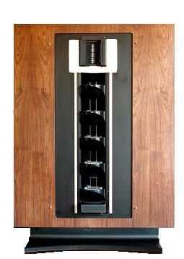
When Oscar Heil invented the Air Motion Transformer, his original intent was that it could be a full range system. The Transar was the fulfillment of that dream. The first time I heard them I was amazed at the crystalline quality of the sound, but after about 10 minutes I found myself running for the door. AS clean and detailed it attacked my senses. Not the reaction I expected since I was a fan of his AMT1s. This was a technical success and a practical disaster. At least that is my opinion.

RTR DR-1 Hybrid Electrostat
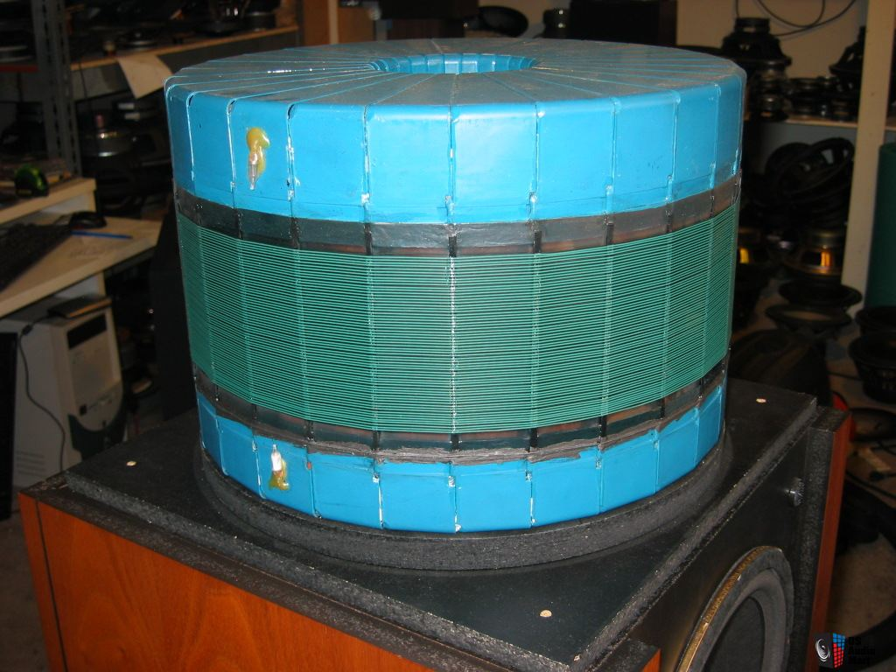
Dating from 1980 this was the was a large very dynamic omni-directional speaker and the big brother to the RTR 280DR, which was an all dynamic design. What was unusual about the DR-1 was it’s 360-degree electrostatic array that sat on the top of the system. The array had 20 of their 2” x 6” panels that circled a heavily damped center core. These were the same panels RTR supplied to companies like Infinity, ESS, Crown and a few other speaker companies.
I think of RTR fondly as they were my very first speaker franchise when I opened my store in 1974. Most people may not aware that RTR got their start as an OEM supplier for Infinity Speakers, building many of Infinity’s early speaker systems.
Similar to the Janzen Z1 RTR also built an add on electrostatic array that I often married to their DR-280 making it an affordable audiophile system performing reasonably close to that of the DR-1.
After the company went bankrupt the name was purchased by BIC which still produces a line a mid-fi speakers under the RTR banner, regrettably a far cry from their original designs.

Vandersteen Model II
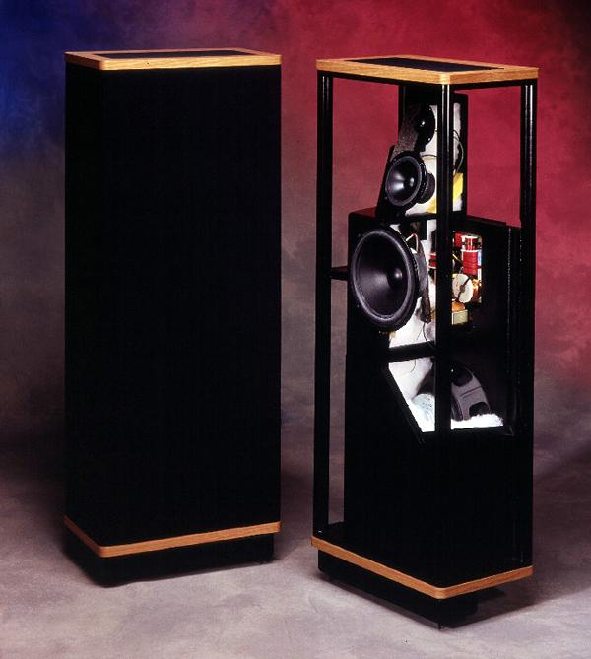
I believe the Model II debuted in 1977 at CES in Chicago. Richard Vanderseen’s intent was to produce an absolutely correct phase and time aligned speaker system. I want to emphasize the term absolutely phase correct because up until then there were phase corrected speaker systems, but I believe this was the first that was absolutely phase correct.
Richard is very adamite about that this feature of his speakers. Although the IIs had minor sonic issues that would ultimately be addressed in later models, the original was a remarkable speaker system that still holds up 40 years later.

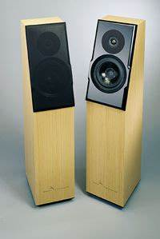
Meadowlark Kestrel
The Meadowlark Kestrel was a phase and time aligned small tower speaker that reminded me a lot of the mini monitors because of its precise imaging, but better because you didn’t have to buy a pair of speaker stands. Plus, you could order them in almost any wood finish and detail you wanted, which was very unusual then and now.

I was so disappointed when Meadowlark went under because I sold a lot of these little jewels over the years. I have to admit, I am not sure if these speakers actually deserve to be in the mix, but I loved all the details of their design. I believe that Meadowlark as a company was one of the first if not the first that offered total customization of the cabinetry.

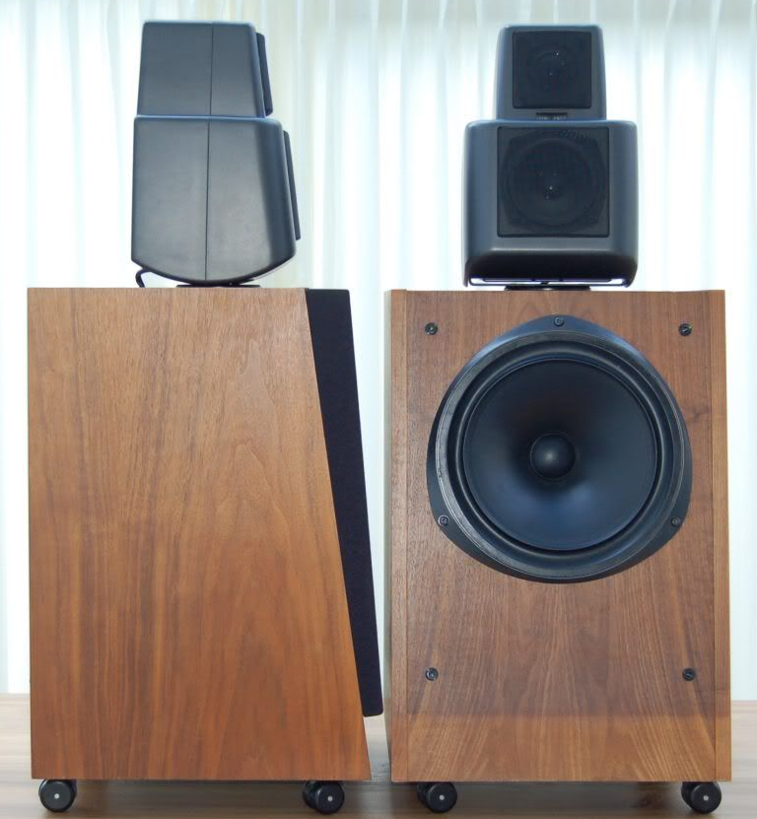
KEF 105
Both KEF and B&W introduced head to head competitors in their class at the same time. The reason I put the 105 on my list is they were the first system that utilized a Mid/tweeter assembly that both pivoted and tilted to optimize performance and placement. I actually prefer this model over comparable speakers in their line today. They were smooth, detailed and demonstrated great imaging and depth of stage. Plus, the soft dome was far warmer than most of the current KEF designs.

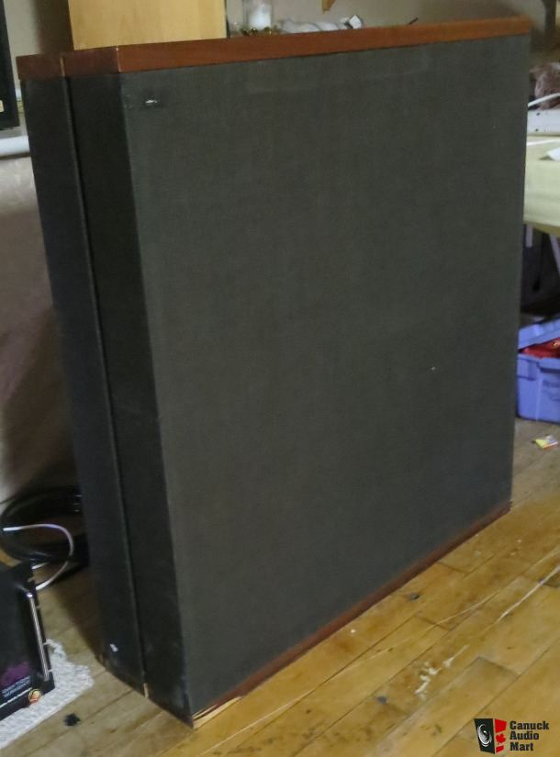
Dayton Wright XG-8
I have to admit I have only sold one pair of XG-8 speakers and it was a bit of a disaster. What was totally unique about these electrostats is they were incased in a rare-earth gas bag that had a bad habit of leaking gas. Additionally, the pair I sold kept failing and needing to be returned to the factory for repairs and updates. On the plus side it imaged incredibly well, had fabulous dynamics and bass. But like most electrostats of the time they were very beamy and with a speaker impedance of 80,000 ohms it was very amp critical.

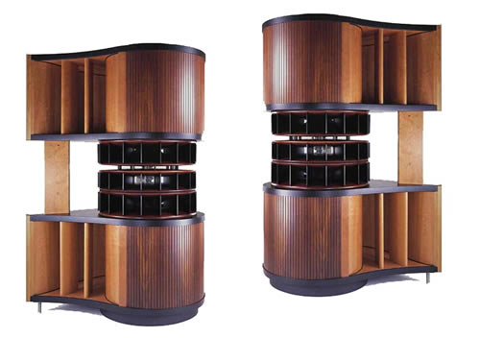
Platinum Air Pulse3.1 Referance
The Air Pulse speakers were the brainchild of world renown speaker designer Phil Jones. Not to be confused with Andrew Jones who is also a world renown speaker engineer. Phil has a long list of remarkable designs including Acoustic Energy in the 80s, the Lynnfield High-End project for Boston Acoustics, then Platinum Audio and currently AAD. The Air Pulse was his effort to produce a cost no object Horn speaker design introduced at a mere $175,000 per pair. I am tossed between these and the JBL Paragon as the most remarkable Horn speaker ever built.

OHM Walsh A, F and TLS
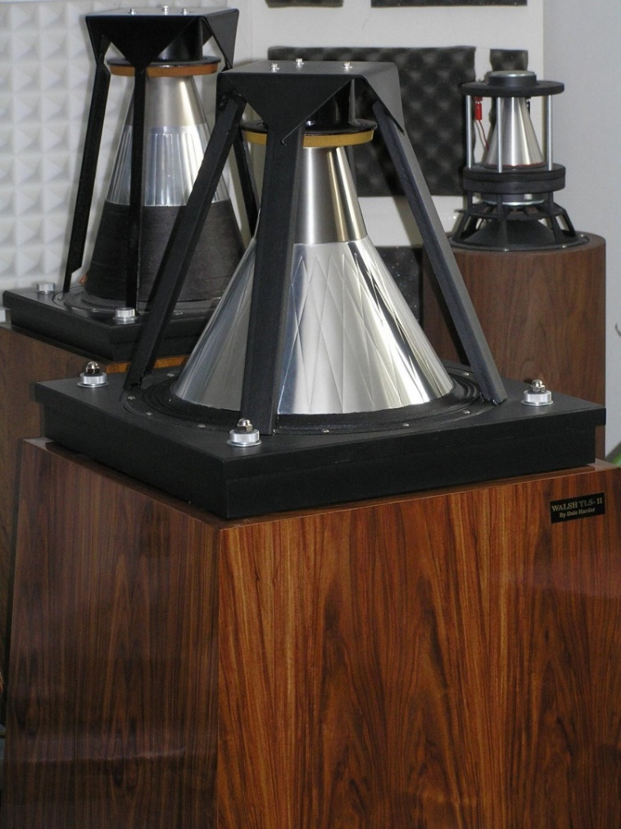
Although I am mentioning three different models, they all were introduced at the same time and were similar in design concept. I remember when the Ohm A came out. I was an apprentice at Stereo Mart in Tarzana outside Los Angeles. I was invited to Woodland Stereo to hear the new Ohm Walsh A speakers. They were huge. There were the first speaker I had heard that actually produced a uniform omnidirectional sound. These speakers were a totally different approach to a dynamic speaker. The original designs used a multi-segmented, deep-set inverted cone design firing downward into a base enclosure and producing a 360-degree dispersion pattern.
The TLS used a conventional woofer down firing with a Walsh assembly mounted above it. The downside to the design was they were incredibly difficult to drive. I recall Walt Lucetter (Woodland Stereo’s owner/manager) having to use SAE’s largest amp to bring them to life. It was some years later that I became an Ohm dealer selling their far easier to drive and more accessible models 1 through 5 at my shop in Northridge.
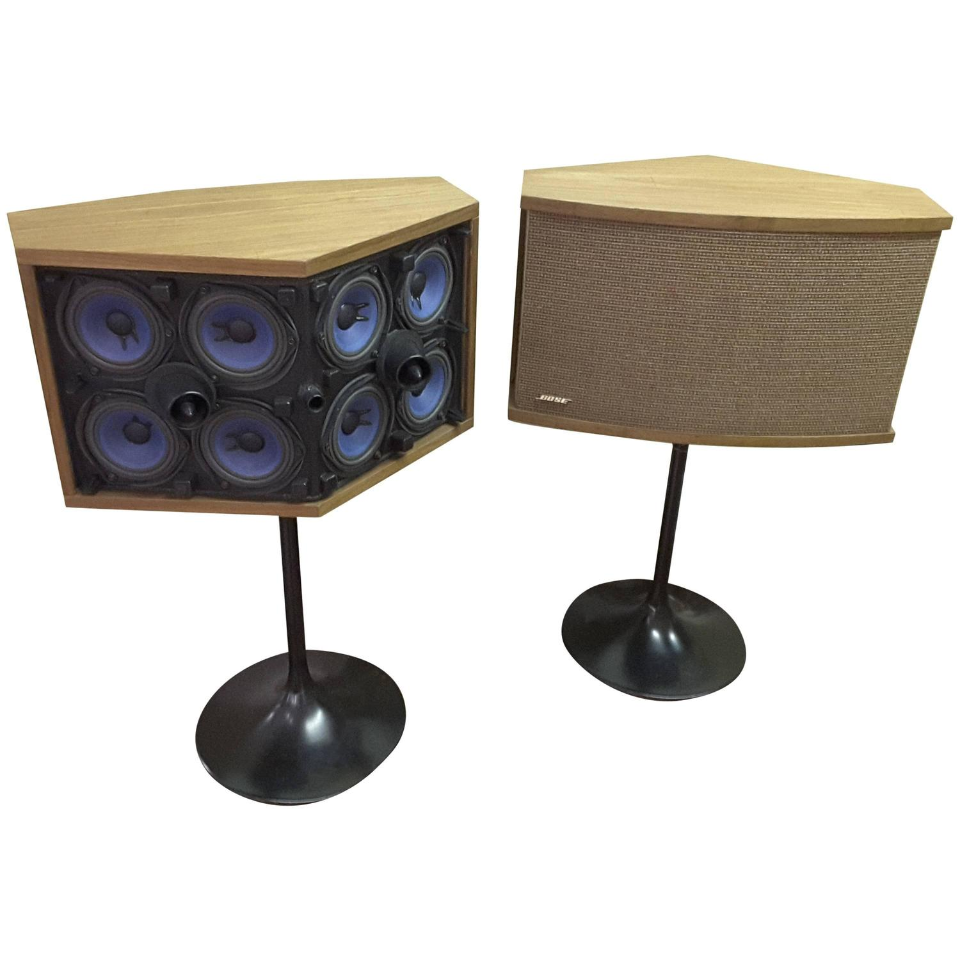
Bose 901
The last speaker on my list is one I know I’m going to get flack for. I was new to the industry when the first 901s came on the market and initially I like most people thought it was totally cool. Here was a rather small speaker that could produce a huge sound stage and handle any amp on the market. What I didn’t know at the time was what this product was going to be the first speaker for what was to become the world’s largest and most successful audio company in the world. I need to admit that Bose is probably my most favorite speaker to hate. Although I personally would never own a pair of Bose speakers (at least based on everything I have heard to date) the company has done more to promote HiFi throughout the world and has grown into unquestionably the largest and most successful audio company in the history of the world. Love it or hate it, you have to respect it.

***************************************

TAS’s List of Historically significant speakers
Staff member of the Absolute sound in their Sep 18th, 2010 issue came up with their list of the 12 most significant loudspeakers of all time. They chose speakers that introduced a new technology, changed the market, influenced future designs, or revealed some previously unheard aspect of sound quality. Below is their list in reverse order.
12. Klipschorn
My feeling is the K Horns are the most successful corner horn design ever produced. “Other companies as produced corner horns, but the Klipschhorn has been in production in one form or another (the original was a 15” 2-way) for over 50 years.
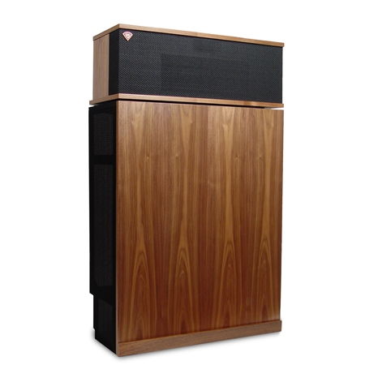
11. MBL 101 E
The MBL 101E is one of the most unique speaker designs ever to hit the market. Their approach to a pulsating sphere has never been duplicated in a similar fashion.
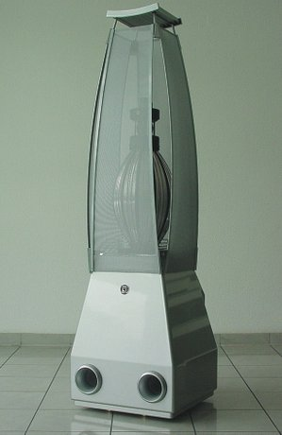
10. Large Advent
The original Large Advent was a significant speaker at the time, but for all intense it was an updated version of an earlier Acoustic Research version. I am not sure why this made their list.
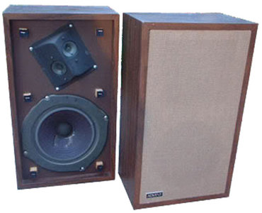
9. KLH Model Nine
This was the second full range electrostatic loudspeaker. I would leave it on the list simply because it overcame many of the problems if the original Quad ELS. The most significant issue being vertical dispersion.
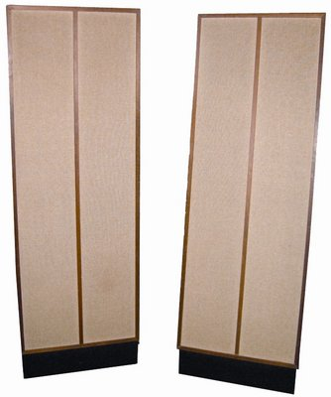
8. Infinity IRS V
This system was the very first Monster Audiophile speaker system to hit the market. Later to be followed by functionally similar systems from Genesis, Nola, Wilson Audio, Von Schwerte and more.
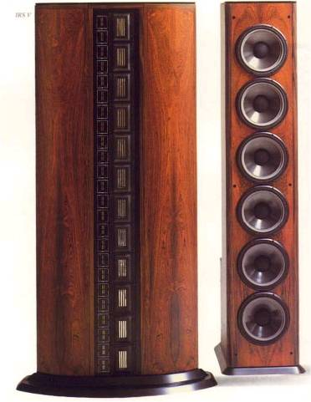
7. Magnepan 1-U/1-D
Magnepan is responsible for the very first reliable and functional full range ribbon speaker system to enter the market.
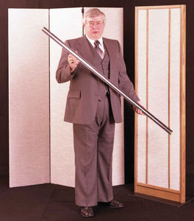
6. Dahlquist DQ-10
This design came from the engineering team of three of the worlds form most designers, Saul Marantz, John Dahlquist and Carl Marchisotto. They used the woofer out of the AR 2ax/Large Advent and married it with other off the shelf speakers in a time aligned system. According to my conversations with Jon Dahlquist, he wanted to produce a speaker that was a dynamic speaker system that emulated the Quad ELS.
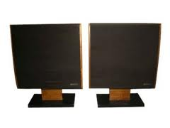
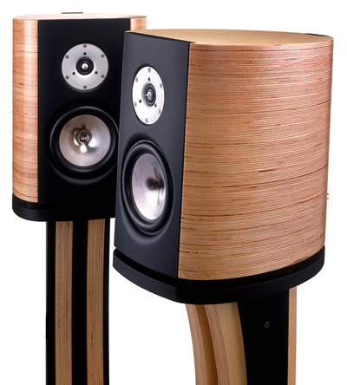
5. Magico Mini II
The only thing I can think of that may have gotten Magico’s Mini II on the list is their use of the pole-piece ring radiator tweeter. (not on my list)

4. Wilson Audio Tiny Tot (WATT) (not on my list)
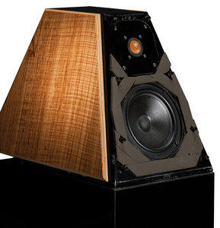
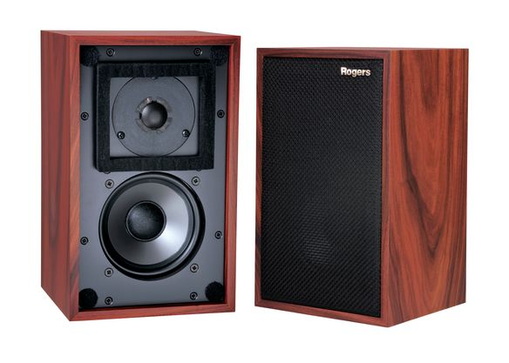
3. Rogers/BBC LS3/5a
When KEF developed the LS3/5a for the BBC it was the first audiophile class mini monitor to reach the market. It was licensed to multiple companies including Rogers, Chartwell, Castle and others.
2. Acoustic Research AR3a
I would have thought that the original AR3 and not the 3a would have been the This was the most successful version of the AR3 and was the first full range Air Suspension Speaker.
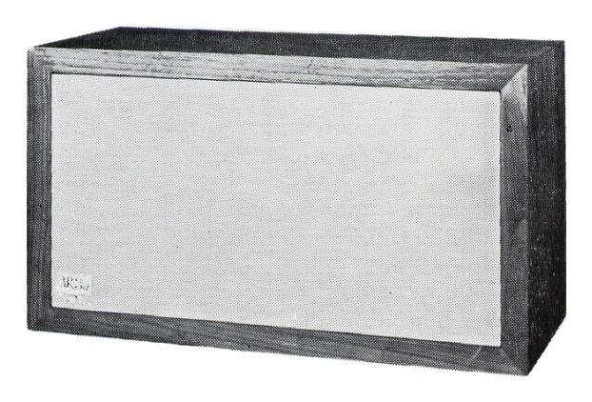
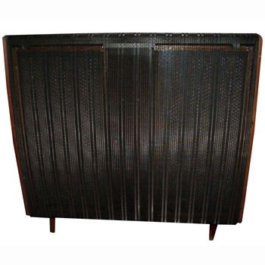
Quad ESL-57
One cannot refute that the ESL-57 is the number one choice as it was the very first electrostatic speaker and responsible for the best in sound products to every be produced. Including speakers such as Sound Labs, Martin Logan, and many others.

