Speaker Technology
by Marc Silver
I have been wanting to write an article about speaker technology for many months, but I needed to compile some added research to allow me to not just disseminate what knowledge I have acquired over the last 51 years I have spent as an audio professional.

In short I didn’t just want to talk but to have the content meaningful. Additionally, I needed to work out exactly what I wanted to write about. How much history versus how much technology? After all this is primarily a technology article, but without a background of the history of speaker design and development it would be a rather dry presentation. Hopefully the following will be both instructional as well as entertaining.

What is a speaker?
I am sure everyone is familiar with the idea of what a speaker is, but just so we are all on the same page let me define what a loudspeaker is:
Basically, a loudspeaker is any device that converts electrical signal and turns it into audible sound.
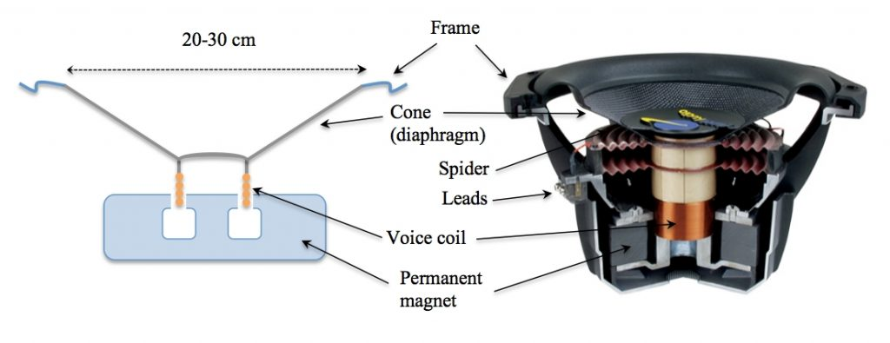
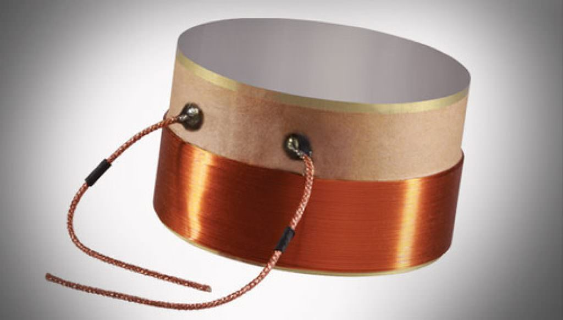
The most common design is a dynamic speaker that does this by the use of a voice coil (wire wrapped around a round former that is suspended inside the gap between a pole piece and a magnet). This is referred to as the moving assembly and it attaches to some form of cone material that moves back and forth similar to a piston. It is that motion that moves the air and produces sound. Speakers are commonly referred to as transducers. Something that converts electrical signal into physical motion.
There are variants, however, that include ribbon speakers, electrostatic speakers and ionic speakers. I will get into the various designs later in this article.
I should also comment that experiments have been going on to produce a direct neural stimulator. But since this is a Top-Secret project being developed by the military, perhaps I have already said too much.
Speaker Enclosures
When it comes to dynamic designs, there are numerous approaches to what makes a good speaker. We have all seen numerous designs but the most common is a box.
Many speaker systems are typically housed in a speaker enclosure or speaker cabinet which is often a rectangular or square box made of several forms of wood. There are some designs that use more exotic materials such as Concert, glass, Lexan, composites of rock and polymer and sometimes plastic. The enclosure's materials and design play an important role in the quality of the sound. The enclosure generally must be as stiff and non-resonant as practically possible. Where high fidelity reproduction of sound is required, multiple loudspeaker transducers are often mounted in the same enclosure, each reproducing a different part of the audible frequency range.
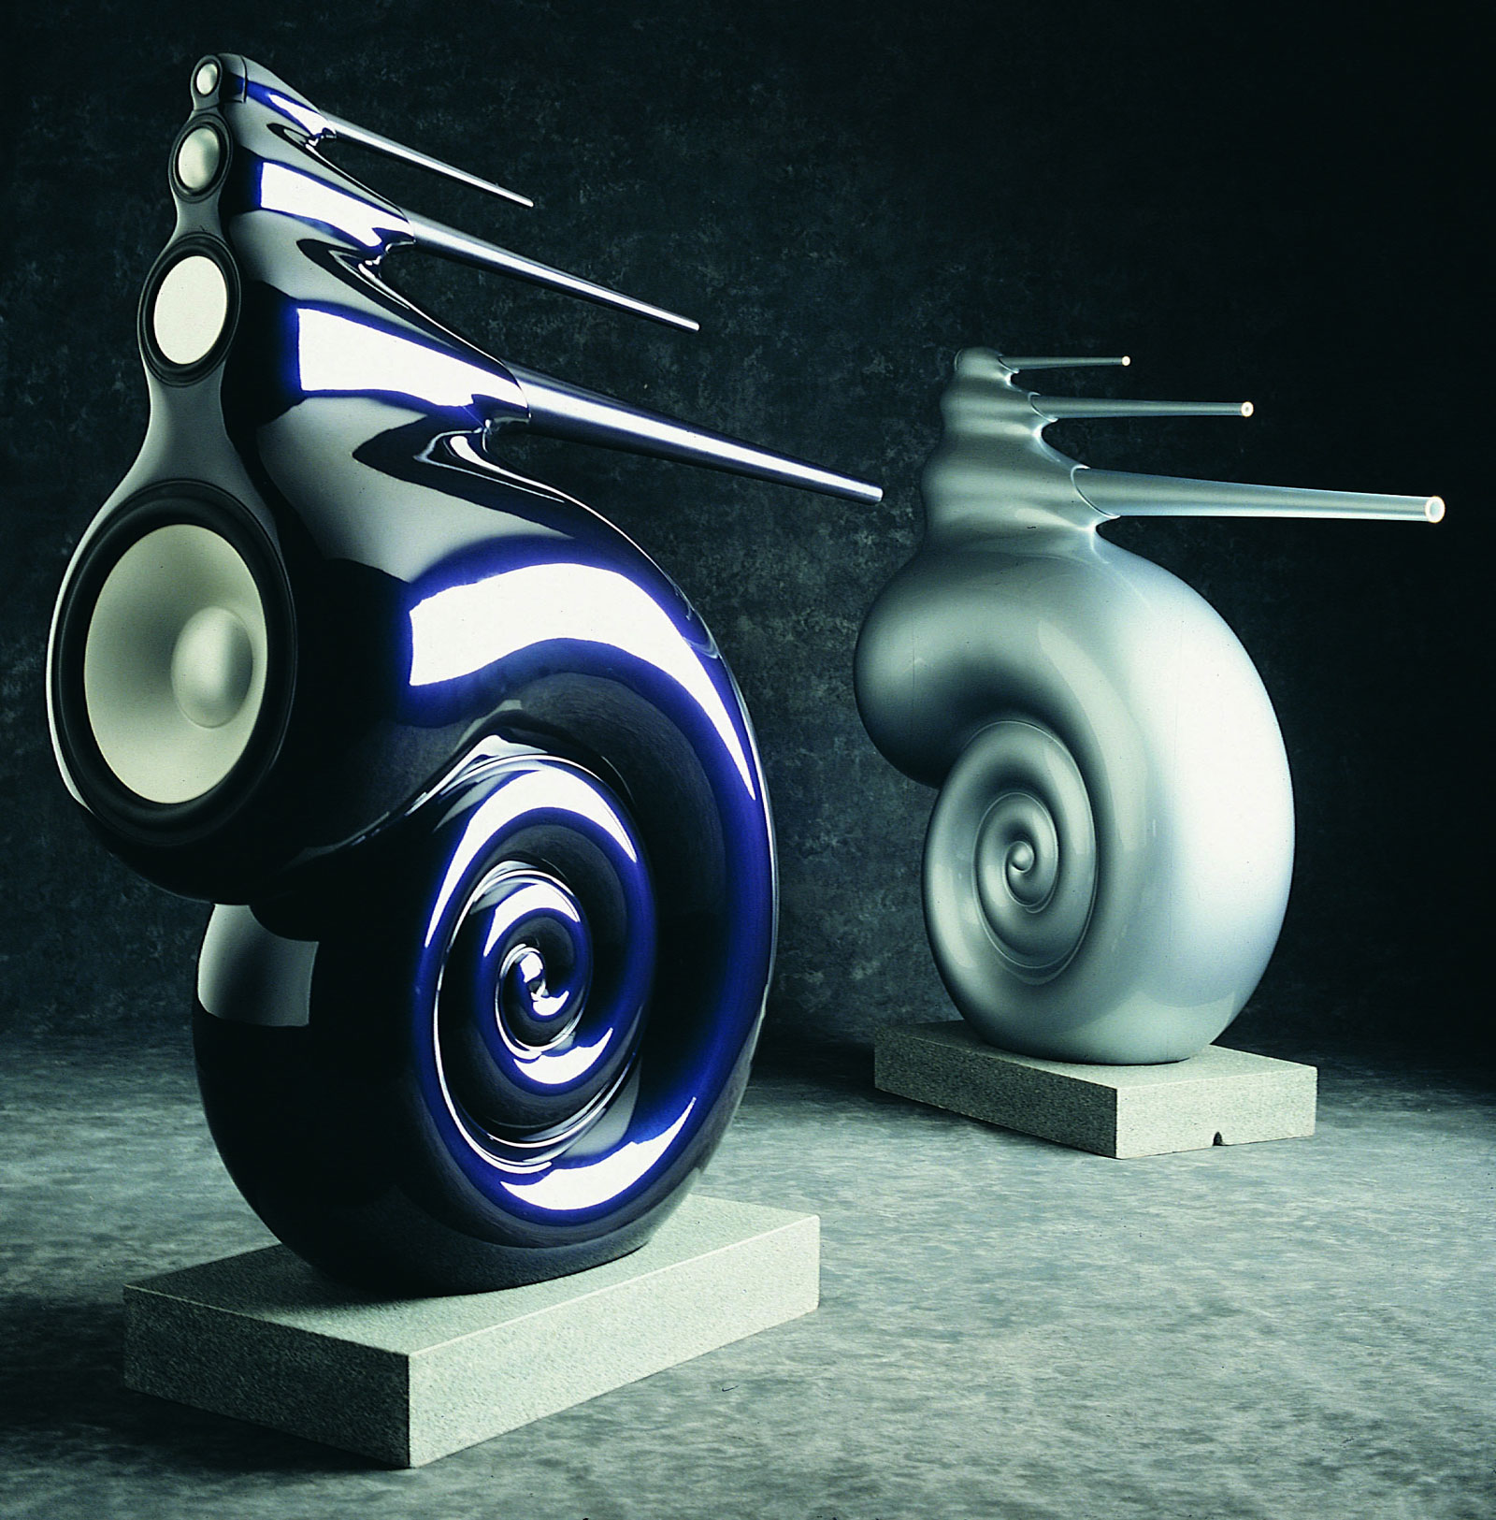 Shown is a rather exotic approach to speaker design by Bower & Wilkins. In this case the individual speakers (referred to as "drivers") with the entire unit comprising a loudspeaker system. Each driver has their own name. High audio frequencies are called tweeters, Speaker that produce the middle frequencies are called mid-range drivers. Back in the fifties they were also called “Squawkers”. Low frequency divers are called woofers. Extremely low frequencies (16Hz-~50Hz) are referred to as subwoofers.
In electronics such as TVs, Computers and portable audio players smaller speakers are often used and referred to as full range drivers, primarily because they are called on to produce all the sound from their assigned electronics.
The sound produced by speakers is determined by frequency and amplitude of the sound reproduced. Frequency is the range of how high or low the pitch of the sound. For example, the sound produced by small bells produces high frequency sound, while the pedal notes of an organ generates sounds in the low frequency range. A speaker’s ability to accurately reproduce the full range of music is a good indicator of how accurate the audio will be. Looking at the example of the B&W Nautilus above, you can see multiple speaker cone materials and sizes for different frequency ranges, which helps produce more accurate sounds for each range. Two-way speakers typically have a tweeter and a mid/woofer, while three-way speakers have a tweeter, mid-range, and woofer.
For stereo speakers typically come in pairs, which allows them to produce a sound stage with the intension of recreating the illusion of the original performance. I have often said that surround sound is easy, and stereo is hard. By this I mean that multiple drivers create a surrounding effect that is a very immersive experience. But to produce a three-dimensional sound stage with instruments spread across the room while creating a feeling of depth and height with only a single pair of speakers is very demanding on the system and far more difficult to attain. When done well, the experience displays how good a speaker system truly is.
I have always believed by using just two speakers, music sounds much more natural.

Speakers are one of the most common output device used with everything from home entertainment systems to portable radios to computer systems to commercial sound reinforcement. Regardless of their design, the purpose of speakers is to produce sound that can be heard by the listener.

EARLY DEVELOPMENT of the Loudspeaker
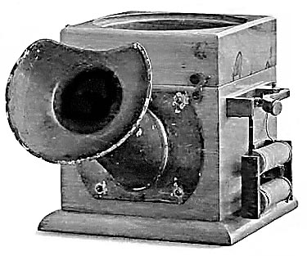
The first loudspeaker was invented in Germany by Johann Philipp Reis for use in a telephone back in 1861, but the first design only produced acoustic tones and barely discernable speech. It was some years later when Alexander Graham Bell was issued a patent based on Reis's work in 1876 for a speaker that reproduced intelligible sound. This was part of his patent for the telephone.

Werner Von Siemens created an improved design the following year when he developed the concept of an electromagnetic coil driven speaker and improvements on the basic design continues to this day. At that time however, there was not enough understanding of physics and material engineering to allow Bell or any other inventor the ability to successfully produce an electrodynamic loudspeaker.

Many inventors and engineers developed electrodynamic loudspeakers but without amplification they could only create rather poor and distorted sound. There was no way at the time to electrically amplify the signal to create very loud sounds. It took the development of tube amplifiers before modern speaker designs could become viable.
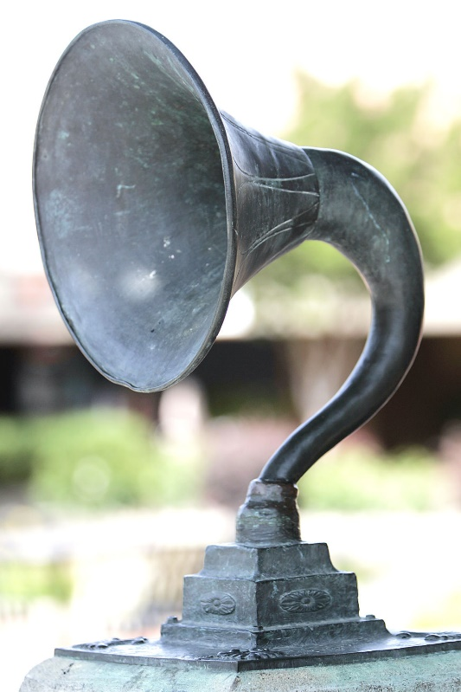
In 1898 Oliver Lodge produced a dynamic (moving coil) loudspeaker, but the first practical design came from Danish inventors, Peter Jensen and Edwin Pridham in 1915. Interestingly they were living in Napa California at the time. The team were never issued a patent and additionally were unsuccessful in their attempts to sell their designs to telephone companies. Fortunately for us, they founded Magnavox and focused on producing Radios.
Inventor Chester Rice and Edward W. Kellogg were issued a patent in 1924 for the direct radiator speaker, what now is the moving coil design that has become the most widely accepted design for loudspeakers in use today. 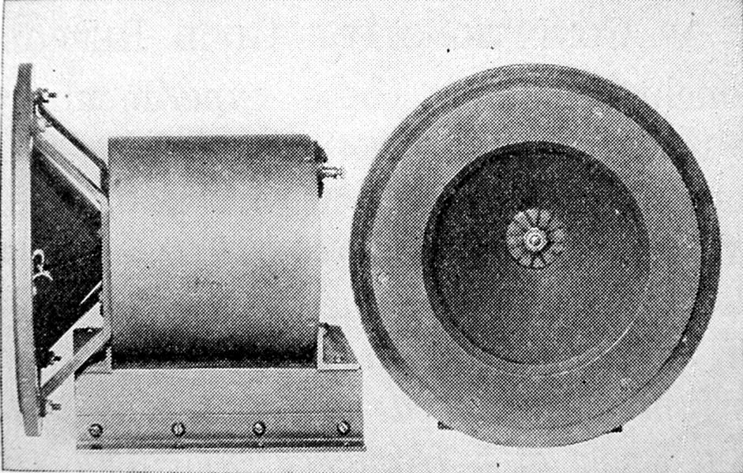
Interestingly at about this same time Walter Schottky invented the first ribbon loudspeaker together with Dr. Erwin Gerlach.
Unlike modern ribbon designs the first ribbon loudspeakers had to use electromagnets due to the very poor quality of large permanent magnetic material of the day.
An electromagnet used AC power to produce a stable magnetic field that the ribbon coil would reside. The regrettable side effect of this early design was that the electromagnet produced prodigious amounts of hum along with the sound.
It was Jensen who produced the first practical fixed magnet dynamic speaker design, but cost prevented its’ widespread adoption until World War II when the Alnico Magnets many audiophiles still covet today came into use.
C.W. Rice of General Electric and E.W. Kellogg of AT&T worked together to develop the modern speaker and first electrically amplified audio system. They created a working prototype in 1921.
Rice and Kellogg solved the final problems which led to sound that could eventually be called High Fidelity. Their designs had acceptable frequency range and played loud enough to be considered superior to the mechanical horns of the day. They were issued patents in 1925 and produced the first commercial product called the Radiola Loudspeaker #104. under the company name of RCA.
SPEAKER TYPES
HORN LOUDSPEAKERS
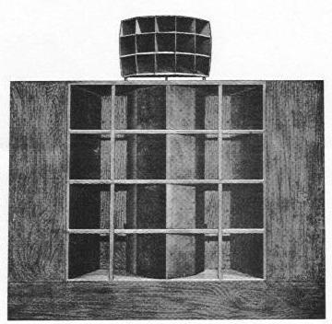
Prior to the late thirties, speakers were incapable of sound reinforcement. Technology just hadn’t advanced to a point that speakers were capable of high-volume output. That changed in 1937 when Metro-Goldwyn-Mayer introduced the "The Shearer Horn System” for use in movie theatres. Similar to today’s designs it was a two-way speaker system utilizing four 15″ low-frequency woofers and a multi-cellular horn with dual compression drivers providing the high frequencies. The trio of engineers to develop this system included James B Lansing, Douglas Shearer and John Hilliard.
Two years later at the New York World’s Fair, Rudy Bozak came up with an outrageous system consisting of eight 27” Woofers and an array of high-frequency horn tweeters. This was to be a standard that would take years to surpass.
In 1943 Altec Lansing produced the first co-axial (DUPLEX) speaker called the 604. This was a 15” woofer with a tweeter mounted on the opposite side of the main magnet and fired through a hole in the center of the pole piece of the speaker.
Two years later Altec introduced the "Voice of the Theatre" loudspeaker system. The Voice of the Theater system was accepted by the Academy of Motion Pictures and Sciences and became an industry standard in 1955 and is still considered a classic design to this day by many audiophiles. Over the years there have been many improvements to both sound quality and performance and are still in use today.
There are literally thousands of different designs of horn loudspeakers but there are only three basic type of horn speakers. Folded Horn, Transmission Line and Direct Horn. At this point I will discuss the various types of the most conventional Horn designs.
Direct Horn Designs.
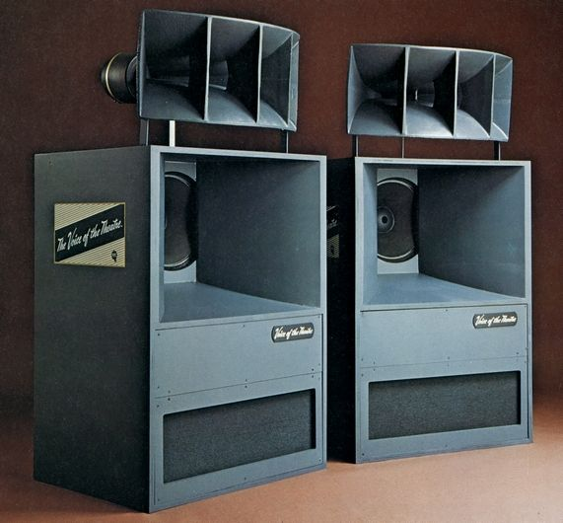
Some of the first speakers to arrive on the audio scene were direct horn designs. By mounting a direct radiating speaker at the base (or throat) of a horn a speaker gets an increase in the dynamic capability, and image size. The advantage of all horn designs is efficiency. You get more output with less power with all these designs. There are numerous horn speakers that achieve greater than 100db of output with just one watt of power.

Folded Horn / Transmission Line Designs
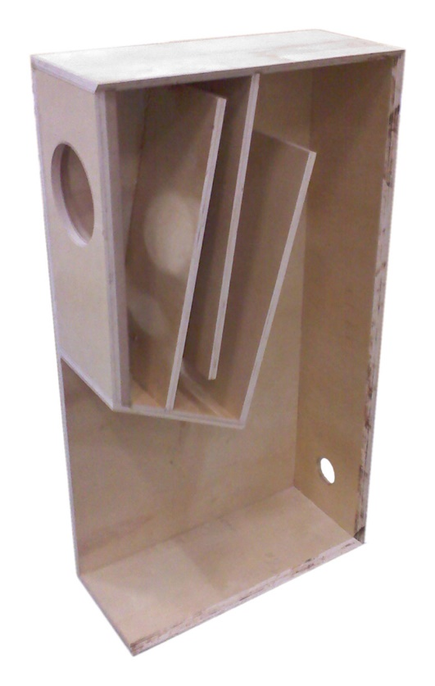
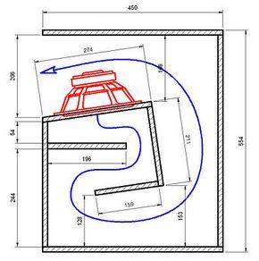
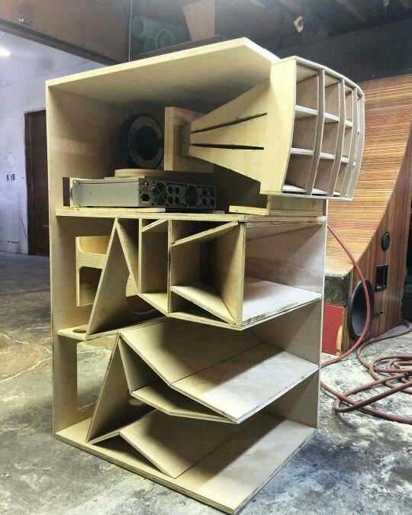
The principle behind a folded horn is it allows the waveform to travel further and propagate lower bass frequencies while increasing efficiency. The engineering that goes into the multitude of these designs is amazing.
I am not even going to attempt get into the engineering and physics as these represent some of the complex designs found in any speaker design.

TradiTIONal Box Speaker designs

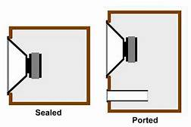

Vented Loudspeakers
Vented designs include both ported and slot loaded speaker designs. There are variations to each of these designs including Venturi designs from BIC, “Flowport” from B&W, and many others. Conceptually, companies are working to minimize the flow of air through the port or vent. Poorly designed versions have issues with port chuffing caused by uncontrolled air moving in and out of the port. The advantages of ported speakers are many including greater efficiency and bass extension. The disadvantages include difficulty controlling the woofer movement and cabinet resonance issues.

Acoustic Suspension Loudspeakers
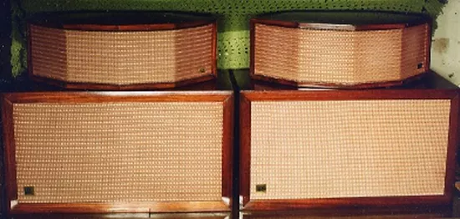
Up until the early 1950s if you wanted to produce big sound you needed big speakers. But in 1954 Edgar Villchur developed the acoustic suspension speaker design. Villchur along with Henry Kloss founded Acoustic Research Speaker Company in Cambridge, Massachusetts. The original Model 1 utilized a single 12” woofer mounted in an airtight enclosure. It was most commonly paired with the JanZen model 1-30 electrostatic tweeter array to make a complete full range speaker system.
This is a sealed cabinet principle that uses the back pressure of the box to control the cone movement of the primary speaker driver. The result was better bass response from a much smaller speaker enclosure. Air suspension speakers have the advantage of producing much better bass response from a much smaller enclosure than previously available, but at the expense of efficiency.
The AR air suspension design sparked numerous speaker companies, many still in existence today.

The next area of discussion is about flat panel speakers also call dipole radiators. These include Ribbon and Electrostatic speakers.

Planar Types

Electro-dynamic Planar Speakers
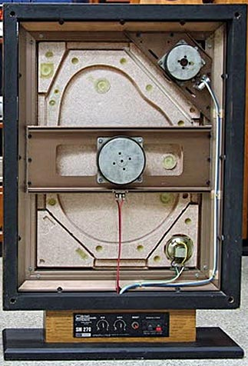
There are numerous designs of this type. Typically, they use a conventional voice coil motor assembly attached to some form of flat diaphragm. Back in the late 70s I worked with Jose Bergagni, founder of BES speakers. He patented a system that used a Styrofoam panel of varying densities that when excited by a magnet/voice coil driver allowed the panel to resonate at different frequencies depending upon the density of the panel. What is truly unusual about this variant is it produced a near spiral dispersion pattern.
Other companies have produced variants of this design using anything from PET foam, polypropylene foam, polypropylene, ABS, glass fiber and carbon fiber, flat Styrofoam, as well as everything from glass, to plastic, to wall board. Each with some success.

RIBBON LOUDSPEAKERS
The early Ribbon loudspeakers used electromagnets to energize coils. The energy then went through these coils into a second pair of connections to the driver in the system. This worked as a power supply and amplifier for the loudspeaker.
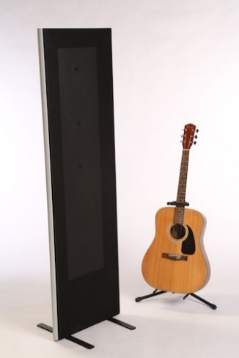
I have to admit I have never seen any early ribbon designs, but I am very familiar with most modern design Ribbon Technologies. Probably the most notable modern design is from Magnapan. They use a super light (low mass) aluminum foil film securely glued to a mylar diaphragm stretched tight over a frame and in close proximity to a series of bar magnets. The power amplifier applies a signal to the aluminum coil causing the diaphragm to move and produce music.
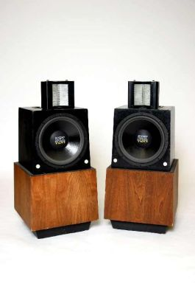
One of the most famous early ribbon designs was the Air Motion Transformer invented by Dr. Oskar Heil’s in the 1970’s. This design used a flat wire voice coil positioned between mylar material and folded into an accordion shape that slipped between the pole piece of the magnet assembly. This was a dipole resonator producing equal signal output from both the front and back of the speaker. Versions of the original AMT1 are still available today by ESS.

A version of this design is currently available as a mono-pole design from both Martin Logan and Golden Ear. Another variant of some note was the Linaeum Tweeter. It was very unique dipole ribbon two tweeter. Here the voice coil was attached to sets of opposed half domes that are slotted between dual fixed magnets. As the polarity changes the ribbon moves back and forth through the gap causing the energy to be transmitted across the diaphragm, producing sound.
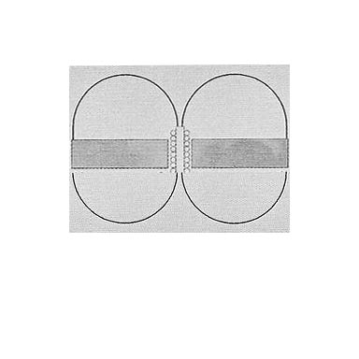

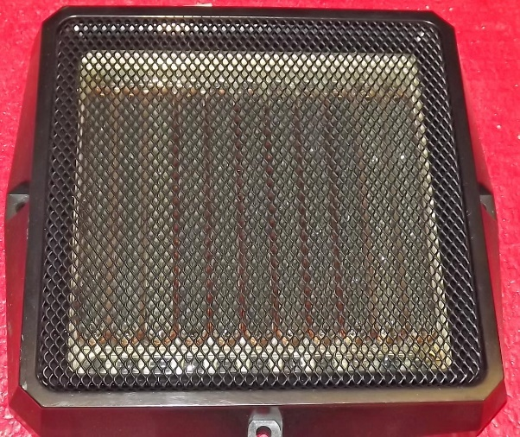
Multi-cell Flat Diaphragm Speakers
This speaker is related to the electrodynamic loudspeaker in that it uses magnetic fields to move an element, however its shape is different. This speaker has the coil directly mounted on the diaphragm. Some years ago, I acquired a pair of these mid/tweeter drivers. The copper coils have been wrapped around the base of the clear plastic bulges in the photos below. The long permanent magnets create separate 'cells' and the whole diaphragm ends up moving uniformly. This is a heavier speaker than the flat panel speakers above. This type of speaker requires a transformer because each small cell has a lower impedance than a standard speaker with single exciter.

ELECTORSTATIC LOUDSPEAKERS
Electrostatic speakers happen to hold a special place in my heart as I became a Quad dealer back in 1976 and have had either Quad or Acoustat electrostatics as my primary listening speakers in my home system ever since. I have also sold almost every electrostat produced with very few exceptions over my 51 years in the audio industry. The history and technology are fascinating and I could go on far deeper into the history and technology of the design, but I will attempt to keep this section informative and relatively short.
As far back as 1947, at the forefront of the development of electrostats, was an applied physicist, Arthur Janszen. At the time he was working for the US military to develop a new instrument for testing microphones. Janszen felt that he could do better than the traditional cone speaker designs by applying the electrostatic principle. His early designs seemed to confirm his beliefs, but it would be a while before he could resolve the many technical problems that stood in his way such as speaker arching for one.
Ultimately Janszen would add insulation to his stators to resolve this issue and by 1952 had developed a working electrostatic tweeter. Soon after he formed Jasnzen Laboratory Inc and introduce the model 1-30 electrostatic tweeter array. This array turned out to be the perfect complement for the AR1 introduced in 1955 which needed the extended high frequencies available from the Janszen array.
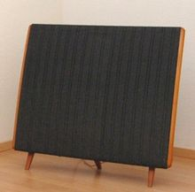
Although many other inventors also tried to develop an electrostatic flat panel speaker it wasn’t until 1955 when Peter Walker finally produced a reliable and acoustically transparent full range electrostatic speaker.
The introduction of the QUAD ESL in 1956 in the United Kingdom and a year later in the US, marked the greatest advancement in speaker technology to that date. Even by today’s standards the original “ESL 56” is considered a true audiophile loudspeaker.
The principle behind the design is astoundingly simple. A light, thin plastic sheet is coated with carbon graphite and then stretched between two metal grids (or stators). The stators are electrically charged and act as electromagnets and when audio signal is added to the system the polarity alternates between the stators causing the diaphragm to move in relation to the signal. The result is clean, detailed and very low distortion sound.
The original Quad had limited bass response below 50 hertz but was nearly linear from 50 hertz to 20,000 hertz.
In the early 1960's Arthur Janszen joined forces with the KLH and developed the renowned Model 9 large panel full range electrostats. Due to the large size of the KLH 9, it was felt that it did not have as many sonic limitations as the Quad. The KLH 9
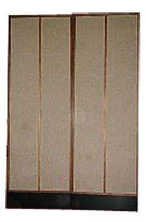
could play louder and produce more extended low end than the Quad ESL.
All electrostatic speaker designs were basically the same with only size being the main difference between them. All of them being a rectangular flat screen. Alfred Janszen was also instrumental in the development of the Koss Model One, the Acoustech and Dennesen electrostatic speakers. Roger West, the chief designer of the Janszen Corporation later became the president of Sound Labs.
In 1980 Gayle Martin Sanders and Ron Logan Sutherland developed their first prototype full range electrostatic speaker. However, it wasn’t until 1983 when they introduced their first hybrid electrostat called the Monoliths at CES and the Martin Logan Speaker Company was officially formed. Martin Logan electrostats are unique in the way they are manufactured. They have developed a curved electrostatic panel with the result of avoiding the inherent issue of limited horizontal dispersion of sound. Martin Logan Loudspeakers are now the largest producer of electrostatic speakers in the world today.
Unique Technology
IONOVAC
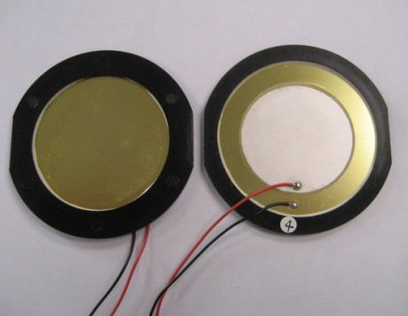
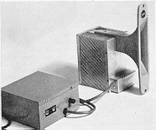
My choice in 1980 for the most unusual speaker design goes to the Ionovac. According to physics the perfect speaker has no mass, is an infinitely small point source and can be moved without resistance. The original concept dates back to the late 1800s when Paulson demonstrated what he called his singing arc. But it wasn’t until 1954 when DuKane developed the DUKE-30 ionic tweeter. Electro-Voice marketed the Ionovac in 1958 under a temporary agreement with DuKane.
Piezoelectric Speakers
Some people may question my putting Piezoelectric speakers in the Unique Technology section, but as simple a device as they are they are defiantly a unique device. They work by using an expanding and contracting crystal to vibrate the air and produce sound. Piezoelectric speakers are limited in frequency response. Typically limited to very high frequencies. Therefore, they are only used as tweeters or in small electrical devices like watches/clocks to make simple sounds. In the future this technology may improve and provide a speaker with wider frequency sound characteristics, but this will be the job for tomorrow's engineers.
There are some advantages to Piezo electronics. Since thy are a solid-state device, this technology makes them durable and good for use in devices that need to be durable and used in unusual environments not suitable to traditional speakers.
Conclusion
This has been a rather condensed version of what can easily be expanded into a several hundred-page book. I may one day get around to writing such a volume, but for now I hope I covered enough that may have spurred some interest into a subject that I have always been fascinated by. Needless to say I have dedicated most of my 51 years in the audio industry to loudspeaker technology and product development. Additionally, I am fortunate to say I have gotten to meet and know some of the world’s finest speaker designers and engineers. I have also had the good fortune of influencing some of the speaker designs on the market as well. Also, I have been developing a new speaker design of my own that, with any luck, I will be able to produce a prototype of this design concept, to see if it will actually work. But until then I hope to continue to produce articles of interest. On that if you have an interest or question please let me know and I will be happy to answer your inquiry to the best of my ability.

