Venice of the East - Suzhou’s Canal Culture
By: Marc Silver
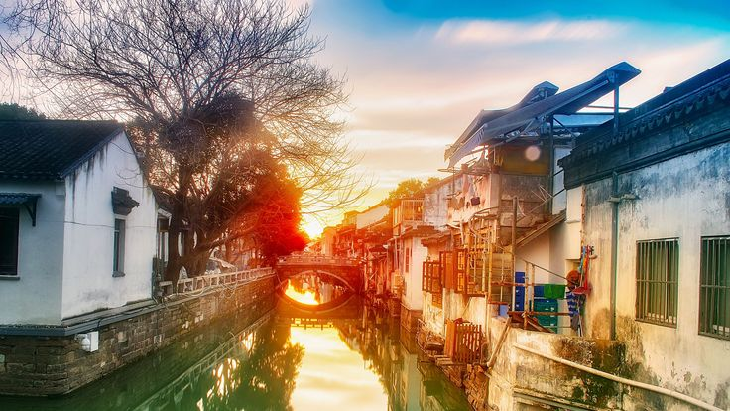
If you spend enough time traveling, you start to notice certain cities speak the same language even if they’ve never met. Suzhou is one of those places. On both of my trips through China, my wife and I ended up there, gliding along its narrow canals in a small wooden boat.
It shouldn’t have felt familiar, but it did. The memory of our trip to Venice came back instantly, the way water reshapes a place until it becomes a living organism. Yet Suzhou never pretends to be Venice.
It has its own rhythm, its own texture, its own quiet confidence. It’s a city that learned centuries ago how to live with water, not battle it.
A City Built on Water, Memory, and Precision
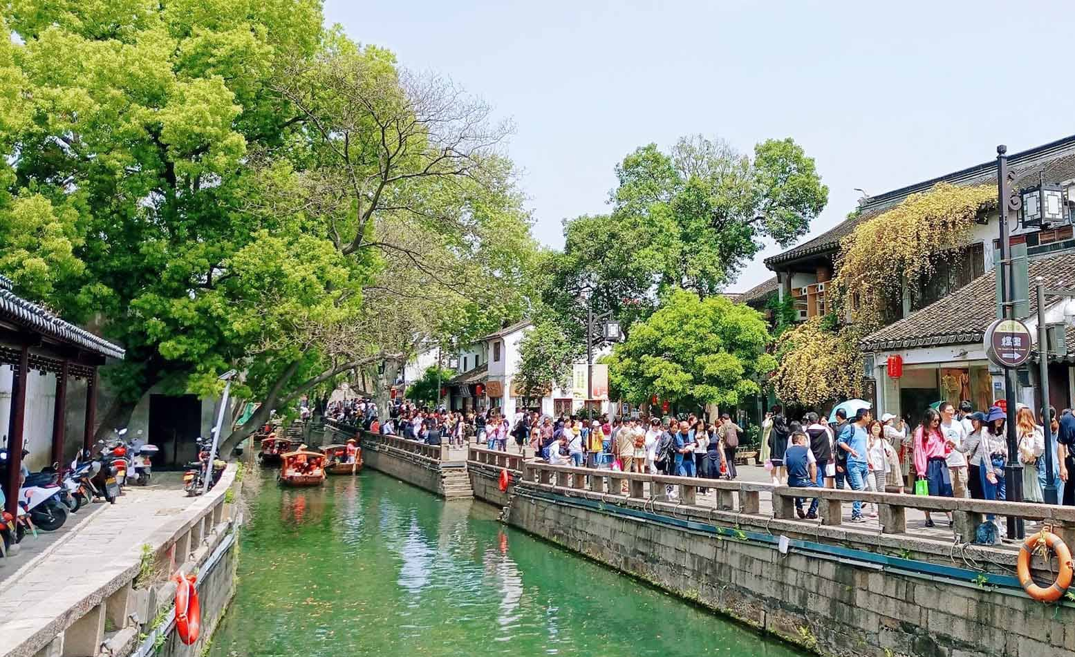
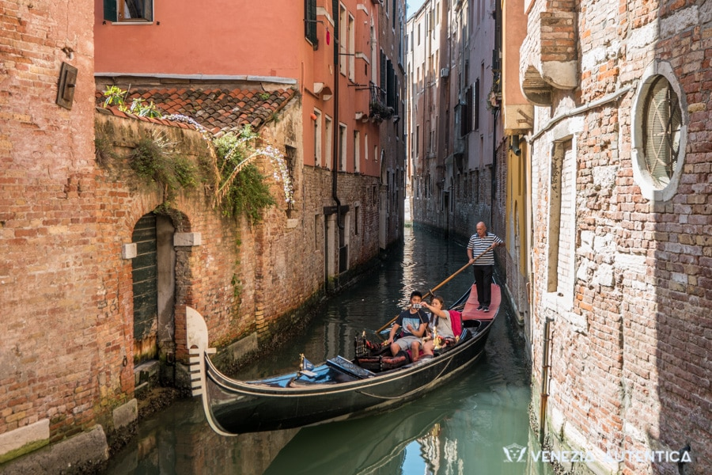
Suzhou’s canal culture didn’t arrive by accident. Ancient Chinese engineers treated water the way some cultures treat stone, shaping it, redirecting it, coaxing it into a system that supported daily life, trade, and agriculture. The result was a network of waterways that feels both intimate and grand. Stand at the edge of one of the narrow residential canals, and you see a domestic life arranged around water. Step into the heart of the Grand Canal system, and you feel the scale of an empire.
What struck me, both times I visited, was how naturally everything flows. Venice has drama. Suzhou has balance. You sense it in the geometry of the bridges, the way a canal bends gently toward a courtyard, the layout of gardens that seem to take the water into account without fuss. Nothing is accidental. Nothing is wasted.
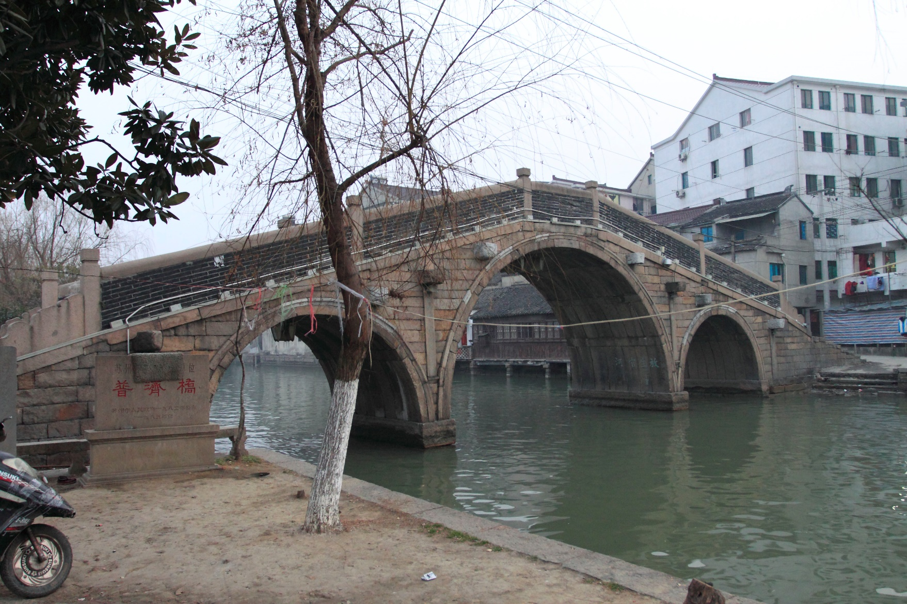
Walking Through Water Towns Older Than Most Kingdoms
Suzhou is the centerpiece, but it’s part of a constellation of ancient water towns scattered along the Yangtze River Delta. Places like Zhouzhuang, Tongli, and Luzhi feel like someone pressed pause on the 1300s. Narrow lanes. Whitewashed homes. Wooden balconies hanging just above the waterline. Elderly residents who don’t seem to care that tour boats glide by a few feet from their kitchen doors.
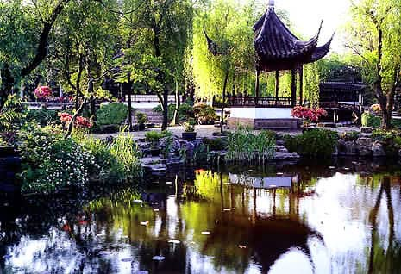
China’s “Venice of the East” moniker gets reused endlessly, but in these towns, you see why.
Their sense of age is different. The waterways aren’t a stage set for tourists. They’re part of the cultural scaffolding. Fishing boats, laundry poles, shopfronts dipping down toward the canal, everything was designed around the assumption that water wasn’t an obstacle but a partner.
When you drift through one of these small towns, especially in the early morning before the crowds arrive, you hear the water working the way water always does, a steady undertone against stone. It’s a reminder that people in this region learned to understand rivers and tides long before hydraulic engineering had a name.
The Day Suzhou Reminded Me of Venice
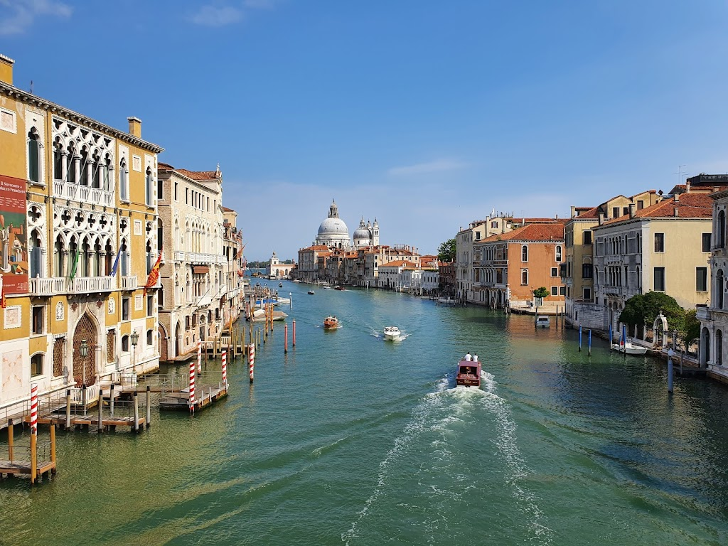
Venice hits you with its theatricality right away. Suzhou is subtler. But on the canal, there’s a moment when the comparison becomes inevitable. For me, it was in a shaded stretch where small homes lined the water. A woman leaned out of her window, rinsing vegetables in a basin. A man, maybe her husband, stood on a small step descending into the canal, washing a rag. It was domestic, ordinary, and timeless.
That’s when it happened, that same feeling I’d had gliding through Venice’s smaller canals, away from the crowds, where life just keeps going because it must. The boatman in Suzhou didn’t sing, but his movements had the same effortless skill. The water carried the same soft echoes. The stones felt worn in the same way.
Yet the vibe was entirely different. Venice wears its past like a jeweled cloak. Suzhou wears it like a favorite jacket.
A Tradition of Craft: Silk, Scholars, and Stones
Walk a few streets away from the canals, and you find the city’s other identity, the refined world of scholars, poets, and artisans. Suzhou has been famous for its silk for over 2,500 years. Its classical gardens, like the Humble Administrator’s Garden and the Lingering Garden, are UNESCO World Heritage Sites. Precision defines everything here, from embroidery that looks painted to the latticework carved into old windows.
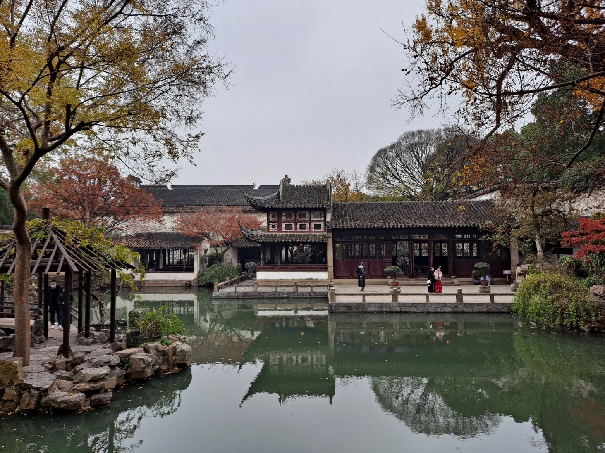

What ties it all together is the same principle that shapes the canals: harmony. Suzhou’s aesthetic isn’t about showmanship. It’s about calibrating space, water, and light until the environment feels inevitable.

China’s Water Engineering Rivaled Nations Thousands of Miles Away
When most people think of ancient hydraulic systems, they often think of Angkor’s massive reservoirs and canals in Cambodia. And they were extraordinary, vast structures that could store and move unimaginable volumes of water to support a complex empire.
What many travelers don’t realize is that China was developing its own engineering breakthroughs around the same periods. The Suzhou region in particular benefited from a surprisingly sophisticated network of levees, spillways, and canal locks. Much of the canal system wasn’t just for moving people. It was designed for agriculture, flood control, and trade, especially during the height of the Imperial era.
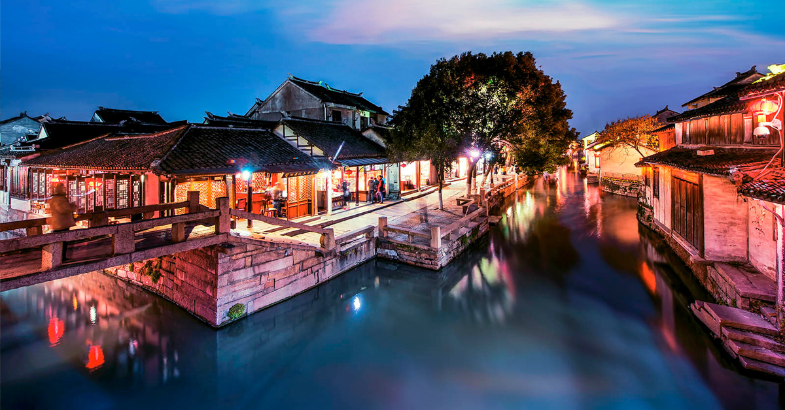
The Grand Canal, which connects Hangzhou to Beijing, is the longest and oldest man-made waterway on the planet. Suzhou was one of its critical hubs. Its prosperity was built on the ability to move grain, silk, and goods with astonishing efficiency.
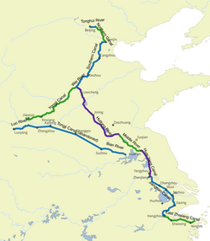
A Boat Ride You Don’t Soon Forget
When you settle into a small wooden boat on one of Suzhou’s residential canals, it’s the sound of the oar that stays with you. Not the splash, but the soft vibration that runs through the hull with each pull. The water carries every sound a little farther, so conversations drift across the canal even when you’re not trying to listen.
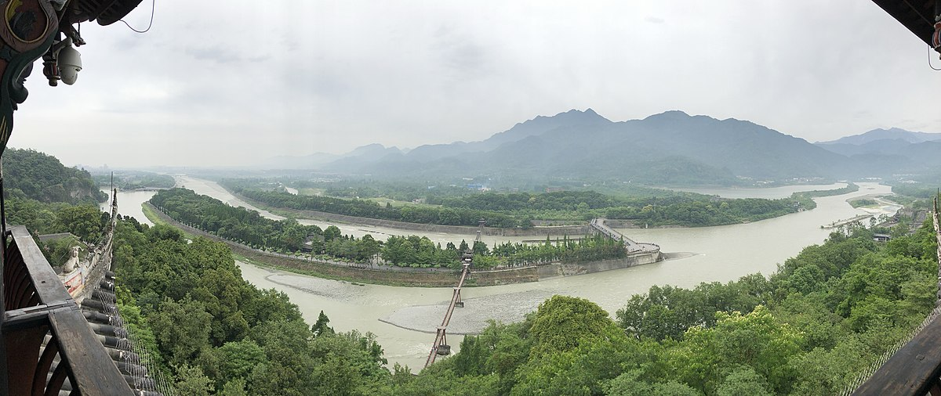
You pass under white stone bridges only a few feet above your head. You see people living their lives at the water’s edge: a cook cleaning fish, a woman sweeping her stone doorstep, a grandmother airing quilts from an upstairs window.
There’s no narration, no theatrics. The guide doesn’t feel compelled to fill the air with explanation. It’s one of the few tours in China where silence feels expected, even welcomed.
On my second visit, my wife and I sat back and didn’t even try to take many pictures. Some places ask you to pay attention with your eyes, not your phone.
Suzhou by Night
If you can stay into the evening, the canals take on an entirely different personality. Lanterns glow softly along the embankments. The light bounces across the water in narrow, broken shapes. The sound of foot traffic fades, replaced by restaurant chatter and the occasional clink of tea cups.
Suzhou’s nightlife isn’t loud. It’s gentle. And the canals are its main stage. A night ride feels slower than the daytime version, almost meditative.

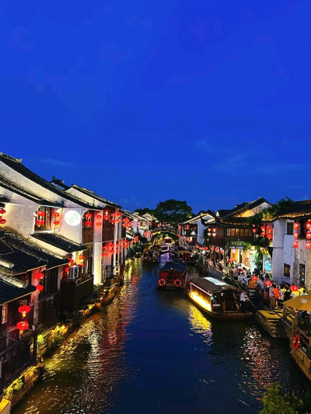
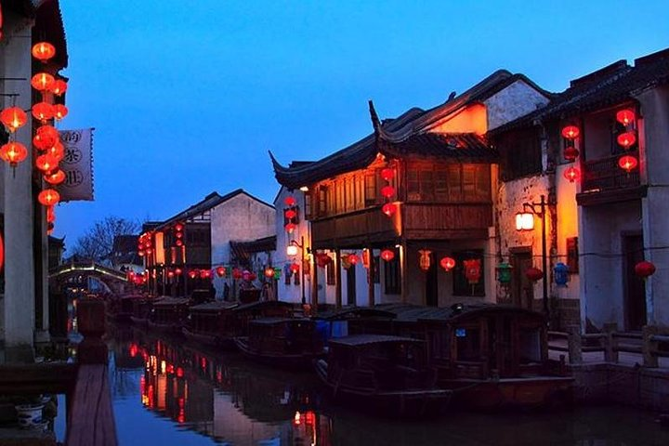
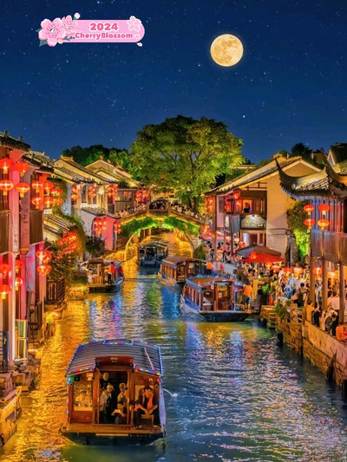
A Tale of Two Water Cities
Comparing Venice and Suzhou is tempting because they share the same basic blueprint: a city built around water instead of land. But the similarity ends quickly. Venice grew into a maritime republic driven by trade, rivalry, and naval power. Its canals became a symbol of independence and wealth.
Suzhou grew into the cultural heart of China’s literati, a place where scholarship mattered as much as commerce, where gardens were considered extensions of the mind.
Both cities relied on engineering, but Venice’s genius was improvisational, adapting to tides and lagoons. Suzhou’s was premeditated. Its waterways look effortless today because someone long ago thought hard about how water should behave. You appreciate the contrast most when you visit both cities within a few years of each other. Venice feels dramatic. Suzhou feels composed. Venice is a performance. Suzhou is a conversation.

The Poetry of Bridges
Suzhou has over 160 bridges, each one a small piece of architecture that shapes the water beneath it. Some are simple stone slabs. Others curve sharply, giving you a perfect arch reflected in the canal at the right time of day.
Bridges matter here. They’re not just connectors. They’re viewpoints. You stand on one bridge and see five more lined up in a row, each spaced just far enough to frame the next. It’s a photographer’s dream even if you don’t care about photography.
And unlike in Venice, where every bridge seems designed to impress, many of Suzhou’s bridges feel modest, worn down, smoothed by time, and perfectly content to be overlooked.
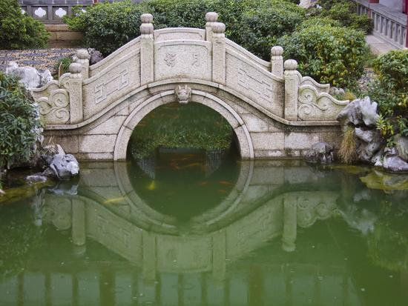
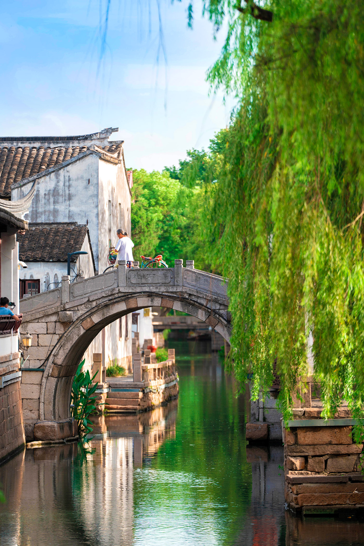
Gardens That Think Like Water
Suzhou’s classical gardens are famous, and for good reason. They’re small masterpieces of design, the kind of places where you find yourself staring at a rock formation longer than you expected because it doesn’t look random. Nothing in these gardens is random.
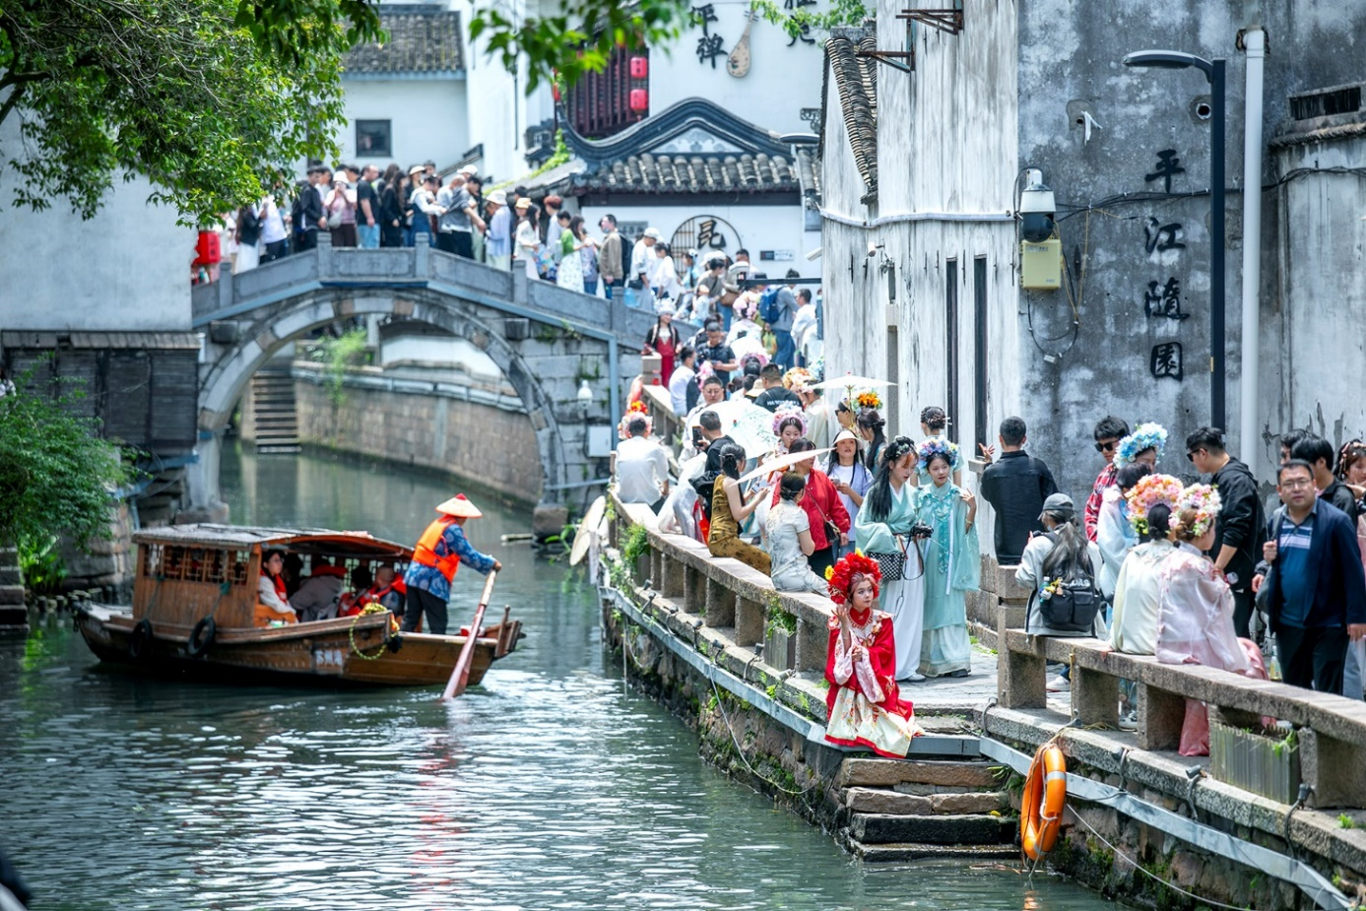
But it’s the relationship to water that ties everything together. Ponds reflect the architecture. Winding walkways give you glimpses of the surface, then take them away. The water becomes a kind of moving mirror for the sky and the greenery.
The gardens feel like an extension of the canal world, quieter, more controlled, but still shaped by the idea that water should be part of daily life.
Why Suzhou Stays With You
There are big cities in China you remember because of size and spectacle, Shanghai’s skyline, Beijing’s imperial monuments, Hong Kong’s electric glow. Suzhou stays with you for different reasons. It’s the quiet corners. The doorways opening directly onto water. The way life seems to insist on moving at a slower speed once you’re near the canals.
Both times I visited, I left thinking the same thing: this is a city that knows exactly who it is. It doesn’t need to reinvent itself. It doesn’t need to compete with its own past. The canals do the talking.
What to Photograph (or Look For) on Your Next Visit
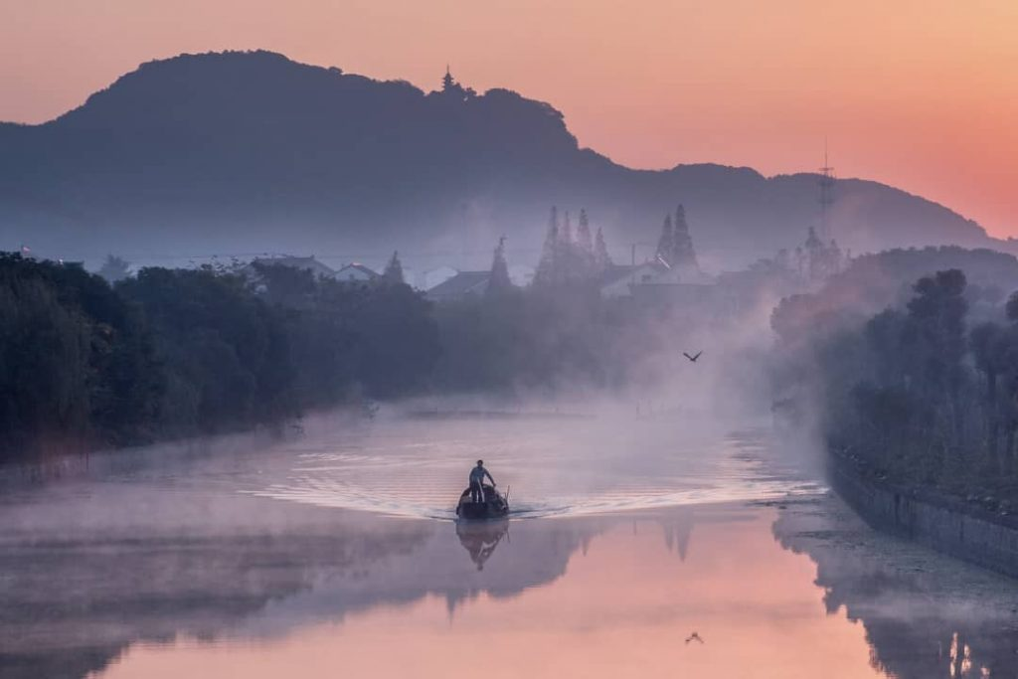
Since you’ll be choosing your own images, here’s a quick guide to great visual subjects worth capturing or pulling from your existing library:
Look for:
- Tight residential canals with stone steps descending directly into the water.
- Small wooden boats gliding under low bridges.
- Stone bridges in a row, creating repeating arches.
- Lantern-lit night shots along Pingjiang Road.
- Garden ponds framed by pavilions and zigzag walkways.
- Local life moments, like laundry hanging over water or someone rinsing vegetables at a windowsill.
These are the images that tell Suzhou’s story without needing a caption.
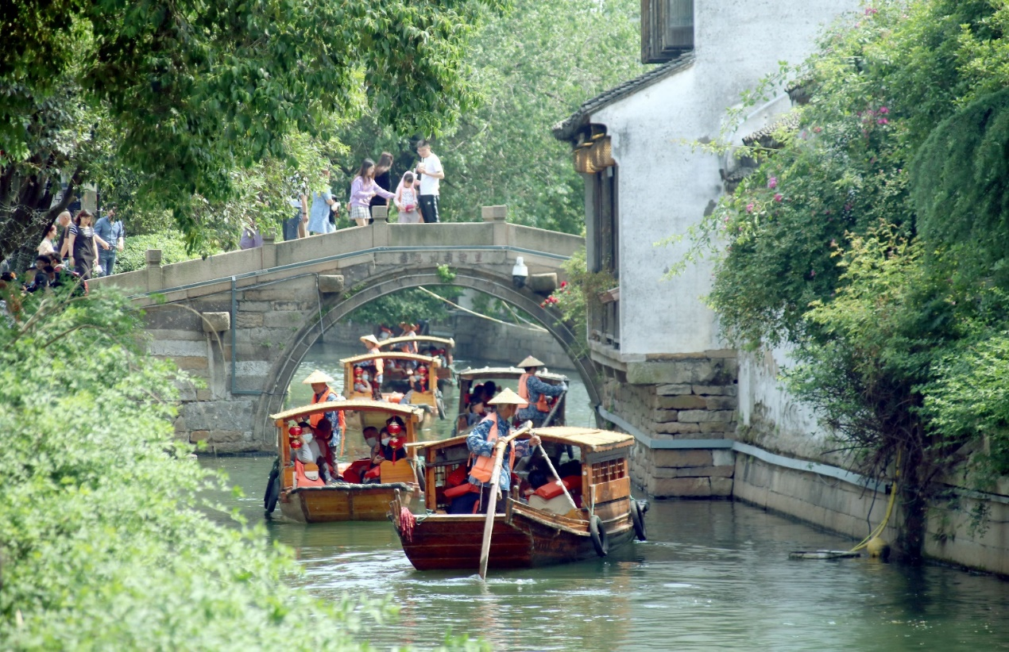
Final Thoughts
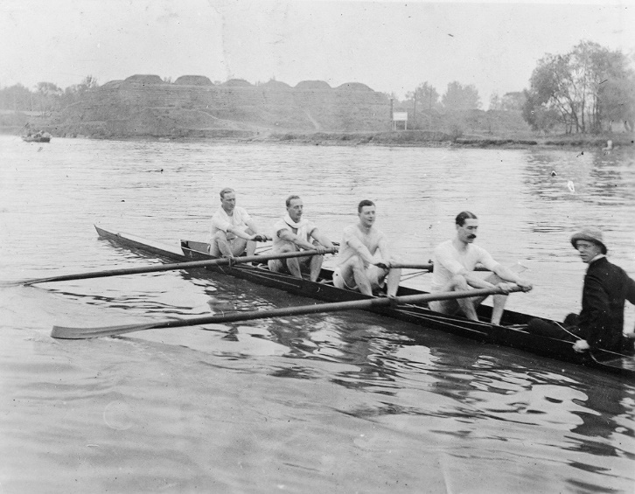
If Venice is a floating opera, dramatic, ornate, unforgettable, Suzhou is a string quartet played beside still water. More intimate. More deliberate. No less stunning.
Both cities learned long ago that water isn’t the enemy. It’s the framework.
And if you’ve walked through Suzhou’s water towns or cruised quietly along its canals, you understand why the place stays with you. It has the calm confidence of a city that figured out how to live with nature, not against it.
That might be its greatest achievement. And its greatest gift.

