Southern Region (Sur): Chile’s Emerging Cool-Climate Wine Frontier
Region Overview
The Southern Region (Sur) of Chile is an exciting and emerging cool-climate wine region, located between 37° and 40° latitude south. This area is known for its moderate temperatures, higher rainfall, and strong coastal influences, making it significantly different from the warmer, drier conditions of central Chile. While the Southern Region has a long history of viticulture, it is only recently gaining recognition for producing fresh, elegant, and terroir-driven wines.
With a cooler, wetter climate, this region is well-suited for aromatic whites, high-acid reds, and traditional old-vine varieties. Soils vary widely, with volcanic, alluvial, and clay-rich deposits contributing to the diverse wine styles found here. The region is also one of the key areas for organic and biodynamic viticulture, with many producers shifting towards sustainable winemaking practices.
Key Grape Varieties
The Southern Region is best known for its old-vine reds, aromatic whites, and lighter-bodied cool-climate reds:
- País – One of Chile’s oldest grape varieties, producing fresh, rustic reds with bright acidity.
- Carignan – Grown from century-old vines, offering structured, fruit-forward wines with lively acidity.
- Pinot Noir – Delicate and aromatic, thriving in cooler subregions like Itata and Bío Bío.
- Chardonnay – Mineral-driven and crisp, with citrus and saline notes influenced by coastal breezes.
- Sauvignon Blanc – Vibrant, high-acid, and fresh, with distinct herbal and tropical fruit notes.
- Cinsault – Gaining popularity for its juicy, easy-drinking reds with floral and red fruit character.
Wine Classification System
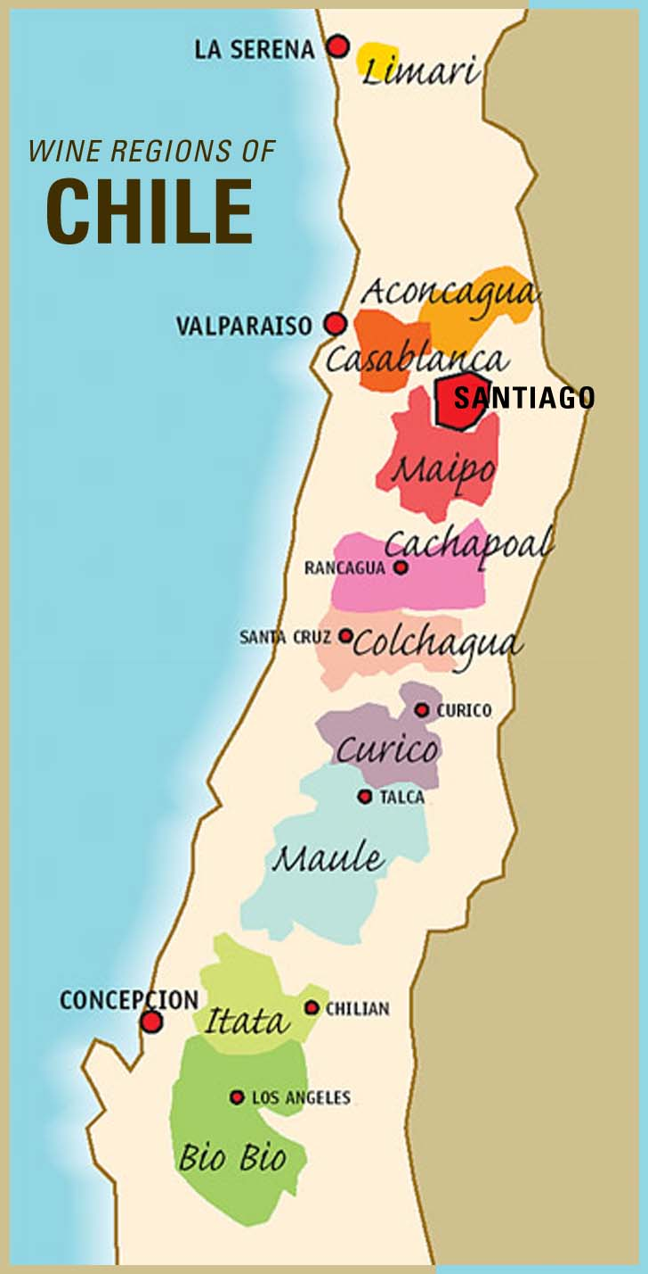
The Southern Region DO is divided into three main subregions, each offering unique expressions of cool-climate Chilean wine:
- Itata Valley – One of Chile’s oldest wine regions, known for dry-farmed País and Carignan grown on granitic soils.
- Bío Bío Valley – A leading area for Pinot Noir, Chardonnay, and Sauvignon Blanc, benefiting from strong Pacific influences.
- Malleco Valley – The southernmost recognized subregion, producing high-acid Chardonnay and Pinot Noir in volcanic soils.
Notable Wine Styles
- Rustic País – Fresh and fruit-forward, often vinified in a light, easy-drinking style.
- Old-Vine Carignan – Structured, high-acid reds with deep color and wild berry notes.
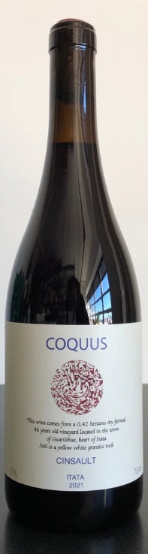
- Cool-Climate Pinot Noir – Bright and aromatic, with red fruit and earthy minerality.
- Volcanic Chardonnay – Crisp, high-acid, and mineral-driven, with citrus and saline character.
- Lively Cinsault – Light, juicy, and floral, often produced using carbonic maceration.
Additional Context
The Southern Region is undergoing a renaissance, as winemakers rediscover its potential for high-quality, terroir-driven wines. Historically, this region was dominated by bulk wine production, but today, it is home to innovative small-scale producers who focus on organic, biodynamic, and minimal-intervention winemaking.
With its unique combination of volcanic soils, high rainfall, and cool temperatures, the Southern Region is a key area for Chile’s growing natural wine movement. Many wines from this area are made using old-vine, dry-farmed grapes, emphasizing authenticity and sustainability.
Takeaway for Sommeliers
For sommeliers, the Southern Region represents Chile’s next frontier, offering highly distinctive, cool-climate wines that contrast with the richer, full-bodied wines of the Central Valley. The rise of old-vine País and Carignan, elegant Pinot Noir, and mineral-driven whites makes this a region worth exploring for fresh, expressive, and terroir-focused wines.
References
- Robinson, J., & Harding, J. (2020). The Oxford Companion to Wine (5th ed.). Oxford University Press.
- Wines of Chile. (2023). Regional Profiles and Climate Data. Retrieved from https://www.winesofchile.org
- Tapia, P. (2022). The Wines of South America. Infinite Ideas.
- Wine Spectator. (2023). The Cool-Climate Revolution in Chile’s South. Retrieved from https://www.winespectator.com

