South-Eastern Australia Wine Region: A Sommelier's Guide
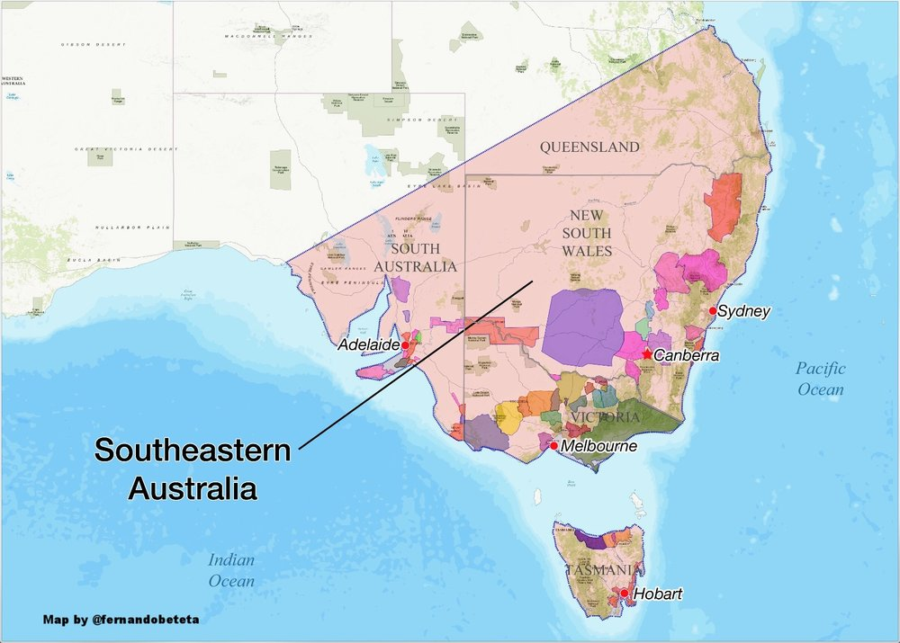
1. Region Overview
Geographic Location
South-Eastern Australia is Australia’s largest Geographic Indication (GI), encompassing New South Wales, Victoria, South Australia, and parts of Queensland and Tasmania. It spans diverse climates and terroirs, including the cool, maritime regions of Tasmania and Victoria, the warm inland valleys of New South Wales, and the Mediterranean-influenced zones of South Australia. This broad designation allows wineries to blend grapes from multiple regions to create consistent, high-volume wines.
Climate and Terroir
Given its vast expanse, South-Eastern Australia exhibits extreme climatic variation:
- Cool-climate zones: Tasmania, Yarra Valley, Mornington Peninsula (Victoria), and Adelaide Hills (South Australia) produce refined, high-acid wines.
- Mediterranean zones: Barossa Valley and McLaren Vale (South Australia) are known for powerful Shiraz and Grenache.
- Warm, inland regions: Riverland (South Australia), Murray Darling (Victoria/New South Wales), and Riverina (New South Wales) are high-production zones for affordable, fruit-forward wines.
Soils vary widely, from ancient limestone and terra rossa (Coonawarra) to alluvial loams (Murray Darling), influencing the quality and structure of the wines.
Structural Organization
South-Eastern Australia GI is a super-zone designation, allowing for multi-regional blending. The structure includes:
- State-based GIs: New South Wales, Victoria, South Australia, Queensland, and Tasmania.
- Sub-regional GIs: Well-known appellations within these states, such as Barossa Valley (SA), Hunter Valley (NSW), and Yarra Valley (VIC).
- Unofficial sub-regions: Often used by producers to highlight smaller, distinct vineyard areas.
Historical Context
The designation was created in 1996 to support large-scale production and exports, giving producers flexibility in sourcing fruit. While fine wine regions exist within South-Eastern Australia, the GI itself is mainly associated with mass-market wines from Riverina, Riverland, and Murray Darling.
Distinctive Features
- Vast diversity: Includes both world-renowned fine wine regions and high-volume production areas.
- Multi-regional blending: Supports consistent, fruit-forward wines aimed at export markets.
- Key fine wine pockets: Barossa Valley (Shiraz), Coonawarra (Cabernet Sauvignon), Hunter Valley (Semillon), Yarra Valley (Pinot Noir, Chardonnay).

2. Key Grape Varieties
Primary Red Varieties
- Shiraz – The flagship red, ranging from elegant cool-climate styles (Yarra Valley) to bold, opulent wines (Barossa, McLaren Vale).
- Cabernet Sauvignon – Best known in Coonawarra (terra rossa soils), producing structured, age-worthy wines.
- Grenache – Common in McLaren Vale and Barossa, often blended with Shiraz and Mourvèdre (GSM blends).
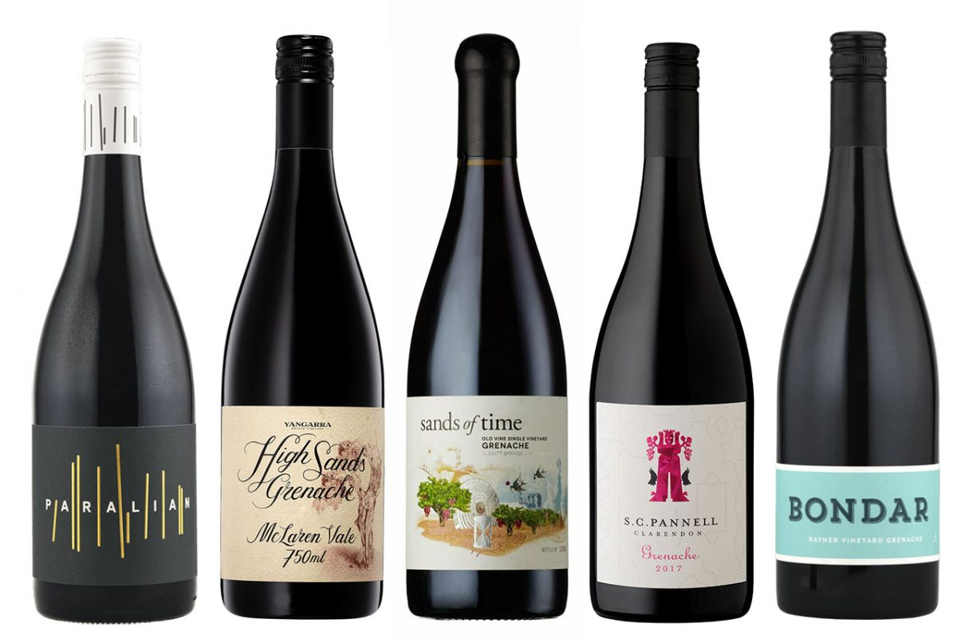
- Pinot Noir – Thrives in Tasmania, Yarra Valley, and Mornington Peninsula, making delicate, aromatic wines.
Primary White Varieties
- Chardonnay – The most widely planted white, from rich, oaked styles (Barossa, Riverland) to cool-climate, mineral-driven expressions (Tasmania, Yarra Valley).
- Sauvignon Blanc – Grown in Adelaide Hills, Tasmania, producing fresh, high-acid wines.
- Semillon – A Hunter Valley specialty, known for its age-worthy, low-alcohol style.
- Riesling – Found in Eden Valley and Clare Valley (SA), offering crisp, citrus-driven wines.
Indigenous/Regional Varieties
South-Eastern Australia has no indigenous grape varieties, but is home to significant regional specializations, such as:
- Hunter Valley Semillon
- Coonawarra Cabernet Sauvignon
- Barossa Shiraz
- Tasmanian Sparkling Wine (Chardonnay & Pinot Noir)
Significance
While Shiraz, Cabernet Sauvignon, and Chardonnay dominate, Riesling and Semillon stand out as high-quality white varietals. Pinot Noir is also gaining prominence in cooler regions.

3. Wine Classification System
Quality Hierarchy
- South-Eastern Australia GI – Broadest designation, often used for blended, high-volume wines.
- State-Level GIs – Example: Victoria GI, South Australia GI.
- Regional GIs – Example: Barossa Valley GI, Hunter Valley GI.
- Sub-Regional GIs – Example: Eden Valley GI (within Barossa Valley), Coonawarra GI (within Limestone Coast).
Special Classifications
- Old Vine Charters – Barossa and McLaren Vale classify Shiraz and Grenache based on vine age (e.g., “Centenarian Vine”).
- Regional Icons – Semillon (Hunter Valley), Riesling (Clare & Eden Valley), Cabernet Sauvignon (Coonawarra).
Sub-Regional Distinctions
- Barossa Valley & McLaren Vale – Bold Shiraz, GSM blends.
- Coonawarra – Structured Cabernet Sauvignon.
- Yarra Valley & Tasmania – Cool-climate Chardonnay, Pinot Noir.
- Hunter Valley – Low-alcohol, age-worthy Semillon.
- Riverina, Riverland, Murray Darling – High-production, fruit-driven wines.

4. Notable Wine Styles
Barossa Shiraz
- Classification Level: Barossa Valley GI
- Composition: 100% Shiraz
- Production Method: Oak aging (French/American)
- Aging Requirements: Typically 12–24 months in oak
- Alcohol Content: 14–15%
- Organoleptic Profile: Dark fruit, chocolate, spice, full-bodied
Hunter Valley Semillon
- Classification Level: Hunter Valley GI
- Composition: 100% Semillon
- Production Method: Stainless steel fermentation
- Aging Requirements: Typically aged in bottle for 5+ years
- Alcohol Content: 10–12%
- Organoleptic Profile: Lime, honey, lanolin (with age)

5. Additional Context
Recent Developments
- Increased focus on premium single-region wines despite the broad South-Eastern Australia designation.
- Rising prominence of alternative varietals, such as Fiano, Vermentino, and Nero d'Avola.
- Sustainability efforts, with organic and biodynamic practices gaining traction.
Food Pairing Notes
- Shiraz – Grilled meats, BBQ, aged cheeses.
- Semillon – Fresh seafood, sushi, Asian cuisine.
- Cabernet Sauvignon – Roasted lamb, hard cheeses.
- Chardonnay – Poultry, creamy pasta dishes.
Producer Information
- Penfolds – Multi-regional blends and single-region icons.
- Yalumba – Known for Barossa Shiraz and Viognier.
- Wynns Coonawarra Estate – Benchmark Cabernet Sauvignon.
- Tyrrell’s – Leader in Hunter Valley Semillon.

6. Key Takeaways for Sommeliers
- South-Eastern Australia GI is vast, covering multiple climates and styles.
- Shiraz is the dominant red variety, with regional expressions varying.
- Semillon (Hunter Valley) and Riesling (Clare/Eden Valley) are world-class white wines.
- The region supports both fine wines and large-scale commercial production.
- Blending across regions allows for stylistic consistency in large brands.

7. Citations and References
- Wine Australia, 2023. https://www.wineaustralia.com/
- Halliday Wine Companion, 2023. https://www.winecompanion.com.au/
- Australian Wine Research Institute, 2023. https://www.awri.com.au/

