South Australia Wine Regions

1. Region Overview
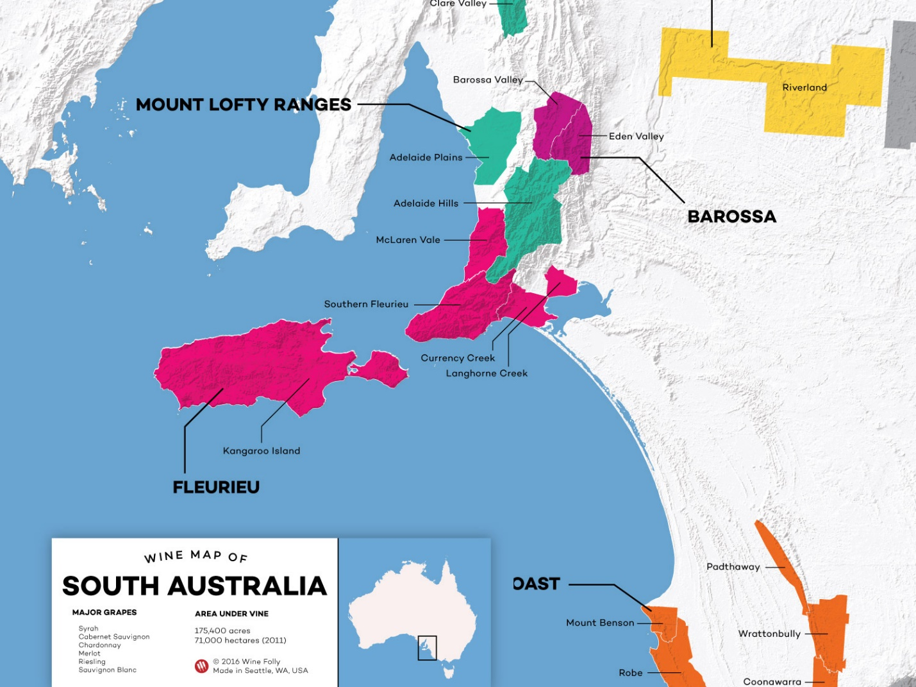
South Australia is the heart of Australia’s wine industry, producing 50% of the nation’s wine and home to globally celebrated regions like Barossa Valley, McLaren Vale, Clare Valley, and Coonawarra. The state’s diverse terroir spans Mediterranean climates (Adelaide Hills), arid continental zones (Riverland), and cool maritime pockets (Adelaide Hills, Eden Valley). Ancient soils—from terra rossa (Coonawarra) to iron-rich schist (McLaren Vale)—and old-vine vineyards (some dating to the 1840s) define its viticultural prestige. South Australia’s reputation rests on bold Shiraz, refined Cabernet Sauvignon, and world-class Riesling, underpinned by pioneering sustainability initiatives.

2. Key Regions & Grape Varieties
- Barossa Valley
  - Climate: Warm, dry Mediterranean.
  - Key Varieties:
    - Shiraz: Full-bodied, with blackberry, chocolate, and licorice (e.g., Penfolds Grange).
    - Grenache: Old-vine expressions (raspberry, spice) from sub-regions like Greenock.
- McLaren Vale
  - Climate: Maritime-influenced Mediterranean.
  - Key Varieties:
    - Shiraz: Plush, with blueberry and Mediterranean herbs.
    - Cabernet Sauvignon: Structured, with blackcurrant and mint.
- Clare Valley
  - Climate: Continental (hot days, cool nights).
  - Key Varieties:
    - Riesling: Lime, floral, and petrol-driven, age-worthy (e.g., Grosset Polish Hill).
    - Shiraz: Medium-bodied, with red fruit and pepper.
- Coonawarra
  - Climate: Cool maritime.
  - Key Varieties:
    - Cabernet Sauvignon: Minty cassis, structured tannins (terra rossa soils).
- Adelaide Hills
  - Climate: Cool, high-altitude (400–600m).
  - Key Varieties:
    - Chardonnay: Lean, citrus-driven with flinty minerality.
    - Sauvignon Blanc: Zesty, tropical, and herbal.
- Eden Valley
  - Climate: Moderate, elevated.
  - Key Varieties:
    - Riesling: Crisp, floral, with lime zest (e.g., Henschke Julius).
    - Shiraz: Elegant, with red fruit and violet.

3. Wine Classification System
South Australia uses Australia’s Geographical Indication (GI) system:
- GI Zones: Barossa, Fleurieu (McLaren Vale), Limestone Coast (Coonawarra).
- Sub-regions:
  - Barossa Valley → Greenock, Marananga.
  - Clare Valley → Watervale, Polish Hill River.
- Sustainability: Over 50% of vineyards are certified under Sustainable Winegrowing Australia.

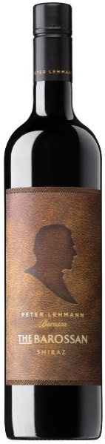
4. Notable Wine Styles
Barossa Valley Shiraz (GI)
- Composition: 100% Shiraz, often from 100+ year-old vines.
- Production: Open-fermented, aged in American oak.
- Profile: Blackberry, mocha, and velvety tannins.
- Market Position: Global benchmark for opulent Shiraz.

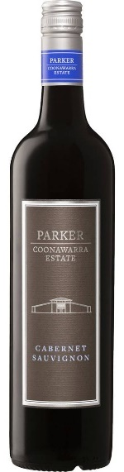
Coonawarra Cabernet Sauvignon (GI)
- Composition: Often blended with Merlot.
- Terroir: Terra rossa over limestone.
- Profile: Cassis, eucalyptus, and firm structure.
- Comparison: Likened to Bordeaux’s Left Bank.
Clare Valley Riesling (GI)
- Composition: 100% Riesling, dry style.
- Aging: Develops honey, toast over 10–20 years.
- Profile: Lime, green apple, and racy acidity.

5. Additional Context
Recent Developments:
- Sustainability: Solar-powered wineries (e.g., Yalumba), regenerative farming in McLaren Vale.
- Climate Adaptation: Drought-resistant rootstocks, water recycling in Riverland.
Historical Context:
German settlers planted the first vines in the 1840s. The 1951 discovery of terra rossa in Coonawarra revolutionized Cabernet production.
Food Pairings:
- Barossa Shiraz with slow-cooked lamb or wagyu beef.
- Clare Riesling with spicy Thai cuisine or fresh oysters.
- Coonawarra Cabernet with herb-crusted lamb rack.
Key Producers:
Penfolds (Grange), Henschke (Hill of Grace), d’Arenberg (McLaren Vale), and Wynns (Coonawarra).
Takeaway for Sommeliers:
South Australia’s strength lies in its old-vine heritage and regional contrasts—Barossa’s power vs. Adelaide Hills’ finesse. Highlight sustainability credentials and iconic labels like Grange for storytelling.
Final Thoughts:
A land where ancient soils meet pioneering vision, South Australia crafts wines of depth and distinction, cementing its role as Australia’s vinicultural cornerstone.

Citations:
- South Australian Wine Industry Association. Sustainability Report. 2023.
- Halliday, J. Wine Atlas of Australia. 2022.
- “Barossa’s Old-Vine Legacy.” Decanter, 2021.

