Simple Modifications That Make a Difference
By: Marc Silver
Real-world tweaks for the Practical Audiophile
It’s easy to get sucked into the audiophile rabbit hole. Boutique caps, $200 fuses, or oxygen-free wire so thick it needs its own postal code. But let’s set that aside for now. This article isn’t about chasing marginal gains or impressing your friends on the audiophile forums. I’m talking about the simple, often-overlooked tweaks that actually make a real difference.
These are hands-on fixes that can bring old electronics back to life, kill a nasty buzz, or smooth out a rough-sounding preamp, all without draining your bank account or requiring a degree in electrical engineering.
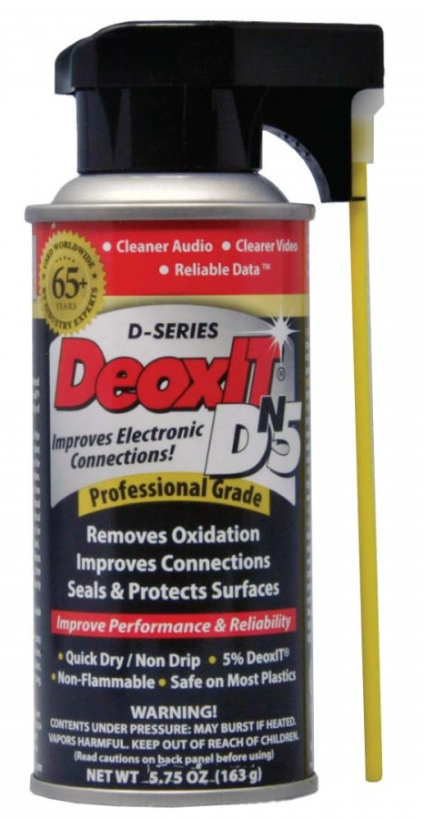
Clean Your Contacts (Seriously)
Figure 1 DeoxIT
Let’s start with the easiest and most obvious fix that most people ignore: contact cleaning.
When I had my retail store and service department, I made a fair income using this technique to fix “dead channels” that were really just dirty switches or oxidized RCA jacks. Get yourself a small can of DeoxIT and a toothbrush you never plan to use again. That’s your starting kit.
Start by removing the cabinet to get into the gear. Then, using the long plastic tube that came with the cleaner, spray all your selector switches, contact switches, and pot wipers. Clean all the RCA jacks, tube sockets, and relay contacts. A quick spray in every control potentiometer on the front of your gear. Don’t soak them. Just a dab on a swab or small brush. Work it in, then exercise the control. You’ll often hear the improvement before you even close the chassis back up.
One time, a customer dropped off a Marantz 2270. He was sure the tone board was toast. A little contact cleaner, and it was singing again.
Damping: Taming the Ring
Next up, damping. Not just for speakers. Anything that rings, rattles, or hums can benefit.
Ever notice a transformer that buzzes like a fluorescent light? Or a metal chassis that seems to sing along with certain bass notes? That’s resonance, and it’s not doing your sound any favors.
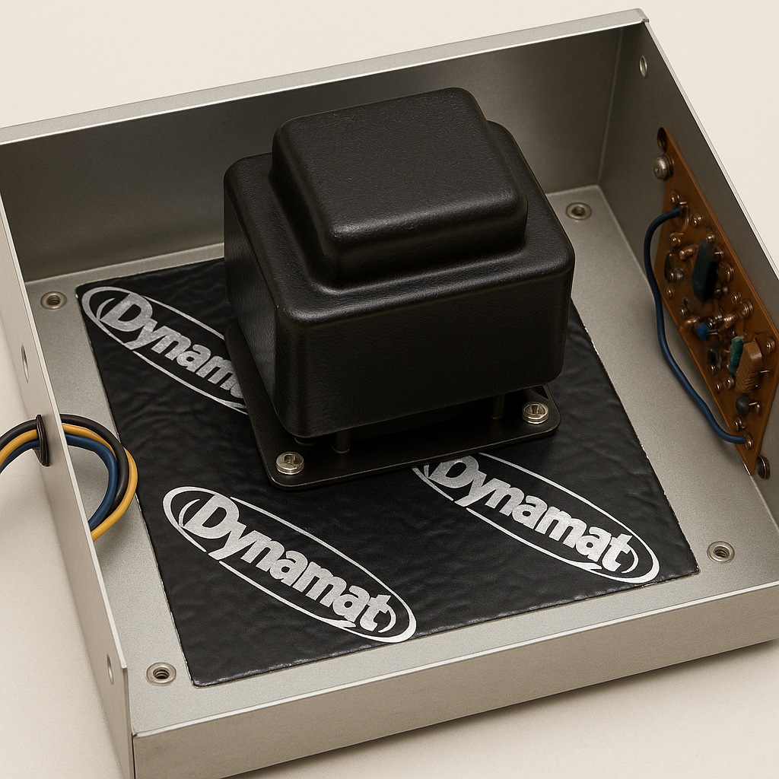
For transformers, a felt pad or a bit of mass loading can help. I’ve used Dynamat inside old speaker cabinets, rope caulk on driver baskets, and even stuffed felt in tonearm tubes to quiet down microphonics. None of this is exotic. It’s just knowing where to look and when to stop.
Figure 2 Dynamat under transformer
Go too far and you’ll overdamp the life right out of your gear. But a little attention here can smooth out edginess or reduce low-level fuzz you didn’t know was there.
Bypass Caps: The Sneaky Fix
Ever heard of a bypass capacitor? Think of it like giving an old electrolytic a sprinter’s shoes.
Electrolytics are slow, electrically speaking. When you parallel a small-value film cap (say, 0.1µF to 0.47µF) across a big electrolytic, you give the circuit access to quick transients while preserving bulk energy storage. It’s a common trick in tube gear, and it works wonders in power supplies and coupling stages.
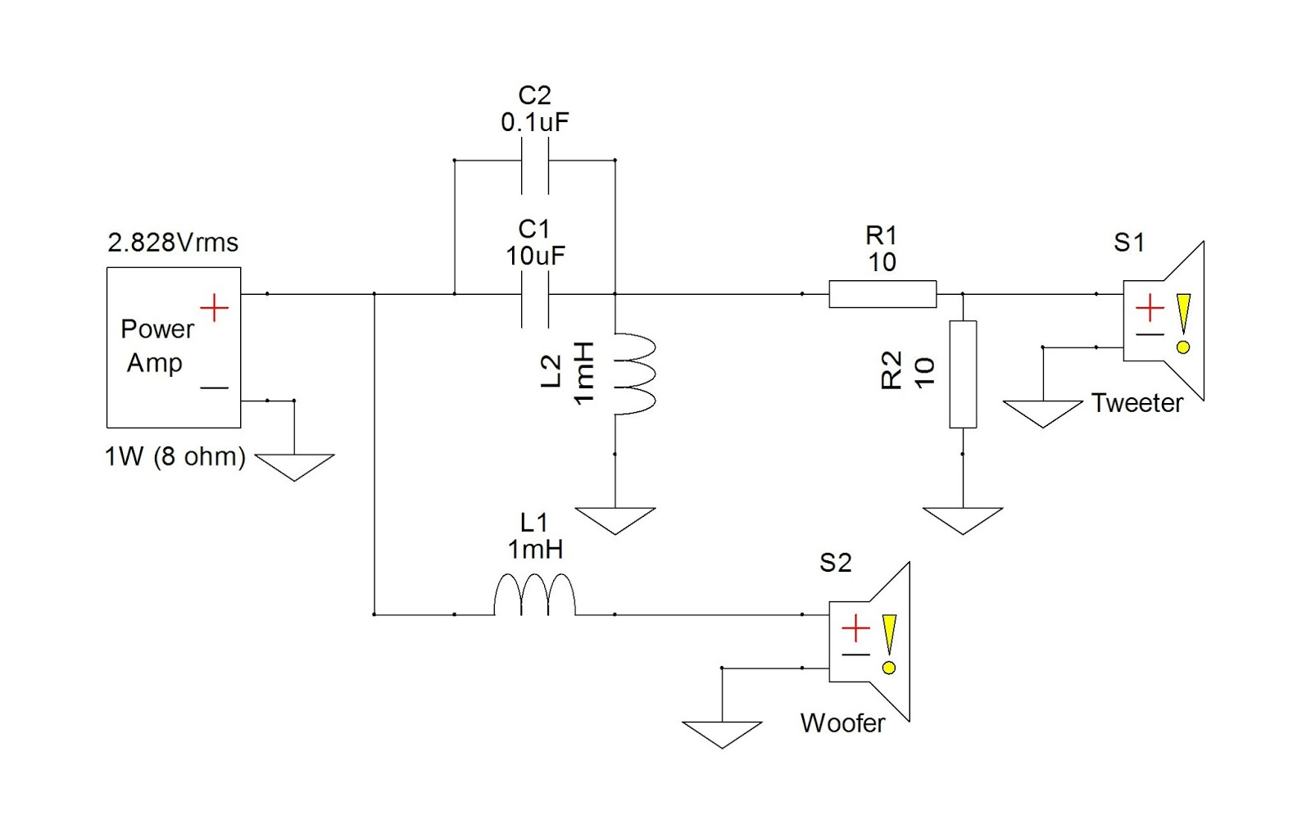Figure 3 C2 is the bypass Cap
Don’t get carried away. Keep the voltage ratings appropriate and the lead lengths short. I’ve done bypass jobs on Dynaco SCA-35s that tightened the bass and opened up the midrange without changing the character of the amp. I’ve also modified speaker crossovers using this technique.
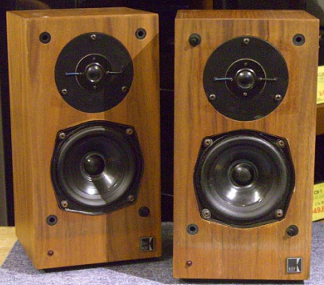
I had a pair of KEF 101 small monitors, and I was surprised to see the basic parts quality in their crossover. By adding a 0.1µF metal film cap in parallel with the high-frequency capacitor, it cleaned up the high end and improved the speaker’s focus. This two-dollar fix returned five hundred dollars in performance improvement.
Is it night and day? Sometimes—like with the KEFs—yes. But often, it’s just a subtle yet noticeable improvement, and it costs next to nothing.
Figure 4 KEF 101
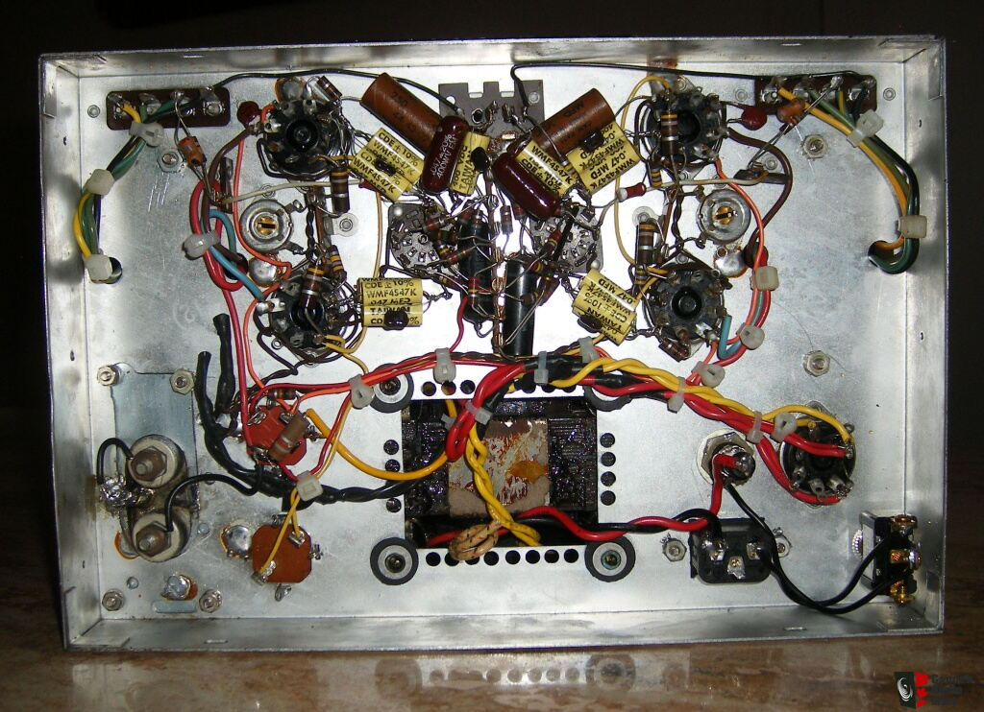
Cable Cleanup: From Rat’s Nest to Respectable
Figure 5 Electrohome 6V6 Tube Stereo Power Amp
Ever open a vintage receiver and wonder if the guy who wired it had a personal vendetta against neatness? Yeah, me too.
Cable cleanup isn’t just for looks. Twisting your AC pairs, separating signal paths from high-voltage lines, and re-routing wires away from transformers all cut down on induced noise.
I once opened a Sherwood receiver that had lamp cord soldered between the volume pot and the board. Replacing it with decent shielded wire and correcting the routing dropped the noise floor by a good 10 dB and brought the stereo image into focus.
If you’ve ever doubted that internal wiring affects sound, you haven’t rewired enough gear.
Tighten It Up: Grounds, Screws, and Fuse Clips
You’d be amazed how many grounding problems are caused by loose screws and oxidized lugs.
When you’re in the chassis anyway, take five minutes and tighten every fastener you can reach. Clean ground points. Polish fuse contacts. Reflow a solder joint that looks cold or crusty. These aren’t glamorous mods, but they often fix hums, buzzes, or intermittent problems you’d otherwise chase for hours.
If it carries current, treat it like it matters. Because it does.
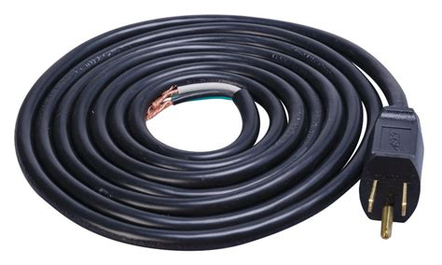
Power Cord Replacements: Just Use Common Sense
Figure 6 Power Cord Replacements
Not every old amp needs a hospital-grade power cord, but if the insulation is brittle or the plug is scorched, it’s time.
I’ve replaced dozens of two-prong cords with modern grounded cables—not because I wanted to improve the “PRaT,” but because I didn’t want the amp to kill someone.
A safe, well-grounded cord isn’t a sonic upgrade. It’s a sanity upgrade. And in some cases, a legal one.
Don’t fall for the trap of thinking your 1970s receiver suddenly needs a $300 cryo-treated power cable. It needs a safe, reliable connection to the wall. Period.
When to Leave Well Enough Alone
Here’s the part the mod-happy folks don’t want to hear.
Sometimes the best mod is no mod at all.
If you’ve got a clean, working example of a vintage amp—especially a rare one—think carefully before swapping parts. Once you pull out original caps, redo the wiring, or drill the chassis, you’ve changed more than the sound. You’ve altered the soul of the piece.
There’s a difference between keeping it alive and trying to turn it into something it was never meant to be.
Final Thoughts
The best tweaks aren’t flashy. They don’t involve boutique parts or audiophile folklore. What they do is restore, refine, and remind you what the gear was meant to do in the first place—play music, clearly and cleanly.
Whether it’s the scratchy pot you finally silenced, the transformer hum you tamed with a felt washer, or the subtle clarity that came from a simple bypass cap, these changes bring forgotten gear back to life. They make it usable again, not just collectible. And they connect you, hands-on, to the hardware in a way spec sheets never could.
So, before you chase the next big upgrade, take a look under the hood. You might find that a few simple touches are all it takes to turn your “pretty good” system into something that surprises you every time you press play.
Because sometimes, making music better doesn’t mean making things complicated. It just means paying attention.

