Room & Speaker Placement Tweaks
Physics Over Fairy Dust
By Marc Silver
That Time I Wasted $300 on Fairy Dust
Let me start with a confession: I once spent $300 on cable risers.
Yeah. I know.
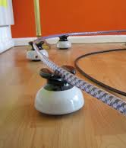
Some forum guru said they’d “lift the veil” and “clarify the midrange.” Seemed legit. They looked cool. And honestly? I could afford it. So I took the plunge.
Know what changed?
Not the sound. Just my bank balance. So don’t feel bad if this happened to you.
This hobby is full of stuff like that, things that sound smart, cost a fortune, and deliver nothing. But it’s not all bad news. Some tweaks actually do work. And the funny part? The real ones are usually dirt cheap or free.
So no, this isn’t another rant against the audiophile world. It’s a guide to the tweaks that matter, and the ones that should be tossed straight into the gimmick graveyard.
Grab a coffee. We’re going in.

I. Bass Traps: 4” Foam Is a Joke
Here’s the problem: bass doesn’t behave. It doesn’t sit quietly in the corner while your fancy bookshelf speakers do their thing. It’s wild, it’s long, and it fills your room like a slow-moving flood.
A 40Hz wave is about 28 feet long. Let that sink in. This means your room is the problem, not your sub.
And those trendy 4" acoustic foam panels? At 100Hz, they absorb like a paper towel in a hurricane. You might as well tape pillows to your wall.
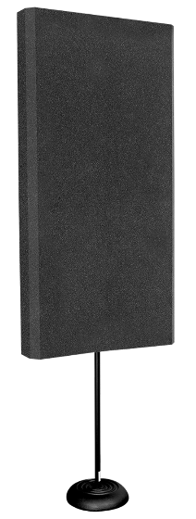
I once borrowed a $600/pr foam “bass trap”. You know the type about a 4” deep rectangle that mounts on the wall. It is a trap but just not for bass. It worked better as a dog bed.
The Fix: Depth and Density
Bass doesn’t just bounce. It compresses air, especially at pressure points like corners. To absorb it, you need real depth. The rule?
¼ wavelength = trap depth
- 100Hz → 28 inches
- 80Hz → 35 inches
Enter the SuperChunk.
Here’s the build:
- Grab 8 panels of rockwool (around $40 from your home improvement store).
- Slice into triangles.
- Stack in the corner, floor to ceiling.
It’s ugly. But it works. If your partner glares at it, spend another $30 on fabric and build a 1x2 frame. Let them pick the color. Happy house, happy ears.
Result? Bass goes from “mud pie” to “tight jeans.” Suddenly you’re hearing articulate bass lines, not just boom. It’s shocking.

II. Speaker Placement: The Best Free Upgrade
You could drop $10k on cables. Or you could move your speakers three feet.
Guess which one actually improves your sound?
Step 1: Pull ’Em Out
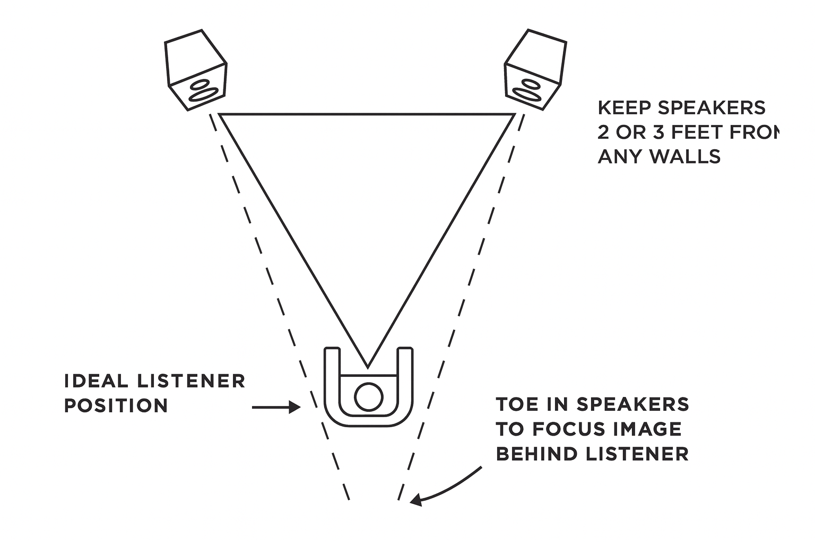
Start by placing speakers 2–3 feet from the front wall and about the same for the side walls. That “wall hug” adds boundary reinforcement, which basically means bloated bass and smeared imaging.
Step 2: Toe-In Tango
Aim the tweeters just behind your head.
- Too much: imaging shrinks.
- Too little: vocals lose focus.
There’s no perfect angle. Just experiment and listen.
Step 3: Ear-Level Tweeters
Seriously. Ear level. Not your knees. Not your cat’s perch. If you need to stack some textbooks to raise a stand, now’s the time those old college texts finally become useful.
The 38% Rule
Sit 38% into the room from the front or back wall. Why? It’s a good starting point to avoid standing wave nodes.
15-foot room? Start at 5.7 feet.
This puts you away from the worst bass nulls and peaks. A little forward or back from there can work even better. Trust your ears.

III. The Chair: Your Secret Weapon
Here’s what nobody tells you: your seat matters as much as your speakers.
Sit in the wrong spot, and your amazing $10,000 system will sound like a clock radio.
I once blamed an amp for veiled Mids. Turned out I just needed to move the chair forward six inches. Suddenly the image snapped into place. Felt like an idiot.
Try This:
- Scoot forward and backward while music plays. Bass drop out? You’re in a null. Move.
- Sit too low? Tweeters fly overhead. Raise your seat, throw a cushion down.
- Off-center? Imaging leans. Fix that or you’ll be chasing phantom upgrades for years.
Bonus test: hang a towel on one side wall. If imaging improves, your room’s reflections are unbalanced. Treat it with a bookshelf or diffuser.
A $10 chair mistake can ruin a $10,000 setup. Let that one sit with you.

IV. Room Symmetry: Why One Curtain Can Ruin Everything
Ever notice how vocals seem to lean to one side of the room? Imaging that’s just a bit off? It’s probably not your speakers, it’s your walls.
Sound reflects. And when one side of your room has a bookshelf and the other side has a bare wall or a big window, those reflections arrive at your ears out of sync.
What happens? The soundstage shifts. Instruments wander. The stereo image collapses.
The Fix? Symmetry, or as close as you can get.
Try this: hang a curtain on the bare wall to balance out the reflection time. Or place a tall diffuser (bookshelf, plant, absorber) to break up the flat surface.
Still not sure? Try the towel trick again: tack one up temporarily. If the image locks in, you’ve found your culprit.
This kind of imbalance is invisible, but it’s real. Don’t blame your speakers. Blame your room’s left-right mismatches.

V. First Reflection Points: The Midrange Muddler
Let’s talk about the real acoustic troublemakers: the first reflection points.
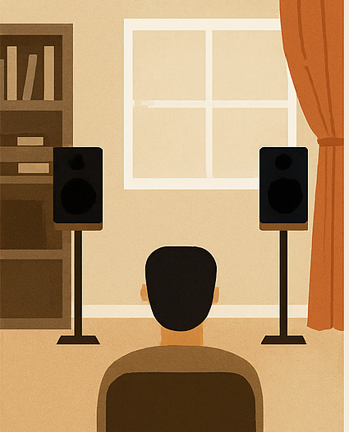
You sit down. Music plays. But what you’re hearing isn’t just coming from the speakers, it’s bouncing off nearby walls and arriving milliseconds later. That tiny time delay? It smears transients and messes with detail.
The worst offenders are:
- The wall to your left and right
- The ceiling above your speakers
- The coffee table in front of you
Here’s a simple test: sit in your chair and have a friend hold a mirror flat against the side wall. When you can see the speaker in the mirror from your seat? That’s a reflection point.
What to do:
- Use an absorber (like a 2" fiberglass panel, not foam)
- Or a diffuser (like a bookshelf with random-sized books)
- Or just move furniture to scatter the reflection
These small changes make a big difference. Imaging gets tighter. Vocals get cleaner. It’s like refocusing a lens.

VI. Power Problems: Clean, Not Mythical
Audiophiles love to argue about power conditioners. Some claim a $1,200 power regenerator opened up the highs. Others say it's snake oil.
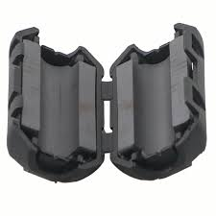
Here’s what’s real: if your power line is noisy, shared with appliances, dimmers, or motors, you’ll hear it. If your power is clean, you probably won’t.
A few practical tools:
- Ferrite clamps on power and data cables: cheap and effective at killing RF noise.
- Basic line conditioners: surge protection with some filtering, usually $30–$100.
- Ground loop isolators: especially if you’re running multiple components plugged into different circuits.
Skip the boutique power cords unless you’ve already solved all your real problems. A filtered socket won't fix poor speaker placement.

VII. Measuring the Room: Ears First, Tools Second
You don’t have to be an engineer to measure your room. But the tools can help confirm what your ears are already telling you.
Room EQ Wizard (REW) is free software that lets you visualize room problems. Use it with a UMIK-1 mic ($75), and you’ll get data on:
- Frequency response (do you have a 70Hz hump?)
- Decay time (do low frequencies linger?)
- Phase issues (are your speakers fighting each other?)
Don’t chase the graph. Chase the sound.
Use measurements to identify why something sounds off, not to justify expensive gear.
I’ve seen rooms where the subwoofer was perfectly flat on paper… but still sounded slow and bloated. Turned out the decay time at 40Hz was over 600ms. Fix the decay with treatment, and suddenly it tightened up.
Use your ears. Then check the readout. Not the other way around.

