Room Measurement: Why and How!
By: Marc Silver

Why Measurement Isn’t Optional
In my 50+ years tuning rooms, I’ve learned one thing: you can’t fix what you don’t understand. Throwing panels at random walls might help a little, but without measurements? It’s guesswork. And usually expensive guesswork.
Measurements turn frustration (“Why does my room sound like crap?”) into data you can act on.
Here’s a real example. A client had a $50,000 listening room that sounded like a $5,000 system. Boomy bass, wandering imaging. Top-shelf gear, overpriced panels, and zero results. We brought in a $50 mic and ran REW. The problem? A nasty 70Hz room mode. Two bass traps, a 12-inch couch move, and a couple degrees of toe-in later, the whole system opened up.
The good news? You don’t need a degree in acoustics. Just curiosity, a laptop, and a decent mic. I’ll walk you through what to measure, how to measure it, and what to do with what you find, no lab coat needed.

What You’re Hunting: Key Acoustic Problems
Frequency Response Issues
Peaks are spots where certain frequencies, usually bass, build up and get too loud.
Nulls are the opposite, frequencies disappear because sound waves cancel each other out.
Imagine standing in just the wrong place at a concert. The bass vanishes. Take a step, and it’s back. That’s a null. It’s why speaker and listener placement matter, and why measurement matters even more.
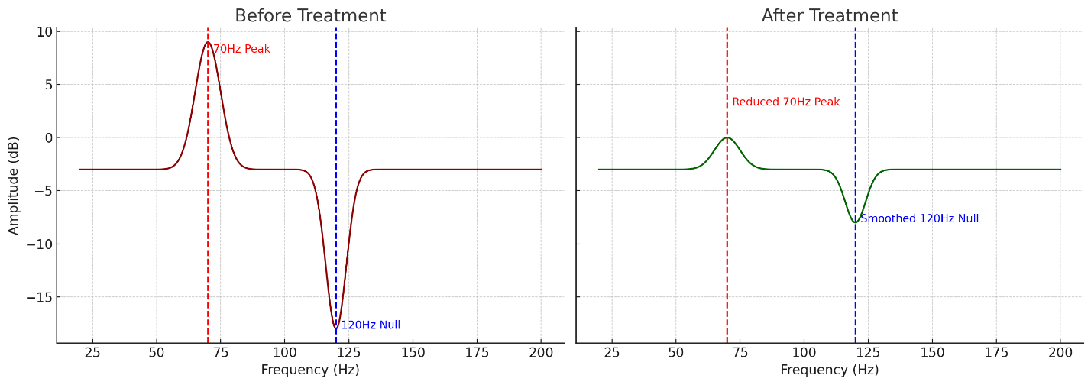
Reverberation Time (RT60)
RT60 is how long it takes sound to fade by 60 decibels after it stops. In plain English? It tells you how echoey your room is.
- Long RT60 (0.8 seconds or more): Feels like a cathedral. Bad for clarity.
- Shorter RT60 (0.3 to 0.6 seconds): More controlled, more musical.
Do the clap test:
Hear a sharp “slap” or “zing”? That’s flutter echo, sound bouncing between parallel walls.
Bathroom-style echo? That’s excessive reverb.
✅ Fix both with properly placed absorption panels.
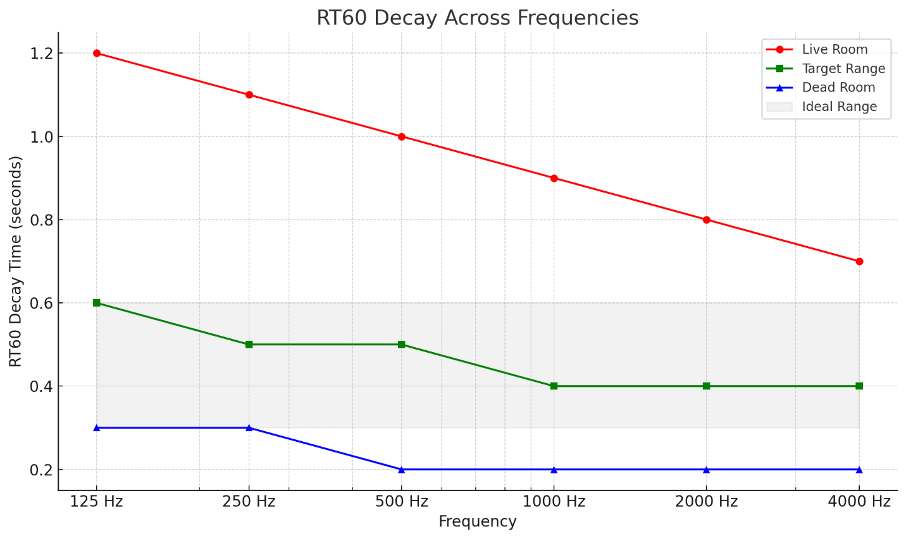
First Reflection Points
Here’s the easy trick:
Sit in your listening chair. Hold a mirror flat against the wall or ceiling. Slide it until you see your speaker’s driver reflected. That’s a first reflection point.
✅ Fix: Mount absorption panels there. It’ll tighten up your imaging immediately.
Still not convinced? Software like REW will show you reflection paths and decay times in black and white. It’s not voodoo, it’s physics.
[INSERT DIAGRAM: Illustration of the mirror trick, showing listener, speaker, mirror on side wall, and line of sight to reflection]

Tools of the Trade: Budget Gear That Works
Software
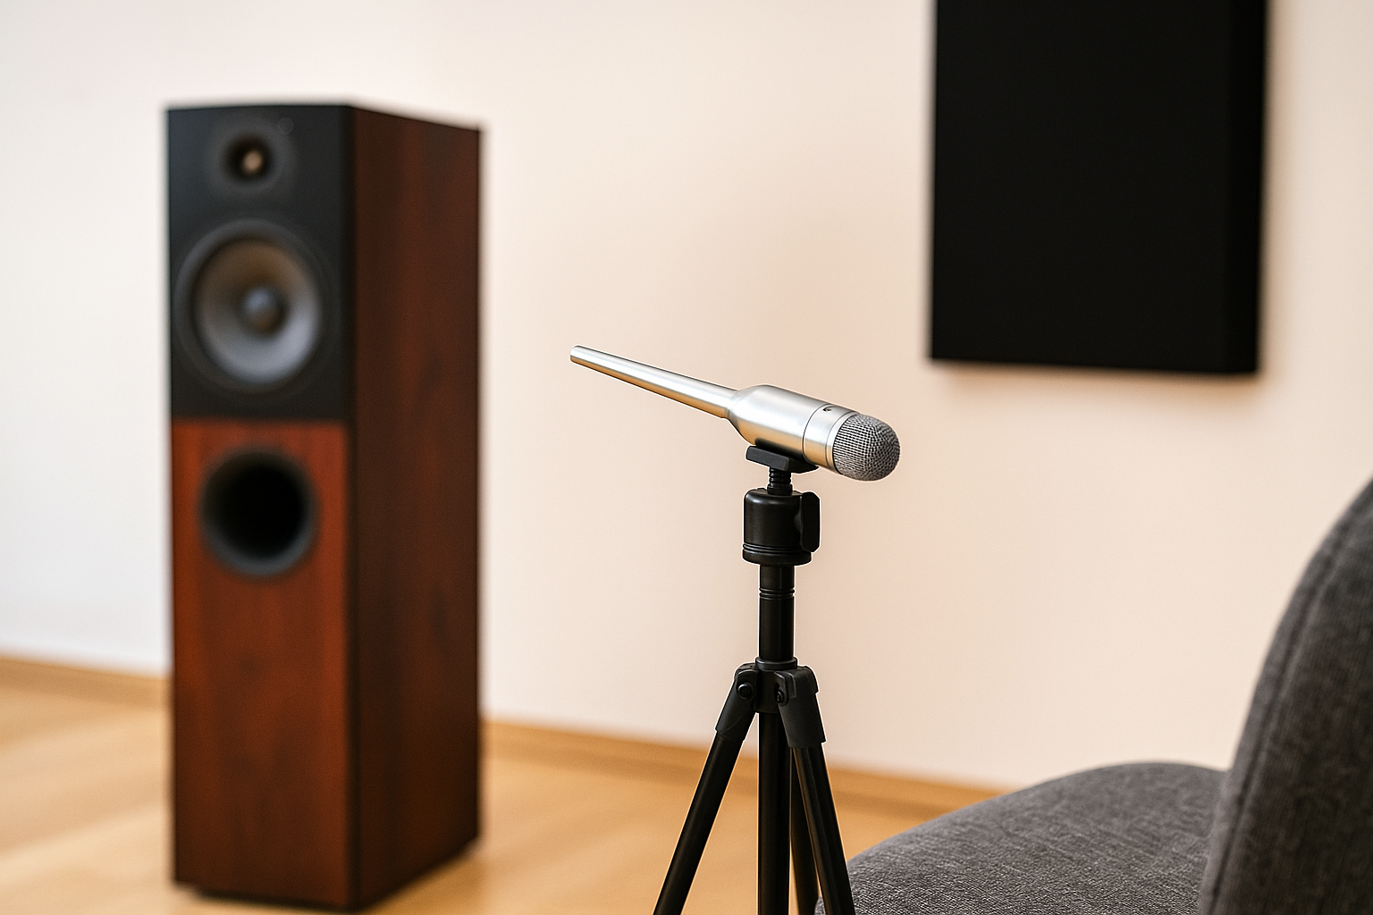
- REW (Room EQ Wizard): Free and powerful. Works on Mac, PC, and Linux.
- Phone apps (Decibel X, AudioTools): Okay for basic checks.
⚠️ Don’t trust anything below 200Hz, phones can’t hear deep bass properly.
Microphones
- Behringer ECM8000 (~$50): Solid choice. Calibrated, flat response.
- Dayton iMM-6 (~$20): Good for quick field checks. ⚠️ Not great for bass.
Sound Source
Use your laptop or AV receiver to play test sweeps. It’s not glamorous, but it’s like using a dipstick instead of guessing your oil level by the smoke.

Step-by-Step: Running Your First Tests
Prep the Room
Turn off fans, HVAC, anything noisy. Close the windows.
Set the mic at ear height in your listening position. Use a stand or tripod, don’t just prop it up.
Frequency Response
In REW, run a sine sweep from 20Hz to 20kHz.
You’ll see a jagged graph, don’t panic.
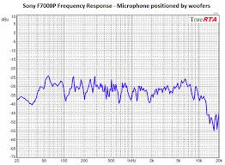
What to look for:
- Big humps (e.g., +12dB at 50Hz) = boom.
- Dips (e.g., a null at 100Hz) = missing bass.
RT60 (Reverberation Time)
In REW, run an impulse test.
Check the decay time at different frequencies.
Targets:
- Home Theater: ~0.3 sec
- Podcast Room: ~0.4 sec
- Living Room or 2-channel audio: ~0.6 sec
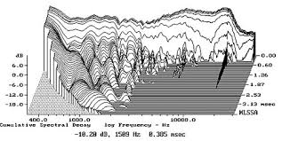
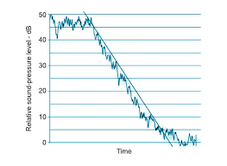
Or just clap your hands. If it sounds like a bathroom or has a metallic ring, your mid and high frequencies are hanging around too long.

Reading the Tea Leaves: Understanding Your Graphs
Frequency Response
- Peaks = too much energy at specific frequencies.
✅ Fix: bass traps, better speaker or seat placement.
- Nulls = phase cancellations.
✅ Fix: try moving the mic, listener position, or add a second sub.
Waterfall Plot
This shows how long sound lingers.
- Long tails below 100Hz? You’ve got low-frequency ringing.
✅ Fix: thicker bass traps, especially in corners.
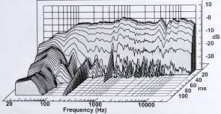
RT60 Graph
- If mids and highs take more than 0.5 seconds to decay?
✅ Fix: sidewall or ceiling absorption panels at first reflection points.

From Data to Action
Boom at 50Hz?
Add or thicken your corner traps. Why?
A 50Hz sound wave is about 22.6 feet long. A quarter of that (λ/4) is roughly 68 inches, the minimum depth where a porous trap starts to absorb effectively. Shallower traps won’t do much. You either go thick, or you go smarter, with pressure-zone traps like membranes or diaphragmatic absorbers.
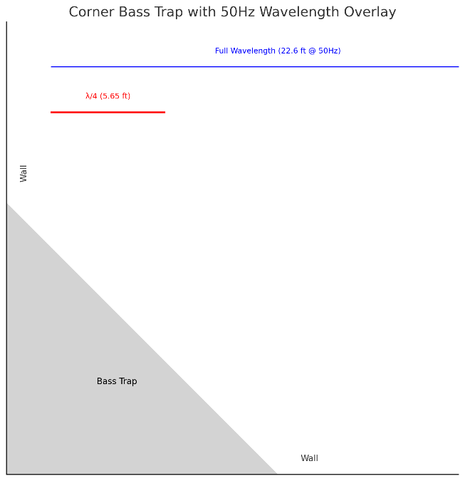
Vocals Hang Too Long?
You’re likely dealing with excessive midrange decay.
✅ Fix: Baffles or panels on sidewalls and ceilings, use the mirror trick.
Null at 100Hz Behind the Couch?
That’s wave interference.
✅ Fix: Move your seating slightly. Or try a second subwoofer to smooth out the room’s low-end response.

Advanced Tactics (Optional, but Worth It)
- Overlay before/after graphs: See exactly how much your changes help.
- Phase & delay alignment: REW can help you time-align your subwoofer to your mains.
- Spectral decay plots: Show resonances that might not appear in standard frequency response graphs.
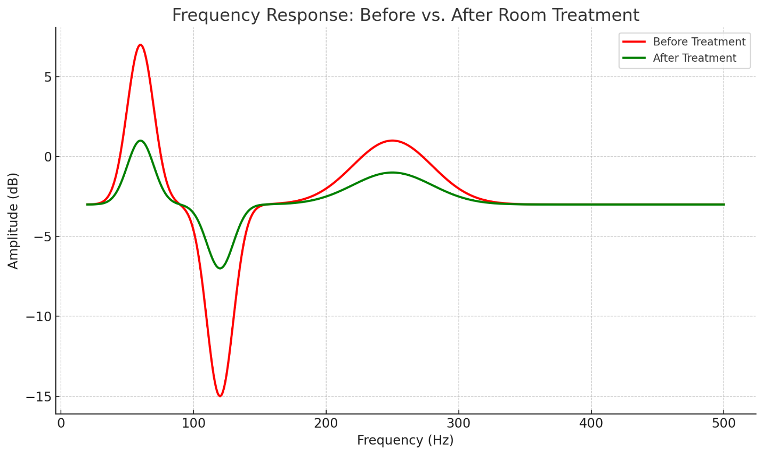
Final Thoughts: Knowledge is Power
Measurement stops the guesswork. It saves you money, frustration, and endless trial and error. Once you’ve seen a 12dB bass peak vanish with a single trap or heard imaging snap into focus after moving a panel, you’ll never go back to blind tweaks.
Run your first sweep tonight. Don’t overthink it. If you hit a snag, search YouTube or TikTok, there are plenty of solid tutorials that walk through every step.
Once you hear the difference, you’ll wonder why you waited so long.

