Reflection on the Bible
and Other Religious Texts
By Marc Silver

Reflection: The Bible and Its Human Hands (continued)
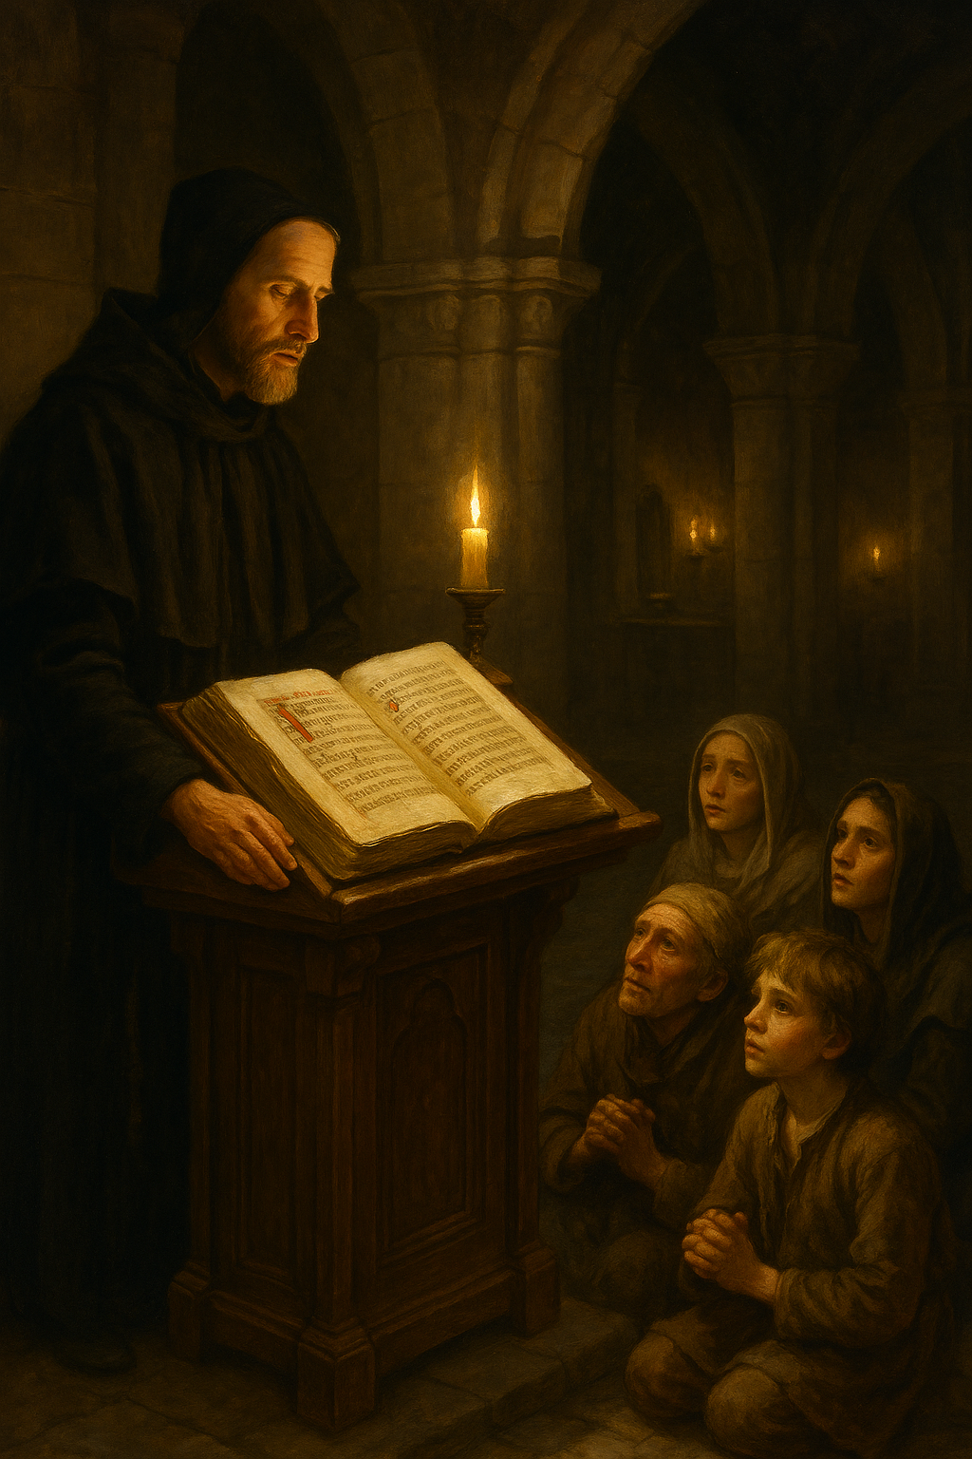
After the councils and canon debates, the Bible entered a new phase, one defined not by revelation, but by translation. If the early centuries were about deciding which books belonged, the next thousand were about deciding what the words meant. And nothing reveals the human hand more clearly than the struggle to translate what some believed was untranslatable.
In the Middle Ages, Latin became the church’s sacred language. The Vulgate, translated by Jerome around the late fourth century CE, was the standard for a millennium¹⁰. Yet few people could read it. Most of Europe was illiterate, and even those who could read didn’t know Latin. The Bible was heard through priests, not read by individuals. Authority rested in the pulpit, not the page.
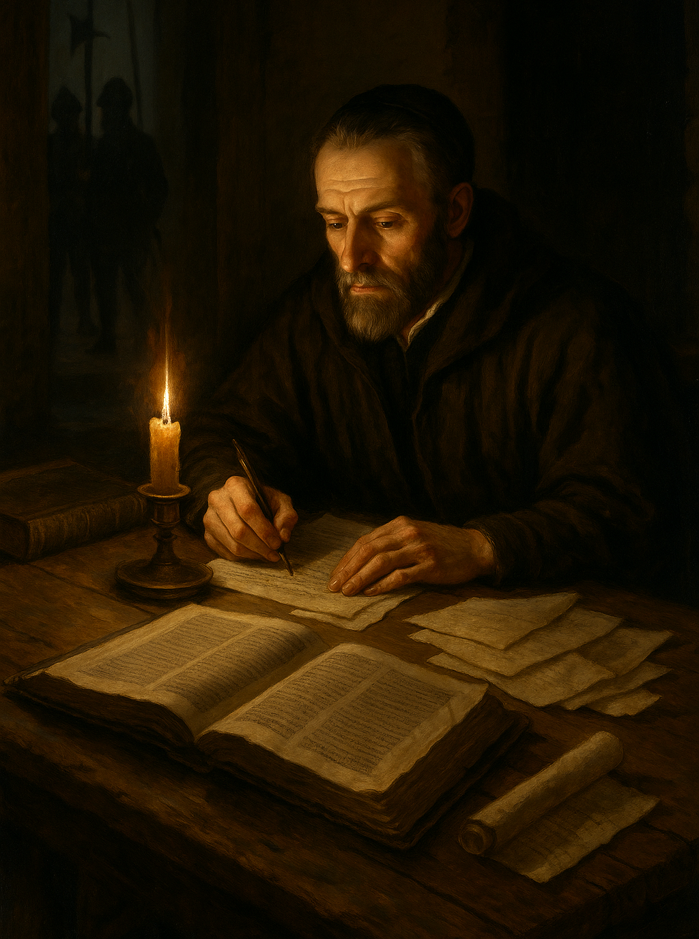
Then came a quiet revolution, the translators. John Wycliffe in the 14th century was among the first to render the entire Bible into English¹¹. He believed that every believer had the right to read the Word in their own tongue. The church disagreed. Translating scripture without authorization was considered heresy, and his followers, the Lollards, were persecuted for distributing his hand-copied English Bibles. A century later, William Tyndale picked up the same fight. His translation, published in fragments and smuggled into England, would shape English prose for centuries¹². Tyndale was eventually strangled and burned at the stake, his dying words reportedly, “Lord, open the King of England’s eyes.”
Ironically, that prayer was answered. Less than a century later, King James I authorized a new English translation, the one that bears his name. The 1611 King James Version became a literary monument as well as a religious one. Its cadences shaped the English language itself, influencing everyone from Shakespeare to Lincoln. But even that translation was a product of compromise, committees of scholars debating every word, balancing theology with politics, poetry with doctrine¹³.
The more the Bible was translated, the more errors it multiplied. Every rendering carried interpretation within it. Words like “love,” “sin,” and “spirit” never align perfectly across languages. The Hebrew ruach means breath, wind, or spirit; the Greek pneuma carries similar layers; the English “spirit” narrows it. Each choice shapes theology. Translation isn’t just about meaning; it’s about worldview.
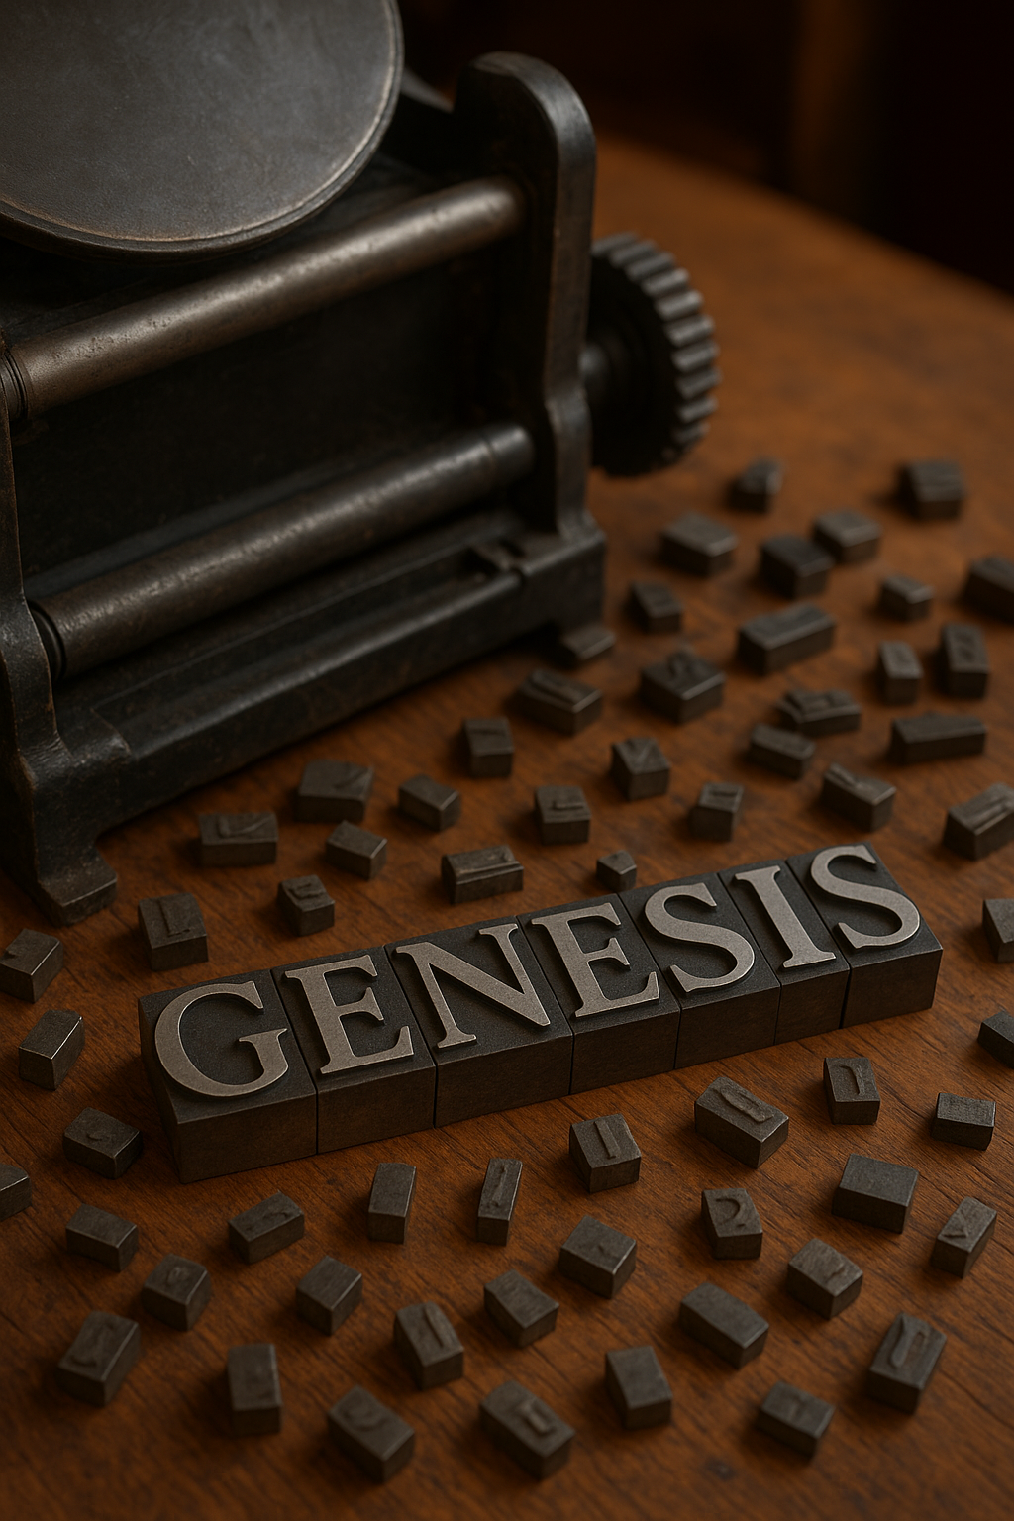
Then came the printing press. In 1455, Johannes Gutenberg produced the first mass-printed Bible¹⁴. For the first time in history, scripture escaped the control of the elite. What had been copied by hand in monasteries and only owned by the very rich, could now be owned by merchants and farmers. The Reformation that followed was as much a revolution in media as it was in belief. Martin Luther’s German translation of the Bible made faith personal again. People no longer needed priests to mediate meaning; they could read and decide for themselves. That freedom also meant fragmentation. Dozens of denominations emerged, each claiming to possess the truest interpretation.
That democratization of scripture was both a triumph and a tragedy. On one hand, it gave ordinary people a voice in their own faith. On the other, it fractured Christianity into competing certainties. The Word of God became a mirror reflecting human interpretation.
Even in the modern age, the Bible continues to evolve. Archaeological discoveries have revealed older and sometimes radically different versions of familiar texts. The Codex Sinaiticus, discovered in the 19th century, contains passages missing from later copies¹⁵. The Dead Sea Scrolls exposed variations within ancient Hebrew manuscripts that no one had seen for two thousand years. Each new find reminds us that what we hold today is the end of a long line of revisions, edits, and decisions.
The irony is beautiful. For a text often invoked as proof of divine permanence, the Bible’s history is one of continual change. It has been shaped by empires, copied by hand, debated by councils, translated by rebels, and printed by inventors. And yet it endures. Not because it was frozen in perfection, but because it was flexible enough to survive. The Bible’s humanity, its errors, its inconsistencies, its capacity for reinterpretation, is what kept it alive.
When I look at this vast record, I don’t see failure. I see persistence. Each generation believed the words mattered enough to rewrite them, to risk death for them, to argue and translate and fight over them. That’s faith of a different kind, not faith in infallibility, but faith in meaning. The divine, if it exists, may not have written the Bible. But humanity did, and that might be the greater miracle.
Reflection: The Qur’an’s Balance of Perfection and Paradox
If the Bible is a patchwork of human memory, the Qur’an presents itself as something entirely different, a revelation whole and perfect, dictated by God and preserved without error. That’s the claim, at least. To the faithful, it is not a record of humanity’s search for the divine; it is the divine speaking directly to humanity. The Word of God, not about God. Yet even this text, revered for its purity, carries the fingerprints of history.
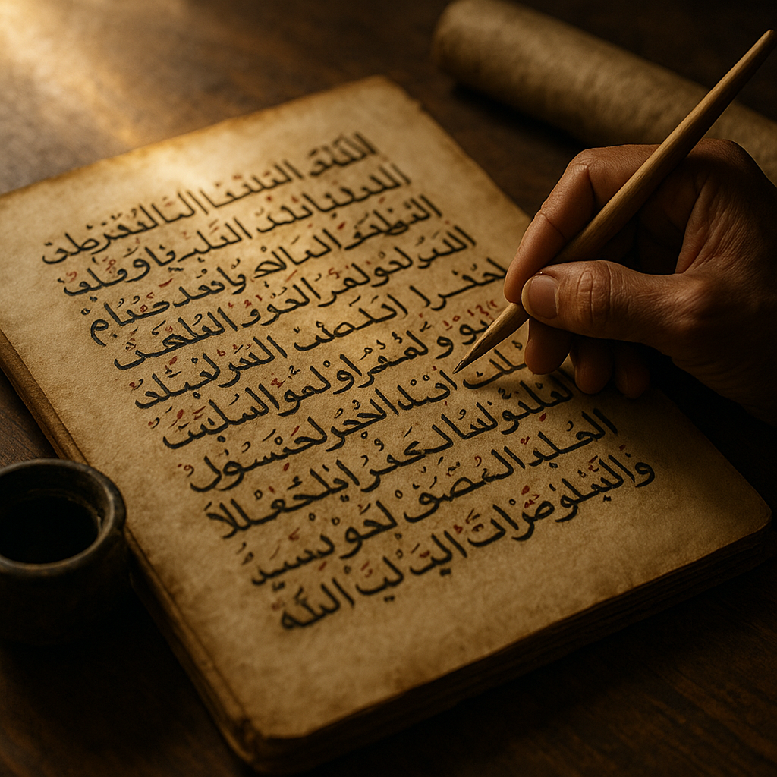
When I first began studying the Qur’an, what struck me wasn’t its unfamiliarity but its continuity. It shares deep roots with Jewish and Christian traditions, retelling the stories of Abraham, Moses, and Jesus, but reframed through a new lens. These weren’t foreign tales to 7th-century Arabia; they were part of a cultural landscape already rich with oral stories of prophets and revelation. The Qur’an entered that conversation not as a replacement, but as a culmination, or so it claimed¹⁶.
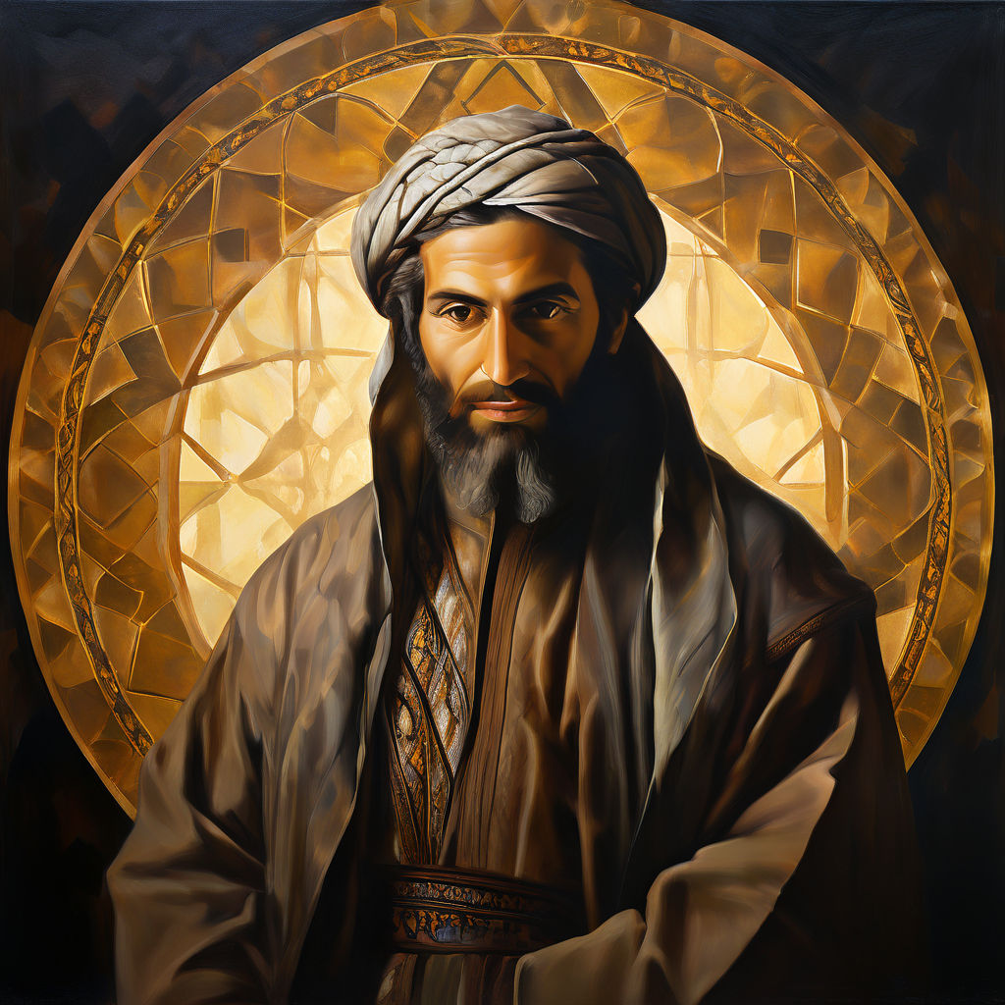
Figure 7 Portrait of the Prophet Mohamad
According to Islamic tradition, the Qur’an was revealed to the Prophet Muhammad over twenty-three years, beginning around 610 CE, through the angel Jibril (Gabriel). Muhammad recited what he heard, and his followers memorized the verses or wrote them on scraps of leather, palm leaves, or bone. After his death in 632 CE, these fragments were gathered and compiled into a single manuscript under the caliph Abu Bakr, then standardized under Uthman ibn Affan some twenty years later¹⁷. The goal was unity, to prevent regional variations from dividing the faith. In that decision, Islam did what Christianity never quite managed: it fixed the text early.
This preservation gave rise to a powerful conviction: that the Qur’an is unchanged and unchangeable, the literal word of God in Arabic. To Muslims, translation isn’t true scripture, only interpretation. The sacred lies not only in meaning but in sound. The Qur’an must be recited, not merely read. Even those who don’t understand Arabic memorize entire chapters, trusting the rhythm and rhyme to carry divine resonance. The beauty of the language itself becomes proof of its origin.
Yet for all its insistence on perfection, the Qur’an contains one of the most remarkable theological devices in any sacred text: abrogation, or naskh. This doctrine holds that certain verses revealed later in Muhammad’s life supersede or cancel earlier ones. In practice, it’s a mechanism for divine revision, allowing revelation to evolve as circumstances changed. A peaceful verse calling for tolerance might yield to a later verse calling for struggle, or vice versa. To outsiders, that looks like contradiction. To Muslim theologians, it’s adaptation, a sign of divine wisdom responding to human reality¹⁸.
That’s what fascinates me. In Islam, abrogation doesn’t deny perfection; it redefines it. The divine remains perfect, even if its expression changes. For the believer, God’s word is alive, unfolding in time. For the skeptic, it’s proof that all scripture reflects the context of its audience. Either way, it acknowledges something profound: that revelation doesn’t land in a vacuum.
Historical scholarship paints a more complex picture. Early Qur’anic manuscripts, like those found in Sana’a, Yemen, show small textual variations, differences in spelling, word order, and phrasing that don’t alter doctrine but remind us that even the most sacred words pass through human hands¹⁹. These aren’t errors in faith; they’re artifacts of transmission. Just as the Dead Sea Scrolls revealed the diversity of early Judaism, the Sana’a fragments show that Islam, too, had a living, breathing scripture before it was standardized.
But once standardized, it stayed stable. No religion has guarded its text more jealously than Islam. Every copy of the Qur’an in the world today, from Indonesia to Istanbul, contains the same verses in the same order. That uniformity has power. It unites over a billion believers across centuries and continents under one shared recitation. It also discourages questioning. If the text is divine and perfect, then interpretation becomes the only safe battlefield.
Throughout history, that tension, between perfection and paradox, has played out in Islamic thought. Philosophers like Averroes and al-Farabi tried to reconcile reason with revelation, while theologians like al-Ghazali warned that too much philosophy could endanger faith²⁰. The debate itself mirrors the older rabbinic tradition I grew up with: the belief that questioning is part of worship. In Islam, as in Judaism, argument is not blasphemy; it’s devotion.
When I read the Qur’an today, I don’t look for flaws or contradictions. I look for humanity. I see a community trying to define itself, a prophet trying to guide his followers, and a people striving to connect their daily lives to the infinite. Whether you believe the words came from heaven or from a human heart, they reveal something essential: our need to make meaning sacred.
The Qur’an endures because it satisfies both sides of that longing. It offers certainty to those who seek perfection and poetry to those who hear its rhythm as revelation. In its insistence that God speaks through language, it affirms what all sacred texts suggest, that the divine, if it exists, speaks through us.
Reflection: When Many Truths Coexist – The Hindu Way
If the Bible reflects the human struggle to define truth, and the Qur’an claims to reveal it perfectly, Hinduism does something else entirely. It opens the door and lets truth wander in many directions at once. No single revelation, no single prophet, no single book contains it all. The sacred is too vast for that.
I first encountered the Vedas in college, long after Hebrew school had taught me to think of scripture as fixed and final. The Hindu approach was startlingly different. There was no fear of contradiction, no need to harmonize conflicting ideas. The Rig Veda could say, “Truth is one, though the wise call it by many names,” and no one saw that as a problem¹. In the West, such a line might have caused a theological crisis. In India, it became the foundation of faith.
The earliest Hindu texts, the Vedas, were not written but sung. For centuries, they existed as sound, transmitted orally from teacher to student. Even today, some priests in southern India still chant them using methods that preserve pitch and tone with remarkable precision. The goal was not just to remember the words but to reproduce the vibration itself. The sound was considered sacred, a living connection to the divine. The written form came much later, when the oral precision was already perfected².
Over time, the Upanishads emerged, philosophical commentaries that reimagined the ritualism of the Vedas as inward truth. They shifted focus from sacrifice to self-knowledge, asking not what to offer to the gods, but what it means to know the self as divine. “You are that,” says the Chandogya Upanishad, a radical claim that the essence of each individual is one with ultimate reality³. There’s no original sin here, no separation to be healed. Instead, ignorance is the only barrier, and enlightenment the cure.
When you read the Bhagavad Gītā, that vision becomes even more dynamic. Here, divinity speaks directly to humanity through Krishna’s counsel to the warrior Arjuna. The message is both moral and metaphysical: do your duty without attachment to results, and you align yourself with the eternal order, or dharma⁴. It’s a philosophy of action rather than belief, an invitation to live meaningfully, not to obey blindly.
What fascinates me most about Hinduism is its comfort with complexity. Where the Abrahamic faiths often insist on orthodoxy, Hinduism thrives on diversity. It allows for monotheism, polytheism, pantheism, and atheism to coexist. The same tradition can see God as one, as many, or as none. The divine is not a person but a principle, or sometimes both.
That multiplicity shaped India’s entire cultural identity. New deities, philosophies, and schools of thought arose and were rarely discarded. Instead, they were absorbed, adapted, and woven into the tapestry. The Bhakti poets of the medieval period sang of personal devotion to Krishna, Shiva, or the Goddess, while philosophers like Śaṅkara argued that all names and forms dissolve into a single consciousness. One said God was everywhere; another said God was illusion. Both were right, in their own way.
To someone raised in the Western tradition, that flexibility can feel disorienting. I was taught that truth, by definition, had to be singular. Two contradictory ideas couldn’t both be right. But Hindu thought doesn’t see contradiction as failure. It sees it as depth. The divine, it suggests, can hold paradox because reality itself does. Truth is not a straight line but a circle, and we each walk our part of it.
In this pluralism, I see something profoundly human. Life is contradictory, after all. We believe and doubt, love and fear, seek freedom and crave order. The Hindu vision doesn’t deny that tension; it sanctifies it. It tells us that the path to understanding isn’t about choosing one truth over another, but learning to see how they coexist.
When I think of the Vedic sages or the Gītā’s dialogue on the battlefield, I see less a religion than a philosophy of acceptance, a recognition that the divine can’t be cornered by language or doctrine. Every culture that touches Hindu thought seems to take something different from it, and somehow, it still remains whole.
Maybe that’s the secret. Where others guard revelation, Hinduism releases it. It lets truth breathe.
Reflection: Lost and Found in Translation
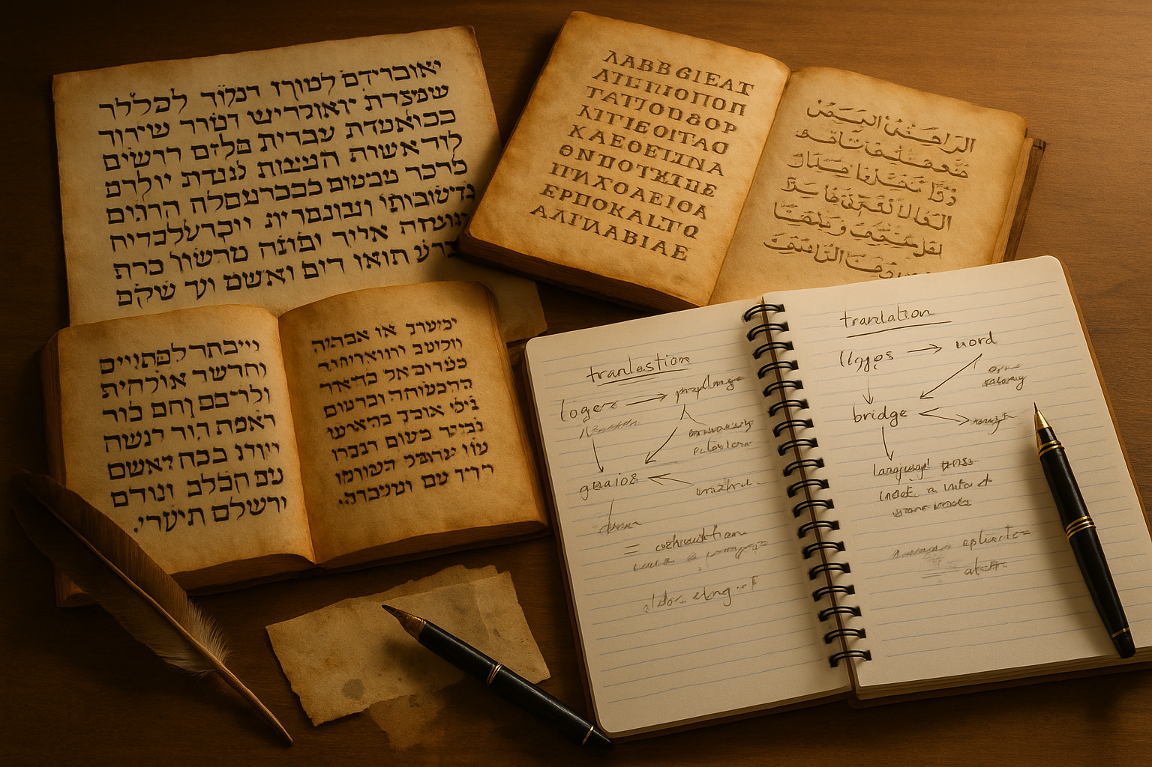
Every act of translation is an act of faith. You take words born in one world and ask them to survive in another. When it comes to sacred texts, that leap is never clean. Something always slips through the cracks, a rhythm, a nuance, a shade of meaning that can’t quite cross the bridge. Yet without translation, the world’s religions would have remained isolated, each speaking only to its own tribe. The irony is that what we call “universal truth” exists only because someone dared to translate it.
I’ve always been drawn to that paradox. Growing up, I heard Hebrew chanted in synagogue but understood almost none of it. Later, I read English translations and found them beautiful, but different, more precise, less mysterious. The language carried the sense of the original but not its music. It made me wonder how much of the sacred is in the sound, not the sense.
The problem is ancient. Every translator must decide which matters more: the word or the meaning. The Greek translators of the Hebrew Bible, those who created the Septuagint, faced that choice constantly. When they rendered YHWH, the unspoken name of God, as Kyrios (“Lord”), they changed theology forever. A name became a title. Mystery became hierarchy. 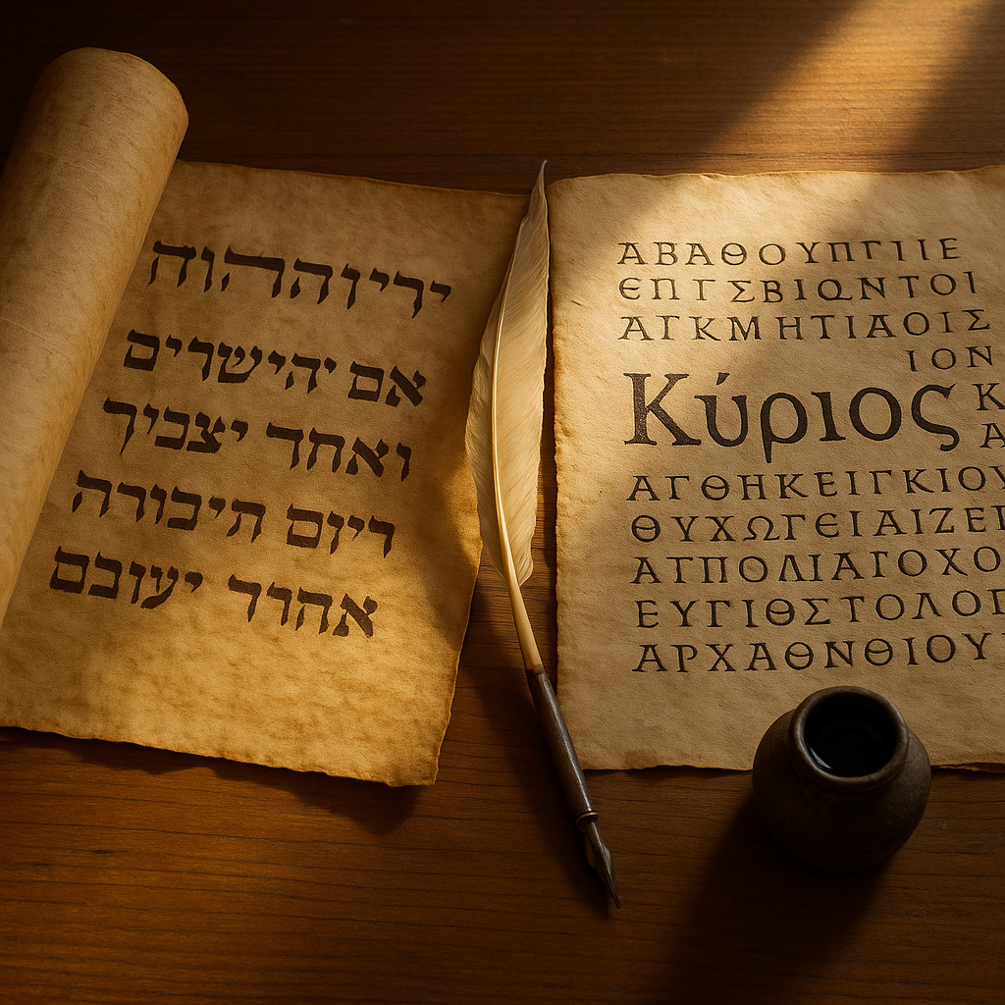
Figure 8 When Mystery Became a Name
The same happened centuries later when Latin translators used Dominus. The shift wasn’t just linguistic; it reshaped how millions imagined the divine¹.
The Qur’an faces a similar dilemma. In Islam, translation is not revelation. The Arabic original is considered the only true Qur’an, and every translation is merely an approximation. When I first read English versions of the Qur’an, I noticed something subtle: different translators produced entirely different tones. Some were lyrical, others austere. The meaning of God’s mercy or wrath depended not only on faith, but on syntax. A single Arabic word like rahmah can mean compassion, mercy, or grace, and translators must choose. Their choice becomes scripture for the reader².
Christianity has wrestled with this tension for centuries. When Jerome translated the Bible into Latin in the 4th century, he faced criticism from every side. His Vulgate was accused of distorting both Hebrew and Greek originals. Yet for a thousand years it became the standard, the only text the Church permitted. Later, when Wycliffe and Tyndale dared to render it into English, they were condemned not for mistranslation, but for translation itself. The Church feared what might happen when ordinary people read divine words in their own language. It was right to worry. The Reformation began not with a rebellion of faith, but a revolution of language³.
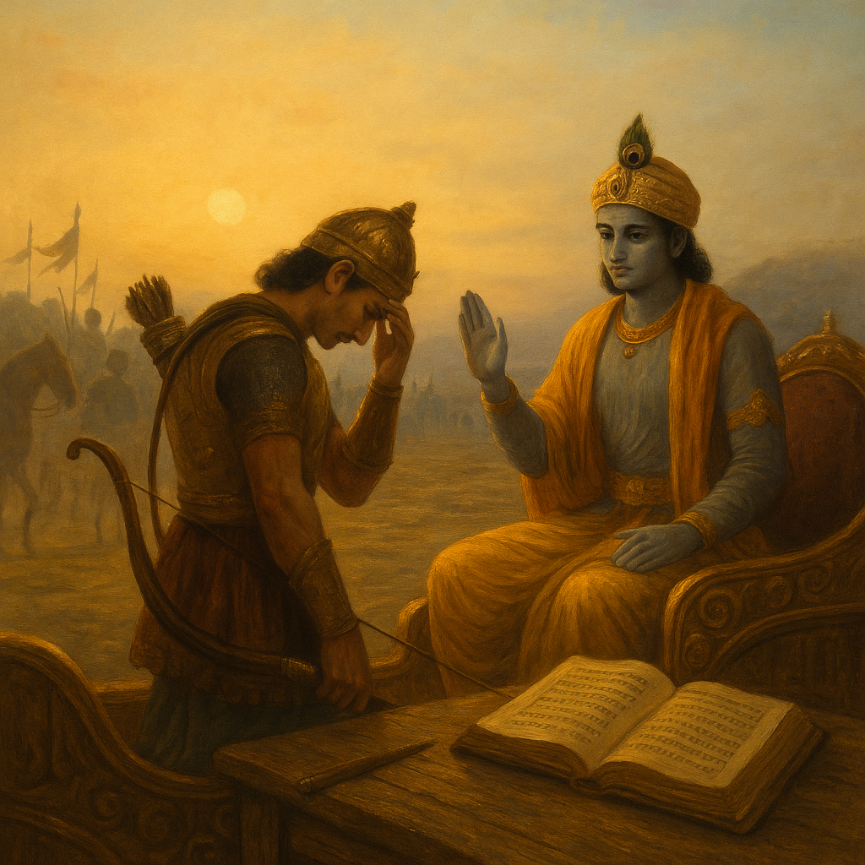
Translation doesn’t just carry meaning; it creates it. The English word “sin,” for example, comes from Old English synn, rooted in ideas of moral failure. But in Hebrew, ḥet means “to miss the mark,” a term borrowed from archery. One implies guilt; the other implies error. The difference changes everything. One burdens; the other teaches. Multiply such shifts across thousands of words, and you begin to see how theology itself is built on vocabulary⁴.
Figure 9 Act, Arjuna, but without attachment.
Even modern translators face impossible choices. In the Bhagavad Gītā, Krishna tells Arjuna to act without attachment to results. The Sanskrit term karma-phala-tyāga carries layers of meaning that “detachment” or “selflessness” can’t capture. In Buddhism, the Pali term dukkha is often translated as “suffering,” but it really means something closer to “unsatisfactoriness”, the subtle ache of impermanence. Each language chooses what it can bear⁵.
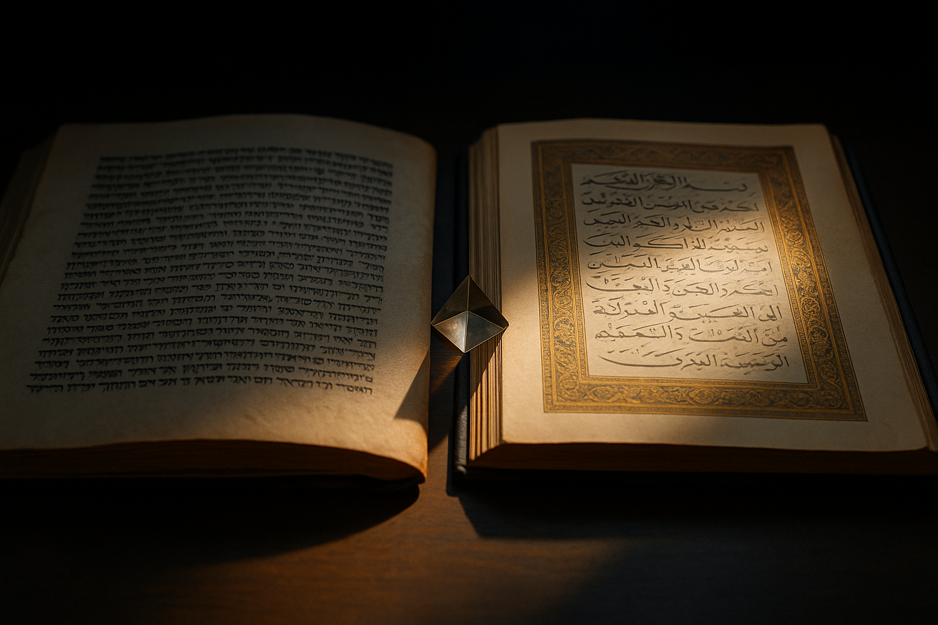
What fascinates me is that every translation, even the flawed ones, keeps the sacred alive. Meaning may shift, but the impulse to understand persists. Translation turns belief into dialogue. It invites new minds to engage with old words. It’s the reason these texts haven’t vanished into obscurity. Without translation, the Bible would have remained in Hebrew and Greek, the Qur’an confined to Arabic, and the Vedas to Sanskrit. Instead, each crossed linguistic borders and entered new civilizations. Every version added a layer of interpretation, but also a layer of survival.
When I think about it now, I realize translation is the purest metaphor for faith itself. Both ask us to trust what we can’t fully verify. Both accept imperfection as the price of connection. Every translator, like every believer, works with what they have and hopes it’s enough.
In a sense, the divine has always been multilingual. We just keep trying to catch up.
Reflection: Why Contradictions Refuse to Disappear
Every sacred text carries its own set of contradictions. Some are small, like differing genealogies or numbers. Others are vast, conflicting depictions of God, morality, or truth itself. For centuries, theologians have tried to smooth them over, to explain them away with context, allegory, or divine mystery. But contradictions persist, and perhaps they should. They reveal more about us than about God.
When I was younger, I thought the inconsistencies in scripture were proof of its human origins. Later, I realized they were also proof of its endurance. A perfect text would have ended conversation centuries ago. An imperfect one keeps people talking. Debate is what keeps the sacred alive.
Take the Bible. The Hebrew prophets preached justice and mercy, yet the same texts justify conquest and slaughter. The God who commands “love thy neighbor” in one verse orders the destruction of Amalek in another¹. Scholars and clergy can argue historical context, but the paradox remains: the same deity embodies compassion and cruelty. The tension isn’t just literary; it’s moral. And yet, those contradictions mirror our own nature. We’re capable of both. Scripture reflects the people who made it.
The New Testament has its own puzzles. The four Gospels tell the same story in different voices, each emphasizing a different vision of Jesus. In Mark, he’s secretive and human, struggling with his mission. In John, he’s serene and divine, speaking in poetry. For centuries, Christians have harmonized these accounts, weaving them into one seamless story. But I find something beautiful in their disunity. It reminds me that faith isn’t a photograph; it’s a collage².
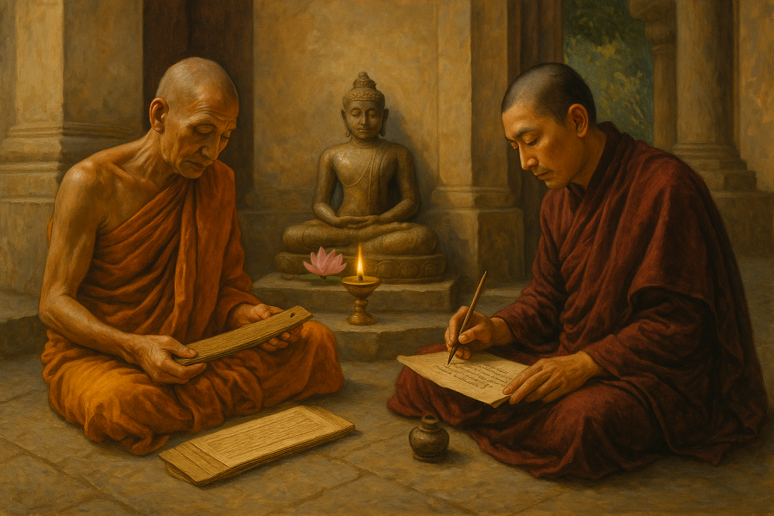
In the Qur’an, abrogation, naskh, allows God to replace earlier verses with later ones. In Hinduism, the Upanishads reinterpret the older Vedas. Even Buddhism contains tensions between early Theravāda teachings and later Mahāyāna philosophy. Every faith carries its contradictions forward like heirlooms, refusing to discard them entirely. They become part of the family story, too precious to throw away.
Figure 10 Buddhism studies
The persistence of contradiction also says something about how humans think. We don’t live in absolutes; we live in flux. Life contradicts itself constantly. We love what hurts us, seek peace through struggle, find meaning in suffering. Why should our holy books be any different? If they truly reflect the human condition, then paradox is not a flaw, it’s accuracy.
Of course, institutional religion doesn’t always see it that way. For centuries, scholars have tried to unify or control interpretation. The early Christian councils codified doctrine to settle disputes; Jewish rabbis debated endlessly to resolve ambiguities in the Talmud; Islamic jurists categorized verses as clear or ambiguous to manage theological consistency³. Yet despite all that effort, disagreement never ended. Each attempt to enforce uniformity produced new divisions. Reformation, schism, sect, all born of contradiction.
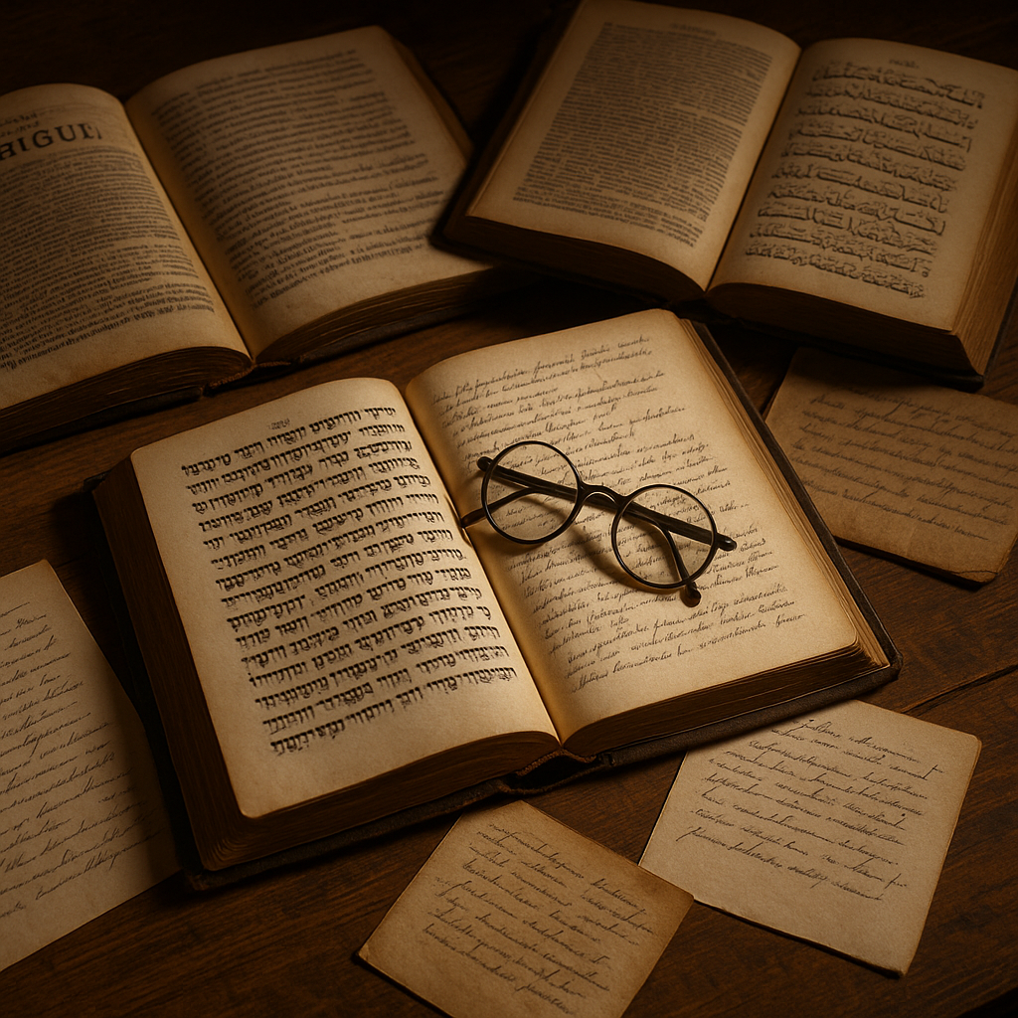
I sometimes think of contradiction as scripture’s built-in defense mechanism. It prevents any one person or institution from owning the truth entirely. A perfectly consistent book could be used as a weapon of certainty. An imperfect one demands humility. It forces interpretation, which means participation. Every reader becomes part of the creative process.
That’s why the rabbinic tradition I grew up with feels so wise to me now. The ancient rabbis didn’t fear disagreement; they recorded it. The Mishnah and Gemara preserve arguments side by side, often without resolution. The question itself becomes sacred. In the Talmud, one rabbi says the law follows one opinion; another says the opposite; the text simply notes, “Both these and those are the words of the living God.” What a radical idea, that opposing truths can both be divine⁴.
Maybe that’s the point. Contradiction is the heartbeat of faith. It keeps us returning to the same words, seeing them differently as we change. The problem isn’t that the Bible, the Qur’an, or the Vedas contradict themselves. The problem is that we expect them not to. Faith, like language, was never meant to be static. It was meant to be lived, questioned, tested, renewed.
In a way, contradiction is proof that the sacred is still speaking. As long as we can argue with it, it isn’t dead.
Reflection: The Beauty Hidden in the Flaws
The older I get, the more I see beauty where I once saw failure. I used to think contradictions proved that sacred texts couldn’t be divine. Now I think they prove something else entirely, that they’re alive. A flawless book would be finished, closed to interpretation. The great ones stay open.
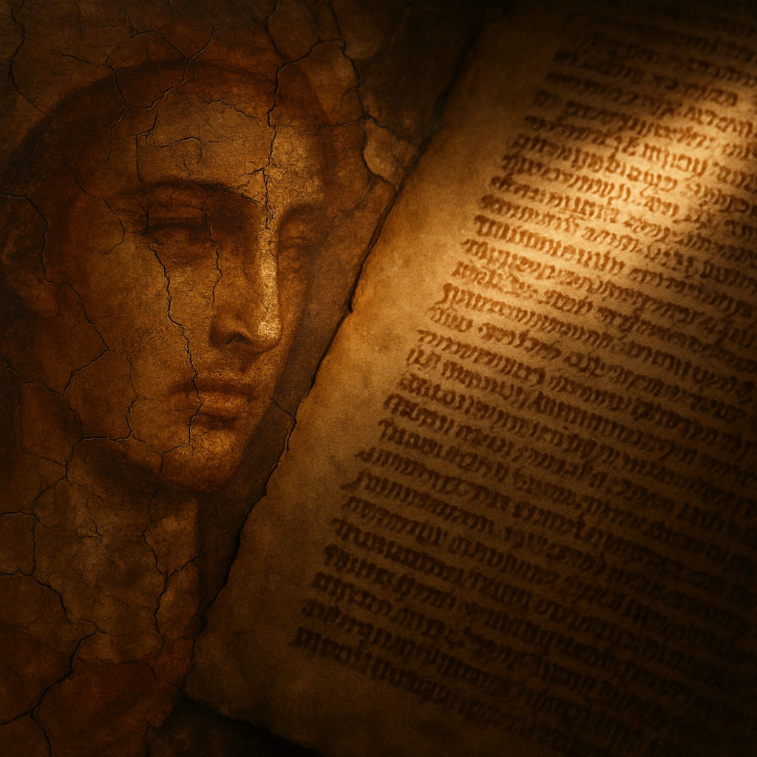
For centuries, people have tried to defend scripture from its own humanity. They patch gaps, explain away errors, and smooth over tensions with clever theology. But to me, those imperfections are the very thing that make the texts worth reading. They show us where the human voice breaks through, where culture, history, and personality leak into the divine narrative. They remind us that faith was never written by angels; it was written by people trying to understand what angels might mean.
Take the Book of Psalms. Some verses praise peace; others cry for vengeance. Some sound serene; others howl in despair. Together, they form the most honest portrait of spiritual life ever written, not certainty, but struggle. King David, or whoever wrote those lines, didn’t hide doubt; he sanctified it. “My God, my God, why have you forsaken me?” isn’t blasphemy. It’s humanity. It’s what makes the text real¹.
The same is true in the Qur’an, where beauty and warning intertwine. A single surah can move from mercy to judgment to awe, sometimes in the space of a few verses. The rhythm, repetition, and language pull you in, not because they make sense in a linear way, but because they feel like life itself: beautiful, uncertain, unresolvable. The sacred isn’t tidy. It’s textured.
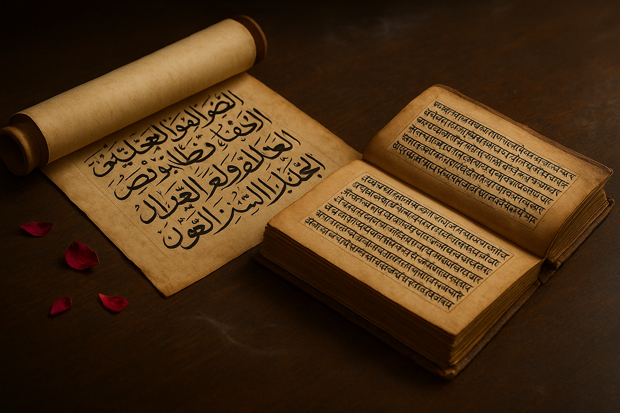
Even in Hindu scripture, where divine order governs the cosmos, imperfection plays a central role. In the Mahābhārata, Krishna’s perfect wisdom meets Arjuna’s human confusion. The battle is not between good and evil, but between knowledge and ignorance. Arjuna’s hesitation, his flaw, becomes the path to enlightenment². The hero’s doubt is the hinge on which revelation turns.
Figure 11 Hindu scriptures
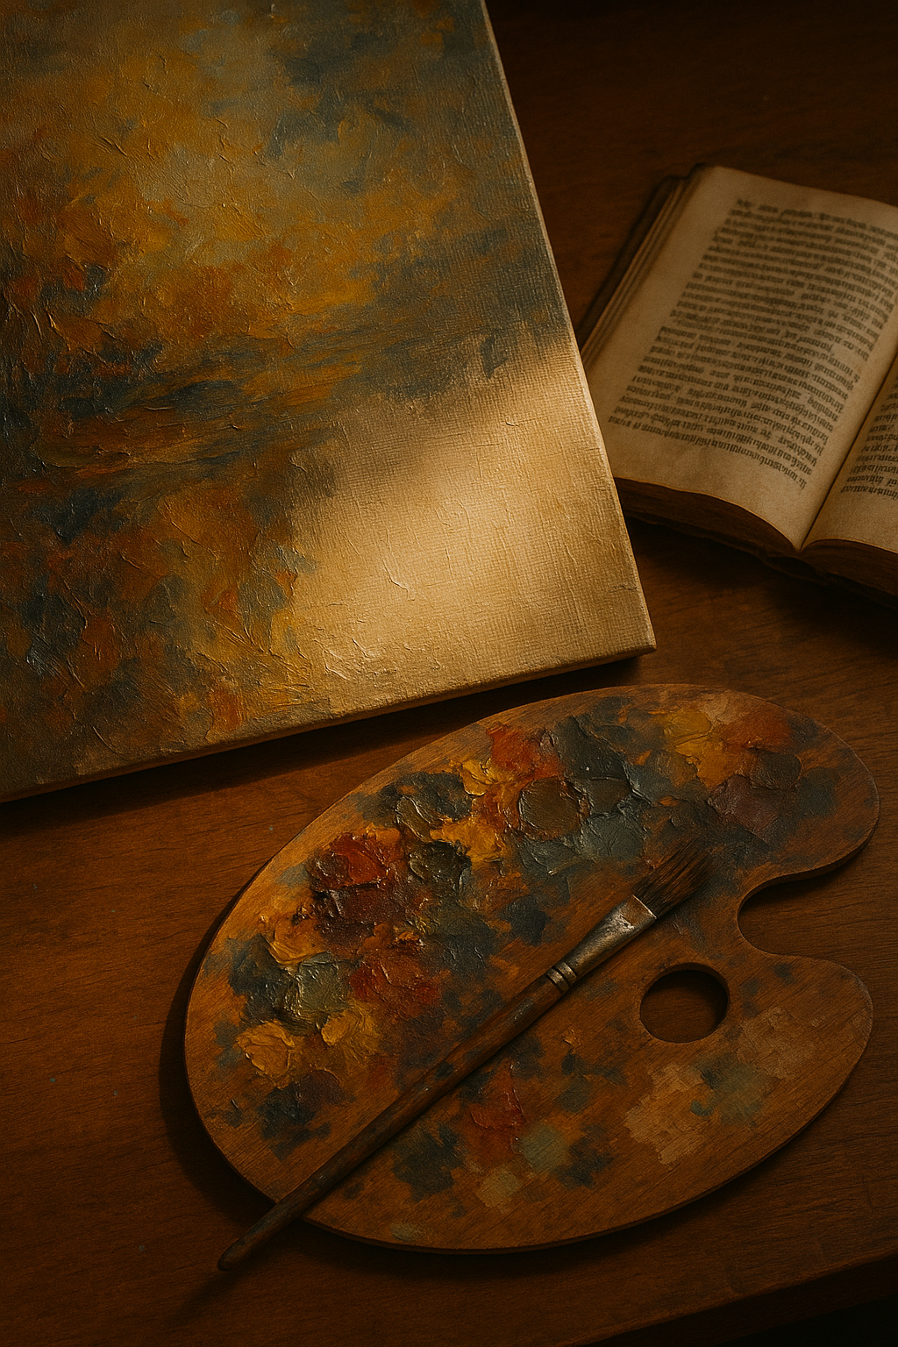
These imperfections aren’t unique to religion; they define every form of art. A painting without variation looks lifeless. A symphony without dissonance feels flat. Perfection bores us because it leaves no room for discovery. The same is true of scripture. Its flaws are what make it endlessly re-readable. Each inconsistency is an opening, a space where interpretation, imagination, and faith can enter.
Figure 12 Imperfection invites participation — in art, as in faith, the unfinished spaces are where meaning enters.
That’s what I find most moving about religious tradition. Every generation revisits the same verses, not to preserve them untouched, but to find new meaning in old words. When rabbis argue, when imams debate, when priests reinterpret, they are, in their own way, repairing the text, not with ink, but with insight. It’s a living process. The flaws make room for us.
Maybe that’s the deeper truth behind revelation: not that it came down perfect, but that it invites participation. The divine spark isn’t in the text itself; it’s in the dialogue it creates. Without its cracks, there would be no light between the words.
To me, that’s the miracle. The Bible, the Qur’an, the Vedas, the Gītā, all imperfect, all contradictory, all stitched together by centuries of voices, and yet, somehow, still speaking. Still teaching. Still reaching across time to remind us that truth isn’t a static thing we find once and hold forever. It’s a conversation we join.
If perfection means silence, I’ll take the flaws.
Reflection: Other Paths, Other Scriptures
The story of sacred writing doesn’t end with the Bible, the Qur’an, or the Vedas. Every generation seems to produce its own scripture, new words claiming to carry timeless truth. Some rise from visions, others from philosophy, and a few from defiance. What unites them is not doctrine, but impulse: the need to give shape to belief through story.
When I first began tracing the history of revelation, I expected the pattern to end somewhere in antiquity, but it never does. Humanity keeps writing. Every few centuries, someone declares that the message has been misunderstood, lost, or corrupted, and then sets out to rewrite it. The details change, but the rhythm remains.
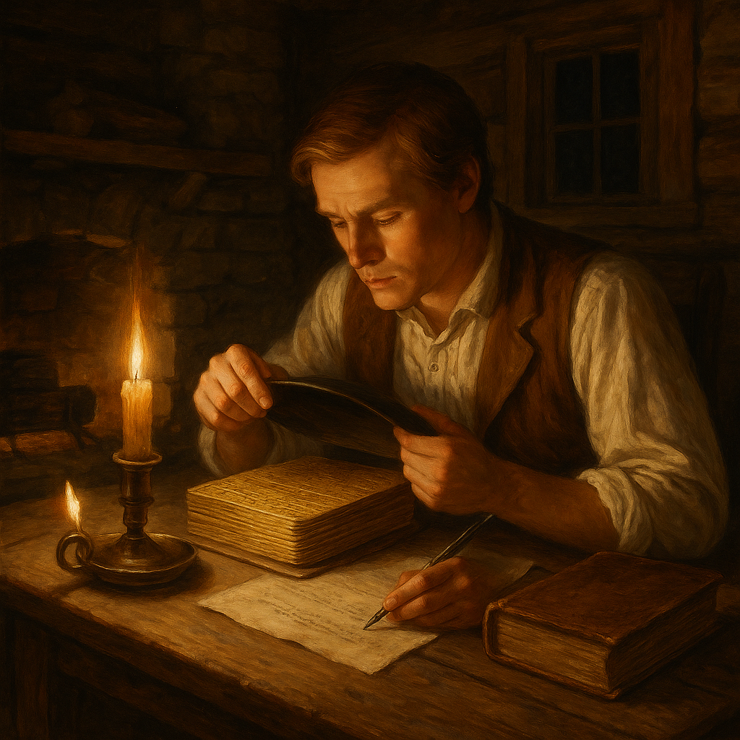
The Book of Mormon is one of the clearest examples. In 1823, a young farmhand named Joseph Smith claimed that an angel named Moroni appeared to him in upstate New York and revealed the location of buried golden plates. On them, Smith said, was a record of ancient Israelites who had migrated to the Americas. By translating these plates “through the gift and power of God,” he produced the Book of Mormon, published in 1830¹.
Critics called it fabrication; followers called it revelation. Either way, it followed a familiar pattern, new scripture born in a moment of crisis. Nineteenth-century America was awash in revivalism, skepticism, and social change. The old certainties of European Christianity no longer fit a frontier world. Smith’s vision offered a new narrative, blending biblical style with American geography. For believers, its re-anchored faith in their own landscape. For historians, it proved that revelation can speak in any accent.
The pattern repeats across centuries and continents. In 5th-century BCE India, Siddhartha Gautama, later called the Buddha, abandoned ritual and caste to pursue enlightenment through experience rather than revelation. After his death, his teachings were preserved orally for nearly two hundred years before being written down in Pali and Sanskrit. The Tripitaka, the “Three Baskets” of scripture, contains sermons, monastic rules, and philosophical analysis.². Buddhism doesn’t claim divine authorship, yet its canon functions exactly like one. It defines doctrine, ritual, and identity. Even a tradition that denies a creator still needs a text to remember what it discovered in silence.
Other movements take that pattern in stranger directions. In the 20th century, L. Ron Hubbard’s Dianetics promised spiritual liberation through psychology disguised as science.
Anton LaVey’s Satanic Bible inverted Christian moral language to celebrate individualism³. The modern Wiccan Book of Shadows collects spells and rituals written mostly in the last century, yet its practitioners treat it with the reverence of scripture⁴. Each of these texts, whether mystical or rebellious, reveals the same instinct: to carve meaning into permanence. Even rebellion needs a sacred book to declare what it rejects.
It’s easy to dismiss such writings as fringe or false, but I see them as part of the same human conversation. Whether they speak of gods, galaxies, or inner power, they all testify to the same need, to make belief visible, repeatable, and transmissible. Every text begins as an attempt to capture something ineffable, and every one eventually becomes tradition. The line between scripture and literature is often just time.
What fascinates me is how quickly the language of revelation evolves but never disappears. Today’s prophets hold microphones instead of stone tablets, but the function is the same: they give people a story big enough to live inside. And while the names and symbols shift, from angels to aliens, from demons to data, the hunger behind them doesn’t change. We keep writing because we keep searching.
That’s what I find moving, even in the strangest corners of belief. Whether it’s Joseph Smith dictating from his plates, Buddhist monks memorizing the Buddha’s words, or modern seekers chanting in candle-lit basements, they’re all doing the same thing humans have always done, trying to find coherence in chaos. The sacred text, however unlikely its origin, is a way of saying: We were here. We felt something. We wanted it to last.
Reflection: Faith After the Facts
When you spend enough time studying scripture, something curious happens. The more you learn, the less you believe in the old sense, but the more you understand why belief exists. Facts can dismantle a story, yet they can’t extinguish what the story means. At some point, you stop asking whether it’s all literally true and start asking why it still matters.
For me, that shift was slow and uncomfortable. I spent years reading, comparing, dissecting. The contradictions that once annoyed me became proof of the human hand at work. I could trace influences, see edits, spot borrowings from older myths. The scholar in me was satisfied. The child in me, raised to believe in miracles and covenants, was not. It felt like losing something, until I realized I’d only traded one kind of faith for another.
Belief in facts has its own kind of devotion. It requires discipline, humility, and trust, trust in evidence, the reliability of reason, and the honesty of one’s own doubt. In a way, that’s what the best religious minds have always practiced. Every generation has tried to square revelation with reason, to make sense of mystery without losing it. They weren’t abandoning faith; they were refining it¹.
When people talk about “losing faith,” they often mean losing comfort. Certainty feels safe; ambiguity does not. But real faith, I think, begins when certainty ends. Once you stop defending the text as infallible, you can start seeing it as something richer, a window into how humanity has always searched for meaning. These stories endure not because they’re flawless, but because they speak to something permanent in us: our need to connect the visible to the invisible, the temporal to the eternal.
The more I read, the more I see faith as participation, not possession. You don’t own truth; you engage with it. You question, test, and revise, then return to the same words with new eyes. The Bible, the Qur’an, the Vedas, the Gītā, all of them are maps drawn by people who were trying to navigate the same mystery we still face. The fact that their maps don’t agree doesn’t make them useless; it just means the landscape is bigger than any one tradition could describe.
I sometimes think about what it means to believe after the facts, after carbon dating, archaeology, and comparative linguistics have shown how these texts came to be. For me, it’s not about believing in the story, but believing through it. The stories become metaphors, frameworks for understanding, moral architectures. They carry the wisdom of centuries, distilled through myth and metaphor. You don’t have to believe that the Red Sea parted to grasp the power of liberation. You don’t have to accept a literal resurrection to feel the pull of renewal.
That’s what faith becomes after knowledge, not obedience, but openness. Not certainty, but curiosity. It’s what allows someone like me, a secular Jew who doesn’t believe in God, to still feel awe when I hear a prayer sung in Hebrew, or when I see someone bow in the direction of Mecca, or when I watch a Hindu light a small lamp at dusk. In those gestures, I see continuity. I see humanity remembering itself.
The facts matter, of course, history, context, and accuracy matter, but they don’t destroy meaning; they illuminate it. To know how something was made is not to love it less. When a restorer studies the brushstrokes beneath a painting’s surface, they’re not trying to disprove its beauty, they’re trying to preserve it. Understanding the human process behind scripture does the same thing. It reveals the hands, the minds, the centuries of effort that made these texts what they are.
I no longer look for perfection in sacred books. I look for conversation. They speak, we answer, and somewhere between those voices, meaning happens. If that’s not divine, it’s close enough for me.
Epilogue: Why I Wrote This
I’ve been asked, more than once, why I write about religion at all, especially when I don’t believe in God. It’s a fair question. You could say I’m an outsider looking in, but that’s not quite true. I may not share the faith, but I share the curiosity. Religion fascinates me because it’s the longest conversation humanity has ever had with itself. It’s the record of our fears, our hopes, our moral experiments, our imagination of the infinite. I study it not to dismantle it, but to understand how we keep returning to the same questions, generation after generation.
In a way, this reflective essay began when I was thirteen, chanting Hebrew verses I didn’t yet understand. It deepened when I was sixteen, arguing theology with my best friend, a Catholic who believed completely. We’d sit on the hood of his kitchen after school, talking about sin, forgiveness, and whether God paid attention to either of us. He’d quote the Gospels; I’d counter with something from the Torah or, more often, my own doubts. What bound us wasn’t agreement, but honesty. He believed with his whole heart. I questioned with mine.
He died young, far too young, and I never stopped thinking about those conversations. They taught me something I didn’t have words for then: that belief and skepticism are two sides of the same hunger. Both come from wanting life to mean something more than itself.
As I grew older, I found myself drawn not to the answers religions offered, but to the effort behind them. Every prayer, every ritual, every text is an attempt to reach beyond the ordinary, to touch what can’t be proven but feels too important to ignore. Even when I disagree with the doctrines, I can’t help admiring the persistence of that search. It’s the most human thing about us.
When I read sacred texts now, I don’t look for divine perfection; I look for the people behind the words. The priest who first whispered a hymn to the goddess in a Sumerian temple. The scribe who copied a scroll by candlelight in a cold monastery. The poet who wove philosophy into song along the Ganges. The prophet who stood in the desert, believing the wind carried God’s voice. They all left something of themselves behind. Every verse, every flaw, every repetition is a fingerprint.
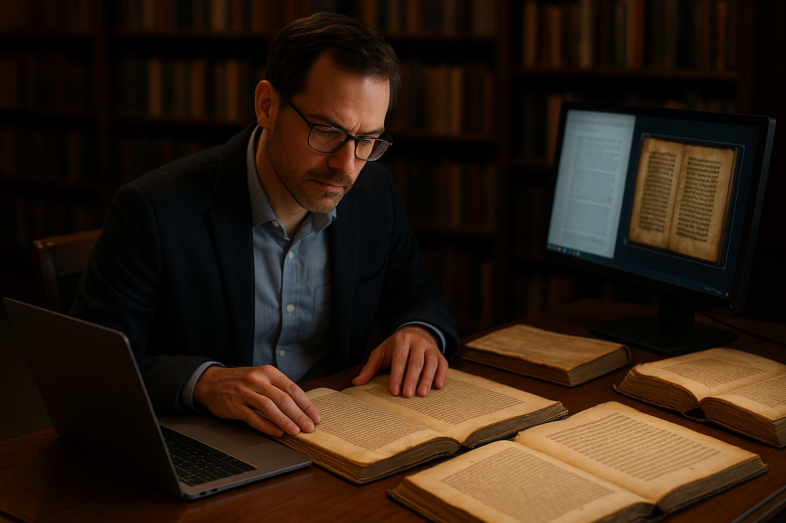
Maybe that’s why I write, because I see in these old texts a mirror of everything I love and fear about being human. Our brilliance and our blindness, our cruelty and our compassion, our yearning to know and our need to believe. We wrote the Bible. We wrote the Qur’an. We wrote the Vedas. And in doing so, we wrote ourselves.
If there’s holiness anywhere, maybe that’s where it lives, not in heaven, but in the endless human effort to imagine one.
Selected References
- Samuel Noah Kramer, History Begins at Sumer (University of Pennsylvania Press, 1963), 184–187.
- Michael D. Coogan, The Old Testament: A Historical and Literary Introduction to the Hebrew Scriptures (Oxford University Press, 2011), 53–55.
- Richard Elliott Friedman, Who Wrote the Bible? (HarperCollins, 1997), 36–41.
- Fred M. Donner, Muhammad and the Believers: At the Origins of Islam (Harvard University Press, 2010), 72–74.
- Geza Vermes, The Complete Dead Sea Scrolls in English (Penguin, 2004), xviii–xxii.
- Frank Moore Cross, Canaanite Myth and Hebrew Epic (Harvard University Press, 1973), 18–20.
- Emanuel Tov, Textual Criticism of the Hebrew Bible (Fortress Press, 1992), 131–135.
- Raymond E. Brown, The Birth of the Messiah (Yale University Press, 1999), 147–149.
- Bart D. Ehrman, The New Testament: A Historical Introduction to the Early Christian Writings (Oxford University Press, 2016), 96–100.
- Henry Chadwick, The Early Church (Penguin, 1967), 120–124.
- Jaroslav Pelikan, The Reformation of the Bible/The Bible of the Reformation (Yale University Press, 1996), 27–29.
- Anne Hudson, The Premature Reformation: Wycliffite Texts and Lollard History (Oxford University Press, 1988), 135–138.
- David Daniell, William Tyndale: A Biography (Yale University Press, 1994), 382–385.
- Alister McGrath, In the Beginning: The Story of the King James Bible and How It Changed a Nation, a Language, and a Culture (Anchor, 2002), 144–148.
- Elizabeth Eisenstein, The Printing Press as an Agent of Change (Cambridge University Press, 1979), 70–72.
- Bruce M. Metzger, The Text of the New Testament: Its Transmission, Corruption, and Restoration (Oxford University Press, 2005), 52–56.
- Reza Aslan, No God but God: The Origins, Evolution, and Future of Islam (Random House, 2005), 33–35.
- John Burton, The Sources of Islamic Law: Islamic Theories of Abrogation (Edinburgh University Press, 1990), 42–44.
- Gerd R. Puin, “Observations on Early Qur’an Manuscripts in San’a,” in The Qur’an as Text, ed. Stefan Wild (Brill, 1996), 107–111.
- Majid Fakhry, A History of Islamic Philosophy (Columbia University Press, 2004), 152–156.
- Rig Veda 1.164.46.
- Frits Staal, Discovering the Vedas: Origins, Mantras, Rituals, Insights (Penguin India, 2008), 77–81.
- Patrick Olivelle, The Early Upanishads: Annotated Text and Translation (Oxford University Press, 1998), 216–218.
- S. Radhakrishnan and Charles A. Moore, eds., A Sourcebook in Indian Philosophy (Princeton University Press, 1957), 111–113.
- Karen Armstrong, The Bible: A Biography (Knopf, 2007), 83–85.
- A. J. Droge, The Qur’an: A New Annotated Translation (Equinox, 2013), xxiv–xxvi.
- Jeffrey Tigay, Deuteronomy: The Traditional Hebrew Text with the New JPS Translation (Jewish Publication Society, 1996), 12–13.
- Eknath Easwaran, The Bhagavad Gita (Nilgiri Press, 1985), 21–22.
- Richard Elliott Friedman, The Bible with Sources Revealed (HarperSanFrancisco, 2003), 175–178.
- Bart D. Ehrman, Jesus, Interrupted: Revealing the Hidden Contradictions in the Bible (HarperOne, 2009), 34–39.
- Fazlur Rahman, Islam and Modernity: Transformation of an Intellectual Tradition (University of Chicago Press, 1982), 44–47.
- Jacob Neusner, The Talmud: What It Is and What It Says (Rowman & Littlefield, 2006), 82–84.
- Walter Brueggemann, The Message of the Psalms (Augsburg Fortress, 1984), 56–59.
- Michael Sells, Approaching the Qur’an: The Early Revelations (White Cloud Press, 1999), 77–80.
- R. K. Narayan, The Mahabharata: A Shortened Modern Prose Version (University of Chicago Press, 1978), 102–104.
- Richard Lyman Bushman, Joseph Smith: Rough Stone Rolling (Knopf, 2005), 41–46.
- Bhikkhu Bodhi, The Connected Discourses of the Buddha: A Translation of the Samyutta Nikaya (Wisdom Publications, 2000), xv–xx.
- L. Ron Hubbard, Dianetics: The Modern Science of Mental Health (Hermitage House, 1950), 21–23.
- Anton Szandor LaVey, The Satanic Bible (Avon, 1969), 32–34.
- Gerald Gardner, Witchcraft Today (Rider, 1954), 88–91.
- David B. Burrell, Faith and Freedom: An Interfaith Perspective (Wiley-Blackwell, 2004), 15–19.

