Reflection on the Bible
and Other Religious Texts
By Marc Silver

Reading Between the Lines
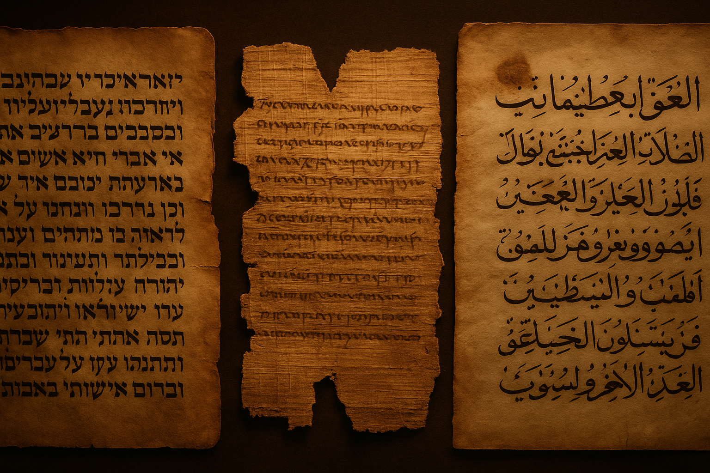
There’s no faster way to start an argument than to question someone’s holy book. Politics can divide a dinner table, but religion can clear it. Faith sits deeper than opinion, it lives in people’s bones. The moment you start talking about the Bible, the Qur’an, or any other scripture, you step into sacred ground where words aren’t just ideas, they’re identity.
Figure 1 The Hebrew Torah, the Bible, and the Qur’an
I learned early that curiosity doesn’t always ask permission.
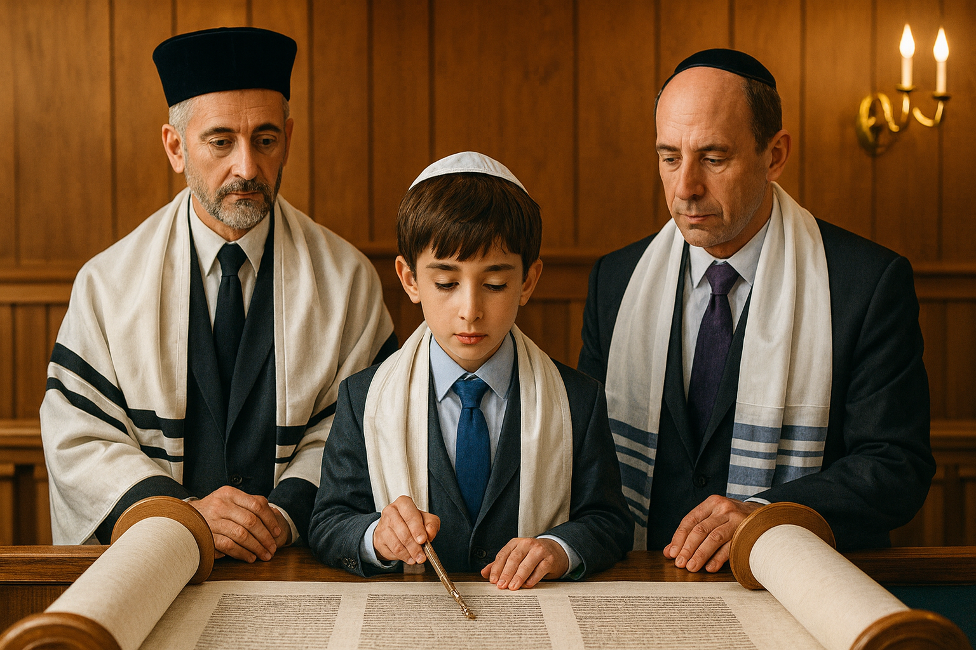
I was raised Jewish. I went to Hebrew school, learned my Bar Mitzvah portion, and carried the weight of a people who have survived by memory. I don’t practice religion, but I respect the endurance of my heritage, the stubborn continuity of a culture that refused to vanish. I believe in history, in tradition, in the wisdom of argument. But I’ve never believed in God.
Figure 2 Bar-Mitzva boy reading from the Torah
Faith never took root in me, but fascination did.

In ninth grade I met my best friend, a Catholic who had spent his entire childhood in parochial school. When he moved to public school, we crossed paths, and for the next decade, until his accidental death at twenty-six, we talked endlessly about belief. He never tried to convert me, and I never tried to talk him out of his faith. We argued, compared rituals, and laughed at how similar our values were despite the theological gap between us. Those conversations taught me something important: belief may divide people on paper, but it often unites them in practice.
That friendship planted the seed for this work. It showed me that understanding another person’s faith isn’t about agreement, it’s about curiosity. It’s about listening closely enough to see where their story touches your own.
Over the years, that curiosity turned into a question that refused to go away: why do so many people defend sacred texts that are obviously full of contradictions, historical gaps, and human fingerprints? Why cling to perfection when imperfection is what makes them human?
This dissertation isn’t a rejection of faith. It’s an examination of it, of how these texts came to be, how they evolved, and how they continue to shape people who may never open them. What I found wasn’t evidence of divine perfection or deliberate deceit, but something more interesting: a record of human imagination trying to reach the divine.
The reflections that follow aren’t attacks. They’re attempts at understanding, part history, part philosophy, part cultural archaeology. I don’t want to tell anyone what to believe. I want to show how belief survives its own contradictions.
If you’re looking for certainty, you won’t find it here. But if you’re willing to read between the lines, to see beauty in imperfection, you might come away with a deeper respect for the very thing you doubt.

Reflection: On the Courage to Question
Let’s be honest, questioning religion takes nerve or perhaps a little insanity.
Every tradition, no matter how open-minded it claims to be, guards its boundaries. Questioning scripture feels like pressing against a wall that’s been standing for centuries. For many, doubt is treated like a disease; for me, it’s always been a symptom of thinking.
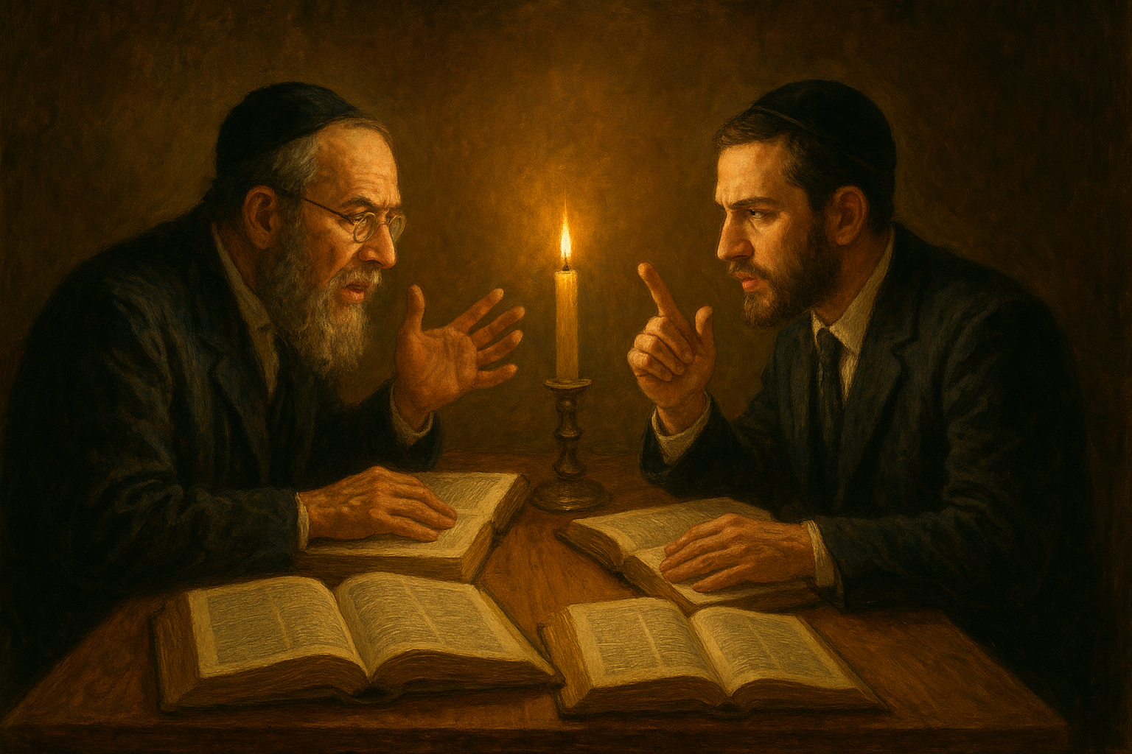
In my own culture, debate isn’t rebellion, it’s tradition. For centuries, rabbis have sat across tables arguing about what a single word in the Torah means. The Talmud is basically a library of disagreements, page after page of scholars debating not just what’s written, but what it might imply. Faith, for them, isn’t about ending the argument, it’s about keeping it alive.
Figure 3 Rabbis auguring over the Talmud
That attitude shaped me early. It taught me that questions aren’t threats, they’re oxygen.
When I started comparing sacred texts, the Hebrew Bible I was raised with, the Christian scriptures my friend knew so well, and the Qur’an I later studied out of curiosity, I began to see the same pattern repeated. Each tradition claimed divine perfection, yet each carried contradictions, revisions, and context. That didn’t make them false. It made them human.
The Bible alone offers two creation stories before you finish the second chapter of Genesis. The Qur’an contains verses that later override earlier ones, a process called naskh, or abrogation, where revelation unfolds and corrects itself as the community changes. Hindu scriptures openly embrace multiplicity; they never insist on a single path.
The question isn’t why contradictions exist; it’s why we expect them not to.
To me, real courage in faith isn’t blind obedience, it’s the willingness to look at your own tradition honestly. If the divine is truly divine, it shouldn’t fear examination. Truth can handle the spotlight. What collapses under scrutiny was never truth to begin with.
That’s the spirit of this exploration, not to tear anything down, but to understand how belief works when you remove the armor of certainty.
Because when you stop insisting that sacred texts be flawless, you can finally appreciate what they actually are, living documents shaped by people, translated through time, adapted to survive. And that survival, across centuries, languages, and cultures, is its own kind of miracle.
Reflection: The Bible and Its Human Hands
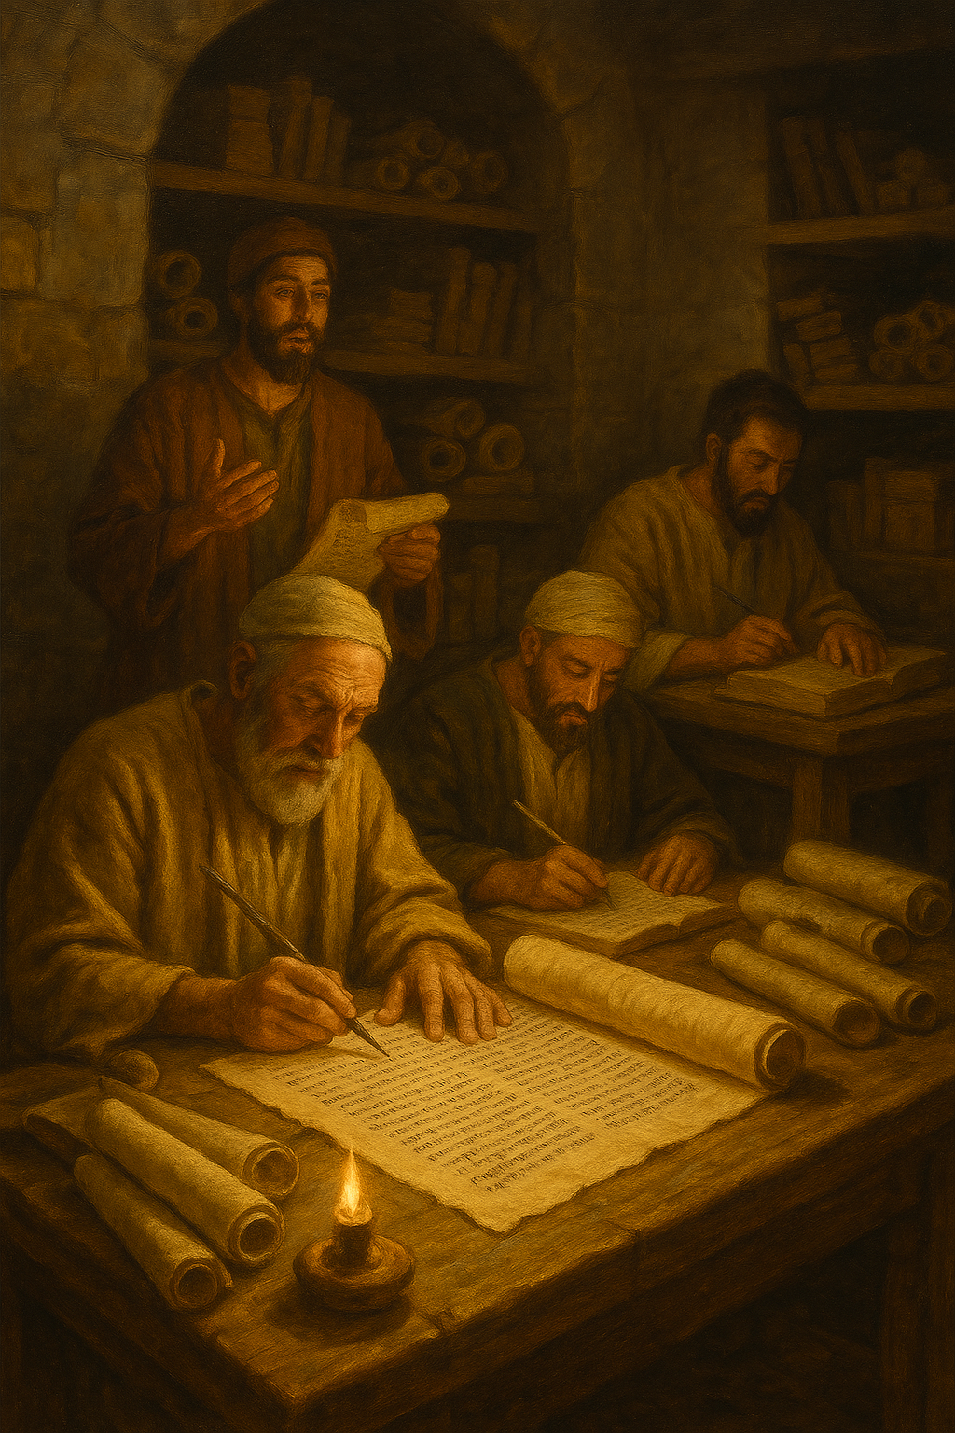
If sacred words began as memory, the Bible represents the moment when memory learned to write. What we call the Bible wasn’t written as a book at all. It was a library, a compilation of scrolls, fragments, oral traditions, and tribal histories gathered over nearly a thousand years.
Each story began with a voice, was shaped by a community, and was finally preserved by scribes who believed they were serving something eternal. What they left us is not one voice, but a chorus.
Figure 4 Transition between oral tradition and written scripture
For me, that chorus is what makes it fascinating. The Bible is human through and through. You can hear its seams if you listen closely, the joins between different writers, the shifts in tone, the echoes of older myths adapted to fit new identities. Faithful readers see unity; I see evolution. And evolution, to me, is its own form of faith, a belief that truth can survive transformation.
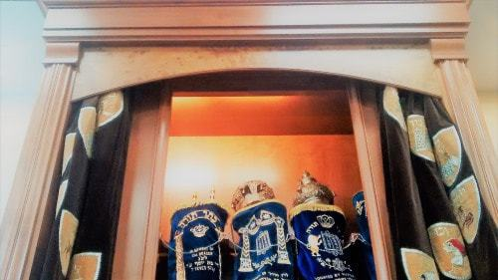
The Hebrew Bible, or Tanakh, didn’t fall from heaven; it grew in the soil of human need. The earliest portions, such as the Song of Deborah in Judges, likely date to around the 12th century BCE¹. Later sections, like Deuteronomy or parts of Isaiah, reflect theological reforms from centuries afterward. The so-called “Books of Moses” were written by multiple authors whose identities have long since been lost. Scholars now identify four main sources: the Yahwist (J), Elohist (E), Priestly (P), and Deuteronomist (D) writers². Each had a different purpose. The Yahwist wrote vivid, earthy narratives. The Priestly writer focused on ritual and genealogy. Together they produced what later readers called “the Word of God.”
Figure 5 Books of Moses in the tabernacal
You can see the layers right in the opening pages. Genesis doesn’t give one creation story, but two. In the first, God creates heaven and earth in six days, speaking reality into existence and forming man and woman together in his image. In the second, the order reverses: man is shaped from dust, then the garden, then woman from man’s rib. These aren’t simple repetitions; they are two different theologies written generations apart³. The first reflects a structured, priestly worldview; the second, an older, agrarian myth that treats creation as a story of intimacy and loss.
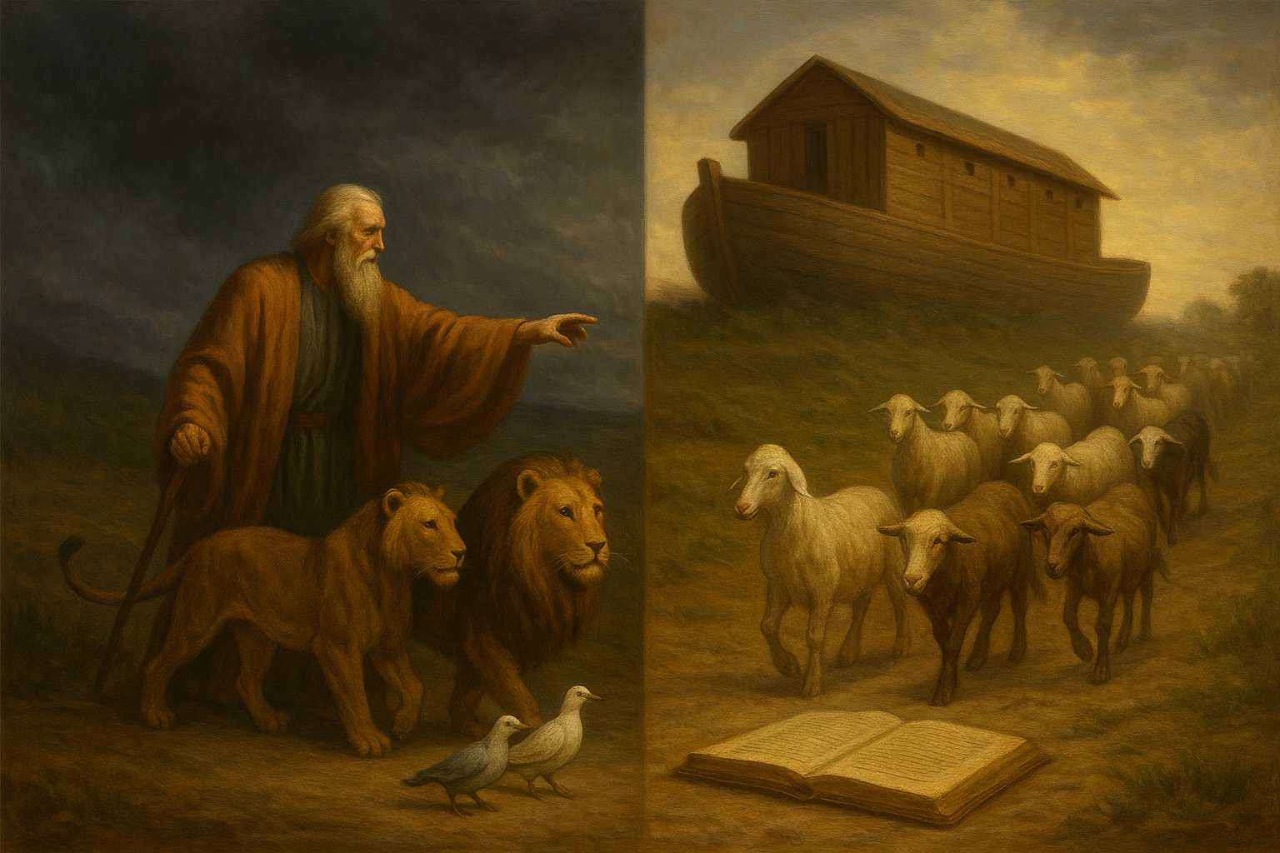
The same happens in the flood story. One account says Noah takes two of every creature; another says seven pairs of clean animals and one pair of unclean⁴. One lasts forty days; the other, a full year. These contradictions weren’t “errors” in the ancient world; they were variations on a theme. The editors who joined them didn’t erase either story; they layered them. To the modern eye, that looks inconsistent. To the ancient one, it was complete.
When you start to see the Bible this way, as a product of centuries of compilation, its contradictions stop being accidents. They become fingerprints. Each doublet, each shift in tone, is a trace of the people who carried these words forward. The human hand is everywhere in it, even in what later generations called divine.
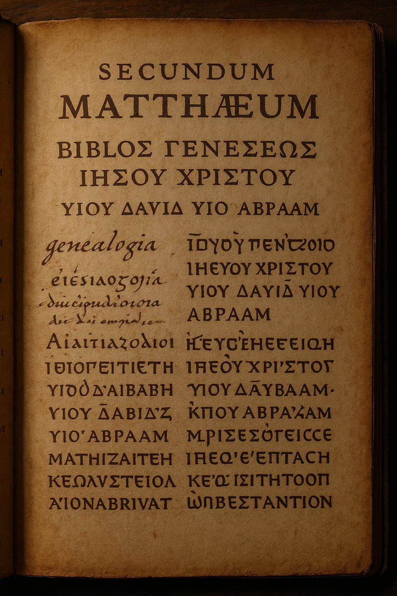
The process continued long after the Hebrew texts took shape. When the Jewish diaspora spread through the Hellenistic world, many Jews no longer spoke Hebrew fluently. They read Greek. Around the 3rd century BCE, a group of translators in Alexandria began rendering the scriptures into Greek, a version now known as the Septuagint⁵. It included several books not found in the later Hebrew canon, such as Tobit, Judith, and The Wisdom of Solomon. Christians later adopted many of these texts, while Jewish scholars excluded them. The difference between the Hebrew Bible and the Christian Old Testament begins right there, not with theology, but with translation.
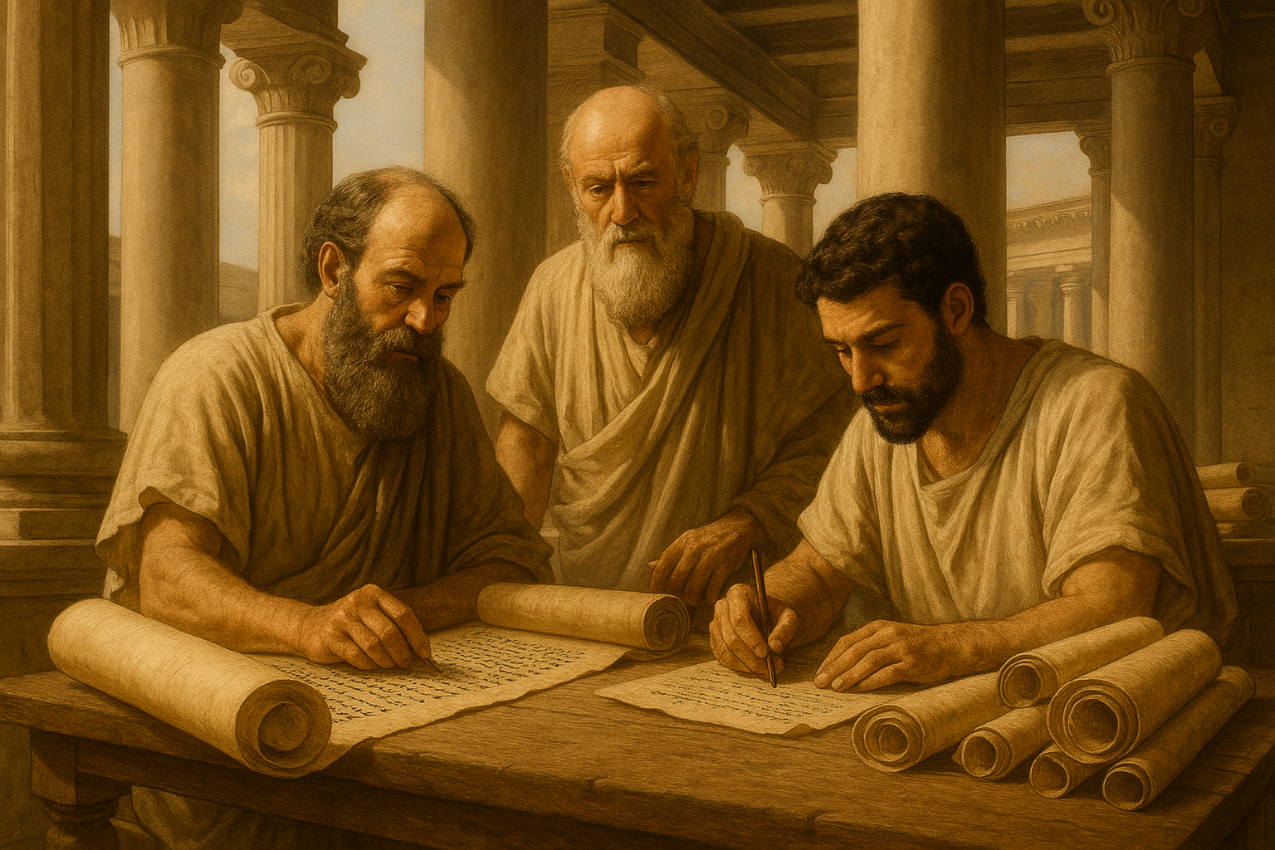
Translation is interpretation. No matter how faithfully a translator works, meaning shifts. In the Septuagint, the Hebrew ʿalmah, “young woman”, in Isaiah 7:14 became parthenos, “virgin.” When the Gospel of Matthew later cited that prophecy to describe the birth of Jesus, it inherited not the Hebrew meaning, but the Greek one⁶. In a single linguistic leap, the foundation of a major Christian doctrine was set. Words changed, and belief followed.
Figure 6 Septuagint translators in Alexandria
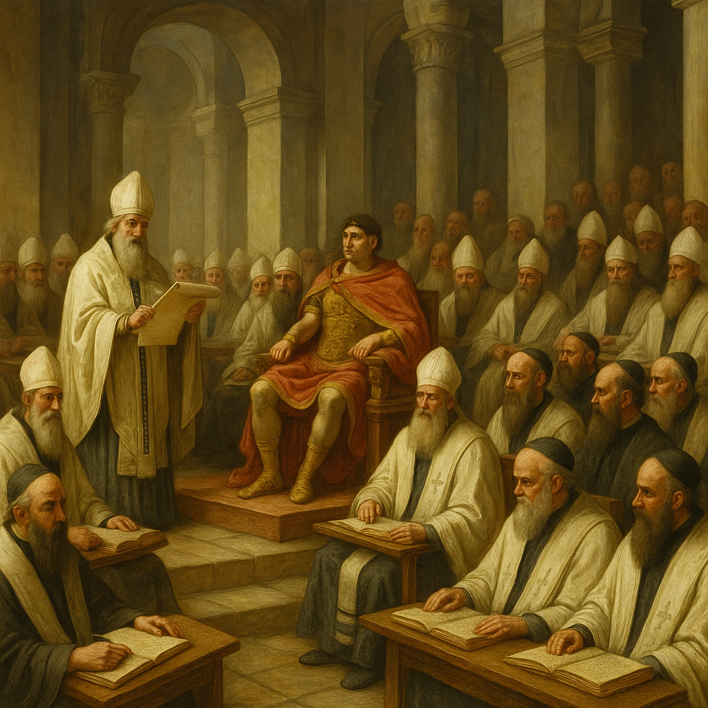
The New Testament added a new set of human fingerprints. The Gospels weren’t written by eyewitnesses but by communities’ decades after Jesus’ death, each trying to preserve and shape their understanding of him. Mark, the earliest, was composed around 70 CE, with Matthew and Luke expanding it later, and John arriving near the end of the first century⁷. Their voices sometimes harmonize and sometimes clash. Matthew traces Jesus’ ancestry through Joseph back to Abraham; Luke traces it to Adam, and the names don’t even match⁸. The resurrection stories differ in detail: who visits the tomb, what they see, and what is said. None of that diminishes their power, but it does reveal their humanity. Faith wrote these texts, not dictation.
Even the early church fathers recognized the problem of divergence. Councils were convened to decide which writings truly belonged. At the Council of Nicaea in 325 CE, bishops gathered under Emperor Constantine to establish orthodoxy⁹. The canon wasn’t fully finalized until centuries later. The version of the Bible most Christians now read, particularly the 66-book Protestant canon, is the product of choices, exclusions, and politics. “The Word of God” was edited by committee.
And still, the human hand kept rewriting.

