Rare Vintage Gear Worth the Hunt
By Marc Silver
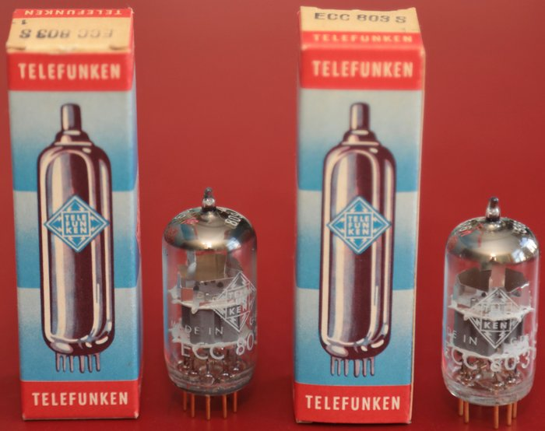
Most vintage gear that grabs attention were household names. But there’s a quieter tier, designs that didn’t win the sales race but earned respect in the back rooms of serious hi-fi dealers like myself. Built in small batches, often ahead of their time, these are the ones you rarely see in the wild but never forget once heard. They’re rarer than an unopened box of Telefunken ECC803S tubes. These are the unicorns of vintage integrated amplification.
Figure 1 Telefunken ECC803S tubes
To qualify for this list, the gear needs more than scarcity. It has to sound good. Really good. Something about its design, topology, parts, or voicing made it stand out. These weren’t just strange or obscure, they were special. And if you’re lucky enough to find one, you may end up with something that doesn’t just compete with the greats, it leaves them in the dust.
These are the ones that got away. Or the ones you never knew to look for in the first place.

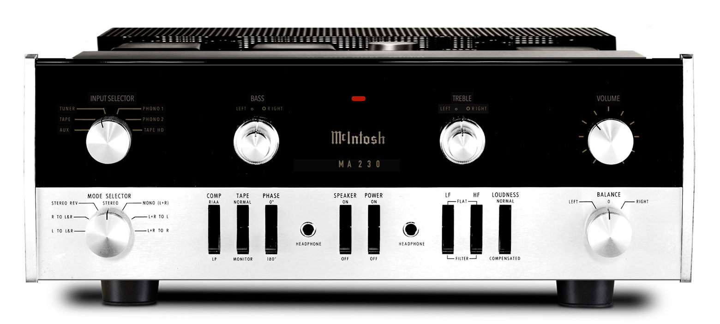
McIntosh MA230
Year Introduced: 1963
Power Output: 30 watts per channel @ 8 ohms
Original Price: ~$399 USD
Current Mint Rebuilt Price: $3,000–$4,500+
Production Numbers: Limited early run; McIntosh's first integrated amp
The MA230 was McIntosh’s first integrated amplifier and an early hybrid, featuring a tube preamp section mated to a solid-state output stage. This design delivered the classic McIntosh warmth and musicality, with improved efficiency and reliability. It retained the signature glass faceplate, chrome chassis, and meticulous layout McIntosh became famous for. While not produced in huge numbers, it set the tone for what a premium American integrated amp could be.
The MA230 is modest in its output of only 30 watts per channel, but it sounds like a state-of-the-art 100W/Ch separates after restoration. Today, the MA230 commands alarmingly high prices on the vintage market. Collectors covet it not only for its historical significance but also because it delivers tube sonics in a user-friendly, compact format. Pristine examples with full restorations regularly sell for many times their original price, and they don’t stay on the market long.
Why it’s worth chasing: Historical significance, exceptional build quality, unmistakable McIntosh sound, and resale values that reflect its near-mythic status among collectors. Restoration often includes replacing aging filter caps, refreshing the power supply, re-tubing the preamp section, and carefully cleaning or reconditioning the glass faceplate and chrome chassis. Due to its hybrid design, it's easier to maintain than full-tube designs, and many vintage audio technicians are familiar with servicing the MA230 specifically. * Historical significance, exceptional build quality, and unmistakable McIntosh sound. Hard to find, expensive to restore, but an absolute gem in any serious collection. * Rare and refined. Makes you rethink early tube/transistor gear.

Revox B750 MKII
Year Introduced: 1979
Power Output: 60 watts per channel @ 8 ohms
Original Price: ~$1,100 USD
Current Mint Rebuilt Price: $2,500–$3,500
Production Numbers: Unknown, but low
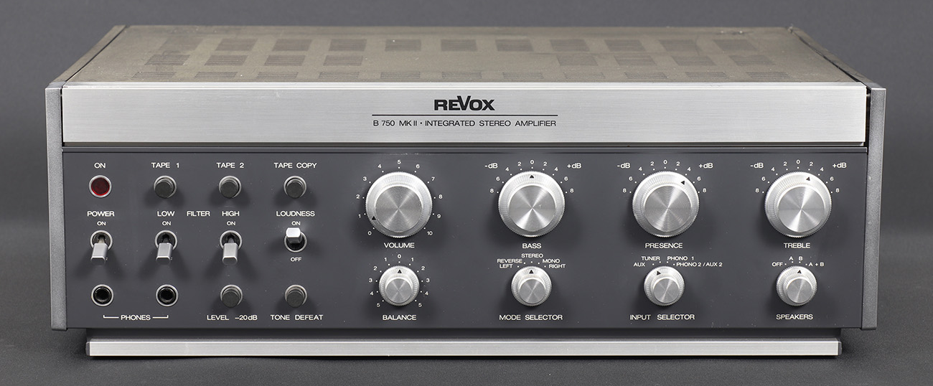
Revox (by Studer) built this tank-like integrated in Switzerland with a level of precision that rivaled medical instruments. The B750 MKII improved on the original with better S/N ratios and even more refinement. Designed for studio use, but beautiful in a home system. I used to sell the full Revox rack system, which included the B750, the B760 digital FM tuner, the B710 cassette deck, the B77 reel-to-reel, and the B790 linear tracking turntable. Revox also offered a matching grey rack to house the entire system. It was a sleek, beautifully engineered setup that delivered clean, neutral sound and silky functionality, a top-tier system for those who could afford it.
Why it’s worth chasing: Germanic build quality, reference-level sonics, and it looks like nothing else. Very hard to find in North America. * Germanic build quality, reference-level sonics, and it looks like nothing else. Very hard to find in North America. * Germanic build quality, reference-level sonics, and it looks like nothing else. Very hard to find in North America.

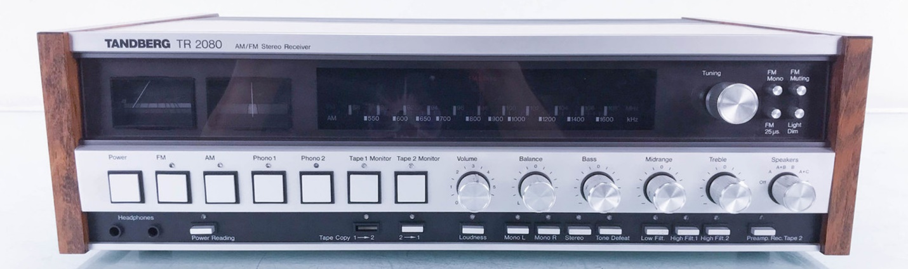
Tandberg TR-2080
Year Introduced: Late 1970s
Power Output: 75 watts per channel @ 8 ohms
Original Price: ~$995 USD
Current Mint Rebuilt Price: $1,800–$2,800
Production Numbers: Low export volume
Technically a receiver, but its amp section deserves integrated-class respect. With dual transformers, gorgeous walnut cabinet, and a lush, tube-like voicing, the TR-2080 exemplified Norwegian audio purity. Sadly, the brand disappeared before it was fully appreciated.
Why it’s worth chasing: One of the best-sounding receivers ever made. Built like art. Sounds like velvet. Rare in the U.S. That said, reliability can be an issue. Tandberg’s U.S. service network was notoriously thin, and sourcing parts today can be a challenge. Consider this a unicorn with a caveat, it’s a gem when it’s working, but make sure you have a trusted technician on call if you bring one home. * One of the best-sounding receivers ever made. Built like art. Sounds like velvet. Rare in the U.S.

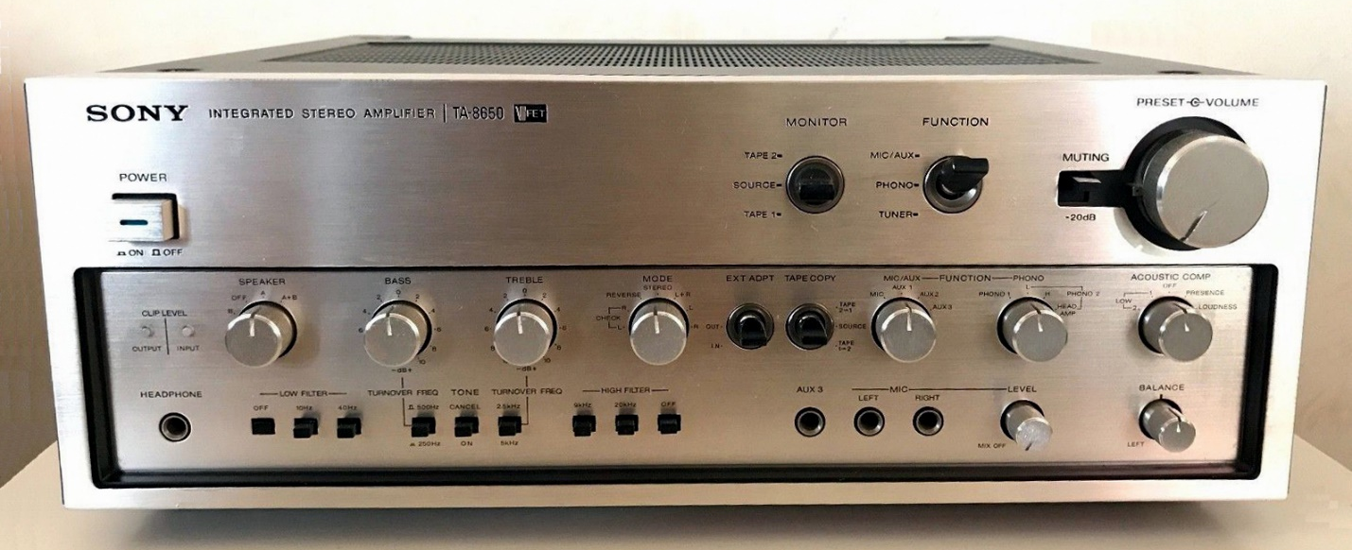
Sony TA-8650 (VFET)
Year Introduced: 1975
Power Output: 75 watts per channel @ 8 ohms
Original Price: ~$750 USD
Current Mint Rebuilt Price: $3,000–$5,000
Production Numbers: Very low; VFET models were a short-lived experiment
Sony’s VFET (Vertical Field Effect Transistor) line tried to blend the warmth of tubes with the control of solid-state. VFETs behave more like vacuum tubes in their linearity and dynamic response, and Sony was one of the few companies to implement them in consumer hi-fi. The TA-8650 was the flagship of that effort. Fast, smooth, holographic, and delicate. Many didn’t survive. Parts are rare, repairs tricky, and VFET transistors themselves are nearly impossible to replace if damaged. But when it works, it’s magic.
Why it’s worth chasing: Legendary VFET voicing with tube-like fluidity and control. Rare in any condition. Deserves its cult following and then some. * Legendary VFET voicing. Rare in any condition. Deserves its cult following.

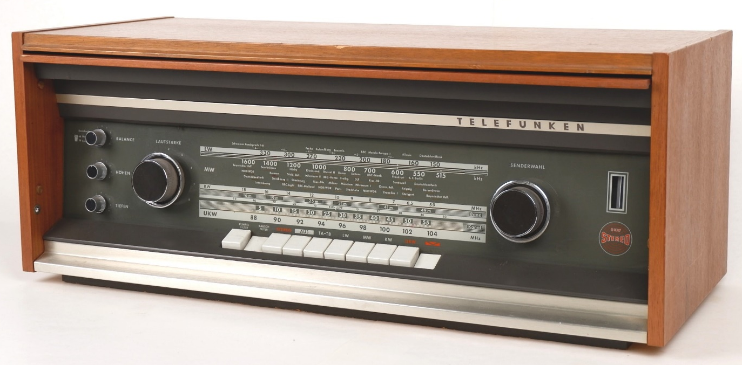
Telefunken Opus Studio 2630
Year Introduced: Early 1970s
Power Output: 40 watts per channel @ 8 ohms
Original Price: ~$600 USD
Current Mint Rebuilt Price: $2,000–$3,200
Production Numbers: Unknown, extremely scarce outside Germany
Built like a high-end laboratory instrument, the 2630 represented the pinnacle of Telefunken's engineering. Designed for precision and longevity, it featured motorized controls, refined tonal balance, and an internal layout more akin to medical or industrial test gear than typical consumer hi-fi. Today, it’s exceedingly rare.
Why it’s worth chasing: Exceptional build quality, unique German engineering, and a smooth, balanced sound that lives up to its mystique. If you want to find one, you may have to look in Europe and ship it to the States. * Gorgeous internal construction. Superb tonal balance. As rare as it gets.

Linn Majik-I
Year Introduced: 1990s
Power Output: 33 watts per channel @ 8 ohms
Original Price: ~$1,000 USD
Current Mint Rebuilt Price: $1,500–$2,200
Production Numbers: Limited early production; improved in later revisions
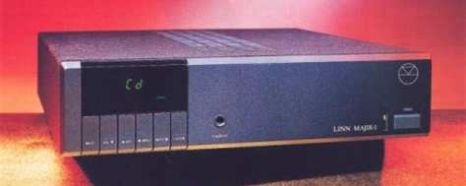
The Majik-I was Linn’s answer to audiophiles who wanted more than the Intek. Designed as a refined, higher-spec integrated amp with a top-class MM phono stage, the Majik-I offered hallmark Linn musicality in a more stable and better-supported platform. With a modular design and understated styling, it was one of the quiet contenders of the 1990s.
Why it’s worth chasing: Smooth, rhythmic, and musical. Built to last, better supported than the Intek, and delivers that unmistakable Linn timing and presence. * Musical and involving. Real Linn sound in a compact, overlooked chassis.

Kenwood KA-700
Year Introduced: Circa early 1980s
Power Output: ~50 watts per channel @ 8 ohms
Original Price: ~$395 USD
Current Mint Rebuilt Price: $1,000–$1,500 (rare collector sales only)
Production Numbers: Extremely limited
This was Kenwood’s Audio Purist integrated; a small, heavy, industrially styled unit sold in very low numbers. Unlike the better-known KA-7100 or 9100, the KA-700 was quiet, focused, and musical. It was designed for performance, not mass appeal. Most people have never seen one. Those who have one, rarely let it go.
Why it’s worth chasing: One of Kenwood’s best-kept secrets. Warm, natural midrange. Incredible phono section. Almost no documentation exists, and reviews are scarce, but the few who’ve owned or serviced one consistently praise its musicality and design purity. It’s a true collector’s piece, a high-performing outlier that slipped through the cracks of mainstream audio history. * One of Kenwood’s best-kept secrets. Warm, natural midrange. Incredible phono section. Almost no documentation exists.

Final Thoughts
Finding these amps isn’t easy. Many weren’t sold in large numbers, and fewer still survive in good shape. But if you like the hunt, and the reward, these unicorns offer a different kind of satisfaction. Not just great sound, but the feeling that you’ve discovered something truly rare.
These Integrateds represent more than nostalgia. They’re the product of engineering vision and niche design philosophies that sometimes fell out of favor or were simply too advanced for their time. Each one reflects a moment when a company dared to make something exceptional, even if it wasn’t commercially successful. And that’s exactly what makes them worth chasing.
Restoring one of these amps takes work. Parts may be hard to source, documentation may be scarce, and you’ll need either a skilled hand or a trusted technician. But when done right, the payoff isn’t just a beautiful-sounding piece of gear, it’s something almost no one else has. You’re not just restoring audio gear; you’re preserving history and uncovering buried potential.
So next time you’re scanning the classifieds, walking a vintage hi-fi show, or digging through a forgotten shelf in a dusty repair shop, keep your eyes open. The right knob, transformer shape, or model badge might tip you off. Because every once in a while, that strange old amp nobody’s ever heard of turns out to be a unicorn.

