Queensland Wine Region: A Sommelier's Guide
1. Region Overview
Geographic Location
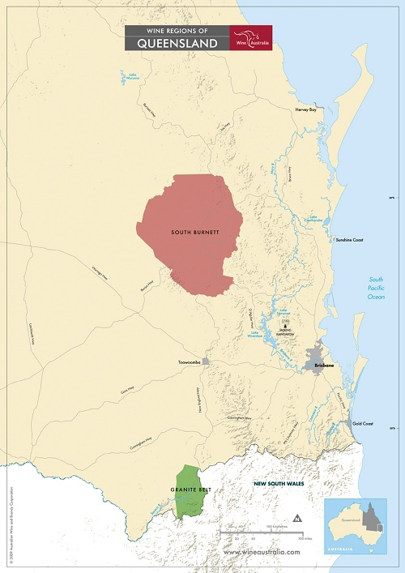
Queensland’s wine regions are primarily located in the southeastern part of the state, with the most significant areas being the Granite Belt and South Burnett. The Granite Belt, approximately 150 miles southwest of Brisbane, is the most prominent wine region, while South Burnett lies further north, around 130 miles from the coast. These regions benefit from elevated altitudes, which counteract Queensland’s otherwise warm, subtropical climate.
Climate and Terroir
Queensland's climate is predominantly warm and humid, but the Granite Belt enjoys a continental climate due to its elevation (2,000–3,000 feet), making it one of Australia’s highest-altitude wine regions. This results in cool nights and a long growing season, preserving acidity in the grapes. The soil is predominantly decomposed granite-based sandy loam, offering excellent drainage and mineral complexity. South Burnett, by contrast, experiences a warmer, subtropical climate with lower elevation, leading to fuller-bodied wines with riper fruit expressions.
Structural Organization
Queensland’s wine regions are part of the Australian Geographic Indications (GI) system, with official designations for:
- Granite Belt GI – The premier Queensland wine region, known for its diverse varietal expressions.
- South Burnett GI – The second-largest region, producing approachable, fruit-forward wines.
Historical Context
Viticulture in Queensland dates back to the 1860s, but the industry struggled due to the hot climate. Modern commercial production only gained traction in the late 20th century, with the Granite Belt emerging in the 1960s as a serious player. Today, Queensland's wine industry remains small but is gaining recognition for its unique high-altitude wines and alternative varietals.
Distinctive Features
Queensland is one of Australia's most climatically diverse wine regions, with high-altitude cool-climate wines from the Granite Belt and warmer, fruit-driven wines from South Burnett. The region is also at the forefront of Australia’s alternative varietal movement, with winemakers experimenting with Mediterranean grapes suited to warm conditions.

2. Key Grape Varieties
Primary Red Varieties
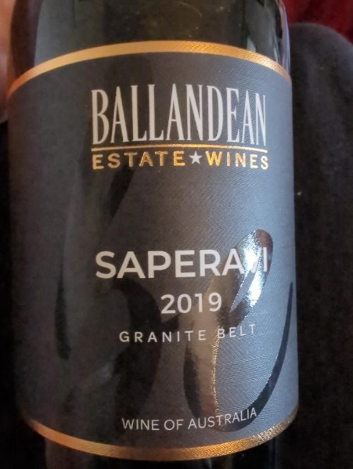
- Shiraz – Producing both cool-climate (Granite Belt) and warmer, more robust (South Burnett) styles.
- Cabernet Sauvignon – Grown in both regions, often blended with Shiraz or Merlot.
- Tempranillo – Thrives in Queensland’s climate, offering medium-bodied, spicy reds.
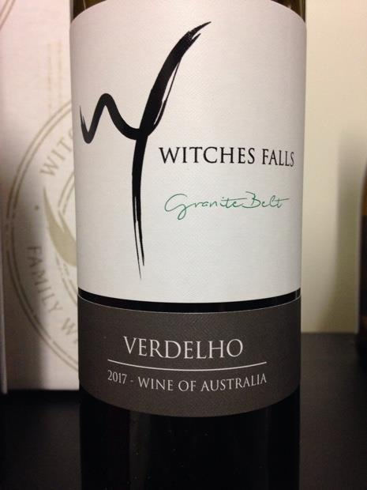
- Saperavi – A Georgian variety well-suited to Queensland’s conditions, producing deep, structured reds.
Primary White Varieties
- Verdelho – A signature Queensland white, known for tropical fruit aromas and fresh acidity.
- Chardonnay – Granite Belt expressions showcase minerality and restrained oak usage.
- Viognier – Produces aromatic wines with floral and stone fruit notes.
- Fiano – An emerging variety that performs well in the warm Queensland climate.
Indigenous/Regional Varieties
Queensland is becoming a leader in alternative varietals, particularly Saperavi, Fiano, Tempranillo, and Vermentino, reflecting a shift toward heat-resistant grape varieties.
Significance
Queensland’s most important varieties are Shiraz, Verdelho, and alternative Mediterranean grapes, which thrive in the warm climate and offer a unique contrast to traditional Australian wine regions.

3. Wine Classification System
Quality Hierarchy
Queensland follows the Australian GI system, with the Granite Belt GI recognized as the state’s highest-quality wine-producing region.
Appellation Structure
- Granite Belt GI – Known for its cool-climate varietals and experimental wines.
- South Burnett GI – A warmer region producing fruit-forward, approachable styles.
Special Classifications
- "Strange Bird" Alternative Wine Trail – A unique initiative in the Granite Belt promoting alternative grape varieties.
Sub-Regional Distinctions
- Granite Belt – High-altitude vineyards with a focus on cool-climate wines.
- South Burnett – Warmer conditions producing fuller-bodied reds and aromatic whites.

4. Notable Wine Styles
Shiraz
- Classification Level: Granite Belt & South Burnett GI
- Composition: 100% Shiraz or blends with Cabernet Sauvignon or Viognier
- Production Method: Traditional fermentation, often with some whole-bunch inclusion
- Aging Requirements: Typically aged in French or American oak for 12–18 months
- Alcohol Content: 13.5–15%
- Organoleptic Profile: Pepper, dark berries, chocolate, and earthy spice
Verdelho
- Classification Level: Granite Belt GI
- Composition: 100% Verdelho
- Production Method: Stainless steel fermentation to preserve freshness
- Aging Requirements: No oak aging; bottled young
- Alcohol Content: 12–13%
- Organoleptic Profile: Pineapple, citrus, tropical fruit, bright acidity
Tempranillo
- Classification Level: Granite Belt GI
- Composition: 100% Tempranillo
- Production Method: Traditional fermentation, often aged in neutral oak
- Aging Requirements: Typically 6–12 months in oak
- Alcohol Content: 13–14%
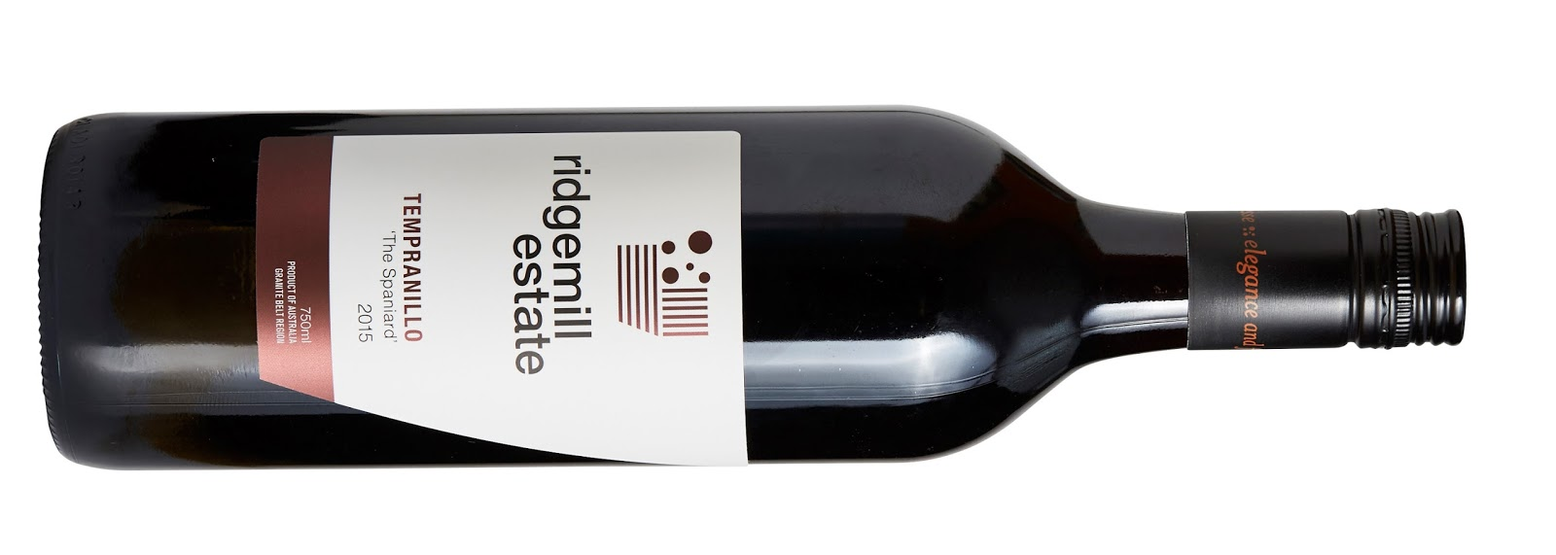
- Organoleptic Profile: Red berries, spice, earthy undertones, smooth tannins

5. Additional Context
Recent Developments
Queensland’s wine industry has focused on sustainability, with many wineries adopting organic and biodynamic practices. The state is also gaining attention for its alternative varietal plantings, particularly in the Granite Belt.
Historical Evolution
From a struggling industry in the 19th century to a dynamic and evolving wine region, Queensland has carved out a niche for cool-climate and alternative wines.
Food Pairing Notes
- Shiraz – BBQ meats, slow-cooked beef, aged cheddar.
- Verdelho – Spicy Asian cuisine, seafood, grilled chicken.
- Tempranillo – Tapas, grilled lamb, roasted vegetables.
Producer Information
- Ballandean Estate – One of Queensland’s oldest and most respected wineries.
- Golden Grove Estate – A leader in alternative varietals.
- Sirromet Wines – Queensland’s largest premium winery, producing a wide range of styles.
- Ravens Croft Wines – Boutique producer known for high-quality small-batch wines.

6. Key Takeaways for Sommeliers
- Queensland’s wine regions are dominated by Granite Belt and South Burnett, with the former excelling in cool-climate varieties.
- The state is a leader in alternative varietals, particularly Saperavi, Tempranillo, and Fiano.
- Verdelho is Queensland’s signature white grape, producing vibrant, tropical wines.
- Queensland’s high-altitude vineyards create wines with bright acidity and balance.
- Sustainability and organic winemaking are becoming central to Queensland’s wine identity.

7. Citations and References
- Wine Australia, 2023. https://www.wineaustralia.com/
- Halliday Wine Companion, 2023. https://www.winecompanion.com.au/
- Granite Belt Wine Tourism, 2023. https://granitebeltwinecountry.com.au/
- Queensland Wine Industry Association, 2023. https://queenslandwine.com.au/
- Australian Wine Research Institute, 2023. https://www.awri.com.au/

