Puerto Plata Walking Tour from Taino Bay Port
Presented by
Marc Silver
Starting Point: Taino Bay Cruise Port
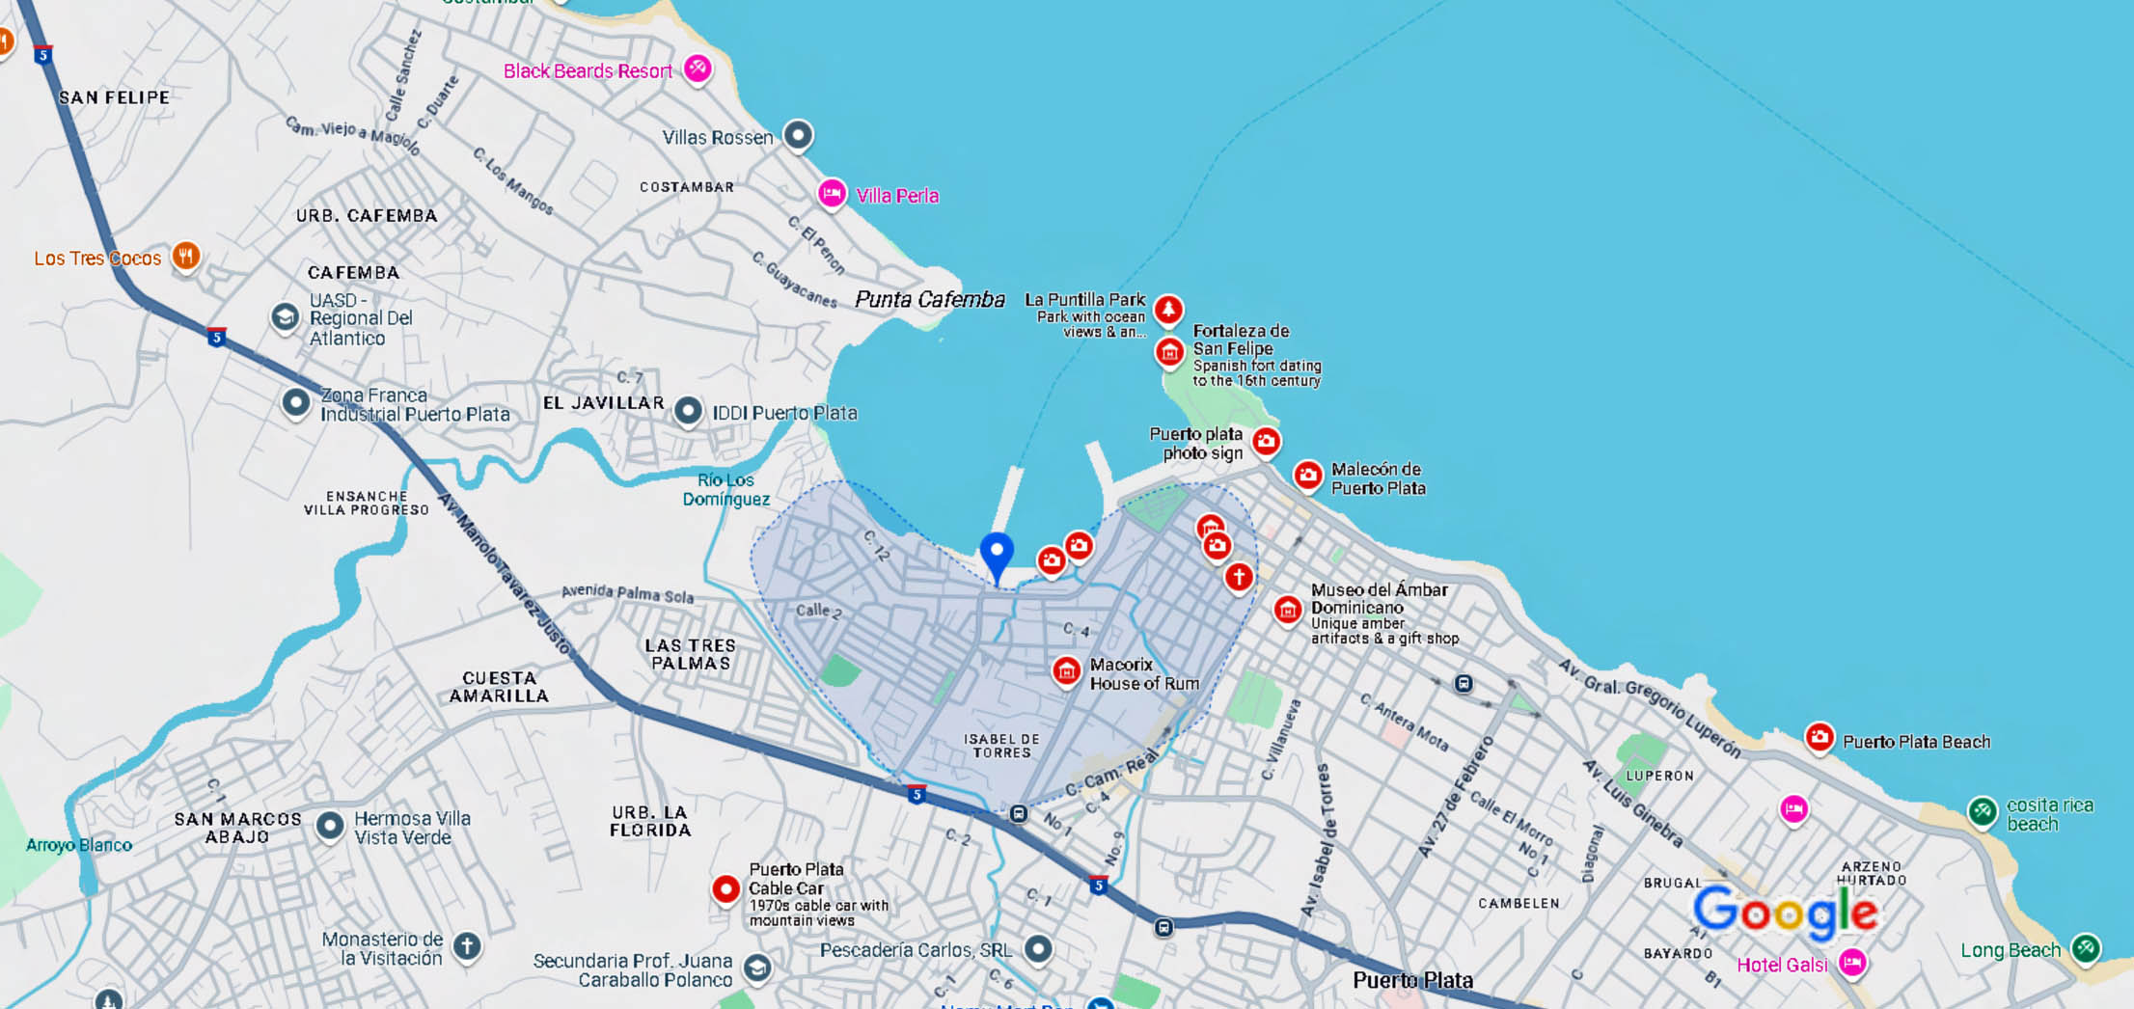
(If docking at Amber Cove, I recommend taking a taxi into town and starting this tour from Central Park.)
- Once you exit the port area, head southeast toward the city center.
- The walk to Central Park takes about 25-30 minutes (1.5 miles).
- Enjoy views of the ocean and local streets along the way.

1. Central Park (Parque Independencia)
💡 Why visit? This charming square is the heart of Puerto Plata, surrounded by Victorian-style buildings and lively local culture.
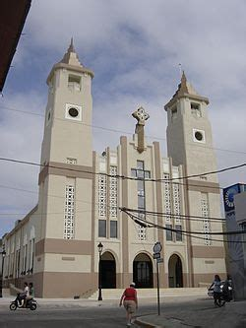
- Highlights:
  - The beautiful San Felipe Cathedral (built in 1956) stands at one side of the square.
  - A Victorian gazebo in the center makes for a great photo.
  - Shaded benches for resting and people-watching.

2. Victorian Houses on Calle José del Carmen Ariza
💡 Why visit? Puerto Plata is famous for its Gingerbread-style houses with colorful facades and intricate woodwork.
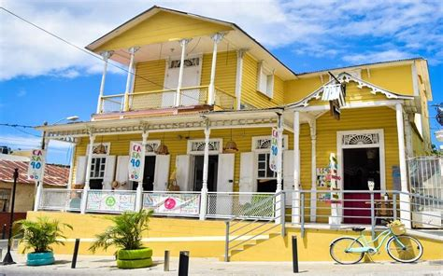
- Walk along Calle José del Carmen Ariza to admire the best-preserved houses.
- These historic homes reflect the 19th-century architectural charm of the city.

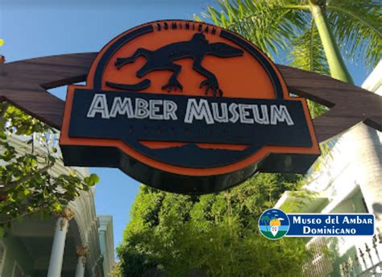
3. Amber Museum (Museo del Ámbar) – Optional Stop
📍 Calle Duarte #61, 5-minute walk from Central Park
💡 Why visit? The Dominican Republic is known for its high-quality amber, and this small museum showcases fossilized resin, including specimens with trapped insects.
- Admission is affordable.
- You can browse unique amber jewelry in the gift shop.
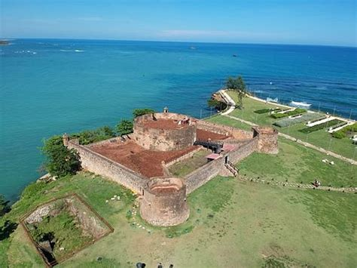
4. Fortaleza San Felipe (San Felipe Fortress)
📍 15-minute walk from Central Park along the Malecón
💡 Why visit? One of the oldest military forts in the Americas, dating back to 1577.
- Great ocean views from the fortress walls.
- A small museum inside offers historical insights into colonial-era conflicts.
- Entry fee: Around $2-3 USD.

5. The Malecón – Puerto Plata’s Waterfront Promenade
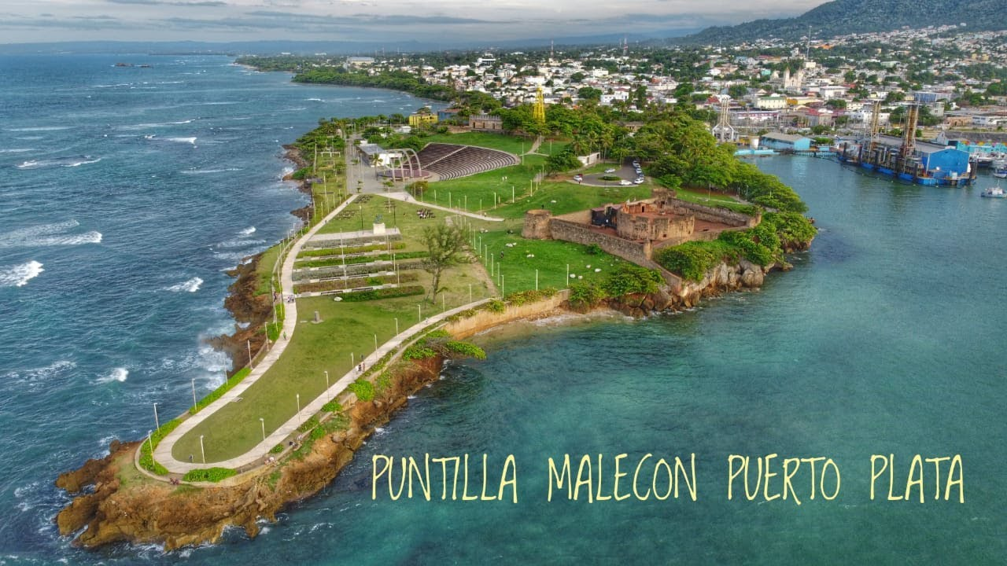 💡 Why visit? This scenic coastal boulevard offers stunning sea views and cool ocean breezes.
- Walking along the Malecón from the fortress gives a feel for local life.
- Spot the Puerto Plata sign for a fun photo op.
- You may see street vendors selling fresh coconuts and local snacks.

6. Local Market & Souvenir Shopping
📍 Near Central Park, short walk from the Malecón
💡 Why visit? Puerto Plata is known for unique local crafts, gemstones (amber and larimar), and Dominican coffee.
- Bargain for souvenirs like handmade jewelry, cigars, and rum.
- Small bills are helpful for negotiations.

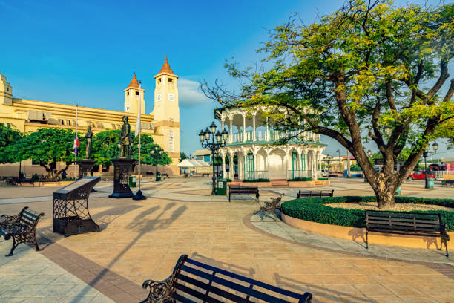
7. End at Independence Square – Relax with a Coffee or Cold Drink
💡 Why visit? This historic square has some nice cafes where you can enjoy a break.
- Try a Dominican coffee at a local café.
- Sample Mamá Juana, a traditional Dominican herbal rum drink.

Return to the Port
- If docking at Taino Bay: Walk back (~30 minutes).
- If you’re tired: Grab a taxi (around $5-7 USD back to the port).
- If docking at Amber Cove: A taxi is your best bet (15-20 minutes).

Total Walking Time & Distance
- From Taino Bay Port: About 2.5 to 3 miles total, spread over 2-3 hours with stops.
- From Amber Cove: A taxi into town is needed before starting the walking tour.

Tips for Your Walk
✔️ Start early to avoid the hottest part of the day.
✔️ Wear comfortable shoes—some streets are cobbled.
✔️ Bring water, sunscreen, and cash (small bills).
✔️ Be mindful of street vendors—friendly but persistent.

