The Art and Science of Polynesian Navigation
Way-Finding Across the Pacific
By Marc Silver
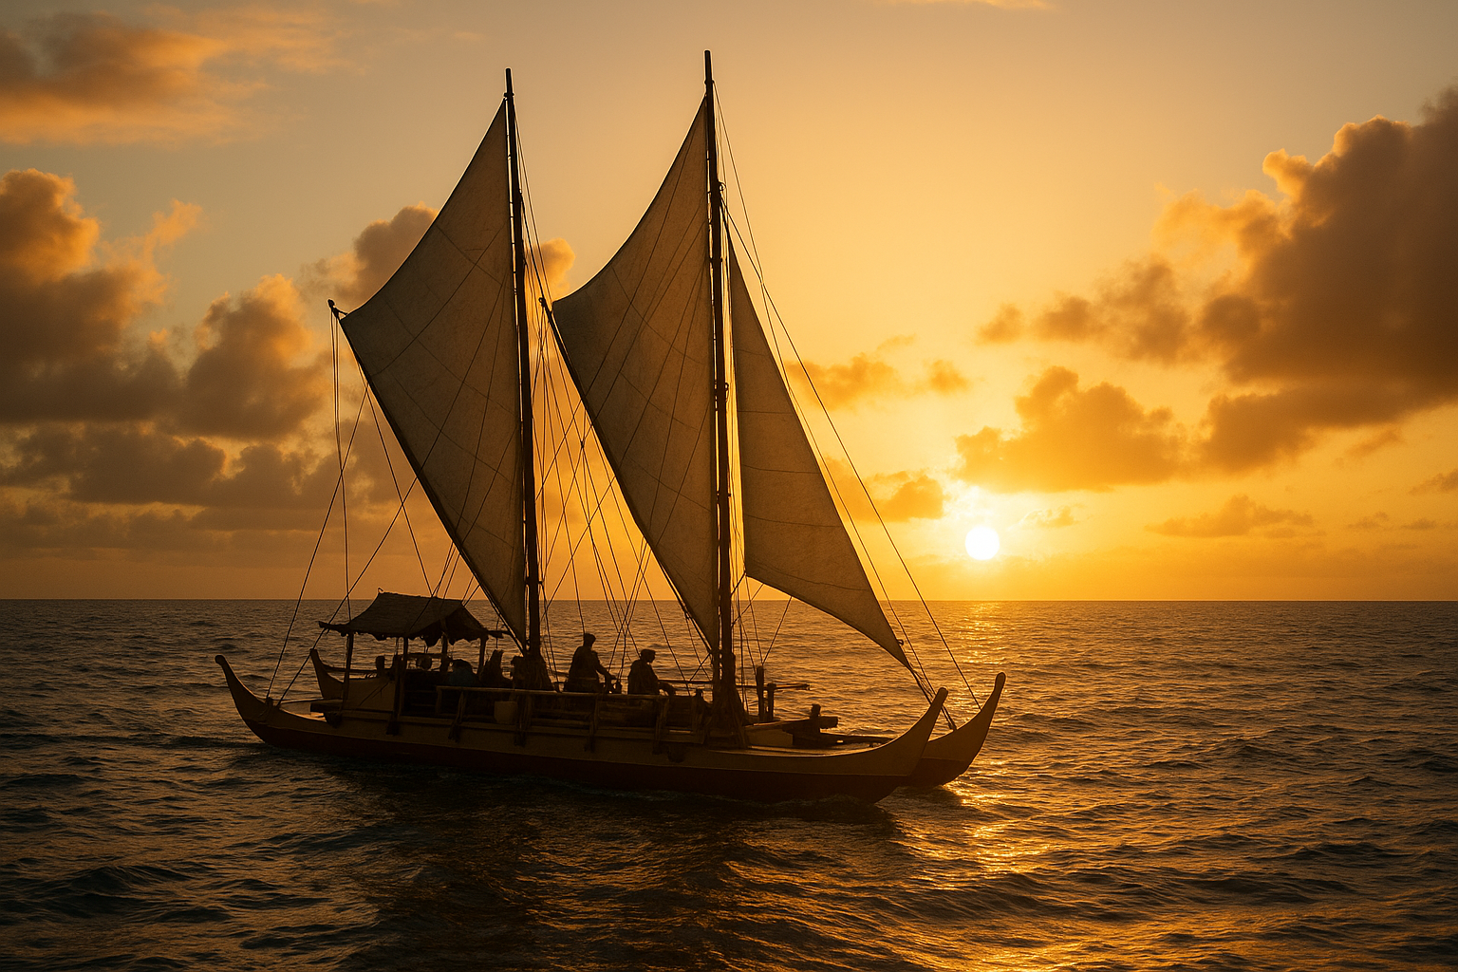Long before Europeans set sail with compasses and sextants, a network of navigators were already exploring and connecting one of the most remote regions on Earth, the Pacific Ocean. These were the Polynesian way-finders, mariners who crossed thousands of miles of open water using nothing more than the stars, the wind, the waves, and their deep understanding of the natural world.
Their voyages would eventually lead to the settlement of Hawai‘i, one of humanity’s greatest achievements of exploration.

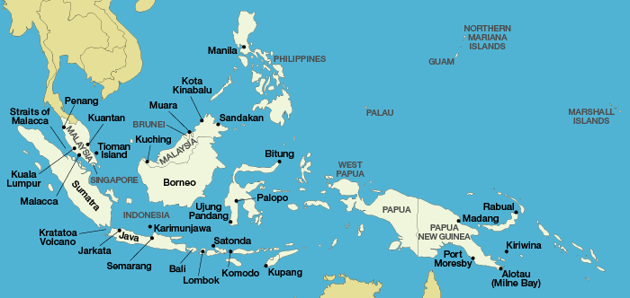
The First Way-finders
The story begins thousands of years ago in the islands of Southeast Asia. Seafaring peoples there had developed large, double-hulled canoes capable of carrying families, animals, food, and plants across great distances. As their populations grew, they began venturing eastward, first into Melanesia and Micronesia, and eventually into the vast open ocean of Polynesia.
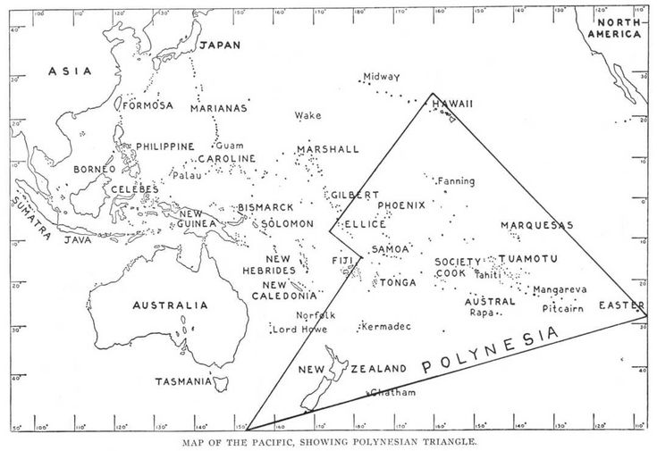
Over centuries, these navigators discovered and colonized an immense area of ocean. Their domain stretched from Aotearoa, or New Zealand, in the south, to Rapa Nui (Easter Island) in the east, and northward to Hawai‘i. This immense region is known today as the Polynesian Triangle, and at its center lies a remarkable legacy of navigation, culture, and science.
These voyagers didn’t stumble upon new islands by accident. Their journeys were deliberate. They observed the world around them, the patterns of waves, the paths of birds, the rising and setting of stars, and learned to read them as others read a map. Their canoes became extensions of their homes, carrying entire communities and their traditions across the open sea.
By the time the first voyagers reached Hawai‘i, around 1,500 years ago, they had already developed one of the most sophisticated navigation systems ever known.

Canoes and Culture
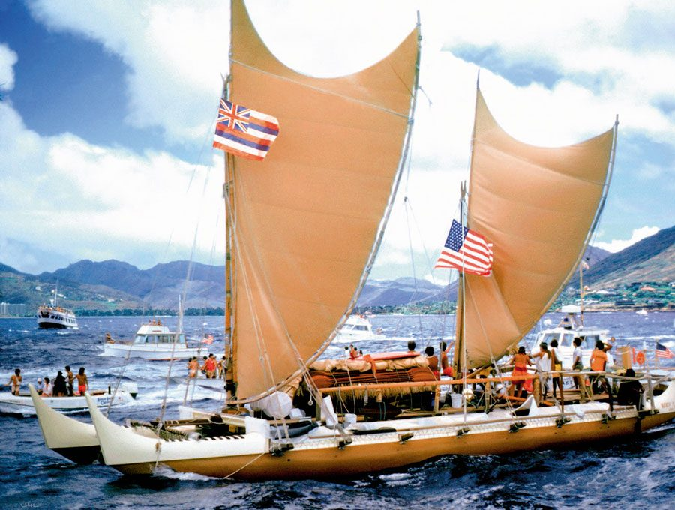
To understand how they traveled, it helps to look at their vessels. The double-hulled canoe was both practical and symbolic. Two long hulls provided stability and speed, while a platform across the center offered living and working space. Each canoe could carry provisions for long voyages, carrying water stored in gourds, taro roots, coconuts, and even small pigs and chickens.
A large voyaging canoe, known in Hawai‘i as a wa‘a kaulua (wah-ah kah-oo-loo-ah), could reach 60 to 100 feet in length. Crews often included both men and women, with roles divided among sailors, navigators, and caretakers of the cargo.
But these weren’t just boats, they were microcosms of society. Songs, chants, and prayers guided every part of the voyage, tying navigation to both science and spirituality. To Polynesian cultures, the ocean wasn’t an obstacle to be conquered, it was a living pathway connecting islands and families across the sea.

Reading the Ocean
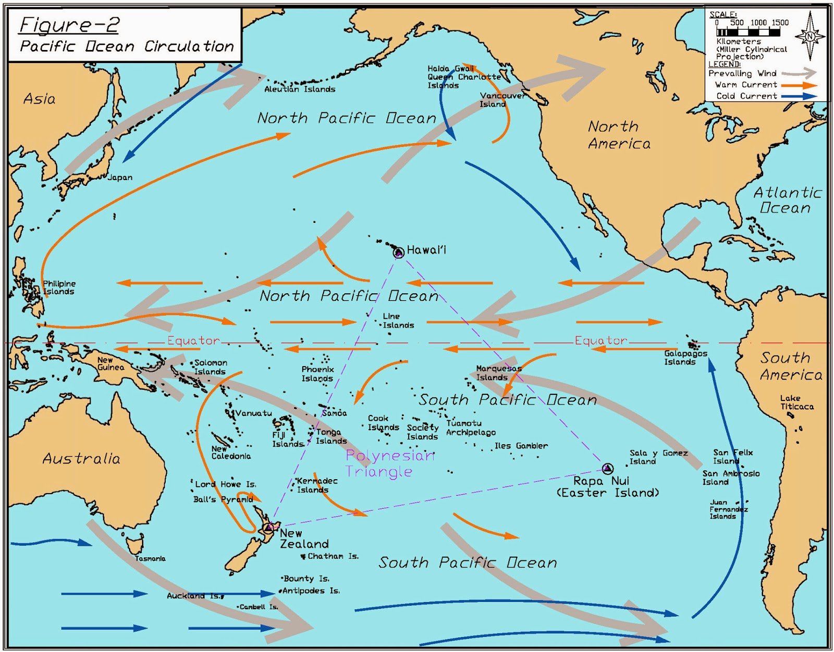
Imagine being surrounded by nothing but horizon. No land in sight. No compass. No map. How would you know where you were, or where you were going?
For the way-finder, the ocean itself was the first instrument. Every swell carried a direction. Long, low ocean swells travel thousands of miles from their point of origin, often formed by storms far away. A skilled navigator could feel these swells through the movement of the canoe.
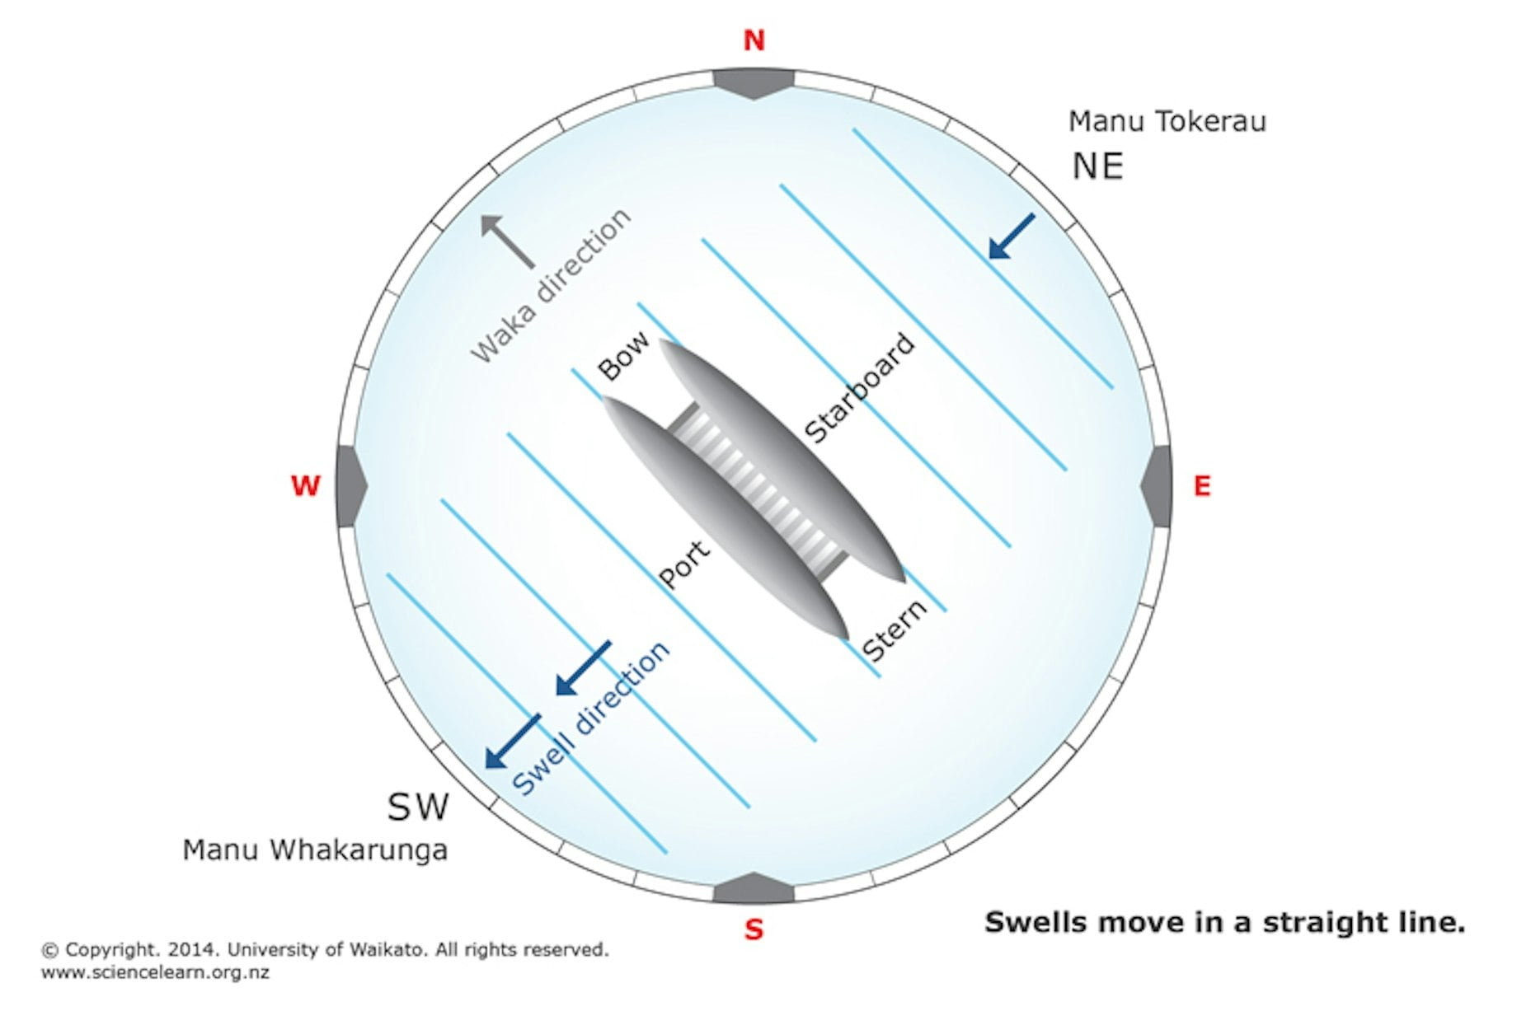 When stars or sun were visible, navigators took note of the swell’s direction relative to the canoe’s heading. When clouds or fog hid the sky, they used the feel of the swell beneath the hulls to maintain course. If that steady rhythm shifted, it meant a change in weather, or the possible approach of land, where swells reflect and refract.
Each pattern was a clue. Some swells came from the northeast trade winds, others from distant southern storms. Layered together, they created an invisible grid across the ocean, which only experience could decode.

The Star Compass
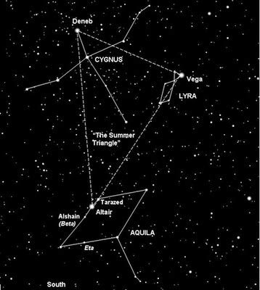
The most beautiful and complex of all Polynesian navigation tools was the star compass. It wasn’t drawn on paper or carved in wood, it existed entirely in the navigator’s mind.
Each rising and setting point of a star was known and memorized. Navigators divided the horizon into 32 “houses” of direction, each marked by key stars or constellations. If you knew where a star rose and where it set, you could orient your canoe to any point on the horizon.
This knowledge wasn’t casual; it took years to master. In Hawai‘i, modern navigators like Nainoa Thompson (nye-NOH-ah) learned this ancient art from Mau Piailug (pee-eye-LOOG), a master navigator from Satawal in Micronesia. Mau had preserved the traditions that had nearly disappeared elsewhere. He taught that every star has a home on the horizon and that when one star climbs too high to steer by, another takes its place.
As the Earth turns, navigators mentally “change houses,” switching from one star to another to maintain their course through the night.
When the stars disappeared at dawn, they turned to the sun, the wind, and the ocean’s motion for orientation.

Clues from Nature
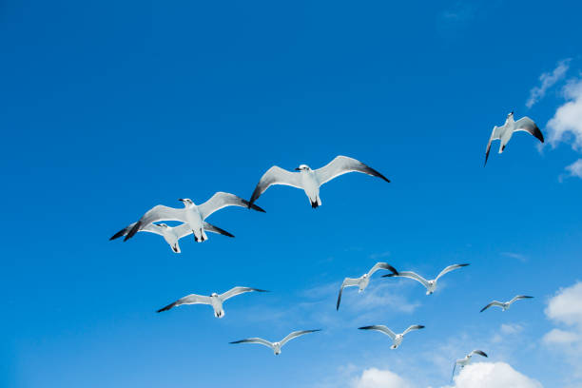 The way-finders didn’t rely on celestial clues alone. Nature itself was full of information, if you knew how to read it.
Birds were among the most reliable signs of land. Certain seabirds, like terns and noddies, leave their islands at sunrise to hunt at sea and return before dark. Their flight paths told navigators both the direction and distance to land.
Clouds also revealed secrets. Islands with high peaks often generated their own clouds. From far away, a skilled observer could distinguish an isolated weather cloud from one formed by a volcanic island. Shallow reefs reflected sunlight upward, creating a pale glow on the underside of the clouds above them, what navigators called “cloud shadows.”
Color and smell played a role too. The hue of the ocean changed near islands, from deep blue to lighter turquoise as the seafloor rose. Winds carried the scent of vegetation long before land appeared.
Even wildlife patterns mattered. The presence of floating debris or schools of certain fish often hinted at proximity to reefs or lagoons.
To the way-finder, these weren’t random observations, they were data points. Every sensory detail formed part of a living, three-dimensional map.

Making Landfall
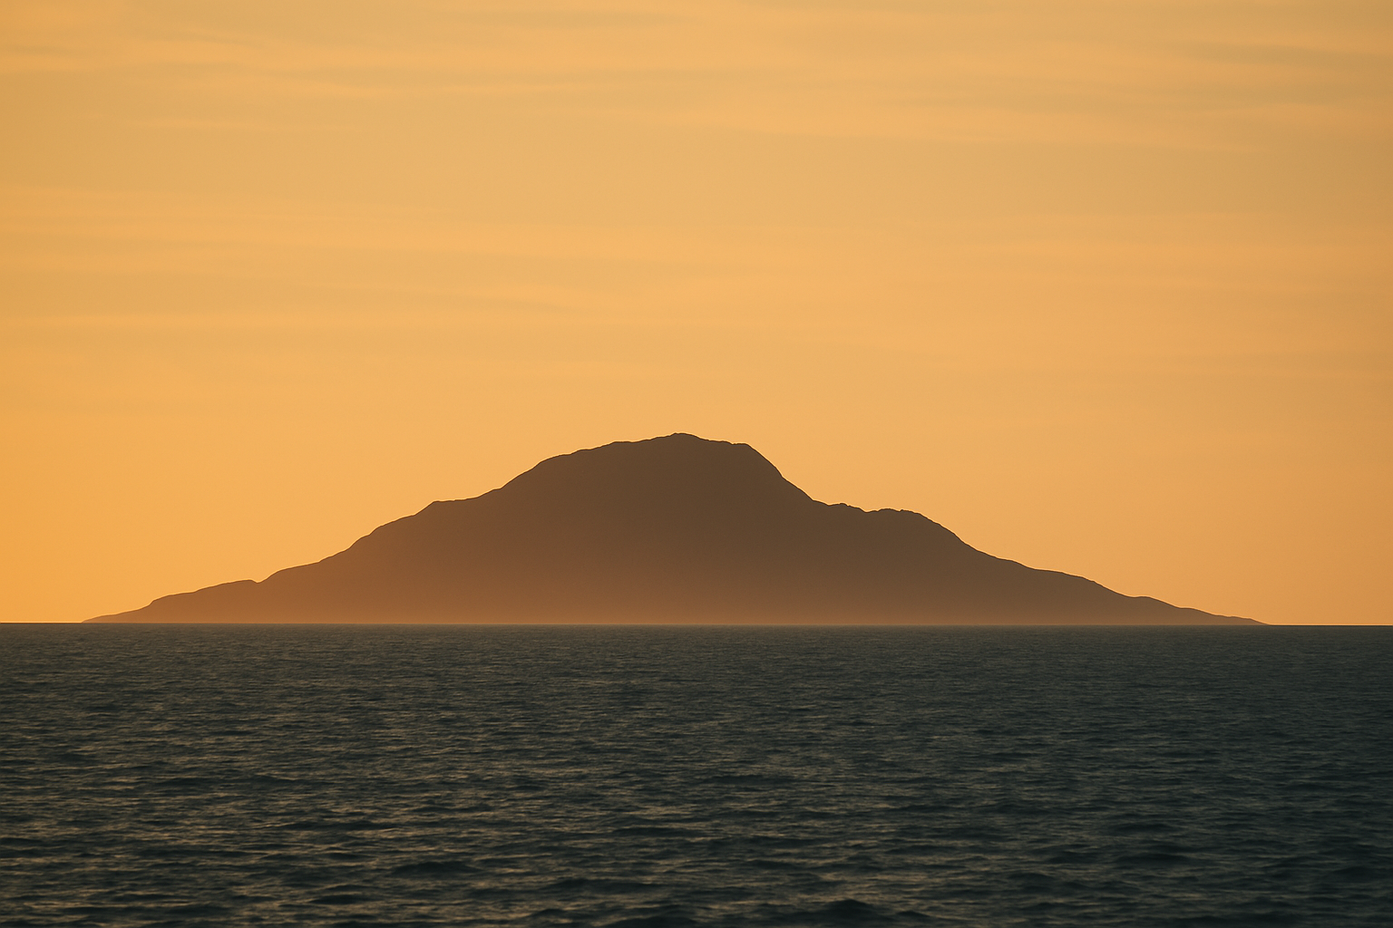 Finding land after weeks at sea was never a matter of luck, it was a practiced, strategic process.
Before departure, the navigator would define a reference course, a mental line toward the target island’s latitude. They aimed not for a pinpoint, but for what they called the “target box.” This was a zone surrounding the island group, wide enough to ensure entry even with small navigation errors.
Once inside that box, the navigator switched from long-range to local cues, watching the waves, the birds, and the sky. Early morning or late afternoon light often revealed the faint outline of land when visibility was best.
Sometimes, the first evidence wasn’t visual at all. It might be the change in swell rhythm as waves bounced off unseen shores, or the faint earthy scent of vegetation carried on the wind.
When land finally appeared, it wasn’t just a geographical discovery, it was a spiritual arrival. In Hawaiian tradition, landfall was greeted with chants and offerings, honoring both the sea that carried them and the gods who watched over them.

The Hawaiian Arrival
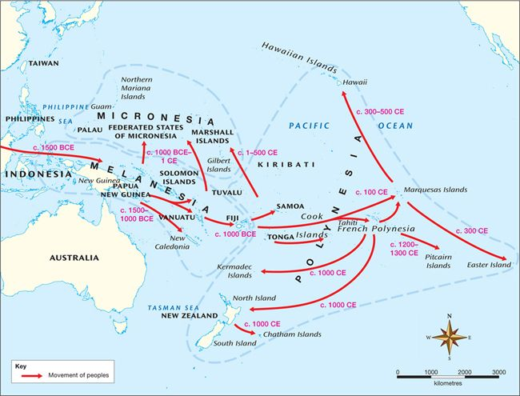 The ancestors of modern Hawaiians are believed to have arrived from the Marquesas Islands around the 4th or 5th century, with later migrations from Tahiti. These voyages covered more than 2,000 miles of open ocean.
They brought with them plants and animals essential for survival, breadfruit, taro, bananas, dogs, pigs, and chickens. They also carried a system of knowledge that shaped Hawaiian culture for centuries: the understanding that land, sea, and sky were interconnected.
Once settled, the navigational arts continued to be taught, but over time, as voyaging between distant islands became less common, much of that knowledge faded. By the 1800s, Western instruments had replaced traditional methods, and many feared the ancient art of wayfinding was lost forever.

The Silence and the Revival
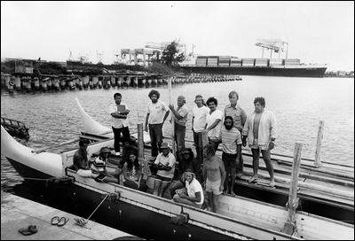
In the 20th century, a quiet revival began. In the 1970s, a group of Hawaiians formed the Polynesian Voyaging Society, determined to prove that their ancestors’ voyages were intentional, not accidental.
They built a traditional double-hulled canoe named Hōkūle‘a (HOH-koo-LAY-ah), “Star of Gladness.” In 1976, she set sail from Hawai‘i to Tahiti, navigated entirely without modern instruments. Guiding the voyage was Mau Piailug, one of the few remaining masters of non-instrument navigation.
Against all skepticism, Hōkūle‘a made landfall in Tahiti after 34 days at sea. Thousands greeted her arrival, and that moment became a cultural turning point. It confirmed not only the accuracy of ancient navigation but also the enduring spirit of Polynesian exploration.
Since then, Hōkūle‘a has voyaged around the world, carrying messages of cultural renewal and environmental respect. New generations of navigators, many trained by Nainoa Thompson, continue to sail by the stars, reconnecting modern Hawai‘i with its voyaging past.

Legacy of the Navigators
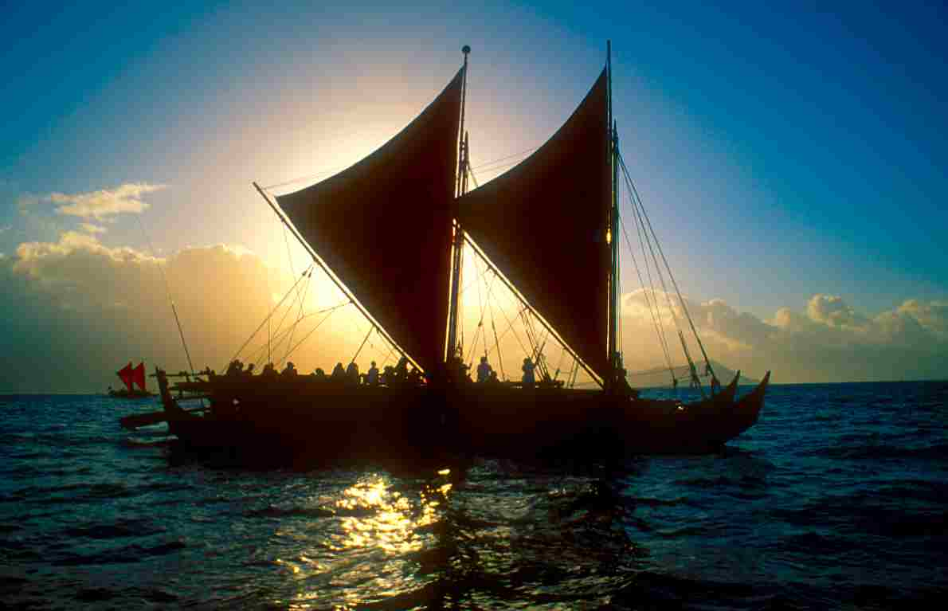
What makes Polynesian wayfinding so remarkable isn’t just its technical brilliance, it’s the worldview it represents.
Western navigation relies on fixed coordinates. Wayfinding relies on relationship. The navigator doesn’t see themselves as moving across a static ocean; instead, the canoe is stationary, and the world moves around it, the stars rising, the swells shifting, the winds changing.
It’s a living dialogue with nature, one that demands constant awareness and respect.
Today, many schools and museums in Hawai‘i and across the Pacific teach these principles, not just as history but as a way to reconnect people with the natural rhythms of their environment. The lessons of the way-finders extend beyond sailing, they speak to how we find our way in the world.

Closing Reflection
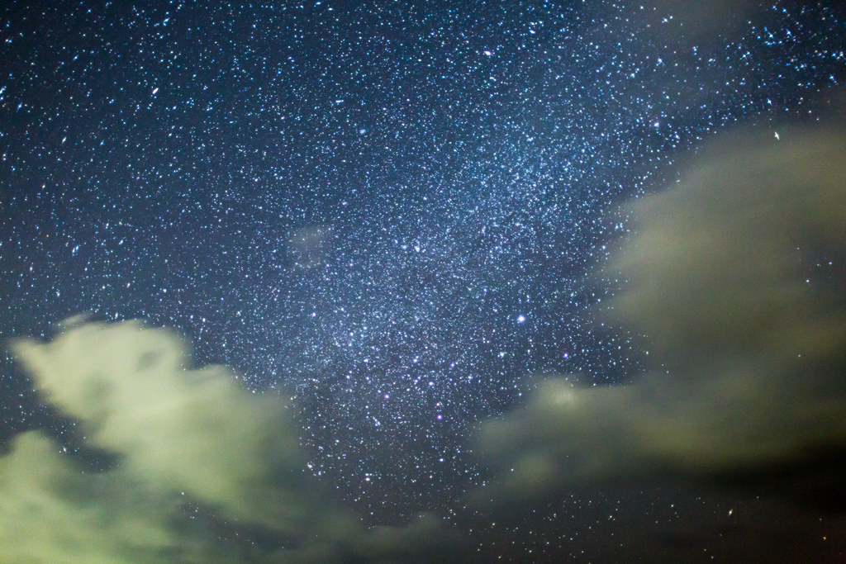 When you stand on deck tonight and look out across the Pacific, take a moment to imagine those first voyagers, guided only by the stars and the sea. They saw the same constellations, felt the same swells, and followed the same winds that touch us today.
They crossed one of the largest oceans on Earth with nothing more than knowledge, courage, and faith in their understanding of nature.
And as you look up tonight, remember,
you’re seeing the same stars that guided the first voyagers to these islands.
References
Finney, Ben R. 1994. Voyage of Rediscovery: A Cultural Odyssey through Polynesia. Berkeley: University of California Press.
Lewis, David. 1994. We, the Navigators: The Ancient Art of Landfinding in the Pacific. 2nd ed. Honolulu: University of Hawai‘i Press.
Polynesian Voyaging Society. 2016. “Hōkūle‘a and the Art of Wayfinding.” Accessed October 2025. https://www.hokulea.com
PBS. 2000. Way-finders: A Pacific Odyssey. Accessed October 2025. https://www.pbs.org/way-finders
University of Hawai‘i at Mānoa. 2024. “Wayfinding and Navigation.” Exploring Our Fluid Earth. Accessed October 2025. https://manoa.hawaii.edu/exploringourfluidearth
BBC Travel. 2019. “The Polynesian Navigators Who Discovered the Pacific.” Accessed October 2025.
National Geographic Society. 2016. “Reviving the Ancient Art of Polynesian Navigation.” National Geographic Online.
Smithsonian Magazine. 2019. “How the Polynesians Discovered Hawai‘i.” Washington, DC: Smithsonian Institution.
University of Auckland. 2020. “Polynesian Navigation and the Discovery of New Zealand.” School of Environment.

