A Walking Tour of Philipsburg, St. Martin
An easy and scenic stroll through the heart of Dutch St. Martin
Philipsburg, the capital of Dutch St. Martin, is a lively waterfront town known for its duty-free shopping, golden beaches, and colonial charm. The entire downtown area is compact and pedestrian-friendly, making it perfect for a self-guided walking tour. With stunning ocean views, historic landmarks, and vibrant streets, this route allows you to experience the best of Philipsburg in just a few hours.
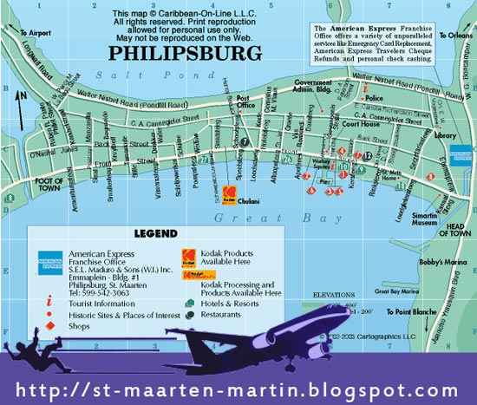
🚢 Stop 1: Cruise Ship Port (Starting Point)
- As you disembark, you’re greeted by stunning views of Great Bay and the pastel-colored buildings of Philipsburg.
- The port area has a few shops and tour kiosks, but the real adventure begins just beyond.
- You can walk into town in about 10–15 minutes or take a quick water taxi ($7 round-trip) for a scenic ride across Great Bay. Taxis cost about $4/ person each way.
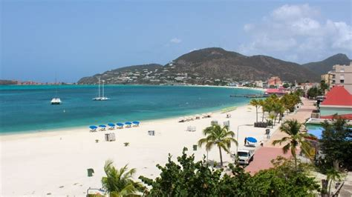
🏖 Stop 2: Great Bay Beach (5–10-minute walk from the port)
- One of the most accessible and picturesque beaches in the Caribbean, sitting right at the edge of town.
- Enjoy soft white sand, crystal-clear waters, and a relaxed vibe, with plenty of lounge chairs for rent.
- Beach bars like The Greenhouse or Honky Tonk Bar serve cold drinks and fresh seafood.
- For adventure seekers, jet ski rentals and banana boat rides are available.
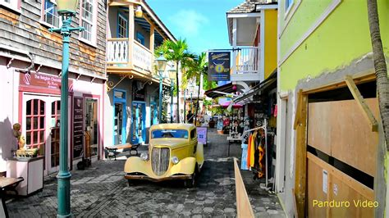
🛍 Stop 3: Front Street (1-minute walk from Great Bay Beach)
- The main shopping artery of Philipsburg, stretching parallel to the boardwalk.
- This duty-free zone is packed with high-end jewelry stores, electronics, and local souvenir shops.
- Look out for Guavaberry Emporium, where you can sample and buy the island’s signature guavaberry rum.
- The colorful mix of Dutch colonial and Caribbean architecture adds to the charm.
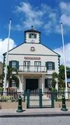
🏛 Stop 4: Philipsburg Courthouse (2-3 minute walk down Front Street)
- One of the most recognizable landmarks in St. Martin, located in the heart of town.
- Originally built in 1793 as a home for the town’s first commander, it later served as a post office and fire station.
- The iconic white-and-green wooden structure is still used as a courthouse today.
- A great photo stop, especially when adorned with Dutch and St. Martin flags.
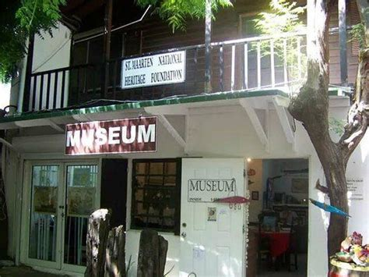
🏺 Stop 5: Sint Maarten Museum (3-minute walk from the Courthouse)
- A small but fascinating museum showcasing the island’s history and cultural heritage.
- Exhibits include pre-Columbian Arawak artifacts, colonial relics, and stories of the island’s salt trade.
- A hidden gem, perfect for those interested in the deeper history of the island.
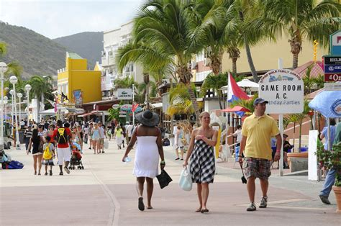
- Located in a traditional Caribbean-style building on Front Street.
🌅 Stop 6: (2-minute walk from the Museum)
- A lively oceanfront promenade offering beautiful views of Great Bay.
- Lined with restaurants, bars, and street vendors, making it a great place to grab a local snack.
- Try Johnny Cakes or Conch Fritters at Lazy Lizard or Big Wood Grill.
- Perfect for a relaxed stroll before heading back to the cruise port.
Practical Tips for Your Philipsburg Walking Tour
✔ Total walking distance: Approx. 1.5 km (1 mile)
✔ Estimated time: 30–45 minutes (longer if you shop, eat, or swim)
✔ Best time to go: Morning or early afternoon to beat the heat
✔ Footwear: Comfortable sandals or sneakers (streets are mostly flat)
✔ Currency: U.S. dollars are widely accepted; credit cards work in most places
✔ Bonus Tip: If you have extra time, take a quick taxi to Maho Beach to see planes land dramatically over the sand!
This short yet rewarding walk offers a perfect mix of history, culture, shopping, and beach time, all within easy reach of the cruise port. Whether you're looking to grab a duty-free bargain, relax by the sea, or snap some memorable photos, Philipsburg has it all—without ever needing a taxi! 🚶‍♂️🌴

Reasearch:

Near the Philipsburg port in St. Martin, here are key attractions:
- Front Street: Main shopping district with duty-free stores, local boutiques, and restaurants
- Great Bay Beach: Walkable public beach right near the cruise port with water sports and beach bars
- Philipsburg Courthouse: Historic Dutch colonial building in the town center
- Sint Maarten Museum: Small local museum showcasing island history and culture
- Boardwalk: Scenic oceanfront promenade with restaurants and souvenir shops
Pro tip: The entire downtown area is quite compact and walkable, so you can easily explore these attractions on foot from the cruise port.
Here's a concise description for each stop on the Philipsburg walking tour:
- Cruise Ship Port (Starting Point)
- Located at Great Bay
- Primary entry point for cruise passengers
- Offers immediate views of the harbor and town
- Great Bay Beach
- Public beach adjacent to the port
- Free public access
- Offers water sports rentals and beach bars
- Soft white sand and clear turquoise waters
- Front Street
- Main commercial thoroughfare
- Duty-free shopping district
- Numerous local boutiques and souvenir shops
- Vibrant pedestrian street with Dutch Caribbean architecture
- Philipsburg Courthouse
- Historic Dutch colonial building
- Built in traditional Caribbean architectural style
- Represents local governmental heritage
- Photogenic landmark in town center
- Sint Maarten Museum
- Small local history museum
- Exhibits showcasing island's cultural heritage
- Displays artifacts from indigenous and colonial periods
- Located in a historic building
- Boardwalk
- Scenic oceanfront promenade
- Restaurants and souvenir shops
- Panoramic views of Great Bay
- Ideal for leisurely evening strolls
Total walking distance: Approximately 1.5 km Estimated walking time: 30-45 minutes

