Nha Trang Vietnam Walking Tour
Slide 1 – Welcome to Nha Trang
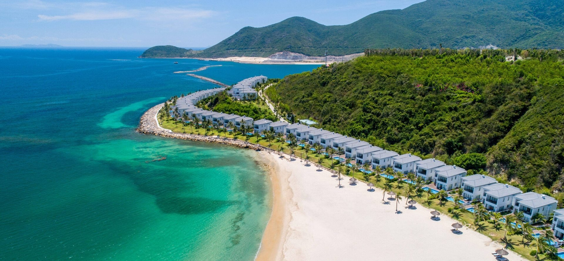
Welcome to Nha Trang, Vietnam’s sun-splashed coastal jewel on the South China Sea.
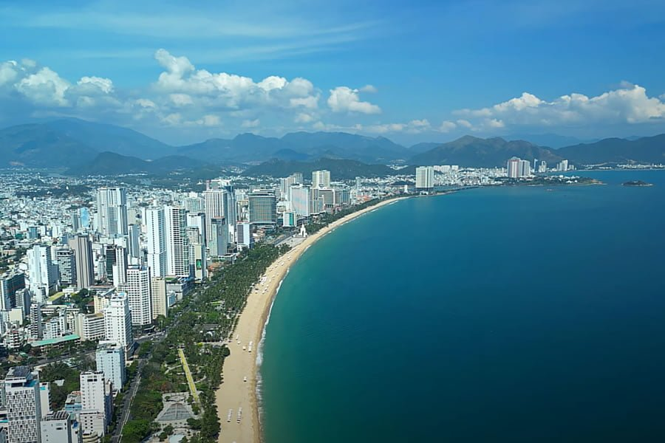
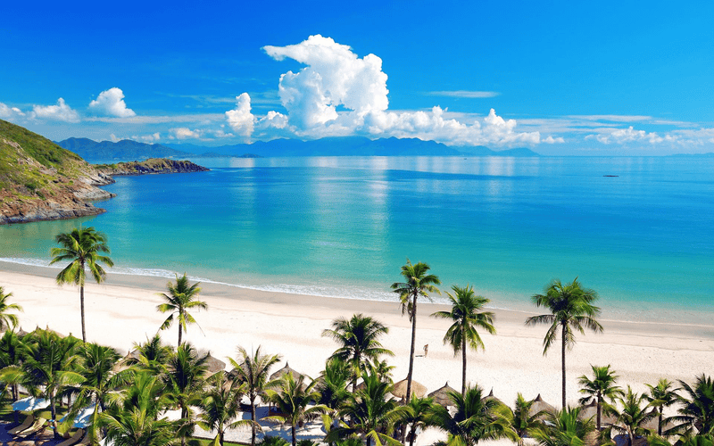
This city blends golden beaches, Cham-era history, and the warmest hospitality you’ll find in the country.
Today’s walking route explores Nha Trang’s waterfront, local markets, and cultural landmarks, all easily reachable from the port.
Pacing note: 1–2 minutes overview before transition.

Slide 2 – Starting Point: Cruise Dock & Beachfront
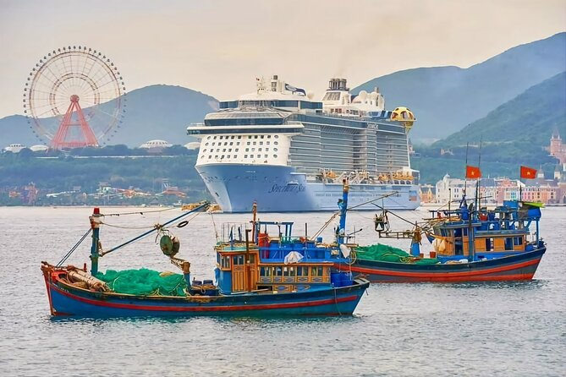
Your ship docks near Cầu Đá Port, a short ride from Nha Trang’s beachfront promenade.
Begin your walk at the Trần Phú Boulevard, lined with palms and cafés facing the sea.
The Trầm Hương Tower, shaped like an incense blossom, is your visual landmark — it marks the heart of Nha Trang’s seafront.
Pacing note: 2 minutes, include ship-to-town shuttle explanation.

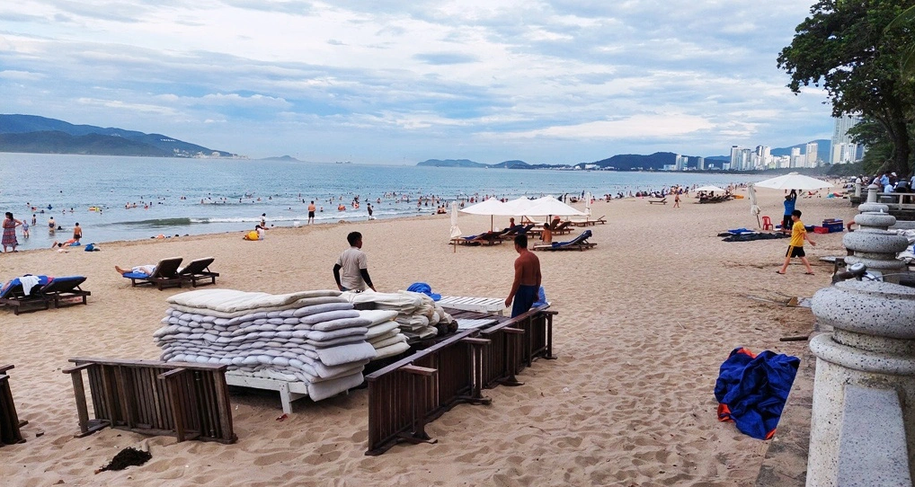
Slide 3 – Stop 1: Nha Trang Beach Promenade
Image cue: Palm-lined walkway and the turquoise shoreline.
This promenade stretches for nearly 4 miles, ideal for strolling or people-watching.
Early mornings you’ll see locals exercising and fishermen bringing in their catch; by mid-day, it’s beach umbrellas and coconut vendors.
Pause here for a cà phê sữa đá, the local iced coffee with condensed milk, or a fresh coconut right from the shell.
Pacing note: 2 minutes, casual tone — “feel the rhythm of the coast.”

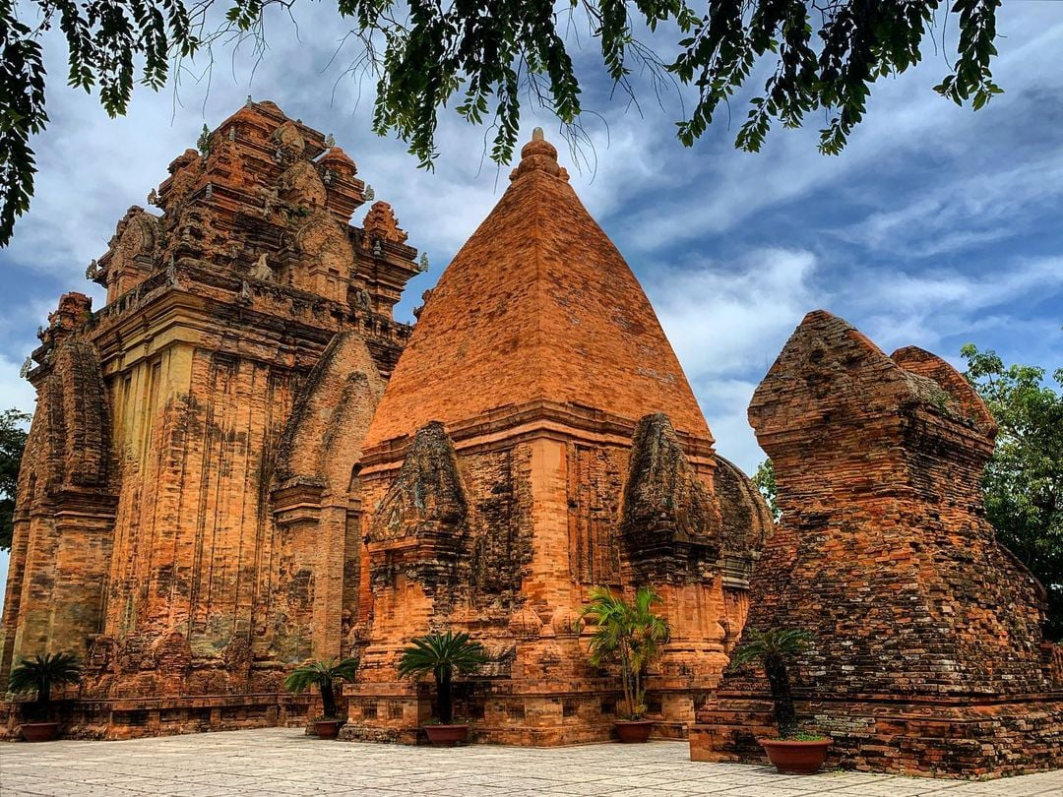
Slide 4 – Stop 2: Po Nagar Cham Towers
Image cue: Brick towers rising over the river delta with city backdrop.
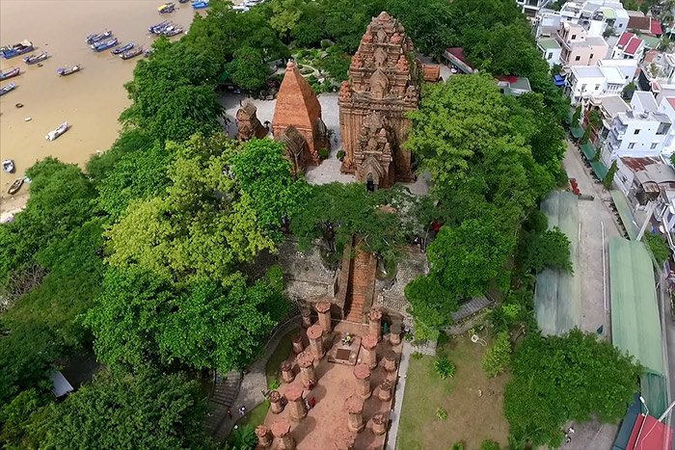
Next, a short taxi or shuttle ride brings you to the Po Nagar Cham Towers, dating from the 8th century.
Built by the ancient Cham civilization, these Hindu-inspired towers once honored the goddess Yan Po Nagar.
The site sits on a hill overlooking the river — perfect for photos and a sense of Vietnam’s layered history.
Pacing note: 3 minutes with historical context; mention modest dress.

Slide 5 – Stop 3: Long Sơn Pagoda and the White Buddha
Image cue: Giant seated Buddha gleaming above tiled temple roofs. 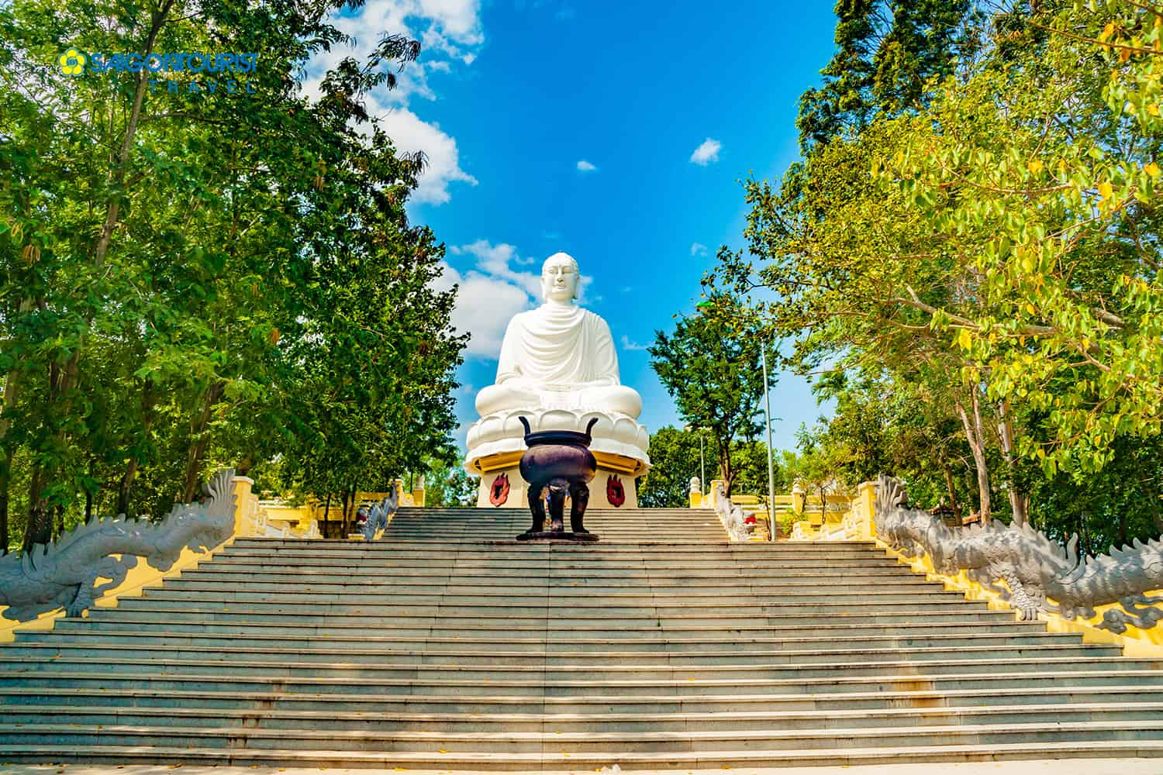
A short ride inland leads to Long Sơn Pagoda, the city’s main Buddhist temple.
Climb the 150 steps to reach the White Buddha — serene and visible across town.
From the top, you’ll have a panoramic view of Nha Trang and the mountains beyond.
Pacing note: 3 minutes; invite guests to imagine the climb and breeze.

Slide 6 – Stop 4: Dam Market
Return downtown to Chợ Đầm, or Dam Market — a lively indoor bazaar selling seafood, spices, coffee, and handicrafts.
Browse the souvenir section or sample bánh xèo (crispy rice pancakes) from the snack stalls.
The chatter, aromas, and colors here make it a photographer’s dream.
Pacing note: 2–3 minutes, keep sensory language vivid.

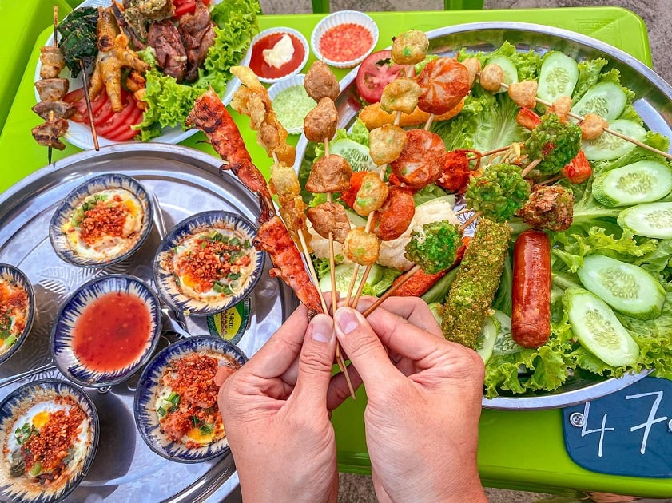
Slide 7 – Stop 5: Street Food & Café Culture
Image cue: Locals sitting on small stools enjoying bowls of noodles.
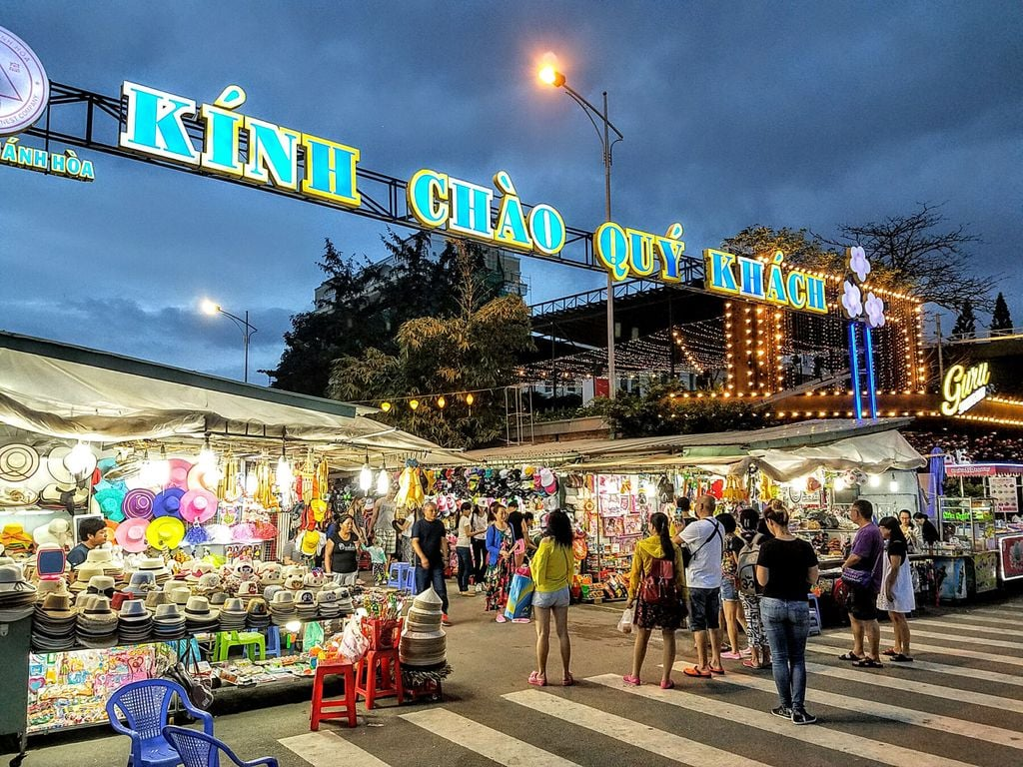
Vietnam’s food is half the fun of walking.
Try a steaming bowl of phở bò, grilled skewers of bún thịt nướng, or tropical fruit smoothies from street stands.
Nha Trang is famous for its seafood — look for grilled shrimp or clams cooked over charcoal right on the sidewalk.
Pacing note: 2 minutes; transition to evening market.

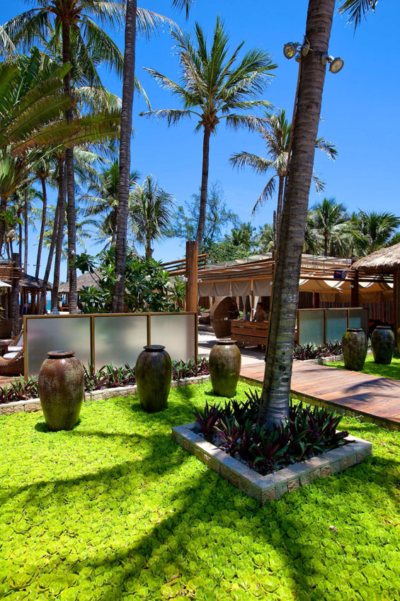
Slide 8 – Stop 6: Evening Market & Promenade Lights
Image cue: Night market stalls glowing under lanterns.
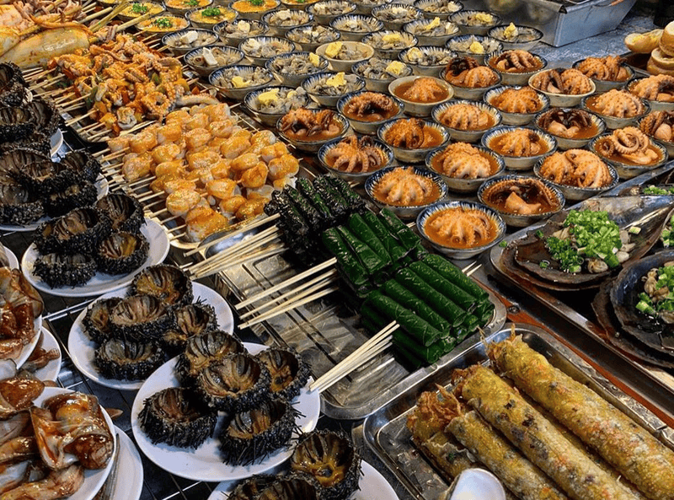
As the sun sets, the beachfront transforms into the Nha Trang Night Market — a mix of street food, crafts, and ocean breezes.
Try a scoop of coconut ice cream or browse silk lanterns while music drifts from nearby cafés.
It’s an easy, pleasant walk back along the promenade toward your shuttle point.
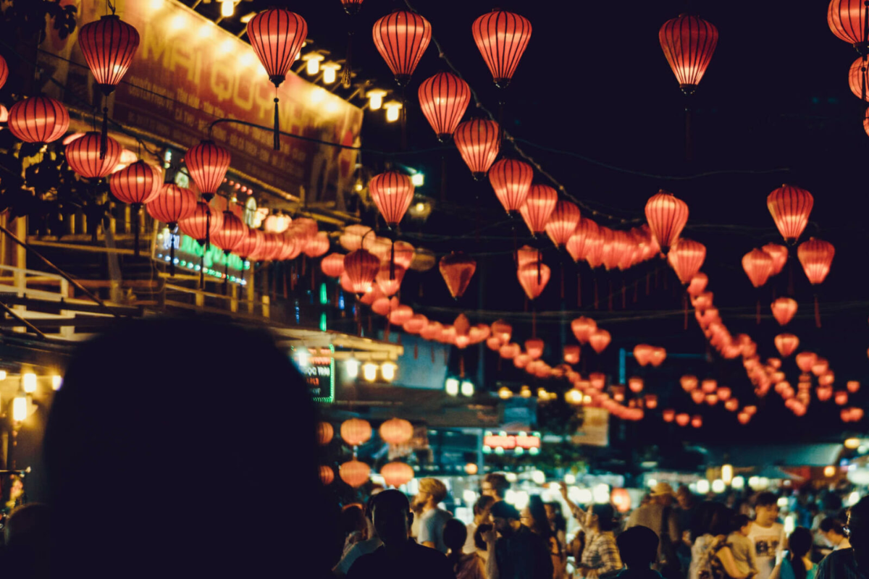
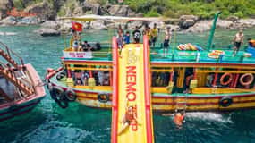
Pacing note: 2–3 minutes; encourage guests to stay aware of time for last shuttle.

Slide 9 – Optional Add-Ons
Image cue: Hon Chông rocks and small islands offshore.
If time allows:
- Visit Hon Chông Promontory for dramatic seaside rock formations and temple views.
- Or take a short boat trip to Mun Island, known for clear waters and coral reefs.
Each option is close enough for a half-day excursion before returning to port.
Pacing note: 2 minutes.

Slide 10 – Return Toward Port
Image cue: Sunset over Nha Trang Bay with boats silhouetted.
As we return to the ship, the late afternoon light glows across the bay.
Fishing boats drift out toward the horizon, and the city lights begin to sparkle behind us.
It’s the perfect time to reflect on what makes Nha Trang so appealing — a blend of ocean calm, local culture, and endless hospitality.
Pacing note: 1 minute wrap-up.

Slide 11 – Closing Slide
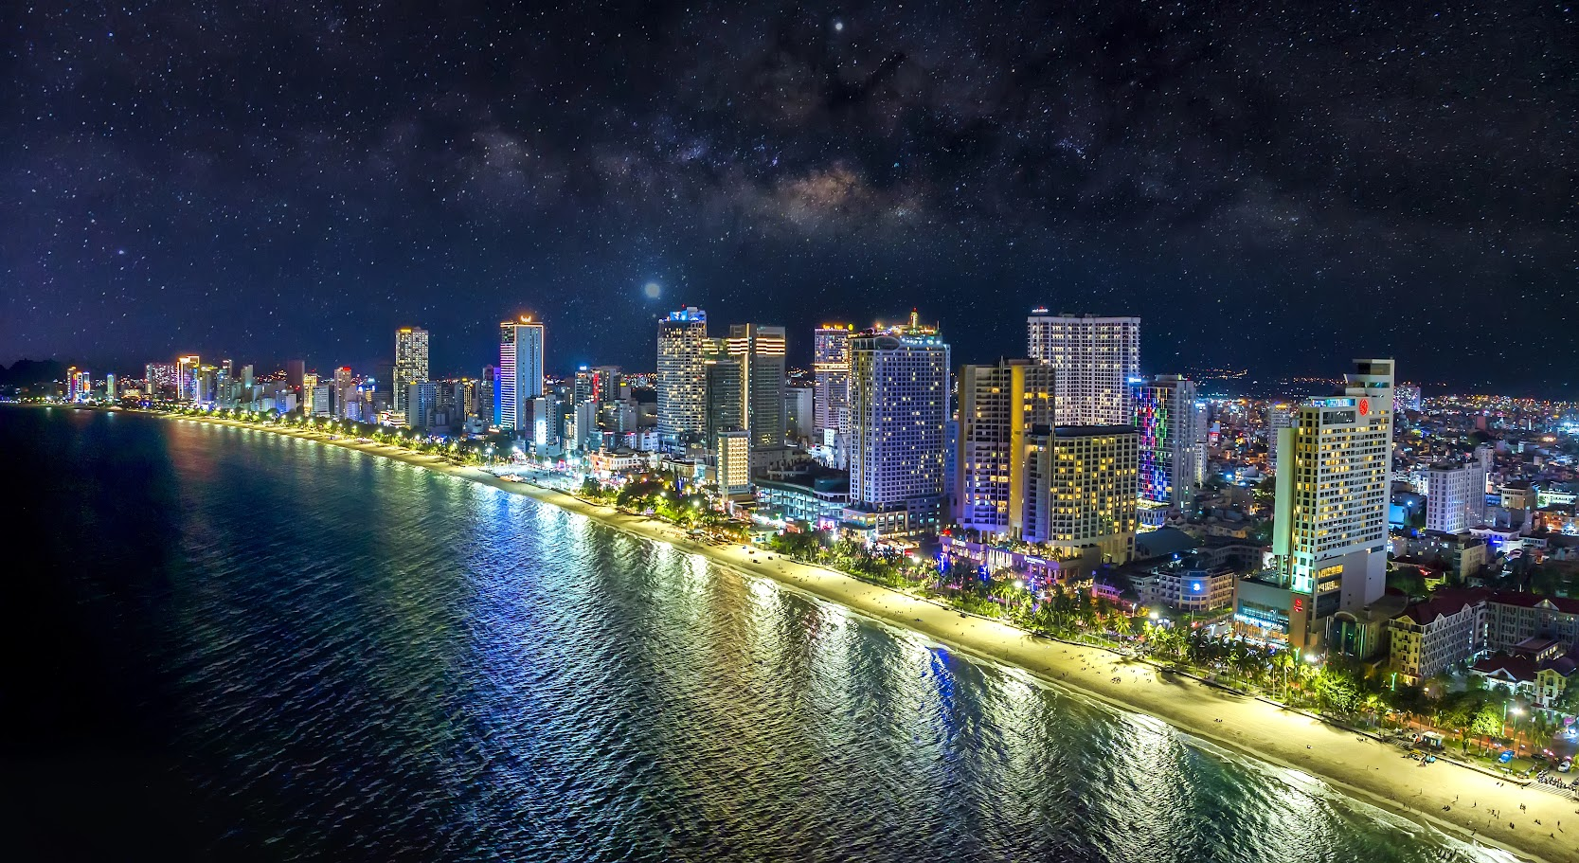
Walking Nha Trang offers more than sights — it connects you with the daily rhythm of coastal Vietnam.
Whether it was the temple bells, the aroma of street food, or the laughter from the market, this city leaves a warm, lasting impression.
When your ship sails tonight, take one last look at that curving bay — it’s one you’ll remember long after you leave.
Pacing note: 1 minute closing reflection.

Presenter Notes (for cruise delivery)
- Total length: 25–30 minutes narrated, plus optional Q&A.
- Best flow: Use Slides 1–8 for short port talks; include 9 & 10 for extended sessions.
- Visual rhythm: Alternate between wide landscape shots and close-up street scenes for audience engagement.
- Sound cue idea: Gentle background of sea breeze and street sounds at open and close.

