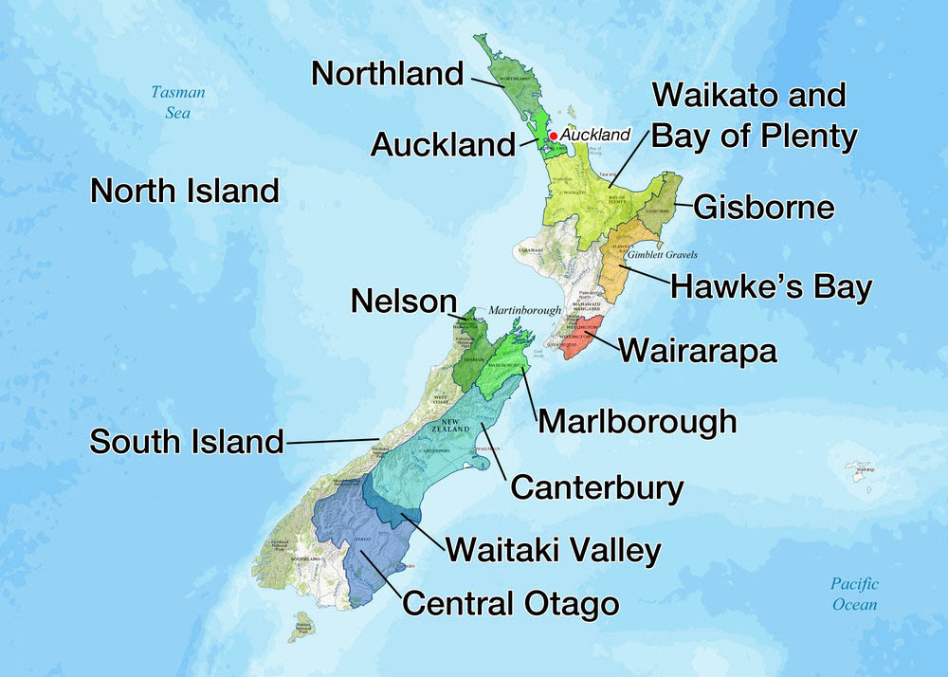
New Zealand Wine Regions: A Sommelier's Guide
1. Region Overview
Geographic Location
New Zealand’s wine regions span both the North Island and South Island, stretching from subtropical Northland to the cool, maritime-influenced Central Otago. Key wine regions include Marlborough, Hawke’s Bay, Central Otago, Wairarapa, and Nelson. The country benefits from its isolated island geography, ensuring clean air, low pollution, and pristine growing conditions.
Climate and Terroir
New Zealand has a predominantly maritime climate, with strong oceanic influences from the Tasman Sea and Pacific Ocean. Cooler temperatures and long sunshine hours create wines with high acidity and vibrant fruit expression.
- North Island: Warmer regions like Hawke’s Bay and Gisborne have more sunshine, producing fuller-bodied wines.
- South Island: Cooler regions like Marlborough, Nelson, and Central Otago create crisp whites and elegant reds.
Soils vary widely:
- Marlborough: Free-draining alluvial soils, ideal for Sauvignon Blanc.
- Hawke’s Bay: Gravelly river terraces, perfect for Bordeaux-style reds.
- Central Otago: Schist-based soils, providing structure and minerality to Pinot Noir.
Structural Organization
New Zealand follows a Geographic Indication (GI) system, with 12 official wine regions:
- North Island GIs: Northland, Auckland, Waikato/Bay of Plenty, Gisborne, Hawke’s Bay, Wairarapa.
- South Island GIs: Marlborough, Nelson, Canterbury, North Canterbury, Central Otago, Waitaki Valley.
Historical Context
New Zealand’s wine industry began in the 1800s, but modern winemaking took off in the 1970s with the rise of Marlborough Sauvignon Blanc. Today, New Zealand is globally recognized for high-quality, cool-climate wines, particularly Sauvignon Blanc and Pinot Noir.
Distinctive Features
- Global leader in Sauvignon Blanc, known for intense aromatics and vibrant acidity.
- Cool-climate Pinot Noir from Central Otago is among the world’s best.
- Strong focus on sustainability, with over 96% of vineyards certified sustainable.
- Diverse terroirs allow for a wide range of wine styles, from sparkling wines to Bordeaux blends.

2. Key Grape Varieties
Primary White Varieties
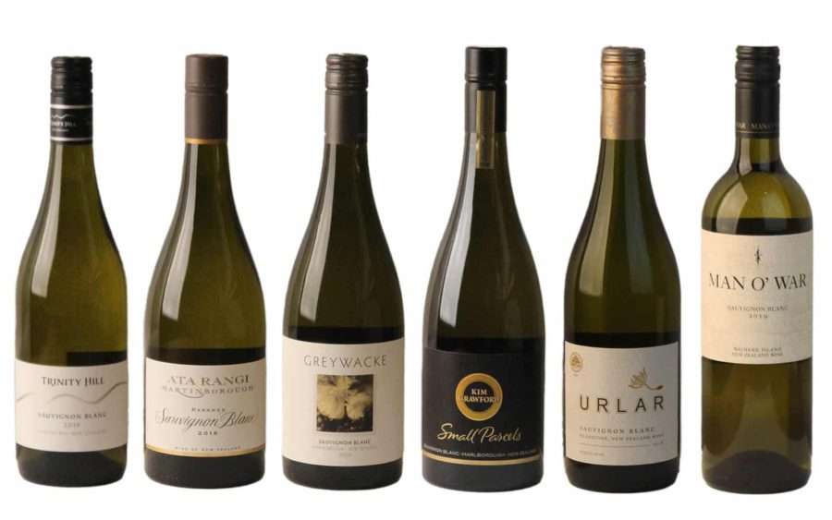
- Sauvignon Blanc – The signature grape, producing high-acid, aromatic wines with notes of citrus, passionfruit, and fresh herbs.
Figure 1 New Zealand Sauvignon Blanc
- Chardonnay – Found in Hawke’s Bay and Marlborough, offering both oaked and unoaked styles.
- Riesling – Grown in Canterbury, Marlborough, and Central Otago, producing dry to off-dry styles with crisp acidity.
- Pinot Gris – Increasingly popular, yielding rich, textural wines in Nelson and Hawke’s Bay.
Primary Red Varieties
- Pinot Noir – The flagship red variety, thriving in Central Otago, Marlborough, and Wairarapa. 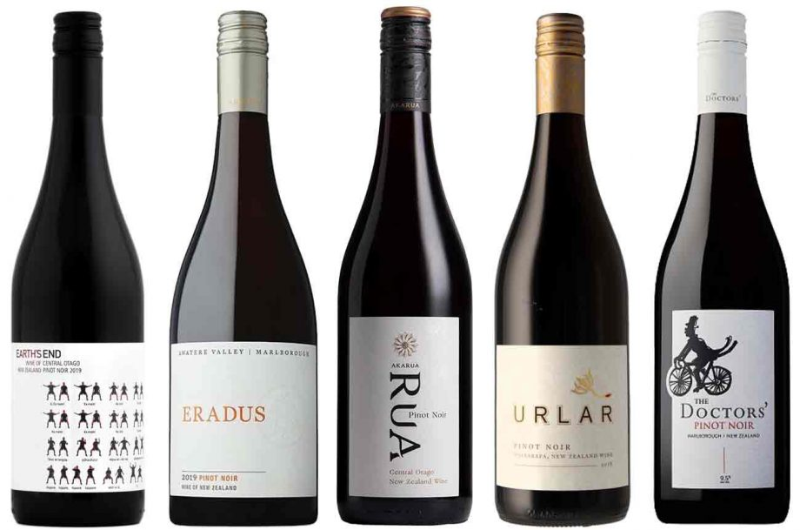
Figure 2 New Zealand Pinot Noir Best New Zealand Pinot Noir
- Syrah – Grown in Hawke’s Bay, producing elegant, peppery, Northern Rhône-style wines.
- Bordeaux Varieties (Merlot, Cabernet Sauvignon, Cabernet Franc) – Found in Hawke’s Bay, often blended.
Indigenous/Regional Varieties
New Zealand does not have indigenous grape varieties but is pioneering alternative plantings, such as Albariño, Grüner Veltliner, and Tempranillo.
Significance
- Sauvignon Blanc dominates, accounting for over 70% of plantings.
- Pinot Noir is the top red variety, excelling in cooler climates.
- Chardonnay and Riesling continue to gain international acclaim.

3. Wine Classification System
Quality Hierarchy
New Zealand has a single-tier GI system, focusing on regional distinction rather than strict classification.
Appellation Structure
- New Zealand Wine GI – Covers the entire country.
- Regional GIs – 12 specific wine-growing areas.
- Sub-Regional Distinctions – Not formally classified but widely recognized, such as Wairau Valley and Awatere Valley (Marlborough).
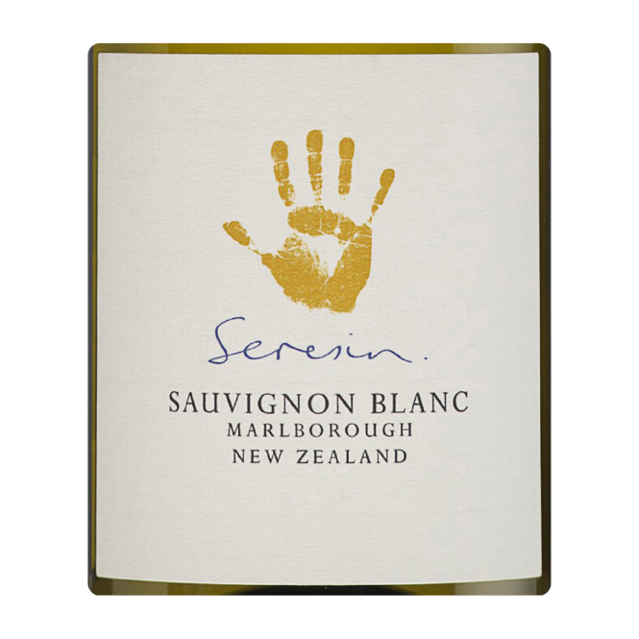
Special Classifications
- Sustainable Winegrowing New Zealand (SWNZ) – A certification for environmentally friendly vineyard practices.
- Organic & Biodynamic Wines – A growing movement, with producers like Seresin and Felton Road leading the way.
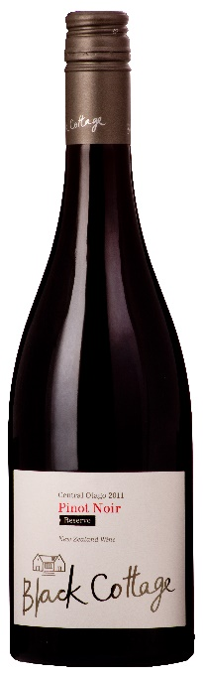
Sub-Regional Distinctions
- Marlborough – Sub-regions like Wairau Valley and Awatere Valley produce distinct Sauvignon Blanc styles.
- Central Otago – The world’s southernmost wine region, known for elegant Pinot Noir.
- Hawke’s Bay – Home to the Gimblett Gravels appellation, famous for structured Bordeaux-style reds.
Figure 3 Black Cottage 'Central Otago' Pinot Noir
4. Notable Wine Styles
Marlborough Sauvignon Blanc
- Classification Level: Marlborough GI
- Composition: 100% Sauvignon Blanc
- Production Method: Stainless steel fermentation to preserve freshness
- Alcohol Content: 12–13%
- Organoleptic Profile: Intense aromas of citrus, passionfruit, cut grass, and mineral notes
Central Otago Pinot Noir
- Classification Level: Central Otago GI
- Composition: 100% Pinot Noir
- Production Method: Traditional fermentation, often aged in French oak
- Alcohol Content: 13–14%
- Organoleptic Profile: Red cherry, raspberry, earthy undertones, fine tannins
Hawke’s Bay Bordeaux Blends 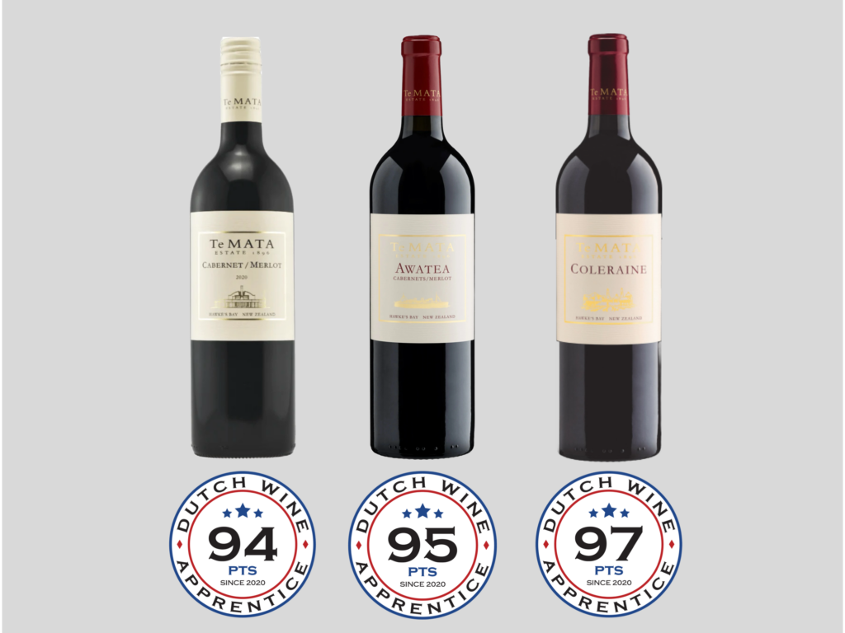
Figure 4 Te Mata Estate Bordeaux Blends
- Classification Level: Hawke’s Bay GI
- Composition: Cabernet Sauvignon, Merlot, Cabernet Franc
- Production Method: Barrel aging in French oak
- Alcohol Content: 13.5–14.5%
- Organoleptic Profile: Blackcurrant, plum, cedar, structured tannins

5. Additional Context
Recent Developments
- Increased focus on organic and biodynamic winemaking.
- Growing interest in alternative varieties, such as Albariño and Grüner Veltliner.
- Recognition of sub-regions, such as Gimblett Gravels (Hawke’s Bay) and Bannockburn (Central Otago).
Food Pairing Notes
- Sauvignon Blanc – Fresh seafood, goat cheese, Thai cuisine.
- Pinot Noir – Roast duck, mushroom risotto, lamb.
- Chardonnay – Grilled fish, creamy pasta, poultry.
Producer Information
- Cloudy Bay – Pioneer of Marlborough Sauvignon Blanc.
- Felton Road – Leading biodynamic producer in Central Otago.
- Craggy Range – Top Hawke’s Bay winery specializing in Syrah and Bordeaux blends.
- Kumeu River – Premier Chardonnay producer from Auckland.

6. Key Takeaways for Sommeliers
- New Zealand is best known for Sauvignon Blanc and Pinot Noir.
- Marlborough dominates production, but Central Otago and Hawke’s Bay produce world-class wines.
- Sustainability and organic practices are a major focus.
- Emerging varietals like Albariño and Grüner Veltliner show promise.
- The country’s cool-climate conditions produce wines with vibrant acidity and purity.

7. Citations and References
- New Zealand Winegrowers, 2023. https://www.nzwine.com/
- Wine Spectator, 2023. https://www.winespectator.com/
- Halliday Wine Companion, 2023. https://www.winecompanion.com.au/
- Decanter, 2023. https://www.decanter.com/

