New South Wales Wine Regions

1. Region Overview
New South Wales (NSW), is Australia’s oldest wine-producing state, that stretches from the humid Hunter Valley coast to the high-altitude cool climates of Orange and Tumbarumba. The state’s diverse terroirs, that range from coastal maritime, to a continental environment, and alpine region, support a wide range of styles, from iconic Hunter Valley Semillon to elegant Tumbarumba sparkling wines. NSW accounts for 30% of Australia’s wine production, with over 40,000 acres under vine cultivation.
Its reputation balances heritage (home to Australia’s first commercial vineyards) and innovation, driven by sustainable practices and climate adaptability.

2. Key Regions & Grape Varieties
Primary Wine Regions:
- Hunter Valley
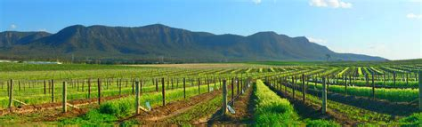
  - Climate: Humid subtropical, moderated by coastal breezes.
  - Key Varieties:
    - Semillon: Unoaked, citrus-driven youth → honeyed complexity with age.
    - Shiraz: Medium-bodied, earthy, with red and black fruit.
    - Chardonnay: Ranges from lean to rich, oak-influenced styles.
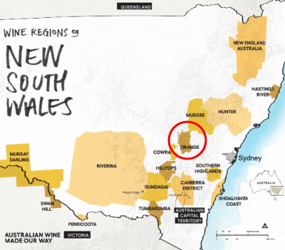
- Orange
  - Climate: Cool continental (600–1,100m elevation).
  - Key Varieties:
    - Chardonnay: Crisp apple, flint, and subtle oak.
    - Pinot Noir: Bright cherry, spice, and silky texture.
    - Sauvignon Blanc: Zesty, with tropical and herbal notes.
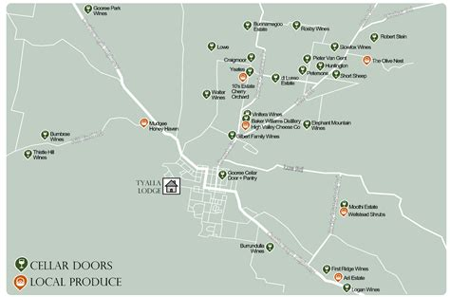
- Mudgee
  - Climate: Warm days, cool nights.
  - Key Varieties:
    - Cabernet Sauvignon: Bold, blackcurrant, and mint.
    - Shiraz: Ripe plum, pepper, and chocolate.
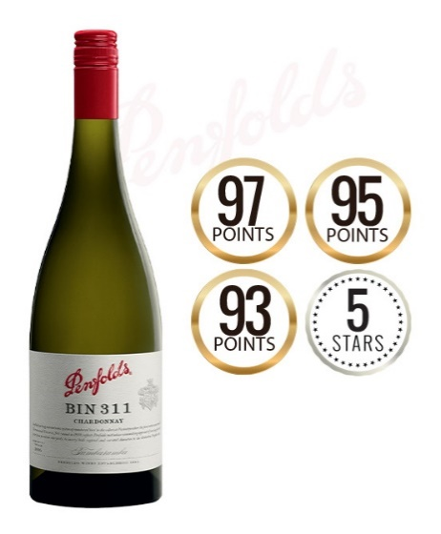
- Tumbarumba
  - Climate: Alpine cool (800–900m elevation).
  - Key Varieties:
    - Sparkling Wine: Traditional method Chardonnay/Pinot Noir.
    - Pinot Noir: Delicate red fruit and floral notes.
- Hilltops
  - Climate: Continental with warm summers.
  - Key Varieties:
    - Shiraz: Structured, blackberry, and spice.
    - Cabernet Sauvignon: Cassis, eucalyptus, firm tannins.

3. Wine Classification System
NSW uses Australia’s Geographical Indication (GI) system:
- GI Zones: Hunter Valley, Central Ranges (includes Orange and Mudgee), Northern Slopes (Hilltops).
- Sub-regions:
  - Hunter Valley → Broke Fordwich, Pokolbin.
  - Orange → Elevation-driven sub-zones (e.g., “High Altitude” labels).
- Standards: 85% of grapes must come from the stated GI.

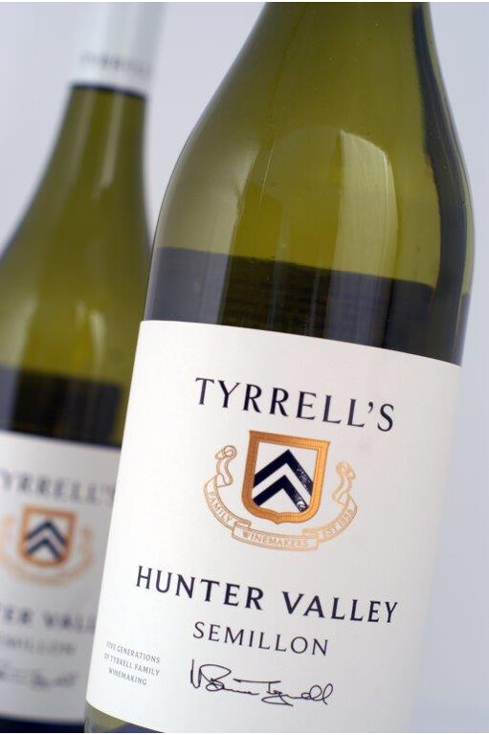
4. Notable Wine Styles
Hunter Valley Semillon (GI)
- Composition: 100% Semillon, early harvested.
- Production Method: Stainless steel fermentation, no oak.
- Aging Potential: 10–20+ years, evolving from lime zest to toast and honey.
- Alcohol Content: 10–11% ABV.
- Market Position: Globally unique, a benchmark for ageable dry whites.
Orange Chardonnay (GI)
- Composition: 100% Chardonnay, often Dijon clones.
- Production Method: Partial malolactic fermentation, French oak aging.
- Organoleptic Profile: Green apple, wet stone, and hazelnut.
- Sub-categories: “High Altitude” labels emphasize cool-climate purity.
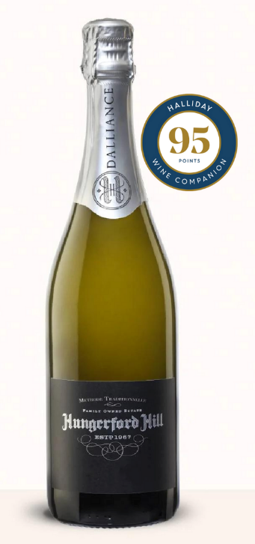
Tumbarumba Sparkling (GI)
- Composition: Traditional method Chardonnay/Pinot Noir.
- Production: Hand-harvested, extended lees aging.
- Organoleptic Profile: Brioche, lemon curd, and fine mousse.
- Comparison: Rivaling Tasmania’s sparkling wines in finesse.

5. Additional Context
Recent Developments:
- Sustainability: Over 25% of Hunter Valley vineyards are certified sustainable (Hunter Valley Wine Industry Association).
- Climate Adaptation: Drought-resistant rootstocks in Mudgee; frost fans in Orange.
Historical Context:
Viticulture began in the 1820s with James Busby’s plantings. The 1960s “modern era” saw Tyrrell’s Wines elevate Hunter Semillon to global acclaim.
Food Pairings:
- Hunter Semillon with Sydney rock oysters or grilled prawns.
- Orange Pinot Noir with duck breast or beetroot salad.
- Mudgee Shiraz with slow-cooked lamb shoulder.
Key Producers:
- Hunter Valley: Tyrrell’s Wines (Vat 1 Semillon), Brokenwood (Graveyard Vineyard Shiraz).
- Orange: Philip Shaw (No. 11 Chardonnay), Printhie Wines (sparkling).
- Tumbarumba: Courabyra Wines (traditional method sparkling).
Takeaway for Sommeliers:
NSW’s strength lies in its diversity—coastal heritage (Hunter) vs. alpine coolness (Tumbarumba). Highlight Hunter Semillon’s aging potential and Orange’s elevation-driven elegance.
Final Thoughts:
A state where history meets innovation, New South Wales crafts wines as varied as its landscapes, from the sunlit slopes of the Hunter to the crisp peaks of Tumbarumba, solidifying Australia’s legacy as a wine powerhouse.

Citations:
- NSW Wine Industry Association. Sustainability & Innovation Report. 2023.
- Halliday, J. Wine Atlas of Australia. 2022.
- “The Rise of Cool-Climate NSW.” Decanter, 2021.

