Mice, Money, and Getting Old
Presented by: Marc Silver
Idioms About Animals, Aging, and Being Broke
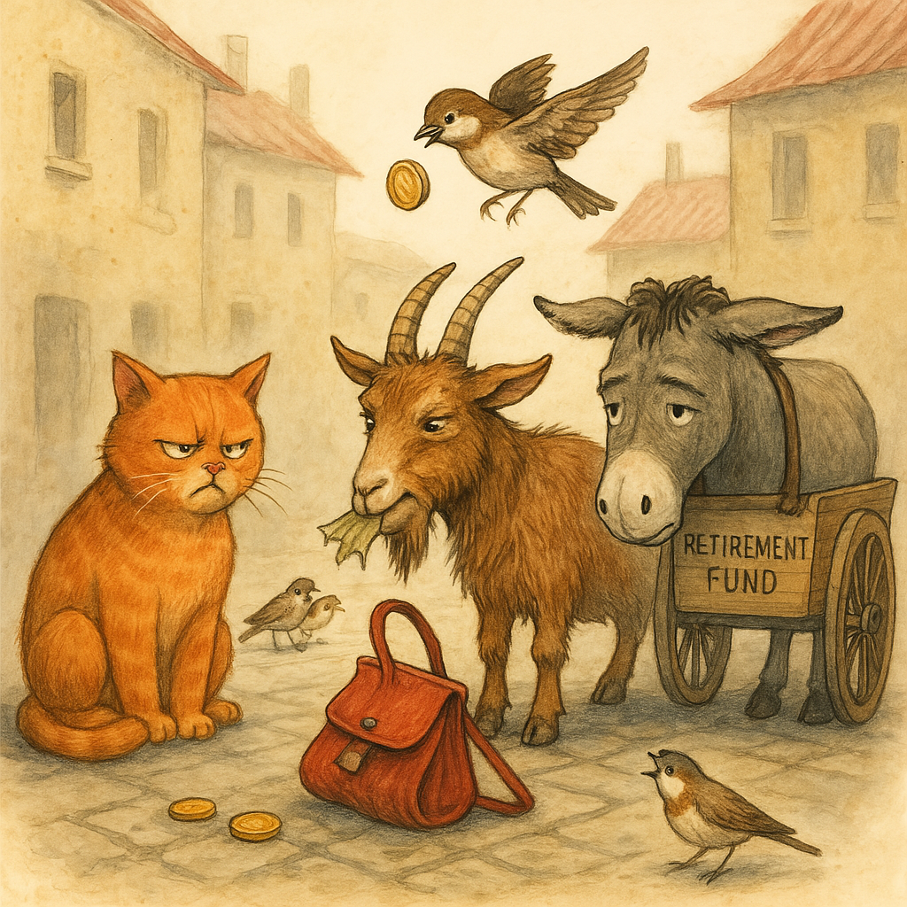What do cats, goats, sparrows, and donkeys have in common? They all show up in idioms that reveal how we feel about life’s harder truths—getting older, losing money, and making a fool of ourselves along the way.
So, whether you’re broke, gray, or just trying to avoid looking like a bewildered chicken, these global expressions have something to say.

Animal Idioms: Because Humans Can’t Take All the Blame
Spain: “Estar como una cabra” – “To be like a goat.”
You’re wild, unpredictable, maybe a little nuts. The goat is to blame, not you.
Malaysia: “Seperti kera mendapat bunga” – “Like a monkey getting flowers.”
Having something beautiful but not knowing what to do with it. Clueless appreciation at its finest.
Germany: “Da steppt der Bär” – “That’s where the bear dances.”
That’s the place to be. It’s hopping. The party is so good, even bears can’t help but break into a jig.
Netherlands: “Hij doet alsof hij de hond in de pot gevonden heeft” – “He acts like he found the dog in the cooking pot.”
Disappointed too late. Used when someone misses out and shows up after the action’s over.
China: “对牛弹琴” (duì niú tán qín) – “Playing a lute to a cow.”
Trying to impress or explain something to someone who just doesn’t get it. Think: arguing logic with a rock.
Jamaica: “Mek mi tell yuh ’bout di dawg weh nyam di suppen” – “Let me tell you about the dog that ate the supper.”
A warning tale. Someone messed up big-time, and you'd be wise not to follow their example.

Aging Idioms: Gray Hair, Sharp Tongues, and Worn-Out Legs
Arabic:” قلبه وقع في رجليه “Old in age, small in mind.”
Getting older doesn’t guarantee wisdom. A cautionary phrase for the cranky elder who forgot to grow up.
Italian: “Essere nella terza età” – “To be in the third age.”
A graceful way to describe elderhood. Less about decline, more about entering a final act—with wisdom and retirement discounts.
French: “Il n’a plus toute sa tête” – “He no longer has all his head.”
A gentle nudge at forgetfulness or mental decline. Often said with a shrug and a sigh.
Japanese: “還暦” (Kanreki) – Refers to turning 60, symbolizing a return to the zodiac sign of your birth.
Not just getting older—coming full circle. Celebrated, not dreaded.
Greek: “Τον έφαγε το σαράκι” – “He was eaten by the woodworm.”
Used to describe someone consumed by worry or bitterness with age. Slowly gnawed from the inside out.

Broke Idioms: When the Wallet Echoes
Hungary: “Még a verebek is kiröhögik” – “Even the sparrows laugh at you.”
So poor it’s public knowledge—and the wildlife’s mocking you.
Portuguese: “Nem um tostão furado” – “Not even a rusty coin.”
Completely broke. Not a cent. Not even one worth throwing away.
Thai: “จนตรอก” (Jon-trok) – “Trapped in an alley.”
No options. No way out. Used when someone’s hit financial rock bottom.
Yiddish: “Er hot kein Groshn nit” – “He doesn’t have a penny.”
Said with the universal tone of someone checking their pockets and coming up empty.
Brazil (Portuguese): “Ficar com a mão abanando” – “To be left waving your hand.”
Used when you walk away with nothing—no deal, no cash, not even a thank-you.
Romanian: “A face foamea cu stil” – “To starve with style.”
No money, but still keeping up appearances. Think lipstick and a hole in the shoe.

Final Thoughts: Fur, Wrinkles, and Empty Pockets
Across languages, animals do the talking when people won’t. Age is respected, mocked, or quietly mourned. And being broke? That’s a universal joke we’re all invited to laugh at—often through our teeth.
These idioms reveal the soft belly of everyday life. We laugh, we age, we misplace our money—and still find a way to turn it all into poetry.
Next Time:
Idioms about fear, bravery, and foolishness. (Spoiler: In the Czech Republic, when you’re terrified, you’ve got a hamster in your stomach.)

