McIntosh D150 Digital Pre-amp Review
by Marc Silver

I have to say this review is late coming. By that I mean the D150 has just been discontinued and a replacement is more than likely to be introduced soon. But it took me a while to get my hands on a D150 to put into my system and give it a good listen. I almost scraped the entire article but since I did the work why not get it out for your benefit? Some of my readers may be looking for a world-class DAC on a budget. And I have seen some on the after-market at fairly reasonable prices.
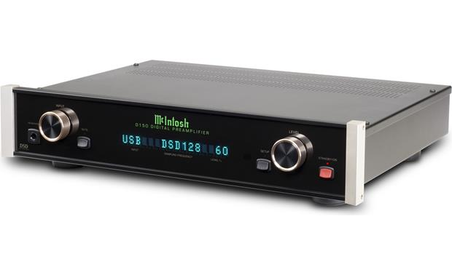
It has been a while since I had the earlier version of this amazing product in my hands. When I was in retail and owned Soundscape Audio, I used to be a McIntosh dealer and sold the D100 which was McIntosh’s first venture into a DAC/Digital Preamp. At its introduction, it was only $2500. That seems like a lot until you consider its completion.. The D150 went through some minor upgrades and a price increase to $3000. I have listened to some amazing DACs that sound remarkably similar but cost as much as 22 times more expensive.

I am not saying that if you have an appropriately esoteric system you shouldn’t spend the money on comparable competitors like the Brinkmann Nyquist at $18,000, the Berkeley Audio Design Alpha DAC Series 2 MQA at $19,995, or the MSB Technologies Reference at $39,500. But for 99.9% of the audiophile world, the McIntosh D150 (in my opinion) gets you 99% of the way there. Short comment: If I had more money than I could ever spend in a lifetime, I would probably buy the MSB as in my opinion, it is the ultimate DAC I have ever heard.
Now that I have ticked off some of you let me explain myself.
Let us start by explaining what a DAC is.

What is a DAC?
The job of a DAC is to convert the digital signal from a plethora of digital sources from such sources as computers, phones, streamers, CD/DVD players, and high-res and MP3 players and convert that digital stream into analog sound for our listening enjoyment.
In today’s digital world that is more important than ever. There are lots of cheap DACs that range from $39 to $200 that do the job. That is to say, they function, and for the mass market customers who primarily listen to highly compressed music on cheap headphones, they need look no further. There are of course exceptions like the Audio Quest Dragon Fly or the Cambridge Audio DacMagic that sound pretty good, especially for the money. For the more critical listener, it is difficult to find anything under $1000 that can approach the sound of good analog music from a vinyl record. In this middle range are some very respectable options like the Teac UDH-01 or the Rotel RDD-1580 in the $799 range.
The third step is the $2000 to $5000 range. This is the range of products that seem to squeeze the most out of the available sources and where the McIntosh is located. The final level is the DACs that exceed $10,000 where cost is no object. The DACs in the rarefied range must every last musical note from the best digital sources available.
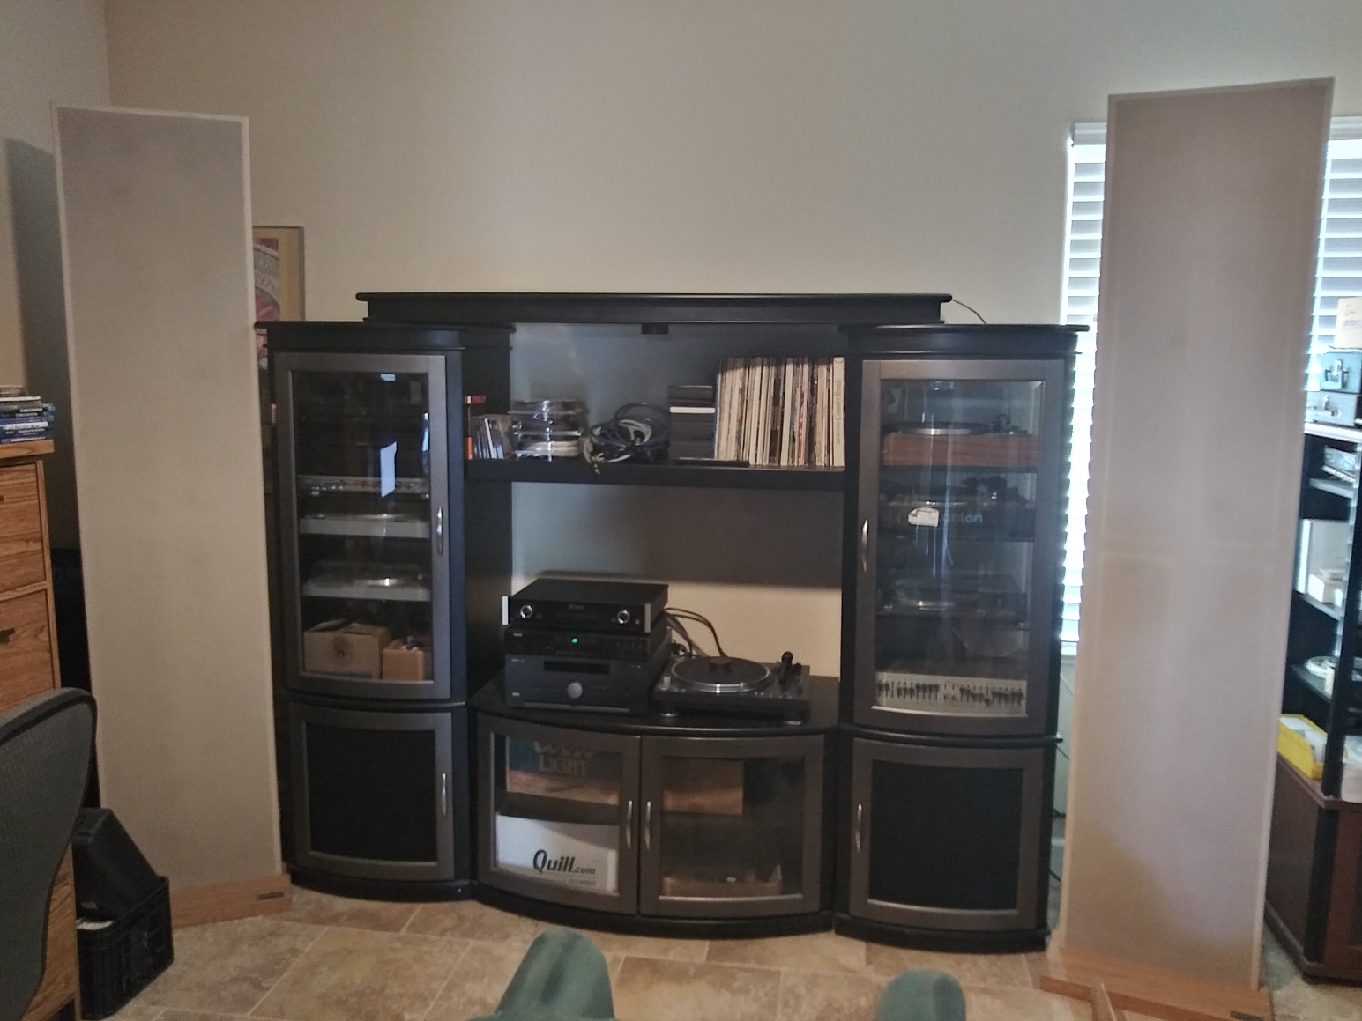
My contention is that the McIntosh D150 is capable of achieving musical satisfaction that meets and in some cases exceeds the performance of some (not all) of the competition in this most rarefied product category.

My System

I have to talk about my system. To me, the most important part of any system is the loudspeakers. In my case, I have used the same pair of primary speakers for over 24 years. They are Acoustat 2+2 full range electrostats. I have used over 20 different pairs of speakers in my various systems of the last 52+ years but settled on the Acoustats because (like most full range electrostats they are incredibly accurate, produce a wide and detailed sound stage and when properly coupled to a very high current amplifier produce a remarkably musical illusion of performance. When coupled to with the wrong electronics, however, they will drive you out of the room with bleeding ears. I currently am powering them with an Anthem Class A complimentary Integrated amplifier which does a very good job. It is not the best sounding amp I have had on the 2+2s but I at this time cannot justify the cost of the Tube gear I would like to use. The Anthem is detailed and mystical and most importantly is stable enough and has the current needed to drive the Acoustats.
For this demo, I used a Denon DVD-1930Ci transport. Although not as good as the Denon transport used by McIntosh in their own CD player, as a transport only it is very stable and does an excellent job.
The Speaker cables are Apture Silver Teflon 4+4 and I am using assorted Tara Labs and Nordost cables. So, my system does have limitations and certainly is not the last word in audiophilia.

How it functions.
Once installed through one of the AUX inputs on the Anthem, the D150 offers a lot of flexibility.
It uses an 8-channel DAC chip configured to operate with four channels per stereo channel. I consider that a bit of overkill, but it results in virtually no data loss.

McIntosh describes the D150 as a “stereo preamp with a digital mind and an analog soul.”
McIntosh is known for their dedication to analog sound and the D150 seems to echo this heritage well.

I should also note that all McIntosh products are designed and built at their Binghamton factory in upstate New York factory.
Although I didn’t use them for this review, the D150 has 6 audio inputs, and volume control so it can be used as a conventional line stage preamp. On the digital side, there is an array of inputs to choose from. The D150's optical and coaxial digital inputs support high-res music files up to 24-bit/192kHz. Its USB input handles even higher-resolution files: up to 32-bit/384kHz for PCM, as well as DSD and DXD formats which are not often found in most other DACs.
If you have a SACD player like their MCT500 you can connect directly to the D150 for decoding.
Their remote is simple to use and fairly ergonomic. I hate most remotes because they rarely make any sense, and the buttons are hard to either reach or see what they do. The D150 remote is acceptable. It controls volume and other functions, just as you'd expect. But if you also listen to analog sources, and already have a preamp or A/V pre/pro you like, you can still take advantage of the D150's superb DAC section. Connect all your digital music sources to the D150, then use its fixed-level outputs to connect to your preamp. In that situation, the volume level is controlled via your preamp.

How did the D150 perform?
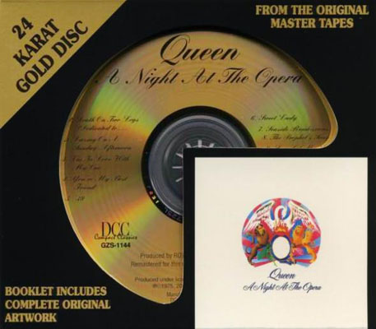
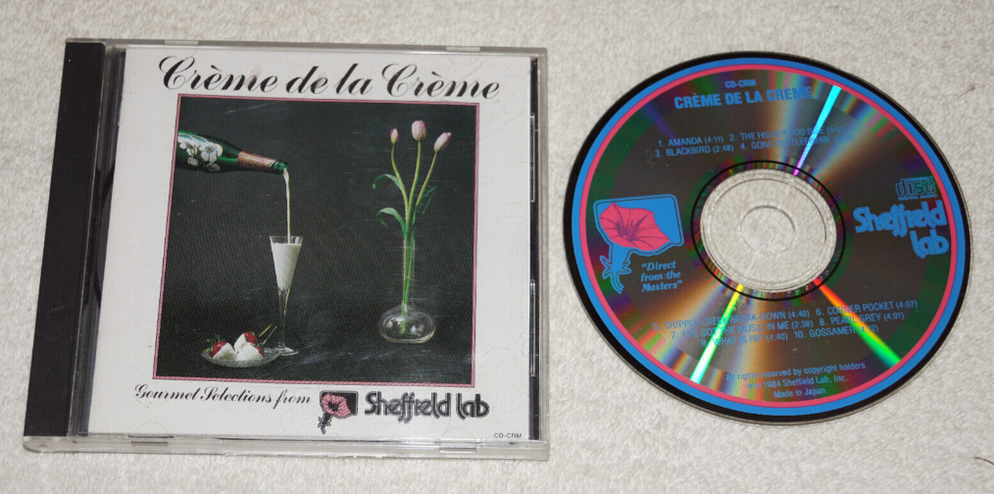
I have a long list of CDs I like to use when listening to a different gear. One of my favorites is a demo disc I was given by Gary Koh CEO and Lead Designer of Genesis Advance Technology. This particular disc was compiled, engineered, and produced by him and is not available at all. It was designed to demonstrate the capabilities of the Genesis Loudspeakers and push the limits of system performance. Another disc I use is also a demo disc from Usher Audio also designed for the same purpose. I have used them over many years and find them to be a great tool for me. I also played a selection of CDs including Hotel California, a number of MoFi OMR including The Fantasy Film World of Bernard Hermann, Queen's “A Night at the Opera”, Rick Wakeman's “Journey to the Center Of the Earth”, Carreras Domingo Pavarotti in Concert”, Telarc’s “Ein Straussfest”, Windam Hill “Piano Sampler”, Sheffield Labs “Cream de la Cream”, and Fresh Aire 7.
What I didn’t do mostly because I don’t stream anything, is listen to its performance with high-resolution files and streamed music. So, I admit this is not a comprehensive review. Also, I did not use any SACD music either. My intent was how it performs under typical applications and for me that means CDs. I feel that if it sounds great on standard CDs it should go equally well on other applications. I am willing to admit to my failings.
After many hours of listening, I concluded that the D150 performed far beyond my expectations. It came remarkably close to the analog vinyl copies of the same material I own. For my application, this was very respectable. I was not put off by any digital hardness so often apparent in most digital sources I have experienced.
If you haven’t guessed by this point in the article I favor analog over digital. I concede to this preference as being somewhat out of place but prefer the warm smooth character of a good vinyl recording. I do listen to more digital music than analog simply because of convenience but make no apologies for my personal preferences. That being said, I could happily live with McIntosh D150 as my only DAC.
In the past, I have always said that good gear will always be good gear. I guess that is why I never replaced the 2+2s. I see the D150 falling into that group of products that will hold their own for many decades to come.

Product Spec:

Features:
- Stereo preamp with a built-in digital-to-analog converter (DAC) and digital inputs
- Digital inputs let you connect sources like a computer, disc player, media streamer, or TV and enjoy superior sound
- 8-channel 32-bit/500kHz DAC used in Quad Balanced mode (4 stacked channels per stereo channel)
- Accepts and plays high-resolution digital audio sources, including PCM, DSD, and DXD files
- Asynchronous USB technology for reduced timing jitter and better sound when connecting to a computer
- Fully regulated power supplies and R-Core Power Transformer ensure stable, noise-free operation
- Full-size headphone output
- Remote control
- Fluorescent front-panel display with adjustable brightness
- fiber optic illuminated glass front panel
- Handcrafted at McIntosh's Binghamton, New York factory

Connections:
- Variable-level balanced XLR and unbalanced RCA outputs for connecting directly to a power amplifier
- Fixed-level balanced XLR and unbalanced RCA outputs for using the D150 as a DAC and connecting to a preamplifier
- 2 Toslink optical digital audio inputs — supports files up to 24-bit/192kHz
- 2 coaxial optical digital audio inputs — supports files up to 24-bit/192kHz
- USB (Type B) input for connecting a Mac® or Windows® computer (USB driver required for audio playback on Windows computers)
  - supports PCM music files up to 32-bit/384kHz, plus DSD64, DSD128 & DSD256, as well as DXD 352.8kHz & DXD 384kHz
  - USB audio driver required for playback on a Windows PC (free USB driver download available from McIntosh's website)
- proprietary digital DSD connection for playback of SACD audio when paired with the McIntosh MCT500 SACD/CD Transport
- 12-volt output for activating an external accessory
- RS-232 port for automated control systems
- IR input for connecting an IR receiver
- data port allows basic remote control of a connected McIntosh source component
- Detachable power cable
- If connecting to a TV, please make sure you can select "PCM" output in its audio menu — the preamp's DAC cannot decode multichannel Dolby® Digital signals

Specifications:
- Total harmonic distortion: less than 0.0015%
- signal-to-noise ratio: greater than 110 dB
- 17-1/2"W x 3-7/8"H x 16"D
- weight: 13.5 lbs.
- warranty: 3 years
- MFR # D150

What's in the box:
McIntosh D150 owner's manual
- Digital stereo preamplifier
- 6' AC power cord
- Remote control
- Owner's Manual

