Lesser-Known Wine-Producing States in the United States
Region Overview
While California, Oregon, and Washington dominate U.S. wine production, wineries exist in all 50 states, with several emerging as significant contributors to the country’s diverse wine landscape. Regions such as New York, Texas, Virginia, Michigan, Colorado, Missouri, and Arizona are gaining attention for their distinctive terroirs, innovative winemaking approaches, and dedication to both classic and indigenous grape varieties.
These states span a wide range of climates, from the humid East Coast to the high-altitude vineyards of the Rocky Mountains. Winemakers in these regions adapt to climatic extremes by using techniques such as selecting hardy grape varieties, employing frost protection measures, and adjusting harvest times to optimize ripeness. While each region presents its own challenges—such as extreme weather conditions, short growing seasons, and diverse soil compositions—winemakers are producing increasingly high-quality wines that deserve recognition.

Key Grape Varieties
- Primary Red Varieties:
  - Cabernet Franc (New York, Virginia) – Thrives in cooler climates, producing structured wines with red fruit and herbal notes.
  - Tempranillo (Texas, Arizona) – Grows well in warm, arid conditions, yielding bold wines with dark fruit and spice.
  - Norton (Missouri, Virginia) – A native American grape known for its deep color, high acidity, and earthy complexity.
  - Chambourcin (Missouri, Pennsylvania) – A French-American hybrid with bright acidity and red berry flavors.
  - Sangiovese (Texas) – Well-suited to Texas’s dry climate, producing wines with cherry, spice, and firm tannins.
- Primary White Varieties:
  - Riesling (New York, Michigan) – Produces crisp, high-acid wines with green apple, citrus, and mineral notes.
  - Chenin Blanc (Texas) – Increasingly popular for its fresh acidity and ability to retain balance in warm conditions.
  - Seyval Blanc (Missouri, New York) – A hybrid variety offering citrus and floral aromas, often used in sparkling wines.
  - Viognier (Virginia, Texas) – Known for its rich texture, stone fruit flavors, and floral aromatics.

Wine Classification System
Unlike the American Viticultural Area (AVA) system used in California, Oregon, and Washington, lesser-known wine states often rely on more flexible classification approaches.
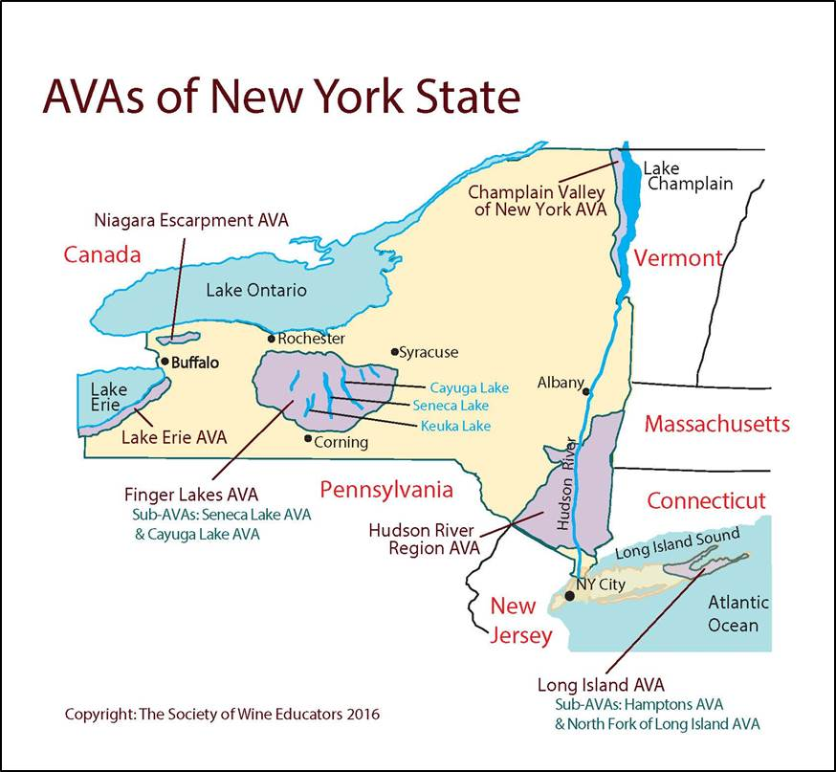
However, some states, such as Texas and Virginia, are working toward stricter AVA regulations to enhance their credibility and ensure consistency in regional wines.
- New York: Features well-known AVAs such as Finger Lakes, Long Island, and Hudson River Region.
- Virginia: Uses AVAs such as Monticello and Shenandoah Valley, known for high-quality wines.
- Texas: Features AVAs like Texas Hill Country and High Plains, with significant variation in terroir.
- Michigan: Focuses on cool-climate varieties in AVAs such as Old Mission Peninsula and Leelanau Peninsula.
- Missouri: Home to the Augusta AVA, the first designated AVA in the U.S., known for Norton and hybrid varieties.
- Arizona & Colorado: Emerging as high-altitude wine regions, with AVAs such as Sonoita (AZ) and Grand Valley (CO).

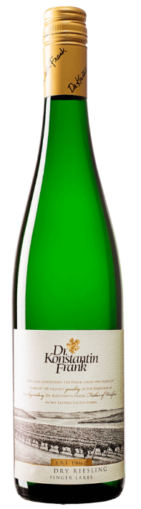
Notable Wine Styles
- Finger Lakes Riesling (New York’s Signature White)
  - Classification Level: AVA Finger Lakes.
  - Composition: 100% Riesling.
  - Production Method: Stainless steel fermentation for freshness.
  - Aging Requirements: Typically released young, with some aged versions.
  - Alcohol Content: 11–13% ABV.
  - Organoleptic Profile: Green apple, lime, petrol, and high acidity.
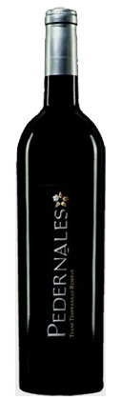
- Texas Tempranillo (Bold and Sun-Drenched)
  - Classification Level: AVA Texas High Plains.
  - Composition: 100% Tempranillo.
  - Production Method: Aged in American or French oak.
  - Aging Requirements: 12–24 months in oak.
  - Alcohol Content: 13.5–15% ABV.
  - Organoleptic Profile: Black cherry, tobacco, and earthy spice.
- Virginia Viognier (Elegant and Aromatic)
  - Classification Level: AVA Monticello.
  - Composition: 100% Viognier.
  - Production Method: Barrel or stainless steel fermentation.
  - Aging Requirements: Typically 6–12 months.
  - Alcohol Content: 12.5–14% ABV.
  - Organoleptic Profile: Peach, honeysuckle, and a rich, creamy texture.
- Missouri Norton (America’s Native Red)
  - Classification Level: AVA Augusta.
  - Composition: 100% Norton.
  - Production Method: Aged in oak for complexity.
  - Aging Requirements: 12–18 months.
  - Alcohol Content: 12–14% ABV.
  - Organoleptic Profile: Dark berries, spice, and earthy undertones.

Additional Context
- Recent Developments: Increasing investment in sustainable and organic viticulture in regions such as New York and Virginia.
- Historical Evolution: Missouri and New York were among the earliest U.S. wine regions, pre-dating California’s dominance.
- Food Pairing Notes: Finger Lakes Riesling pairs well with seafood; Texas Tempranillo complements barbecue and grilled meats.
- Notable Producers:
  - Dr. Konstantin Frank Winery (New York) – Pioneering cold-climate viticulture in the U.S.
  - Barboursville Vineyards (Virginia) – Leading producer of Viognier and Bordeaux-style blends.
  - Duchman Family Winery (Texas) – Known for Italian varieties like Sangiovese and Vermentino.
  - Stone Hill Winery (Missouri) – One of the oldest wineries, specializing in Norton and hybrid varieties.

Key Takeaways for Sommeliers
These lesser-known U.S. wine states offer distinct terroirs and grape varieties that set them apart from the West Coast. Sommeliers should focus on regional differences, hybrid varieties, and the impact of climate on winemaking in these states. Understanding the rise of high-altitude vineyards, warm-climate adaptations, and hybrid grape success stories will provide valuable insights into the evolving landscape of American wine.
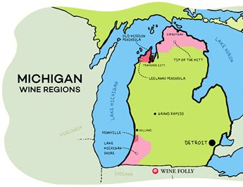
Final Thoughts
The U.S. wine industry extends far beyond California, Oregon, and Washington. With emerging regions like Texas, New York, Virginia, and Michigan gaining global recognition, these states are proving that world-class wines can be made across the country. As production quality continues to improve, these regions will become even more significant in the evolving story of American viticulture.

References
- U.S. Alcohol and Tobacco Tax and Trade Bureau (TTB). American Viticultural Areas. www.ttb.gov
- Wine America. Emerging Wine Regions in the U.S. www.wineamerica.org
- Dr. Konstantin Frank Winery. Finger Lakes Riesling & Viticulture. www.drfrankwines.com
- Texas Wine Growers. Texas Terroir & Grape Varieties. www.texaswine.org
- Missouri Wine & Grape Board. Norton: America’s Native Grape. www.missouriwine.org

