Legendary Vintage Preamps and Power Amps Worth the Chase
By Marc Silver
Legendary Vintage Preamps and Power Amps Worth the Chase By Marc Silver
Most audiophiles chase the usual suspects Most audiophiles chase the usual suspects—McIntosh, Marantz, the gear with name recognition. But the real treasures? They’re hiding in plain sight—rare separates built in limited runs, often by visionaries more interested in perfect sound than profit margins. These are the unicorns. They weren’t built to sell. They were built to stun.
A unicorn, in vintage audio terms, isn’t just rare. It must meet three benchmarks:
- It still sounds spectacular.
- It introduced bold or unusual engineering.
- And it has a story worth retelling.
These are the pieces that don’t show up often—and when they do, they don’t stay on the shelf for long. Here’s a curated list of legendary vintage preamps and power amps that deserve the title: Unicorn Separates.
Welcome to the world of Unicorn Separates.
Restoration Reality Check
Almost every unit listed here needs some level of restoration. That means recapping, resistor replacements, and possibly hunting down obsolete transistors or tubes. For VFET designs or oddball tube types, parts are extremely scarce. A proper rebuild can cost anywhere from $500 to over $1,500, not counting labor. But the payoff? You’re listening to living audio history.
Resources like Audiokarma, The Vintage Knob, and DIYAudio can be invaluable. Restoration shops like Analog Restorations (NYC) or Classic Audio Repair (CA) can help bring these legends back to life.
To earn "unicorn" status, gear must pass three tests:
- Sound that still astonishes today.
- Bold engineering that broke new ground.
- A story worth retelling.

I feel I need to begin this observation with the pair that I think belongs at the pinacol of the vintage audio marketplace. I can’t think of a better pair to start with than the Marantz Model 7 stereo preamp and the Model 8 stereo power amp. Both these designs came from the mind of one of the audio industries founders Mr. Saul Marantz.
Personal Note: I was fortunate enough to spend some time with Saul at CES in Las Vegas over 40 years ago. His wife and I sent part of my visit, as she said, “making lunch for the boys”. Yes, I spent the afternoon cooking for Saul Marantz and Stu Hegeman who was visiting him at the time. You never forget afternoons like that.
Restoration Reality Check
Original: Scattered warnings about restoration.
Rewritten & Consolidated:
⚠️ The Hard Truth: Most unicorns need resurrection.
Capacitors dry out, resistors drift, and tubes fade. For gear with VFETs (Sony) or exotic tubes (Luxman’s 8045G), replacement parts are nearly extinct. Restoration costs? $500–$1,500+. But the reward? A time machine to audio’s golden age.
Pro Tip: Forums like Audiokarma and The Vintage Knob are lifelines for schematics and parts swaps.

Marantz Model 7 and Model 8
Year Introduced: 1958 (Model 7), 1959 (Model 8)
Power Output: 30 watts per channel (Model 8, EL34 push-pull)
Original Prices: ~$250 (Model 7), ~$250 (Model 8)
Current Mint Rebuilt Price: $7,000–$12,000 for the pair
Production Numbers: Estimated ~130,000 Model 7s; fewer than 10,000 Model 8s
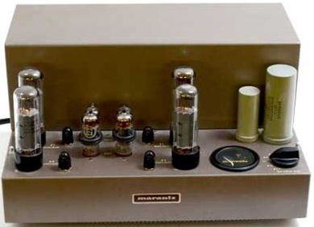
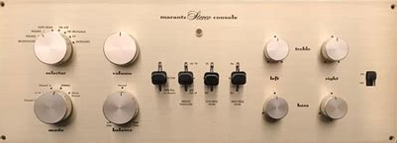
I’ve always believed the Marantz Model 7 and Model 8 belong at the top of any vintage audio list. These weren’t just popular—they were groundbreaking. Designed by Saul Marantz himself, they represent the moment when high-end audio really started to define itself. And for me, they still do.
The Model 7 preamp’s phono stage is still a benchmark, and the Model 8B power amp brought tube warmth with precision. Both were hand-wired, overbuilt, and have become symbols of the golden age of audio.
Why Unicorns: Iconic performance, classic design, and still musically relevant decades later.

McIntosh MC275 and C22
Year Introduced: 1961 (MC275), 1963 (C22)
Power Output: 75 watts/channel (MC275)
Original Price: ~$444 (MC275), ~$399 (C22)
Current Mint Rebuilt Price: $8,000–$12,000+ for the set
Production Numbers: Limited original runs; reissues came later
Still in production 60+ years later—the MC275 is the only amp here with that honor.
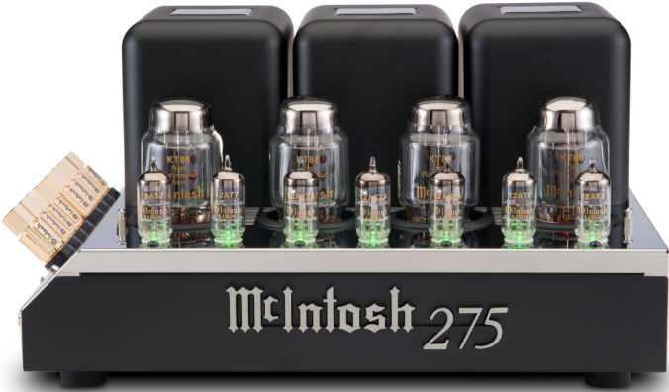
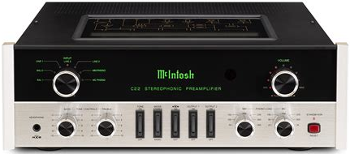
The MC275 is possibly the most famous tube amp ever made. Designed to drive real-world speaker loads with poise and warmth, it’s still in production in revised forms. The C22 preamp is equally respected, with a full-featured layout, premium phono section, and signature McIntosh cosmetics, a testament to its enduring value.
Why they’re unicorns: Original glass, transformers, and tubes command high premiums. Restored correctly, this combo delivers old-school magic with incredible resale. Unlike many classics, parts are still available via McIntosh and third-party specialists.

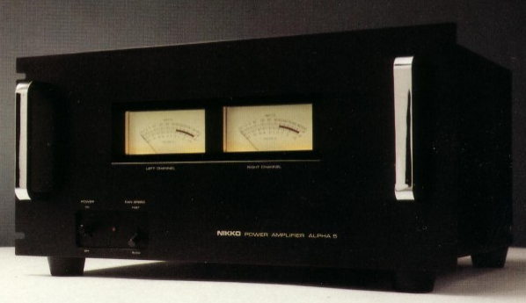
Nikko Beta V and Alpha V
Year Introduced: 1980
Power Output: 200W/ch (Alpha V)
Original Price: ~$500 (Beta V), ~$950 (Alpha V)
Current Mint Rebuilt Price: $2,000–$3,000 for the set
Production Numbers: Modest, this was the high-end line from a mid-market brand.
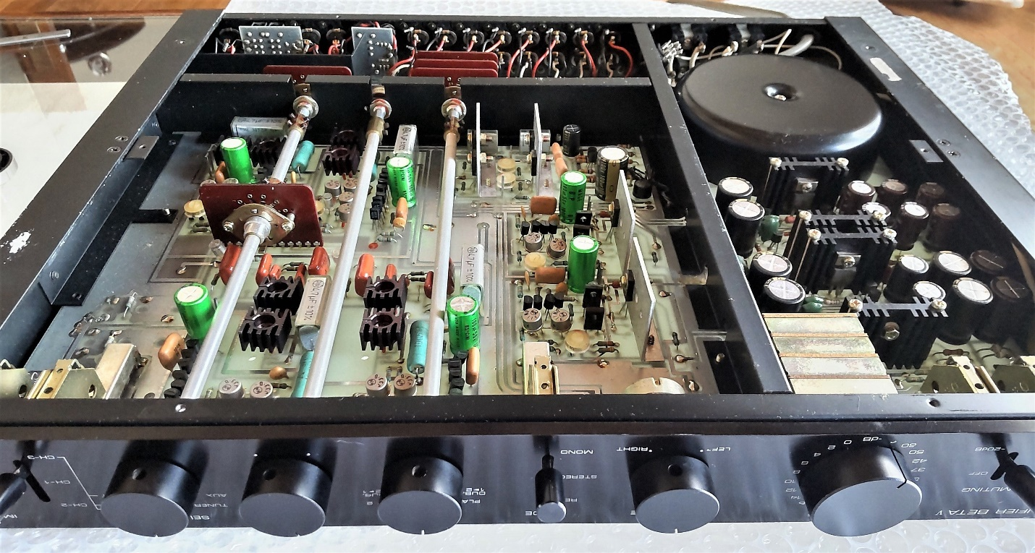
Nikko surprised a lot of people with this one. The Alpha V was a muscular, high-current power amp that handled complex speaker loads with ease. Its companion, the Beta V preamp, was an all-out audiophile effort, offering fully discrete circuitry, a dual-mono layout, and an excellent phono stage that punched far above its price. Together, they looked the part and played it too—quiet, clean, and refined.
While Nikko rarely competed in the high-end arena, this pairing proved they could. Never a big seller, it’s become a cult favorite for its bulletproof build quality and honest, musical sound. I really loved this combo for it’s great esthetics and amazing performance.
Why they’re unicorns: Nikko didn’t have the brand prestige of Luxman or McIntosh, but the Alpha and Beta V combo delivered quiet, detailed sonics and serious build quality. 70s lab-chic aesthetics Matching sets are rare today—and good ones even rarer.

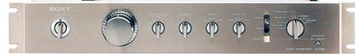
Sony TA-N7B and TA-E88B (VFET Series)
Year Introduced: 1976
Power Output: 100 watts/channel (TA-N7B)
Original Price: ~$1,200 for the pair
Current Mint Rebuilt Price: $3,500–$6,000
Production Numbers: Very low; VFET production was brief
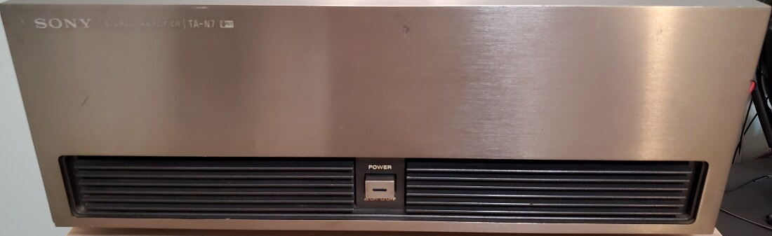
Sony’s VFET gear was an attempt to capture tube-like sound with new solid-state tech. The TA-N7B power amp and TA-E88B preamp were high-spec designs with incredible build quality and soundstage performance. VFETs behave more like tubes, with smooth clipping and graceful overload. The 7B ran cool and sounded enormous.
Why they’re unicorns: Working units with original VFETs are rare—maybe one in twenty still have them intact
These amps have a following rivaling that of some classic tube gear, and in some ways, surpass it.

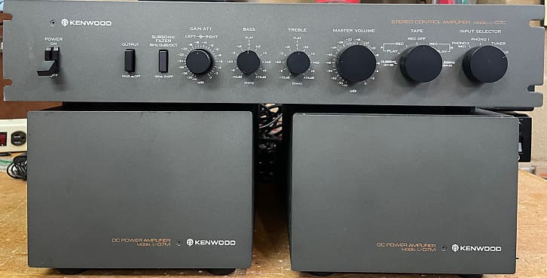
Kenwood L-07C and L-07M Monoblock
Year Introduced: 1979
Power Output: 150 watts per monoblocs @ 8 ohms
Original Price: ~$400 (L-07C), ~$800 per pair (L-07M)
Current Mint Rebuilt Price: $3,000–$4,000 for the set
Production Numbers: Limited export availability
Kenwood’s Audio Purist line was a brief but dazzling moment in Japanese audio history. The L-07C preamp and L-07M Monoblocks were designed with true dual-mono signal paths, ultra-low noise architecture, and high-speed response. The styling was pure 1970s laboratory chic: heavy, no-nonsense, and serious. I need to make an observation here. At the time 1980 Infinity was producing the first commercial audio Class D amplifier affectionally referred to at the SWAMP. Few people knew Infinity had replaced their amp with the Kenwood L-07M to drive their IRs speakers because their own SWAMP (switching amp) constantly failed during testing. Kudos to Kenwood!
Why they’re unicorns: These were Kenwood’s Audio Purist Group products, intended to compete with Accuphase, Luxman, and early Mark Levinson. Many suffered abuse or poor storage, so finding a full, working trio is getting rare. Properly restored, they’re dead-quiet, punchy, and revealing without being clinical. I used them to drive our store Acoustat model 2+2 electrostats because the McIntosh MC2500 struggled to drive them.

Bedini 66DE and 25/25
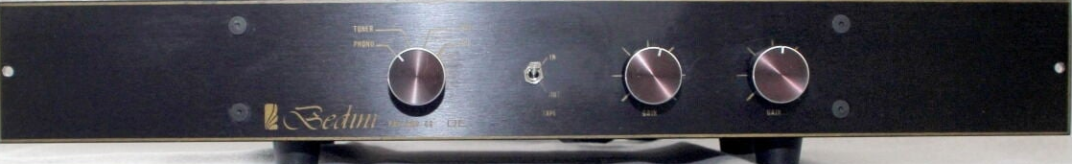
Year Introduced: Early 1980s
Power Output: 25W/ch Class A (25/25)
Original Price: ~$495 (66DE), ~$995 (25/25)
Current Mint Rebuilt Price: $3,500–$5,000 for the set
Production Numbers: Low—hand-built in California
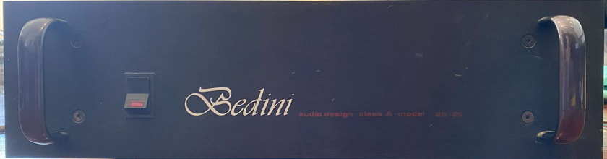
The Bedini brothers were iconoclasts in the audio world, engineering savants who built gear by ear, not marketing plan. The 66DE preamp was dual-mono and minimalist in all the right ways. Its matching partner, the 25/25 power amp, ran in pure Class A and delivered a level of transparency and tonal purity that stunned listeners accustomed to higher-powered beasts. Though not massive in output, the sound was anything but small. The soundstage was open, dynamics were lightning-quick, and voices had a startling realism.
all the audio engineers I knew at the time the Bedini brothers were the strangest. They both thought so far outside the box, you couldn’t even see the box with binoculars. In my opinion they produced some of the finest designs for the time. In my store I used their 25/25 with the Nikko Beta V to drive Quad ELS electrostats. It would be decades before I found a system that compared.
These were not easy pieces to find even in their day. Now, they’re collector bait.
Why they’re unicorns: Built in small batches with uncompromising design goals, the 66DE and 25/25 offer a glimpse into what’s possible when two audio visionaries decide to do it their way. And the few that exist still make music with startling immediacy.

Threshold 400A and NS10
Year Introduced: Late 1970s
Power Output: 100 watts/channel (400A)
Original Price: ~$1,000 (400A), ~$500 (NS10)
Current Mint Rebuilt Price: $3,000–$5,000
Production Numbers: Limited
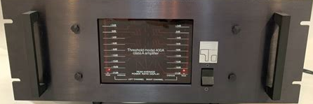
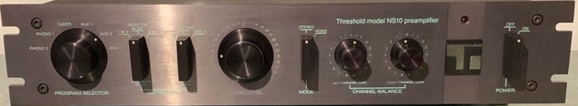
One of Nelson Pass’s earliest commercial efforts. The 400A was a pure Class A amp with huge headroom and amazing bass grip. The NS10 preamp was lean, fast, and honest, ideal for studio or critical home listening. Together, they defined the West Coast "muscle with finesse" aesthetic. It was years before I discovered their audio twins from Usher. So if you want to explore the character of the Threshold gear and can’t find them look for the Usher R1.5 and P-307A MKII.
Why they’re unicorns: Many were modded beyond recognition. Original units are becoming rarer by the year. Restored correctly, they deliver sound that still holds up to Pass Labs gear today.

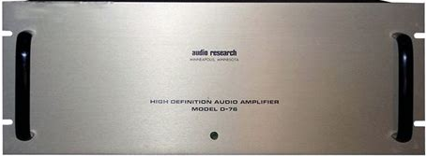
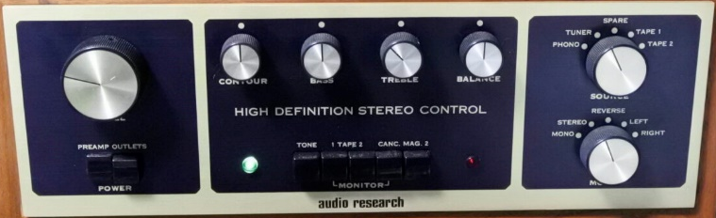
Audio Research SP-3 and D-75/D-76
Year Introduced: 1972 (SP-3), 1974–75 (D-75/D-76)
Power Output: 75 watts/channel (D-75/D-76)
Original Price: ~$595 (SP-3), ~$995 (D-75)
Current Mint Rebuilt Price: $3,000–$5,000
Production Numbers: Moderate but aging rapidly

Audio Research helped reignite the tube evolution. The SP-3 preamp was known for its musicality and phono performance, while the D-75 and D-76 offered serious tube muscle without bloated sound. This was classic American high-end, no frills, just performance. Here is a pair I wish I had invested in back in my early years of selling audio, but investing over $1500 at the time was out of my budget. I considered selling the line and was approached by Bill Johnson, but he wanted a commitment that was just to much. Looking back, at their history with dealers was terrible as they had the highest attrition rate or dealers going out of business more than any other franchise.
Why they’re unicorns: Properly restored, they’re still competitive with modern tube gear. The SP-3 is highly collectible and often praised in vintage shootouts.

Luxman CL-35 and MB-3045 Mono Blocks
Year Introduced: 1970s
Power Output: 50–60 watts per mono block
Original Price: ~$450 (CL-35), ~$800 pair (MB-3045)
Current Mint Rebuilt Price: $3,500–$6,000
Production Numbers: Low, especially outside Japan
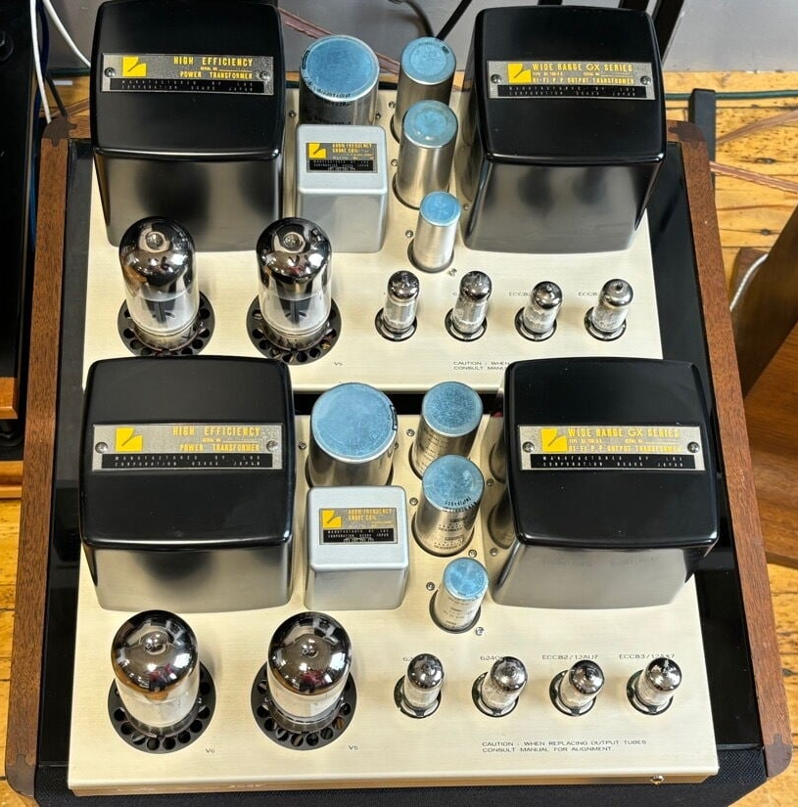
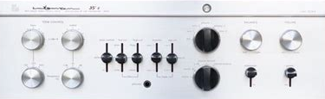
Luxman’s top-tier tube offerings of the era were refined, airy, and dynamically satisfying. The MB-3045’s 8045G output tubes gave them an exotic flavor, with plenty of headroom and finesse. Paired with the versatile CL-35 preamp, it was Japan’s answer to McIntosh. I loved selling Luxman. Not only did they look and sound amazing, they NEVER FAILED!
Why they’re unicorns: The rare tubes and service complexity scare off many buyers, but those in the know treasure them. Fully restored examples are scarce and getting more so.

Mark Levinson ML-1 and ML-2 Monoblocks
Year Introduced: 1977–1978
Power Output: 25 watts/channel (ML-2, Class A)
Original Price: ~$1,895 (ML-2 pair), ~$1,200 (ML-1)
Current Mint Rebuilt Price: $6,000–$10,000
Production Numbers: Very low
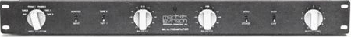
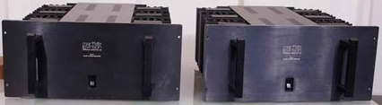
These weren’t just high-end—they were laboratory-grade. The ML-1 preamp was all discrete, while the ML-2 monoblocs ran full Class A and could drive electrostats or ribbons with uncanny control and grace. Quirky, hot-running, but sonically breathtaking. Mark Levinson is now 78 years old, but I still hear from him from time to time. He along with Nelson Pass are probably the two best designers still living.
Why they’re unicorns: They were niche products in their own time. Today, they're almost folklore. Most have lived hard lives, so finding a clean set is a rare joy.

Final Thoughts
What defines a unicorn isn’t just scarcity, it’s the convergence of great sound, bold design, and the sense that you’ve stumbled onto something almost forgotten. Each of these separates earned its place by outperforming its era and lingering in the minds of those who heard them. In truth they may be older than your parents, but they can still perform like an amorous teenager.
These unicorns aren’t relics—they’re invitations.** When you restore a Marantz 7 or spin vinyl through a Bedini 25/25, you’re not just hearing history—**you’re communing with the obsessives who defied commerce to chase sonic perfection.** Saul Marantz, Nelson Pass, William Z. Johnson—they built art that outlived spreadsheets.
So, hunt fiercely. Buy patiently. Restore meticulously. And when you power up that first recapped circuit… **you’ll feel the magic that made hi-fi holy.
Restoration matters. A tired vintage amp is just a project; a properly restored one is a revelation. When done right, these units not only bring you closer to the music, they bring you into the workshop and boardroom where hi-fi history was made.
If you want to own something far beyond what your rich friends listen to without spending your 401K to do it, any of these examples make a great choice.
These components weren’t just made—they were willed into existence by visionaries like Saul Marantz, Nelson Pass, and William Zane Johnson. Their designs weren’t about hitting price points; they were about making gear that stood the test of time.
And they did.
Whether you’re chasing clean vinyl tone, brute-force power, or minimalist design, these unicorn separates offer more than nostalgia. They deliver performance with personality, and they reward the kind of obsessive curiosity that built the audio hobby in the first place.
And if you find one? Don’t hesitate. These don’t come along very often.
- Sourcing and Pricing Notes
- Prices listed here reflect mint, restored examples—often the result of months of work and several hundred dollars in parts. Bargain hunters may find unrestored units for less, but you’ll need patience, soldering skills, or a trusted tech.
- Where to Find Unicorns:
- Markets: US Audio Mart, HiFi Shark
- Forums: Audiokarma, DIYAudio, The Vintage Knob
- Restorers: Analog Restorations (NYC), Classic Audio Repair (CA)
- Warning: Budget for surprises. "Mint restored" often means $500+ in parts and 100+ hours of labor.
If you’re ready to own gear your rich friends have never even heard of—and won’t soon forget—this is your short list.
"Modern Alternatives" Sidebar
Can’t Find These? Try Their Spiritual Successors
Vintage Unicorn | Modern Equivalent | Why It’s Similar
Marantz Model 7 | Schiit Freya | Tube/SS hybrid, great phono
Bedini 25/25 | First Watt J2 | Class A purity by Nelson Pass
Threshold 400A | Usher R1.5 | Same muscle/finesse blend

