Indigenous Peoples of the Amazon
By: Marc Silver
The Amazon rainforest, often called "the lungs of the Earth," is not just a vast ecological wonder, it's also home to over 300 indigenous tribes whose cultures predate the Roman Empire. These communities have thrived along the winding banks of the Amazon River for millennia, passing down language, knowledge, and tradition through generations. Today, they face unprecedented threats: illegal mining, deforestation, and climate change jeopardize both their lands and their ancient ways of life.
As you prepare for your journey to Brazil, understanding these guardians of the forest will transform your visit into something deeper than a sightseeing trip. These are living cultures with extraordinary insight into what it means to live in harmony with nature.
222 Major Indigenous Groups Along the Amazon
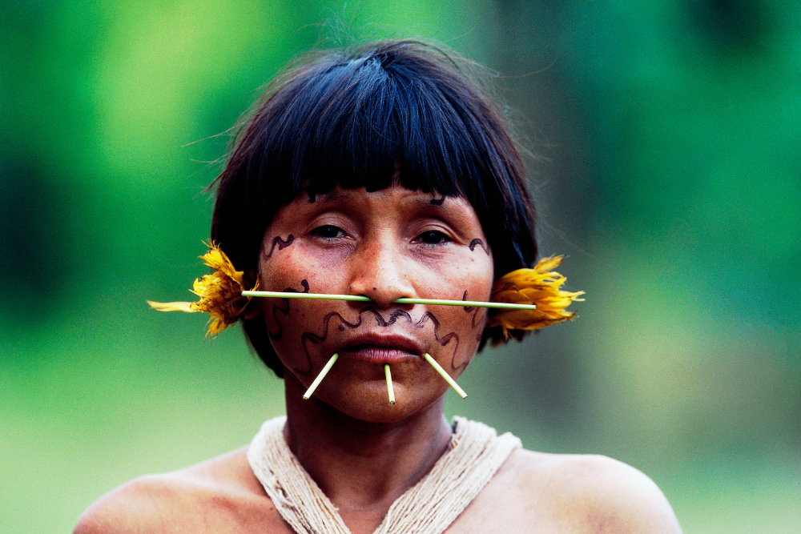
The Yanomami: Bridging Worlds 22
With approximately 35,000 members living in the northern Amazon across Brazil and Venezuela, the Yanomami are one of the largest relatively isolated groups in South America. Their circular communal houses, called shabonos, reflect their egalitarian society. Within these structures, generations live, work, and participate in communal rituals.
The Yanomami are known for their deep botanical knowledge, over 500 plant species used for medicine, food, and tools. Shamans play a central role, guiding the community through rituals involving yopo, a hallucinogenic powder used to communicate with the spirit world. As shaman Davi Kopenawa has said, "The white man's hunger for gold is devouring our forest."
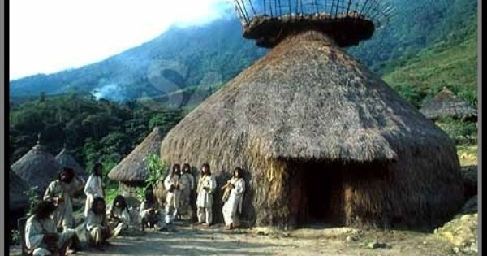
That hunger has recently intensified. Illegal gold mining surged by 30% in Yanomami territory in 2022, polluting rivers with mercury and introducing disease to isolated villages.
The Kayapó: Warriors of Resistance
The Kayapó people, about 8,500 strong, inhabit the southern tributaries of the Amazon River. Their territory, roughly the size of Austria, is fiercely protected. Why do the Kayapó paint their bodies? These intricate patterns aren't just decorative; they signify clan identity, social status, and spiritual protection.
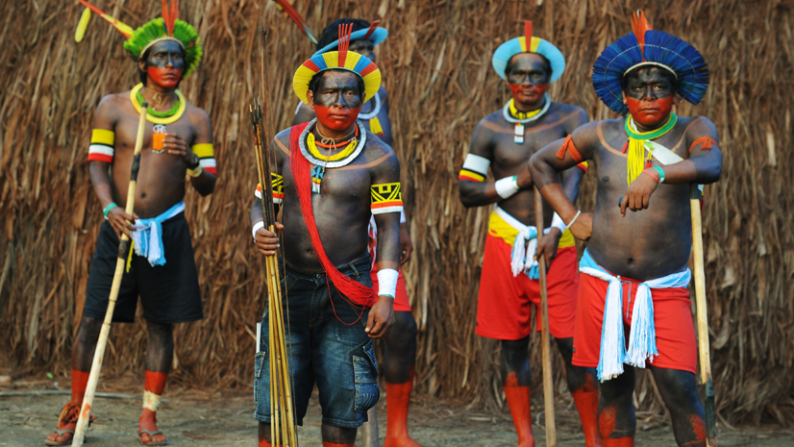
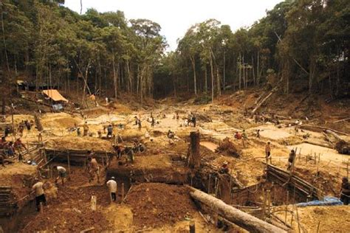
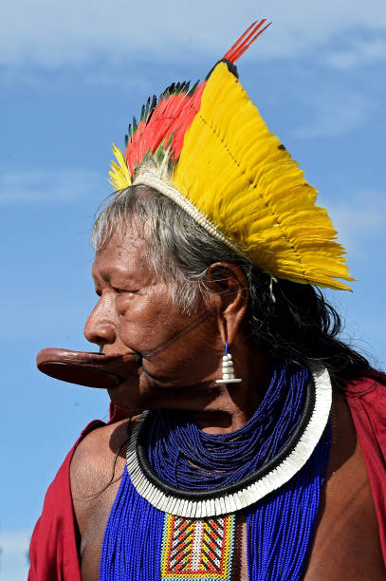
The Kayapó have gained global attention through their organized resistance to environmental exploitation. Chief Raoni Metuktire became a symbol of indigenous resistance after successfully halting dam projects that threatened to flood ancestral lands. "We fight not just for our land, but for the future of the forest," he told international audiences.
Their honey cooperative, Mel dos Kayapó, offers a glimpse of what sustainable development looks like. It provides income, funds education and healthcare, and helps preserve over 10 million hectares of rainforest.
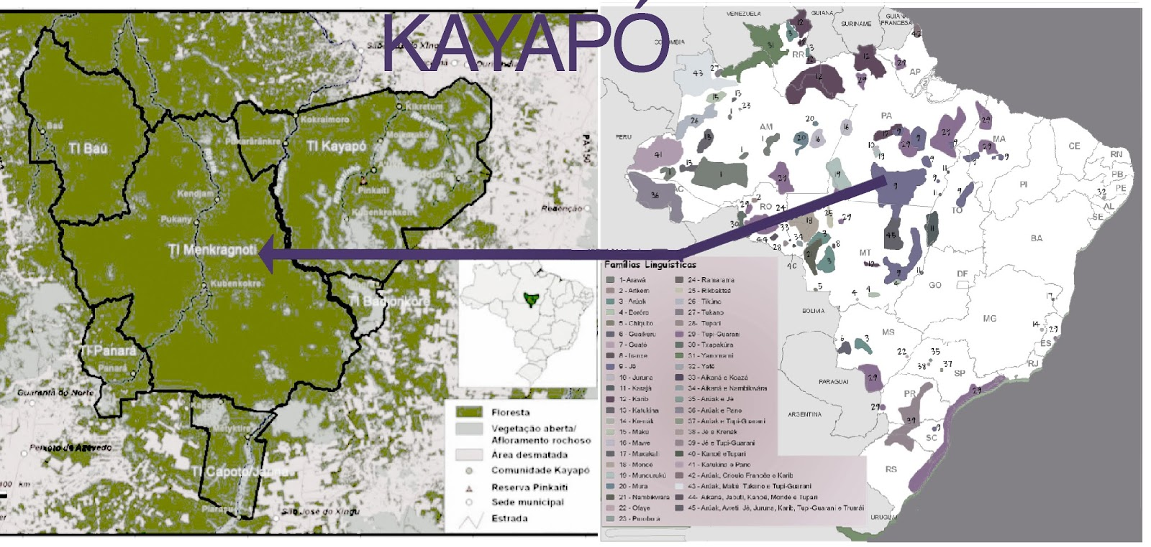
The Munduruku: Defenders of the Tapajós
Primarily based along the Tapajós River, the 13,000-member Munduruku tribe have long been known for their warrior traditions. Today, their battles take place in courtrooms and environmental hearings rather than with spears. In 2023, they successfully blocked a major hydroelectric dam project that would have inundated their territory.

The Munduruku practice sustainable hunting and fishing and maintain matrilineal clans, with heritage passed down through the mother's line. Their facial tattoos, once marks of warrior status, remain visible symbols of cultural pride. "The river is our ancestor," says community leader Alessandra Korap. "We will never stop fighting for it."
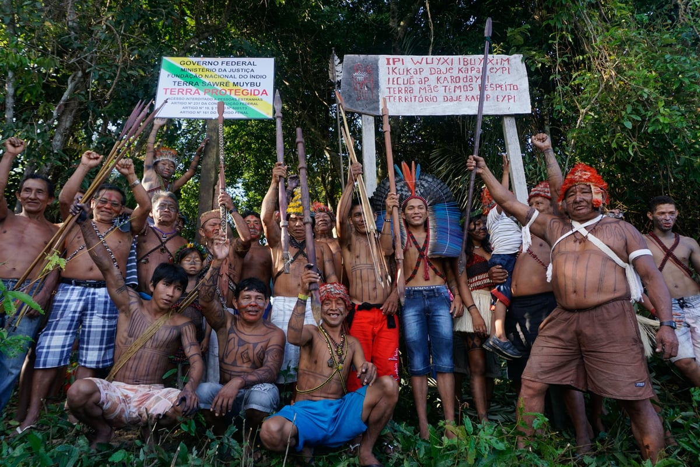
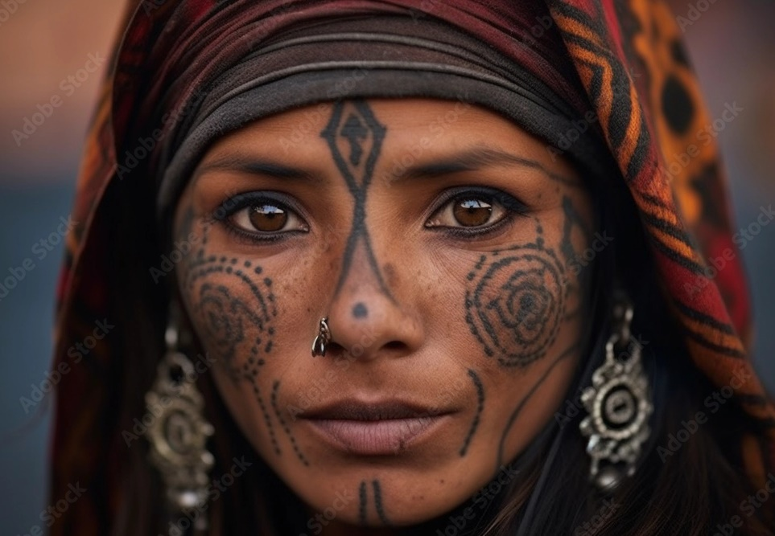
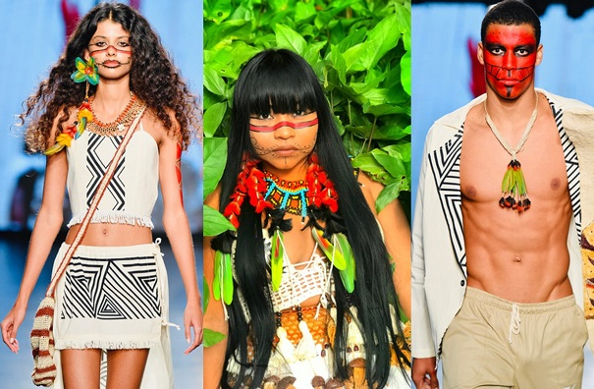
The Tikuna: Artists of the Upper Amazon
The Tikuna (also spelled Ticuna) are the largest indigenous group in the Brazilian Amazon, numbering over 50,000 people. They live in the upper Amazon near the tri-border region of Brazil, Colombia, and Peru.
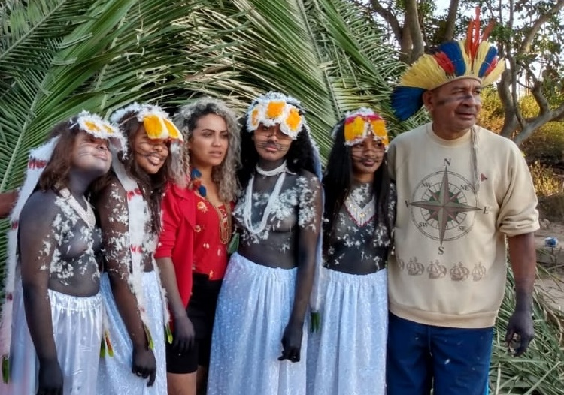
The Tikuna are celebrated for their vibrant artistic traditions, including bark cloth paintings, carved wooden figures, and ritual masks. Central to Tikuna culture is the Festa da Moça Nova, a girl's coming-of-age ceremony filled with music, elaborate costumes, and ritual performances.
Far from being frozen in time, the Tikuna are adapting. Today, Tikuna youth use social media to raise awareness about land rights and environmental issues, blending digital tools with ancestral storytelling. [7]
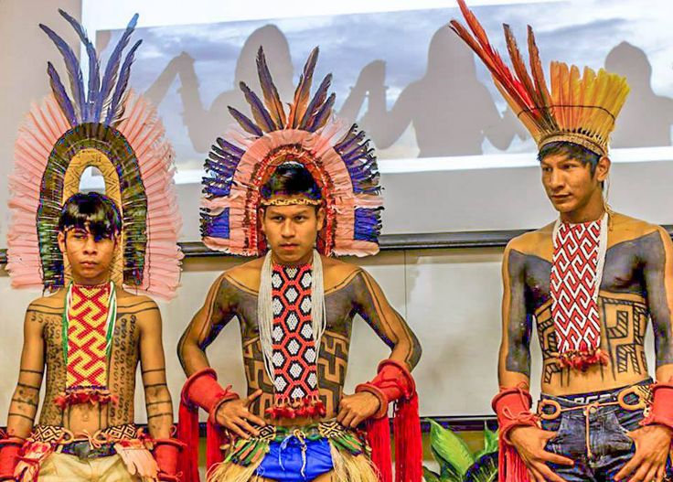
The Karajá: Keepers of the River
Along the Araguaia River live the Karajá, a group of about 4,000 people known for their fishing prowess and ceramic artistry. Their ritxoko dolls, which depict daily life and ancestral spirits, have been recognized by UNESCO as cultural heritage. [8]
The Karajá hold the river at the center of their cosmology. It is the birthplace of their myths and the highway of their subsistence. Traditional body paint and ritual songs continue to express identity, while digital archives and school programs help preserve their language.
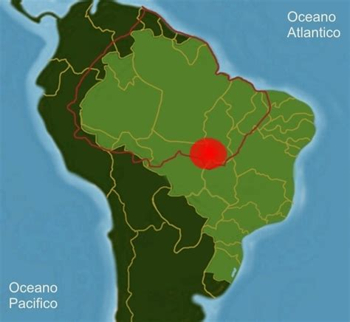
Indigenous Life Today: Tradition Meets Modern Challenges
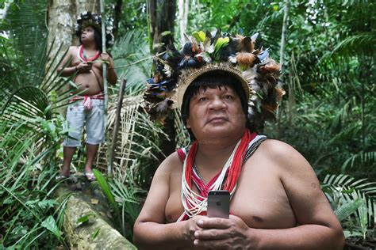
Many Amazonian tribes walk a delicate line between ancient tradition and modern survival. Some remain completely isolated, while others engage with technology, political activism, and education.
Key Contemporary Challenges:
- Land Rights: While legal recognition of indigenous land has improved, enforcement is weak. Encroachment by loggers, miners, and developers continues.
- Environmental Threats: Deforestation and mining in Yanomami territory reached a 15-year high in 2023.
- Health Concerns: Diseases introduced by outsiders, including measles outbreaks caused by unauthorized tours, remain a major threat.
- Cultural Preservation: Many communities now run language revival programs, digital storytelling projects, and sustainable enterprises that merge tradition with innovation.
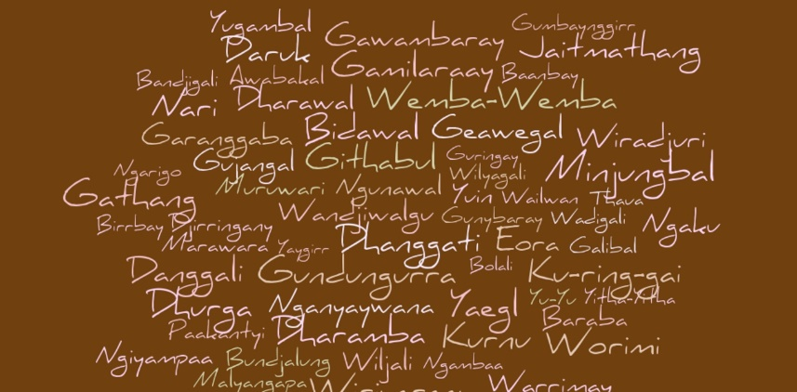
Examples of cultural resilience are everywhere. The Munduruku’s legal victories, the Kayapó’s forest-based honey production, and the Tikuna's digital advocacy efforts all illustrate how tradition and modernity can coexist.
Respectful Tourism: Engaging with Indigenous Culture
Travelers interested in indigenous cultures must approach with respect, not voyeurism. These communities are not museum pieces, they are living, evolving societies.
Guidelines for Ethical Engagement:
- Visit with Authorization: Only enter communities through organized programs with proper permissions. The Tukano Cultural Center in Manaus, for instance, hosts events and workshops led by Tikuna artisans.
- Avoid Unauthorized Tours: These can inadvertently introduce disease or exploit communities.
- Support Indigenous Enterprises: Buy directly from cooperatives such as Wariró in São Gabriel da Cachoeira to ensure artisans benefit.
- Ask Before Photographing: Many communities have specific rules about photography. When in doubt, ask, and respect refusals.
- Learn Before You Go: Understanding a community’s history and current challenges deepens your experience and reduces unintentional harm.
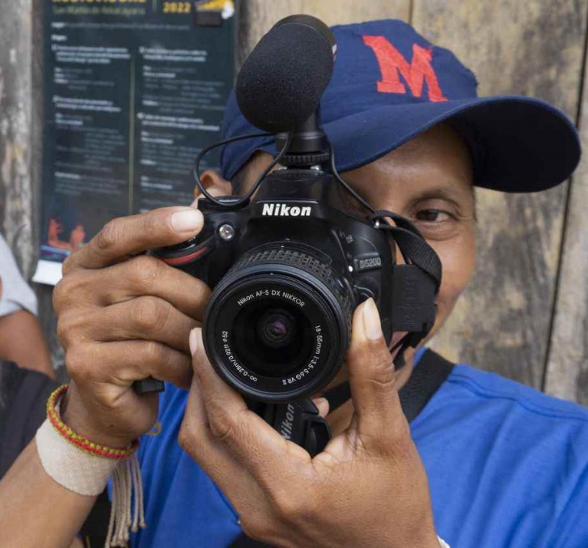
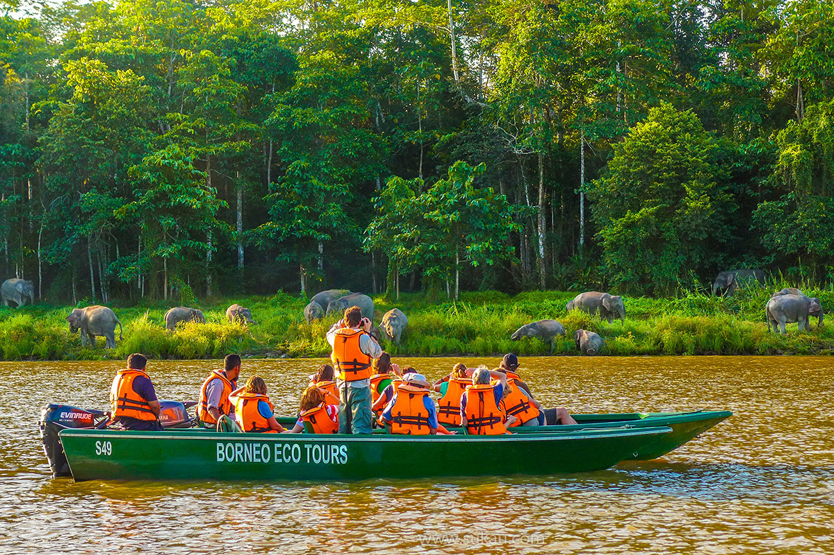
Unforgettable Cultural Experiences
If you're looking to engage meaningfully, several ethically managed opportunities allow for direct, respectful cultural exchange:
- Museum of Indigenous Peoples (Manaus): A well-curated institution with exhibits on Amazonian spirituality, daily life, and art.
- Rio Negro Ecotours: These indigenous-led tours teach forest medicine and fishing practices.
- Festa da Moça Nova: With prior arrangement, some Tikuna communities allow outsiders to witness this celebration. It has been described as "a living tapestry of heritage."
- Craft Cooperatives: Purchase authentic, fair-trade ceramics, baskets, and textiles from cooperatives that return profits to their communities.
Final Thoughts: Your Role in the Story
The indigenous peoples of the Amazon are not relics of the past. They are guardians of the forest and stewards of some of the world’s most sophisticated ecological knowledge. As you journey through these lands, remember: losing their territory is like burning a library of irreplaceable wisdom.
Your journey doesn’t end when the trip is over. You can advocate for sustainable policies, support indigenous media, donate to nonprofits like Amazon Watch, or simply amplify their stories. The forest breathes through these people. To preserve one, we must respect and defend the other.

References
[1] Survival International. "The Yanomami." https://www.survivalinternational.org/tribes/yanomami
[2] Mongabay. "Gold mining in the Amazon: The new threat to indigenous lands." https://news.mongabay.com/2022/12/illegal-gold-mining-surges-in-brazilian-amazon/
[3] BBC News. "Kayapó Chief Raoni: Defender of the Amazon." https://www.bbc.com/news/world-latin-america-50080373
[4] Instituto Socioambiental. "Mel dos Kayapó Project." https://www.socioambiental.org/en/projetos/mel-dos-kayapo
[5] Reuters. "Brazil court halts Amazon dam project after Munduruku protests." https://www.reuters.com/world/americas/brazil-court-stops-dam-project-after-indigenous-protests-2023-06-05/
[6] The Guardian. "Indigenous women fight to save the Tapajós River." https://www.theguardian.com/environment/2023/mar/17/indigenous-women-brazil-river-dam-fight
[7] Cultural Survival. "Tikuna Youth Embrace Digital Tools." https://www.culturalsurvival.org/news/tikuna-youth-digital-activism
[8] UNESCO. "Ritxoko Dolls: Cultural Heritage of the Karajá People." https://ich.unesco.org/en/USL/ritxoko-dolls-of-the-karaja-people-01358
[9] Amazon Watch. "Illegal Deforestation in Indigenous Lands." https://amazonwatch.org/news/2023/0201-deforestation-on-indigenous-lands-hits-record-high
[10] WHO. "Measles outbreaks in uncontacted tribes." https://www.who.int/news-room/feature-stories/detail/measles-and-the-threat-to-isolated-tribes

