Idaho Wine Regions

1. Region Overview
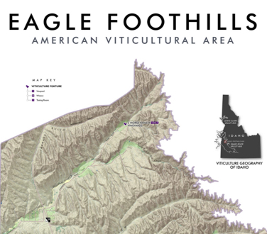
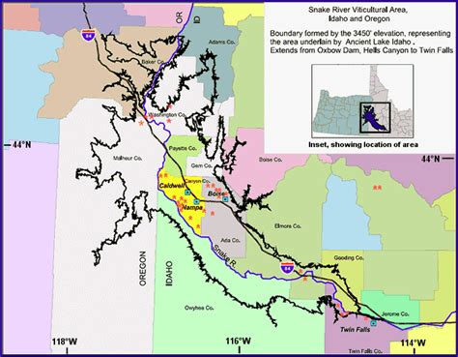
Idaho, nestled in the Pacific Northwest, is an emerging star in the American wine scene, characterized by its high-elevation vineyards (1,500–3,000 feet) and dramatic continental climate. The state’s two AVAs—Snake River Valley (established 2007) and Eagle Foothills (2015)—span rugged landscapes shaped by ancient volcanic activity and the winding Snake River. Cold winters, hot summers, and significant diurnal temperature swings (up to 40°F) preserve acidity and extend hang time, fostering balanced, structured wines. Volcanic soils, alluvial deposits, and loess dominate the terroir, providing excellent drainage and minerality.
With just over 1,300 acres under vine, Idaho’s wine industry is small but dynamic, producing less than 1% of U.S. wine. Despite its scale, the state earns acclaim for cool-climate whites and bold, high-altitude reds, blending Old World restraint with New World fruit expression.

2. Key Grape Varieties
Primary Red Varieties:
- Syrah: Thrives in Snake River Valley’s warm days and cool nights, offering blackberry, smoked meat, and violet notes.
- Cabernet Sauvignon: Grown in warmer microclimates, yielding structured wines with cassis and herbal undertones.
- Tempranillo: Emerging in Eagle Foothills, showcasing red cherry, leather, and tobacco.
Primary White Varieties:
- Riesling: Idaho’s signature white, ranging from bone-dry to off-dry, with lime, peach, and petrol complexity.
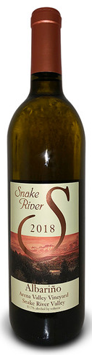
- Viognier: Aromatic and textural, exuding apricot, honeysuckle, and crushed stone.
Heritage/Notable Varieties:
- Chardonnay: Adaptable to both crisp, mineral-driven styles and richer, oak-aged expressions.
- Lemberger (Blaufränkisch): Cold-hardy red with tart cherry and spice, reflecting German immigrant influence.
International Varieties:
Malbec, Petit Verdot, and Albariño are gaining traction, particularly in experimental vineyards.

3. Wine Classification System
Idaho’s two AVAs emphasize elevation and geologic diversity:
- Snake River Valley: The largest AVA, spanning 8,000 square miles across southern Idaho and into Oregon. Volcanic soils and high elevation (2,500–3,000 feet) define its terroir, ideal for Riesling, Syrah, and Cabernet Franc.
- Eagle Foothills: A sub-AVA within Snake River Valley, with warmer, lower-elevation slopes (1,500–2,500 feet) suited to Bordeaux varieties like Merlot and Cabernet Sauvignon.
Like all U.S. regions, Idaho lacks regulated production standards beyond the 85% grape origin rule for AVA labeling.

4. Notable Wine Styles
Snake River Valley Riesling (AVA)
- Composition: 100% Riesling, often with a touch of residual sugar.
- Production Method: Stainless steel fermentation, early harvesting to retain acidity.
- Alcohol Content: 11–12.5% ABV.
- Organoleptic Profile: Green apple, lime zest, and wet stone, with a crisp, mineral finish.
- Market Position: Compared to Germany’s Mosel Rieslings for freshness, yet distinct for Idaho’s volcanic minerality.
Eagle Foothills Syrah (AVA)
- Composition: 85–100% Syrah, sometimes blended with Viognier.
- Production Method: Hand-harvested, whole-cluster fermentation, aged 12–18 months in neutral oak.
- Alcohol Content: 13.5–14.5% ABV.
- Organoleptic Profile: Blackberry, smoked bacon, cracked pepper, and a savory finish.
- Sub-categories: “Reserve” bottlings highlight single-vineyard intensity.

5. Additional Context
Recent Developments:
- Sustainability: Over 30% of vineyards adopt sustainable practices, including drip irrigation and solar energy, with certifications like Idaho Preferred.
- Climate Adaptation: Frost-resistant clones and wind machines mitigate spring frost risks in high-elevation sites.
Historical Context:
Modern viticulture began in the 1970s with pioneers like Ste. Chapelle Winery, Idaho’s oldest operating winery. The 2000s saw a quality revolution, with boutique wineries elevating the state’s reputation.
Food Pairings:
- Snake River Valley Riesling with Idaho rainbow trout or spicy Thai curry.
- Eagle Foothills Tempranillo with smoked brisket or huckleberry-glazed pork.
- Viognier with goat cheese tart or roasted butternut squash.
Key Producers:
Sawtooth Winery (Riesling pioneers), Koenig Vineyards (barrel-aged whites), Cinder Wines (Syrah specialists), and Telaya Wine Co. (Snake River Valley blends).
Takeaway for Sommeliers:
Idaho’s strength lies in its high-elevation terroir and value-driven quality. Highlight its volcanic minerality and emerging reds as alternatives to pricier West Coast regions. Embrace its underdog narrative for storytelling.
Final Thoughts:
A frontier of resilience and innovation, Idaho transforms its rugged landscapes into wines of purity and character, proving that great wine thrives where mountains meet the sky.

Citations:
- Idaho Wine Commission. Vineyard & Winery Report. 2023.
- Haeger, J. Pacific Northwest Wines: A Comprehensive Guide. 2018.
- “Idaho’s Rising Stars.” Wine Enthusiast, 2022.

