Hybrids,
Are they the Labradoodles of the Wine Industry?
By: Marc Silver
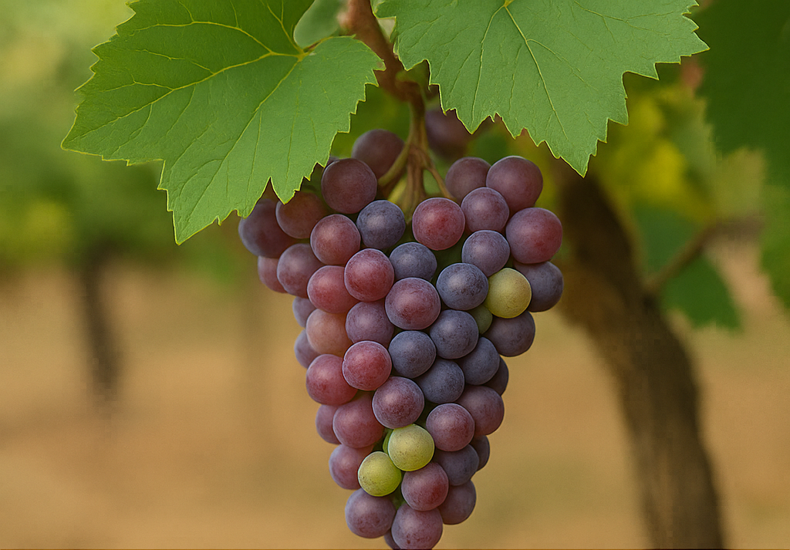
Ever tasted a wine made from grapes that could survive a Minnesota winter? If so, you might just be sipping the future of viticulture.
Over the last several decades, the wine industry has faced a shift in production techniques and the exploration into new wine varietals. Many staunch wine advocates have taken a position in opposition to the development of new wine varietals, arguing that wine is an art form and genetically enhanced wine has no place in the industry.
Others believe that if the wine industry is going to survive, wine grapes need to adapt as worldwide conditions change due to global warming.
This article is intended to examine the interest in hybrid wine, why and where hybrid varietals are being developed, and what the future holds for these created wine varietals.
Unlike Labradoodles and Cockapoos, hybrid wines are not being developed as a fashion statement. Simply put, new wines are not being created because someone thought it was a “cute” idea. Hybrid wines are being researched and developed at prestigious viticultural universities, such as U.C. Davis in Northern California, out of a growing need.
As the wine industry expands across the world and weather patterns are shifting due to global warming, the traditional wine varieties like Cabernet Sauvignon or Chardonnay are under pressure to adapt to this new ever-changing man-made environment.
In some cases, however, as wine spreads into areas not normally well suited to these varieties—areas like Oklahoma or Nebraska—wineries need to be more creative if they want to produce wine. Perhaps crossing native varieties such as Norton with Merlot or Pinot Noir can produce a hybrid wine that is complex and interesting, yet capable of withstanding the harsher environment far from their native regions and terroir.
Let’s take some time to explore some of these wine hybrids and discover what the impetus was behind their creation.
What Exactly Is a Hybrid Grape?
A hybrid grape is a cross between two different grape species, typically one from the European vitis vinifera family and one from a North American species like vitis labrusca or vitis riparia. The aim is to combine the desirable characteristics of both: the refined flavors of vinifera with the hardiness and disease resistance of native American grapes.
These aren’t genetically modified organisms (GMOs) in the lab-made, sci-fi sense. Most hybrids are bred the old-fashioned way—cross-pollinating two different plants and selecting the offspring with the best traits. It's slow work, and often thankless. Many hybrids fail. But the ones that succeed can do something remarkable: thrive where no other vine can grow.
Why the Push for Hybrids Now?
Now that we know what hybrid grapes are, let’s explore why they’ve become such a hot topic.
Climate change is the short answer. As summers grow hotter, winters become more unpredictable, and weather events turn violent, traditional wine regions are experiencing challenges they weren’t bred for. Frosts come too late or too early. Pests and fungal diseases that were once rare now flourish.
And here’s the kicker: traditional European vinifera grapes are delicate. Think of them as the purebred poodles of the wine world. They need a very specific kind of care. Hybrids, by contrast, are more like Labradoodles, resilient, adaptable, and better suited to unfamiliar conditions.
In places like Quebec, Minnesota, and parts of Eastern Europe, hybrid grapes have allowed winemakers to thrive where classic vinifera simply couldn’t.
A Brief History of Wine Hybrids
Wine hybrids aren’t new. In fact, they’ve been around since the 1800s. After phylloxera wiped out most of Europe’s vineyards in the 19th century, winemakers began looking to North American vines for help. These native vines were naturally resistant to the phylloxera louse, though they weren’t especially good at producing drinkable wine.
The solution? Cross them. The early results were often dismissed as “foxy,” a euphemism for tasting a little like a wet dog. But over time, some hybrids improved.
By the mid-20th century, the use of hybrids was booming, especially in colder climates and emerging wine regions. But they faced stiff resistance in Europe, where wine laws heavily favored vinifera. France, for example, banned the use of many hybrids in AOC-designated wines.
Still, they hung on. And now, as climate instability grows, hybrids are getting a second look.
Popular Hybrid Grapes You Should Know
Let’s start with a few names you might actually encounter.
Marquette – Developed by the University of Minnesota, Marquette is a cold-hardy hybrid descended from Pinot Noir and a complex mix of American and French varieties. It ripens early and survives winter temperatures as low as -36°F, making it a favorite in northern U.S. regions. The wine it produces is light to medium-bodied with flavors of cherry, blackcurrant, and baking spice. Its moderate tannins and bright acidity make it food-friendly, especially with pork, duck, or roasted root vegetables.
Vidal Blanc – This French-American hybrid is a cross between Ugni Blanc (also known as Trebbiano) and another hybrid grape, Rayon d'Or. Vidal is valued for its thick skin and ability to withstand cold climates, particularly in Canada where it’s the dominant grape for ice wine production. The high sugar levels in its juice allow for richly textured dessert wines, yet it also produces clean, aromatic dry and off-dry whites with tropical fruit and citrus flavors. Vidal is often praised for its balance of acidity and richness.
Seyval Blanc – Created in France but embraced in England and the eastern U.S., Seyval is a hybrid of Seibel 5656 and Rayon d'Or. It’s known for its early ripening and high yield. Seyval can produce a crisp, unoaked white wine with notes of green apple, lemon, and flinty minerality. Some producers choose to barrel ferment or age it on lees to give it more complexity and body. Its refreshing style makes it a great match for seafood, salads, or goat cheese.
Chambourcin – One of the few teinturier hybrids (where the pulp is also red), Chambourcin is a French hybrid that produces a deep-colored wine with good tannin structure and aging potential. It’s often used for varietal wines or blends and has a flavor profile that includes blackberries, black cherries, plums, and earthy herbs. Unlike some other hybrids, Chambourcin can undergo malolactic fermentation and benefit from oak aging. It’s grown widely in the mid-Atlantic U.S., Australia, and France's Loire Valley.
Frontenac – Another cold-hardy creation from Minnesota, Frontenac is known for its versatility. It can be made into red, rosé, and even port-style wines. The grape has very high acidity, which requires careful winemaking to balance. Its flavor profile includes sour cherry, blackcurrant, and sometimes chocolate or tobacco depending on fermentation and aging choices. Despite its tartness, Frontenac is gaining traction among producers looking to create bold wines in unforgiving climates.
More Than Winter Warriors
While cold-weather performance is a major benefit, hybrids also offer resistance to fungal diseases like downy mildew, powdery mildew, and black rot. These issues are made worse by humidity and unpredictable rains—and they require extensive spraying to manage in traditional vineyards.
Hybrids, by contrast, need fewer chemical treatments. That makes them appealing to growers pursuing sustainable or organic practices. In regions like the Hudson Valley or Virginia, hybrids offer a chance to make wine with less intervention.
From Snub to Sip: The Hybrid Reputation Shift
Let’s be honest: hybrids used to have a branding problem. They were the underdogs, often associated with cheap, overly sweet, or just plain weird wines. Even today, some sommeliers turn up their noses to hybrids.
Why? Traditional vinophiles, especially those steeped in Old World traditions, often regard hybrids as impostors. In their view, true wine comes from vitis vinifera, full stop. These purists argue that hybrids lack the subtlety, structure, and ageability of classic vinifera wines. They’re also seen as unpredictable: where vinifera has centuries of reference points, hybrids are still a bit of a gamble, with a smaller body of work to judge from.
There’s also a lingering sense of classism. Hybrids, especially in the U.S., have long been associated with underfunded growers in marginal regions. If Bordeaux is the Ivy League, then hybrids are the scrappy state schools—underrated, practical, and surprisingly innovative. Add in early hybrid wines that truly were flawed—thin, overly acidic, or cloying—and the stigma stuck.
But that’s starting to shift. Younger winemakers are embracing hybrids not as second-tier options, but as unique varietals with stories worth telling. And they’re doing it without apology. In the U.S., small producers in the Finger Lakes, Vermont, and even Ohio are making hybrids trendy. Europe is seeing the rise of so-called "PIWI" grapes (fungus-resistant varieties) in Austria and Germany.
This generation of drinkers is also more open-minded. For many, sustainability trumps pedigree. If a hybrid wine is delicious, organically grown, and supports local agriculture? That’s a win, even if it can’t trace its lineage back to Burgundy.
Are They Here to Stay?
That depends on who you ask. Traditionalists argue that hybrids lack the nuance and age ability of vinifera wines. They believe the focus should be on adapting traditional grapes to new conditions through different farming practices.
But in an increasingly unpredictable world, resilience matters. Hybrids offer a lifeline. They may not replace Cabernet or Riesling, but they can complement them—filling in the gaps where classic grapes fall short.
For many growers, hybrids are less about replacing the old guard and more about ensuring there’s a future for wine at all.
Hybrids and the Future of Wine Culture
As more consumers explore outside the usual grape suspects, hybrids may well gain popularity for their novelty and their environmentally conscious appeal. Wine tourism may begin to celebrate regions not historically known for their vines: Wisconsin, Nova Scotia, even South Korea.
What we’re witnessing is the wine world adapting—not abandoning its traditions, but expanding them. Just as Labradoodles found a home in a world of purebred show dogs, hybrid wines are finding space in a field once dominated by Old World purity.
They’re not just a novelty anymore. They’re a necessity.
Takeaway?
Hybrid grapes are one of the tools that may help preserve the wine industry for the next generation. Whether you drink them for their climate resilience, their low-intervention farming benefits, or simply because you like how they taste, they deserve a spot at the table.
And who knows? In 20 years, the phrase "non-vinifera" might not sound like a compromise—it might sound like innovation.
References
- University of Minnesota Grape Breeding & Enology Program: https://mnhardy.umn.edu/wine-grapes
- UC Davis Viticulture & Enology Department: https://wineserver.ucdavis.edu/
- Vitis International Variety Catalogue (VIVC): https://www.vivc.de/
- Wine Enthusiast: "Hybrids Are the Future of Winemaking," https://www.winemag.com/2022/08/01/hybrid-grapes-wine-future/
- Decanter: "Are Hybrid Grapes the Future of Wine?" https://www.decanter.com/learn/hybrid-grapes-future-of-wine-463341/
- Wine Folly: "Hybrid Wine Grapes You Should Know," https://winefolly.com/tips/hybrid-wine-grapes/
- New York Times: "Climate Change and the New Era of Hybrid Grapes," https://www.nytimes.com/2023/09/15/dining/wine-hybrid-grapes.html

