Hoi An’s Trading Heritage
By: Marc Silver
Where Cultures Met and Never Quite Let Go
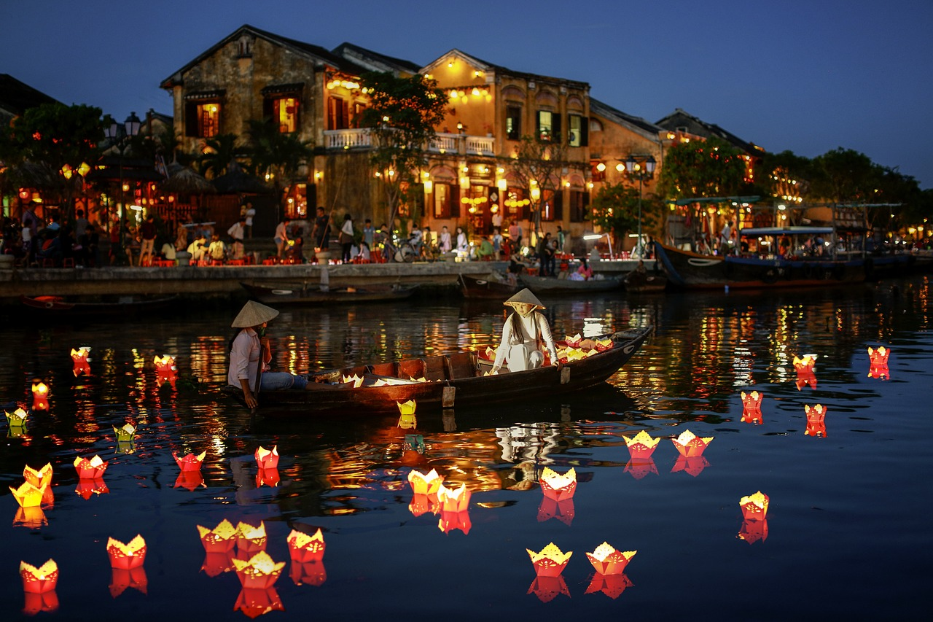
Hoi An doesn’t announce itself. It sidles up slowly, the way old port towns do when they know time is on their side. You step onto a narrow street washed in sunlight, yellow walls soft as old parchment, wooden beams darkened by centuries of river breeze, and it becomes clear that you’re standing inside a place shaped more by people coming and going than by anything that tried to stay still.
Stand by the Thu Bon River at dusk long enough and the present slips into the background. Lanterns glow over the water. Wooden sampans nudge the docks. Houses lean forward as if listening. It’s not nostalgia. It’s continuity. What you’re seeing is the same curve of river where sailors from Champa, China, Japan, Siam, and later Europe once tied off their boats. And whether anyone admits it or not, the city still carries the muscle memory of those encounters.
Hoi An’s secret is simple. Cultures came here, collided a bit, learned from each other, and refused to fully separate again.

Champa: The First Mariners of the Coast
Long before Vietnamese rulers managed the central coast or Chinese guilds laid bricks here, the region belonged to the Cham people, whose maritime strength defined this stretch of coastline for centuries. They sailed fast, built ports along trade routes that stretched deep into India and Indonesia, and helped move everything from spices to ceramics.
Hoi An—known then as part of a Cham-controlled territory—wasn’t yet the town we see today, but it was already a strategic stop. Cham sailors mapped these waters, ferried foreign traders up the Thu Bon, and linked inland communities with the sea. They left behind weaving traditions, architectural fragments, and place names that linger in the background of the city’s story.
Their influence matters, because when the Vietnamese state began expanding southward in the 15th century, it didn’t build a commercial hub from scratch. It inherited one.

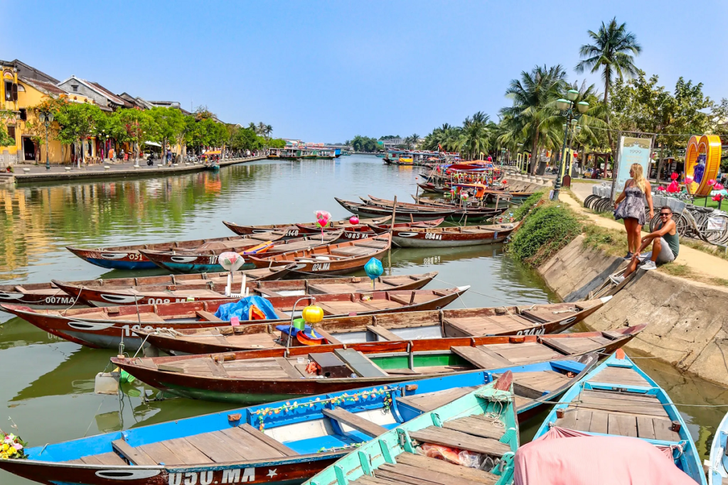
The River That Built a City
The Thu Bon River looks gentle, but it behaves like a negotiator. Tidal, deep enough for merchant ships, yet tucked inland just far enough to dodge typhoon-heavy seas. In the 1400s and 1500s, Vietnamese rulers recognized its value and invested in making this place a gateway for international trade. The Lê and then Nguyễn dynasties encouraged foreign merchants to settle, set up fair taxation, and kept the waterways secure.
Hoi An became one of Southeast Asia’s busiest ports from the 1500s through the 1700s, a stopping point on the maritime silk routes that stretched from Japan through China, into Siam and Melaka, across to India, and out toward Persia.
Portuguese, Dutch, and Spanish vessels started showing up along the central coast in the 16th century. They didn’t build colonial enclaves here the way they did elsewhere. Instead, they folded themselves into a system already running smoothly. Hoi An didn’t need reinventing. It needed room for everyone.
The town kept its human scale. Narrow streets, deep houses, shady courtyards. Traders stayed for months, sometimes years. Deals were made in open-air markets, at guild halls, under the rafters of long timber houses built by mixed-heritage families who understood the rhythms of multiple cultures at once.

A Japanese Quarter and a Bridge That Became a Symbol
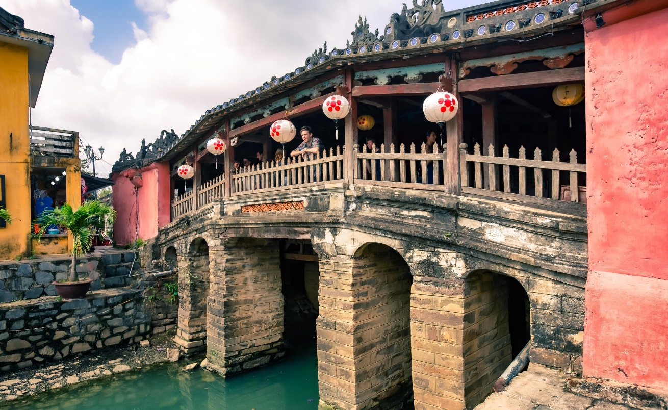
By the late 1500s, Japan entered a period of outward expansion. Merchant ships loaded with silver and Japanese lacquerware headed south, and hundreds of traders settled in Hoi An. They built homes, married local women, and created what became known as the nihonmachi—the Japanese quarter.
They weren’t tourists. They were specialists. Japan needed silk, and Hoi An’s silk was some of the best in the region. The trade was so profitable that many Japanese merchants stayed permanently. Their district sat opposite the large Chinese community. The two areas were divided by a canal, which prompted the construction of one of Hoi An’s most iconic structures: the Japanese Covered Bridge.
Part shrine, part walkway, part symbol, the bridge served not just as a physical connection but as a cultural handshake. Built in the early 17th century, it held a small shrine to the northern deity Bắc Đế Trấn Võ, protector of the region. It expressed in wood and stone what the town represented: cooperation across cultures.
When Japan later embraced sakoku, its isolationist policy in the 1630s, Japanese merchants were recalled home. Their quarter faded. The bridge stayed.
Vietnamese Life in a Multicultural Port
Hoi An wasn’t solely shaped by foreigners. Vietnamese officials, traders, artisans, and families formed the backbone of everyday life. They mediated deals, taxed incoming goods, built warehouses, patrolled the waterways, and managed everything from boat licenses to festival calendars.
Vietnamese families worked as translators, brokers, boatbuilders, farmers supplying the markets, woodcarvers shaping the roofs of merchant houses, and craft workers filling orders that came from Japan, Fujian, Guangdong, or Siam.
They were the ones who stitched the edges of this multicultural world together. They adapted recipes, adopted foreign building methods, borrowed language expressions, and blended religious practices across households. When you see an altar inside a merchant house that mixes Vietnamese Confucian practices with Fujianese protective deities and Japanese carpentry elements, you’re looking at Vietnamese agency—not just foreign influence.
This was never passive cultural absorption. It was negotiation, integration, and creativity.
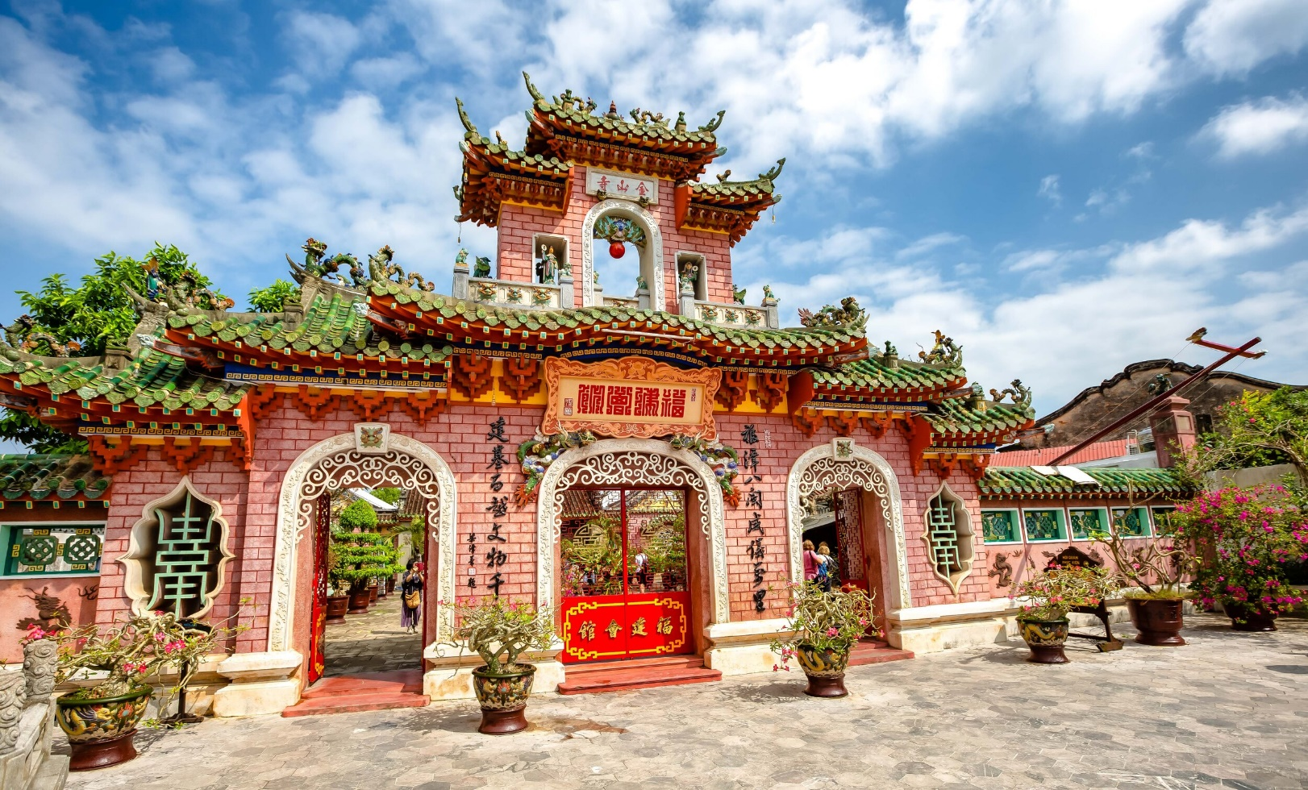
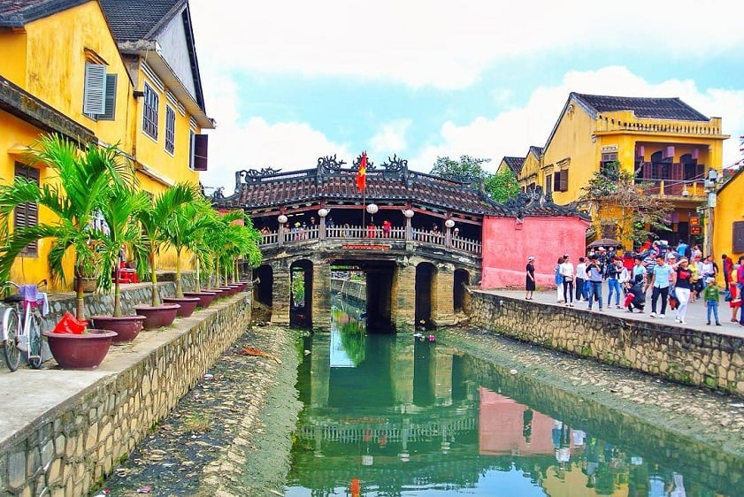
Chinese Guilds and the Heart of Urban Life
When Japanese traders left, Chinese merchants—especially from Fujian, Guangdong, Chaozhou, and Hainan—became the dominant economic force in Hoi An. They didn’t just trade. They organized.
Assembly halls acted as:
- business centers
- spiritual sanctuaries
- community support networks
- arbitration sites for merchant disputes
Inside the Phúc Kiến (Fujian) Assembly Hall, you see heavy lacquer beams, curling dragons, incense spiraling from the ceiling, and altars dedicated to deities who protected sailors and merchants. These halls helped Chinese communities maintain structure in a foreign land, but they also welcomed Vietnamese families, mixed-heritage households, and other groups.
Neighborhoods grew around these halls. Merchants built long houses near the river for easy access to boats. Temples appeared at intersections. Festivals from China merged with Vietnamese traditions, creating annual events that filled the town with color and noise.
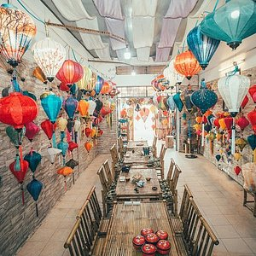
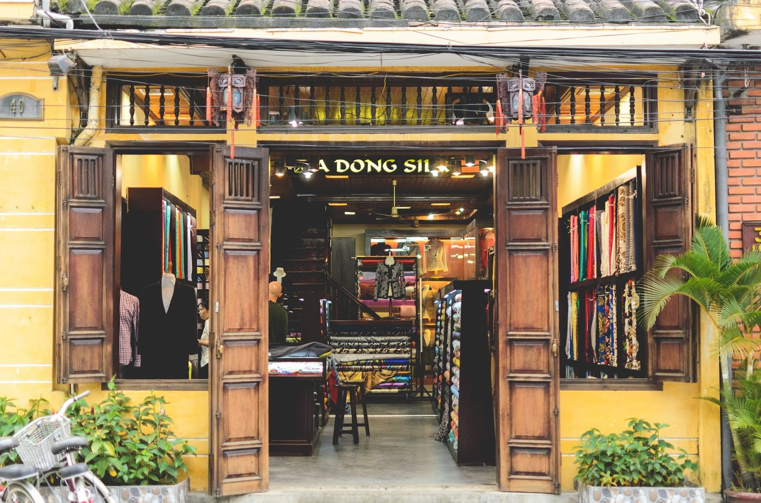
Craft, Skill, and the Engine of Trade
Silk
Silk weaving had ancient roots in the region and became central to Japanese–Vietnamese trade. Workshops operated behind merchant homes, producing lengths of fabric that traveled to Kyoto, Osaka, and Nagasaki.
Lanterns
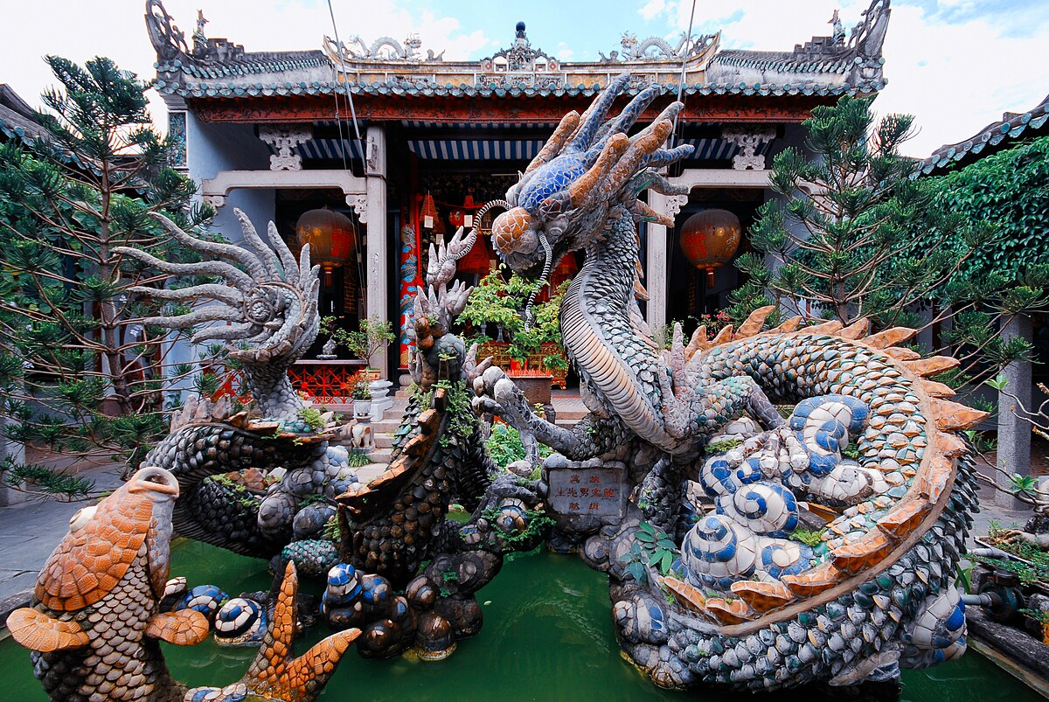
Lanterns, now iconic, were originally practical. Influenced by Chinese and Japanese designs, they lit merchant homes and temples. Their colors symbolized prosperity, protection, or good fortune. Modern lantern workshops keep the same bamboo ribs, silk coverings, and folding structure that families used centuries ago.
Tailoring
Hoi An became known for rapid, precise tailoring—a modern expression of long-held textile skills. While tourism accelerated demand, the foundation was already here.
Markets
Visit the market at dawn and you’re stepping into a centuries-old pattern: fish pulled from the river, rice noodles steaming on woven trays, herbs piled high. The soundtrack—quiet bargaining, baskets shifting, knives tapping—has hardly changed.
Craft wasn’t decoration in Hoi An. It was the economy.
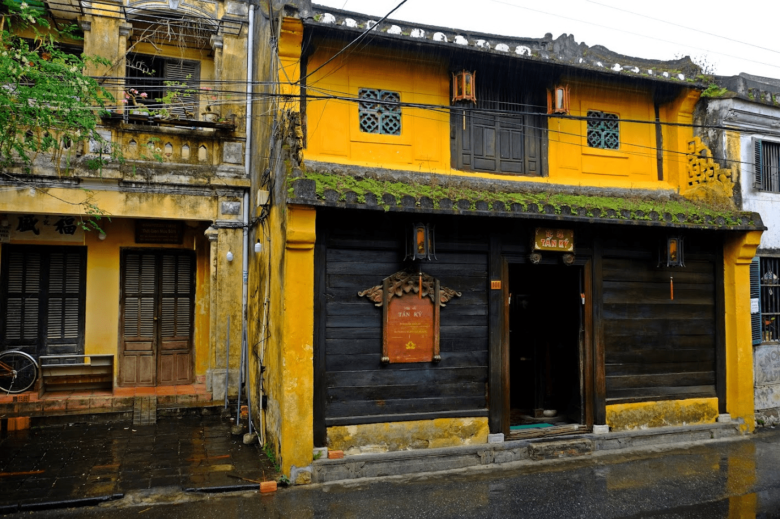
Merchant Houses: Architecture With a Memory
Walk into the Tan Ky house—a seven-generation merchant home—and the blend is unmistakable. Vietnamese layout, Chinese decorative motifs, Japanese joinery.
Why long and narrow?
Simply put…Taxes.
Merchants pay based on the width of the façade. So, they built houses like corridors: narrow facing the street, stretching far back with inner courtyards for airflow.
Why flexible joints?
Japanese carpentry techniques allowed wooden frames to shift with humidity and heat.
Why such ornate beams and altars?
Chinese symbolism and family-based religious practice.
What emerges is not a hybrid style created by accident. It’s a deliberate architecture that solved the practical needs of a trading community while reflecting the identities of the families inside.
Hoi An’s street plan mirrors the same logic. Homes doubled as storefronts. Warehouses sat close to the docks. Assembly halls sat at the center of neighborhoods because trade and community were inseparable.

Life in a Multicultural Port: The Social Side
Hoi An wasn’t just a place where cultures coexisted. They interacted, blended, and shaped each other.
Language
People spoke Vietnamese, Hokkien, Cantonese, Japanese, Cham, and Malay. Mixed families often spoke two or three languages at home.
Marriage
Intermarriage wasn’t rare—it was part of the city’s fabric. These families became cultural translators, landowners, and essential brokers between communities.
Festivals
Events fused beliefs: Vietnamese ancestral rites, Chinese deity festivals, and Japanese spiritual practices overlapped in calendars and ceremonies.
Cuisine
Food carried these intersections more directly than anything else.

Food as a Map of Cultural Exchange
Hoi An’s cuisine is a palimpsest—layer after layer written over older ones.
Cao lầu
A bowl of noodles with Japanese echoes (alkaline-water noodles), Chinese touches (pork and greens), and unmistakable Vietnamese flavor.
White rose dumplings
Delicate steamed dumplings influenced by Chinese dim sum traditions but adapted into a uniquely local version.
Chicken rice
Tied to Hainanese migration, now a Hoi An staple.
Cham spices
Subtle but present, especially in broths and grilled dishes.
Food in Hoi An isn’t simply “local.” It’s a map of centuries of trade compressed into a single meal.

A Port Built on Craft, Skill, and Merchant Ambition
Trade isn’t just numbers. It’s hands-on work. Hoi An grew because local artisans made goods worth shipping across oceans. Silk weaving thrived here long before Western traders arrived, and many families still pass down techniques through generations.
Lantern-making, now one of the city’s most recognizable traditions, traces directly back to Chinese and Japanese influence from the 16th and 17th centuries. The original purpose wasn’t tourism; lanterns lit merchant homes, guild halls, and altars. Their colors signaled prosperity and good fortune.
Tailor shops are a more modern expression of an old habit: rapid production of high-quality garments. For centuries, Hoi An specialized in textiles. When trade collapsed after the 18th century due to river siltation and shifting regional politics, the tailoring tradition survived in smaller, local forms until it revived with tourism in the 1990s.
Markets still do what markets have always done here. They anchor daily life. Walk through one early in the morning and you’re stepping into a pattern that hasn’t changed much in generations, fresh herbs, fish pulled from the river before sunrise, baskets of fruit and flowers, the low hum of bargaining.
The goods have shifted, the pace may be different, but the bones of commerce remain the same.

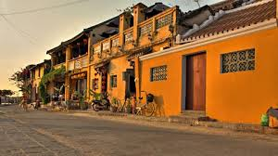
Merchant Houses and the Architecture of a Trading Town
Hoi An’s architecture is its greatest storyteller. The long, narrow merchant houses—like the Tan Ky house, which has been preserved by the same family for over seven generations—blend Vietnamese structure, Chinese decorative elements, and Japanese joinery techniques.
Why long and narrow? Taxes. Under old Vietnamese law, property tax was based on the width of the house fronting the street. Merchants built deep instead of wide, stacking living quarters, warehouses, and workspaces in a single property. Courtyards broke up the length, cooling the house and letting in light.
Timber frames used Japanese carpentry methods that allowed joints to flex in heat and humidity. Rooflines layered Chinese design elements with Vietnamese clay tiles. Inside, carved beams, mother-of-pearl inlays, and ancestral altars reflected the heritage of the families who built them.
Walk these streets and you see an entire urban plan shaped by trade. Houses doubled as storefronts. Warehouses sat close to the river for easy loading. Temples and assembly halls were never far from the commercial heart. Everything was placed with purpose, because in a trading world, time was money and access was everything.

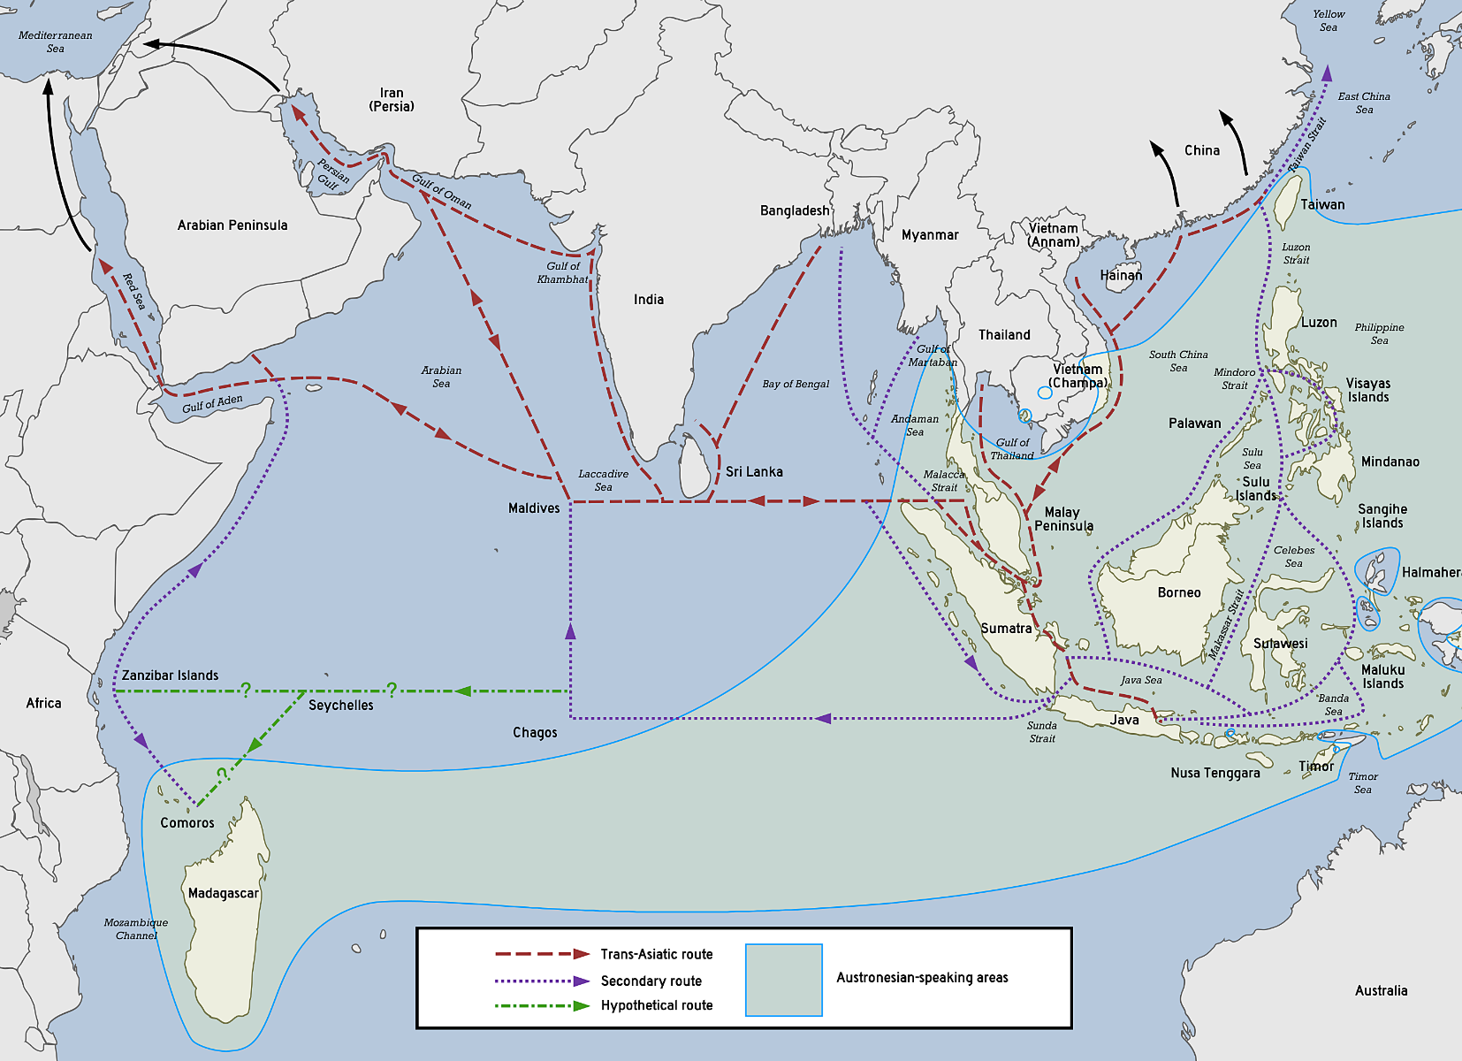
The Maritime Silk Road: Hoi An’s Global Neighborhood
Hoi An wasn’t provincial. It was global.
Goods passing through included:
- Vietnamese silk → Japan
- Chinese ceramics → Southeast Asia and beyond
- Spices from Malaysia and Indonesia
- Indian cottons
- Persian metalwork
- Vietnamese cinnamon, lacquerware, medicinal herbs
Foreign traders carried silver, copper, swords, porcelains, and even woolens from Europe.
Archaeologists still find fragments from Persia, Japan, China, Portugal, and India buried in Hoi An’s soil. These are not museum artifacts—they’re remnants of daily life.

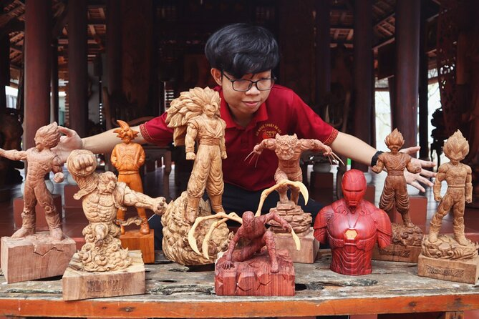
Lantern Festivals: Light as Cultural Memory
Hoi An’s modern lantern festival is popular, but its roots run deeper than tourism suggests.
Lanterns were used historically for:
- lighting merchant homes
- guiding boats along the river
- marking homes during festivals
- signaling prosperity or celebration
The monthly full-moon lantern festival draws from Vietnamese Buddhist tradition combined with older Chinese lunar rituals. What you see today—lanterns drifting on the river, music from the old town, candles glowing in shopfronts—is a contemporary expression of a long history of light marking community life.
The Decline of a Port and the Survival of a Town
Hoi An’s fall as a regional power wasn’t simple.
Siltation - The Thu Bon River began to choke with silt, making large vessels avoid it.
Japanese I solation - Japan’s sakoku policy cut off one of Hoi An’s most lucrative trade relationships.
Changes in Chinese trade - The fall of the Ming dynasty reshaped overseas merchant networks.
Rising European interests - Dutch and Portuguese ships prioritized other regional hubs.
Rise of Da Nang - A deeper, more accessible harbor suited changing political and commercial needs.
But the miracle is what happened next: almost nothing.
Hoi An stayed inhabited but avoided the waves of demolition and modernization that swept through Asian port cities in the 19th and 20th centuries. The result is an urban time capsule—not frozen, just preserved through a long period of quiet.

UNESCO and the Meaning of Preservation
UNESCO added Hoi An to its World Heritage list in 1999. It didn’t do this because the town is picturesque, though it is. It did it because the town is a rare example of:
- a perfectly preserved Southeast Asian trading port
- a multicultural urban layout reflecting Vietnamese, Chinese, and Japanese influence
- intact merchant houses that still match their historical forms
- living traditions maintained by local families
Hoi An isn’t a museum. It’s a living heritage zone.

Modern Hoi An: The Balancing Act
Hoi An’s challenge today isn’t survival—it’s managing popularity. Millions of visitors arrive each year. That brings income, jobs, and opportunity, but also strain.
To protect the historic core:
- Residents must follow preservation rules for altering houses
- Vehicle access is limited
- Businesses operate under guidelines to maintain the historic aesthetic
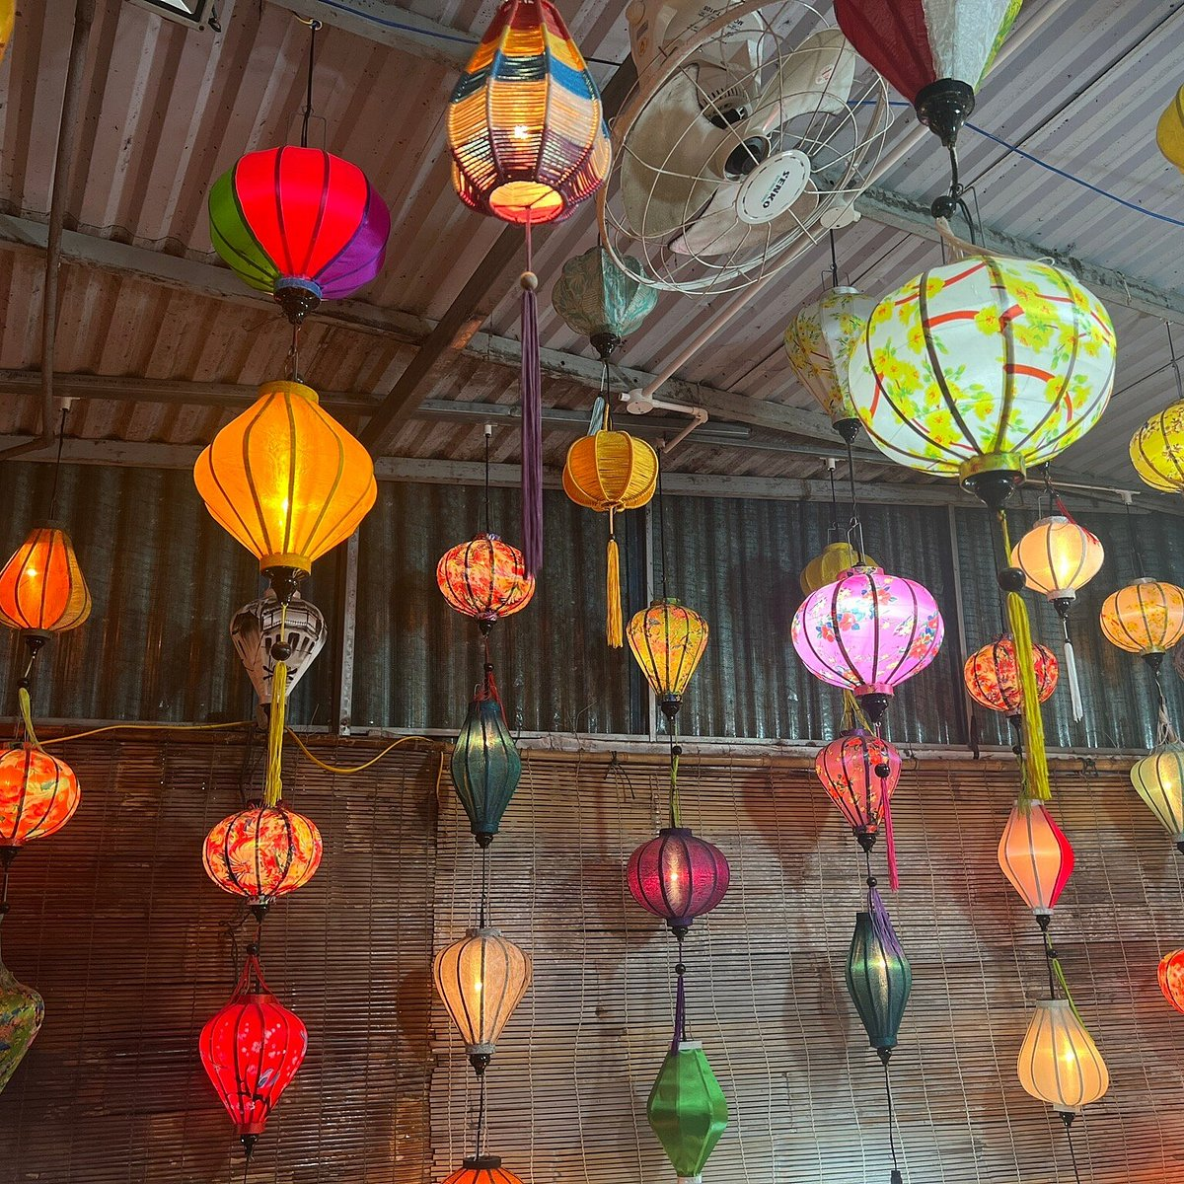
- Conservation efforts focus on the waterfront, temples, and old houses
Some families move out because tourism pressures make daily life harder. Others stay because these houses are part of their identity. It’s a delicate balance.
Hoi An is adapting, but carefully. Tourism funds restoration work. Community groups teach lantern-making, carpentry, and weaving to the next generation. And the river still guides the rhythm of the day just as it did centuries ago.
Southeast Asian Connections and Cultural Intersections
Hoi An wasn’t only shaped by Japan and China. Traders from Siam, Java, and the Malay world brought their own influences, some subtle, some lasting. Certain weaving patterns resemble Indonesian batik motifs. Traditional boat styles echo older Southeast Asian designs. Even local cooking carries faint traces of regional exchange, particularly in spice usage.
Vietnamese communities—Cham, Kinh, and ethnic minorities from the region—interacted with foreign traders daily. Some married into merchant families, creating tightly interwoven social networks. You can still taste it in dishes like cao lầu, a local noodle specialty tied to Japanese and Chinese heritage but ultimately unmistakably Vietnamese.
These cross-cultural connections weren’t theoretical. They were lived experience. Hoi An succeeded because people from different worlds needed each other. And over time, they shaped one another.
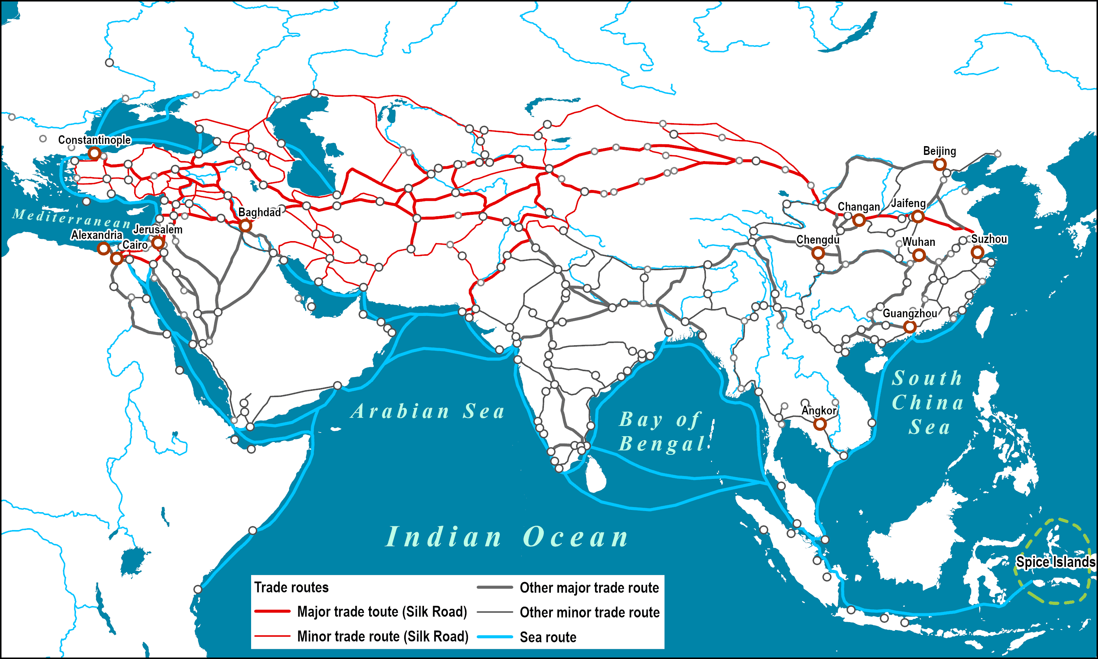
The Decline of the Port and the Survival of a Culture
Hoi An’s decline wasn’t due to politics alone. The river that made the city possible eventually betrayed it. By the late 18th century, the Thu Bon River silted up, making it increasingly difficult for large merchant ships to reach the main port. As the Nguyễn Dynasty consolidated power, trade shifted north to Da Nang, which had a deeper harbor and easier access.
But here’s the remarkable part. Hoi An didn’t vanish. It paused.
While other port cities rushed to modernize, Hoi An remained in a kind of cultural time capsule. People lived here, fished here, worked here, but it didn’t experience the large-scale demolition and rebuilding that transformed so many Asian cities during the 19th and 20th centuries.
This is why its architectural core survives so beautifully. The decline of international trade accidentally saved the town’s character.
When UNESCO recognized Hoi An Ancient Town as a World Heritage Site in 1999, it wasn’t just for preservation. It was acknowledgment of a rare, living record of how Southeast Asian port cities once looked and functioned.

A Town That Kept Its Traditions Working
Walk the streets at night and you feel a story that never really ended. Lanterns sway, temple drums echo from across the river, and boats drift slowly under bridges built long before electricity. Tailors still measure fabric in doorways. Carpenters still shape beams with traditional tools. Families still talk about Japanese or Chinese ancestors who arrived here with little more than cargo and ambition.
Hoi An isn’t preserved because it’s old. It’s preserved because it never stopped being itself.
The city still moves at the pace of the river, steady, patient, and aware of everything it’s carried.

References
Alberts, E. (2019). A History of Southeast Asia. Cambridge University Press.
Andaya, B. W. & Andaya, L. Y. (2015). A History of Early Modern Southeast Asia, 1400–1830. Cambridge University Press.
Chapman, A. (2016). “Hoi An and the Japanese Trade Networks of the 16th Century.” Journal of Asian Maritime Studies 11(3).
Lockard, C. (2010). Southeast Asia in World History. Oxford University Press.
Nishimura, M. (2002). “Japanese Merchants in Hoi An.” International Journal of Asian Studies 3(1).
UNESCO World Heritage Centre. (1999). “Hoi An Ancient Town.”
Wheeler, T. (2017). Vietnam. Lonely Planet Publications.

