Historically Significant Phono Cartridges
Part 3
By Marc Silver

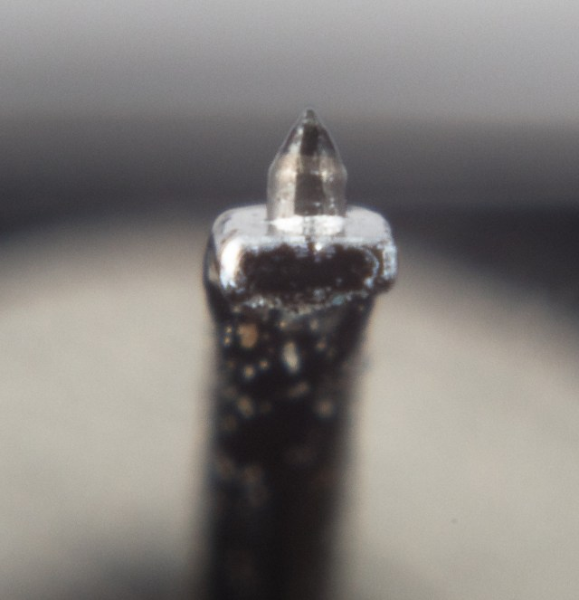

This morning, I woke up at 3 a.m. Not the slow, drifting kind of waking. The kind where your eyes open and your brain is already running. I had been dreaming about something that happened at my store more than thirty years ago, a comparison I hadn’t thought about in years. By the time I was fully awake, the dream had shifted from turntables to cartridges, then to specific designs, then to names I hadn’t said out loud in decades.
Once that door opens, there’s no going back to sleep.
I started thinking about cartridges that mattered. Not because they were fashionable, or expensive, or measured well on paper, but because they changed how people listened. Or challenged assumptions. Or refused to behave the way they were supposed to.
By 4 a.m. it was obvious I wasn’t going back to sleep. The upside was that it finally pushed me to start writing this article.

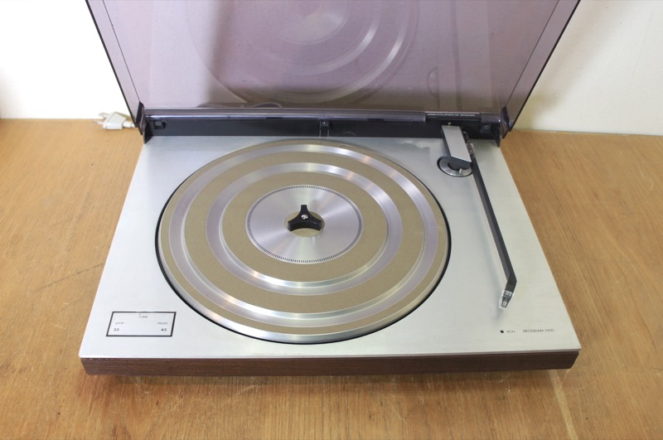
A Memory Worth Revisiting
Thirty years ago, when I was a Bang & Olufsen dealer, I remember reading a short article claiming that B&O turntables performed well beyond their price class. That kind of statement tends to irritate audiophiles, which is usually a good sign that it deserves investigation.
So I decided to test it.
I took a B&O BG-3400, or possibly a BG-3402, fitted with an MMC20EN cartridge. I placed it slightly askew on top of an electronics stack, hardly an ideal setup. For comparison, I used a far more traditional audiophile system: a Systemdek IIX turntable, an Audiocraft AC-300 tonearm, and an Ortofon MC20 Mk II, fed into an MCA-76 moving-coil preamp.
The price difference was not subtle. The Systemdek setup cost more than five times as much.
We set up a proper double-blind test. No visual cues. No commentary during playback. Just switching between sources and listening. I gathered my sales staff in the sound room. A few were openly skeptical. A couple assumed this would be a quick demonstration of why “real” turntables mattered.
That’s not what happened.
The B&O didn’t win. But it didn’t lose either. In fact, it performed shockingly close to the much more expensive system. Close enough that no one in the room felt comfortable dismissing it. Close enough that the conversation afterward lasted longer than the demo itself.
What struck me most wasn’t that the B&O held its own. It was why it did.
The cartridge mattered more than anyone expected.
That experience never left me. It changed how I thought about demonstrations, about value, and about how much of what we hear actually comes from the small assembly riding the groove.
That is what this article is really about.

Why Certain Cartridges Matter
Cartridges sit at an odd intersection of engineering, philosophy, and musical priorities. They are mechanical devices operating at microscopic scales, translating physical motion into electrical signal with astonishing fragility.
Some designers chase neutrality. Others chase energy. Some chase tracking ability at any cost. Others accept compromises in exchange for tone, texture, or scale.
The cartridges that endure are rarely perfect. They are memorable.
What follows is not a ranking, and it is not comprehensive. It is a collection of cartridges that, for one reason or another, left a lasting impression on me over the last fifty years.

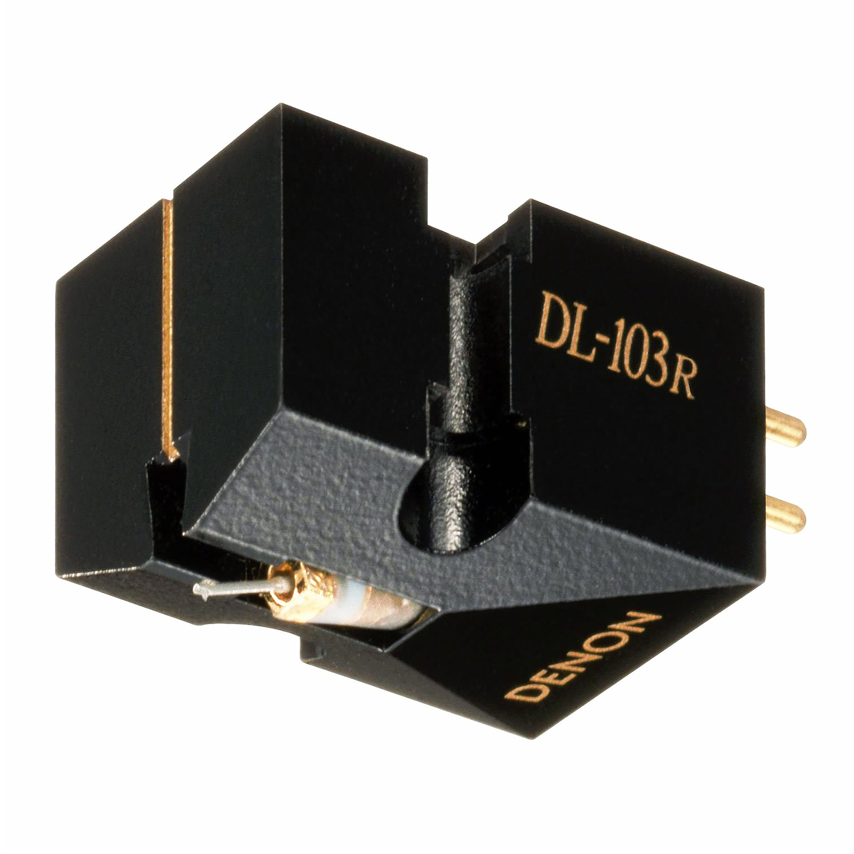
Denon DL-103 and Its Variants
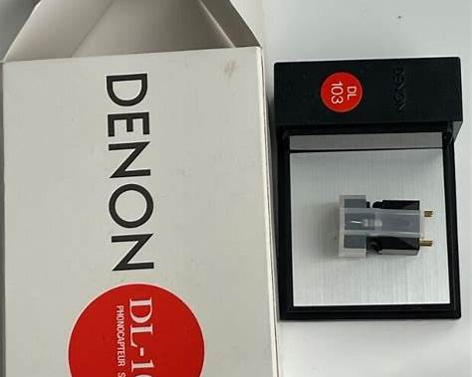
The Denon DL-103 began life in 1962 as a broadcast cartridge, not an audiophile darling. It used a spherical stylus, tracked confidently, and behaved predictably in professional environments. It was never meant to be precious.
I bought my first conical version in 1977 and have used variations ever since. Over the years, Denon produced the S, LS, M, and R versions, along with related designs like the DL-102, DL-110, DL-301 II, DL-304, DL-S1, and the DL-A100.
Denon briefly discontinued their cartridge line, then reversed course due to demand. That alone says something.
I was irritated when Denon eliminated their body-credit trade-in program. It felt short-sighted. But given how much performance you get for the money, I eventually forgave them.
The DL-103SA deserves special mention. Limited to roughly 2,000 units, it featured a glass-fiber resin body, gold pins, gold-plated screws, and slightly higher output. Denon even claimed the screws improved sound. Audiophiles can argue that one out on their own time.
What matters is that, six decades later, the DL-103 remains relevant. That is rare.

ADC ZLM III and the Era of Ultra-Compliance
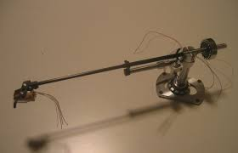
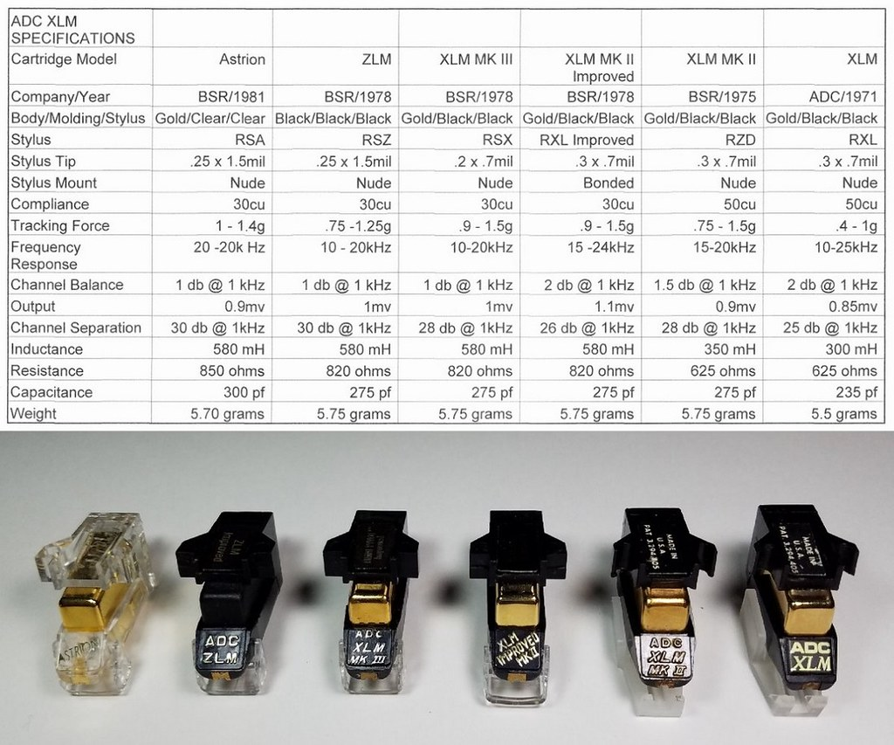
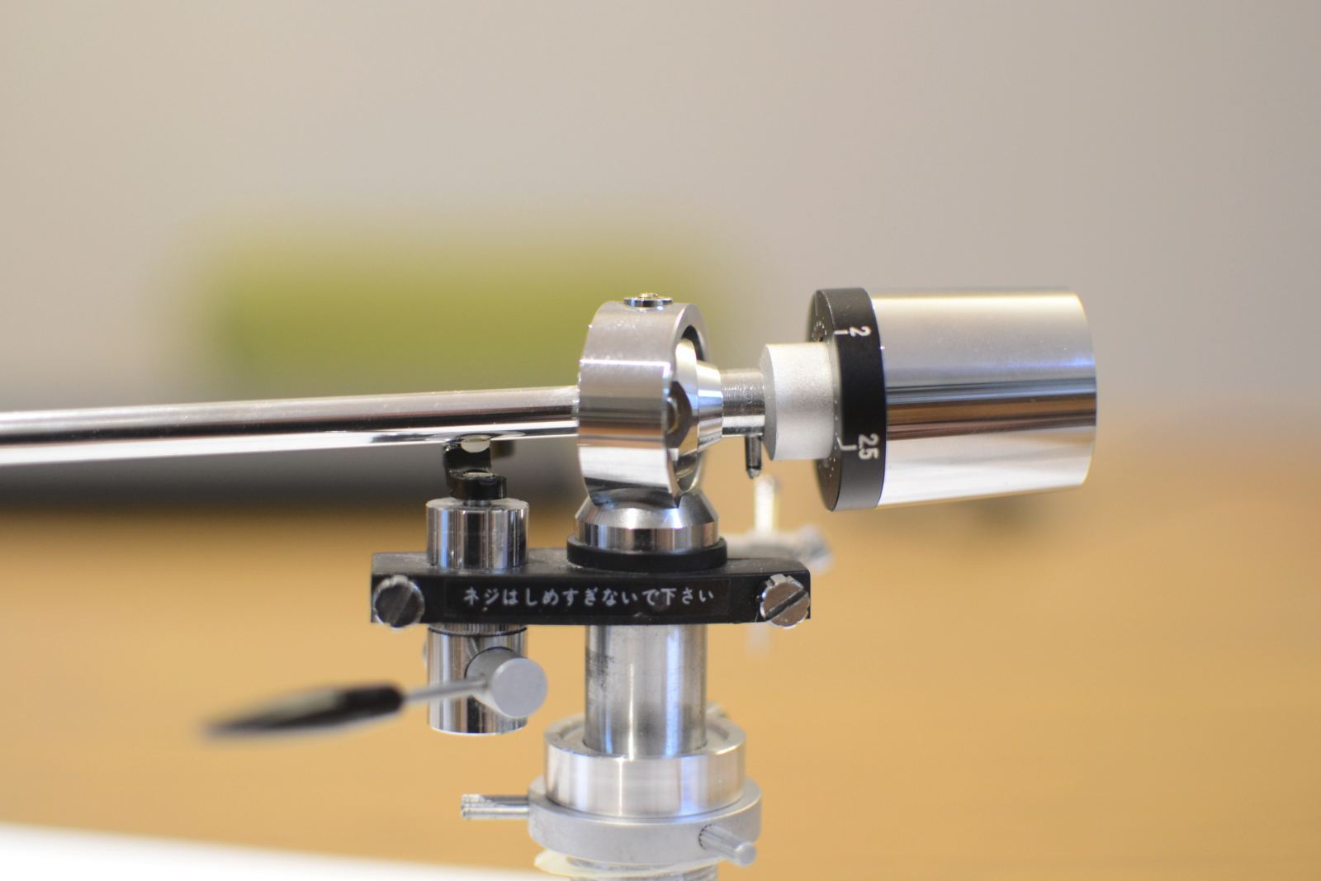
The ADC ZLM III was built for an era that believed low mass and high compliance were the future. When matched with the right tonearm, like ADC’s own, the Infinity Black Widow, or the Grace 707, it could extract startling detail from a record.
Matched poorly, it was a disaster.
A warp could send it airborne. Tracking was arm-dependent in ways that frustrated casual users. But when everything aligned, the ZLM had an uncanny ability to separate instruments and clarify dense mixes.
ADC, founded by Peter Pritchard, shared design DNA with Grado and Bang & Olufsen through induced-magnet technology derived from his earlier work at GE. After ADC was sold, Pritchard went on to form Sonus. Both brands are gone now, which is a shame.

Micro Acoustics 3002e
A Completely Different Idea
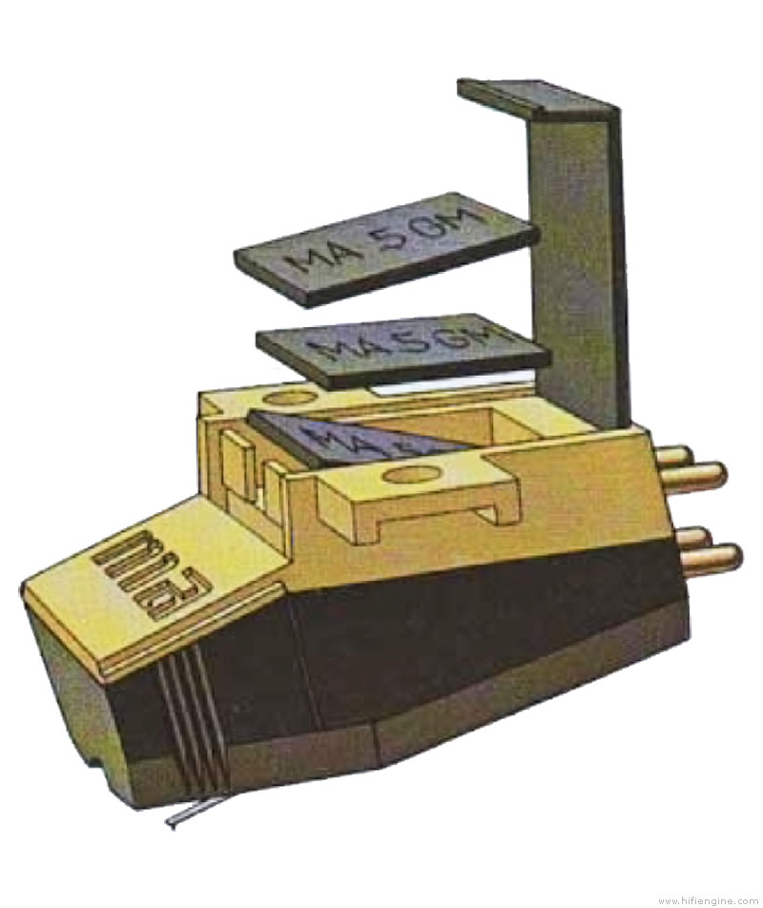
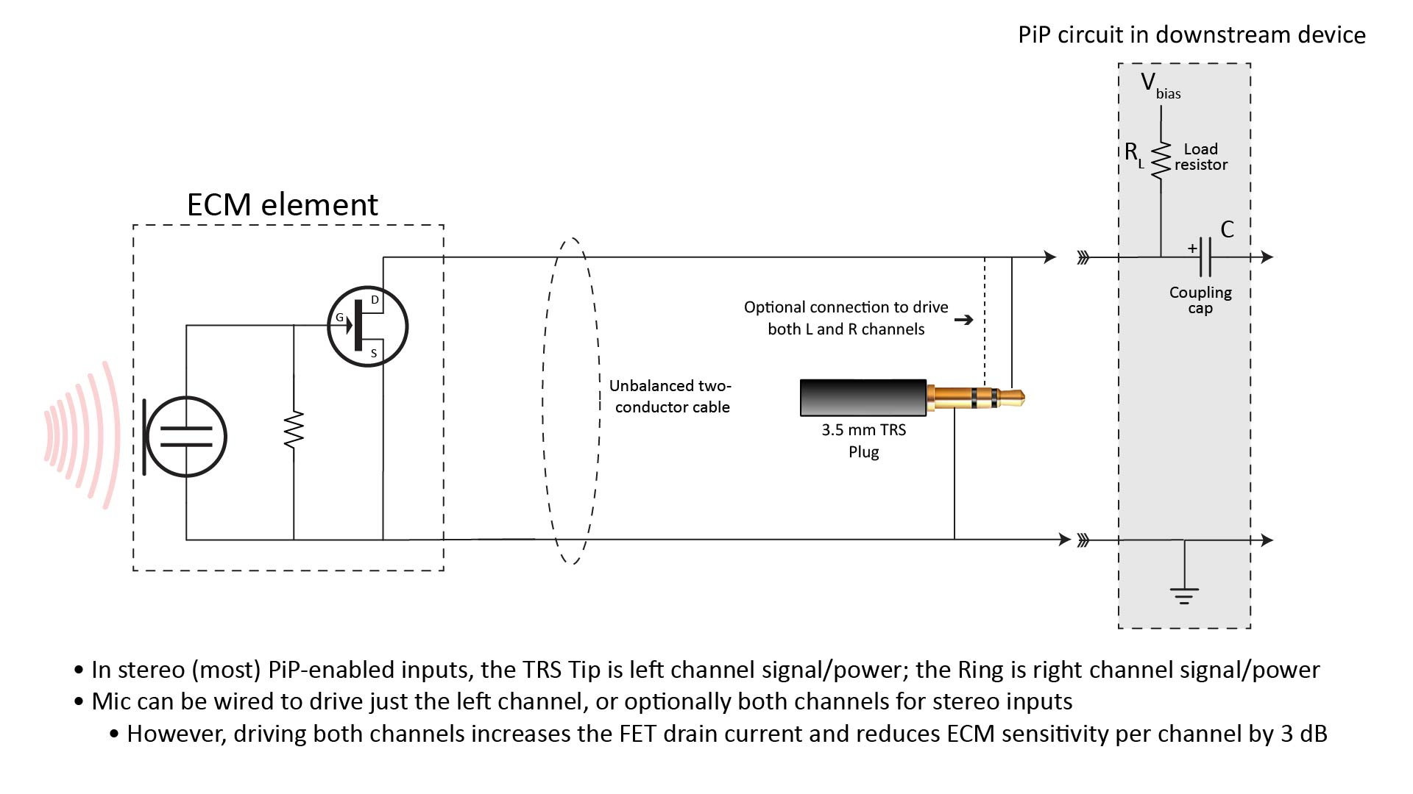
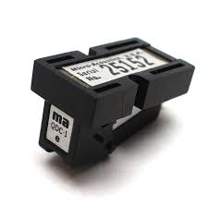
The Micro Acoustics 3002e remains one of the most unconventional cartridge designs ever produced.
Founded by Arnold Schwartz and Sanford Drelinger, Micro Acoustics used an electret-based system with a piezoelectric element directly coupled to the cantilever. A solid-state circuit was driven by the moving assembly itself. No coils. No magnets in the conventional sense.
The cartridges were light, high-compliance, and remarkably flat in response. Micro Acoustics claimed square-wave reproduction. Whether or not you accept that claim, the sound was unmistakable.
They were fast. Clean. Detailed without being etched.
Micro Acoustics has been out of business for decades, but collectors like me have been hoarding them. I own five, two rebuilt. I currently run a 3002e and find it competitive with modern moving-coil designs that cost far more.
That alone makes it historically significant.

Koetsu Rosewood
When Musicality Became a Statement
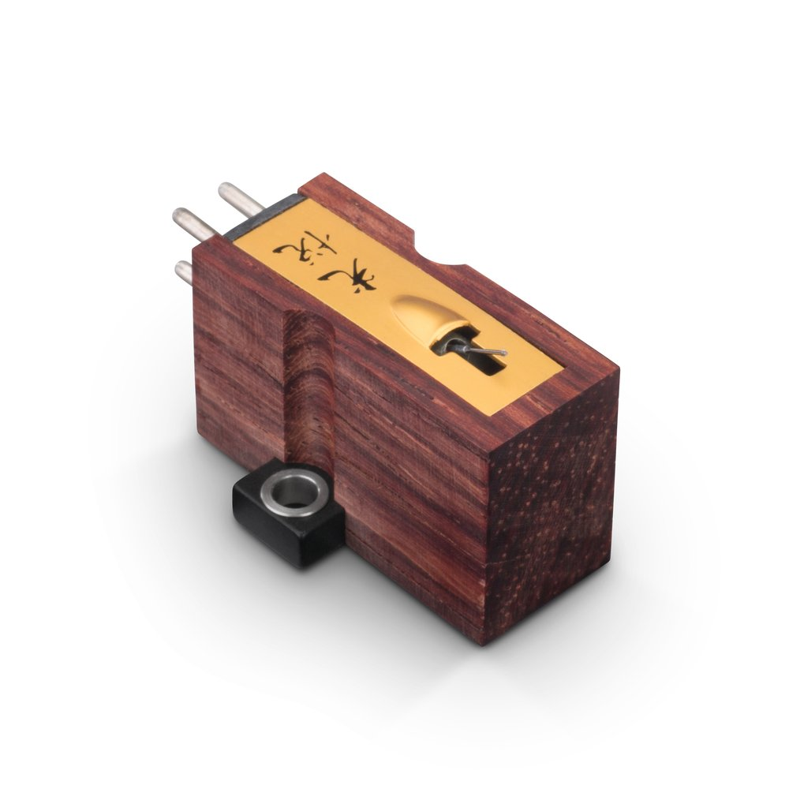
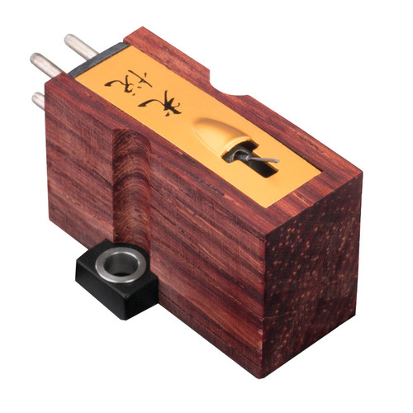
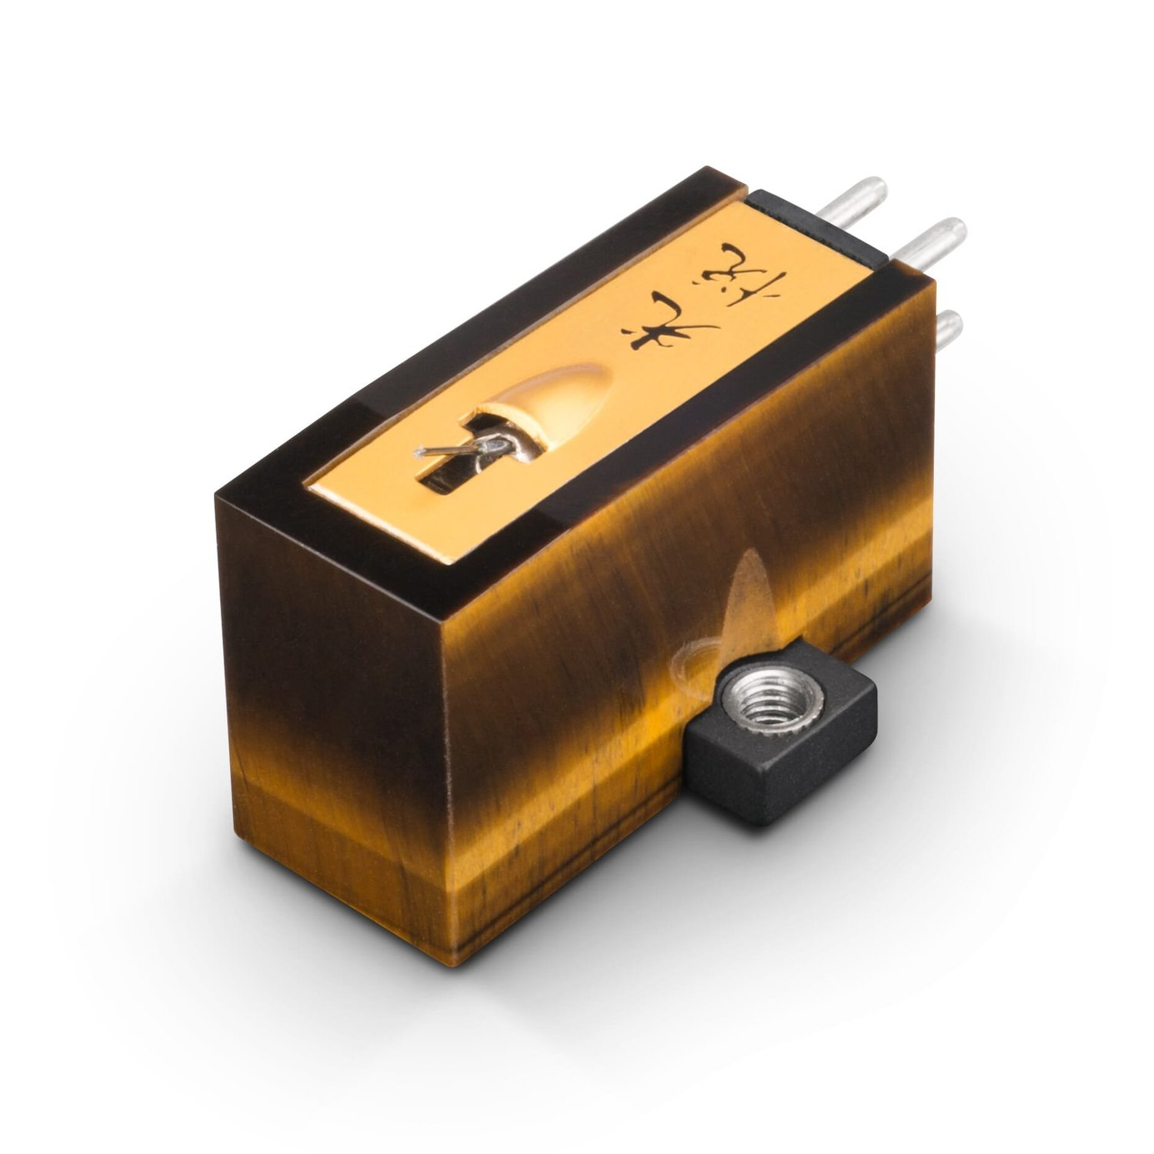
When the original Koetsu Rosewood arrived in the U.S. in the late 1970s with an $800 price tag, it caused genuine outrage.
Hand-built by Yoshiaki Sugano, it didn’t chase specifications. It chased harmonic density, dimensionality, and tone. It was not neutral in the modern sense, but it was deeply musical.
After Sugano’s death, the company’s future was uncertain. His son Fumihiko continued production, preserving both the philosophy and the craft.
Koetsu proved that cartridges could be instruments, not just transducers.

Stanton 681EEE
Indestructibility as a Feature
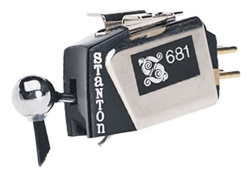
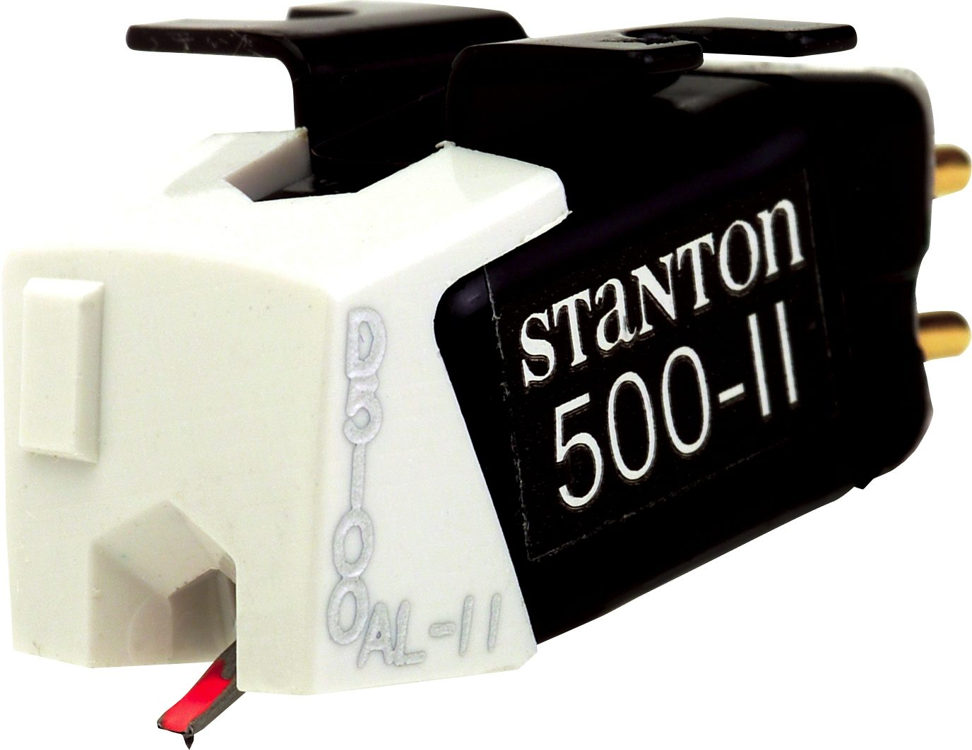
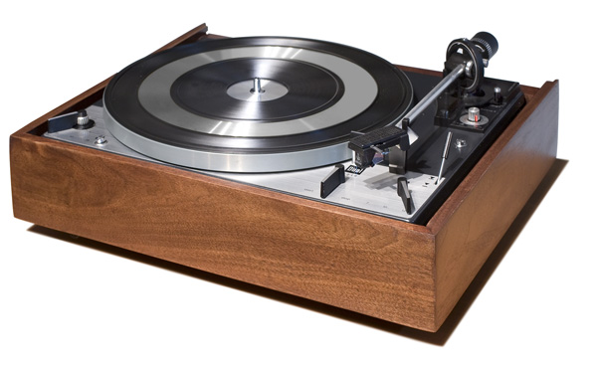
Stanton, founded by Walter Stanton in 1946, gave us the user-replaceable stylus. That alone changed the industry.
The 681EEE was rugged to the point of absurdity. I once witnessed a speaker fall several feet onto a Dual 1219, crushing the turntable and driving the cartridge through the test record. The cartridge survived. It was remounted and sent back into service.
That kind of durability mattered in broadcast and professional environments. It still does.

Dynavector 17D and 23R
Rethinking the Cantilever
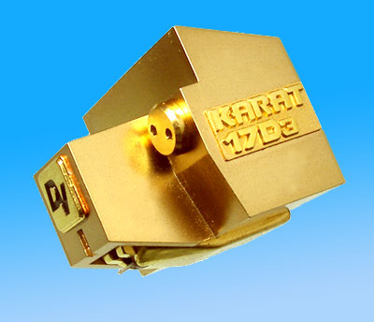
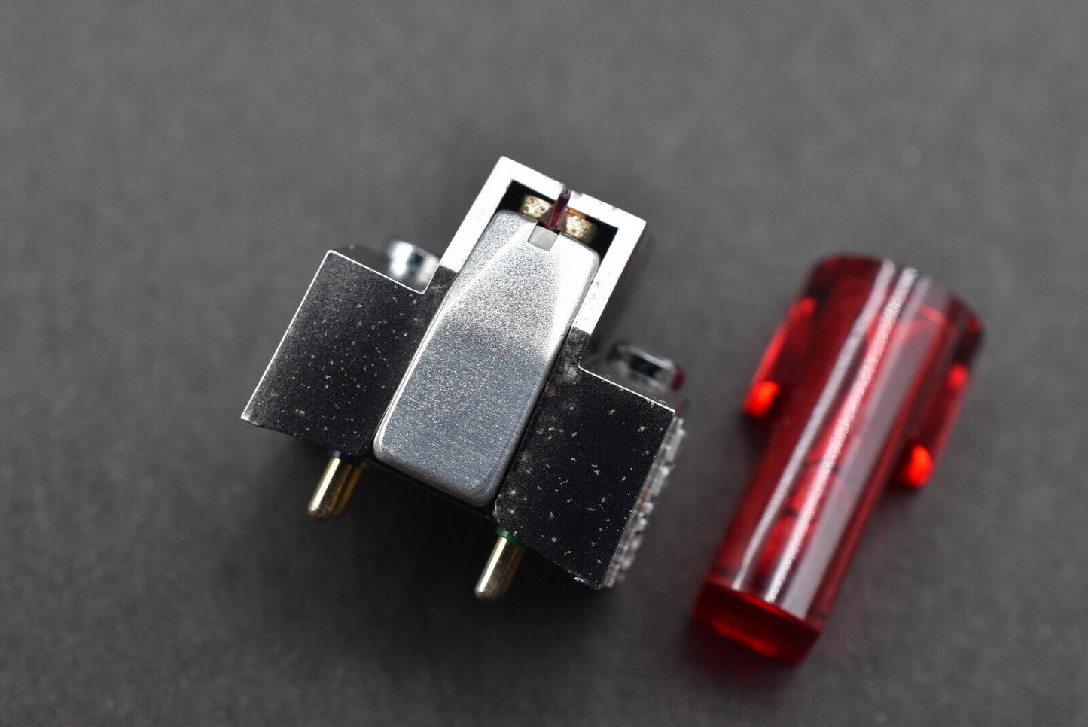
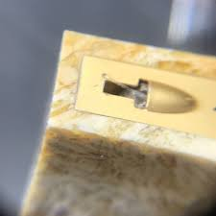
Founded by Dr. Noburo Tominari, Dynavector focused early on production innovation, making high-output moving coils affordable.
The Karat series introduced a radical idea: a solid diamond cantilever, extremely short, extending frequency response beyond 70 kHz. Whether or not you believe in ultrasonic benefits, the audible results were undeniable.
Dynavectors have always struck me as detailed yet musical, with excellent soundstaging and coherence.

Decca Gold
Brilliant and Unforgiving
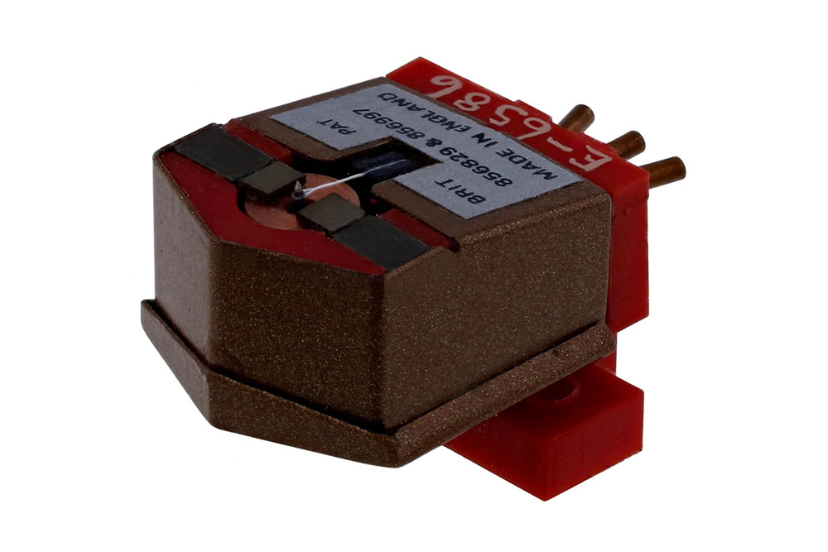
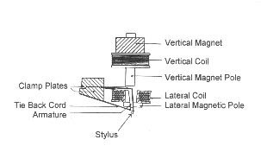
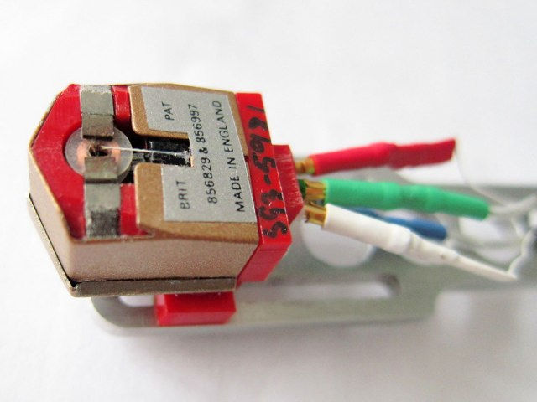
Decca cartridges are unlike anything else. Near direct-coupled. Extremely rigid. Demanding of tonearm mass and bearing quality.
Get it right and they sound alive in a way few cartridges can match. Get it wrong and they will punish you.
They are not polite. They are honest.

Ortofon SPU
The Beginning of Moving Coil History
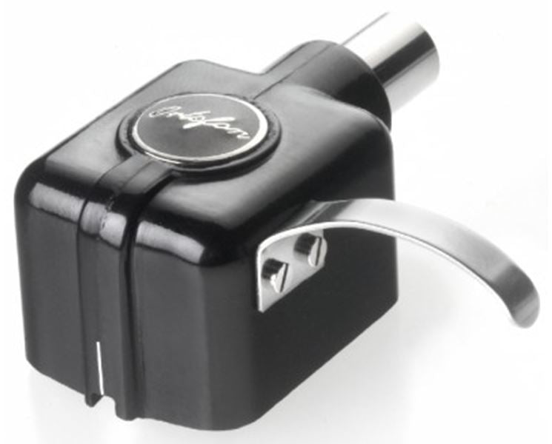
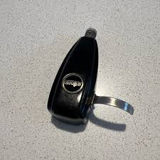
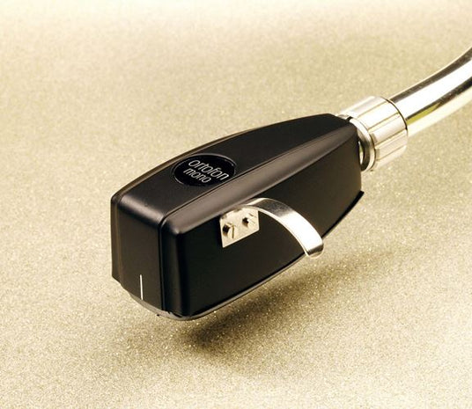
Introduced in 1958, the Ortofon SPU was Europe’s first production moving-coil cartridge. Based on Bang & Olufsen patents, “SPU” stood for stereo pick-up.
More than sixty years later, it remains in production. That is not nostalgia. That is relevance.

A Personal List, Not a Verdict
Before closing, here is a list of cartridges I consider historically significant. Not because they were perfect, but because they mattered.
(List retained as submitted.)

Closing Thoughts
I’ll be continuing this series with a fourth installment. If there are cartridges or manufacturers you believe deserve attention, let me know.
Chances are, I’ve owned one. Or sold one. Or argued about one late into the evening, long after the store was closed.
And sometimes, they still wake me up at 3 a.m.

