Historically Significant Phono Cartridges
Part 2 – Grado
By Marc Silver
When Constantine suggested I write this series of articles on significant phono cartridges, Grado was one of the very first cartridges that came to mind. I started selling Grado cartridges in 1968 when I was working at Stereo Mart in Los Angeles. In fact, I have continued to sell Grado cartridges continuously ever since.
Grado was established by Joe Grado back in 1953 and has continued for three generations. Today Joe’s nephew John Grado owns the company with John’s two sons, Jonathan and Matthew, next in line.

Recently I had the opportunity to interview John by phone about the history of Grado Labs as a company but discovered it also has a fascinating family history.

If you go to the Grado website one of the first things you see is this quote:
“The Grado family has deep roots in Brooklyn, where they have been hand building headphones and cartridges since 1953. Tradition and heritage have been carried down through three generations.”
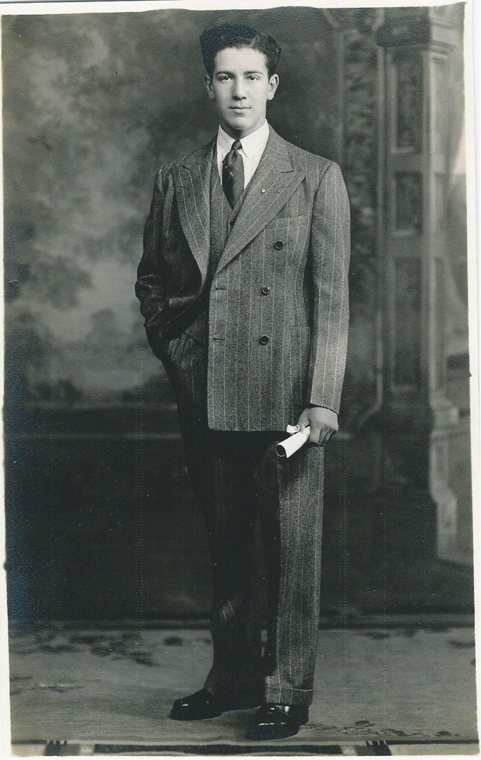
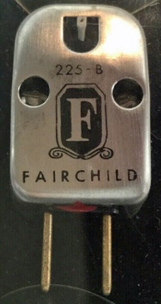
Brooklyn-born Joseph Grado attended a trade school, but he dropped out at 17 to join the Navy. He studied watch making at vocational school and after the Navy was able to secure a position at Tiffany & Company. In 1948 he started his own watch repair shop but continued to work for Tiffany. In the early 50’s Grado discovered the newly evolving high-fidelity industry. In 1950 he went to work for Fairchild Recording Equipment Company to resolve production issues with their phono cartridge. HiFi ultimately became Joe’s lifetime passion.

High Fidelity was his hobby and he started building monaural phono cartridges by hand at home in Brooklyn.

Historical Fact: In 1950 Joseph Grado was one of only two master watchmakers at the time (John Chaipis was the second) both men worked for Tiffany and Company in New York City.

Joe Grado was John’s Uncle who lived upstairs in the same two-house flat in Brooklyn New York. John got his start at Grado in 1965 as a 12-year-old sweeping the floors to earn extra spending money. Jose (who didn’t have a son) took his nephew John under his wing to teach him everything HiFI related from sound to electrical engineering.

When John graduated Brooklyn Tech High School in ‘71 he started full time at Grado and has been there ever since.

- Marc: When was Grado Founded?
John: Joe started building phono cartridges in 1953. He scraped together $2000 and began hand building monaural cartridges on his kitchen table. Eventually the company grew and he took over his father’s fruit store, Grado Fruit, around the corner from their flat and Grado Laboratories is founded.
Joe Grado became friends with Saul Marantz. Marantz was impressed with the young man and sent him over to Sherman Fairchild, whose hi-fi division at Fairchild Industries was showing little signs of progress. Grado promptly landed a top-level consulting engineering position with the company in their phono cartridge division. After correcting the production issues at Fairchild Joe had come up with his own design for a phono cartridge and left Fairchild to begin his own business, that was in 1953. Before long he had developed a revolutionary item in stereo design, the stereo moving coil cartridge. Scraping together $2,000 he began building phono cartridges out of his home. In 1958 he formed Grado Laboratories and opened a factory in Brooklyn on the site of his Sicilian-born father’s grocery business.
- Marc: What was Joe's relationship with Saul Marantz?
John: Joe was an audio enthusiast, today known as an audiophile, I believe Joe and Saul met at Leonard Radio, an audio store in Manhattan, around 1948. They shared interest in audio, singing and photography, they became friends. Saul was impressed with Joe’s hearing abilities and mechanical design ideas and often consulted with Joe as Marantz products were being developed. Joe and Saul continued to be lifelong friends till Saul's death in 1997.

- Marc: Were Grado cartridges at the time Ceramic or Magnetic?
John: His first cartridge was a Monaural Moving Coil.

Historical Fact: In 1955 Joseph Grado sells the first Grado cartridge to Leonard Radio. Up until that time he was selling directly to hobbyists.

- Marc: That leads me to another question. Was Joe the inventor of the Moving- Coil Cartridge?
John: Historically the Moving-Coil had been around for years in both rotary and linear motors. Joe adapted it for use as a phono cartridge. He developed the first stereo Moving-Coil patent in the late 50s and it was approved in 1960 or 1961. Joe received fees from many manufacturers during the life of the patent and was very vigilant about protecting his patent from infringement by other companies.
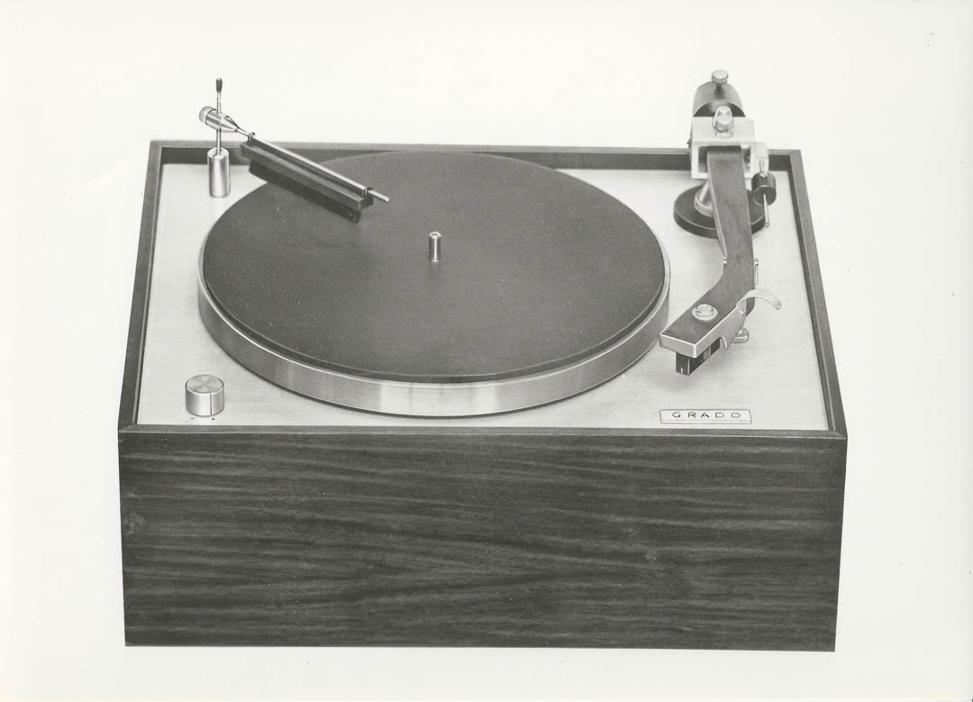
Historical Fact: In 1959 Joseph Grado is awarded patents for the first Stereo Moving Coil Cartridge. Joseph Grado is responsible for more innovations in phono cartridge design than any other person in our lifetime, inventing the stereo moving coil phono cartridge and holding more than 48 patents.

- Marc: Can you tell me the timeline?
John: At the time there were only two master watch makers in the United States; Joe was one and John Chaipis the other. In 1953 Joe left Fairchild and started building cartridges. In 1958 he incorporated and moved to where his father’s fruit store was around the corner. Which was when John Chaipis joined Grado Labs. John worked along Joe’s side for many years and ultimately retired in 2008.
Grado Labs Built Turntable with Dustat.

Historical Fact: In 1961 Grado introduced the Dustat Record Cleaner, the Lab Series of phono cartridges, speakers, tonearm, and turntables, but opted to concentrate on exclusively building phono cartridges

- Marc: Grado was building other audio products in the early 60’s. When did that change?
John: In 1963 he started building just the phono cartridges until the early 80s. We were producing over 10,000 cartridges per week in our peak. In 1989 we started building headphones.
- Marc: I remember in the early 70s Grado was producing the most amazing entry-level cartridges. The FCE+1 for $17.50, the FTE was $13.50 and the FTR $9.95. What can you tell me about those cartridges.
John: We were too successful with those models and consistently had a 6 month back order situation. I did the math and discovered we were losing fifteen cents per unit on the entry level cartridges FTR and FCR, so I went to my uncle and explained our problem and shortly afterwards we discontinued the bottom models. Interestingly the FCE+1 at $17.50 when you factor in inflation is within a few dollars of the current price for a Grado Black 2 cartridge at $75.

- Marc: Tell me about the design?
John: The patent is called a Flux Bridger. Flux-Bridger design enables the Prestige Series to have one of the lowest effective moving mass generating systems and creates an excellent balance throughout the full frequency range.

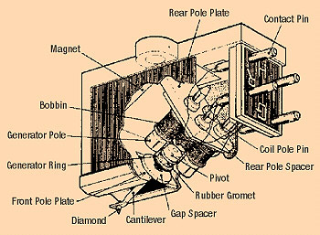
The Flux Bridger concept is similar to moving iron or induced magnet designs. Basically, there is a fixed magnet and a fixed coil with a smaller lighter piece of iron or similar material mounted on the cantilever that interrupts the magnetic field between the magnet and coil. Other companies who used this concept include B&O, Soundsmith, ADC, Sonus and some others.

Historical Fact: John bought Grado in 1990. Grado is currently in their 67th year of continuous production, making Grado one of the oldest cartridge companies currently in production.

- Marc: What do your son’s do at the company?
John: My oldest son Johnathan handles all the marketing and partnerships, e.g. Bushmills, Oreo, Microsoft, Dolce&Gabbana and many others for the company, while my younger son Matthew works with me in product development and the daily running of the company.

Historical Fact: Grado is still all family owned. John owns it all, however his two sons, Jonathan and Mathew will eventually inherit the company. In 2013 Jonathan Grado, (John’s eldest son) entered the company under his father with a goal of modernizing their word-of-mouth style and expanding the brand. In 2014 Jonathan became Grado’s Vice President of Marketing. Matthew Grado came on board in 2017 and has assumed the role of VP of Operations.

- Marc: What was the greatest accomplishment of the company?
John: Our longevity. But the two major items were the SR60 headphone and the original stereo moving coil cartridge. When the SR60 came out it was a major turning point for the company.

Historical Fact: By the time Joseph Grado ended his working career he held the rights to forty-eight patents and had been inducted into the Audio Hall of Fame.

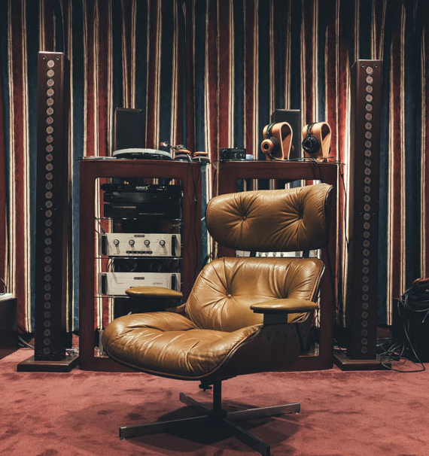
- Marc: Not many people are aware that you developed a loudspeaker. Whose idea was your speaker?
John: When I bought the company in 1990, I wanted to get into all audio markets. I worked on the speakers for five years, in that time the designs took all different looks. Finally wanting something that was all Grado, we used our drivers that we used in headphone production and finished with 5 models, standing from 18 inches to 7 feet. When we went to CES in 1995 with our newly offered SR60 ($69) we came back, and our headphone business took off like a rocket and I made an executive decision to stick to making headphones and phono cartridges. The Grado Towers remain unreleased to this day. The Towers are currently in Grado’s Listening Room.

In 1974 the cartridge is still king as Grado Labs rides the heyday of vinyl records. The Grado Signature Series is created to discover new levels of audio perfection and releasing the first $1000 phono cartridge to the audio market.

Historical Fact: In 1975 John Grado graduates college and joins Grado Labs full time. In 1977 John starts running day-to-day operations. The phono cartridge business continues to grow.

Historical Fact: Joe Grado was inducted into the Audio Hall of Fame in 1982.

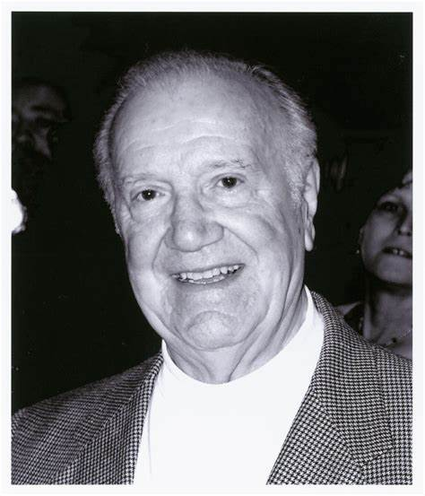
Historical Fact: 1988 With global turntable sales slowing due to more portable options becoming prevalent, Joseph plans on retiring from Grado Labs. In 1990 John decides to buy the whole company from his uncle, becoming President and CEO.

Historical Fact: In 2003 Grado Labs’ celebrated their 50th year anniversary with the release of a limited-edition Gold SR325 Headphones.

Historical Fact: 2015 Joseph Grado passes away.

Joe Grado was truly one of High Fidelity’s most significant figures. He was responsible for bringing musical joy to so many people all over the world. I am proud to have met him and believe we all benefited by his unique genius.
###

